Super Summary of Literature on Learner Autonomy in Language Learning:
http://www.finchpark.com/afe/ch1.htm#11

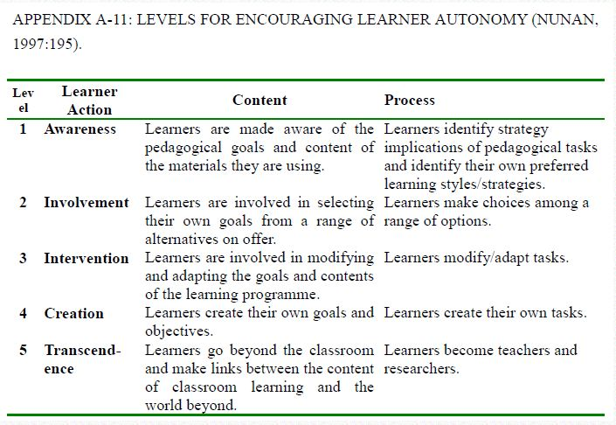

Nunan, D. (1997). Designing and adapting materials to encourage learner autonomy. In P. Benson, & P. Voller. Autonomy and Independence in Language Learning. Harlow: Longman, 192
- 203.

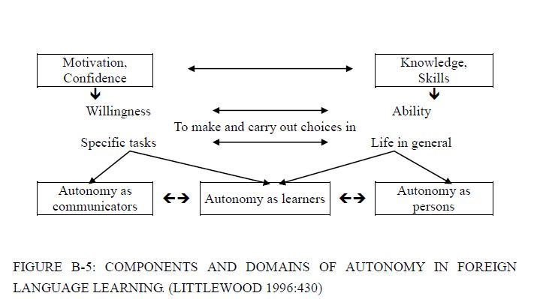

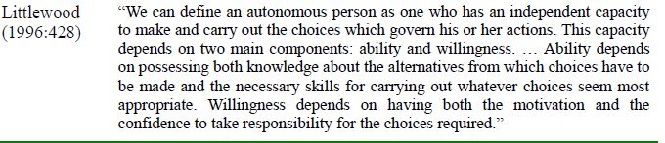

Littlewood, W. (1996). "Autonomy”: an anatomy and a framework. System, 24/4, 427-435.

