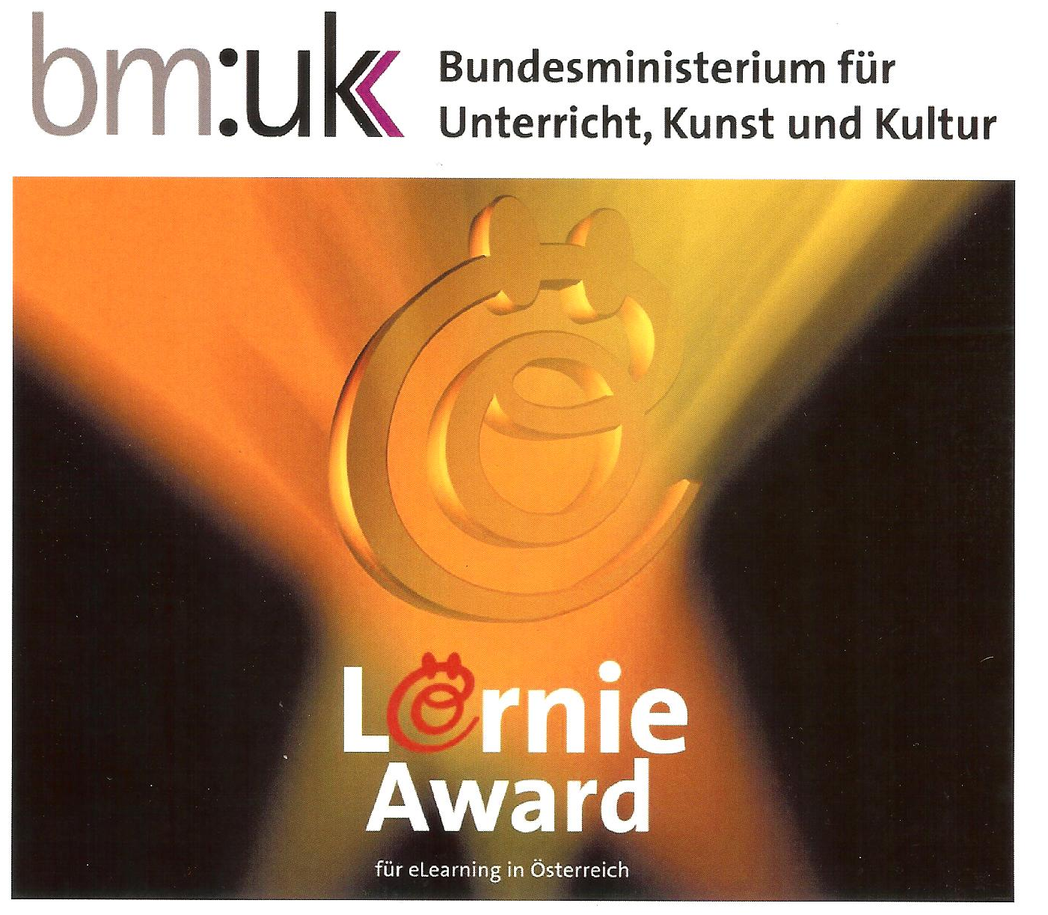
Spooky Stories Project
Elisabeth Pölzleitner
3. Preis: Kategorie Sprachen
2013
The “Spooky Story Project” combines different aspects of language learning with creative use of media and computer skills and was therefore selected as one of the best projects that have been submitted in the category “Languages”. To find out more about this project follow this link.

