Portfolio – Language Education for Specific Contexts

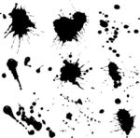
- English for Artists


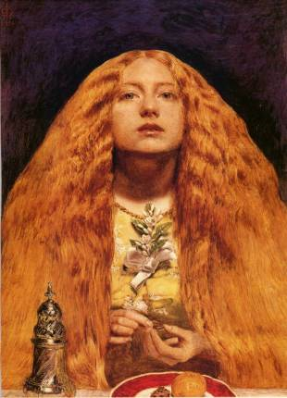
Laura Ecker – 0835282
Dr. Pölzleitner
SS 2011

Contents
1. Learner’s language biographies ……………………………………………………..3
2. Course Advertisement …………………………………………………………………..6
3. Course outline ……………………………………………………………………………….7
4. Session one – outline …………………………………………………………………….9
5. Session one – activities ………………………………………………………………..10
- 5.1. Pairs: Which painting materials has the artist used? ............10
- 5.2. Shopping list …………………………………………………………………….12
- 5.3. Words in context ……………………………………………………………..13
- 5.4. Explain the differences …………………………………………………….16

6. Session two – outline …………………………………………………………………..17
7. Session two – activities ………………………………………………………………..18
- 7.1. Art Domino ………………………………………………………………………18
- 7.2. Vocabulary Bubbles: How to describe a painting? …………….20
- 7.3. Stamps: Describe what you see! ……………………………….........22
- 7.4. Dialogue …………………………………………………………………………..23

2
1. Learner’s language biographies

John – 63 years old/ B1
John is a full time artist who spent most of his career working in Barcelona; Spain. He is fluent in Spanish but also speaks English since many of his clients are Americans. John sold his studio as well as his gallery in the city centre of Barcelona when he was 50 years old. He spent quite some time travelling the world together with his wife until he got a job offer while he was on vacation in San Francisco. The owner of the hotel they stayed in asked John to paint the interior of the dining hall as well as the spa area. He took the job but needs to learn the English names for his working materials because otherwise he won’t be able to give any directions to his English speaking employees.

- I want to be able to use the appropriate description for my painting material.

David - 37 years old / B1
David is a 37 year old artist from Vienna. He studied Architecture at the Boston College for about one year and quickly found that being schooled was not for him. He then went back to Vienna and started working as a contract 2 D / 3D Animator Artist for a game company. After three years David left the gaming industry and refocused his talents to painting full time. His painting skills are incredible but due to his lack of knowledge about certain “art terms”, he has difficulties expressing himself when asked specific questions during exhibitions in English speaking countries. David speaks English on a B1 level since he spent quite some time in Boston.
- I want to be able to lead a sales talk.
- I want to acquire necessary language for costumer relations.
3
William - 42 years old / B1
William is a high school teacher who studied Art and Math at the PÄDAK in Graz. Since teaching art as a school subject wasn’t satisfying enough for Alfred he additionally started working as a stage designer for the Opera of Graz. However, Alfred has no freedom when it comes to his artistic creations. His first priority is to fulfill the stage directors’ requirements. As a matter of fact, the stage director was born in Oxford and only speaks English. Therefore Alfred sometimes gets complex topic related directions wrong. Although Alfred speaks the language properly due to the fact that he spent some time in London in his teenage years, he is not familiar with most of the specific English terms used in the world of art. He finds himself on a B1 level.

- I want to be able to understand and use specific art related topics and acquire a certain knowledge about the names of the specific painting materials I work with.

Alice - 21 years old / B1
Alice is a 21 year old art student who wants to strengthen her artistic skills in the genre of “Pop Surrealism”. She just started to learn about the basics of drawing surrealistic objects but is lacking in knowledge about art styles in general. This year, the University has been offered a promising exhibition opportunity in the TATE gallery in London. Since only those students who will pass an oral exam checking on the student’s ability to identify the various art styles are allowed to be a part of the exhibition, Karen needs to step up her game. The exam will be in English in order to test language competence. Karen finds herself on a B1 level.
- I want to acquire vocabulary connected to the various art styles.
4
The artists are on Level B1 according to the CEFR scale. They are able to maintain an interaction by expressing much of what they want to say although they might have difficulties expressing exactly what they want to say. This is especially the case when it comes to engaging in a conversation dealing with a specific topic. They are communicating in a standard dialect and are furthermore able to express their personal opinion.

5
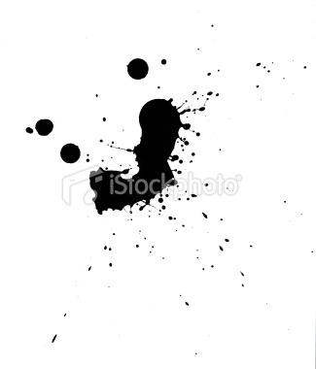
2. Course Advertisement

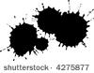
“HOW TO GET THINGS ROLLING IN THE ART SCENE”
Are you able to speak English on a B1 level?
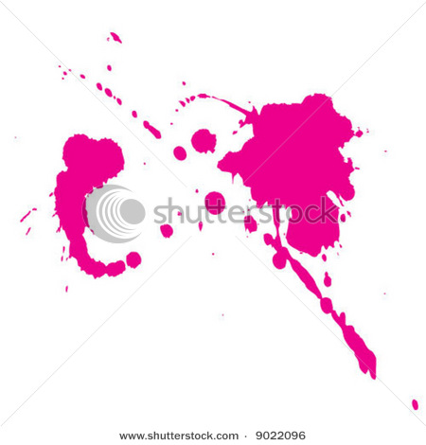
Do you want to further your communication skills in the art scene?
It will only take you 8 language sessions!
NOW IT'S YOUR TIME TO SHINE!

6
3. Course outline
1. Session  “Painting Materials” | 2. Session  “Art Styles” | 3. Session  “Meaning of paintings” | 4. Session  “Advertisement”
Content: | Content: | Content: | Content:
Get to know the specific terms for painting materials according to the various painting types (oil painting, watercolor, acrylic, etc.)  Acquire the ability to identify these topic related terms in appropriate context.  Deal with the actual usage of painting material terms by bringing them in connection with your own familiar environment. | Learn vocabulary connected to the specific art styles. (Realism, Surrealism, Impressionism, Abstraction)  Develop an understanding for the visual differences of these various art styles and the language needed to express this diversity.  Identify your own artistic style as an artist by applying the vocabulary that has been learned so far. | Learn how to talk about the meaning of paintings in terms of feelings, emotions as well as the importance of symbolic meaning.  Acquire the ability to express you own opinion towards art and feelings for your own artistic creation. | Acquire language that enables you to advertise your own artistic work efficiently.  Develop an understanding for what your costumer target group wants to hear and create your advertisement around these specifications.
Aim: | Aim: | Aim: | Aim:
I want to acquire knowledge about the names of the specific painting materials I work with.  I want to use these terms appropriately and efficiently in art related contexts. | I want to acquire a broader knowledge about art in general by learning about the differences that exist in terms of style.  I want to be able to talk about my own style of painting. | I want to be able to express the emotional intentions behind my paintings. | I want to be able to use art related language for advertising my own pieces of art.

7
5. Session  “Getting in touch” | 6. Session  “Payment and Insurance” | 7. Session  “ Group Exhibition”
Content: | Content: | Content:
Acquire language for getting in touch with English speaking costumers.  Get to know the appropriate language for being able to advertise your own pieces of art and to engage in a conversation with potential customers. | Get to know the specific terms used for payment and insurance related topics.  Acquire knowledge about the conditions that have to be made clear to the costumer when engaging into sales negotiations. | In the last session of this course there will be an exhibition taking place. Each of the participants will be exhibiting his/her paintings in a group exhibition.  They’ll be able to test and express what they have learned throughout the course. They will get the chance to talk about the painting materials they use, the style and meaning of their artistic creations as well as experience real life costumer relations.
Aim: | Aim: | Aim:
I want to be able to talk about various types of art related topics that can function as a conversation starter. | I want to acquire the basic vocabulary for payment and insurance related topics. | I want to be able to experience a real life situation in an authentic environment under realistic circumstances.  I want to link what I have learned throughout the course to a personal experience.

8
4. Session one – outline
“Painting Materials”
In the first session of this course the participants will be made familiar with the specific terms used for painting materials according to the various painting types. These various painting types are represented by differences in technique and a diversity of materials that were used for the creation of certain paintings. Therefore we will differentiate between oil and acrylic painting materials, watercolor materials as well as many others. The course participants will furthermore acquire the ability to identify these topic related material terms in appropriate context. Towards the end of this session they’ll also be able to deal with the actual usage of painting material terms by bringing them in connection with their own familiar environment.

Aims:
- I want to acquire knowledge about the names of the specific painting materials I work with.
- I want to use these terms appropriately and efficiently in art related contexts.

9
5. Session one - activities
5.1. Pairs: Which painting materials has the artist used?
Task: Get together in groups of 3 or 4 people. Each of you will receive cards. One of you will read out the list of materials that were used for the creation of one of these specific paintings. The person who has the matching painting to the material list collects the pair and reads out the next card. In the end, the person who has collected most pairs is the winner.
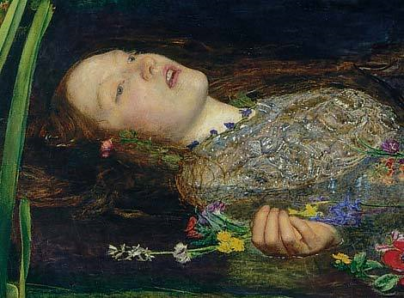
The artist has…
- … painted on canvas
- … sealed the canvas with gesso
- … used oil paint
- … put oil paint on a palette
- … used a palette knife for mixing colors
- … used a thinner to clean the painting
brushes
- … added medium to the oil colors to
make them flow more smoothly

The artist has …
- … drawn on paper or a sketching
pad
- … used charcoal pencils and graphite
sticks
- … used blending paper stumps for
smoothening large areas of pastel or
charcoal
- … used a sandpaper block to sharpen
drawing pencils
- … used a gum eraser

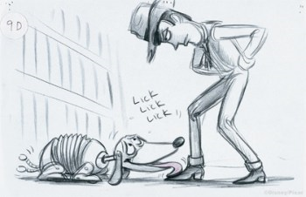

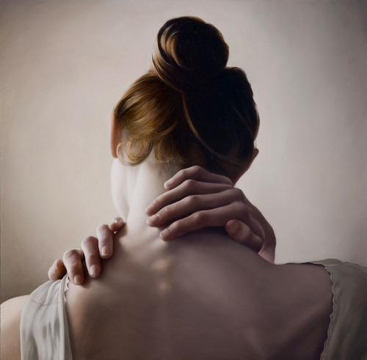
The artist has…
- … painted on paper or acrylic pads
- … used fluid and craft acrylics
- … used an acrylic gouache which
combines the elements of fluid and
craft acrylics in one
- … used iridescent, pearl and

interference colors
- … used a masking tape to “mask off”
areas that should not be painted
- … used an easel to hold the painting

10
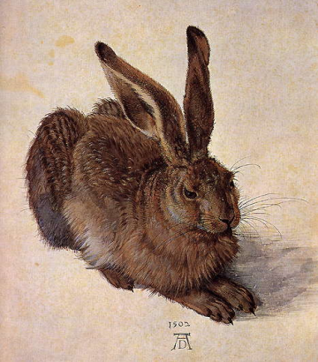

The artist has…
- … painted on paper or blocks
- … used watercolor half-pans
- … applied watercolor masking fluid to
block out areas of a watercolor
- … worked with a nib pen to apply
masking fluid precisely
- … used egg tempera to produce thin,
translucent effects

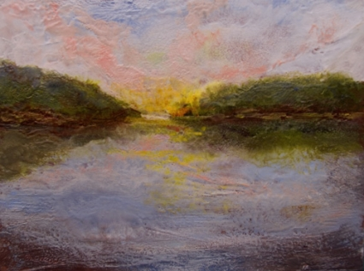

The artist has…
- … painted on paper
- … used watercolor sticks and encaustic
wax paints
- … added modeling wax to fuse the
encaustic paint over a shape
- … used a hot air gun
- … distribute color with a heat resistant
fan brush

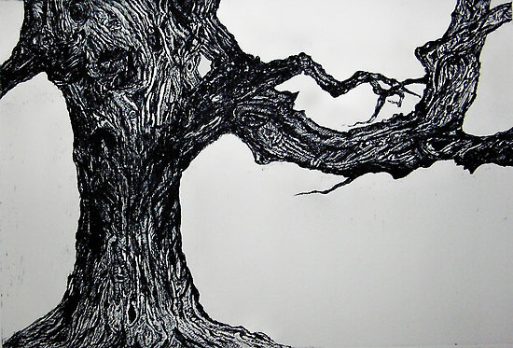
The artist has…
- … carved into a etching plate
- … used Etching & Lithographic ink
- … worked with a point scriber and a
curved burnisher
- … applied ball ground to a heated plate
(a thin black layer to make etching
work visible)
- … worked with lithography pencils

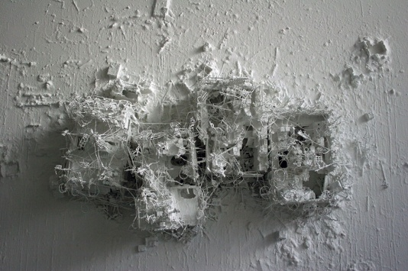
The artist has…
- … worked on relief printing linoleum
- … used cutting knives
- … used multi-surface and multi-layer
relief paints
- … used a relief paint roller to distribute
color evenly
- … used a rag to wipe off spare paint

3.2. Shopping list
11
5.2. Shopping list
Task: Imagine yourself being out of painting materials. Since your exhibition is coming up in two weeks and you still need to start one new painting and have a few others to lay some final touches on, you immediately have to put together a shopping list.
Unfortunately, you find yourself in an Art supply store in New Jersey where you are advised by an employee who does not have much knowledge about what is actually sold in the store. With some items the employee simply does not know what you mean. In order to make sure that you get the right things, you have to explain what some of the materials you want to buy look like and what they are used for.
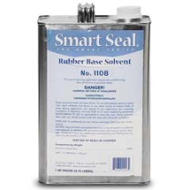
Write everything you need in the blank shopping list provided and explain the items listed beneath so that the Art supply store employee knows what you mean.

painting materials

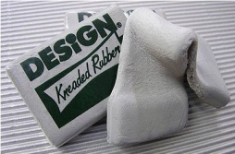

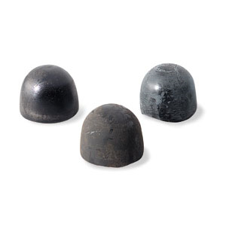


12

5.3. Words in context
Task: Since you are now familiar with the names of the materials artists use for various types of painting, try to find some of these newly acquired words in the article provided. Once you have identified the words, look at the context in which they are used. Choose three sentences as well as three useful collocations from the text and write them on the vocabulary cards at the bottom of the article.
Maybe you can also come up with some useful collocations on your own that might help you to explain your own painting technique in a conversation with possible costumers.
Attention: Don’t forget to draw a personal symbol in the upper right corner of each vocabulary card that represents the various words you find in the text.

How to Paint
Have you ever wanted to paint beautiful, expressive paintings with oils? Here are some basics to guide you into the wonderful world of oil paints. Once you've got the basic techniques down, the world is your canvas!
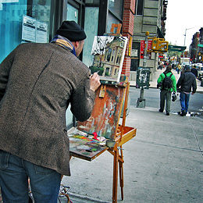
Choose a place to work where there is good ventilation--a window or door can be opened, or good ventilation can be turned on, and/or you have a fairly open space where air can circulate and move around. If you paint outside, remember that you will need to set up securely so the wind won't blow things over. Note that insects, especially bees, love Citrus Thinner!
Adjust your easel so that you can easily touch the painting surface without bending down or standing on tip-toes while holding the brush. You will stand for hours, so make sure you won't strain your back. Standing is better than sitting, but if you must sit, paint at arm's length from the easel.
13
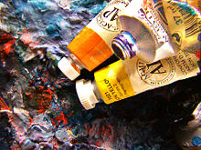
Set up your paints. Have enough room for your palette, brushes and palette knife, solvent and solvent/oil containers, rags and paint tubes to be comfortably displayed, readily available for you to use.
A standard painting medium is 1 part oil to 2 parts solvent. The most common oil is linseed and its varieties but some painters use safflower, walnut or poppy oils. Consider putting the medium in a squirt bottle. You can squirt the contents onto the palette to work into your paint.
If you choose to buy a variety of paint colors, try not to get excited about squeezing every single color onto your palette before you begin to paint, as this will waste a lot of paint. Give yourself 2 or three colors to start with and go from there.
Paint. This part really depends on what you want to produce. However, there are certain things to keep in mind no matter what you're painting.
For example, oil paints have a short blending life on the canvas. It is not hard to turn an area into a dull brown mud spot if there are a lot of repetitive layers and alterations made. If you try to alter something and it doesn't work immediately, grab a rag and wipe it off. All the paint from that area will come off.
Oils take a while to dry, so you have time to remove paint for almost 24 hours after the application. Just like any other paint, if you make the first coat too thick, it won't dry all the way.
Clean your brushes well between color changes. When you are ready to remove paint from your brush and use a different color, wipe as much paint off with a rag as you can before putting the brush into the thinner. This will make your thinner last longer and will remove more paint from the brush. Swish your brush in the thinner container, then dry it off with a rag.
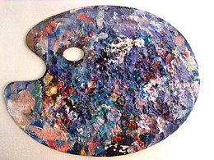
Give your work of art its space. When the first layer is complete, it will be about 48 hours before it will be dry enough to do the second application without smearing your first day's work. Don't leave your work in an area that is especially hot, or humid, and keep it in an area where it won't get smeared, scraped, touched, brushed up against, etc.
If there is a good amount of paint left on your palette that can be used next time, use your palette knife to scrape the "good" paint together, then dampen a clean rag with thinner just slightly and wipe the rest of your palette clean. Use a piece of saran wrap to cover the leftover paint, wrapping it fairly snug.
14

Word: Color/Picture/Doodle
Sentence I found in my reading:

Second example sentence from my dictionary:

Useful collocation:

Word: Color/Picture/Doodle
Sentence I found in my reading:

Second example sentence from my dictionary:

Useful collocation:

Word: Color/Picture/Doodle
Sentence I found in my reading:

Second example sentence from my dictionary:

Useful collocation:

15
5.4. Explain the differences
Task: Take a look at these two paintings. Can you identify what kind of painting materials were used with each of these pictures? Which major differences can you identify in terms of the painting surface, the paint as well as possible additional devices? Please write down full sentences!
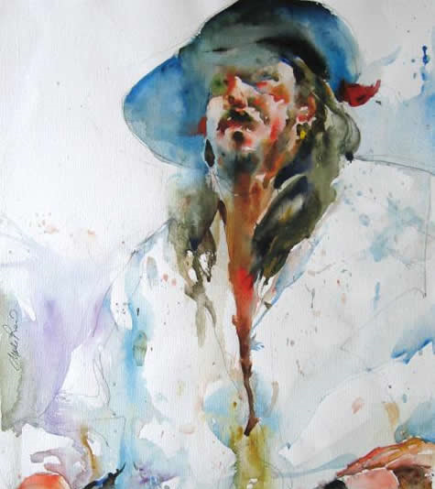


Homework: Please bring a photo of one of your own artistic works to our next class. We’ll need it for one of the following activities.
16
6. Session two – outline
“Art Styles”
In the second session of this course, the participants will be confronted with the vocabulary connected to the specific art styles. These specific art styles are represented by Realism, Surrealism, Impressionism, and Abstraction amongst many others. The knowledge about these artistic varieties will not only help the participants to develop an understanding for the visual differences of these various art styles but also allows them to acquire the language needed to express this diversity. In the end they’ll additionally be able to identify their own artistic style as an artist by applying the vocabulary that has been learned throughout this session.
Aims:
- I want to acquire a broader knowledge about art in general by learning about the differences that exist in terms of style.
- I want to be able to talk about my own style of painting.

17
7. Session two - activities
7.1. Art Domino
Task: Get together in groups of 3 or 4 people. Then deal out the whole set of dominoes. Player A in each group starts by laying down a domino. The next player to his/her right lays down a domino one end of which matches one end of A’s domino. The play continues round the circle until there are no cards left. If the player can’t lay down a domino, he/she misses a turn. The winner of the game is the first one who gets rid of his/her dominoes.
Expressionism
Impressionism
Painterly
Realism
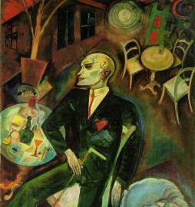
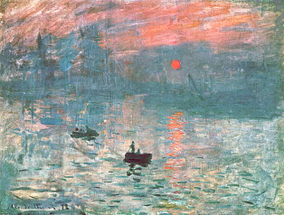
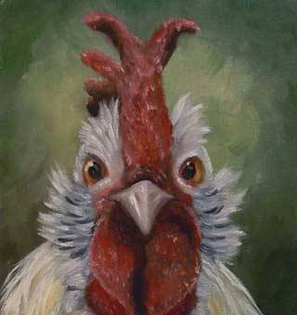
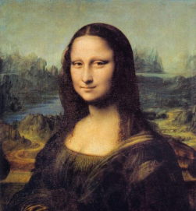

no use of realistic colors or perspective techniques

unfinished and rough painting style representing the impact of light on nature

celebrates the use of paint through evident brushwork and texture in the paint

the subject of the painting looks very much like it appears in real life

Cubism
Photorealism
Abstract
Abstraction
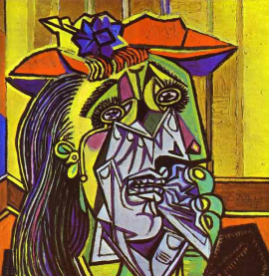

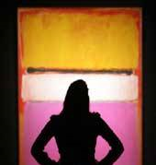
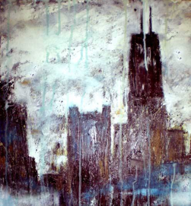

use of geometric shapes and bright colors

the illusion of reality is created through paint

an art style that does not look like anything from the "real world”

painting the essence of a subject rather than the detail
18
Surrealism

Primitivism
Pop Art

Pointillism
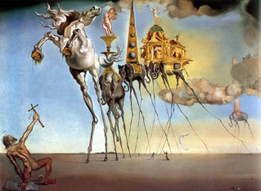
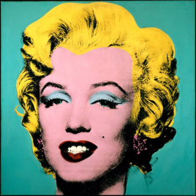
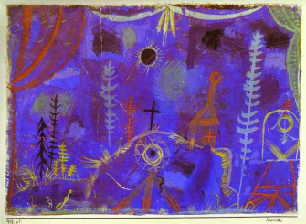
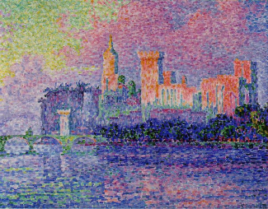

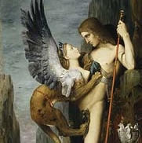
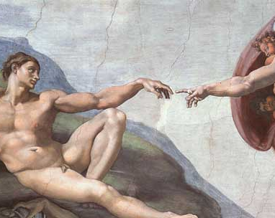
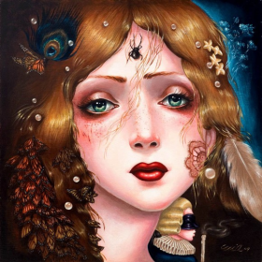
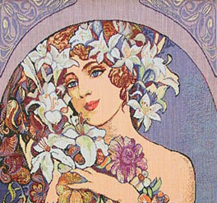

use of symbols to concentrate or intensify meaning

represents a distinctive and individual gesture or trait

Surrealism + Pop =
Pop Surrealism

characterized particularly by the depiction of leaves and flowers in flowing, sinuous lines
Read more: http://www.answers.com/topic/art-nouveau#ixzz1PErz6cyt

Symbolism

Mannerism
Pop Surrealism

Art Nouveau

paintings were filled with familiar objects which were painted to look strange or mysterious

pictures are painted very simply and the subjects are two-dimensional

inspired by comic strips, advertising, and popular entertainment

small dots or strokes of paint to make up the pictures

19
7.2. Vocabulary Bubbles: How to describe a painting?
Task: The following vocabulary bubbles will give you an idea of how a painting could be described in terms of color, the emotions the painting might convey and the technique the painting is characterized by.
Take a close look at these words and try to form meaningful sentences with the phrases provided below the vocabulary bubbles.
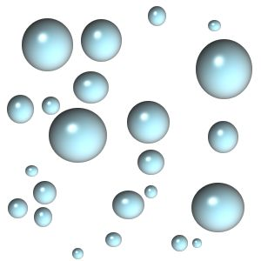

to apply a luminescent layer of paint
to use breathtakingly beautiful colors
20
to add a variety of especially rich colors
to create a abstract artistic composition
to incorporate primitive elements
to experience a feeling of disgust
to burst out in anger
to fall in love with the painting
to enjoy the exclusiveness of these colors

21
7.3. Stamps: Describe what you see!
Task: First you have to get together in pairs. Then each of you will receive a sheet with five stamps on it. Every single stamp is representative for one specific art style.
Explain to your partner what the painting on the stamp looks like and try to identify what artistic style it is. Then your partner will check if he/she has the same stamp or not. Take turns so that each of you can explain an equal number of paintings!
Attention: There is one painting that does not match up with one of your colleague’s paintings. Can you identify which one it is?
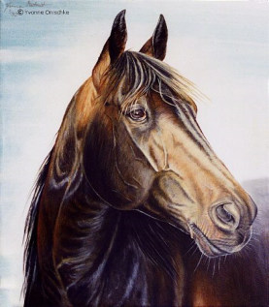
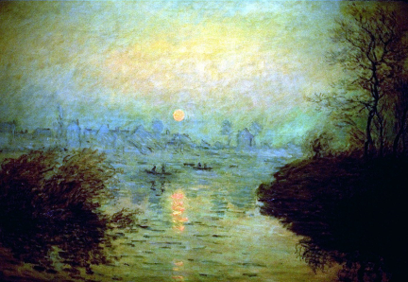

Stamp sheet: A
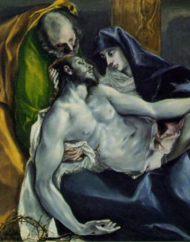
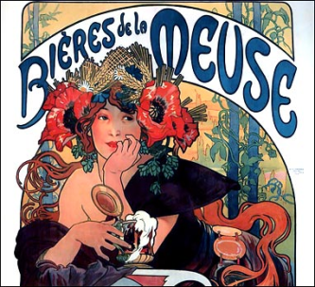

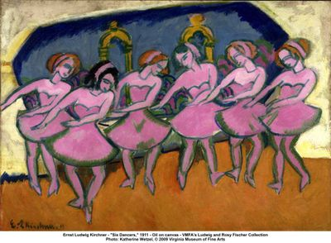

Stamp sheet: B
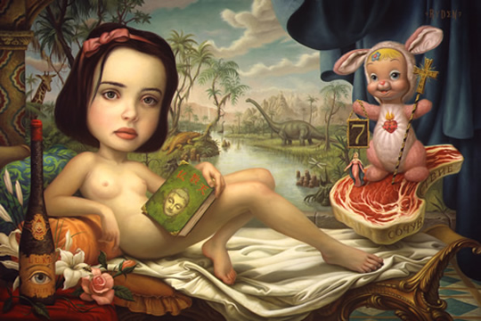
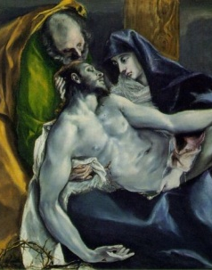

22
7.4. Dialogue
Task: Take the photo of your own artwork you’ve brought to class today and give it to your neighbor. You are now asked to engage into a dialogue with your partner but unfortunately the person you are working with will be playing a blind person. So you have to be extremely accurate when giving your description of your artwork by using the vocabulary you’ve learned throughout today’s session.
Try to cover the following points:
- explain your choice of colors as precisely as possible

- give information about the emotions you intended the painting to trigger

- try to give your blind colleague an idea of how you think your painting technique could best be described
If you are not comfortable working with a photo of your own painting, just take the one that is provided below.


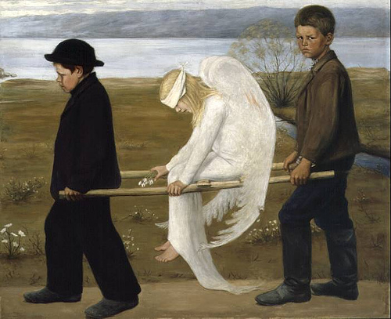
23

