Business English for Ticket Sellers

for

Language Education for Specific Contexts (Fachdidaktisches PS 6)
Dr. phil. Elisabeth Poelzleitner

WS 2010/11

Written by
Thurnher Karin (0611502)
Content

1. Needs Analyses – Questionaire 3

2. Language Learner Biographies & participants aims in attending the course 3

3. Main course goals 4

4. Course Advertisement 5

5. Course Objectives 6

6. Materials for two sessions 7
6.1 Materials for Session 1 7
6.2 Materials for Session 5 11

1. Needs Analyses – Questionaire
1) Haben Sie bereits Englisch gelernt? Wenn ja, wo und wie lange?
2) In welchen Situationen haben Sie die englische Sprache bisher verwendet (z.B. Reisen, Auskunft geben, etc.)?
3) Schauen Sie Filme auch auf Englisch an? Lesen Sie englische Bücher?
4) Wo würden Sie Ihre Englischkenntnisse auf einer Skala von 1-10 (1 = mäßig; 10 = sehr gut) positionieren?
5) Wie sicher sind Sie sich, wenn...
... Sie jemandem den Weg auf Englisch erklären sollen?
... Sie jemandem auf Englisch Auskunft über die Uhrzeit geben sollen?
... Sie auf Englisch etwas zu Essen bestellen sollen?
... Sie selbst auf Englisch nach dem Weg fragen müssen?
... Sie einem Kunden den Inhalt einer Veranstaltung erklären sollen?
... Sie einem Kunden auf Englisch Auskunft über Ticketpreise geben sollen?
... Sie einem Kunden auf Englisch erklären sollen, das man sowohl mit Karte, als auch bar bezahlen kann?
... Sie einen Kunden darauf hinweisen müssen, das eine Veranstaltung bereits ausverkauft ist?
... Sie einen Kunden auf Englisch auf ein Sonderangebot aufmerksam machen wollen?
... Sie einem Kunden auf Englisch erklären müssen, dass es Ihnen (aus technischen Gründen) leider gerade nicht möglich ist, Tickets zu verkaufen?
6) Was sind Ihre Hauptaufgaben im Umgang mit Kunden?
7) Nennen Sie 10 - 15 Dinge, die Sie in einem Kundengespräch gerne auf Englisch sagen können würden:
8) Was wären Ihre Gründe an einem auf Ihren Beruf ausgerichteten Englischkurs teilzunehmen?

2. Language Learner Biographies & participants aims in attending the course

Kathrin (38) had five years of English in school and has since used it to give information during her travels in the US. Her English is generally good (A2). Kathrin’s main workfields are sales and consulting. Concerining these tasks she would like to improve her English, in order to give information conerning ticket prices. Moreover, she would also like to take part in this course, in order to improve her conversation skills.

Anni (43) learned English in for five years in secondary school. Additionally, she took several English courses at Wifi and AK. Further, Anni used English during her travels, to give information and to converse with non-English speaking relatives. Generally, she considers her command of English to be very good. As far as her work is concerned Anni would like to improve her English in the fields of sales and consulting.

Manuela (32) had four years on English and sometimes used the language outside of school to give information to people. Generally, she considers her command of English to be rather poor. Conserning her work in the ticket shop Manuela would like to be able to give information, both in face to face conversations as well as on the telephone. This skill would be particularely important for her concerning ordering tickets, giving information about certain discounts, making reservations, etc.

Monika (46) studied English in school for fours years and so far used the language during travels, to converse with non-English speaking friends and in studying with her children. Generally, she considers her command of English to be rather low. Concerning her work Monika would like to be able to use English in order to give information about upcoming events

3. Main course goals
- This course will enable the participants to engage in basic sales conversations effortlessly.
- The participants will be able to successfully deal with any request concerning their events and tickets.
- This course will enable the participants to converse over their customers’ vacation in Austria.

4. Course Advertisement

BUSINESS ENGLISH LEICHT GEMACHT!
Sie verkaufen Eventtickets, haben immer wieder mit nicht deutschsprachigen Kunden zu tun und wollen Ihre Englischkenntnisse in Schwung bringen? Dann sind Sie hier genau richtig!

Dieser 10-wöchige Kurs soll Ihnen dabei helfen Ihren Kunden mit einfachem Englisch Auskunft zu geben. Begonnen von Fragen wie "How can I help you?" bis hin zu kurzen Verkaufsgesprächen, werden Sie hier für Ihre individuelle Verkaufs- und Beratungssituation ausgerüstet. Alles was Sie dazu brauchen ist 1 Stunde pro Woche.

Und keine Angst: wir beginnen von vorne!

Anmeldung unter:
Business English for Everyone
Landstraße 13
6850 Dornbirn
e-mail: befe@aon.at
Tel.: + 43 (316) 456987-0
Kursgebühr: € 80,-
Kurszeiten: Mo, 19:30-20:30Uhr oder Do, 18:30-19:30Uhr

5. Course Objectives
Session | Main Topic | Homework | Objectives
1 | How much is a ticket? | Go through your notes again and write down the words you find particularly useful for your work. Make a vocab-card like the one below for each word. | Given a list of ticket prices and useful phrases you will be able to inform customers about different prices, available seats and paying options using basic English.
2 | What is the event about? (1) |  | Given a set of cards reading different events and their starting times you will be able to give information about the starting times of different events using basic English.
3 | What is the event about? (2): |  | Given a list of events you will be able to inform your customers about the different kinds of events that can be booked with your company using basic English.  You will also be able to inform your customers about how to get additional information on the ticketshop-homepage.
4 | What is the event about? (3) |  | Given a brochure you will be able to give information about different events using basic English.
5 | How do I get there? |  | Given a map you will be able to give information about public transportation using basic English.
6 | How to take and place a reservation (1) |  | Given a set of questions and respective answers you will be able to take an event reservation using basic English.
7 | How to take and place a reservations (2) |  | Given a set of questions and the respective answers you will be able to take an event reservation over the phone using basic English.
8 | How to take and place reservations (3) | Think about what you still want to know and bring your questions to our next session. | Presented with different sales scenarios you will be able to respond via e-mail using appropriate English.
9 | Small Talk |  | Presented with a range of fictitious characters you will be able to interact in typical "small talk-dialogues" using meaningful English.
10 | Things we still need to know |  | This session will be a revision of the course topics and should address the participants' open questions, in order to round off the course successfully.

6. Materials for two sessions
6.1 Materials for Session 1
After today’s session you will be able to offer your help.
You will also be able to inform your customers about ticket prices, available seats (verfügbare Plätze) and paying options (Zahlungsmöglichkeiten).

Task 1
Take some time to read through the dialogue below (unten). Then get together with a partner and try to act out the dialogue using the paper slips (Papierstreifen) provided by your teacher.

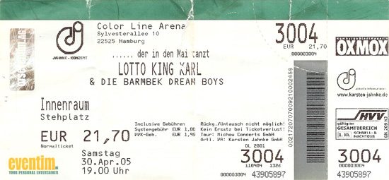
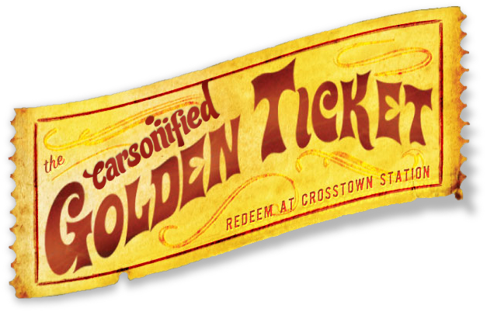
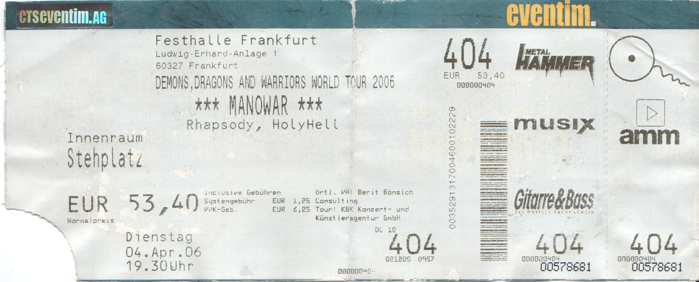

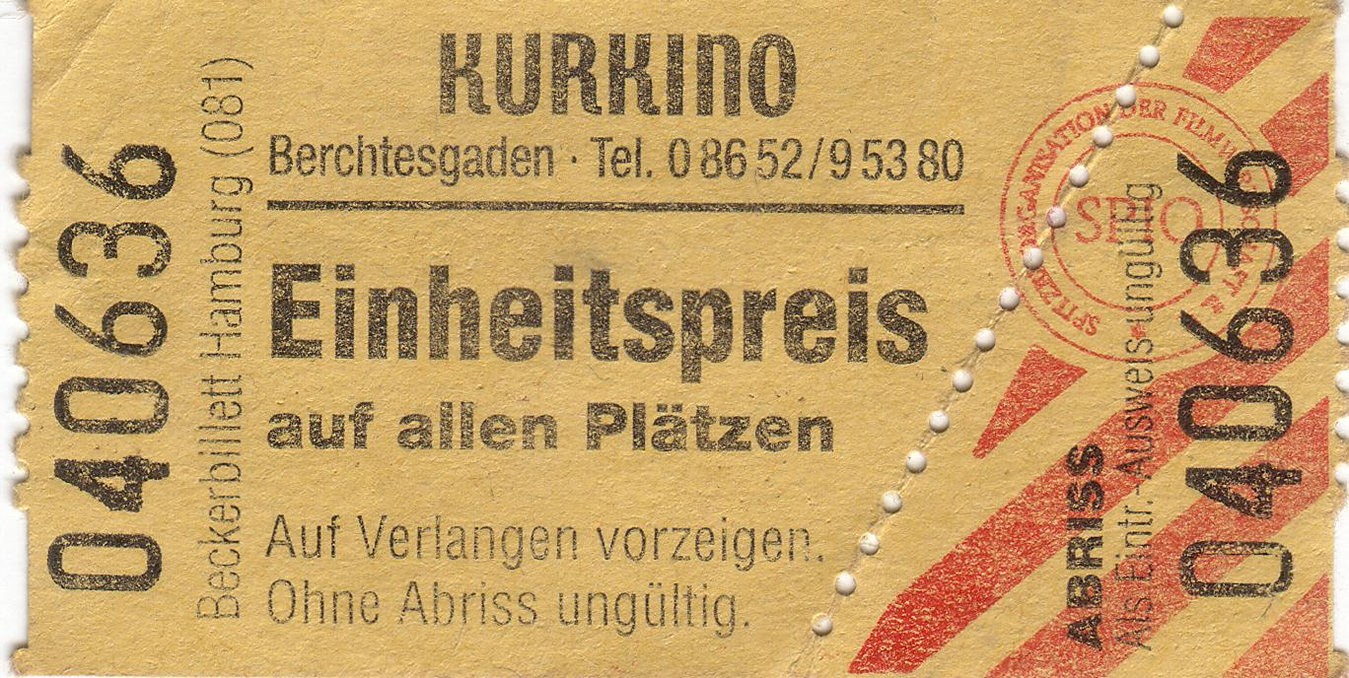
A: Good morning, my name is … How can I help you?
B: Hello, I would like to buy tickets for the Robbie Williams concert tonight.
A: How many would you need?
B: Two.
A: That would be € 120,-.
B: Can I pay with credit card?
A: Yes, of course. Here are your tickets.
B: Thank you.
A: Thank you. Goodbye.

Task 2
Try to translate the dialogue above (oben). Ask the teacher if you need any help.
Then try to find a movement (Bewegung) for each phrase. This will help you to remember them better!
Task 3
Make a list of 5-10 German words and phrases that you would like to use in a sales dialogue. Try to think of something that did not occur (vorkommen) in the dialogue above. Use the categories on the work sheet (Arbeitsblatt).
You phrases will later be translated (übersetzt) for the whole class.

Task 4
Now try to make your own dialogue together with a partner. Use the new phrases and the phrases from Task 1. Also notice the English numbers at the bottom of the page (am Seitenende).

Homework:
Go through your notes again and write down the words you find particularly useful for your work. Make a vocab-card like the one below for each word.

Word:

Sentence I found in my reading:

Second example sentence from [dictionary, internet, etc.]

Useful collocations:

Paper slips for Task 1
A: Good morning, my name is … How can I help you?

B: Hello, I would like to buy tickets for the Robbie Williams concert tonight.

A: How many would you need?

B: Two.

A: That would be € 120,-.

B: Can I pay with credit card?

A: Yes, of course. Here are your tickets.

B: Thank you.

A: Thank you. Goodbye.

Sheet of phrases for sales dialogues:

Ways to offer your help:


Asking for information:


Giving information about prices:

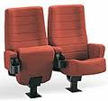
Giving information about available seats:

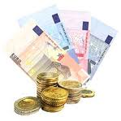
Giving information about payment options:


English Numbers:
0 zero; 1 one; 2 two; 3 three; 4 four; 5 five; 6 six; 7 seven; 8 eight; 9 nine; 10 ten;
11 eleven; 12 twelve; 13 thirteen; 14 fourteen; 15 fifteen; 16 sixteen; 17 seventeen; 18 eighteen; 19 nineteen; 20 twenty; 21 twenty-one; 22 twenty-two; 30 thirty; 40 forty; 50 fifty;
60 sixty; 70 seventy, 80 eighty, 90 ninety; 100 one hundred; 101 one hundred and – one
1000 one thousand; 1001 one thousand and - one

6.2 Materials for Session 5
After today’s session you will be able to give information about public transportation.
You will also slip into your customer’s role in order to ask for information.
Task 1:
Player 1 picks a card from the red pile (Stapel), player 2 picks a card from the yellow pile. Player 2 then tries to answer player 1’s question. Make sure that the numbers on your cards match (zusammen passen)!
Take a look at the Vorarlberg Map for information about public transportation routes (Routen der öffentlichen Verkehrsmittel). After each round player 1 becomes player 2.

Player 2: If you can’t remember certain parts of player 1’s question, use one of the following phrases:
- “Excuse me, could you repeat (wiederholen) that please?”
- “Excuse me, from where to where do you want to go again?”

Task 2
Go through the sheets of phrases and discuss it with a partner. Ask yourselves: What do/ don’t you understand? (eg. sentence structure, vocabulary, etc.)
If you have questions you cannot answer yourselves, ask your teacher.

Task 3
Take a new set of cards and act out the dialogues like in Task 1.

Game cards for Task 1
(front)
1 | 1
2 | 2
3 | 3
4 | 4
5 | 5
6 | 6
7 | 7
8 | 8

(back)
Excuse me, I have bought a ticket for a concert in Lustenau. Could you maybe tell me how to get there from Dornbirn? | Of course! The best way to get to … from … is by …
Excuse me, do you know how to get from Bregenz to the Monfordsaal in Feldkirch? | Yes. You can either take the … or you take the … But when you take the … you have to change (umsteigen) in …
Excuse me, I really don’t know how to get from Fußach to the Poolbar in Feldkirch can you maybe help me? | Oh that is very easy. First you take the … to … and there you change to the … directly to …
Excuse me, could you tell me how to get from Feldkirch to the Spielboden in Dornbirn? | Of course. You simply have to take the … which takes you directly to …
Hello Madam, I have bought these tickets for the concert at the Conrad Sohm in Dornbirn and I completely forgot how to get there from Bregenz. Can you maybe help me? | Of course I can help you! You can either take the … or you take the … But taking the … is faster.
Good morning Madam, I have these tickets for tonight’s play at the Kornmarkttheater in Bregenz, but I completely forgot how to get there from Fussach. Can you help me? | Yes, of course. The easiest way to get from … to … is by …
Good morning, could you maybe tell me how to get from Dornbirn to the Festspielhaus in Bregenz? | Of course! You can either take the … or the … But the … is definitely (mit Sicherheit) faster (schneller).
Hello Madam, could you maybe tell me how I can get from Feldkirch to the Reichshofsaal in Lustenau ? | Good morning. Yes of course I can tell you that. To get from … to … you can either take the … or the … to Dornbirn. Then you have to change to … which takes you directly to …

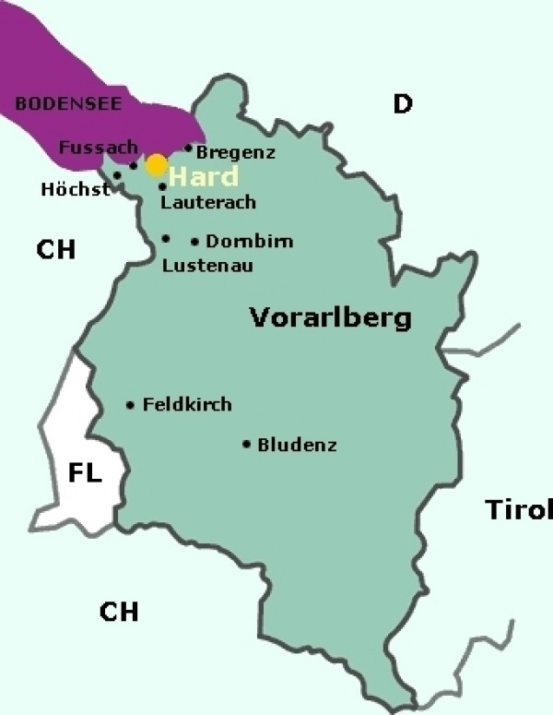

Sheets of phrases for Task 2
Bus No. 51
Bus No. 48
(train)

Asking for information:
- Excuse me, I have bought a ticket for a concert in Lustenau. Could you maybe tell me how to get there from Dornbirn?
- Excuse me, do you know how to get from Bregenz to the Monfordsaal in Feldkirch?
- Excuse me, I really don’t know how to get from Fußach to the Poolbar in Feldkirch can you maybe help me?
- Excuse me, could you tell me how to get from Feldkirch to the Spielboden in Dornbirn?
- Hello Madam, I have bought these tickets for the concert at the Conrad Sohm in Dornbirn and I completely forgot how to get there from Bregenz. Can you maybe help me?
- Good morning Madam, I have these tickets for tonight’s play at the Kornmarkttheater in Bregenz, but I completely forgot how to get there from Fussach. Can you help me?
- Good morning, could you maybe tell me how to get from Dornbirn to the Festspielhaus in Bregenz?
- Hello Madam, could you maybe tell me how I can get from Feldkirch to the Reichshofsaal in Lustenau?

Giving information:
- Of course ! The best way to get to … from … is by …
- Yes. You can either take the … or you take the … But when you take the … you have to change (umsteigen) in …
- Oh that is very easy. First you take the … to … and there you change to the … directly to …
- Of course. You simply have to take the … which takes you directly to …
- Of course I can help you! You can either take the … or you take the … But taking the … is faster.
- Yes, of course. The easiest way to get from … to … is by …
- Of course! You can either take the … or the … But the … is definitely (mit Sicherheit) faster (schneller).
- Good morning. Yes of course I can tell you that. To get from … to … you can either take the … or the … to Dornbirn. Then you have to change to … which takes you directly to …

Game Cards for Task 3
(front)
1 | 1
2 | 2
3 | 3
4 | 4
5 | 5
6 | 6
7 | 7
8 | 8

(back)
Excuse me, I have bought a ticket for a concert in…. Could you … how to get there from Dornbirn ? | Of course I can help you! The best … to get to … from … is by …
Excuse me, do you know … from … to the Monfordsaal in Feldkirch? | Yes. You can either … the … or you take the … But when you … the … you have to change in …
Excuse me, I really don’t know … from … to the Poolbar in Feldkirch can you maybe help me? | Oh that is very easy. First you take the … to … and there you … to the … directly to …
Excuse me, could …how to get from … to the Spielboden in Dornbirn? | Of course. You simply have to take the … which … you directly to …
Hello Madam, I have bought these tickets for the concert at the Conrad Sohm in Dornbirn and I completely forgot how to get there from …. Can you …? | Of course I can help you! You can either take the … or you take the … But taking the … is faster.
Good morning Madam, I have these tickets for tonight’s play at the Kornmarkttheater in Bregenz, but I completely forgot how to get there from …. Could you …? | Yes, of course. The easiest way … from … to … is by …
Good morning, could you maybe …from … to the Festspielhaus in Bregenz? | Of course! You can either take the … or the … But the … is definitely faster.
Hello Madam, could you … from … to the Reichshofsaal in Lustenau ? | Good morning. Yes of course I can tell you that. To get from … to … you can either take the … or the … to Dornbirn. Then you have to … to … which takes you directly to …

