
SS 2010

English for Specific Contexts
Lecturer: Ms. Elisabeth Poelzleitner

designed by Verena Vorraber

Small-Talk can lead to Big Things

Table of Contents
Needs Analysis……………………………………………………………………………………………………………………………………3
Syllabus …………………………………………………………………………………………………………………..….…………………….6
What I have learned so far…………………………………………………………………………………………………………………9
Session 2 – Teacher notes ………………………………………………………………………………………….…….………………11
Student worksheets …………………………………………………………………………………………………….…………………..12
Appendix………………………………………………………………………………………………………………………….………………15
Session 5 – Teacher Notes……………………………………….………………………………………………………………………28
Appendix ………………………………………………………………………….…………………………………………………………….29
Student Worksheets………………………………………………………………………………………………………………………..38

Needs Analysis
- Description of Two Course Participants
Barbara is a 26 year old chemistry grad student, who is currently working on her PhD thesis at the physical chemistry department at Uni Graz. Christoph, the second participant, is 25 years old and is currently enrolled for a master thesis at the same department at Uni Graz. However, they are not in the same research group. The third and fourth participant, Andreas and Julia, do their master thesis in Mathematics and the fifth participant, Elena, is writing a master thesis in biology.
- Student Analysis
Elena, Christoph and Julia attended a BORG. Elena and Christoph haven’t spoken English since their graduation. Julia once stayed in London for a week, but she was there with her best friend and so they didn’t have any extended conversations with natives.
Andreas and Barbara attended a HTL and haven’t been to an English speaking country so far. Both haven’t spoken English since their English classes at HTL, which they told me were rather good. They are used to reading and writing scientific papers in English. Barbara told me about a recent encounter with an English speaking person that was rather embarrassing for her and she noticed that her command of English was good enough to take part in a debate about nanotechnology but by far not sufficient enough to take part in a nice little small talk afterwards. And this is what all the participants have in common:
In most technical and natural scientific fields both master and PhD thesis have to be written in English, as especially graduates, but also undergraduates, have to take part in international conferences at times to present their results. Therefore, all of the participants are familiar with the technical vocabulary they need for presentations and debates in their field of research. They feel secure when they can formally talk about their research, but they are really worried about the small-talk that comes (should come) after the business part.
Especially Christoph and Barbara need some practice in fluency in small talk urgently as both of them will have to present their work to colleagues in San Francisco in October this year, where they will stay for five days, and there will be lots of time for small-talk in these five days in Frisco. So both Christoph and Barbara see this course as their last chance to get prepared for the social part of the business trip. Also the other participants plan poster presentations in the U.S. in the near future.
The following table sums up the results from the CEFR – test:
 | Listening | Reading | Conversation | Presenting | Writing
Barbara | B1.1 | B1.1 | A2.1 | A2.2 | B1.2
Christoph | B1.1 | B1.1 | A2.1 | B1.1 | A2.2
Andreas | A2.1 | B1.1 | A2.1 | B1.1 | B1.1
Elena | B1.1 | B1.2 | A2.2 | B1.1 | B1.1
Julia | B1.1 | A1.1 | A2.1 | B1.1 | B1.1

However, the test does not point at the main problem that the participants have: They are very shy when it comes to talking in English freely. As scientists they see things in a very pragmatic way, and as they belief that their English wasn’t good enough for any kind of social interaction with English speaking people, they don’t have any confidence and are even afraid of small-talk in English.
- Target Situation Analysis
The target of the participants is that they are able to small talk with their U.S. and other international colleagues. They want to come along well with their international and especially American colleagues and so they don’t only need to be able to speak fluent enough, they need to know ‘what’ they could talk about in an American setting. They should be aware of certain social conventions; like that you are not really asked for your emotional state when you are asked “How are you?.” Besides, it is also important to know basic facts about American culture when aiming at socializing with U.S. citizens. To sum up, in order to converse successfully with their American colleagues, they need to be able to talk freely about diverse subjects in an appropriate way in different contexts and in an appropriate manner.
- Lacks
The participants basically lack vocabulary for small-talk. Besides, they have not yet developed a feeling for the American mentality and culture. And all these lacks or perceived lacks, lead to a total lack of self-confidence, which is of course crucial for successful small-talk.
- Goal and what students need to overcome their lacks
The goal is to be able to take part in small talk also outside a University setting successfully and to develop an understanding for the American culture. In order to be able to talk fluently and speak and behave appropriately in specific contexts, they need to learn vocabulary which they need for small-talk. In order to socialize with Americans it is important to understand their culture and this can, to my mind, be best achieved through dealing with American literature and also other important aspects of American life, like sports, politics and economy. Moreover, in order to communicate successfully they need to overcome their shyness and only a lot of practice in speaking can make them self-confident and thus ready for real small-talk.

- Course Description

English Course: Small Talk Can Lead To Big Things
This is the right course for you, if …
- You are an undergrad or graduate student that will go to the U.S for a University project (conference or poster presentation)
- You feel uncomfortable when you think of small talk in English
- You want to learn how to get along in the world of small talk and especially in an American setting
My course Small Talk can lead to Big Things will teach you how to socialize in the U.S in only 8 sessions (a 60 min).
- You will prepare topics for small-talk
- you will gain some insight into the “American psyche” and
- you will talk a lot in order to lose any fear of talking in English!

Contact: Verena Vorraber, Tel:

Contact: Verena Vorraber
Tel:

English Course: Small Talk Can Lead To Big Things
This is the right course for you, if …
- You are an undergrad or graduate student that will go to the U.S for a University project (conference or poster presentation)
- You feel uncomfortable when you think of small talk in English
- You want to learn how to get along in the world of small talk and especially in an American setting
My course Small Talk can lead to Big Things will teach you how to socialize in the U.S in only 8 sessions (a 60 min).
- You will prepare topics for small-talk
- you will gain some insight into the “American psyche” and
- you will talk a lot in order to lose any fear of talking in English!

Session | Main Topic | Objectives | Assignment
1 | “Nice to meet you!”  Small Talk (ST) Topics for the University setting | - Getting to know each other (participants)- Creating a good working atmosphere (games)  - Scripts for meeting people for the first time, for example:  A: Hi, I am Christoph, nice to meet you!  B: Julia, nice to meet you, too!  And how to go on afterwards if you meet …  a) at University before/during/immediately after a poster presentation or a conference  b) at dinner after a poster presentation or a conference  c) for a sightseeing tour  b and c will not be dealt with in this session – but it should be mentioned in order to show how difficult it might be to find appropriate topics for a conversation – a problem that should be solved by the end of the course.  The same thing applies to 3b) beneath.  Small-Talk Strategies like: try to get information that could be helpful for the next time you meet the person.  - Scripts for meeting people for the second time:  A: Hi, how are you?  B: Oh, I am fine, how are you?  And how to go on in …  - a University setting  - a private setting  Small-Talk Strategies like: referring back to something that came up during the previous conversation. (+ watch tenses) | - Practice your dialogues at home and present them in pairs next session!  - Copy down useful phrases from today’s session into your vocabulary file. (phrase or collocation + example sentence)
2 | ST-Topics for conversation outside the University setting  - Travelling Experiences  - America on the Map  - Sightseeing in San Fran | - Tell others about your own travelling experience (focus: present perfect tense)  - Talk about important States in the U.S. and describe their approximate location  - Ask your way through San Fran  - Learn about and tell others about sights and hot spots of the city | - Copy down useful phrases from today’s session into your vocabulary file. (phrase or collocation + example sentence)  - And read the article on the following website:  http://usa.usembassy.de/sports.htm Search for useful items of vocabulary and phrases and copy them down in your vocabulary file as usual.
3 | ST-Topics for conversation outside the University setting  - American Cultural Identity  Sports | - We will talk about typically American sports like baseball, football and golf:  - Specific vocabulary and phrases  - Names of important sportsmen and women  We will also try to understand the importance of sports in America | - And read: Nathaniel Hawthorne, “Young Goodman Brown” and Charlotte Perkins Gilman, “The Yellow Wallpaper”
4 | ST-Topics for conversation outside the University setting  - American Cultural Identity  - Religion and Gender | Gain insight into the American Cultural identity:  Religion  - The Puritan mindset: Early American Literature: Anne Bradstreet “To My Dear and Loving Husband” (http://rpo.library.utoronto.ca/poem/217.html) and extracts from “A Dialogue Between Old England and New” (http://rpo.library.utoronto.ca/poem/211.html) American Renaissance: Nathaniel Hawthorne, “Young Goodman Brown” (http://www.eldritchpress.org/nh/ygb.html)  - Religion today  Gender  - In the Past: Charlotte Perkins Gilman, “The Yellow Wallpaper” (http://www.facstaff.bucknell.edu/gcarr/19cusww/cpg/tyw.html)  - The gender Issue today: Popular Sitcoms’ Influence on Gender Stereotypes - clippings from Two and a half Men | - Copy down useful phrases into your vocabulary file. (phrase or collocation + example sentence)  - And read Gish Jen, “In the American Society” , Countee Cullen, “Heritage”, Paul Laurence Dunbar, “We Wear the Mask” and the extracts from Frederick Douglass
5 | ST-Topics for conversation outside the University setting  - American Cultural Identity  - Race  - Multiculturalism  - Class | Race  - Slavery (extract from Frederick Douglass) Racial Segregation, Lynching)  - Harlem Renaissance: Idea of racial Uplift – problems that appeared with it. Paul Laurence Dunbar, “We Wear the Mask” (http://rpo.library.utoronto.ca/poem/767.html), Countee Cullen, “Heritage” (http://www.poemhunter.com/poem/heritage/)  Multiculturalism  - Gish Jen, “In the American Society” (photocopies) - Notions of Multiculturalism: “Melting Pot vs. Salad-Bowl Theory” - Can multiculturalism work?  - Some facts about the Demographics of the US today  Class  - Edward Arlington Robinson, “Richard Cory” (http://rpo.library.utoronto.ca/poem/1735.html)  - Gap between the rich and the poor today | - Read the texts I will hand out and find useful vocabulary and phrases that would help you in a discussion on sexual harassment and for small-talk in general. Copy down useful phrases into your vocabulary file. (phrase or collocation + example sentence)
6 | ST-Topics for conversation outside the University setting  - sexual harassment  - political correctness | - What is Sexual Harassment?  - How can I judge whether a scenario involves sexual harassment or not?  - What do they mean with political correctness? | - Look through your notes from today’s session again.  - Browse the US news on the internet and note down all items of vocabulary and phrases that appear to be useful for small talk on current affairs.
7 | ST-Topics for conversation outside the University setting  - Politics and Economy | - Get to know the most important structures of the American government and the persons with the most important functions  - Talking about the Latest Current Affairs | Look through What I have learned so far again and make sure that there is nothing left unclear. Revise everything we have done so far.
8 | Bye, Bye! | - We will simulate small-talk in various situations that involves all the topics that we have dealt with throughout the course.  - Wrapping up the course  - Free discussions  - Practical travel tips | Enjoy your stay in the US and do as much small talk as possible


WHAT I HAVE LEARNED SO FAR
Test yourself at home and go through what we have done in class again if you are not sure about something. If there is still anything you are not sure of then please do not hesitate to bring it up in the following session again. I appreciate every question you will come up with!
Session | Evaluate the following: | √ | Notes, Thoughts, Questions
1 | I am confident that I can master a small-talk at University before/during/immediately after a poster presentation or a conference.
 | I know how to introduce myself.
 | I know which topics I could come up with in that setting.
2 | I am able to talk about my travelling experience with someone.
 | I know the hot spots of San Francisco and I am able to tell other colleagues about it.
3 | I can tell others something about my hobbies.
 | I am able to take part in a discussion on typically American sports like baseball, football and golf.
 | I can name some important American sportsmen and women.
 | I understand the importance of sports in America.
4 | I have the impression that I gained much insight into the American cultural identity.
 | I can explain the Puritan mindset to others.
 | I can take part in a conversation on the role of religion in the US.
 | I can take part in a conversation about gender issues in general.
 | I could talk about the influence that sitcoms might have on common gender stereotypes.
5 | I can talk about the effects of slavery and the policy of racial segregation.
 | I can talk about the idea and the negative effects of racial uplift during the Harlem renaissance.
 | I can explain both the Melting Pot and the Salad-Bowl Theory to others.
 | I have my personal opinion concerning the question: Can multiculturalism work? And I can express it in a way that others can follow.
 | I can take part in a conversation about the demographics of the US.
 | I know about the growing gap between the rich and the poor.
6 | I know now what sexual harassment is and I can explain it to another person.
 | I can take part in a discussion on sexual harassment.
 | I know now what political correctness is.
 | I am aware of the importance of acting and speaking in a politically correct way.
7 | I can explain to my colleagues the most important structures of the American government.
 | I can name the persons with the most important functions in the US’s government.
 | I can take part in discussions about the Latest Current Affairs.
8 | I feel comfortable when talking English.
 | I am equipped with a sufficient range of vocabulary and knowledge on the topics we have dealt with in this course so that I am confident that I will have no problems with getting to know my American and international colleagues.

Live each day as if it was your last and learn each day as if you were to live …

Teacher Notes: Session 2 – ST-Topics for conversation outside the University setting
- Travelling Experiences
- Sightseeing in San Francisco

- Revision of Session 1 – Small-Talk (7min)
- Travelling Experience
  - This Boaster Is a Pain in the Neck + The Big Boasting Battle (8min): Grammar focus: One notion of the present perfect tense - Experience: It is a modified and extended version of Billy the Boaster (p. 63) from: Newby, David (1998). Grammar for Communication: Exercises and Creative Activities. Wien: Oesterreichischer Bundesverlag Schulbuch Gmbh & Co. KG. (Activity 1, S (Session) 2, p. 12)
  - Talking about your Travelling Experience (15 min): Grammar Focus: Experience & Past Events. The activity is an extended version of Grammar in Combination (p. 64-5) from Newby (1998). (Activity 2, S2, p. 13)
- The best Tourist Guide of San Francisco (30 min)
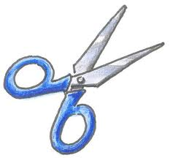
Bring a map of San Francisco to Class. Also bring a little box or a little bag.

  - I would put the names of 10 attractions of San Francisco on little sheets that I would put into a box or a bag and each student pulls 2 sheets, i.e. two attractions out of the box.
  - Then they will engage in a little role play called The Best Tourist Guide of San Fran (Activity 3, S3, p. 14). First, they have to find the descriptions that belong to their attractions. (Appendix 1, S2, p. 15). Then they compose Found Poems (Appendix 2, S2, p.27 - Taken from Elisabeth Poelzleitner’s PS4-Course Handout from SS2010) based on their articles.
  - Presentation: Students show the others their attractions on the map and then read their found poems. Then the other students ask the presenter some questions about his/her attractions that interest them. Every student makes notes, decides for him/herself which sight he/she would like to visit based on how much they liked the found poem and what they have heard in the question round.
  - In the end students have to agree on five attractions, and explain their decision.

Activity 1; S2 – This Boaster Is a Pain in the Neck
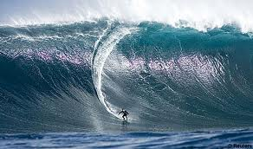
Do you know one of those annoying boasters who have been everywhere and done everything? On your trip to the US you meet exactly such a person and his comments are so predictable that you always know what he is going to say before he actually does so. In pairs take turns predicting his comments!
Your statement: I’d love to go to America.
His comment: I have been there numerous times. This is really nothing special for me anymore.
Your statement: I want to swim across the English Channel one day.
His comment:
Your statement: I’d really love to fly a helicopter.
His comment:
Your statement: I really would like to meet Obama.
His comment:
Your statement: I’d like to sleep in a really expensive hotel.
His comment:
Your statement: I’d like to go sea fishing and catch a really big shark.
His comment:
Your statement: I’d love to climb Mount Everest.
His comment:
Your statement: I want to kick Sarah Palin’s ass.
His comment:

Your statement: It’s my dream to dive with sharks.
His comment:
Your statement: I want to climb the Empire State Building.
His comment:
Your statement: I’d like to ride a 40-foot monster wave.
His comment:
After some time you are really fed up with his behavior and you start boasting as well. So battle your dialog partner in boasting until I stop you. When you pause for more than five seconds your dialogue partner gets a point. The one with the most points will be the proud winner of the first ever “Best Boaster” title.
The Big Boasting Battle
A: You wouldn’t believe it, but I have once played golf with Tiger Woods.
B: Oh, that’s nothing. You know I ………

Activity 2, S2 - Talking about your Travelling Experience

- Look at the grammar box below and then do the warm-up exercise.
A: Have you been to America?
B: Yes, I have. I’ve been there twice.
A: Did you like it?
B: Yes, I liked it a lot!
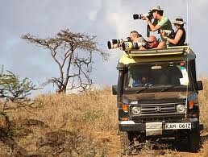
Experience: I have been there three times.
to go on safari
Details: The first time was in 1986.

- Warm-up exercise: Use the notes below to act out dialogues. Make up the last two dialogues yourself.
Example:
A: (hold snake?) Have you ever held a snake?
B: (yes-two) Yes, I have. I’ve held two.
A: (where?) Where did you hold them?
to go cage diving
B: (pet shop – garden) The first time was in a pet shop and the second was when I found one in my garden.
- A: (helicopter?)  B: (no)  A: (airplane?)  B: (yes)  A: (where?)  B: (Australia)  A: (what do?)  B: (uncle) | - A: (read ‘Murder on the Orient Express’?)  B: (yes)  A: (like?)  B: (super)  A: (see film?)  B: (yes)  A: (like?)  B: (boring) | - A: (sleep in open air?)  B: (3x)  - A: (stay up all night?)  B: (2x)

- Small-Talk X-treme – Travel Experience
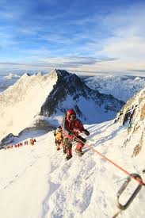
You will do small-talk in pairs on your travel experience. You don’t have to stick to the truth, feel free to make up breathtaking, adventurous journeys. The only thing you are not allowed to do is to stop talking until I give the signal to stop. Enjoy the exciting stories!
Here are some inspirations:

to climb Mount Everest

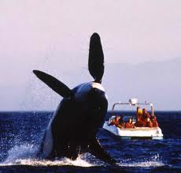
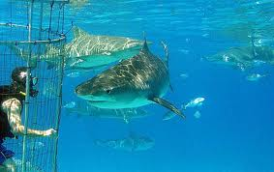
to go to whale watching in British Columbia

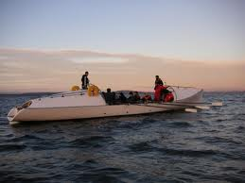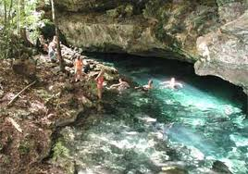
to cross the Atlantic in a rowboat

to go on a jungle tour
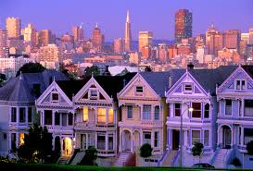
Activity 3, S3 – The Best Tourist Guide of San Fran
- Pull out two sheets from the box. Then find the articles that belong to your attractions. Find a nice place where you can read it. Simultaneously I will hand down a map of San Fran, when you get it, search for your sight on the map and remember its location. You will have to preset your sights to the others and in the end the group has to decide on only 5 sights that you want to see in San Fran. Therefore, you should make your sights appear as attractive to the others as possible!
However, you are not a common Tourist Guide; you are a poetic Tourist Guide. You will present your sights to the others in form of Found Poetry.
- After each presentation there is a question round in which you answer all the questions your colleagues raise. (Each student asks at least one question). Write down some notes after each presentation so that you can chose your favorite five attractions in the end. When you have chosen your favorites, wait until everybody has finished and then compare your favorites to the others’.
- Now decide as a group which five attractions you would like to see and why!

Appendix 1, S2 – Attractions of San Fran

Resplendent in the Western Sun

San Francisco's iconic bridge was built after years of passionate debate—and drastic changes in design

By HERBERT GOLD
The Golden Gate
Bridge is so beautiful—it offers such a lovely play of color, it is such a wonder of engineering and design, not to mention a wonder of location, reaching across San Francisco Bay—that it inspires artists, soothes jaded city residents, lures tourists and even tempts suicides, who have a choice of jumping while facing the open sea or the continent they intend to abandon. Proposals to erect suicide barriers stir the passions of aesthetes who treasure every bridge detail as is. So far, only minor adjustments—refining those proposal and urging bridge personnel to spot potential leapers—deter those avid for oblivion.
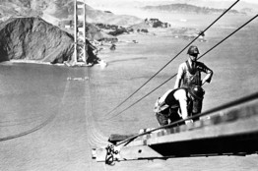
Workers on a catwalk during the construction of the Golden Gate Bridge. It would be completed in 1937.

In my 50 years in San Francisco, I've learned to adore the bridge, too, although not enough to kill myself from it. Kevin Starr, a native San Franciscan and the pre- eminent contemporary chronicler of California life and culture, has now given us an ecstatic meditation on the complicated drama of the Golden Gate Bridge and a chronicle of its history.
It is perhaps fitting that Mr. Starr's prose in "Golden Gate" is drawn toward passionate expression. Bridges can have that effect. Mr. Starr reminds us that Hart Crane, in a famous poetic tribute to his bridge, the Brooklyn Bridge, recounted his feelings about its portentous symbolic meaning. The bridge for him, according to Mr. Starr, was "a triumph of engineering offering a portal into the American past." It was also an emblem of "the hope that modernity, meaning industrialism and the machine era, can be made to serve productive purposes." For Mr. Starr, the Golden Gate Bridge is more than a symbol of American reach; it is an icon, an event of steel, concrete and suspension to be worshipped for itself, "a testimony to the creativity of mankind."
This icon did not appear magically, like the gold nugget that sent San Francisco careening into the world in 1849. It was an idea hatched by various city fathers and booster groups and pushed by Joseph Strauss, an architect and engineer who came up with a design in the early 1920s. At the time as many as 50,000 commuters crossed the Golden Gate each weekday by ferry. For a city effectively walled by water, the project for a great bridge was inevitable, a thing imagined long before it could be built across the channel at the mouth of the wide, wind-rushed, tide-swept San Francisco Bay.
The original design by Strauss was a clumsy jumble of trussed steel towers and, as Mr. Starr puts it, "arrogant superstructures . . . in support of an aesthetically overwhelmed suspension system." It all amounted to "an upside-down rat trap." But over the course of a decade the design was modified to "a pure suspension bridge, the longest on the planet, 4,200 feet from tower to tower."

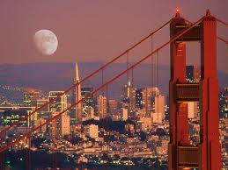
How did this happen? The driven egotism of Strauss fractured enough, over time, to admit the contributions of others—gifted designers, architects and engineers. (Strauss's ego was not so badly hurt in any case: He survived as the bridge project's spokesman, chief engineer and avatar.) It is a cliché that a camel is a horse designed by committee; but in this case a collaboration made the upside-down rat trap into "an almost supernal amalgam of lightness and strength." A first-time sight-seer will note its long, swooping cables and the dance that is played between concrete towers and thrusting steel, appearing and disappearing in billowing fog. And then there is the color, a reddish orange that veers toward gold at sunset.
From: http://online.wsj.com/article/NA_WSJ_PUB:SB10001424052748704738404575347362564325900.html

Lombard Crooked Street
San Francisco
Lombard Street is San Francisco -- and America's crookedest street. What does this mean? The steep, hilly street was created with sharp curves to switchback down the one-way hill past beautiful Victorian mansions. The street is paved with bricks and is an amazing site to see as demonstrated by the photo below.
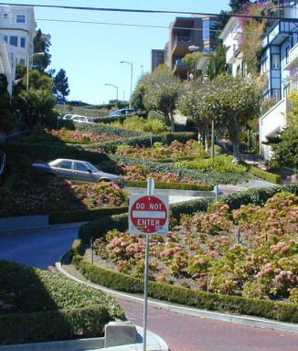
If not for the byzantine curves, easing out this treacherous slope, people would be killed rolling down. For an idea of how steep this street really is, go two blocks up, to Filbert Street and peer down over the ridge. Lombard is even steeper.
Some of the classiest and most expensive Real Estate in the city, exists on Lombard Street. This Russian Hill neighborhood, somehow possesses stately mansions, condos and townhouses, even with the endless array of tourists pouring down the street every day. In the spring and through the entire summer, Lombard Street is alive with color, as the chrysanthemums, and other well tended flowers are in full bloom.
The best place to photograph the street, is from Leavenworth Street, at the bottom - looking up. You will see cars headed down slowly, daring souls walking up, and down the sides, while the flowers and buildings provide dazzling color. It is truly an incredible sight.
To get to Lombard Street, take the Hyde Street Cable Car line, which stops on the crest. From this beautiful vantage point, you can also see down Hyde Street to Ghirardelli Square, Fisherman’s Wharf, Alcatraz and the rest of the Bay. Looking east, North Beach, Telegraph Hill, and the Bay Bridge present a breathtaking sight.
From: http://www.sftravel.com/lomabardcrookedstreet.html



San Francisco's Fisherman's Wharf is a world famous tourist attraction and a thriving and vibrant local neighborhood and commercial area. Home to world-class dining,shopping, hotels and endless entertainment opportunities, the Wharf is truly the place to start your San Francisco experience.
As the home of San Francisco's fishing fleet, docked along Jefferson Street, Fisherman's Wharf is the important center of our city's historic fishing industry. Along our neighborhood's "Fish Alley" you can still see fishermen at work, which is always a fun and unique San Francisco experience. The Wharf area is also the launching point for Bay cruises and charters.
Family entertainment is a neighborhood specialty. With our famous sea lions, Wax Museum, Ripley's Believe It or Not! Museum, The Aquarium of the Bay at PIER 39 and the World War II submarine, USS Pampanito, Fisherman's Wharf is the perfect place to bring the kids. Specialty shops and restaurants line the Wharf--including PIER 39, Anchorage Square and THE CANNERY shopping complexes. The world famous Ghirardelli Squarehas been converted to an open-air center filled with fun shops and restaurants. Here you can even see the company's original chocolate-making machines.

A BRIEF HISTORY OF FISHERMAN'S WHARF

From the days of the Gold Rush until the turn of the century, the San Francisco fishing fleet was composed of lateen-rigged sailboats. They were copies of the craft which the Italian fishermen knew in their native land. Green was the prevailing color of the tiny boats, and the name of a patron saint appeared on the hull. The fishermen themselves were as colorful as their craft. Their natural talent for song was to be heard in renditions of arias from Verdi, lusty if not always true to the ear. In the fog-shrouded waters outside the Golden Gate, the singing was a means of communication. You could not see a companion boat, but you knew it was there.
One of the great pleasures of visiting San Francisco is a stroll along this city’s historic Fisherman’s Wharf. Here visitors can peer down at the fishing crafts riding in the calm water, or pause to watch fishermen mending a net. Most of the boats in view belong to a "third generation" of fishing craft, which have made history at Fisherman's Wharf

From: http://visitfishermanswharf.com/aboutthewharf/default.aspx

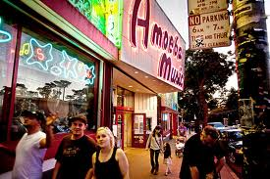
While the Haight-Ashbury eventually became
known as the center for hippies, acid, and acid rock music, it was also the center of many artistic efforts, including painting, poetry, performance art, comics, posters, and literature of all kinds.

From 1964 to 1968, there swelled a gigantic wave of cultural and political change that swept first San Francisco, then the whole United States, and then the world. What was fermenting in the Haight-Ashbury section of San Francisco was a powerful brew that would ultimately stop a war.

As any history book will tell you, the Haight's popularity grew as the Beat Generation in San Francisco was dying out. Many of the Beats, such as Allen Ginsberg, crossed over, but a younger generation gravitated to the Haight-Ashbury district, where the rents were cheap. Many were students at nearby University of San Francisco, UCSF, and S.F. State University. Others were musicians (such as the Grateful Dead), philosophers, artists (such as Alton Kelley), poets (such as Allen Cohen), apartment-dwellers, panhandlers, and even future CEOs of companies such as Pepsi, the Gap, Smith-Hawken, Lotus, and Rolling Stone magazine.

"The Summer of Love [1967] was the peak of the Haight Ashbury experience," wrote founding editor Allen Cohen in his essay on the Summer of Love. "Over 100,000 youth came to the Haight. Hoards of reporters, movie makers, FBI agents, undercover police, drug addicts, provocateurs, Mafioso and about 100,000 more tourists to watch them all followed in their wake."

The efforts of the pioneers in the Haight-Ashbury to create an enlightened community took about two years, from 1964-66, to reach the flashpoint, and during those years the music reached an artistic high point. By the end, two years before Woodstock and Altamont, overcrowding and the negative reaction of police and the San Francisco city government combined to make life in the Haight miserable for everyone.

Still, the experience of enlightenment had left a lasting impression on the minds and hearts of those who participated in the "hippie scene" either in the Haight or in far-flung communities that sprouted from Be-Ins and the acid-tinged philosophers such as Dr. Timothy Leary. The experience, like acid, reached a peak, then subsided, leaving everyone bewildered and changed for life.

From: http://www.lovehaight.org/welcome.html
Coit Tower San Francisco
Coit Tower reigns over San Francisco...
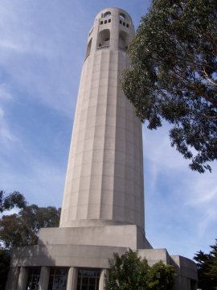
Coit Tower sits atop Telegraph Hill, looming over the eastern side of San Francisco with its almost regal presence. It serves as a directional marker for people lost in the mazes of city streets, but with its rich history and its excellent viewpoint, Coit Tower offers much more than just a way to find out where you are in the city.
Once you have reached the base of Coit Tower, you will see that the structure affords a three hundred and sixty degree view of the city. Unobstructed by taller buildings as a result of a city ordinance, you can go up here to get a view of both the Golden Gate Bridge and the Bay Bridge with a picturesque look at the bay between them. Walking around to the other side of Coit Tower, you can see the peak of the Transamerica Building, the beauty of the cityscape and the curves of Lombard Street.
When you enter Coit Tower itself, you’ll find yourself within a small circular building which holds a gift shop where you can purchase inexpensive tickets to take the elevator to the top of the tower. From there, the view of the city is even more magnificent. Upon exiting the elevator, you should take some time to explore the inside of the tower.
History of Coit Tower
Coit Tower Construction and Lillie Hitchcock Coit
Coit Tower was constructed in 1933 at the request of Lillie Hitchcock Coit for whom the tower was named. Coit was one of those eccentric characters that dot the history of San Francisco and make it the interesting city that it has always been. She was a gender-bending rough-and-tumble type of woman who smoked cigars, gambled avidly and lived raucously. The fact that she came from money and married into more of it helped make her behavior more acceptable to others.
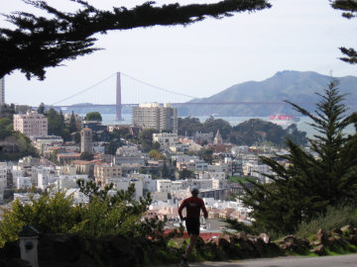
What Lille Hitchcock Coit was best known for in her day, however, was not her wild antics. Instead, it was her obsession with firefighting due surely to the fact that she herself was rescued from a severe fire when she was just a child. She grew up to become a volunteer firefighter who rode along with the firemen to all of the fires in town beginning at the age of 15 when she was dubbed the mascot for Knickerbocker Engine Co. No. 5. In those days, fires broke out frequently due to the materials used to construct buildings at the time. Lillian Hitchcock Coit was frequently found helping put out those fires.
Coit died in 1929 but she had money to her name. She used that money to commission Coit Tower, which was built in honor of the firefighters that she so adored. In addition to honoring the firefighers, Lillie Hitchcock Coit wanted the area to serve as a beautiful spot for viewing the city that she so loved.
From: http://www.sftravel.com/coit-tower-san-francisco.html

Alcatraz
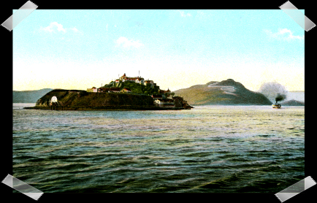
From the time it became a federal prison in 1934 until it was closed down in 1963, the steel doors clanged shut behind more than 1,000 hardened convicts, criminals and escape artists. Alcatraz was not conceived as a facility for rehabilitation. It was a place of total punishment and minimum privilege. And those who survived it often did so at the cost of their sanity... and some believe their souls.
Then in 1861, Alcatraz started to receive Confederate prisoners, thanks to its natural isolation created by the surrounding waters. Until the end of the Civil War, the number of prisoners here numbered from 15 to 50. In 1898, the Spanish-American War sent the prisoner population from less than 100 to over 450. The Rock became a holding pen for Spanish prisoners brought over from the Phillipines. Around 1900 though, Alcatraz again became a disciplinary barracks for military prisoners. Ironically, it also served as a health resort for soldiers returning from the Phillipines and Cuba with tropical diseases. The overcrowding caused by a combination of criminals and recovering soldiers resulted in pardons to reduce the number of men.
Despite the stringent rules though, Alcatraz was still mainly a minimum-security facility. In many cases, the prisoners were even entrusted to care for the children of officers. However, this lack of strict security worked to the favor to those inmates who tried to escape. Most of those who tried for freedom never made it to the mainland and were forced to turn back and be rescued. Those who were not missed and did not turn back usually drowned in the harsh waters of the bay.
Prisoners were punished for nearly everything, like asking for a newspaper. One place of punishment was the "Hole." Mattresses were taken away and prisoners were sustained by meals of bread and water, which was supplemented by a solid meal every third day. Steel doors closed these cells off from the daylight, although a low wattage bulb was suspended from the ceiling. Inmates could spend up to 19 days here, completely silent and isolated from everyone. Time in the "hole" usually meant psychological and sometimes even physical torture.
Usually, convicts who were thrown into the "hole" for anything other than a minor infraction were beaten by the guards. The screams from the men being beaten in one of the "holes" echoed throughout the block as though being amplified through a megaphone.
Prisoners who had the misfortune of being placed in “the dungeons”, the severest form of punishment, were not only locked in, but also chained to the walls. Their screams could not be heard in the main prison. The only toilet they had was a bucket, which was emptied once each week. For food, they received two cups of water and one slice of bread each day. Every third day, they would receive a regular meal. The men were stripped of their clothing and their dignity as guards chained them to the wall in a standing position from six in the morning until six at night.
Often when men emerged from the darkness and isolation of the "hole", they would be totally senseless and would end up in the prison’s hospital ward, devoid of their sanity.
The Hauntings of Alcatraz
During the day, the old prison is a bustling place, filled with tour guides and visitors... but at night, the building is filled with the inexplicable. Many believe that the energy of those who came to serve time on the Rock still remains, that Alcatraz is an immense haunted house... a place where strange things can and do happen today!
Shortened and slightly changed from: http://www.prairieghosts.com/gpalcatraz.html

What's the Castro Like?

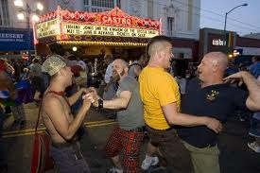
If only the Mexican land barons and European homesteaders who built the Castro district could see it — and the price of its real estate — today. What was once dairy farms and dirt roads is now one of the city's most vibrant and cohesive communities, saturated with stylish shops and bars so popular that patrons spill out onto the street.
Irish, German, and Scandinavian immigrants came to the outskirts of San Francisco in search of cheap land, which became bona fide suburbs after 1887 when the Market Street Cable Railway linked Eureka Valley (as the Castro was then called) with the rest of the city. Thanks to these homesteaders, who built large, handsome Victorian houses for their large families, today's residents have someplace to pour their money, and the vast majority of the neighborhood's classic homes have been lovingly and artfully restored.
Eureka Valley remained a quiet, working-class neighborhood until the postwar era, when large numbers of people started fleeing the city for the "suburbs." Finally, in the 1960s and '70s, gay men began buying the charming old Victorians at relatively low prices ($20,000-$40,000), and the neighborhood was soon named for its busiest thoroughfare, Castro Street.
The activism of the '60s and '70s forged a community with sizable political and economic power, and when the historic Twin Peaks bar at Market and Castro streets was built with floor-to-ceiling windows, most took it as a sign that Castro residents were secure in their gay identity. There were, however, tense and sometimes violent clashes with the police, and the assassination in 1978 of openly gay San Francisco Supervisor Harvey Milk was a turning point in the community's history. Milk's death and the impact of AIDS brought the community together and made activists of almost everyone; the Castro became not just open but celebratory about its thriving gay and lesbian population.
Today, the Castro's queer identity is itself a tourist attraction, beckoning throngs of pilgrims and revelers from all over the world. Since the introduction of the F Market street car, shuttling unsuspecting Midwestern families down from Fisherman's Wharf, denizens have been lamenting the demise and dilution of the gayest spot on earth. Yet the unabated proliferation of shops selling, ahem, adult accessories and sporting neon signs touting "Lube 4 Less" tips off even the most untrained eye to the deeply entrenched community here.
From: http://www.sfgate.com/neighborhoods/sf/castro/

Cable Cars
Early Cable Car History
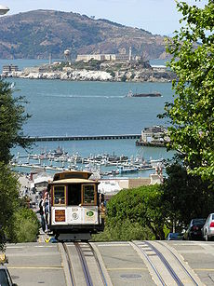
The driving force behind the San Francisco cable car system came from a man who witnessed a horrible accident on a typically damp summer day in 1869. Andrew Smith Hallidie saw the toll slippery grades could extract when a horse- drawn streetcar slid backwards under its heavy load. The steep slope with wet cobblestones and a heavily weighted vehicle combined to drag five horses to their deaths. Although such a sight would stun anyone, Hallidie and his partners had the know-how to do something about the problem.
Hallidie had been born in England and moved to the U.S. in 1852. His father filed the first patent in Great Britain for the manufacture of wire- rope. As a young man, Hallidie found uses for this technology in California's Gold Country. He used the wire-rope when designing and building a suspension bridge across Sacramento's American River. He also found another use for the wire-rope when pulling heavy ore cars out of the underground mines on tracks. The technology was in place for pulling cable cars.
The next step bringing Hallidie closer to his fate was moving his wire- rope manufacturing to San Francisco. All that was now needed was seeing the accident for the idea to become full blown-a cable car railway system to deal with San Francisco's fearsome hills.
From: http://www.sfcablecar.com/history.html

Gripmen and conductors
The driver of a cable car is known as the gripman. This is a highly skilled job, requiring the gripman to smoothly operate the grip lever to grip and release the cable, release the grip at certain points in order to coast the vehicle over crossing cables or places where the cable does not follow the tracks, and to anticipate well in advance possible collisions with other traffic that may not understand the limitations of a cable car. Only a portion of the people who attempt the training course actually pass (about 30%). As of December 2005, there has only been one grip woman, Fannie Mae Barnes, hired on January 15, 1998.
Being a gripman requires great upper body strength needed for the grip and brakes, as well as good hand-eye co-ordination and balance.
Besides the gripman, each cable car carries a conductor whose job is to collect fares, manage the boarding and exiting of passengers, and control the rear wheel brakes when descending hills. With the common practice of carrying standing passengers on the running boards of cable cars, passenger management is an important task.
From: http://en.wikipedia.org/wiki/San_Francisco_cable_car_system

Golden Gate Park
San Francisco's Giant City Park
This is a huge, safe, beautiful park with a lot to do. Here is a glimpse of the incredible breadth of activities available. Definitely worth a trip and very relaxing compared to the City's hub-bub...
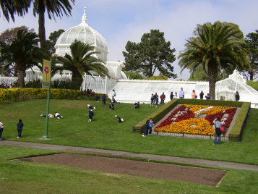
Best Golden Gate Park Activities
1. The Conservatory of Flowers at Golden Gate Park is like a trip to the rainforest filled with exotic flowers and orchids. Different climates from warm, to cooler, to aquatic give incredible flowers their beauty. Don't miss this historic and incredible "flower museum" at Golden Gate Park in San Francisco.
2. The Young Museum of Art is an architectural wonder, rising from the damage of the 1989 earthquake. Filled with classic art, the world-class museum is a treat for all of your senses.
3. GG Park is one of the best places to bike and rollerblade.
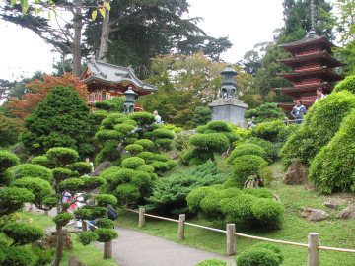
4. The Japanese Tea Garden is one of the park's coolest things but overrun with tourists. For about $3 you explore a beautiful Japanese Garden with streams and bridges-- very peaceful. You can buy tea and cookies and really relax. The oldest Japanese style garden in the U.S.
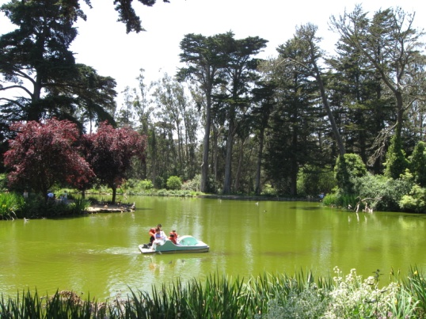
5. Rent a paddle boat, rowboat, or electric boat for the lazy at Stow Lake.
6. The Polo Field is a giant field where you can play soccer, frisbee, or football there.. or just catch some rays.
7. Also San Francisco Aquarium, one of the city's most popular attractions is located right in the park.
From: http://www.sftravel.com/ggpark.html

Union Square

WHAT'S IT LIKE?
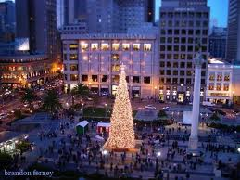
Union Square, one of San Francisco's main retail and cultural centers, also refers to the actual park bordered by Geary, Powell, Post and Stockton streets. Set aside as a park in 1850 and named before the start of the Civil War as a tribute to the frequent demonstrations in support of the Union troop, the park got a major renovation and restoration in 2002.
The redesign, which transformed the square from a grassy slope to a granite platform, made the square more accessible in the literal sense (the old configuration had only four entrances, at the corners), but was criticized by some for its aura of emptiness (and also for uncomfortable benches). Though the planned fountain is still on the way, the square has mostly settled in as a spacious meeting spot where people can take in the sights of the cable cars, hotels and throngs of shoppers. There are occasional music and dance performances, a TIX Bay Area half-price theater ticketing booth and a small cafe, and the Macy's holiday tree takes center stage in November.
Sutter, Post, and Geary streets are filled with fine art galleries, some focusing on selling works by big names like Picasso and Chagall, and others devoted to exhibiting works by contemporary artists. San Francisco's only Frank Lloyd Wright building, built in 1949 and currently housing the Xanadu Gallery, is located at 140 Maiden Lane, and features the same circular interior as the famed Guggenheim Museum in New York.
This is also San Francisco's main theater district, with some
historic, beautiful buildings housing the performances. Shows range from traveling Broadway and off-Broadway shows on limited runs to smaller local productions.
Views of the square are best from Harry Denton's Starlight Room in the Sir Francis Drake Hotel and from some of the second and third floor galleries and shops surrounding the square.
From: http://www.sfgate.com/neighborhoods/sf/unionsquare/

Appendix 2, S2 – Found Poetry
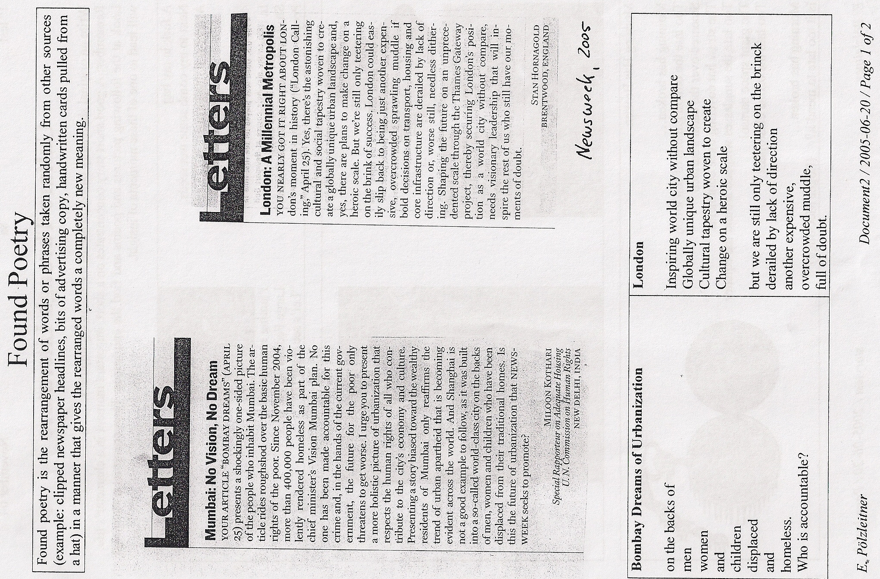

Teacher Notes: Session 5 – Sexual Harassment
- Introduction to Sexual Harassment (30 min)
  - Write Sexual Harassment on the board and ask students for their associations with this term.
  - Give a definition of the term:
    - Short teacher’s talk (Appendix 1, S5, p. 29)
    - Give students a text on sexual harassment in the workplace (Appendix 2, S5, p. 29). Students can now read the text (home assignment) again, make notes, tell me what is still unclear for them or ask whether their example sentences are correct or not.
  - Students have 3 min to study their notes and then everybody has to explain the term to a partner in a little dialogue (Activity 1, S5, p. 38).
  - Show students some short videos that demonstrate how difficult it is to judge whether a case of sexual harassment is grave enough to fight the case. For the last video also print out the comments and ask students if they agree with pedrocanadian – short discussion (Appendix 3, S5, p. 32).

- Hot Discussions: Identifying Sexual Harassment (Activity 2, S5, p. 38) (25 min)

  - Bring a green and a red glass nugget for each student!
  - First step: Students read through the scenarios and their vocabulary file again (Appendix 4, S5, p.32 – home assignment) and discuss language-related problems with each other or/and with me.
  - Second step: They read the instructions for Hot Discussions and begin playing/discussing. When they have discussed and judged (write judgments down in note-form) all the cases, they report their judgments to the teacher. Now the teacher asks them to convert all men that appear in the cases into women and vice versa (also the poster with the naked men changes into naked women) and discuss if this changed anything. This will hopefully lead to interesting discussions (teacher moderates). Teacher asks students for a résumé in the end. This totally depends on the previous discussion, but it might contain that everybody perceives the degree of sexual harassment slightly different and that we unconsciously judge differently depending on whether men or women are doing the harassing or are being harassed. It is clearly a very complex issue and for the person harassed it is a huge problem to decide whether they try to do something against it and thereby risk their jobs or if they just take it to not ‘make any waves.’

- Some more practical tips (5 min)
Make students aware of the fact that political correctness (Appendix 5, S5, p. 34) is an important part of the code of conduct at American Universities. There will not be enough time to question this idea/ the term in class, but for teachers who are interested or who feel that their students might be interested see Appendix 6, S5, p. 34. In Austria it is very common to tell politically incorrect jokes and this really should be avoided in an American setting. If there is still enough time the teacher could hand out an activity on politically incorrect jokes. You can find two sample activities on politically incorrect jokes in Appendix 7, S5, p. 35).
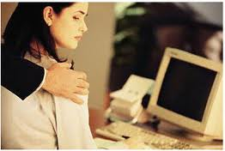
Assignment: I would hand out Appendix 2 and 4 in Session 4 and let them read the texts and find useful vocabulary and phrases that would help them in a discussion on sexual harassment and for small-talk in general. Students should take notes and copy down useful phrases into their vocabulary file (phrase or collocation + example sentence). This will enable them to take part in discussions on sexual harassment more easily and thus foster their fluency in speaking.

Appendix 1; S5
You can say that any unwanted physical or verbal advances that have sexual overtones are sexual harassment.
The kind of behavior that is usually considered to be sexually harassing:
- Inappropriate gestures or leering
- Telling sexual jokes
- Touching someone unwanted or even in an inappropriate way
- Spreading rumors about another person’s sexual behavior

Appendix 2; S5
The article on sexual harassment in the workplace (ready to print starting on the following page) is taken from the following website:
http://www.dotcr.ost.dot.gov/Documents/complaint/Preventing_Sexual_Harassment.htm

Sexual Harassment - A Fact Sheet For Employees
This fact sheet explains what sexual harassment is under federal law and what it is not, the kinds of behavior that may be interpreted as sexual harassment in the workplace and how a workplace environment can become "sexually hostile."
What is Sexual Harassment?
Sexual harassment at work occurs whenever unwelcome conduct on the basis of gender affects a person's job, It is defined by the Equal Employment Opportunity Commission (EEOC) as unwelcome sexual advances, requests for sexual favors, and other verbal or physical conduct of a sexual nature when:
- submission to the conduct is made either explicitly or implicitly a term or condition of an individual’s employment, or
- submission to or rejection of the conduct by an individual is used as a ,basis for employment decisions affecting such individual, or
- the conduct has the purpose or effect of unreasonably interfering with an individual's work performance or creating an intimidating, hostile, or offensive working environment.
The U.S. Supreme Court has simplified matters somewhat by explaining that there are two basic types of unlawful sexual harassment. The first type involves harassment that results in a tangible employment action. An example would be a supervisor who tells a subordinate that he or she must be sexually cooperative with the supervisor or he or she will be fired, and who then indeed does fire the subordinate for not submitting. The imposition of this crude "put out or get out” bargain is often referred to as quid pro quo ("this for that"). This kind of unlawful sexual harassment can be committed only by someone who can make or effectively influence employment actions (such as firing, demotion, and denial of promotion) that will affect the victimized employee.
A second type of unlawful sexual harassment is referred to as hostile environment. Unlike a quid pro quo, which only a supervisor can impose, a hostile environment can result from the gender-based unwelcome conduct of supervisors, co-workers, customers, vendors, or anyone else with whom the victimized employee Interacts .on the job. The behaviors that have contributed to a hostile environment have included:
- unfulfilled threats to impose a sexual quid pro quo.
- discussing sexual activities;
- telling off-color jokes;
- unnecessary touching;
- commenting on physical attributes;
- displaying sexually suggestive pictures;
- using demeaning or inappropriate terms, such as "Babe";
- using indecent gestures;
- sabotaging the victim’s work;
- engaging in hostile physical conduct;
- granting job favors to those who participate in consensual sexual activity;
- using crude and offensive language
These behaviors can create liability only if they are based on the affected employee's gender and are severe or pervasive, as explained in the next section. Nonetheless, even If unwelcome conduct falls short of a legal violation, employers have moral and organizational reasons as well as legal incentives to address and correct that conduct at its earliest stages. The conduct constituting sexual harassment is not always sexual in nature. One court held that a man's violent physical assault on a woman was sexual harassment because the assault was based on the woman's gender, even though there was nothing sexual about the assault itself. Suppose, for example, that men sabotage the work of a female co-worker because she is a woman. Even if the men don't engage in sexual behavior, such as telling off-color jokes or displaying pornographic photos on the walls, their behavior is sexual harassment because the behavior is based on the woman's gender.
When Does an Environment Become Sexually Hostile?
To create a sexually hostile environment, unwelcome conduct based on gender must meet two additional requirements: (1) it must be subjectively abusive to the person(s) affected, and (2) it must be objectively severe or pervasive enough to create a work environment, that a reasonable person would find abusive.
To determine whether behavior is severe or pervasive enough to create a hostile environment, the finder of fact (a court or jury) considers these factors:
- The frequency of the unwelcome discriminatory conduct;
- The severity of the conduct
- Whether the conduct was physically threatening or humiliating, or a mere offensive utterance;
- Whether the conduct unreasonably interfered with work performance;
- The effect on the employee’s psychological well-being; and
- Whether the harasser was a superior in the organization.
Each factor is relevant – no single factor is required to establish that there is a hostile environment. Relatively trivial, isolated incidents generally do not create a hostile work environment. For example, one work environment found no legal violation where a woman’s supervisor, over the course of a few months, had asked her out on dates,called her a “dumb blonde,” placed his hand on her shoulder, placed “I love you” signs in her work area, and attempted to kiss her. (Weiss s. Coca Cola Bottling Co.)
Hostile environment sexual harassment also was not found where women were asked for a couple of dates by co-workers, subjected to three offensive incidents over 18 months, or subjected to only occasional teasing or isolated crude jokes or sexual remarks.
Sexual harassment was found, on the other hand, where women were touched in a sexually offensive manner while in confined workspace, subjected to a long pattern of ridicule and abuse on the basis of gender, or forced to endure repeated unwelcome sexual advances.
These examples simply illustrate how severe or pervasive gender-based conduct must be to be legally actionable (and how blurred the line between lawful and unlawful conduct sometimes is). Given this uncertainty, prudent employers will address incidents of unwelcome gender-based conduct long before they approach the level of severity or pervasiveness that would create a hostile environment as legal matter.

My Notes:

Appendix 3, S5
I would suggest the following videos:

What Is The Definition Of Sexual Harassment In New York? (43sec)
http://www.youtube.com/watch?v=VdKNweWJooY

I'm Afraid Of Retribution In My Workplace If I Speak Up. What Can I Do? (48 sec) http://www.youtube.com/watch?v=nnO6TWux8u0&feature=related

How Can I Prove That I'm Being Sexually Harassed? (57sec)
http://www.youtube.com/watch?v=zdFpjmLlfas&feature=related

The Most Terrifying Sexual Harassment PSA Ever (2 min 32 sec)
http://www.youtube.com/watch?v=H6l87xnJSZM

Comments
- pedrocanadian
11 months ago 17
i just﻿ want to say...i'm a woman. i find this hilarious. i couldn't stop laughing. hahahha!
- PhantomLyric
10 months ago 11
This is hilarious....How do people not get﻿ this?!
- thatdeal1699
1 week ago
too﻿ funny
- MEGAGUY21
3 weeks ago
HAHAHA oh yeah this is so
true when women are﻿ around.
HAHAHAHAHAaaaaaaaaaa!
- Rawkey
3 weeks ago
Kinda reminds me of my workplace﻿ lol
- TheJRomans
1 month ago
wow.........can﻿ anyone make this video any gayer?
- 232J0K3RZakaTRAV13SO
1 month ago
stupid bitch get in da﻿ kitchen hoe
- morgantaban
3 months ago
Sexual harassment accusations are only used to get﻿ easy money. The real problem is too many damn lawyers.
- snufleufugus
3 months ago
dan is so awesome I want to be just﻿ like him whe

Appendix 4, S5 – Cases of Sexual Harassment, or not?
The scenarios 1-6 (ready to print starting on the following page) are taken from:
Madison, Laura and Shoda, Jennifer (2002). Identifying Sexual harassment: A Classroom Activity, Teaching of Psychology. 29: 4, 304 – 307.
Scenarios 7 – 9 are taken from:
Mac Andrew R., R. Martinez (2002). Taboos and Issues -Photocopiable Lessons on Controversial Topics. Boston: Thomson Heinle.

Scenarios of Sexual Harassment, or Not?
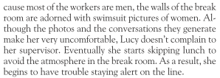
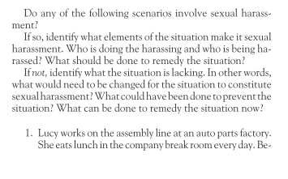

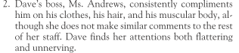
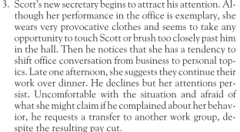
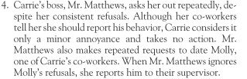
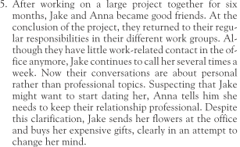
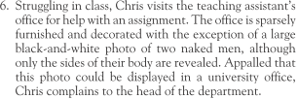
- Shelly Layman is very tactile. She always puts her hand on the arm of the person she’s talking to and always makes a point of making direct eye contact.

- Jennifer Steward has a sexy body and is proud of it. She’s been known to come to work in miniskirts and low-cut sweaters. “why should I be ashamed of what God’s given me?” she argues. “I don’t think it makes anyone feel uncomfortable. I haven’t heard a single complaint from any of the men in the office!

- Susan Bellford gives guys massages in the office during breaks. “She’s got good hands,” they often say. A couple of married men don’t seem totally comfortable with I, but they accept it so as not to ‘make any waves.’
Appendix 5, S5
Political correctness (adjectivally, politically correct) is a term which denotes language, ideas, policies, and behavior seen as seeking to minimize social and institutional offense in occupational, gender, racial, cultural, sexual orientation, disability, and age-related contexts. (Wikipedia)
Appendix 6, S5
For teachers and interested students I really recommend the article on the following website: http://www.scu.edu/ethics/publications/iie/v5n2/

Ethics, Education,
and Political Correctness
By Marilyn Edelstein, Ph.D.
The term "political correctness" is itself a misnomer, a straw man (straw person?). Political correctness, at least on our campuses, has been defined by those opposed to and fearful of viewpoints they lump together under this loaded term. No one of good sense or good will would favor something called "political correctness" as the term is used today. But there are persons of good sense and good will who favor views sarcastically dismissed as "politically correct" by their opponents.
Critics of political correctness combine and often distort three different but related issues. First, political correctness is used to describe the goals of those advocating a more pluralistic, multicultural, race-, gender-, and class-sensitive curriculum. Second, certain academicians are branded politically correct for insisting that intellectual inquiry reflects, to some degree, the values and interests of the inquirer and that aesthetic judgments are always intertwined with moral and political ones. Third, and most harshly, people are labeled politically correct for advocating university policies designed to minimize sexual and racial harassment on campuses. Fuller understanding of these three issues is critical if the widening public debate over political correctness is to become fruitful and illuminating rather than bitter and confused.
First, critics of traditional curricula do not want to throw out Western culture. Rather, we suggest reexamining its history and acknowledging that some important texts and experiences have been relegated to the margins. No one claims that new contenders for inclusion in the curriculum should be admitted solely to make it culturally or politically representative. Instead educators and scholars should consider whether some seemingly universal criteria might have excluded differently worthy, differently excellent works.
Anyone familiar with the history of literary criticism should realize that lists of the books "everyone" considers excellent change over time, as do styles, subject matter, and criteria. Are the experiences and texts of Rousseau timeless, universal, and central to Western culture while those of Frederick Douglass or Maxine Hong Kingston are not? Must the latter be consigned to specialized courses on the curriculum's fringe? Western culture, like Western literature, has, at its core, been shaped by other cultures and by many voices outside it as well as within.
Questions about quality and comprehensiveness in the curriculum are increasingly urgent in the face of indisputably changing demographics in the United States and in U.S. higher education. When we talk about transmitting "our" culture — who is "we"? Does Western culture include the experiences of Native Americans or even women of European heritage? Shouldn't Asian-American or African-American students also learn from texts that reflect those cultures' distinct historical experiences and that reveal those cultures' roles in shaping Western culture?
To answer "yes" to these questions is not to reject Western culture nor to claim that it is only a record of oppression and privilege. Rather, it is to embrace a richer, more dynamic and complex vision of Western culture and its relations to other societies. To answer "yes" and ask others to consider these questions is not to ask for a ghettoization of academic inquiry nor for conformity of answers to the questions. Rather than being questions about political correctness, these are questions that must be asked about what should be taught and learned in higher education and about how and why.
The asking of questions and the questioning of assumptions are central also to the second issue introduced above. Some contemporary thinkers suggest that foundational assumptions, like truth or reason, have a history and should be scrutinized. Yet, even Jacques DerTida, the French philosopher often scapegoated in criticisms of political correctness, said, "I didn't say that there was no center [read "truth"], that we could get along without the center. I believe that the center is a function, not a being - a reality, but a function. And this function is absolutely indispensable."
Some thinkers today question the centrality of Western culture itself as the culture of reference, just as feminists have questioned the traditional view of male experience as normative and universal. But theorists who critique hierarchy and domination certainly do not seek merely to invert hierarchies or to establish their own hegemony in reality or in academic debate. Even within the theoretical perspectives that opponents of political correctness indiscriminately lump together there are wide-ranging debates about the relations between theory and the quest for a more just society.
The third, and perhaps most pressing, concern in campus debates is the charge that those advocating university policies against sexual and discriminatory harassment are "tyrants" of political correctness. That here as elsewhere the act of naming itself exerts a kind of power is clear when one considers that we would more accurately be called advocates of human decency and respect. Nonetheless, it is understandable why those afraid of losing power and legitimacy might overwhelm the media with cries of "political correctness" or "the tyranny of the left." But no one I know wants to inhibit genuine free speech or an open exchange of ideas. We want anti-harassment policies to be carefully and narrowly drawn to avoid infringing on free speech or academic freedom.
Still, when offense becomes harm, when gender-based or racial epithets intimidate and silence and drive their Victims from the arena of academic freedom, then this discourse cannot be defended as free speech. Name-calling does not resemble or produce an open marketplace of ideas. Free play of ideas is not the same as a free-for-all of insults.
Many of us encourage greater sensitivity to the needs and fears of all members of a changing university community and hope this will be accomplished by means other than codes, largely by education itself. Is having to think, before speaking, about the effects of one's speech on others an unreasonable price to pay for a more hospitable and educational campus environment?
To encourage more conscious, self-reflective, sensitive language and behavior is not to tyrannize. To advocate conscientiously constructed codes that address rare and egregious infractions of common decency and civility is not to call for a thought police. Universities already regulate behavior and speech (e.g., plagiarism, residency, alcohol use). In the wider community, zoning laws acknowledge that some locales are inappropriate for some forms of speech and conduct. Defamation and obscenity among other forms of speech are already regulated. Societies perennially weigh the rights of individuals against the needs of the community.
If we are entering a period when conservatives fear the tyranny of the left, does that mean that the left is taking power or that the right is afraid of losing power? I am more certain of the latter. The debate over political correctness is obviously political as well as academic. But it is important for self-professed advocates of free speech who decry political correctness not to inhibit that right by calling speech they detest "tyrannical." Labeling speech "politically correct" may be an attempt to silence that speech through ridicule. It is important to recast these important educational and cultural debates in less-loaded terms. We can begin by agreeing that concern for diversity, justice, and open inquiry is not merely politically correct but humanly decent.

Appendix 7, S5 - Politically Incorrect Jokes
The activities (ready to print starting on the following page) are taken from:
Mac Andrew R., R. Martinez (2002). Taboos and Issues -Photocopiable Lessons on Controversial Topics. Boston: Thomson Heinle.
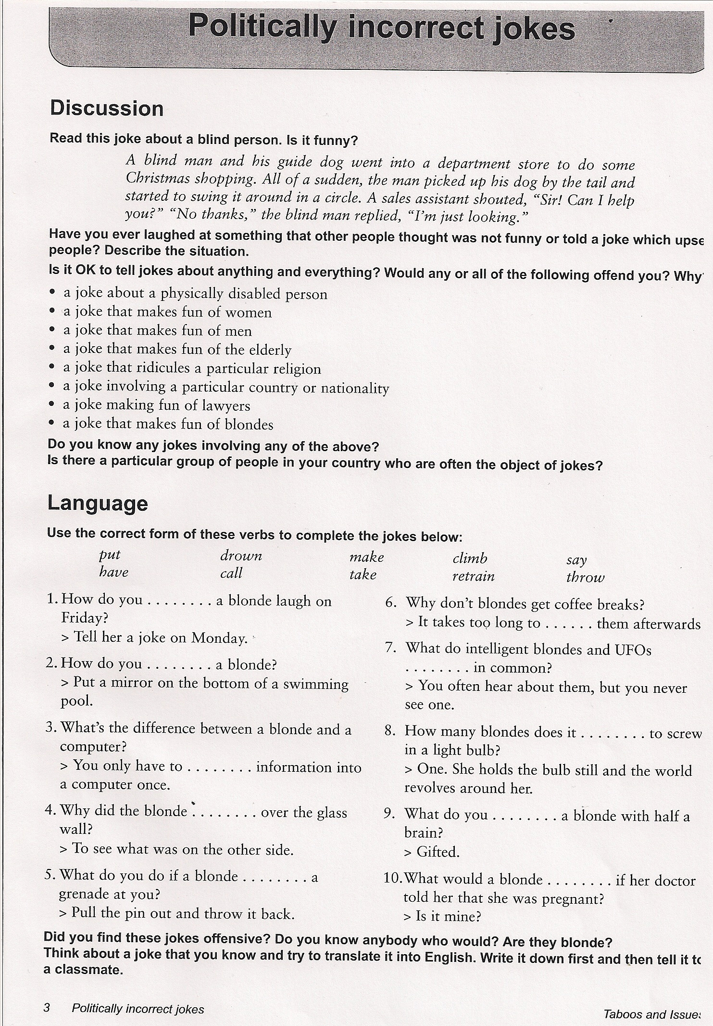

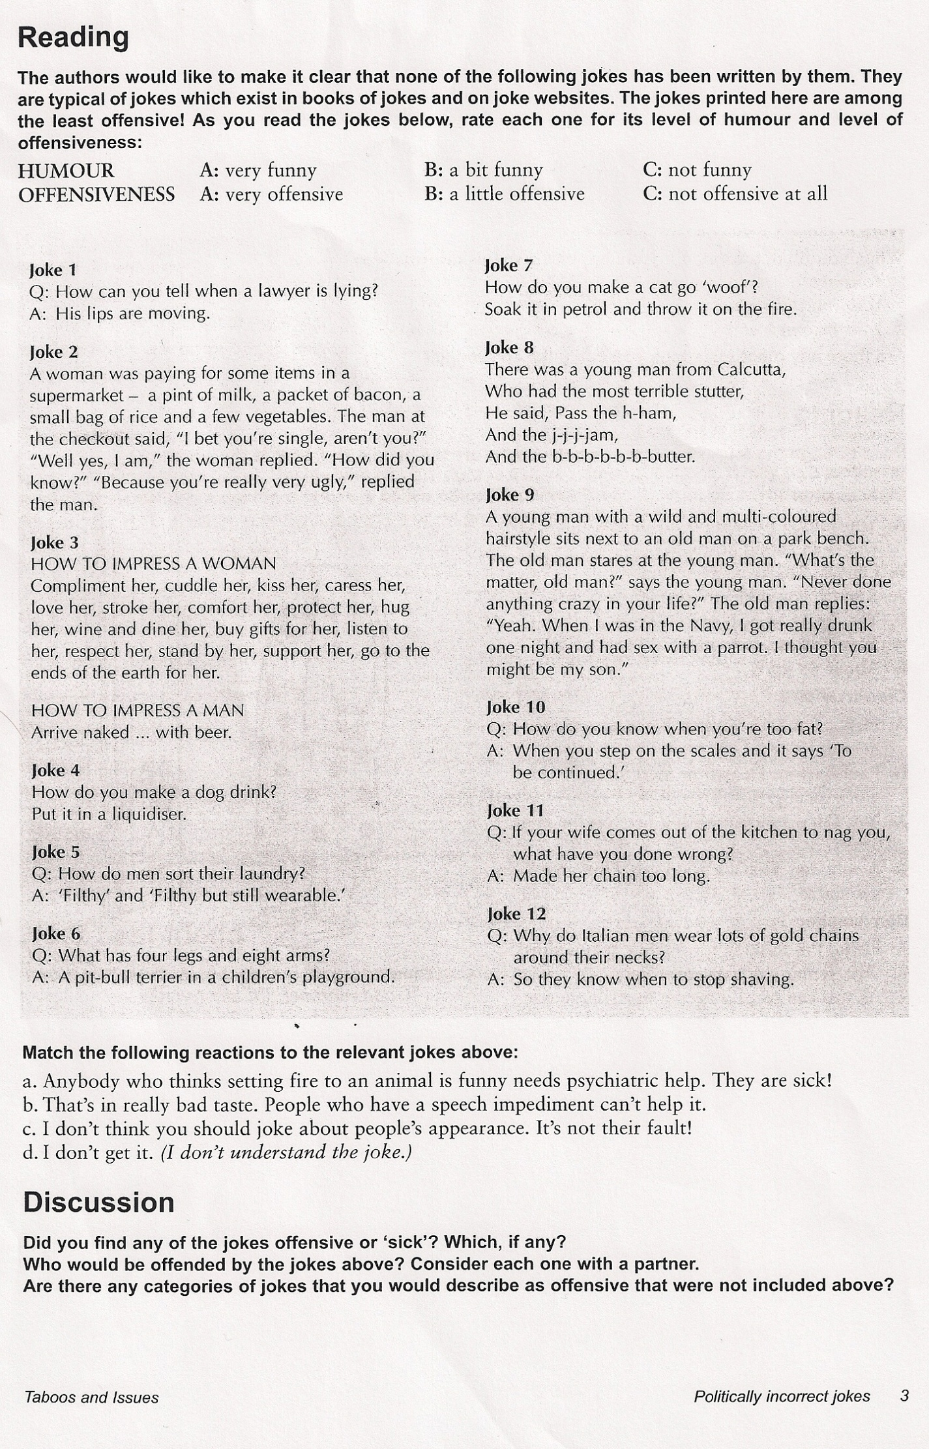

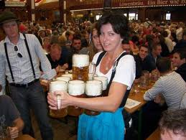
Activity 1, S5 - What is sexual harassment?
Imagine the following situation. You are on a sightseeing tour in San Fran with some new colleagues. There is an Oktoberfest going on and of course you have to go in for a drink. You witness somebody staring at a waitress’ breast, which is of course nothing special in a setting like that, and then he is smiling at her in a greasy way (leering). When she leaves he even touches her fanny. The waitress acts ‘professionally’ and ignores the customer’s behavior:
Now you want to tell your colleague that it must be really difficult to be subject to sexual harassment on a daily basis, but your colleague doesn’t know what sexual harassment actually is and asks you to explain it to him/her. For instance:
A: It must be really tough to be subject to sexual harassment on a daily basis.
B: I am sorry, but I don’t quite know what sexual harassment means, could you please explain it to me?
B: Sexual harassment is ……………..
When you are finished ask your colleagues to explain it back to you so that you can see whether he/she has got the idea or not!

Activity 2, S5 - Hot Discussion: Identifying Sexual Harassment

Instruction:
1. Everybody takes a green and a red glass nugget. In your group read through each case carefully. After reading through a case decide for yourself whether the case concerned involves sexual harassment or not. Secretly choose the red nugget for YES or the green nugget for NO. Then everybody lifts the secret at the same time. Then discuss your decisions:
If you chose YES:
What elements of the situation make it sexual harassment?
Who is doing the harassing and who is being harassed?
If you chose NO:
What would need to be changed for the situation to constitute sexual harassment?

Take notes from your discussion, so that you can report and justify your judgments to me later!
2. Now convert all men that appear in the scenarios into women and vice versa (also the poster with the naked men changes into naked women) and discuss if this changed your judgments.

………………Bottom of Form
Top of Form

