
Student teaching practicum 1and 2
Short info for students

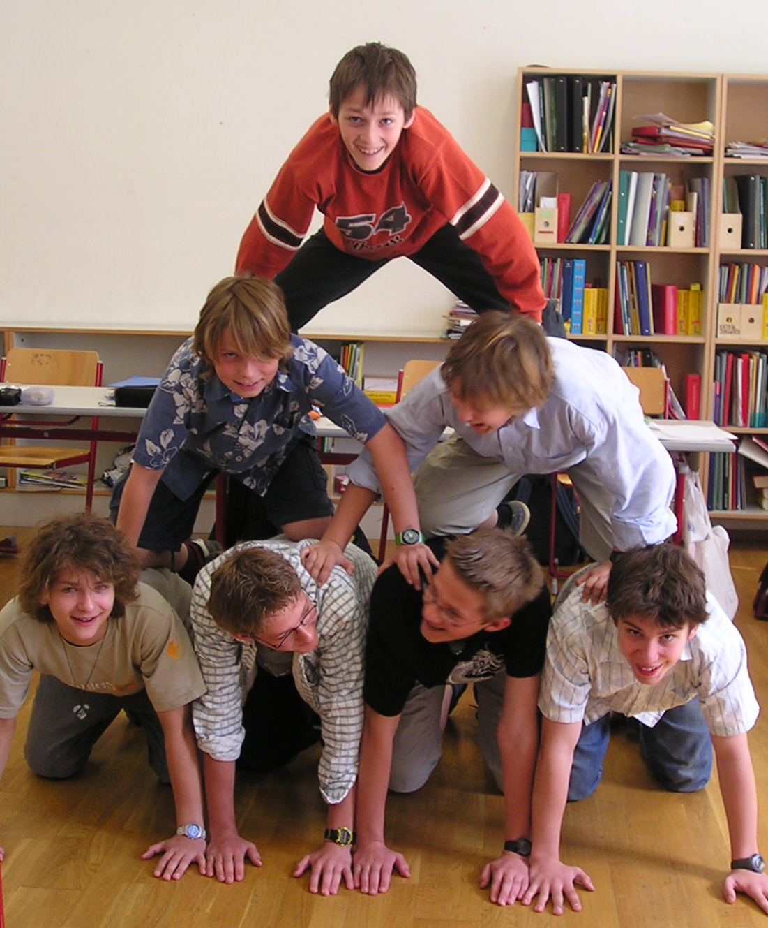

1/1/2011
Department of English, KF Uni Graz
Elisabeth Pölzleitner and David Newby

Student teaching practicum I and II

Dear students,
You have signed up for the student teaching practicum 1 or 2 and are soon going to slip into your new role as a teacher. In order to profit most from this experience at school your Fachdidaktik lecturers have put together a few tips and important information about the practicum.

Materials you will need
- Your EPOSTL, including any reflections or self-assessment that you have done so far.
- An EPOSTL info-folder and info-brochure for your mentor. (You’ll get this from your Frau Grangl in PS1 or Frau Cencic in PS5)
- A notebook for your observation notes (your practicum diary)

Timeframe
This is the official division of hours published in the „Leitfaden für Studierende und MentorInnen”. You will find the full info-brochure at:
http://www.uni-graz.at/lispwww
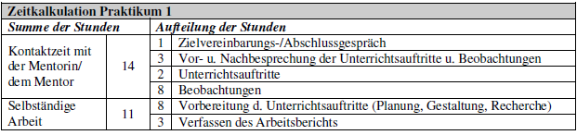

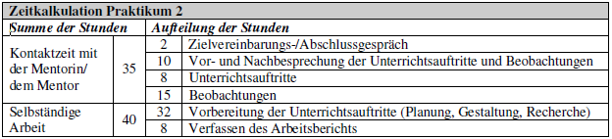

Goal-setting and expectations
Before your first meeting in school, look through your EPOSTL and see what areas of teaching you feel most confident about and where you would like to get some help from your mentor. Take some notes of these +/- areas. This could be your first entry in your practicum diary. These descriptors will form the basis of your final report (Arbeitsbericht).
In the first meeting with your mentor, discuss the following basic issues:
- What are your expectations of the practicum? What would you like to see and learn? What would you like to try out? What are your worries?
- Suggest 5-10 descriptors from your EPOSTL that you would like to focus on during your practicum. These can still be changed in the next few weeks. Your mentor might not have heard about the EPOSTL. Give him/her the info-folder, which includes a copy of the EPOSTL and the info-brochure for mentors and show him/her what you have done with your EPOSTL so far.
- What should you know about specific school rules that will apply during your lessons?
- Discuss the timetable and timeframe of the practicum (see page 10 of this package). At what time are you expected to be in school?
- Exchange contact information in case one of you has to cancel a class. (Telephone, e-mail)

Introductions
The first thing you need to do in your new school is to introduce yourself to all the people you meet. Don’t be shy and hide away in the staffroom or at the back of a classroom. By introducing yourself to the teachers and students and briefly sharing your aims and wishes for this practicum you will become part of the school, rather than being an anonymous figure. Think of and plan a one-minute introduction of yourself that you can use in the different classes that you are going to observe. Ask your mentor to give you a chance to introduce yourself in this short way in each new class that you visit. By doing this you are showing the students that you are actively in charge, that you are a person like them – not an anonymous figure sitting at the back of the class. When it’s your turn to teach them, they will cooperate rather than test your limits.

Lesson observations
The best way to keep track of all your impressions and new insights in this practicum is to keep an informal diary where you note down what you see in each lesson. You might use a thin notebook with a margin and take lots of notes of all the little things that are going on in the classroom. Use the margin for any questions you might want to ask your mentor later in your discussion and analysis sessions.
Switch your focus of observation from the teacher to the students and see what and how things are done in the lesson. You will soon see that unfocused observations are not very helpful if all you can say after a lesson is “the students were noisy” or “the teacher taught the past tense.” In order to get a more detailed view of the interactions going on in the classroom, use the checklists on pages 6-9 of this package and try to relate your experiences to the EPOSTL descriptors that you have chosen. Use the questions on the checklists to help you focus your attention on certain aspects of methodology, classroom management, interaction with the learners, classroom atmosphere and discipline. Focus on a few specific things each lesson – you won’t be able to see the important things if your focus is too wide.
Remember: “Telling is not teaching.” See what the learners DO, how they act and react to the teacher’s instructions. This can be very valuable information for your own teaching.

Lesson evaluation with your mentor
Try to arrange regular feedback and analysis sessions with your mentor where you can discuss your observations and get answers to all the questions that might have occurred during the lessons. In these sessions also discuss and refine your choice of EPOSTL descriptors that you are going to use for your report.
When discussing the EPOSTL descriptors always rephrase them as a question: e.g: “I can encourage learners to use the target language in their activities.” “How can I encourage….” Collect your own ideas, see how your mentor does it or get your mentor’s advice on these issues. Use your collected findings in your final report later.

Planning your own lessons
After observing a few lessons ask yourself in which of the classes you would like to do your own teaching. Find out what topics your mentor has planned for the near future and see what you can contribute to these topics. If you have planned any lessons in one of your methodology courses at the University, you might want to try them out now. See if they fit in.
As soon as you have agreed on a class, a topic and a timeframe, start planning your lesson(s). Use the “checklist for student teachers” in this package (page 8) to help you plan your lessons. Send your lesson plan and materials to your mentor early enough to get some feedback and revise them if necessary.

Your practicum-report (Arbeitsbericht)

If you have taken good notes according to the instructions on the “EPOSTL observation activities”, writing your report won’t be difficult. Write detailed reflections about each of the EPOSTL descriptors that you have chosen for this practicum (approximately 5 for practicum 1, 10 for practicum 2). In your reflections include anything you have learned and realized during the lesson-observations, your own teaching or any other ideas and solutions that you have come across elsewhere. You are not expected to have perfect solutions for each of the problems. Show that you have given the matter a good deal of thought and that you have explored several aspects and possibilities and that you are on the right track.
Have a look at the following sample reflections to get a first idea.

EPOSTL sample reflections
Classroom Management
1. I can take on different roles according to the needs of the learners and requirements of the activity (resource person, mediator, supervisor etc.) (p.42)

When I started my practicum I only thought about lessons from the teacher’s point of view. I saw the teacher in the center of the action, directing everything. Now I am aware of the fact that this is not always the case and that it is not always necessary to play this role. I have learned to look at the lesson from the learner’s point of view and I have come to realize that I must focus on what the learners are doing and what is happening in their brains when I plan a lesson.
This experience has helped me see that it is ok if I am not in the center all the time, if I just walk around and help learners during group-work, or if I am not busy at all, because they do not need me for some time. At first I worried about such times in a lesson – but now I see that actually this is an important phase and I can relax in this new role as a resource person who is only active when needed.
I can only guess what the role of a mediator might be in a classroom. I have seen my Mentorin interfere a few times when groups of children were fighting or insulting one another – I guess this is another role that is not directly related to the teaching of the language – but it is also important so students feel taken seriously and feel comfortable in class. If someone is treated badly or excluded, they cannot learn well because these personal issues get in the way.

2. I can create opportunities for and manage individual, partner, group and whole class work. (p.42)

I have seen in my Practicum that learners can work very efficiently in groups when they have clear instructions and materials. I guess the learners I have seen in my Practicum have got a lot of practice with this type of work. They get a tasksheet (like a Wochenplan) with all the instructions for the project. The teacher explains the main tasks very briefly, sets out the materials (worksheets, games…) and from then on the students work in small groups, pairs or on their own. Only a small number of activities are organized as whole class activities, usually at the beginning of a lesson or when the teacher wants to introduce a new topic. Many students work in the hallways or on the floor – it can get quite noisy but I was surprised by the intensity of the students’ work and by the good results at the end.
I have also seen that double periods are really useful because the learners are not interrupted as much and can keep working on one topic in a more focused way.
When I organized my own project (ghost stories) I made sure that the learners would be very active and speak a lot. Therefore I planned several information-gap exercises (info about ghosts… cut up story…) so they had to walk around and share and exchange the information. The lesson looked very chaotic (I was worried about the noise) but I realized that it was actually very effective because they were all talking in English and using the language from the cards. Nevertheless it was necessary to sum up the story in the end to make sure that all the students had fully understood it.
Group work: When planning group-work I need to provide the learners with clear instructions, otherwise they waste a lot of time before getting started. The instructions should also be written down for the learners (to allow them to re-read the instructions and to keep an overview). When learners are working in groups I give them individual feedback as well as whole group feedback and steer them in the right direction.

3. I can make and use resources efficiently (flashcards, charts etc.). (p.42)

I have to design the handouts very carefully. They should be structured clearly so that the learners can use them easily and effectively. I should always make a good master copy that I can keep for later use. Therefore, I have to put a lot of effort into the materials because the learners should see that I do my work in a responsible way. As a consequence, they should handle their own work in a responsible way as well.
Teaching materials such as cards for specific exercises should be printed on good paper so that the learners can use them effectively (thin paper might tear). In that way I can also use them again (I have to make sure to get them back after the activity). It is also clever to laminate cards that will be used often.
A little technical tip that I learned in my Practicum is to use different colors for each set of a card game so I can easily put lost cards back into the right pile. Simple, but helpful!

Classroom Language (p. 43)
- I can encourage learners to use the target language in their activities.

When I was watching the classes I noticed that learners tend to speak German in groups when they get into hot discussions about a topic. In role-plays or information gap activities it was easier for them to keep speaking English because they used the English prompts and that seemed to get them started the right way.
I have also seen the idea of using some form of language police in group work (one learner makes sure that everybody speaks English). The “language police” received a badge (printed and laminated) from the teacher and was responsible that his/her group would speak English in this lesson.
I also noticed that my Mentorin never used any German in class, even when the learners addressed her in English. When young students answered complex things in German she just summed up their request or reply in simple English. She uses lots of gestures with young learners – to help them understand what she is saying. With more advanced learners who address her in German she just answered “We speak English here” in a very factual tone. The students accepted it like a law of nature and switched back to English.
I also noticed that the teacher hardly ever corrected the students’ mistakes when they tried to express something difficult in English. They made lots of mistakes – the teacher let them finish and then just summed up the request/ or comment in correct English. It sounded something like “Oh, I see , so you couldn’t do your homework because your internet connection wasn’t working and you couldn’t watch the video on Moodle. …” The students never felt embarrassed about their mistakes -- it seemed very natural and they felt that they had communicated their ideas successfully. I think this is really important, otherwise the learners will not want to speak in front of the class.

Interaction with learners
- I can keep and maximize the attention of learners during a lesson. (p.41)

This was one of the most difficult things for me in my first teaching hours. It helped me a lot to use name-cards for the students, because I could call their names if somebody wasn’t working. I also noticed that it is difficult to interrupt a class when they are working in groups. This can get quite noisy and I didn’t want to shout into the class in order to be heard. My teacher used a little harmonica for this purpose. She played a very simple tune that means “Please listen to me.” and raised one arm. The students know that this means that they should stop whatever they are doing in order to get some short instructions or information. Whoever notices this also raises their arm and spreads the information. It worked really well and within half a minute everybody seemed to be listening.
I also noticed in upper school in a literature discussion that the students were all interested and paying attention because the teacher seemed excited about the text and writer herself. This positive energy easily spread to the learners and they had lots of questions
In one of my lessons the students had just had a Spanish test before and were all excited. The teacher gave them an extra five minute break, opened the windows and allowed them to eat their snacks. Afterwards they were more relaxed and I could teach my lesson in a focused way. I see that such important needs of the learners need to be taken seriously in order to work efficiently afterwards.

Grammar
- I can evaluate and select grammatical exercises and activities, which support learning and encourage oral and written communication. p. 27

When choosing exercises for a present perfect tense grammar workshop, the most difficult thing in the beginning was to select exercises that were appropriate for the notions that had been introduced (e.g. duration, general experience etc.). I found a game that I was sure the pupils would enjoy but then I realized that it didn't fit any of the notions. I decided against it because it would only have confused the pupils. I learnt that each exercise should be clearly connected to a notion and that I shouldn’t mix several notions (unless the students are really advanced and are revising things).
By practicing one notion at a time the learners can develop a clear picture of how this tense is used in real life. In the workshop the class practiced “Duration” for a whole hour by playing different games (What are the oldest items in this room? How long have you had all these things…? ) The learners were always using the same tense form for the same notion and just got used to it.
When watching them I noticed that they were getting more and more used to this form and it seemed to sound more normal and automatic to them to use the pres.perf. tense here (rather than the present tense as we would do in German.)
It is still difficult for me to find such exercises. I learned that I can use the “communicative use” tips in the Newby grammar and make up activities around them. This still seems difficult for me.

Observation Activities

Classroom management and interaction with the learners
Use the following questions to guide your lesson observations. You need not answer all the questions. Focus on relevant aspects of the lesson and take extensive notes on an extra sheet.
Teacher: |  | Learners:
How does the teacher get the students’ attention at the beginning of the lesson? (EPOSTL; p41, 1)  What does she/he say?  What mimes or gestures does he/she use? | 1 | What are the learners doing when the teacher arrives?  How do the learners (re)act?
How does the teacher open the lesson? (EPOSTL; p39, 1)  Does the teacher explain his/her plan and objective(s) to the learners? | 2 | Are the learners aware of the objective of the lesson?  What are they doing at this stage?
Are there any organizational tasks that are done by the teacher? | 3 | Are there any organizational tasks that individual pupils do?
Which stages of the lesson can you identify? | 4
Which organizational forms are used by the teacher? (EPOSTL; p42, 2)  - frontal  - groupwork /pairwork  - presentations  - individual work | 5
Does the teacher give the students any choice concerning the order of tasks/ partners/ places/ activities/ topics/ reading…? | 6 | How do the learners decide what to do next?  Do they need any help?
Transitions:  How does the teacher lead from one activity to the next? (EPOSTL; p39, 3)  Is the lesson organized step by step or as a workshop? | 7 | How do the students move from one activity to the next?  How much time is lost for transitions?
How does the teacher react to learners’ mistakes? (EPOSTL; p57, 4) | 8 | Are the learners worried about making mistakes?
(How) does the teacher announce homework? (EPOSTL; p46, 1)  How is the homework related to the activities in class? | 9 | Do the students have a clear understanding of the homework tasks and any materials they will need?
How does the teacher close the lesson? (EPOSTL; p39, 6) | 10
Class atmosphere and discipline |  | Learners’ Behavior
How does the teacher create a positive learning atmosphere?  How does the teacher encourage learners to use the target language?  How does the teacher manage to get everybody involved?  How does the teacher respond to misbehavior or inattention?  Does the teacher use any special words, symbols, gestures to help the learners understand or to get their attention?  What else did you notice? |  | Do the learners seem to be interested?  Do they seem at ease and taken seriously?  Are the learners using the target language?  Are all the learners actively involved?  Do they find group mates easily?  Are there any noticeable cliques?  Are there any outsiders?  Are there any noticeable individual pupils?  Are there any learners who seem easily distracted/ very gifted/ very fast or slow?

What I want to remember:

Lesson Planning Checklist for Student Teachers
Do I know enough about the class?  - language needs, expectations and interests  - language proficiency level  - learners’ personalities  - interpersonal relationships  - preferred learning styles and activities  - learners’ names  - other relevant information (possible distractions, problems…) | EPOSTL  Page Nr.  16
How am I going to establish a good first rapport with the class?  - How am I going to introduce myself?  - What opening activity will I do?  - How can I create a friendly, cooperative atmosphere? | 39  21
Learning Objectives  - What are my objectives for this lesson or project?  - How will I see that the learners have reached them? (What will they be able to DO after this lesson?)  - How am I going to present my objective(s) to the class and show that they are important/relevant? | 34
Lesson Content  - Are the items I have chosen relevant to the learners’ needs?  - Are the items interesting, challenging and personally involving?  - Do I know enough about these topics?  - Do the items/topics link up with any previous or following items? How will I refer to and make use of this previous knowledge? | 35
Lesson Organization and Conducting a Lesson  - What organizational forms am I going to use? (frontal, individual, pair, group work)  - Why am I going to use these organizational forms?  - What resources and media am I going to use? How can I manage these efficiently?  - Are my instructions and explanations clear and simple?  - How can I ensure smooth transitions between activities and tasks?  - How long will the activities take?  - What will I do if they take longer/shorter?  - How am I going to finish off my lesson in a focused way?  - Will there be any homework? | 37  42  39  35,  39  39  46
Interaction with Learners  - How will I keep and maximize the learners’ attention span during the lesson?  - How will I encourage learner participation whenever possible?  - Which discipline problems might occur?  - How will I deal with discipline problems? | 41
Classroom Language: ENGLISH  - How am I going to encourage learners to use English in their activities?  - How can I help the learners to understand the instructions and explanations in the target language? | 37, 43
Reflections on Methodology  Use this sheet for your observations and/or for reflecting upon your own lessons.  Which of the following skills have been/will be practiced in the lesson? Check the EPOSTL descriptors for the most relevant skill(s) and choose a few that seem most important for a specific lesson. How did the teacher put these into practice? // How are you going to put these into practice?  Remember: Do not choose too many descriptors but deal with a few in detail. | EPOSTL  page nr.  20-29
Speaking/Spoken Interaction | 21
Writing /Written Interaction | 23
Listening | 25
Reading | 26
Grammar | 27
Vocabulary | 28
Culture | 29

My Timetable: Practicum 1

Date | Class | Meetings with my mentor: add a few keywords describing the topics
 |  | 1
 |  | 2
 |  | 3
 |  | 4
 |  | Lesson Observations
 |  | 1
 |  | 2
 |  | 3
 |  | 4
 |  | 5
 |  | 6
 |  | 7
 |  | 8
My own teaching (can also be several short activities adding up to
two hours)
 |  | 1
 |  | 2

My Timetable: Practicum 2

Date | Class | Meetings with my mentor: add a few keywords describing the topics
 |  | 1 First meeting, intro and planning | 7
 |  | 2 | 8
 |  | 3 | 9
 |  | 4 | 10
 |  | 5 | 11
 |  | 6 | 12 Final round-up session
 |  | Lesson Observations
 |  | 1 | 9
 |  | 2 | 10
 |  | 3 | 11
 |  | 4 | 12
 |  | 5 | 13
 |  | 6 | 14
 |  | 7 | 15
 |  | My own teaching
 |  | 1
 |  | 2
 |  | 3
 |  | 4
 |  | 5
 |  | 6
 |  | 7
 |  | 8

What makes a good teacher? My ten commandments of good teaching
Use this page to write down the most important things you have learned in this practicum.

What I want to remember!!!


You can also download all the checklists and information from our Fachdidaktik homepage:
http://www.uni-graz.at/angl3www

