Focus on Language and the Learner

Course content and requirements
The course “Focus on Language and the Learner” is both theoretical and practical in nature. The main emphasis lies on adopting a learner perspective and on understanding cognitive and psychological learning needs.
As far as theory is concerned, we shall be considering how learning works in the brain and what kinds of learning environments foster learning. We will be looking at how the new findings of the neurosciences as well as cognitive theories can be used to facilitate learning.
On the practical side we will look at teaching materials and evaluate their efficiency according to the criteria of brain-friendly language learning and cognitive-communicative grammar.

Aims of this course:
- You will have a greater understanding of the mechanisms of learning in the brain.
- You will understand how to create learning environments that foster learning.
- You will have a greater understanding of what cognitive communicative grammar means and how it differs from traditional grammar.
- You will be able to analyze teaching materials (grammar activities, vocab activities, writing tasks) according to theoretical categories and assess their effectiveness.
- You will develop an ability to adapt existing teaching materials to make them more effective and to design activities on your own.

Course materials:
In addition to this handout, all theoretical articles and other background information needed in this course will be provided on Moodle. For our practical work on teaching grammar you will need a copy of David Newby’s Grammar for Communication.

Photocopiable card games and grammar activities
We shall try out and analyse in class several card games and grammar activities. Photocopiable sheets of these games can be found on Elisabeth Pölzleitner’s website epep.at or on the Moodle page of this course. The theories presented in this seminar have been implemented in Grammar for Communication, a reference grammar book, which is approved for use in Austrian schools, and the accompanying book of activities:
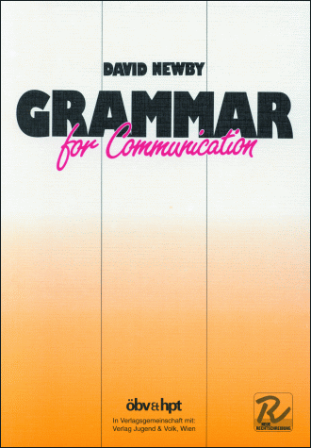
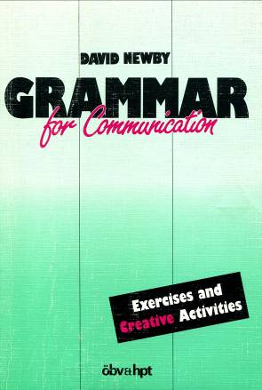

Newby, D. (1989) Grammar for Communication. Vienna: Österreichischer Bundesverlag € 12.50
Newby, D. (1992) Grammar for Communication – Exercises and Creative Activities. Vienna: ÖBV € 7.50
We will use both of these books during the course. The way of describing grammar, the grammar rules and the communicative activities you will find in them strongly reflect the theoretical aspects of grammar that will be discussed in the course. You are strongly advised to buy copies – at least of Grammar for Communication as we shall use it regularly. They will also be useful to you in your teaching career. The books are available from Buchhandlung Dradiwaberl in Zinzendorfgasse or directly at ÖBV. Some copies are available in the University library.

Moodle:
We will be using the Moodle platform for all course resources, communication and assignments. Please note that we are not using the Uni-Graz Moodle but Mrs. Pölzleitner’s own Moodle platform:
www.moodle.epep.at

Create a new account and register for the course “Focus on Language and the Learner”. Please use a password that you will remember easily or write it down, so you can always access the platform easily.


Warning: If you do not manage to register for the moodle course by session 2, you will be automatically deregistered from the course.

Course requirements
To profit most from this course make sure you
- Attend the lessons regularly
- Participate actively and ask lots of questions
- Do your weekly assignments in order to come to class prepared.
To pass the course you will:
- Carry out regular out of class assignments and reading tasks and upload them to Moodle. You will have to
  - read articles and watching video-clips
  - do weekly tasks on your choice-boards
  - analyze and evaluate teaching materials
  - adapt or create teaching materials
- Present your assignments in class
- Write a term paper (grammar project) in which you will plan, analyze and evaluate grammar teaching materials (in pairs).

You will find more useful ideas on my website for creative English teachers: epep.at
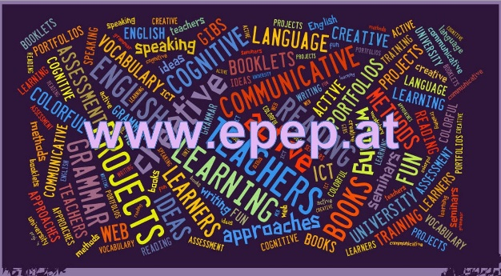

Overview of your assignments
Compulsory tasks after session 1:
- A1: Introduce yourself on Flipgrid. Go to: https://flipgrid.com/q7kc8m9 . Use your phone (download the app) or your computer. Introduce yourself to your teacher and your classmates. You have up to 90 seconds to tell us some important facts about yourself. You might want to tell us something about the following topics:
Where do you come from?
What are your personal interests, your second subject, your hobbies...
What do you expect from this course?
Be creative :)
- A2: Choose a short video-clip on learning and the brain and do one of the tasks on the choiceboard. Upload your work into the Moodle database.
- Sign up for the Moodle course

Choiceboard
Choose an appropriate task each week. Choose a variety of tasks, at least one from each row and column.
Flipgrid Video-message  Present the key facts and information of your resource in 90 seconds. Plan your presentation well. (Tip: prepare a bulleted list of topics that you want to talk about, or make a simple mindmap. DO NOT READ your presentation. You must SPEAK to your audience. Record your message on the Flipgrid app. | Asking Good Questions  Choose a short youtube video about learning and the brain. Load your chosen video into playposit and formulate 5 meaningful questions for your fellow students. Paste the link to your playposit video on Moodle. Make sure your playposit video is set to public so your fellow students can watch it and answer your questions. | Audio Message  While reading or watching, take notes of the main points. Then plan a 2-3 minute audio presentation about the content of your resource. Practice your oral presentation, then record it.  Option: you may work with a partner and do this task in form of an interview. Upload your audio-file or use clyp.it and paste the link into moodle.
Mindmap  Draw a mindmap of the ideas and concepts in your resource. Label your mindmap clearly and indicate the relationships between the parts. Draw your mindmap by hand or use an online tool. (The free version of Mindmeister works well and can be shared with a link) | Checklist  How can you put the ideas presented in the text or video into practice? Write a checklist for yourself and your fellow students. Which of the content points mentioned in the text or video do you want to put into practice? How do you want to do it? | Your Choice  Be creative. Are you good at singing, rapping, drawing, painting, acting…?  Find a way to convey the message of your chosen resource.
Non-stop-free-writing  Sit down for 15 minutes (use a timer) and “chew and digest” the ideas presented in your resource. Write down your ideas without stopping to organize or filter them. Let your ideas flow. Do not worry about language or coherence. Just spill your thoughts about the topic into your computer. | Dialectical Journal  Fold a sheet of paper in the middle so you have 2 equal columns. While reading or watching use the 1st column to take notes of important concepts and ideas, quotes, examples etc. Then write your personal thoughts, opinions, questions, concerns… for each idea into the 2nd column. | E-mail to the Teachers’ List  After reading or watching one of the resources, write an e-mail to the staff of “your” school. Sum up the main ideas and concepts and explain why you think these are important and should be implemented in “your” school. Suggest how this could be done or what the first steps could be.

Your Grammar Project

Preparation
Choose a grammar topic from the “tricky topics list” on Moodle and decide what group of learners (state age and level!) this will be appropriate for. Consult the course handout and materials on Moodle and revise the theoretical concepts. Revise the grammar topic in the Newby Grammar to make sure you fully understand the notional concepts and communicative use.
Teaching materials for three lessons
For your final grammar project plan in detail how you would introduce and practice your chosen topic in class. Plan three lessons + homework and one testing activity that could be used later in the Schularbeit. All your materials must meet the criteria of efficient communicative tasks that we have discussed in this course.
You may use tasks and activities from published textbooks, grammar reference books or online materials. If necessary, adapt and improve them or design your own activities. Do not forget to quote your sources carefully. Organize your materials clearly and write clear instructions for the learners using language that is appropriate for the learners’ age and level. Present your materials nicely so they could be used in class.
Tip: If you design your own activities always try them out with a partner. Check if you would actually use the language you were expecting or if you’d have to force yourself to use it in unnatural ways.
Theoretical Analysis
Below the student instructions and materials for each activity insert a “theory box”. In these theory boxes demonstrate your ability to analyse the activities you have chosen and show how the principles and theoretical categories discussed in the course are relevant to your teaching. Use the “grammar quick checkers” and checklist for brain-friendly learning to help you in your analysis. Decide which categories are most meaningful for your particular topic.

Always start with grammatical objective and learning aim. When you use categories to analyze activities (e.g. cognitive learning stages etc.) you must explain why you think a particular exercise can be assigned to a certain category. For example, if you think an exercise corresponds to the ‘proceduralisation’ stage, explain why you conclude this.
A note on pair-work
Pair-work can be very efficient and can help both partners to learn from each other and critically test their own knowledge and understanding. If you decide to do this project with a partner make sure you
- brainstorm and plan your project togetherdiscuss in detail why you think the exercises and activities of your choice are efficient and fulfil all the criteria of C+C grammar teaching
- share both the practical and theoretical work evenly between you
- try and test each other’s activities and ideas to see if they really work
- critically proofread each other’s contributions and cooperate in improving and polishing them
Pair-work is NOT: one person doing the work while the other partner is having coffee
Structure of your paper
Short (maximum 1-page) teachers’ notes about aims, age/level and an overview (table) of the planned tasks)
Materials for the learners, always followed by your theoretical reflections and explanations. All student materials must be ready-to-use in printable format. Make sure your instructions are written for the learners (not for the teacher) and use simple, clear language.
Deadline
Your grammar project must be handed on time. Please check the deadlines on Moodle and on the course schedule. Upload your paper to Moodle – you need not hand in a printed version.
Compulsory task: Final reflection
At the end of this course go through all the materials again and try to find connections between all the parts and topics that we have discussed. Write a final reflection. What have you learned? What are you going to consider in your future teaching? How does this compare to your previous ideas? What areas would you like to develop further?

Assessment criteria
Your course grade will consist of your active class participation, your weekly assignments and your final grammar project (term-paper). All assignments must be done carefully and on time. Upload your assignments at least 1 hour before the next class. Show your good understanding of the concepts and ideas and always ask yourself how the new ideas could help your teaching and your students’ learning. Do not throw around all the big words of education – be specific and concrete.
For your weekly assignments use a variety of options from the choice-board and stretch your own repertoire of strategies and methods. Double-check your assignments for language mistakes and typos and choose a clearly structured layout.
Active participation in class and presentations of your assignments. |  | 
- You attend class regularly.
- You come to class prepared (you have read the assigned texts or watched the videos).
- You participate actively and constructively in group-work.
- You contribute actively to whole-class discussions.
Keep in mind: You are here to learn. Mistakes are stepping stones of learning. Asking questions shows that you are learning.
Weekly assignments
- Your weekly assignments show that you have actively engaged with the topics and resources.
- Your chosen products show your good understanding and/or good questioning.
- You have chosen a variety of methods to show your understanding of the ideas and concepts.
- Your assignments are carefully done (layout, typos)
- Your language is generally accurate and idiomatic.
Grammar project (student materials)
- Your materials follow the guidelines of “good grammar activities” formulated by David Newby and the criteria on our quick-check grammar chart.
- Your materials have a clear goal and are designed for a specific learner group/level.
- Your materials are ready to be used in the classroom. You have written simple instructions for the learners (Example: Read the text and answer the questions. Not: …and then I would ask the students to…)
- They are well organized and have an appealing layout.
Grammar project: Theory boxes
- Your theoretical reflections and explanations show that you understand the concepts of cognitive-communicative grammar and brain-friendly learning.
- You can select appropriate activities for the different learning stages.
- You understand the grammatical notions that you are planning to teach.
Your final grade

