©Elisabeth Pölzleitner 
Uni Graz and PH Steiermark |
Focus on Language and the Learner
Course Handout for ENF.01

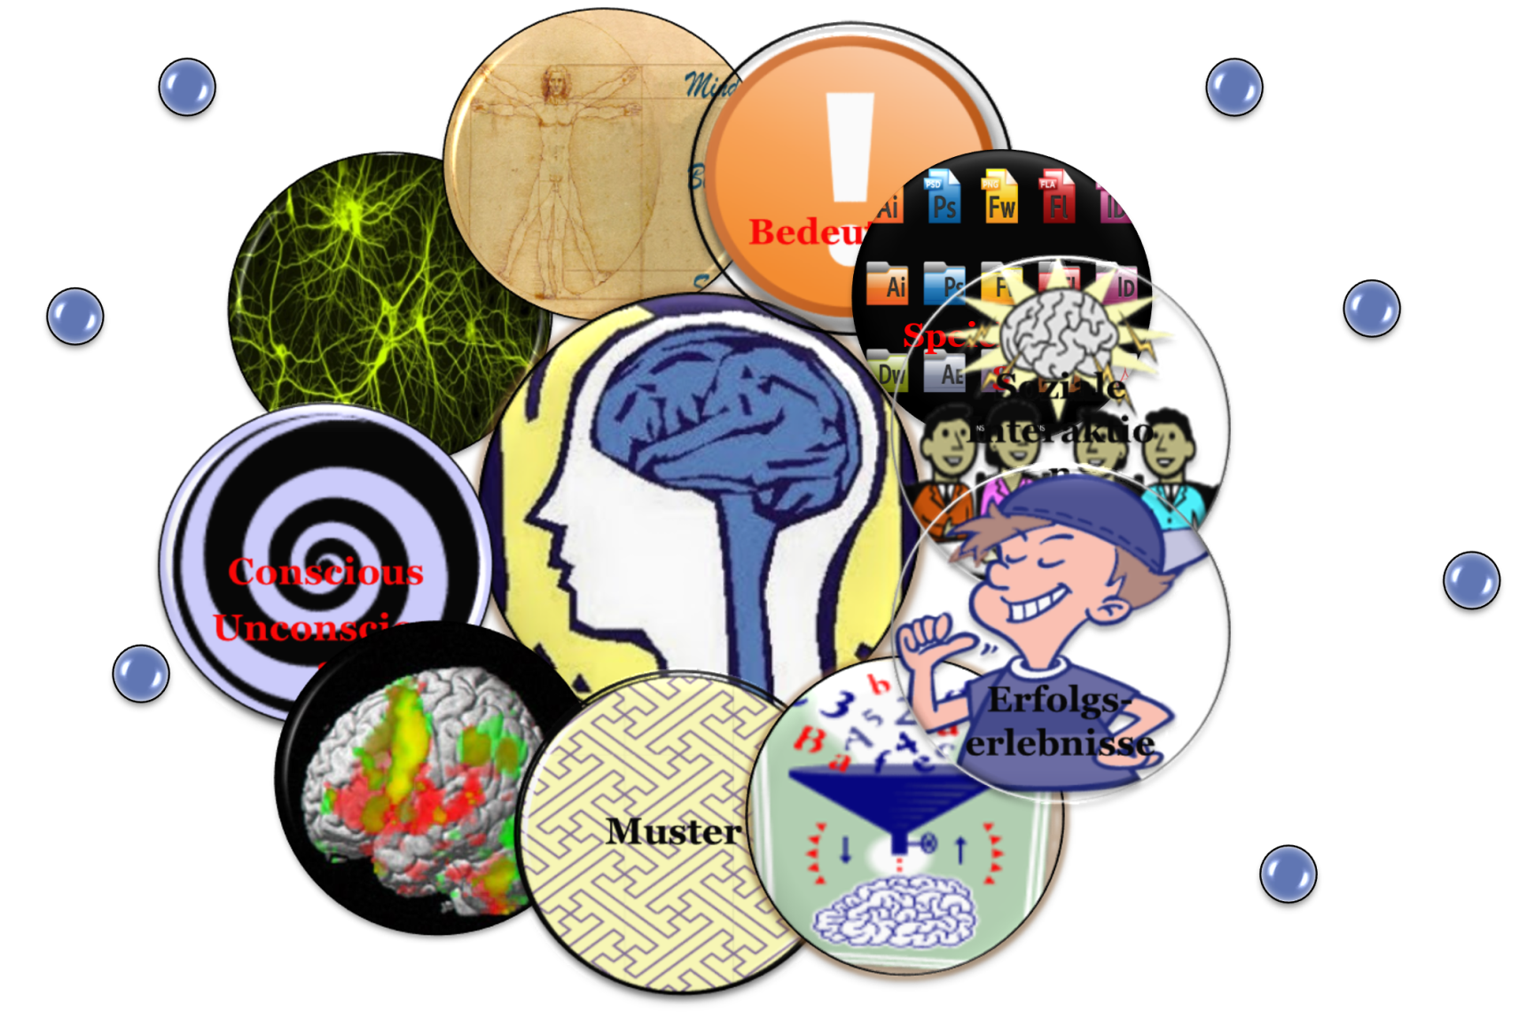



Table of Contents
Course content and requirements 3
Aims of this course: 3
Course materials: 3
Course requirements 4
Overview of your assignments 5
Assessment criteria 7
How can research on the brain help language teachers and learners? 8
K W L 8
10 Principles of brain-friendly learning 9
Types of Memory (Stevick) 11
Checklist for brain-friendly language teaching 12
FIP: Format, Imagination and Pride 13
Die Didaktik des leeren Blattes: Diaries, Booklets, Catalogues, Magazines… 14
Fair 14
Teaching Vocabulary to the Whole Brain 15
How to create multisensory images in the learners’ brains 15
Vocabulary Practice Session 16
Blackout 17
Learning vocabulary by reading 17
Running Dictations for all ages 17
Making Associations – Building Networks 18
The Vocab-Box 19
Vocab Books and Vocab Cards 20
Whole class activities for practicing collocations 21
Testing Vocabulary 23
Theory and practice in communicative grammar 26
1 Influences on modern grammar teaching 26
2 Theories underlying communicative grammar teaching 27
3 Language: grammar as a communication system 27
4 Grammar as a skill: from description to methodology 31
5 Final Comment 34
Relevant Publications 34
Quick Check Grammar Chart 35
Examples of Efficient Grammar Activities: Find details on epep.at 43
Inductive Learning: Making Hypotheses and Building Rules from Examples 46
Bibliography: 47

Focus on Language and the Learner

Course content and requirements
The course “Focus on Language and the Learner” is both theoretical and practical in nature. The main emphasis lies on adopting a learner perspective and on understanding cognitive and psychological learning needs.
As far as theory is concerned, we shall be considering how learning works in the brain and what kinds of learning environments foster learning. We will be looking at how the new findings of the neurosciences as well as cognitive theories can be used to facilitate learning.
On the practical side we will look at teaching materials and evaluate their efficiency according to the criteria of brain-friendly language learning and cognitive-communicative grammar.

Aims of this course:
- You will have a greater understanding of the mechanisms of learning in the brain.
- You will understand how to create learning environments that foster learning.
- You will have a greater understanding of what cognitive communicative grammar means and how it differs from traditional grammar.
- You will be able to analyze teaching materials (grammar activities, vocab activities, writing tasks) according to theoretical categories and assess their effectiveness.
- You will develop an ability to adapt existing teaching materials to make them more effective and to design activities on your own.

Course materials:
In addition to this handout, all theoretical articles and other background information needed in this course will be provided on Moodle. For our practical work on teaching grammar you will need a copy of David Newby’s Grammar for Communication.

Photocopiable card games and grammar activities
We shall try out and analyse in class several card games and grammar activities. Photocopiable sheets of these games can be found on Elisabeth Pölzleitner’s website epep.at or on the Moodle page of this course. The theories presented in this seminar have been implemented in Grammar for Communication, a reference grammar book, which is approved for use in Austrian schools, and the accompanying book of activities:
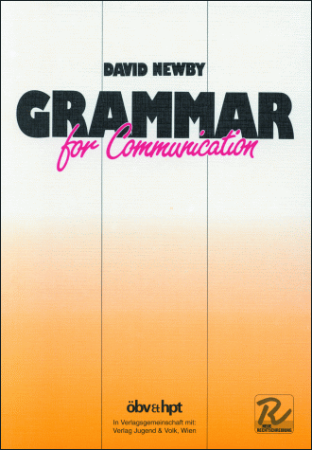
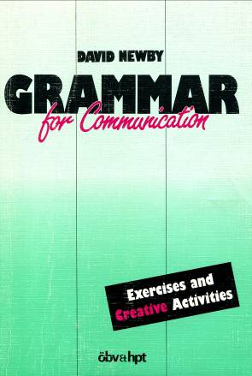

Newby, D. (1989) Grammar for Communication. Vienna: Österreichischer Bundesverlag € 12.50
Newby, D. (1992) Grammar for Communication – Exercises and Creative Activities. Vienna: ÖBV € 7.50
We will use both of these books during the course. The way of describing grammar, the grammar rules and the communicative activities you will find in them strongly reflect the theoretical aspects of grammar that will be discussed in the course. You are strongly advised to buy copies – at least of Grammar for Communication as we shall use it regularly. They will also be useful to you in your teaching career. The books are available from Buchhandlung Dradiwaberl in Zinzendorfgasse or directly at ÖBV. Some copies are available in the University library.

Moodle:
We will be using the Moodle platform for all course resources, communication and assignments. Please note that we are not using the Uni-Graz Moodle but Mrs. Pölzleitner’s own Moodle platform. Go to:

moodle.epep.at

Create a new account and register for the course “Focus on Language and the Learner”. Please use a password that you will remember easily or write it down, so you can always access the platform easily.


Warning: If you do not manage to register for the moodle course by session 2, you will be automatically deregistered from the course.

Course requirements
To profit most from this course make sure you
- Attend the lessons regularly
- Participate actively and ask lots of questions
- Do your weekly assignments in order to come to class prepared.
To pass the course you will:
- Carry out regular out of class assignments and reading tasks and upload them to Moodle. You will have to
  - read articles and watching video-clips
  - do weekly tasks on your choice-boards
  - analyze and evaluate teaching materials
  - adapt or create teaching materials
- Present your assignments in class
- Write a term paper (grammar project) in which you will plan, analyze and evaluate grammar teaching materials (in pairs).

You will find more useful ideas on my website for creative English teachers: epep.at
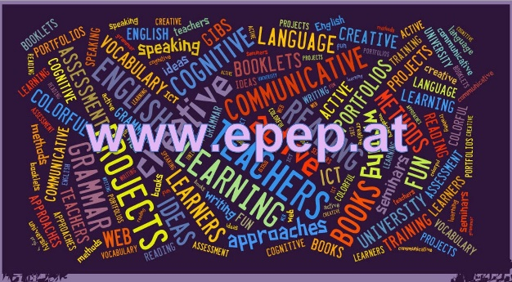

Overview of your assignments
Compulsory tasks after session 1:
- A1: Introduce yourself on Flipgrid. You will find the grid code on Moodle. Use your phone (download the app) or your computer. Introduce yourself to your teacher and your classmates. You have up to 90 seconds to tell us some important facts about yourself. You might want to tell us something about the following topics:
Where do you come from?
What are your personal interests, your second subject, your hobbies...
What do you expect from this course?
Be creative :)
- A2: Choose a short video-clip on learning and the brain and do one of the tasks on the choiceboard. Upload your work into the Moodle database.
- Sign up for the Moodle course

Choiceboard
Choose an appropriate task each week. Choose a variety of tasks, at least one from each row and column.
Flipgrid Video-message  Present the key facts and information of your resource in 90 seconds. Plan your presentation well. (Tip: prepare a bulleted list of topics that you want to talk about, or make a simple mindmap. DO NOT READ your presentation. You must SPEAK to your audience. Record your message on the Flipgrid app. | Asking Good Questions  Choose a short youtube video about learning and the brain. Load your chosen video into playposit and formulate 5 meaningful questions for your fellow students. Paste the link to your playposit video on Moodle. Make sure your playposit video is set to public so your fellow students can watch it and answer your questions. | Audio Message  While reading or watching, take notes of the main points. Then plan a 2-3 minute audio presentation about the content of your resource. Practice your oral presentation, then record it.  Option: you may work with a partner and do this task in form of an interview. Upload your audio-file or use clyp.it and paste the link into moodle.
Mindmap  Draw a mindmap of the ideas and concepts in your resource. Label your mindmap clearly and indicate the relationships between the parts. Draw your mindmap by hand or use an online tool. (The free version of Mindmeister works well and can be shared with a link) | Checklist  How can you put the ideas presented in the text or video into practice? Write a checklist for yourself and your fellow students. Which of the content points mentioned in the text or video do you want to put into practice? How do you want to do it? | Your Choice  Be creative. Are you good at singing, rapping, drawing, painting, acting…?  Find a way to convey the message of your chosen resource.
Non-stop-free-writing  Sit down for 15 minutes (use a timer) and “chew and digest” the ideas presented in your resource. Write down your ideas without stopping to organize or filter them. Let your ideas flow. Do not worry about language or coherence. Just spill your thoughts about the topic into your computer. | Dialectical Journal  Fold a sheet of paper in the middle so you have 2 equal columns. While reading or watching use the 1st column to take notes of important concepts and ideas, quotes, examples etc. Then write your personal thoughts, opinions, questions, concerns… for each idea into the 2nd column. | E-mail to the Teachers’ List  After reading or watching one of the resources, write an e-mail to the staff of “your” school. Sum up the main ideas and concepts and explain why you think these are important and should be implemented in “your” school. Suggest how this could be done or what the first steps could be.

Your Grammar Project
Preparation
Choose a grammar topic from the list of “tricky topics” on Moodle and decide what group of learners (state age and level!) this topic would be appropriate for. Consult the course handout and materials on Moodle and revise the theoretical concepts. Revise the grammar topic in the Newby Grammar to make sure you fully understand the notional concepts and communicative use.
Teaching materials for three lessons
For your final grammar project plan in detail how you would introduce and practice your chosen topic in class. Plan three lessons + homework and one testing activity that could be used later in the Schularbeit. All your materials must meet the criteria of efficient communicative tasks that we have discussed in this course.
You may use tasks and activities from published textbooks, grammar reference books or online materials. If necessary, adapt and improve them or design your own activities. Do not forget to quote your sources carefully. Organize your materials clearly and write clear instructions for the learners using language that is appropriate for the learners’ age and level. Present your materials nicely so they could be used in class.
Tip: If you design your own activities always try them out with a partner. Check if you would actually use the language you were expecting or if you’d have to force yourself to use it in unnatural ways.
Theoretical Analysis
Below the student instructions and materials for each activity insert a “theory box”. In these theory boxes demonstrate your ability to analyse the activities you have chosen and show how the principles and theoretical categories discussed in the course are relevant to your teaching. Use the “grammar quick checkers” and checklist for brain-friendly learning to help you in your analysis. Decide which categories are most meaningful for your particular topic.

Always start with grammatical objective and learning aim. When you use categories to analyze activities (e.g. cognitive learning stages etc.) you must explain why you think a particular exercise can be assigned to a certain category. For example, if you think an exercise corresponds to the ‘proceduralisation’ stage, explain why you conclude this.
A note on pair-work
Pair-work can be very efficient and can help both partners to learn from each other and critically test their own knowledge and understanding. If you decide to do this project with a partner make sure you
brainstorm and plan your project together
discuss in detail why you think the exercises and activities of your choice are efficient and fulfil all the criteria of C+C grammar teaching
share both the practical and theoretical work evenly between you
try and test each other’s activities and ideas to see if they really work
critically proofread each other’s contributions and cooperate in improving and polishing them
Pair-work is NOT: one person doing the work while the other partner is having coffee
Structure of your paper
Short (maximum 1-page) teachers’ notes about aims, age/level and an overview (table) of the planned tasks)
Materials for the learners, always followed by your theoretical reflections and explanations. All student materials must be ready-to-use in printable format. Make sure your instructions are written for the learners (not for the teacher) and use simple, clear language.
Deadline
Your grammar project must be handed on time. Please check the deadlines on Moodle and on the course schedule. Upload your paper to Moodle – you need not hand in a printed version.

Compulsory task: Final reflection

At the end of this course go through all the materials again and try to find connections between all the parts and topics that we have discussed. Write a final reflection. What have you learned? What are you going to consider in your future teaching? How does this compare to your previous ideas? What areas would you like to develop further?

Assessment criteria
Your course grade will consist of your active class participation, your weekly assignments and your final grammar project (term-paper). All assignments must be done carefully and on time. Upload your assignments at least 1 hour before the next class. Show your good understanding of the concepts and ideas and always ask yourself how the new ideas could help your teaching and your students’ learning. Do not throw around all the big words of education – be specific and concrete.
For your weekly assignments use a variety of options from the choice-board and stretch your own repertoire of strategies and methods. Double-check your assignments for language mistakes and typos and choose a clearly structured layout.
Active participation in class and presentations of your assignments. |  | 
- You attend class regularly.
- You come to class prepared (you have read the assigned texts or watched the videos).
- You participate actively and constructively in group-work.
- You contribute actively to whole-class discussions.
Keep in mind: You are here to learn. Mistakes are stepping stones of learning. Asking questions shows that you are learning.
Weekly assignments
- Your weekly assignments show that you have actively engaged with the topics and resources.
- Your chosen products show your good understanding and/or good questioning.
- You have chosen a variety of methods to show your understanding of the ideas and concepts.
- Your assignments are carefully done (layout, typos)
- Your language is generally accurate and idiomatic.
Grammar project (student materials)
- Your materials follow the guidelines of “good grammar activities” formulated by David Newby and the criteria on our quick-check grammar chart.
- Your materials have a clear goal and are designed for a specific learner group/level.
- Your materials are ready to be used in the classroom. You have written simple instructions for the learners (Example: Read the text and answer the questions. Not: …and then I would ask the students to…)
- They are well organized and have an appealing layout.
Grammar project: Theory boxes
- Your theoretical reflections and explanations show that you understand the concepts of cognitive-communicative grammar and brain-friendly learning.
- You can select appropriate activities for the different learning stages.
- You understand the grammatical notions that you are planning to teach.
Your final grade

How can research on the brain help language teachers and learners?
What kind of learning environments support efficient language learning and how can we support learning processes that will lead to long-term language competences in our learners?




K W L
What I know about this topic: | What I want to find out. | What I have learned

10 Principles of brain-friendly learning

A | Learning is a physical, chemical process
1 | Learning is the chemical and physical process of adding new synapse connections to the existing networks.  The existing networks (prior knowledge) play an important role and must be activated in order to add new information. Learning is supported by first looking at the big picture and then zooming in on new details.  Priming – Warming up – Advance Organizer – KWL | 
2 | Our brain stores content in different places and ways.  - Declarative memory: “Knowing what” is the memory of facts (semantic memory) and events (episodic memory) that we can recall consciously.  - Procedural memory: “Knowing how” is the unconscious memory of skills and unconscious patterns that have been acquired through repetition and practice. (riding a bike, typing, grammatical forms of the native language…) | 
B | Turning the brain “on”
3 | Learning engages the entire physiology. Body, mind and emotions are closely linked.  - positive emotions facilitate learning, negative feelings and fear inhibit learning  - the limbic system acts as a “doorman” and decides whether information is relevant and interesting or whether the incoming information is irrelevant and will be filtered out. | 
4 | Long-term learning only happens in meaningful, relevant contexts  - Context-free data are filtered out by the brain or stored in short-term memory. The brain only integrates information that seems new, interesting and relevant.  - Relevant details are connected to/ associated with prior knowledge and experiences  - Elements of choice and autonomous decision making trigger positive chain reactions in the limbic system: choice – sense of self –determination – challenge – dopamine -- acetylcholine… lead to a positive learning spiral.  Examples: That’s me // True grammar sentences (write yourself in) // personalized grammar exercises// FIP: Format – Imagination-Pride | 
5 | Challenge and success are motivating  - Positive challenge and success trigger the release of dopamine, the “feel-good” transmitter. Dopamine signals to the body to “wake up”. Dopamine is addictive – we want more of the same good feeling.  Example: Pride: students who are proud of their products (booklets, portfolios) will experience this kind of “dopamine shower”. | 

6 | Learning works best in social interaction. Social interaction influences neural circuits.  - mirror neurons : empathy, resonance  - limbic system : doorman to the brain  - anterior gyrus cinguly (Vordere Gürtelwindung) : sense of self, mindsets  - groupwork settings encourage authentic use of language, fun and good feelings when creating something together, joint success, acceptance in the group… | 
C | Constructing Knowledge
7 | Learners must actively construct new knowledge and skills.  Information cannot be fed to the brain by the teacher. Constructing knowledge consists of four stages:  - experiencing something new (input)  - awareness raising  - building abstract hypotheses  - active monitoring and proceduralizing (making it automatic)  Example: describing the background (circumstances) in spooky stories | 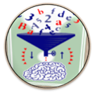
8 | Our brain extracts patterns from meaningful examples  - attention: meaningless examples without context are filtered out and will not lead to this kind of patterning (see next principle)  Examples:  German forms of nonsense verbs  - Ich „moodle“ gerne und oft. Auch gestern habe ich …………..  - Meine Nachbarn „pferden“ gerne. Letzes Wochenende haben sie den ganzen Tag ……….  - Wir „hirnen“ den ganzen Tag. Heute habe ich schon um 6 Uhr früh …..  - Ich „neuroliere“ gerne. Gestern habe ich ganz ausführlich …………………  Notional grammar: concepts (notions) develop slowly as patterns and frames. | 
9 | The brain can process many things simultaneously. Multi-sensory input facilitates learning  - multi-sensory input creates wider neural networks.  - learning involves the whole body  - ISM Model (Ahsen 1984): Images – Somatic response - Meaning  - doodling  - colors  - lexical furniture  - voctivity  - Manner Mimes  - Movement facilitates learning.  - VMI (Manuela Macedonia)  - Walk and talk | 
10 | Learning involves conscious and unconscious processes  - Krashen: acquisition and learning play an important role. Allow more room for acquisition in school. Trust your students.  - Peripheral learning (vocab quilts, using the target language, reading…)  - Conscious learning: awareness raising, hypothesis building (finding rules) | 

Types of Memory (Stevick)
short term memory | - recall within 15-18 seconds  Draw a sketch of these processes.  - unintentional, unconscious  - electrically disruptible storage
working memory or “The Worktable” (Stevick 27) | - gives access to whatever is currently in the electrically disruptible short term memory (Stevick 29).  - We can use this memory intentionally, to repeat items, to compare things … (strategies)  - limited capacity, influenced by the “affective filter”  - capacity can be increased by “chunking” (Stevick 31)  - the chunks increase in size as the student gains in experience
long term memory | - can store an amazing amount and variety of information for a long time  - no direct access, content can only be modified by activities on the “Worktable”. Stevick describes a “two-way traffic between the Worktable and the Files (which is) both continuous and complex. Configurations of sensory data are constantly appearing on the Worktable and evoking the retrieval of various kinds of memories from the Files. These memories in turn work with the other material on the Worktable to trigger the formation of new configurations for storage in the Files, and so on. “ (Stevick 30)
declarative memory (Stevick 32 f.) | - conscious, articulable, explicit knowledge  - not all learning starts with declarative knowledge (e.g. child learning to walk, swim, speak…)  - can lead to procedural knowledge by doing sth. (knitting, driving…)  - explicit knowledge (the ability to recite the rules) is quickly lost (e.g. position of letters on keyboard – vs. typing)
procedural memory | - implicit knowledge, e.g. driving, knitting, patterns and regularities of language  - cannot be articulated (only by painstakingly reconstituating the rules)  - can be influenced by activity on the Worktable
episodic memory (Stevick 37) | - memories of specific situations, including information about different context aspects (place, time, emotions, sounds…..)  - contains personal, dated, autobiographical experiences
semantic memory | - general knowledge of concepts and meanings  - includes information about what usually belongs together (context, collocations, sensations…)
purposes, motifs, intentions | - purposes, motifs and intentions strongly influence the processes on the Worktable and thus have a strong effect on the learning outcomes (Stevick 7)  - only relevant information is processed, the rest (99% or more) is discarded immediately
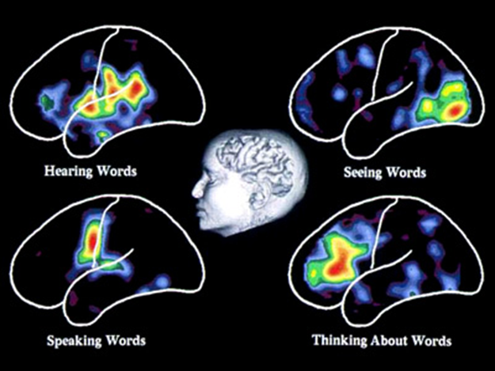
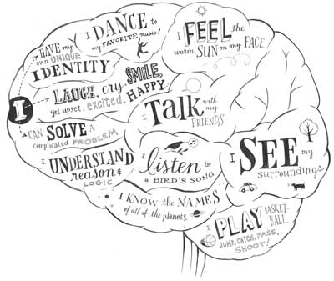

Checklist for brain-friendly language teaching
 | - How am I going to activate my students‘ prior knowledge?
 | - What am I going to do in order to create a positive, relaxed and challenging atmosphere?
 | - Is the topic / text / task really interesting and relevant form my learners?
Speicherung | - How am I going to help the learners to proceduralize the new concepts?  - How can I activate episodic memory?  - How can I create pictures in my learners‘ minds?
 | - How can I create opportunities for social interaction among the learners?
 | - How will the learners be able to see their own success and feel proud of their work?  - How will the learners present their products?
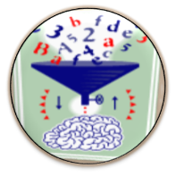 | - How am I going to create opportunities for hypothesis making?  - How am I going to prevent mindless application of the grammar rules given in the textbook?
 | - What examples of authentic communication am I going to present to my learners in order to support pattern building?  - What exercises will support pattern building?
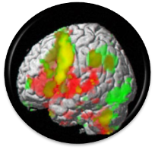 | - How can I activate different areas of my learners’ brains?
 | - How can I create opportunities for peripheral learning and unconscious learning?

FIP: Format, Imagination and Pride

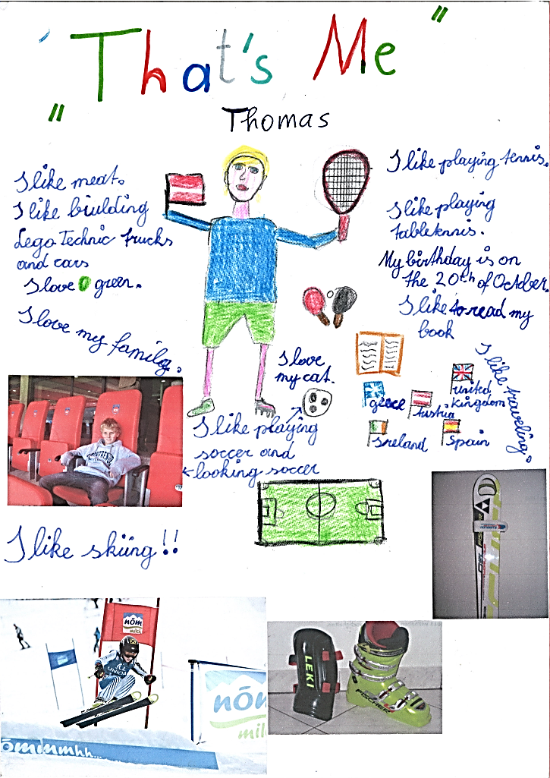
While many textbook units seem only remotely interesting and relevant to the learners, task based learning and project work lead to deeper engagement of the students. The main focus in these projects lies on the content and the meaning. The learners use authentic processes to make sense of the language and use it in realistic, communicative situations. These authentic processes use the learners’ brains in natural ways and thus lead to efficient learning (changes of the neural networks).
Effective projects must be interesting and challenging on the content level and should produce visible results that the learners are proud of. The sense of achievement and pride sets off a positive chain reaction of the limbic system (dopamine cycle) that facilitates learning and encourages the learners to take up the next challenge.
Mini-books Online |  | Origami Books
 |  |  | 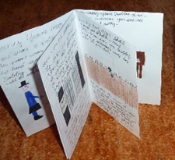
Interactive Posters |  | Audiobooks
 |  | 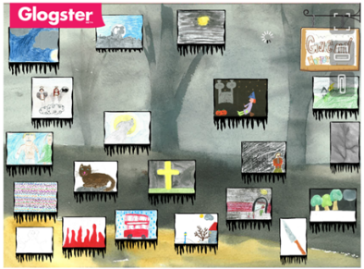 | 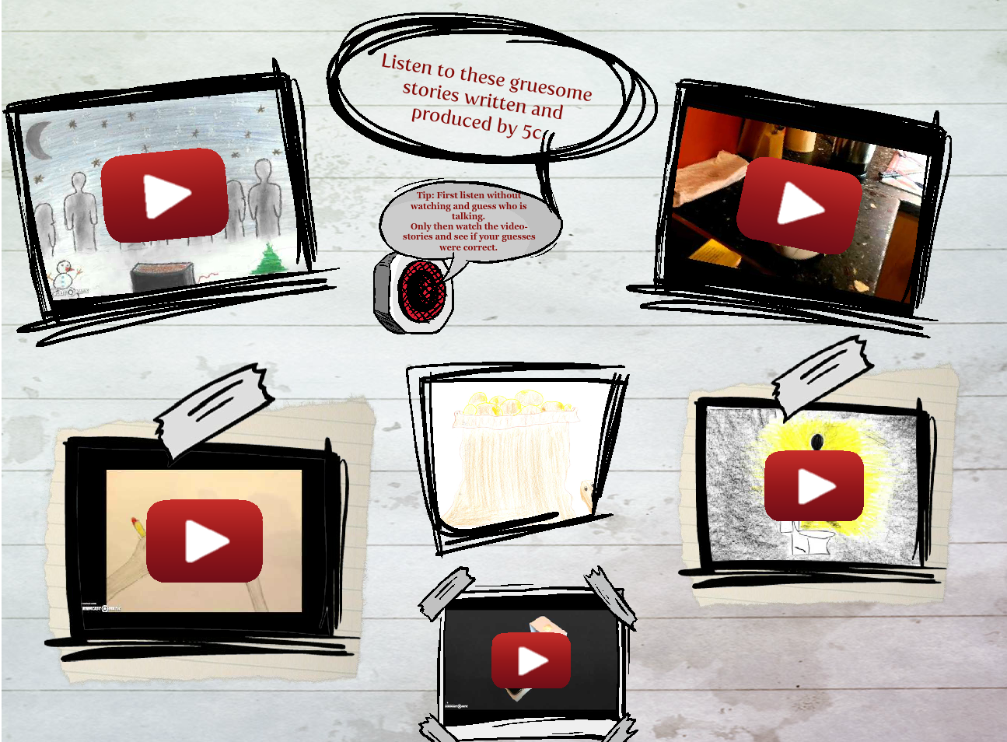

Blogs
 |  | 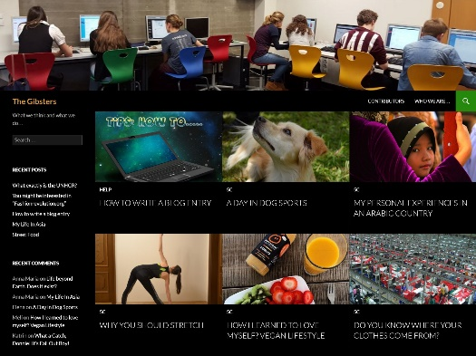

Die Didaktik des leeren Blattes: Diaries, Booklets, Catalogues, Magazines…

„Unser wichtigstes Arbeitsmaterial ist das weiße Blatt Papier, unseres Erachtens das kreativste Material, das es gibt. Es stellt "wahrscheinlich die größte Herausforderung an die Imagination der Kinder dar" stellt Peschel (1996, S.38) fest, nachdem er unsere "Pädagogik des weißen Blattes" kennengelernt hatte. Das leere Blatt fordert oder provoziert geradezu die kindliche Phantasie es zu füllen. Wie, das sagt ihm weder das leere Blatt, noch sagen wir´s. Das Kind muss selber entscheiden und gestalten. Ein Arbeitsergebnis ist zu dokumentieren, ein Sachthema zusammengefasst darzustellen, um in ein gemeinsames Buch zu kommen. Welche Informationsquellen benutzt werden und wie, überlassen wir vollständig dem Kind. (Zehnpfennig/Zehnpfennig 1992)“

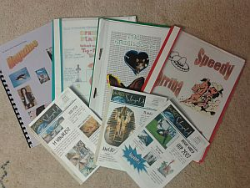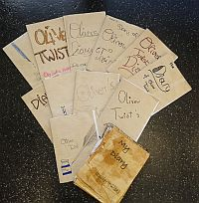

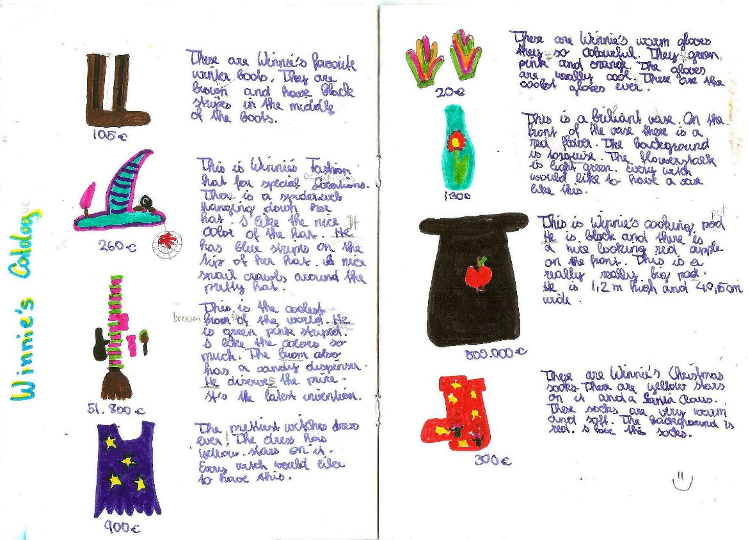

Fair
Have a look at the booklets displayed on the tables and discuss the following questions:
- What have the students learned?
- How much effort have the learners put into these projects/products?
- What skills were involved?
- What can you say about the learners’ range of vocabulary and accuracy?
- What might be missing? What have the students NOT learned here that they would have learned from a textbook unit?
Creativity
Commitment
Effort
Text-types

Teaching Vocabulary to the Whole Brain
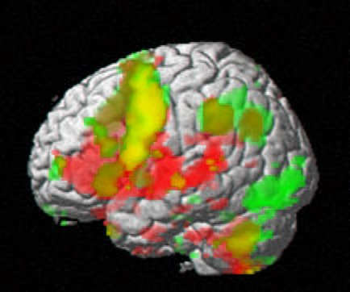

How to create multisensory images in the learners’ brains

The ISM Model
According to Ahsen’s ISM model (Ahsen, 1984) our memory stores “multisensory images” consisting of Images, Somatic responses and Meanings (ISM). These three elements are constantly interacting and interlocking. In general it can be said, that what has been experienced personally is most memorable and will have the most visual and somatic elements attached, followed by richly imagined input, and lastly by input that has only been understood form words. (Stevick, 1996, S. 49)
Images:
- visual stimuli, things we have actually experienced
- mental images, things we have actively imagined
- imagery derived from descriptions in words
Somatic response:
- our body’s reaction to the sensory images (skeletal, muscular, endocrine changes…)
- may be very strong or fleeting and negligible, depending on the input
Meaning:
- includes the full spectrum including lexical meaning, expectations, involvements, purposes
- example: What does the word “bakery” include for you?

VMIs: Voice Movement Icons
The research of Macedonia also shows that meaningful multisensory input leads to better learning of new items. (Macedonia & Müller, 2011)

Dos and Don'ts
- students select useful phrases from meaningful contexts | - never teach single words
- when writing vocab always write phrases rather than individual words | - discourage learners from writing vocab lists in the traditional 2-column vocab-books
- practice collocations
- use all the senses (see activities on the next page)
- make learners say the new phrases out loud several times
- when writing vocabulary use lots of space for each new item so learners can add collocations, sample sentences, doodles etc.
- translating a phrase is often more helpful than long and complex definitions in the target language

Vocabulary Practice Session
Work with a partner (no big groups, please)

VMIs:
Choose 10 difficult phrases from your vocab-collection and find fitting voice-movement-icons for them. Play with these VMIs. Make the moves, your partner says the words, find a rhythm…

Doodling:
Open your vocab collection on the first page, start with the first phrase of student A. Read out the phrase and imagine a scene around it. Try to visualize it, see a clear picture or situation. Then draw a quick and simple doodle/symbol/logo that somehow represents your phrase. Explain your doodles to each other. Do they have anything in common?
Now it’s student B`s turn. Role a die and land on a new phrase on your first vocab page. Design new doodles for this phrase…
Do this for 5 phrases each.

Colors:
Keep rolling the die to select random phrases.
For the next 10 phrases (5 of student A, 5 of student B) choose a typical color that reminds you of the phrase. Again try to visualize as much as possible. Explain your choice of color to each other.

Sounds:
For the next 10 phrases try to “listen” to your phrases. What do you hear? Can you hear any background noises (e.g. For the phrase “Black Americans were discriminated against.” You might hear shouting, gunfire, rioting, sighs, crying…) Be creative and list all the sounds and noises you can imagine “around” your phrase.

Opposites:
Find opposites or “diagonal opposites” for 10 recent phrases in your collection.

Usage -- Find a second example:
Choose 10 new phrases from the texts we have recently read. Find a second example of the word’s usage in your MLD (or freesearch.co.uk) and add these to your collection.


Lexical Furniture:
Find suitable places for 10 new phrases in your home and discuss them with your partner(s) Imagine your phrases were pieces of furniture. Where would you put them in your house? E.g.: I’d put the “scientist” into my bathroom, because it is white and sterile like a lab.
I’d put the phrase “the amount of water vapor will increase…” in my kitchen or bathroom. When I take a shower, there is a lot of water vapor in the air, when I boil water for pasta, the water vapor or steam rises from the pot.

Blackout
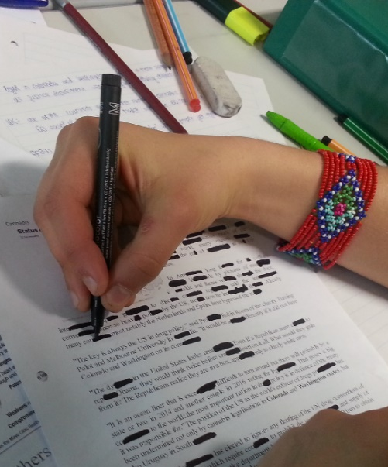
Hand out a page of text that is interesting and suitable for the learners your teaching topic. Allow students to read it and ask any vocab questions they might have. Make sure the learners understand the text.
Pairs then start blacking out parts of words and sentences with thick black markers. They read and re-read the text and keep blacking out more and more letters and words.
How far can they go --- and still read the text?
Option: The pair that can black out most wins a prize.

Try this with the following text:

Learning vocabulary by reading
The way you learned very many of the words in your own language was by meeting them in the books and magazines you read. The context of a new word in a sentence or story was often enough for you to guess the meaning. Meeting the word again and again in your reading helped you learn it for use in your own speaking and writing. Doing lots of extra reading for pleasure - both fiction and non-fiction - is an excellent way to learn new English words, too. But choose books that you find quite easy to read. Difficult stories or texts that you struggle to understand will not help you to develop your vocabulary the natural way. But remember: to learn new words from reading you have to read A LOT! For a more detailed explanation of the role of reading read Stephen Krashen’s book Free Voluntary Reading, Libraries Unlimited, 2011

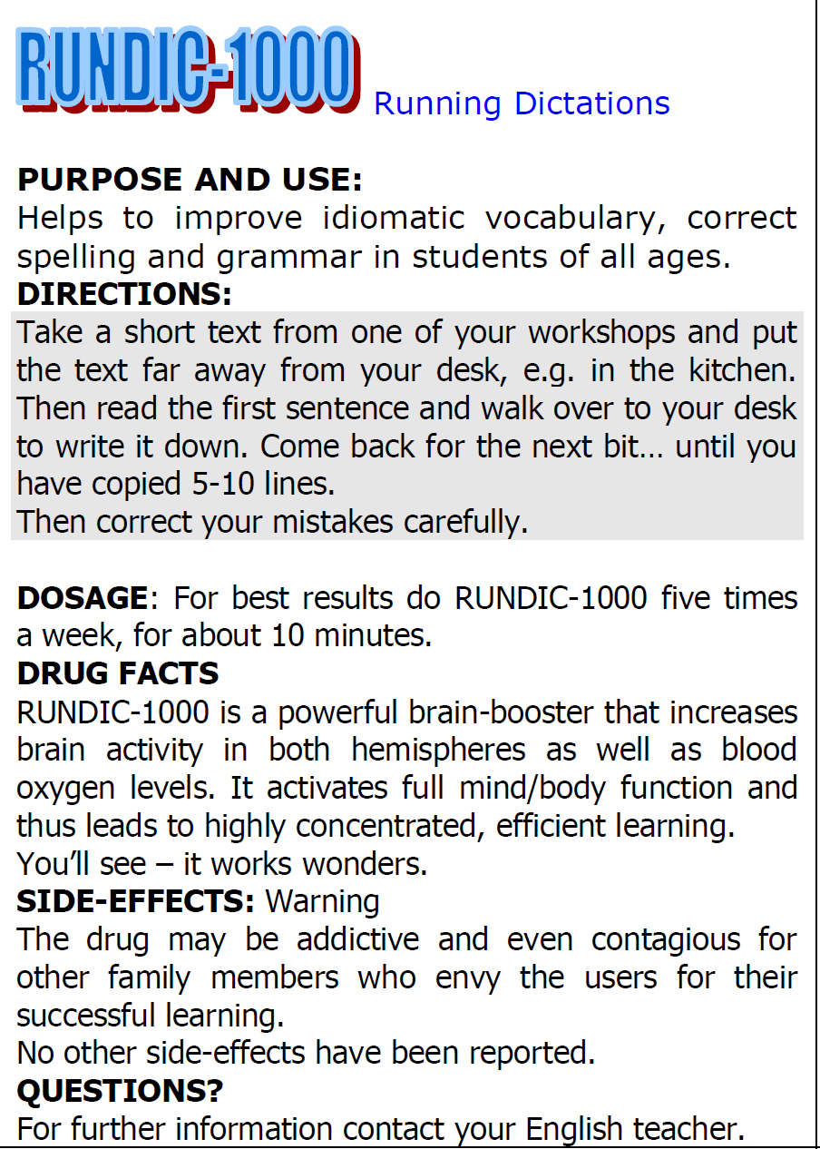
Running Dictations for all ages
Running dictations practice language (vocab and grammar) in meaningful contexts. Movement and high concentration make this a highly effective activity.
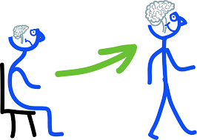

Making Associations – Building Networks
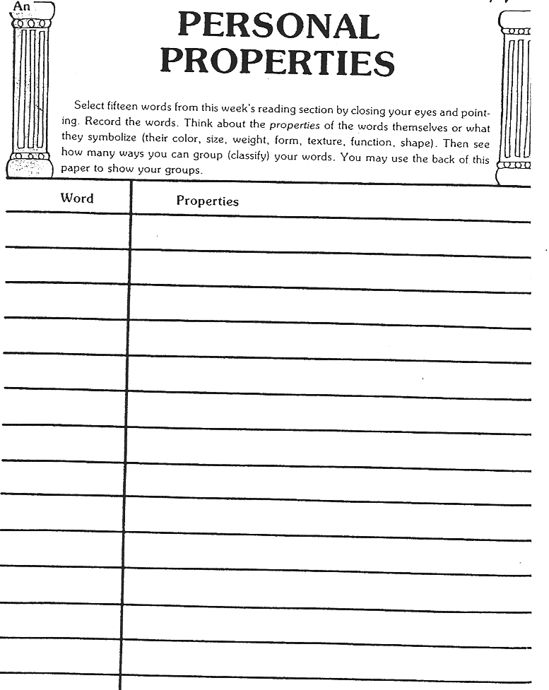

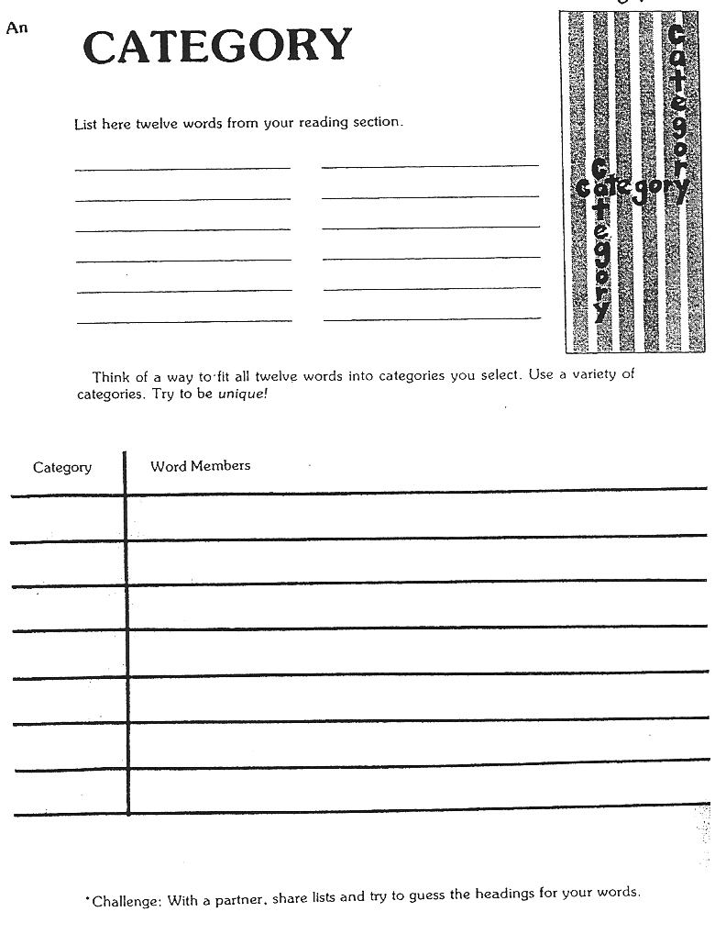

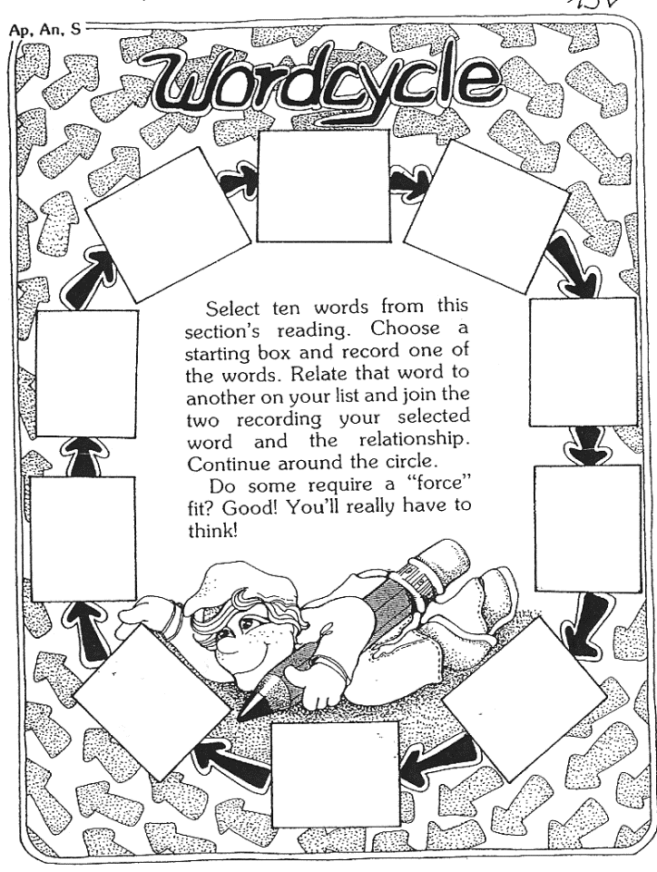
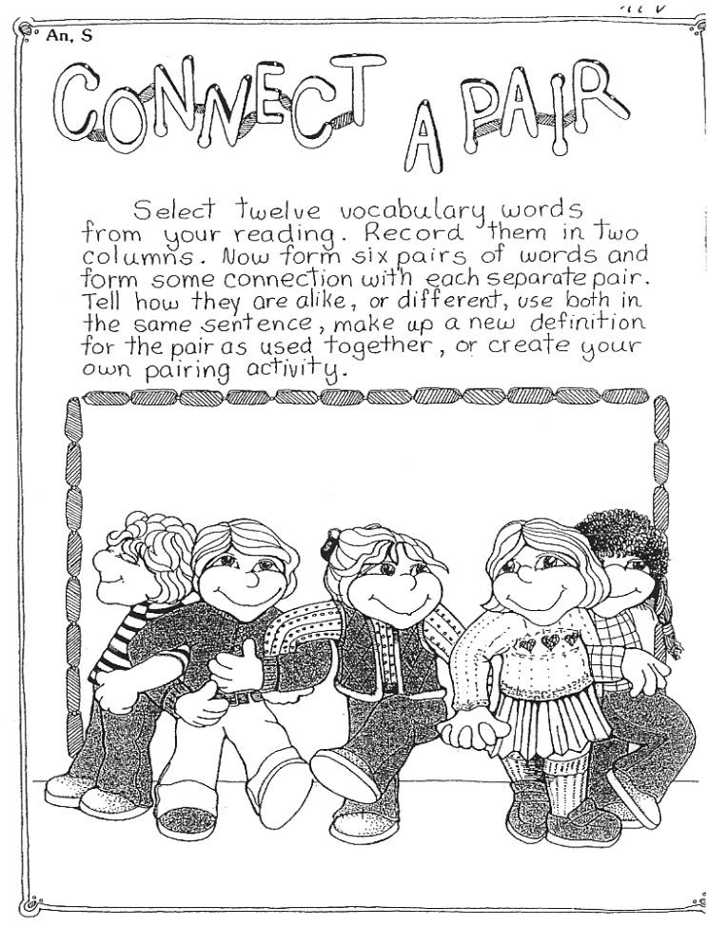

Find these and many more excellent activities in Janice Szabos et al., Reading, A Novel Approach, Good Apple Inc., 1984 (Szabos & Filkins, 1984)

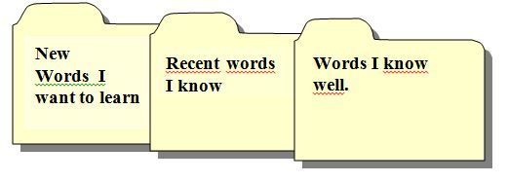
The Vocab-Box
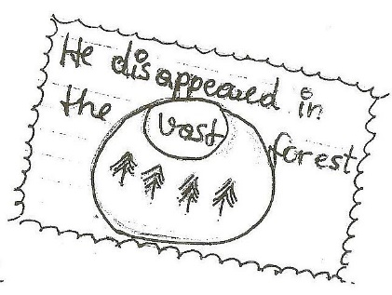

It would be even better to write: Tobi discovered the mouse behind the sofa. – This would remind the student of the story context where he/she encountered the word.

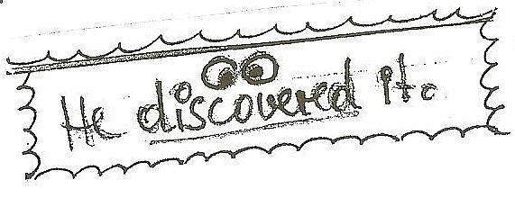

Pro: By working with the vocab. box students regularly revise difficult words rather than going through endless lists of known words as they do with vocab. books. They use their hands and “manipulate” each expression
Con: Cardfiles may be messy, they are hard to check. Tip: Students write the new words on cards and keep this new set in the very front of the box for the teacher to check. Only then can the cards be moved back! Also ask willing parents to help check the box!

Procedure:
Students write their new words on cards (A8) . The cards only contain one expression! The nicer they are the better!!! (Depending on the level of your students, encourage them to use some of the techniques below: drawing words, write yourself in, shapes, calligraphy, collocations, synonyms, antonyms...) SS then put the cards in the first category:
1. New Words I Want to Learn.

When studying vocab. the students work with the cards and are allowed to move them into the next category if they know the item and can spell it correctly. The following categories are titled:
front of card: German translation and/or drawing/doodle of the word
back of card: English word (always used in a short personalized sentence or a collocation:
e.g: “I’ve never been to Greece.” “Our English teacher is very strict”)

2. Recent words I know
These cards will eventually be stored in a shoe-box when vocab.box is full)

3. Words I know well

Working with the box:
Important: Practice this in class several times. Then students will do it at home.

Step 1. Walk and Talk
Students take a selection of new cards and walk up and down the hallway speaking the new phrases out loud. They try to find a rhythm for each phrase and repeat it many times until it sounds natural to them. For difficult phrases they also find a voice-movement-icon (VMI) that they associate with the word.
Encourage the learners to use gestures, facial expressions and tone of voice to express the meaning of the new item. This will create more associations and wider neural networks.
Example: The boy was appalled. (make a face, say it in an emotional way, use your hands…)

Step 2: Write and check
Students read the German phrase on a card and write the English translation into their vocab-practice books. Then turn over the card and check + correct if necessary. The teacher can easily check the work by collecting the vocab-practice books from time to time.

Vocab Books and Vocab Cards
Word: Color/Picture/Doodle

Sentence I found in my reading:

Second example sentence from my dictionary:

Useful collocations:

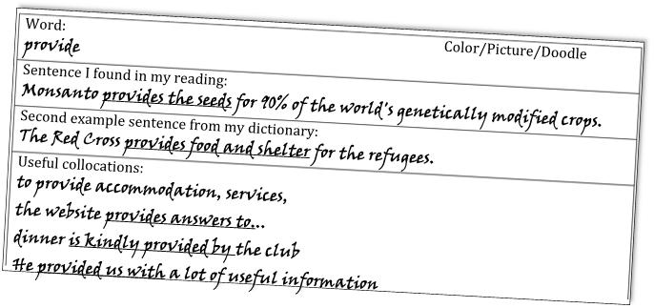

Word: Color/Picture/Doodle
criticism
Sentence I found in my reading:
The government has received a lot of criticism for increasing taxes
Second example sentence from my dictionary:
Scientists have raised strong criticisms of creationist ideas.
Useful collocations  receive criticism  express criticism  provoke criticism  respond to criticism  avoid criticism | heavy criticism  constructive criticism  severe criticism  fierce criticism  bitter criticism

Whole class activities for practicing collocations

Remember: the best way to learn new vocabulary is to use it actively in meaningful contexts. This is best done in a task-based approach where students work on a project actively and produce a high quality product. These products can be oral (interviews, radio-shows, presentations) or written (project books, articles, diaries…). By preparing their products in groups the students will be using the language more actively and they will speak and hear the new expressions many times and thus integrate them well into their existing networks.
Find ideas for such projects on epep.at: Reading projects, book-making, booklets, interviews, presentations, blogs…
Once in a while, it might still be helpful to do specific vocab-activities in class. The following games might be used for this purpose.

As Easy as Possible (Lewis, 2000, p. 104)
Two teams are competing against another. You will need one collocation dictionary per group.
Give each team a list of 10 nouns which are headwords in the collocation dictionary. Choose nouns that are appropriate to the level and interests of the learners.
Groups get 10 minutes to prepare: They list 5 common collocates from the dictionary for each noun.
Team A then slowly read out their collocates while team B try to guess the noun. Team B may write down the collocates as they are being read out.
If they guess correctly after one collocate, Team A scores 5 points, if they need 2 collocates team A scores 4 points and so on.
Teams A and B take turns guessing and reading their lists.

The Collocation Game: adapted from (Lewis, 2000, p. 104)
Prepare a list of nouns with lots of verb or adjective collocates.
Tell the learners that all the words in one list collocate with the same noun. They have to guess that noun.
When they think they know the noun, they stand up/or say “Bingo” and write the noun on their sheet.
This game can be played in teams or as a whole class. Learners collect points for their teams or for themselves.

Odd verb out
One verb in each line does not collocate with the noun. Cross out the one which does not fit.
- accept ,act on ,disregard ,follow ,ignore, make ,solicit, take ADVICE
- come up with, do, expect, get, require, supply AN ANSWER
- build up, close down, set up, put off ,take over ,wind up A BUSINESS
- deal with, do, examine, ignore, reject, respond to A COMPLAINT
- accept, answer ,come in for, give rise to ,make, reject CRITICISM
- describe, do, enjoy, have, recall ,share AN EXPERIENCE
- crash, finish ,hire, park, repair, run, service, start ,write off A CAR
- arrange, do, gatecrash, go to, have ,throw A PARTY

Vocabulary Quilt
Choose one of your favorite new expressions from your book and write it on a piece of colored paper. Write a short, typical sentence and decorate the paper in a suitable way. Your paper must include:
- the new word written in big letters
- a typical sentence
- a drawing that will help you remember the new phrase.

We will put all our word cards together to make a Vocabulary Quilt. Please design your cards nicely.
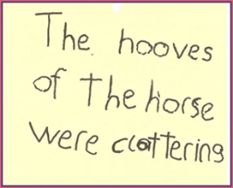

Synonyms:
Three essays, each pair gets one only
- Work with a partner. With the help of your dictionary find suitable synonyms for 10 words or phrases in the text.
- Write a list of these synonyms on a sheet in random order.
- Pass your text and the list of synonyms on to another group. Ask them to find the matching phrases in the text and write them next to your synonyms on the list
- Then work on the lists you get from the other two groups.

Oral Gaps:
Work with a partner. First read through one of the essays very carefully and make sure you know all the words. Use your dictionary. Together underline all the fancy expressions that you might not be able to use actively yourself.
Now take turns. Read a paragraph to your partner and stop before each underlined word. Ask your partner to supply the word…

Voctivity:
download the boards from epep.at
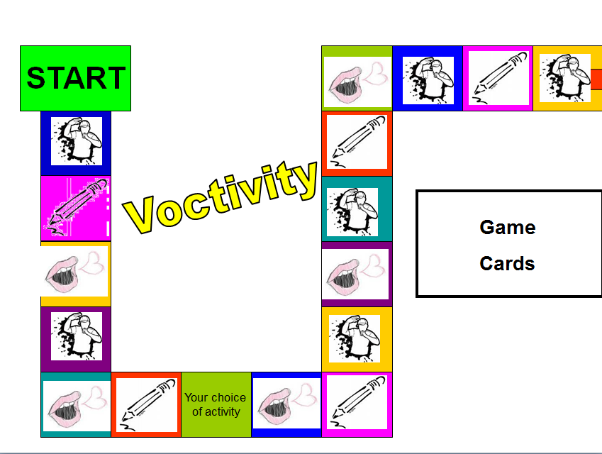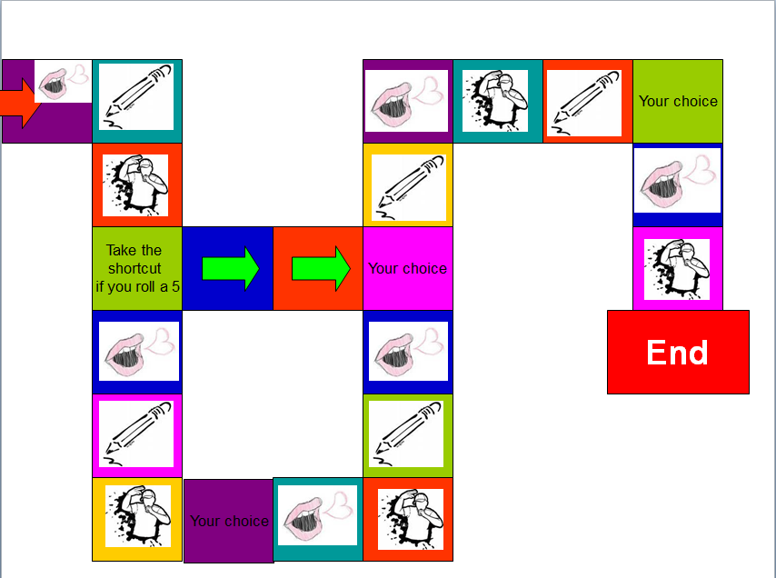
Rules of the Game:
Write or choose 5 new vocab cards per person. Put them in the center. Use these cards as in the game “Activity”. Act, draw or paraphrase the word or phrase on your card. The player who guesses what you are showing may go next.
If you find the game very difficult, go through all the cards before you play and make sure you understand all the phrases that your friends have chosen.

Testing Vocabulary
Remember: Use 99% of your class-time for teaching and only 1% for testing. If you teach a lot and students are ACTIVELY using the language in class, they will learn a lot more than by studying vocab for a test or revision. In task-based learning the students will meet and use the new vocabulary items many times in order to complete a project. By doing these activities they will build multidimensional networks as discussed above and will thus integrate the new vocabulary into their permanent storage. Encourage the learners to choose items they find useful and want to remember and transfer these on vocab cards or into their vocab books.
In some cases a short vocab revision might still be useful. Just like teaching vocab, always test vocabulary IN MEANINGFUL CONTEXT.
What do you want to test? For a good presentation about testing vocabulary, go to
http://www.slideshare.net/songoten77/testing-vocabulary
You will also find the link on the vocab page on http://epep.at
- Word recognition and comprehension?
- Word usage?
- Word building and word form?
- Spelling?

Useful test-formats:
- Textwriting: In the new assessment scales “lexical and structural range” are important criteria for assessment. Make this visible for the learners. Always give feedback on style and range of vocabulary. Do not only mark the wrong expressions. This will lead to avoidance strategies.
- Describe the picture: (e.g.: picture of classroom// Name 10 things you see in Sally’s pencil case// What is Peter wearing today? // Describe the atmosphere of the picture. For more advanced students use postcards, pictures from the textbooks… Describing a picture can also be used as an oral vocab exam.
- Writing short text passages or dialogues: (e.g.: Give weather symbols, students write forecast for the following days.)

- Gap filling: Give the first letter or a jumbled version of the missing word where the first and last letters are correct. If a student knows the word he/she will immediately recognize it, if the student doesn’t know the word, these letters won’t help much.
Try this: Arocdnicg to rsceearch at Cmabrigde Uinervtisy, it deosn’t mttaer in waht oredr the ltteers in a wrod are, the olny iprmoatnt tihng is taht the frist and lsat ltteer are in the rghit pcale. The rset can be a toatl mses and you can sitll raed it wouthit pobelrm. Tihs is buseace the huamn mnid deos not raed ervey lteter by istlef, but the wrod as a wlohe.

- Oral Vocab Revisions: Students bring their vocab box, teacher asks 10 random cards while the class is working on other things.
- Crosswords: Use very clear clues or pictures.
- Matching and multiple-choice: not recommended – It is very difficult to produce good tests. If you really want to use these, check this website for ready-made tests: http://www.vocaboly.com/vocabulary-test/

Knowing Grammar or Using Grammar?

The Austrian school curriculum

AHS-Lehrplan, Unterstufe. Didaktische Grundsätze:
- Als übergeordnetes Lernziel in allen Fertigkeitsbereichen ist stets die Fähigkeit zur erfolgreichen Kommunikation – die nicht mit fehlerfreier Kommunikation zu verwechseln ist – anzustreben. Somit sind die jeweiligen kommunikativen Anliegen beim Üben von Teilfertigkeiten in den Vordergrund zu stellen.
- Der Vermittlung von Wortschatz und Grammatik in vielfältig kontextualisierter und vernetzter Form ist größtes Gewicht beizumessen, zB ist Vokabular, wo immer möglich, in Kollokationen, Redewendungen und Phrasen mit impliziter Grammatik einzubetten.
- Der funktionale Aspekt der Grammatik hat Vorrang gegenüber dem formalen Aspekt.
- Generell sind die situative Einführung und ein induktives Erschließen grammatischer Sachverhalte aus kommunikativen Zusammenhängen und Textbeispielen anzustreben.
- Grammatische Teilsysteme dürfen sich keineswegs verselbstständigen und wegen ihrer leichteren Überprüfbarkeit indirekt zum eigentlichen Lernziel des Fremdsprachenunterrichts werden.
- Wo es sinnvoll ist, sind grammatische Strukturen besser ohne Regelformulierung als lexikalische Einheiten zu vermitteln.
In the section on ‘Context: Curriculum’ one EPOSTL descriptor states:
TASK 1
I can understand the requirements set in national and local curricula. (EPOSTL p. 15)
Read the statements from the Lehrplan and consider:
a) Do they reflect the ways in which you were taught grammar at school?
b) How might these statements influence your teaching?

Approaches to Pedagogical Grammar
As Chalker points out, there tends to be a tacit assumption among many students, teachers and pedagogical grammarians that there exists what she calls a single, ‘God’s truth’ view of grammar: ‘traditional’ ways of categorizing and describing grammar based on formal, rather than semantic, categories (Chalker 42). However there are different ways of approaching grammar, based on the theories that may underlie them. We shall be discussing four approaches to grammar:
- Traditional grammar
- Communicative grammar
- Acquisition-based grammar
- Cognitive grammar
These are summarized in the table on the next page.

Reading assignment
Download and read the following article on Moodle:
Newby, D. (2012). Pedagogical Grammar.

Figure 1: Summary of approaches to grammar (based on Newby, 2002)
Label | Some key concepts | View of language | View of learner | View of teacher
Traditional grammar | grammatical structures; deductive learning of rules; accuracy controlled practice; ‘PPP’ | system of forms which  express meanings | student as a knower of  language | teacher informs and  controls
Communicative grammar | communicative competence; context; fluency; notions & functions; skills; interaction; inductive learning | language as a means of social interaction; communicative events; system of meaning options | student as a user of  language | teacher manages contexts for communication
Acquisition-based grammar | naturalistic acquisition; comprehensible input; intake | language as a set of innate mental processes;  universal grammar | student as an acquirer of language (as in L1) | teacher provides  comprehensible input
Cognitive  grammar | learner-centred, cognitive processes, styles and strategies; learning stages awareness-raising; constructivism | language as concept formation within more general knowledge structures, information processing | student as a responsible learner of language | teacher facilitates awareness and supports learning

Theory and practice in communicative grammar
- David Newby

The purpose of this article is:
a) To focus on some of the issues discussed in modern grammar teaching and to indicate some of the changes that have taken place in recent years in the theories and practice of learning and teaching.
b) To present my personal views of communicative grammar. My approach is based on the one hand on my own theoretical work in what I term ‘notional grammar’; on the other, on my experiences of teaching grammar, of writing grammar books and other teaching materials and of working with teachers in different countries.
This article first appeared as:
'Theory and Practice in Communicative Grammar' in R. de Beaugrande, M. Grosman, B. Seidlhofer, (eds.) (1998) Language Policy and Language Education in Emerging Nations, Series: Advances in Discourse Processes Vol. LXIII, pp 151-164. Stamford, Conneticut: Ablex Publishing Corporation

1 Influences on modern grammar teaching
Modern grammar teaching shows influences from the following general areas: what might be called ‘traditional grammar’; communicative teaching, dating from the late 1970s, the learner-based approaches that became influential in the 1980s; recent theories of second-language acquisition from applied linguistics. The influences are reflected in the following ways:

Traditional grammar:
Language is seen primarily as a set of forms and structures, grammatical meaning playing a secondary role. The sentence is the main unit of analysis and emphasis is placed on the student’s ability to form correct sentences. Grammar rules are given prominence and learning is seen as a mainly cognitive process. The most common forms of exercise type are gapped sentences and sentences for transformation, reflecting a form-based, rather uncontextualized view of grammar and an extremely passive role on the part of the learner. Contrary to popular belief, there is relatively little theory to support traditional modes of description and pedagogical practices, but the force of tradition plays a very strong role and should not be underestimated!

Communicative approach:
Language is seen not as a formal system but as a means of communicating messages between human beings in actual contexts. It follows from this that language is redefined as a set of skills, grammar being seen as a way of expressing certain types of meanings through grammatical forms. Meaningfulness and contextual appropriacy are stressed and formal correctness is given less prominence. Methodological innovations based on semi-authentic tasks and communication in small groups reflect this approach. Although in theory grammar could have been integrated into communicative teaching, in practice linguists and pedagogical grammarians failed to provide adequate theory to support a genuinely communicative approach to grammar and it therefore remained a problem area. On the more extreme fringes, there was in fact a complete swing away from the overt teaching of grammar, though this phenomenon was largely confined to Great Britain.

Learner-based approaches:
Unlike with the communicative approach, which takes an analysis of language as its starting point, learner-based approaches - partly ‘humanistic’ in their orientation - give centre stage to language learners and to acquisition processes and learning strategies. Underlying some of these approaches is the view that a language ‘cannot be taught’ but can only by acquired by the learner, the teacher taking on the role of a facilitator of this process. Thus, grammar rules explained by the teacher give way to discovery techniques and awareness-raising tasks by the pupil. As in the communicative approach, student-centred activities predominate, though additional stress is given to affective factors and to the emotional, rather than functional, needs of the learner.

Second-language acquisition:
A view of acquisition held by certain applied linguists which feeds on Chomsky’s notion of ‘Universal Grammar’ and which might also be described as ‘post-Krashen’. The central tenet is that - as with first-language acquisition - the learner’s brain is already ‘wired up’ to acquire language and this process cannot be greatly influenced by actual teaching. The teacher’s primary function is therefore to provide input through exposure to the language and to allow nature to take over. These views are especially popular amongst certain linguists and some native-speaker methodologists but do not seem to be given very much credence by the majority of teachers.

Summary
In as far as we can generalize, it appears to be the case that most modern grammar teaching is a mosaic of the above approaches. Interestingly, traditional grammar still tends to form the core both of classroom practices and of grammar books; some of the bestsellers among EFL books are those that list grammar rules and contain exercises consisting mainly of the ‘fill-in-the-gap’ variety. Although the layout of these books is perhaps more user-friendly than their forerunners and although their modes of description are more geared to modern usage, they are still very much in the traditional mould. On the other hand, elements of communicative methodology in the form of oral activities and games are available in an increasing number of EFL books; many teachers and coursebooks supplement the traditional grammar base with such activities. ‘Hard-core’ learner-based approaches as outlined above tend to be more popular with native speaker teachers and methodologists than with non-natives, but many teachers have moved some way in the direction of a more student-centred approach.
How do my own ideas fit into this mosaic? I believe that many practices from traditional grammar which still dominate the FL classroom have a negative effect on language learning, so we must begin by putting traditional grammar under the microscope and replacing certain elements with a more communication-based theory of grammar. Second, the focus on the learner and on language acquisition has brought many important insights, which can be incorporated directly into grammar teaching. I should add, however, that I am highly suspicious of methodologists who take a very dogmatic view of language learning and believe that their favoured approach provides all the answers!

2 Theories underlying communicative grammar teaching
If we are to challenge the traditions and dogma, old and new, that figure prominently in discussions of grammar, we must begin by giving some consideration to certain theoretical areas. The word ‘theory’ is often regarded with suspicion by teachers, perhaps since we are all ‘burnt children’ to some extent and have experienced that theory can mean the very opposite of practice! In reality, most of our classroom activities are the result of a mixture of theory and intuition, but it is important to get the balance right and to be open to those elements of theory that will lead to more efficient teaching and effective learning. Concerning grammar, there are three theoretical areas that might be of use to us. They are:
a) Language: a theory of what grammar is and how it functions as a communication system
b) Learning: an understanding of learning processes and of the learner’s functional and emotional needs
c) Teaching: using our understanding of a) and b) to apply the most efficient methodology and classroom techniques will help us in the formulation of teaching objectives, in how we present grammar and deal with rules; b) and c) will determine the form that our teaching takes. In the following pages I shall consider these three areas and present my own view of grammar with regard to each one.

3 Language: grammar as a communication system

3.1 The communication model
Since the mid-1970s most language teaching coursebooks and books on methodology have been firmly embedded within the so-called ‘communicative approach’, although today the term itself sounds slightly dated. At the heart of this approach is the view that in real life language is used to exchange meaningful messages in actual contexts and that this fact should also be reflected as strongly as possible in the classroom. This view of language can be illustrated in the ‘communication model’ of figure 1, which attempts to depict in simple diagrammatic form ‘how language happens’:

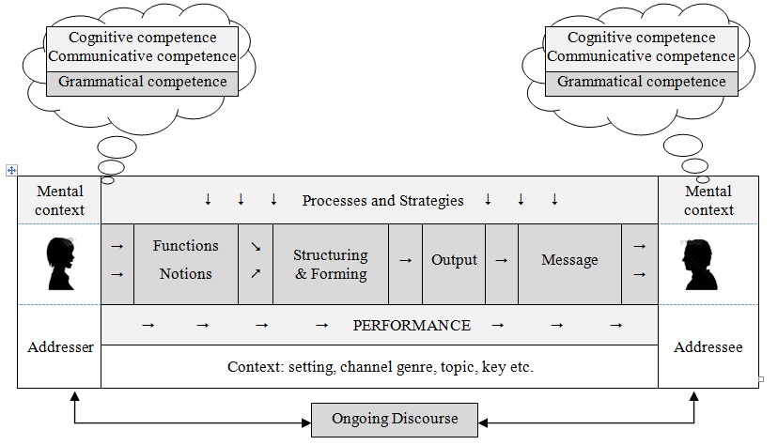
Figure 1: Communication model
It is this simple communication model view of language which lies at the heart of how we view language nowadays and goes some way to explaining some of the changes that have taken place in the description of modern grammar. Traditional grammatical descriptions began by setting up form categories, only then looking at meaning; as a result, syllabuses were defined, and teaching materials organised, according to forms (present progressive, definite article, gerund etc.). ‘Grammatical competence’ was seen largely as the ability to master forms and recognize meanings, usually without much consideration of context, the role of the speaker etc.
In the communicative approach, however, it was recognized that the forms of grammar represent the final stage of an interaction process, in which speakers communicate messages to other human beings in a context. It therefore seemed logical to begin at the beginning of this process and to attempt to define grammar in terms of context and meanings. This entailed taking a much broader view of grammar and attempting to relate grammar to other elements of the communication model such as context, speaker’s purpose etc. It follows from the model that grammatical competence means not only knowing how to form a sentence or knowing the rules for using, say, the past vs the present perfect, but the ability to choose meaningful grammar in real contexts, which might be referred to as part of a more general communicative competence. The overall result of this re-orientation towards context and meaning was that grammar was seen more as a skill and objectives in syllabuses and coursebooks tended to be redefined in terms more closely related to meaning categories.

3.2 Grammatical competence
A speaker’s grammatical competence, part of a wider communicative competence in general, consists of various components of ‘knowledge’.
Knowledge of forms: This tells us:
  - how to form words and structures correctly in:
- word forms: e.g. irregular verbs, comparison of adjectives
- structures: e.g. conditional sentences
  - how to order or pattern these forms within a sentence:
- e.g. word order of adverbs of time, question forms
Knowledge of meanings: notions : This tells us:
- what meanings are available to us when we express our thoughts through grammatical forms
- which choices to make in a specific context:
e.g. definite/indefinite/no article: the/some/0/ boys
past vs present perfect: I went vs I have been
This knowledge also helps us to distinguish different meanings of the same form:
e.g. present progressive referring to now
Sue is playing tennis at the moment.

present progressive for future arrangement
Sue is playing tennis this evening.

Knowledge of purpose: speech functions
Using grammar not only entails knowing how to express meanings through forms but also knowing that grammar can be used to show a speaker’s intention or wish, or to influence the behaviour or attitude of the listener. For example, the conditional form would can be used to express the following functions:
Giving advice: I would buy a new car if I were you.
Requesting help: Would you carry my suitcase for me?

Knowledge of style: appropriacy
This kind of knowledge tells the speaker whether one grammatical form might be more stylistically appropriate than another in a certain context where two or more forms are possible.
For example:
MORE FORMAL  May I borrow this?  Tom and I are going out.  I shall be there next week. | LESS FORMAL  Can I borrow this?  Tom and me are going out.  I will/’ll be there next week.
Knowledge of previous and following language: discourse
In traditional grammar there has been an overwhelming tendency to teach and practise grammar as single items within sentence-level exercises. If more than one grammatical item occurs in an exercise, then the purpose is usually to contrast two grammatical areas which are considered to represent potential areas of difficulty for the learner - past vs present perfect etc. In the past few years, the relatively new linguistic discipline of discourse analysis has led to a broadening of our perspective of language from sentence level to text level, both spoken and written. This has provided important insights for language teaching. If we look at how grammar operates beyond the sentence, we will often discover that there is a tendency for certain grammatical meanings to co-occur in discourse. For example, the present perfect meaning of what I call ‘experience’ is often followed by the past tense, as in the following short dialogue:
A: Have you been to Chile?
B: Yes, I have.
A: Did you like it?
B: Yes, it was brilliant!

Also, an area of grammar such as past simple vs past progressive can only be properly understood by taking a discourse view of grammar and knowing how actions relate to each other, as in the following examples:
I didn’t watch the film on television last night because I was doing my homework.
I didn’t do my homework last night because I was playing football.

Summary
The relationship between these types of knowledge can be illustrated in the following chart, which shows how the different types of knowledge work together to produce the message that the speaker wishes to convey:
Previous discourse  +Context | SPEAKER | Functions  Meanings  Appropriacy | Forms | MESSAGE

Figure 2: Grammar and communication
It is a fallacy that modern language teaching is ‘weak on grammar’, as is sometimes suggested. As can be seen from our discussions, communicative grammar introduces additional categories and, given appropriate methodology, has the potential to provide the learner with the means to communicate through grammar in actual situations.

3.3. Implications for teaching?
A ‘communication model’ view of language will bring various changes to how we define our teaching objectives, in syllabus design and in the type of rules we present to our students. I shall consider some of these changes.
Meaning categories
I stated earlier that by seeing grammar as part of a communicative system, we recognise that in actual language use meanings give rise to forms and not vice versa. As a result of this ‘meaning-priority’ approach, many coursebooks, some syllabuses and even the occasional reference grammar define grammatical objectives no longer as a set or forms, as used to be the case in traditional teaching, but as a set of meanings, either notional or functional. A glance at the contents pages of modern coursebooks will confirm this. In order to describe meaning systematically, however, we need to establish categories of meaning and corresponding terminology with which we can formulate our objectives and which will reflect the meaning system that underlies English grammar. The ‘tag words’ (‘intention’, ‘experience’, ‘recent activities’ etc) that figure in my own books and other materials result from my theoretical work on what I term grammatical ‘notions’, that is to say, single meanings that are expressed through forms, which I believe form the core of a speaker’s grammatical competence. An example of notional categorisation can be seen in the following chart, which contains some of the ‘notions’ I consider to reflect most accurately the categories that speakers of English employ when talking about the future.
Notion | Form | Example
Intention | going to | I’m going (to go) to a party tonight.
Signs/evidence | going to | I’m going to be sick!
Prediction | will | It will be a boring party.
Spontaneous decision | will | I think I’ll go to bed.
Fixed Arrangement | pres. prog. | Dad’s fetching me at midnight.
Figure 3: Ways of expressing the future in English.
Two important points emerge from the above chart. Firstly, one form - for example going to - can express different meanings. It is therefore not logical to talk about ‘the going to future’. Second, if we wish to teach grammatical meaning coherently, then we must take as our teaching objectives the notional categories in the left-hand column rather than those in the centre column, as was the case in traditional, formal grammar. Some of the advantages of taking a notional, meaning-based approach to grammar are the following:
- A ‘meaning into form’ approach reflects the way that grammar is used in real life, as indicated in the ‘communication model’. This makes it possible to integrate grammar into contexts and to apply communicative methodology in the classroom.
- Defining individual meanings in this way and presenting them one at a time makes the teaching objective clear both to teacher and student.
- It therefore avoids the danger of confusing different meanings, which is likely to happen if we define our objectives purely in terms of a grammatical form.
- It provides us with a more systematic overview of grammar; for example, a teacher will know exactly which meanings of a form have been covered.
- It assists in grading: the teacher can decide which meanings to teach and at what stage to introduce them.
- It can lead to more reliable rule formulation as we look at grammatical meaning more systematically.
Context categories
Some areas of grammar might be clearer or more meaningful to students if taught as ‘speech functions’. Some examples are:
Likes and dislikes - gerund:
I love writing essays but I hate learning vocabulary.
Giving advice - modal should, conditional:
You should stop smoking. I would stop smoking if I were you.
Discourse categories
We can look for common discourse structures where different items of grammar co-occur and in this way show how they work together in texts or dialogues. For example:
a/some for first reference, the for subsequent reference:
Boil a litre of water and add some noodles. Take the noodles out of the water ...
intention + prediction
Jill’s going to have a party tomorrow night. It will be very noisy.
Language as a process
Of course, grammar is not only a set of meanings expressed in forms but results from a series of mental processes, which come into play as speakers convert their thoughts and perceptions of the world into words. In communicative grammar teaching the term ‘authenticity’ can be applied not only to the four skills but to how speakers of English actually use grammatical structures. For example, if we consider areas of grammar such as the passive or indirect speech, it is clearly the case that traditional classroom practices such as transforming one tense into another, active into passive, direct into indirect speech are artificial pedagogical techniques, which in no way reflect how this grammar operates in actual use. As a result, communicative grammar teaching will attempt to apply both a form of description and methodological practices which reflect a process-oriented view of grammar.

3.4 Disadvantages of a meaning/communication-based approach
For hundreds of years until the 1970s grammarians had categorized grammar almost exclusively according to formal categories. Both at school and when training to become teachers most of us worked within this formal framework. In crossing the line to semantic categories, we are therefore confronted with a system that contradicts the mighty weight of tradition and what at first sight we might believe to represent the ‘logic’ of grammar. The main - and perhaps the only - disadvantage of this type of approach is that it requires us to rethink grammatical categories and to re-orient ourselves towards meaning. This needs a certain flexibility as well as a willingness to question the dogma of traditional grammar.

4 Grammar as a skill: from description to methodology

4.1 Competence and performance
Competence refers to a speaker’s knowledge of the forms and meanings that exist in (English) grammar and a theoretical knowledge of how to use them. This type of knowledge is reflected in the ‘rules’ found in reference grammars and coursebooks. If cognitive strategies are applied by the learner, competence will help the learner to monitor his/her production, might assist in comprehension and will be a resource when the learner is doing the kind of sentence-based grammar exercises that are widely used in the foreign language classroom.
Performance on the other hand refers to the ability to use grammar correctly and appropriately in real-life situations when the learner is exposed to all the psychological and physical pressures that accompany language use. In a nutshell, competence is what is in the head, whereas performance refers to what comes out of the mouth in real interaction. Most learners and teachers would regard performance as the ultimate goal of language learning yet as we know from experience, there is often a gap between competence and performance: the latter does not follow automatically from the former but needs to be developed both in the classroom and outside. The bridge from one to the other has to be built jointly by student and teacher. In the final part of this article I shall consider some aspects of this ‘joint venture’.

4.2 Aims of grammar teaching
In stressing performance rather than competence we have moved a stage closer to answering a question that is often avoided in grammar teaching: what are our expectations or aims with regard to grammar? For my own students, I like to formulate some general objectives in the following way:
‘My overall aim in teaching grammar is that my students should be able to express their own ideas in real situations in language that is as correct, meaningful and appropriate as possible. It is my task to facilitate this grammatical skill with maximum efficiency.’
Four important implications emerge from this statement:
- we recognize the importance of performance over competence as the main criterion of proficiency
- we stress the meaningfulness of grammar
- we admit that absolute correctness is not an attainable goal and take a more realistic view of this thorny question!
- we state that grammar is an active and creative activity and will therefore adopt an appropriate methodology
So far in our discussions we have been concerned with explaining how language operates as a communication system and how these insights can be incorporated into teaching materials. Point d) of the above list will take us into the second general area: how is grammar acquired by learners and what methodology can be applied?

4.3 Learning and teaching
In traditional grammar, learning processes were seen very much in cognitive terms and were fairly rigidly controlled by the teacher and the teaching materials. The procedural core was as follows: presentation of language - focus on a rule - controlled sentence-level practice - testing of grammar. Whilst these elements can all still be found in most classrooms and coursebooks, in modern teaching we attempt to show more understanding of acquisition processes by a adopting a far greater variety of classroom techniques. In particular, we lay greater stress on increasing motivation and on learner-centred activities which allow the learner to be as active as possible. Some of the key words that are important in my own teaching are the following:
The Teacher’s rôle
The final part of my definition of aims referred to teachers as ‘facilitators’ of learning, reflecting their changing rôle in modern language teaching. Whereas we used to function on the one hand as the source of all knowledge and on the other as the arbiter of what is right of wrong, nowadays we take on a greater range of roles, including some which reflect a move towards greater learner autonomy and a less teacher-centred approach, such as that of an ‘organizer’ or of an ‘observer’. However, this does not mean that we need to abandon our traditional roles, rather that they have been supplemented by additional ones. Part of our professionalism entails expanding our range and knowing which rôle to take at which point in the lesson or at which stage of the learning process.
Motivation
One of the few things that virtually all methodologist seem to agree on is that successful learning can be greatly enhanced by increasing motivation within the classroom and by reducing the rather stressful experience of learning. This applies particularly to grammar, which is often regarded by learners as the least motivating part of language and where teachers often lay too much emphasis on formal correctness at too early a stage of learning. By choosing appropriate activities and by showing a supportive, positive and tolerant attitude to pupils, we can make an important contribution to the learning process.
The learning continuum
One important finding resulting from the increased focus on the learner in the past few years is that grammar is learnt in different ways by different learners, in different situations and at different stages of learning. If follows from this that teachers need to have at their disposal a wide range of methodological techniques together with an awareness of how and when to apply these techniques in order to optimize the learning processes. I shall briefly discuss three aspects of the learning continuum, which I consider to represent important bricks in the ‘bridge to performance’ which I referred to earlier.
Understanding: the rôle of grammar rules
Until the early 1980s it was relatively undisputed among methodologists that an under-standing by the learner of how grammar functions through a knowledge of rules was an important requisite to performance. Then as the methodological pendulum swung away both from instructed grammar and from teacher-based approaches, the new dogma was that cognitive approaches in general and grammar rules given by the teacher in particular had little effect: as in first language acquisition, students could best acquire grammar automatically by means of interaction. In the meantime, this message has been adjusted: cognitive knowledge is back in fashion among methodologists, but with the proviso that students should discover the rules themselves, for example in the course of ‘language-awareness’ activities.
My own view is that for the vast majority of students learning a foreign language in the classroom, some sort of cognitive focus on grammar rules is important for what I have termed their grammatical competence. On the other hand, there is little doubt that in traditional grammar teaching too much emphasis was placed on this aspect of the learning process. It is important therefore that this type of learning is given its proper place and is supplemented by a range of acquisition activities. Also, we should recognize that teacher-given explanations are not the only way of providing a cognitive focus, but that this might also take the form of an activity in which students discover rules for themselves. As with many areas of language teaching, it is the task of the teacher to recognise which type of approach will be most productive in a particular situation and to achieve the right balance between different methods. Discovery techniques and language-awareness activities are an interesting and additional resource and can co-exist quite happily in the classroom alongside teacher-given rules.
Minefields or bridges? Activities and exercises
I said earlier that one of the main - and perhaps the most difficult - tasks of the teacher of grammar is to build the bridge between competence and performance. In traditional grammar very often just the opposite happened: once the teacher had explained grammar and provided a little bit of controlled practice, students were then presented with written exercises, usually of the contrastive variety, in which they had to ‘prove themselves’ by filling in correct forms. (This is what I call the ‘minefield approach’ to grammar!) In my view there is a danger of giving such exercises at too early a stage of learning since we are likely to inhibit rather than assist learning and in doing so are badly confusing testing and teaching. An awareness of the important distinction will lead to our providing different types of activities.
Feeling grammar/confidence building
I believe that, especially in the earlier stages of learning, our grammar methodology should give much more space to controlled oral activities which give the student the chance to ‘get the idea’ underlying a piece of grammar and feel for themselves how it works. In theoretical terms, this might be referred to as ‘internalization’. These may take the form of what I term ‘communicative drills’. In the 1960s and 70s drilling was one of the fundamental techniques in language teaching, based on the belief that frequent repetition led to automatization. In the meantime, this view has been rejected and the word ‘drill,’ like the language laboratories it used to be practised in, has become obsolete. However, I feel that there is something sound about the repetition principle - as long as it does not entail the students being reduced to performing parrot-like activities. Communicative drills are those which entail repetition but include two additional elements: firstly, students practise not just a form but a meaning embedded in a situation; secondly, students make meaningful statements which they relate to their own knowledge or experience. These are activities in which there is not much chance of making mistakes but which serve to build up the students’ confidence. It is interesting that teachers often regard as ‘too easy’ - and therefore tend to reject - exercises which all or most of the pupils get right, a belief that stems from the confusion between teaching and testing. I feel this is fundamentally wrong: this confidence-building stage is an important part of learning.
Learning by doing
As learners become more confident in a certain area of grammar, we can provide them with activities in which they can integrate their newly acquired knowledge into other areas of their competence. This might take the form of exercises or activities which require them to combine this grammatical item with others, for example in connection with discourse structures; activities which focus not only on grammar but on vocabulary as well or those in which students make use of all the linguistic resources they have acquired so far. The principle underlying these activities is ‘learning by doing’. It follows from this principle that oral activities, games etc are often a much more efficient learning device than the more common type of written exercises, which require no interaction between students.
Personalization and creativity
In my definition of aims I included the words ‘own ideas’ and ‘real situation’. In traditional grammar teaching it was often the case that exercises required students to manipulate the teacher’s or the coursebook’s sentences, grammatical competence being equated with their ability to do this successfully. Thus, grammar was reduced to a form of mathematics and had little to do with the communication of ideas. In real life grammar is on the one hand always used to express the speaker’s own thoughts, wishes, needs etc and on the other, it is part of a creative process, which the speaker constantly creates new utterances. These two aspects, which can be referred to as ‘personalization’ and ‘creativity’ respectively, are important elements of human communication and it is important that we integrate them into our methodology at as early a stage as possible.

5 Final Comment
Despite the rather confused patchwork that modern grammar teaching represents, the potential for developing a methodology compatible with communicative teaching is very great. However, this requires us to reflect on our beliefs about grammar and our classroom practices and to adapt them as necessary. Greater professionalism and more efficient grammar teaching and learning entails constantly expanding our knowledge of language, of learning and of teaching; being open-minded to, but also critical of, all methodological approaches; selecting what works best in the classroom for teacher and students.
──────────────────────────────────────

Relevant Publications
Grammar theory:
‘Towards a Notional Grammar of English’ in Kettemann, B, et al (eds) Englisch als Zweitsprache. Gunter Narr, Tübingen: 1989
‘Why dodos and ostriches don’t lay fertile eggs: input and intake in the acquisition of grammar.’ In B. Kettemann and W. Wieden (eds.) Current Issues in European Second Language Research, Gunter Narr, Tübingen: 1992
Methodology:
‘Do methodologists educate or intimidate teachers?’, In Best of ELTECS; Manchester, The British Council: 1995
Reference grammar:
Grammar for Communication, Vienna, Bundesverlag: 1989*
Exercise book:
Grammar for Communication: Exercises and Activities, Vienna, Bundesverlag: 1992*
Coursebook:
Heindler, D. et al, Your Ticket to English (Coursebook in four volumes) Vienna, Bundesverlag: 1993
*Versions of these books have been published by Klett Verlag (Germany, 1994), DZS (Slovenia, 1995), Nemzeti Tankönyvkiado (Hungary, 1996), Skolska Knjiga (Croatia, 1996

Quick Check Grammar Chart

 | Quick Check Grammar Chart | - |  | +
Learning Stages | Awareness raising |  |  |  |  | - Present and practice new grammar in realistic, authentic, contexts that are close to the learners’ experiences.  - Give your learners time to make their own hypotheses and find rules inductively.  - Support the construction of new grammatical concepts (notions) in the learners’ minds through scaffolded (guided) activities where meaning and form connections can be made by the learners.  - Focus on one new concept (notion) at a time or contrast a new concept with one that your learners have already mastered. Do NOT confuse learners by mixing several new concepts and sending them into grammatical minefields.  - Create personalized exercises and activities in which the learners can associate new grammatical concepts and forms with experiences in their (episodic) memory.  - Offer open-ended tasks that require the search for meaning. They lead to more brain activity and more depth of processing.  - Offer grammar tasks that involve several senses (speaking, listening, gestures, images…)  - Use tasks that lead to authentic cognitive processing. e.g.: search for meanings rather than forms. Ask yourself: would anybody do this outside a language classroom?  - Organize group activities. These lead to higher engagement and more “chemical support” of the limbic system.  - Consider your learners’ affective needs: sense of achievement, fun, relevance. These will strongly influence learning.
Learning Stages | Conceptualization and hpothesis building
Learning Stages | Proceduralization in scaffolded conditions
Learning Stages | Performance in real-time context
Pedagogical Principles and Communicative Criteria | Depth of processing and Complex encoding : Will the learners be mentally active and process grammar, lexis and their “world knowledge”?
Pedagogical Principles and Communicative Criteria | Commitment filter:  Will the learners’ cognitive and affective needs be met? (e.g.: curiosity, problem solving, enjoyment, fun, success)
Pedagogical Principles and Communicative Criteria | Peer and social learning and interaction:  Pair – or groupwork, sharing, oral activities, jigsaw activities…
Pedagogical Principles and Communicative Criteria | Personalisation:  Do the learners have the opportunity to draw on their personal experiences and express their own ideas?
Pedagogical Principles and Communicative Criteria | Contextualisation:  Is the exercise embedded in a clear communicative context?
Pedagogical Principles and Communicative Criteria | Authenticity of process:  Will the learners use language in natural, “language-like” ways (rather than manipulate forms)?
Pedagogical Principles and Communicative Criteria | Task-based:  Do the students fulfil a purposeful task that will have an outcome or end product?
Pedagogical Principles and Communicative Criteria | Testing versus teaching:  Does the exercise support learning or only test it?
Pedagogical Principles and Communicative Criteria | This exercise supports learning processes… |  | 

How efficient are these exercises?
Use the Quick-Check Grammar Chart in the back of this handout to evaluate the following grammar exercises and activities.
Work with a partner.
Have a look at these exercises and do them yourself.
What do they practice?
What’s going on in your brain while you do them?
Watch yourself and take a few notes after each exercise.
What do you like /not like about them?

Adverbs of frequency
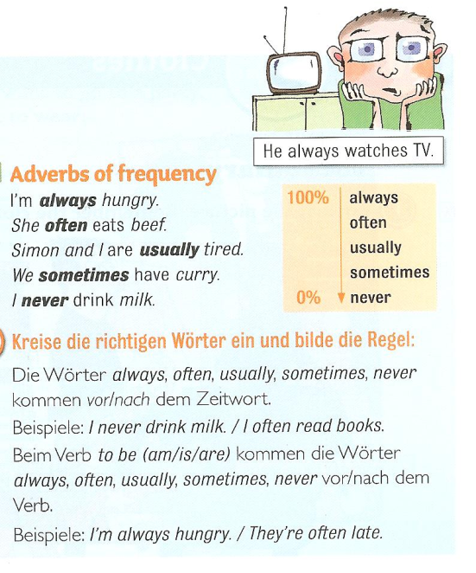
Our friend helps us. (always)
I go shopping in Paris. (never)
She is late. (usually)
I get headaches. (often)
He forgets my birthday. (always)
You are right. (usually)
They stay in bed late. (sometimes
I don’t go to the doctor. (often)
Source: 1
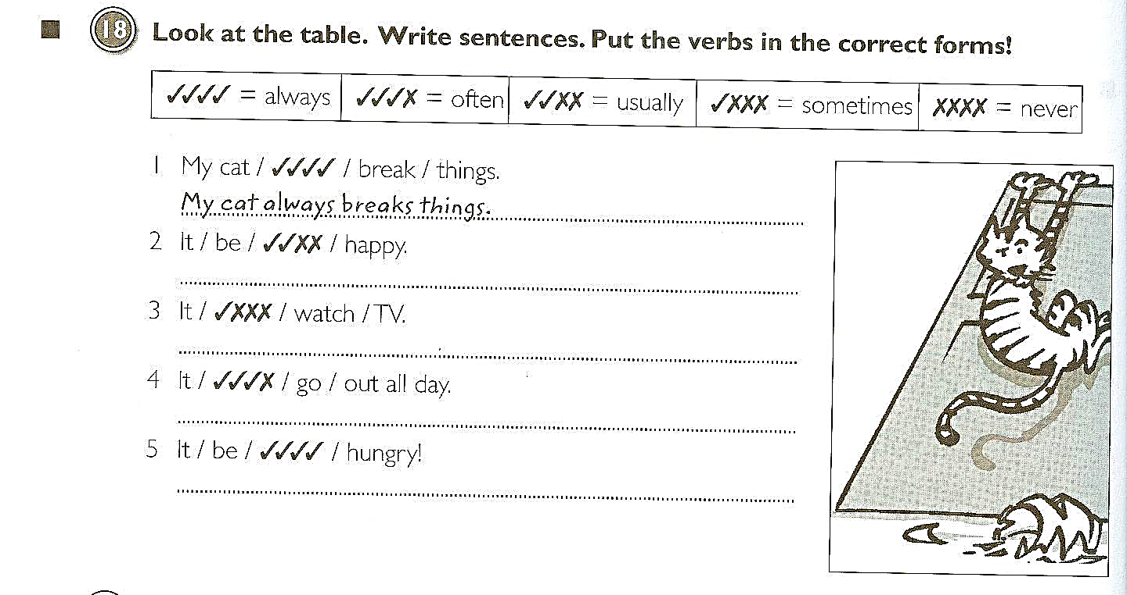
Source: 2

Adverbs of frequency:
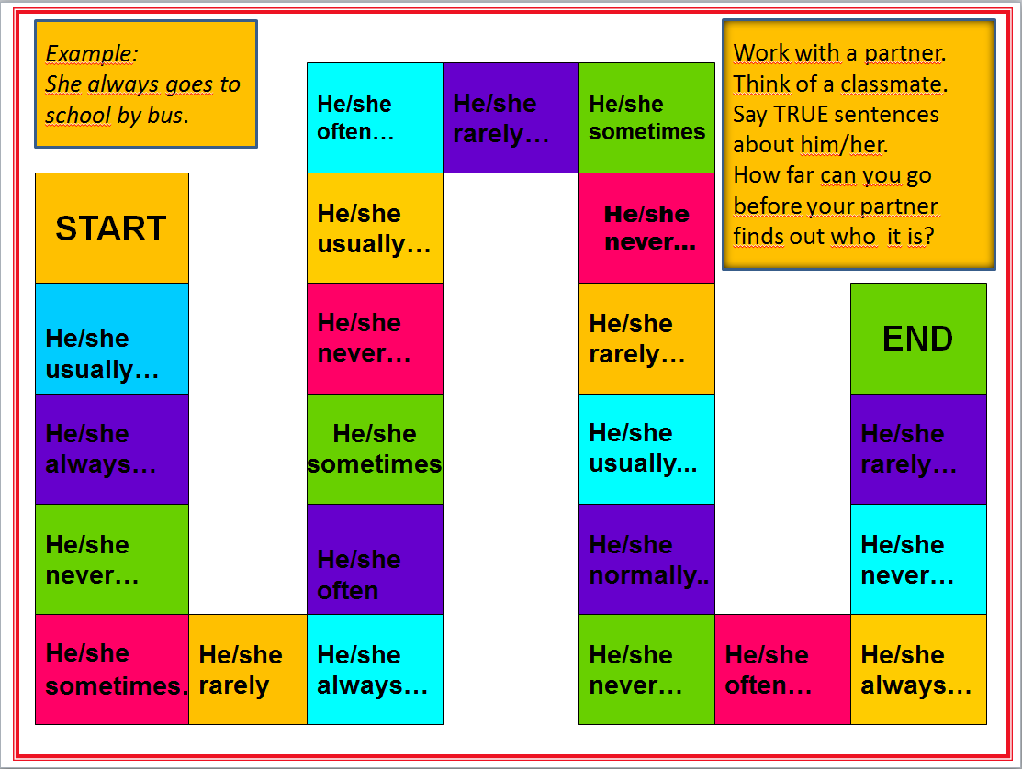
Boardgame

Asking Questions in English
Compare the following exercises
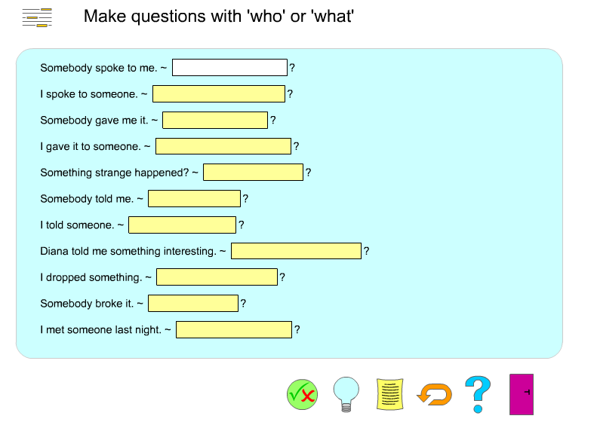

http://www.englishgrammarsecrets.com/questions1/menu.php

What do you think they asked?
? | John’s in the garden and Sylvia is in town.
? | Put on your blue trousers.
? | Because I wasn’t feeling well.
? | Mum gave it to me for my birthday.
? | I did. I’m sorry. I’ll buy you a new one.
? | Yesterday. The postman brought it just before I went to work.
? | I think it’s M-I-S-S-I-S-S-I-P-P-I but you’d better look it up.
Source 3

Form questions
Ask for the underlined part. Write the complete English question into the gap.
Example:
The class plays football.
_______________________
Answer:
The class plays football.
What does the class play?
1) John is writing a letter.
?
2) She walks home from school.
?
3) The children are sitting in the garden.
?
4) Peter runs with his dog on Sundays.
?
5) My rabbit has a cage in the garden.
?
6) They go to work by bus.
?
7) David likes cats because they are nice.
?
9) We are going to the cinema.
?
10) I'm leaving now.
?

http://www.englisch-hilfen.de/en/exercises/questions/form.htm

Finding out about my friends

- What’s the question? Read Mrs. Pö’s answers in column 2 and write the fitting question (passende Frage) into column 1.
- What about you? Write your answers into column 2.
- Now interview 3 classmates. Remember: We speak ENGLISH only!
- Homework: Write about yourself. Use the back of your collage and present yourself (stell dich vor).
How are you today?
Where do you live?
What languages do you speak? What’s your name?

Do you have any brothers and sisters?
Do you have any pets?
What are your favorite hobbies?
When is your birthday?

1 | 2 | 3
What’s the question? | Mrs. Pö’s answer | Possible answers:
What’s the question? | Add your own answers. | Possible answers:
 | My name is Elisabeth Pölzleitner.
 | Your answer:
 | My birthday is on the 30th of January. | My birthday is on the 1st (first) 2nd (second), 3rd (third), 4th (fourth),  5th (fifth)…of January, February,  March, April, May, June, July, August, September, October, November, December
 | Your answer:
 | I like reading, jogging and skiing. | I like playing tennis, playing the piano, watching TV, playing computer games, painting, dancing…
 | Yes, I have one sister. | I do not have any brothers and sisters. I am an only child.
 | Yes, I have a cat and four ducks. | I have a dog, a hamster, some fish, a guinea pig, a horse, a budgie, three white mice (one mouse), a rat, a turtle, …
 | I’m fine, thanks. And how are you? | I’m tired. I’m not feeling well today. I’m o.k.
 | I live in Graz, St. Peter.
 | I speak German, English, French, Italian and Greek.

Practicing questions and the third person -s in an authentic context:
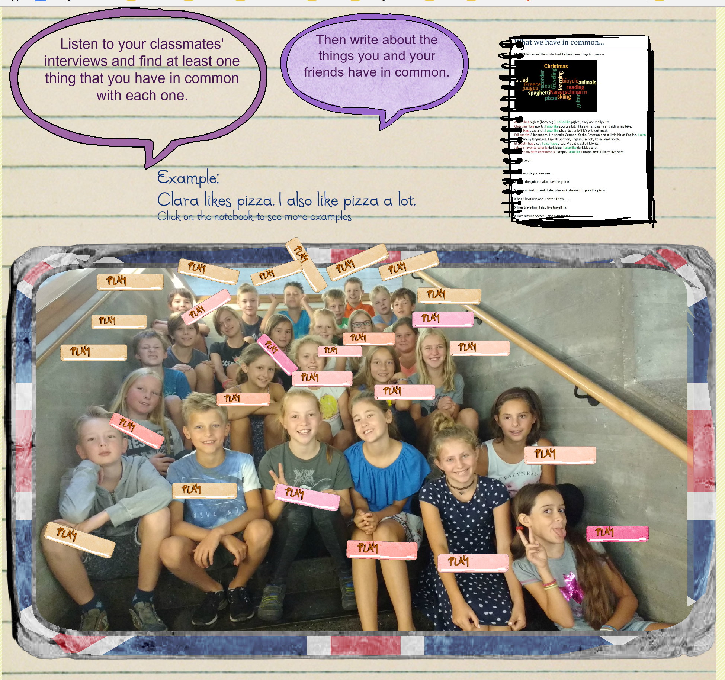


Asking questions:
Use the words from the boxes to write five questions. Use each word once.
When  What  Why  How  Where | does  are  is  does  do | the children  Sue and Katy  Thomas  Anna  Mrs. Pölzleitner’s | have for dinner  birthday  not at school today  live  go to school | ?

Now find out more about your teacher(s). Write questions and guess the answers. Then ask your teacher and find out if your guesses were correct.
What… | Tick off your correct answers:
Your answer:
When
The learners will need a lot more space, of course
Your answer:
Where
Your answer:
Why
Your answer:
How
Your answer:
How many
Your answer:
Who
Your answer:

No, No, No…

  - I do not like/ X does not like…
  - I don’t like / X doesn’t like…
What are the things you do not like at all? Write down five sentences.
Then ask three classmates what they do not like at all and write sentences.
- Example: I do not like….
2
3
4
5
1 My friend...
2
3
4
5
1 My friend …
3
4
5
What do you have in common? Are there any things none of you likes?
Example: Peter and I do not like…

Dogs, dogs, dogs.

- Whose dogs are these? Match the pictures with the words.
Peter’s dog.
Tom’s dogs.

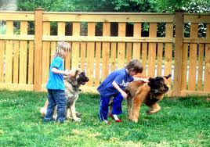
The boys’ dog.
The boys’ dogs.
The dog’s tricks.
No dogs allowed here.


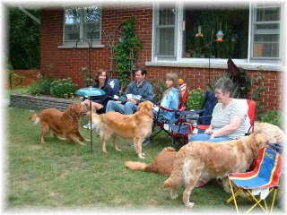
- Now label these pictures. Where do you need an apostrophe?



Example: Our neighbors’ dogs









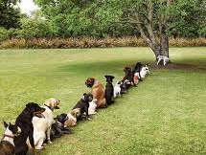

Homework:
Make your own matching exercise (like exercise 1). Choose a different topic – find or draw 6 pictures and write 6 sentences. Bring your page to class and ask one of your classmates to match the pictures and the phrases.
Sources:
- Gerngross et al. (2007) More 1, Student’s Book. Helbling. 53
- Gerngross et al.(2007) More 1, Workbook. Helbling. 64
- Newby, D. (1992) Grammar for Communication. Vienna: Österreichischer Bundesverlag. 187
All others: Elisabeth Pölzleitner

Examples of Efficient Grammar Activities: Find details on epep.at
Do the activities and evaluate them using the Quick-Check Grammar Checkers. Decide for which of the LEARNING STAGES the activity will be suitable. Write your notes and comments in the column on the right.
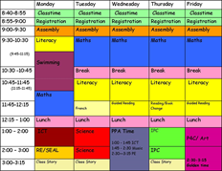 | Talking about routines and daily activities.
 | Describing present activities (What are they doing?)
 | Describing story backgrounds and circumstances (past progressive)  Talking about past events (past simple)
Do you know how ketchup is made? | Describing processes in the Passive Voice
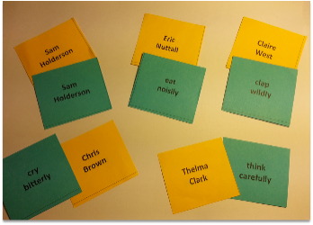 | Describing HOW people do something: Adverbs
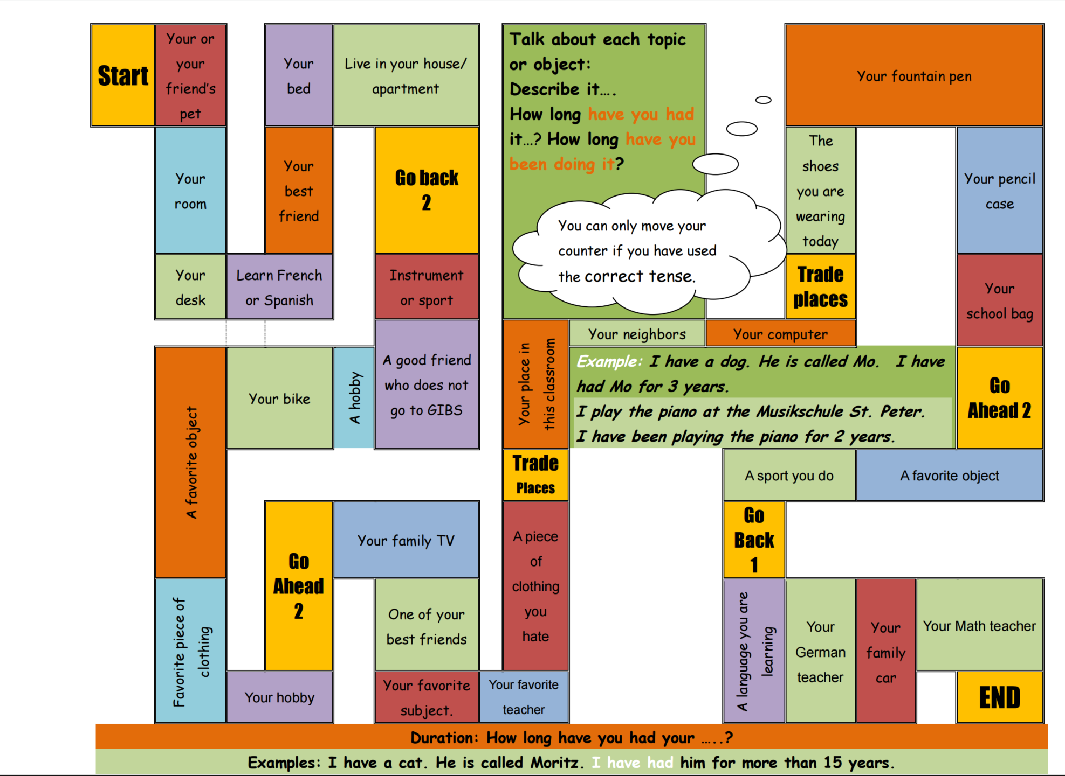 | 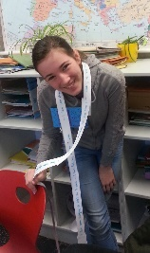  Talking about how long I have had or done something. Duration: present perfect tense
 | Irregular verb forms:  Verbs raps: memorizing what sounds right
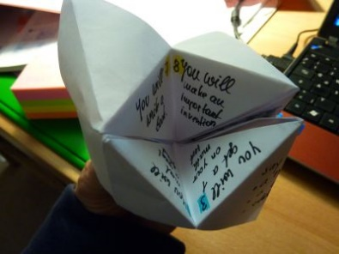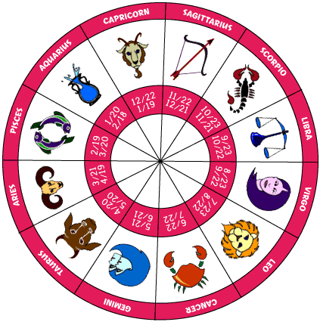 | Predicting the future: (will future)
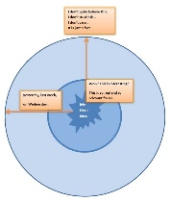 | Reporting and Announcing
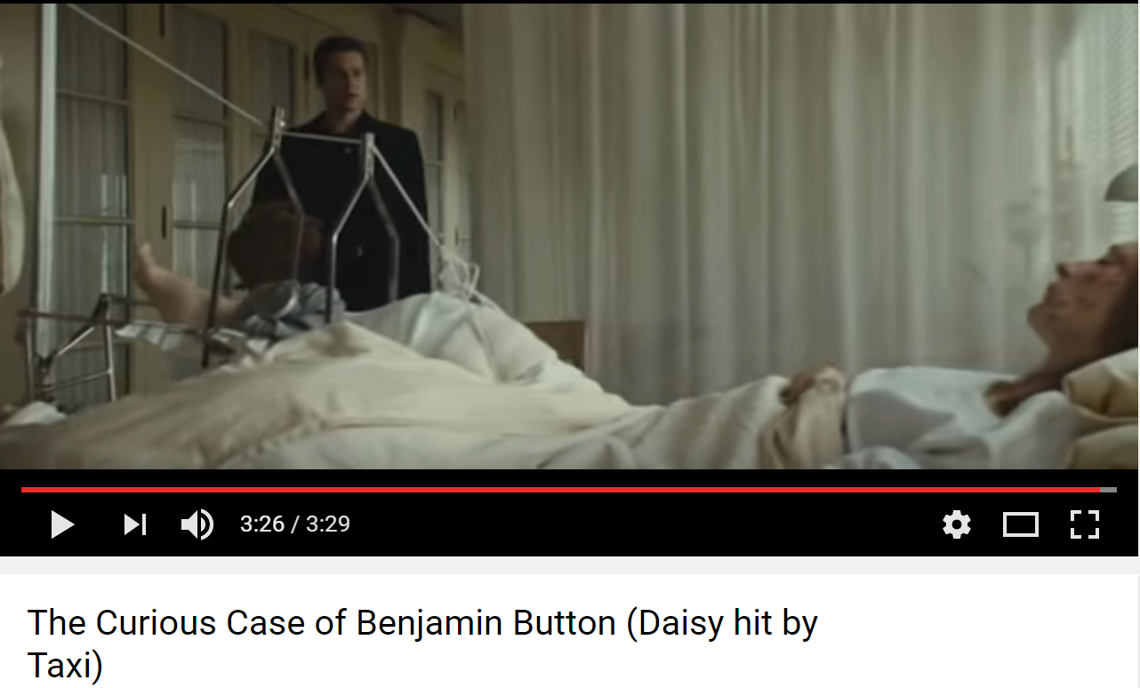 | If III: If we could turn back time  If that taxi had come one second earlier…
 | If II: If I could do whatever I wanted for a whole day….
Find all these and more materials on www.epep.at

Inductive Learning: Making Hypotheses and Building Rules from Examples
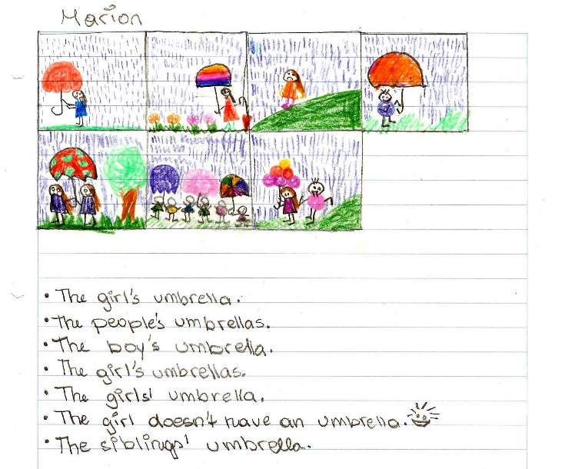
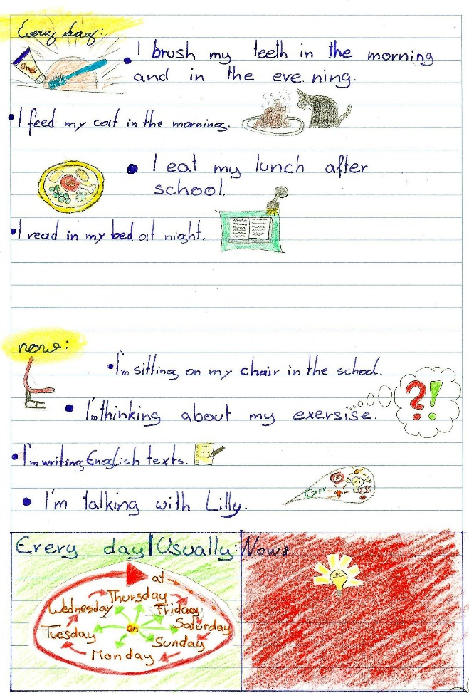
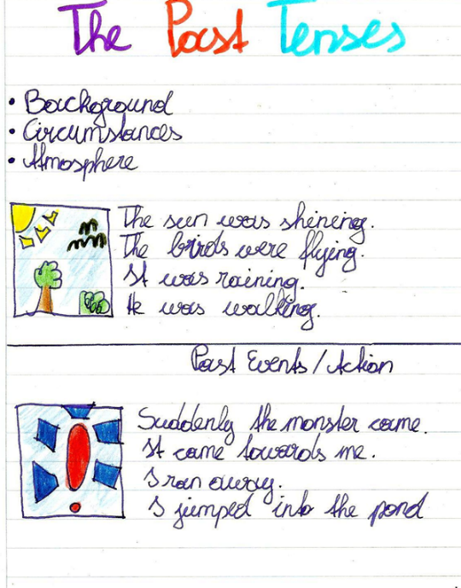
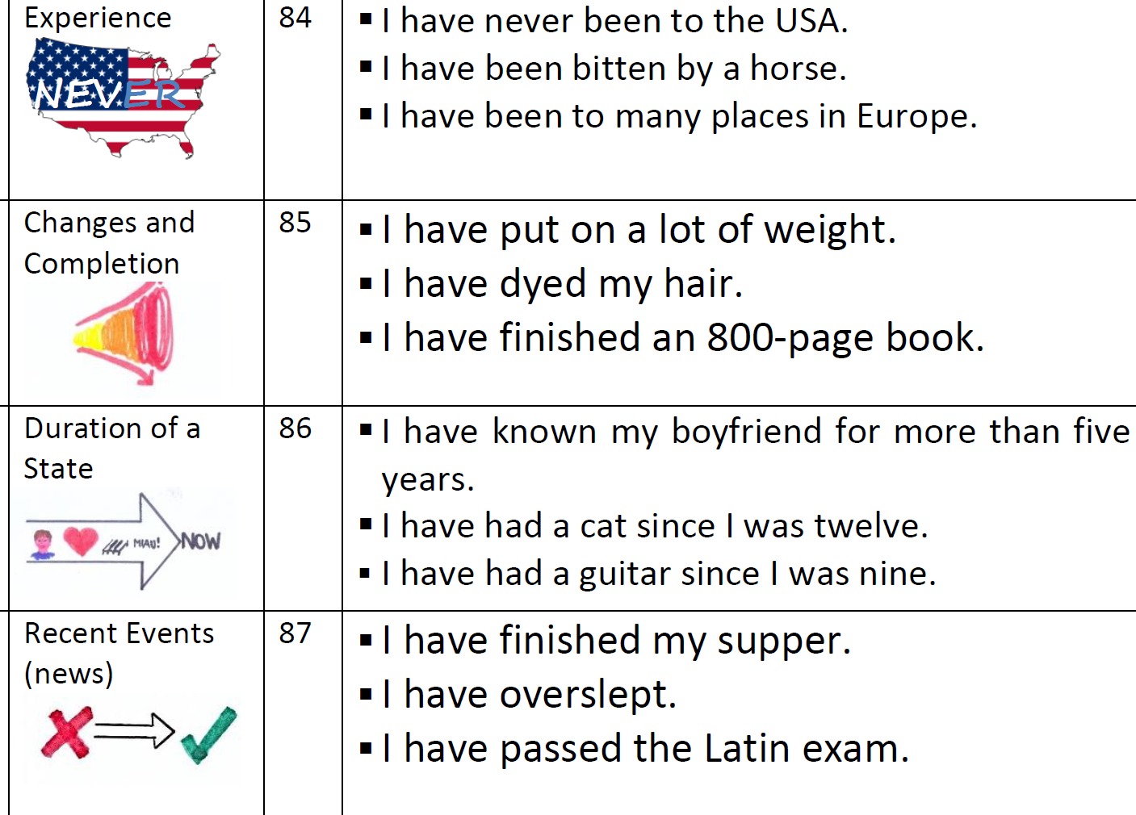
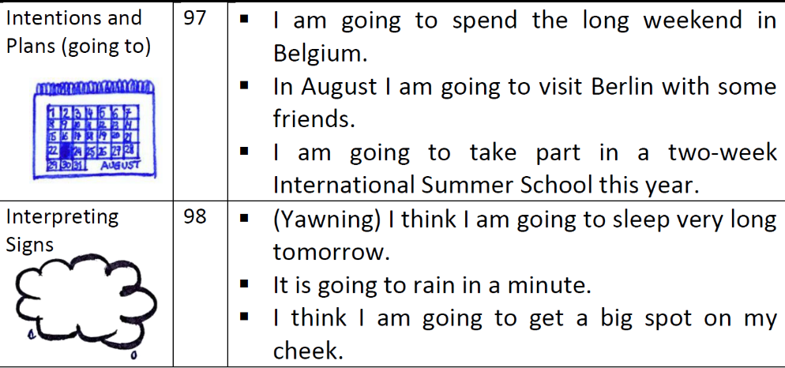

Bibliography:
Ahsen, A. "ISM: The triple code model for imagery and psychophysiology." Journal of Mental Imagery 8.4 (1984): 15-43.
"becindonesia.com." 07 2009. 6 11 2011. <http://www.becindonesia.com/smg/wp-content/uploads/2009/07/Brain-Functions.jpg>.
Buchers, Sam. Vocabulary Cartoons II. Punta Gorda FL: New Monic Books, 2007.
Caine, R.N. and G. Caine. "Understanding a Brain-Based Approach to Learning and Teaching." Educational Leadership 48.2 (1990): 66-70. 06 11 2011. <http://www.sedl.org/scimath/compass/v03n02/1.html>.
Caspary, Ralf. "Dopamindusche im Klassenzimmer." Caspary, Ralf. Lernen und Gehirn. Freiburg im Breisgau: Herder, 2006.
"Flickr." 21 03 2009. Flickr. 06 11 2011. <http://www.cogiscent.com/wp-content/themes/thesis/rotator/neural%20network%20rotator.jpg>.
Gough, Chris. English Vocabulary Organizer. Andover, UK: Heinle, Cengage Learning, 2002.
Hannaford, Carla. Smart Moves: Why learning is not all in your head. Arlington, Virginia: Great Ocean Publishers,, 1995.
Herrmann, Ulrich. "Gehirnforschung und die neurodidaktische Revision schulisch organisierten Lehrens und Lernens." Herrmann, Ulrich. Neurodidaktik. Weinheim und Basel: Beltz, 2006.
Lee, Rebecca. "Flickr." 06 10 2011. Rebecca Lee. 06 11 2011. <http://dickinsonn.ism-online.org/files/2011/10/Neurons-in-the-brain-illustration-by-Rebecca-Lee-on-flickr.jpg>.
Lewis, Michael. Teaching Collocation. Heine, 2000.
"Living with Alzheimer's." 06 08 2011. alz.org. 06 11 2011. <http://www.alz.org/living_with_alzheimers_your_brain.asp>.
Macedonia, Manuela and Karsten Müller. "The impact of iconic gestures on foreign language word learning and its neural substrate." Human Brain Mapping (2011): 982-998.
McCarthy, Michael and Felicity O'Dell. English Phrasal Verbs in Use, Advanced. Cambridge: Cambridge University Press, 2007.
McCarthy, Michael and O'Dell Felicity. Academic Vocabulary in Use. Cambridge: Cambridge University Press, 2008.
Morgan, John and Mario Rinvolucri. Vocabulary, Resource Books For Teachers. Oxford: Oxford University Press, 1986.
Newby, David. Grammar for Communication. Wien: Österreichischer Bundesverlag, 2001.
—. Grammar for Communication: Exercises and Creative Activities. Wien: Österreichischer Bundesverlag, 2001.
Newby, David. "Theory and practice in communicative grammar", in R.de Beaugrande, M. Grosman, B. Seidlhofer, (eds.) Language Policy and Language Education in Emerging Nations, Series: Advances in Discourse Processes Vol. LXIII. pp 151 - 164. Stamford, Conneticut: Ablex Publishing Corporation, 1998.
Redman, Stuart and Robert Ellis. A Way With Words, Book 1. Cambridge: Cambridge University Press, 1989.
Ridzka, B., et al. The Words You Need. London: Macmillan , 1981.
Roth, Gerhard. "Warum sind Lehren und Lernen so schwierig?" Herrmann, Ulrich. Neurodidaktik: Grundlagen und Vorschläge für gehirngerechtes Lehren und Lernen. Weinheim und Basel: Belz, 2006.
Schachl, Hans. Was haben wir im Kopf? Die Grundlagen für gehirngerechtes Lehren und Lernen. Linz: Veritas, 2006.
Scholastic Professional Books. Super-Fun Reading and Writing Skill Builders. Scholastic Professional Books, 1999.
Spitzer, Manfred. Lernen. Gehirnforschung und die Schule des Lebens. Heidelberg/Berlin, 2002.
Spitzer, Manfred. "Medizin für die Schule." Caspary, Ralf. Lernen und Gehirn. Freiburg im Breisgau: Herder, 2006.
Stevick, Earl W. Memory, Meaning and Method. Boston: Heinle, 1996.
Szabos, Janice and Vanessa Filkins. Reading, A Novel Approach. Good Apple Inc., 1984.
Tanushree. 04 03 2011. India Talkies. 06 11 2011. <http://www.indiatalkies.com/2011/03/brain-functions-based-familys-genes.html>.
Woolard, George. Key Words for Fluency, Intermediate. London: Thomson, 2005.
Zull, James. The Art of Changing the Brain: enriching teaching by exploring the biology of learning. Sterling, Virginia: Stylus Publishing, 2002.

Older students can also add a few collocates.

