Asking Questions in English

Compare the following exercises
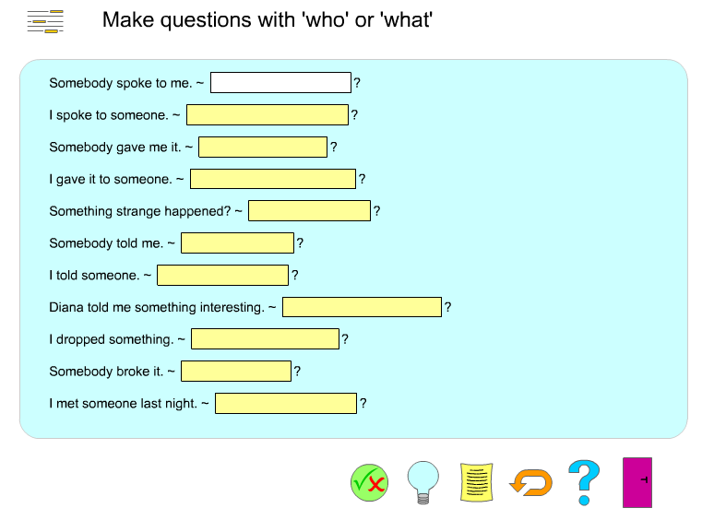

http://www.englishgrammarsecrets.com/questions1/menu.php

What do you think they asked?
? | John’s in the garden and Sylvia is in town.
? | Put on your blue trousers.
? | Because I wasn’t feeling well.
? | Mum gave it to me for my birthday.
? | I did. I’m sorry. I’ll buy you a new one.
? | Yesterday. The postman brought it just before I went to work.
? | I think it’s M-I-S-S-I-S-S-I-P-P-I but you’d better look it up.
? | I went by taxi. I missed the bus!

Newby, D. (1992) Grammar for Communication. Vienna: Österreichischer Bundesverlag. 187

Form questions
Ask for the underlined part. Write the complete English question into the gap.
Example:
The class plays football.
_______________________
Answer:
The class plays football.
What does the class play?
1) John is writing a letter.
?
2) She walks home from school.
?
3) The children are sitting in the garden.
?
4) Peter runs with his dog on Sundays.
?
5) My rabbit has a cage in the garden.
?
6) They go to work by bus.
?
7) David likes cats because they are nice.
?
8) Jenny isn't sleeping late today.
?
9) We are going to the cinema.
?
10) I'm leaving now.
?

http://www.englisch-hilfen.de/en/exercises/questions/form.htm

