Assignment 9: Find a few exercises that teach if-clauses and analyze them according to our criteria. Please bring a printout of your assignment to class.

Conditional 2 or unreal conditional

- The first activity that I have found on Teach-This.com is called “Characterization”
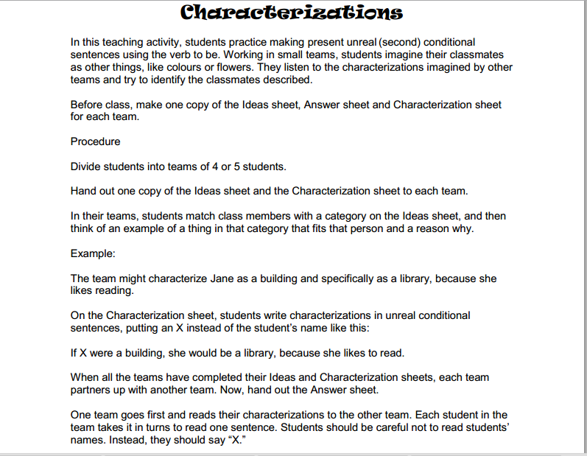
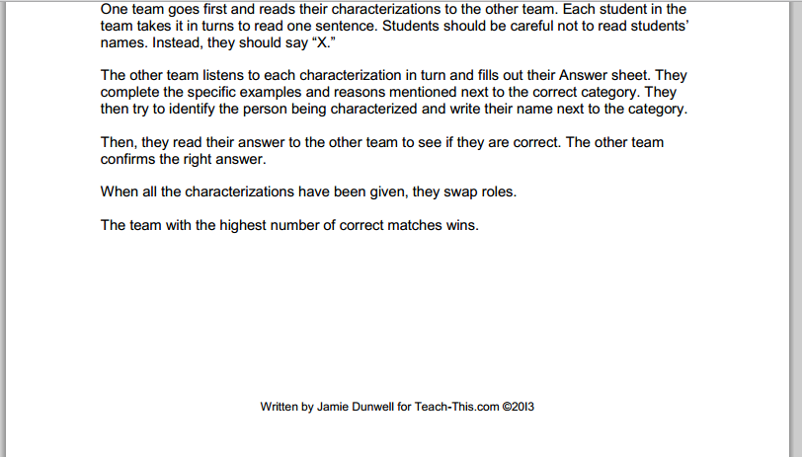

This is an example of Ideas Sheet:

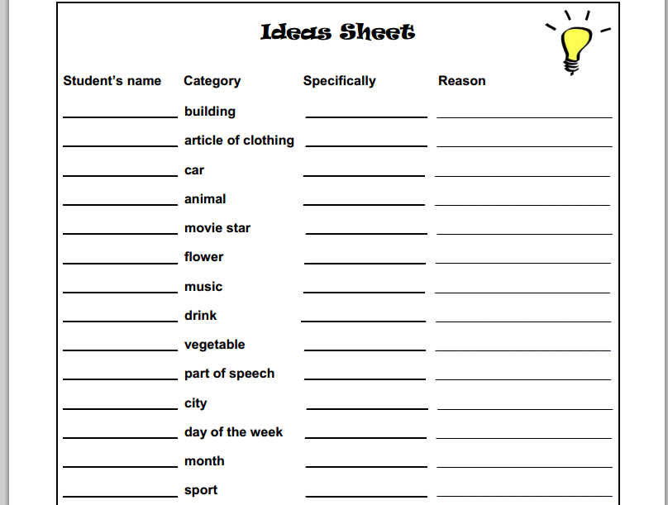

whereas Characterization Sheets are made like this:

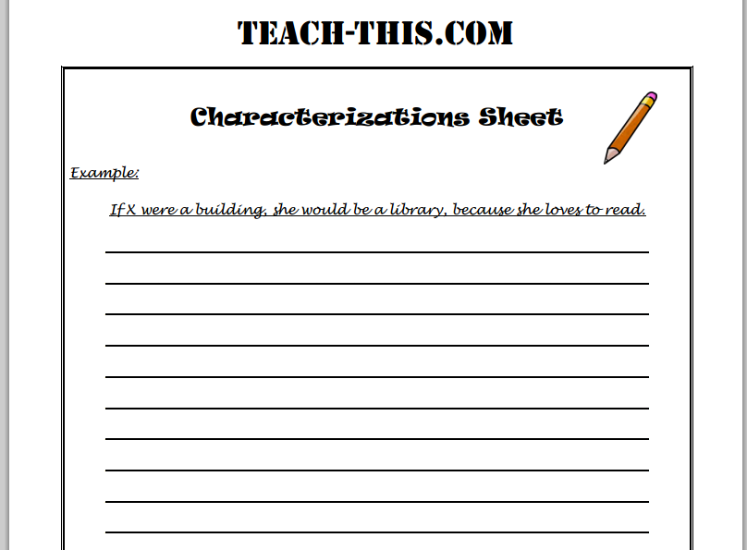

LEARNING STAGES

Awareness raising
The example of the sentence written on the Characterization Sheet and the repetition of the given pattern If X were a…, s/he would be a… give the students the chance to come up with the rule and to understand the new grammar notion.

Conceptualization and hypothesis building
In order to match the categories isted on the Ideas Sheet and to imagine which kind of characteristics could best describe their classmates, the students have to build hypotheses.

Proceduralization in scaffolded condition
Those hypotheses can be formulated in scaffolded conditions, on the basis of the limited categories given by the worksheets and following the example sentence of if-clause that can be found in the Characterization Sheet.

PEDAGOGICAL PRINCIPLES

Depth of processing - Authenticity of process
The activity of thinking about the most relvant features of the classmates and the best way to define them by finding a correlate in the given chategories activates memory and imagination; the guessing game stimulates sense of observation and the ability of making connections.

Personalization
The exercise puts the grammar notion in a context that can be meaningful for the learners (their school and their class play an important part in their lives) and involves a certain knowledge of the classmates.

Commitment filter
The students are required to formulate true sentences and are motivated to find the right match between given categories and real people they know; the exercise is thought as a competition and a guessing game that can be very motivating.

Peer/social learning and interaction
The learners have to work in group and talk to each other to share their ideas and knowledge in order to find solutions and to link the grammar rules to the sentences they want to build. This activities are a good way of interacting and learning together.

Testing vs. teaching
I would say that this is a good teaching exercise.

2) The second exercise is taken from an internet site called TEFLtastic Blog

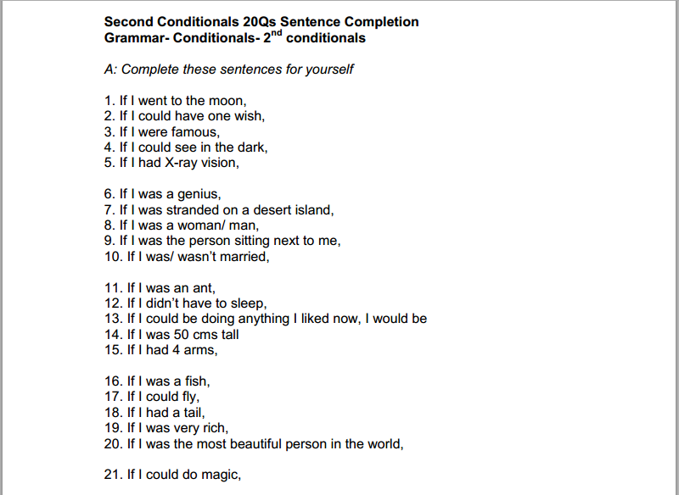
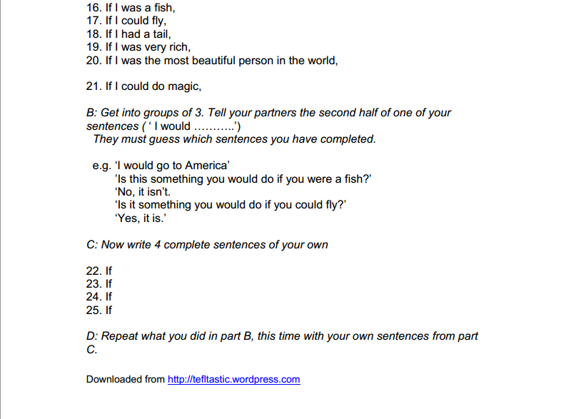
LEARNING STAGES

Conceptualization and hypothesis building
Hypothesis building and conceptualization are activated in section A when students have to complete the sentences and in section B when they have to guess the missing parts.

Proceduralization in scaffolded condition
The scaffolded conditions are given by the pre-formulated if-clauses, on the basis of which the learners can build their sentences, but they have to alreadyknow the grammatical notion of conditional 2. Other scaffolded conditions are the example sentences of part B that have to be used in the dialogues.

PEDAGOGICAL PRINCIPLES

Depth of processing
Depth of processing is necessary in order to formulate the second halves of the sentences in part A: the learners have to imagine themselves in the given situations and think about which kind of attitudes, feelings or reactions those situations would provoke.

Personalization
The situations in which the students have to imagine themselves can be meaningful for the learners’ age and the exercise involve personal answers.

Commitment filter
The sentences of part A have to be true and not only grammatically correct, and part B, encourages the students’ motivation through the activity of guessing.

Peer/social learning and interaction
After a first individual activity, section B involves peer interaction: students have to communicate their completed sentences to the other group members and talk to each other in order to guess which one of the given sentences could be the missing part of what the partner has said.

Testing vs. teaching
I would use this exercise, which involves integrated skills (speaking and writing), as well as individual and group work, for revising and testing.

Bibliography
“Teach-This.com” http://www.teach-this.com/images/resources/characterizations.pdf (Dec. 2014)

“TEFLtastic Blog” http://tefltastic.files.wordpress.com/2007/09/2nd-conditionals-sentence-completion.pdf (Dec. 2014)

