FOR AND SINCE MIX UP

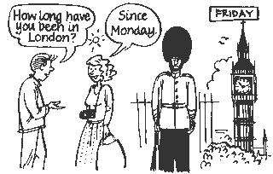

- Go together in groups of 4. Each group gets a set of cards. Please deal out the cards equally. We have 20 cards for each group so everyone should get 5 cards.

- Write 5 true present perfect sentences using since and for and the words in brackets. Example: I have studied English for 3 years.

- Fold up your 5 sentences and put them into the box at the teacher’s desk.

- When every group has finished, stand up and take one sentence from the box. Go around the class and ask classmates “How long have you …?” to find the person that wrote this sentence.

When you find someone who wrote this sentence, check if that person actually wrote the sentence by asking 'Did you write this?' If so, you write the person's name on the card, keep it and take another one from the box. You have to repeat this until there are no cards left. The student with the most sentences at the end of the game wins.

SET OF CARDS:
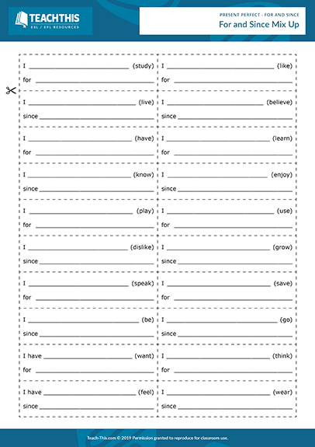

Learning stage: This activity is for the learning stage of “proceduralization in scaffolded conditions”. It also raises awareness but the focus is on practicing these sentences using for and since. We also have these scaffolds with the set of cards. As the students ask the questions repeatedly, they have a performance task too. They practice the present perfect tense by writing their own sentences and by having conversations with their colleagues.

Depth: They are mentally active because they have to think about true sentences.
Commitment: I think this activity can be a lot of fun as there is a game like approach and the student who has the most sentences wins it. Curiosity is also involved because the students want to find out to which person the sentence belongs.
Peer and social learning: The students have conversations with their peers. Therefore, peer and social learning is included.
Personalisation: They draw on personal experiences as they write true sentences.
Contextualisation: We have a clear communicative context as the students have conversations with their colleagues and ask “How long have you …?”.
Authenticity: There is a high possibility that students use the question “How long have you…?” in real life when they get to know people and talk about what this person does.
Task based: There is no real end product as the students try to collect as many sentences as possible. However, they fulfil a purposeful task because they find something out about their classmates.
Testing vs teaching: This task is not about testing something but it should help the students to use the present perfect tense for duration.

