Predictions: Will future good idea to be adapted a bit
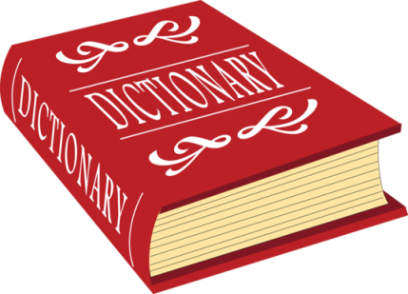
  - Exercise: “Delphic Dictionary”
Source: http://edition.tefl.net/ideas/grammar/will-for-predictions/ - improved by Isabella & Magdalena

Get in pairs and take out one dictionary!
STEP 1:
- put it on a desk, close your eyes and open the dictionary at any page (if you say “let it fall open” the kids might actually let it fall and ruin it. )
- Spin your forefinger around in the air and then let it fall randomly on the open page of the dictionary
- Read out the word and how it is defined.
- Write down the word and continue to do the same procedure up to 3 times.
- Next you have to make up a story about your partner’s future from those words!



e.g.: “You will discover COPPER in your back garden and become WEALTHY, but it will poison your water and so you will grow a LUMP on your back like the Hunchback of Notre Dame”.

