Present routines

Worksheet for activity 1

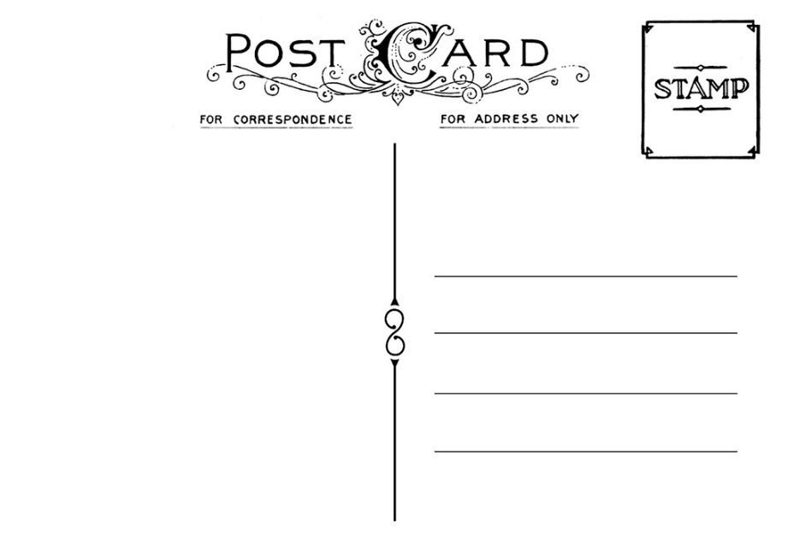
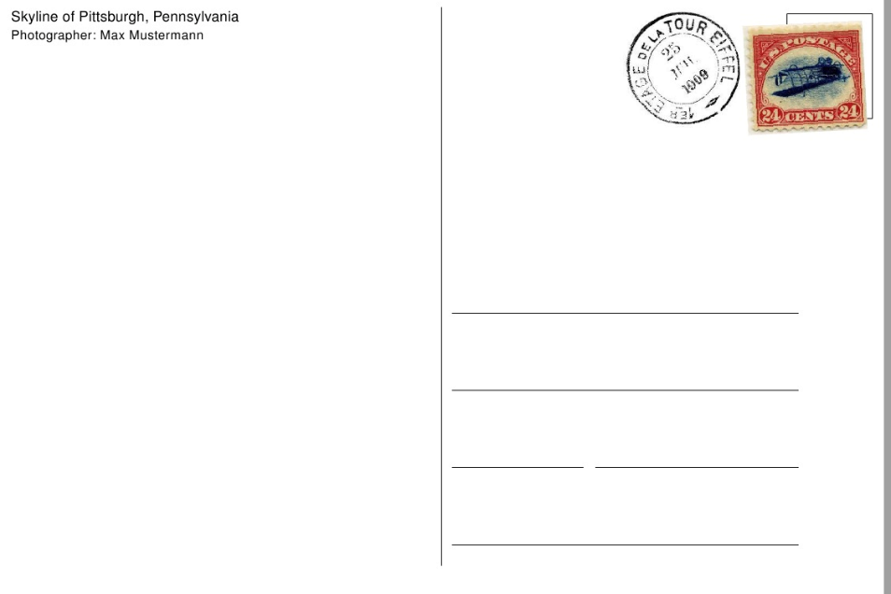
PRESENT ACTIVITIES
Dear Oliver,

Greetings from Ireland!
I am having a wonderful time here. I met some really exciting people and we are spending all our time together. We are getting up early every day because we don’t want to waste any time! We are hiking every morning because the landscape is just marvellous. We are spending our afternoons at the beach singing songs and telling thrilling stories. I hope you are having great holidays too!

Love,
Lisa

Dear Alice,

I am having a terrible time here in England. It’s raining all the time so we’re playing a lot of board games. The food in our hotel is disgusting so we’re eating in a restaurant every day. I’m even reading a book at the moment and you know that I’m not a bookworm. I hope you are having a better time spending your holidays at home.

Hugs and kisses,
Jenny

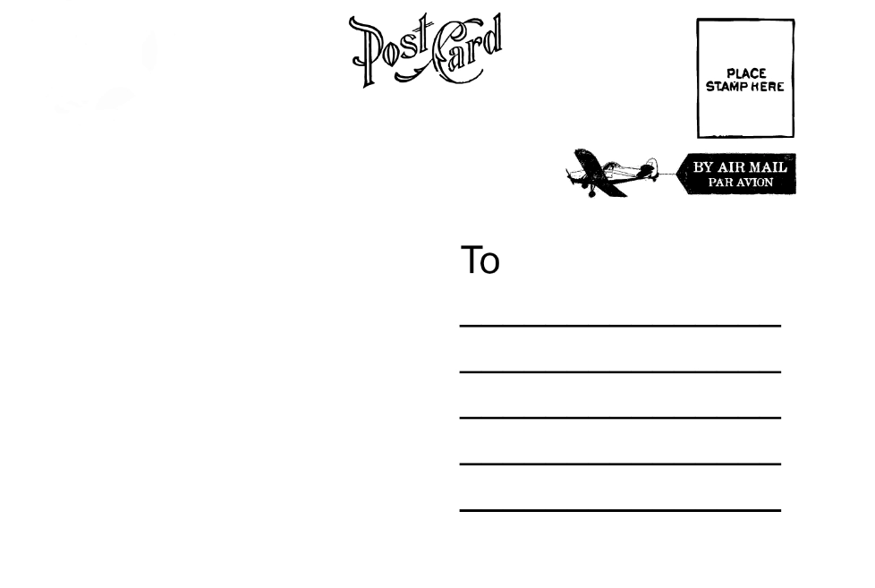
Dear mum and dad,

We are all really enjoying our holidays. We’re going swimming every day and Simon is playing a lot of tennis. At last I’m reading the book you gave me for Christmas! We’re hoping to hire a boat tomorrow if the weather’s nice.

Yours,
Thomas

My rule:

––––––––––––––––––––––––––––––––––––––––––––––––––––––––––––––––

––––––––––––––––––––––––––––––––––––––––––––––––––––––––––––––––

PRESENT ROUTINES

Worksheet for activity 2 and 3 /Homework

Quick postcard writing guide:
You can choose any one of the adjectives to make your postcard even more interesting and exciting.

Dear/ Hello (name of the person you are writing the postcard to),

We're having a great / wonderful / fantastic
/ fabulous/ terrible time here in ……
The weather is hot / sunny / perfect and we're spending our days on the beach / sightseeing / relaxing / exploring the local area / by the pool.
The food is interesting / spicy / pretty good/ disgusting/ terrible and the other people here are friendly / unfriendly / great.
See you soon/on (day you get back)

Love/ Best wishes/ Kisses and hugs (xoxo)/ Yours,
(Your name)

Activity 1:

Introduction to the notion of present routines - awareness raising.
Several different postcards are located at different places in the classroom. Students go around in pairs, read through them carefully and make notes about everything they notice and discover (new forms, vocabulary they do not know etc.). Then the whole class discusses one postcard after another (students are provided with a worksheet with the postcards). During this process, the rule is discovered.
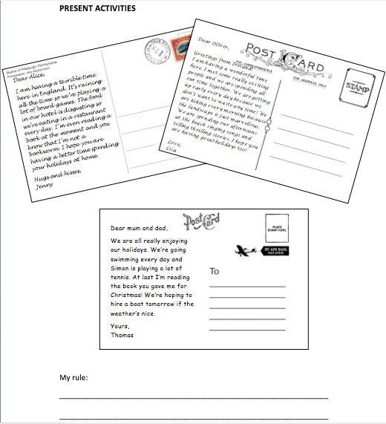
After everything has been discussed together thoroughly, students have to write down the rule of the new notion on their worksheet in pairs.

 | ANALYSIS ACTIVITY 1
Learning stage | Awareness raising,  Discovery activity
Depth of processing,  mental activity | Depth of processing is quite high because students do a discovery task and have to find a rule.
Dual processing/ Authenticity | The language used in the postcards corresponds to the learners’ language. It is likely that they have written /will write a postcard to their family and friends.
Personalization | The activity is not personalized but the topic should be in the learners’ interest.
Commitment filter | This activity produces an AHA effect when pupils find out the rule. Students might be interested in how to write a postcard in English.
Peer/ social learning and interaction | The activity encourages peer learning. Students have to read the postcards in pairs and have to think about the rule together.
Testing vs. teaching | This activity could only be used for teaching.

Activity 2:
 | ANALYSIS ACTIVITY 2
Learning stage | Awareness raising,  Students think for themselves how a postcard should look like and draw on existing knowledge
Depth of processing,  mental activity | The activity has high depth of processing because it is a discovery task.
Dual processing/ Authenticity | Writing a postcard is an authentic process. This knowledge is useful in real-life situations.
Personalization | The activity is not personalized, but each student has to think about how a good postcard looks like according to him/her.
Commitment filter | The activity produces an AHA effect. Students might get motivated to write postcards in English.
Peer/ social learning and interaction | The activity does not encourage peer learning, but while brainstorming the whole class works together.
Testing vs. teaching | This activity is designed for teaching.
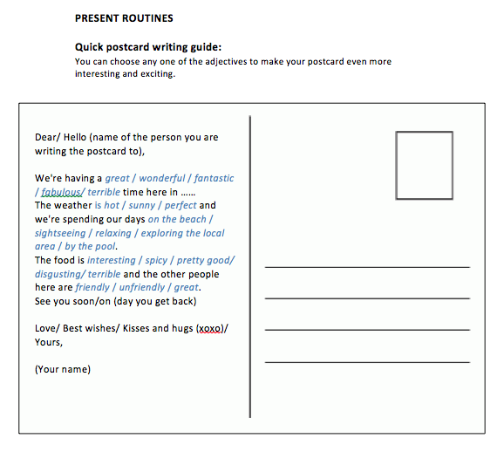
Students are asked what a good postcard has to be like (which components, which kind of language, which information has to be included etc.). After brainstorming, students are given the second worksheet which is discusses together. New vocabulary will be explained and students write the new words in their vocabulary books.

Activity 3/ Homework:

Students can begin with their homework in class (if there is time left). They can also draw a picture of Kate’s holiday.
(from Newby: page 177, 73)
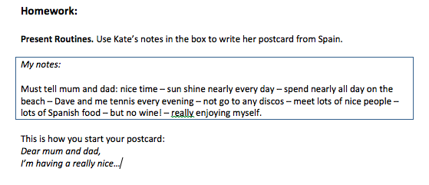
 | ANALYSIS ACTIVITY 3/ HOMEWORK
Learning stage | Proceduralization, very guided exercise
Depth of processing,  mental activity | Depth of processing is not very high in this activity since it is very scaffolded and the content of the postcard is already given. However, it is very useful because the aim of this exercise is that pupils focus on the new notion and get used to it.
Dual processing/ Authenticity | It is useful for student to know how to write a postcard, this is useful real-life knowledge.
Personalization | The activity is not personalized because the content of the postcard is already given.
Commitment filter | This activity gets students to practise writing a postcard in a very scaffolded and guided way. It does not really activate the commitment filter, but really focuses on brainwashing the new notion into pupils’ heads.
Peer/ social learning and interaction | Peer learning and social interaction is not encouraged as every pupil should focus on his/her ability to write a postcard.
Testing vs. teaching | This activity should be used for teaching because it is too scaffolded.

