
Tip for myself:
lots of good ideas that I told her
be careful – there are some language mistakes and other little flaws. but all my ideas are there.

KF - Universität Graz
Fakultät der Geisteswissenschaften, Englisch

Course: Communicative Grammar
Supervisor: Pölzleitner, Elisabeth, Dr. phil.

The Reported Speech -
Teaching the Notions Reporting and Announcing by using the
Cognitive and Communicative Grammar Approach

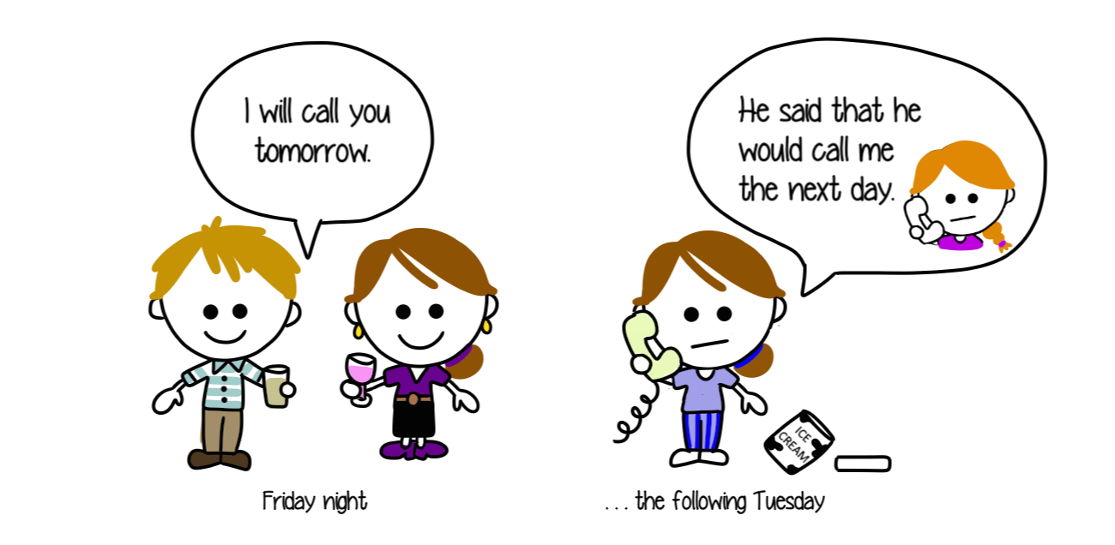

Submitted by:
Leitenmüller Rebecca, BEd, 1214079
rebecca.leitenmueller@gmx.at

Table of Contents
I. Introduction 3
II. Teaching materials 6
1. First lesson 6
Activity 1.1. Boasting or lying (~15-20mins) 6
Activity 1.2. The new English-Assistant (adapted from Pölzleitner “Our new co-teacher”) (~15-20 mins) 10
Activity 1.3. Newspaper articles (~20 mins) 12
2. Second Lesson 13
Activity 2.1. What did they say? (adapted from Pölzleitner) (~20 mins) 13
Activity 2.2. Detect the lie (~10-15mins) 16
Activity 2.3. Where is the class’ lucky charm? (30 mins) 17
Third lesson 19
Activity 3.1. Spot the difference (Newby 1989: 110) (~10 mins) 19
Activity 3.2. Celebrities (~30-40 mins) 20
Activity 3.3. Alien language (adapted from Timesaver: 48) (~15-20 mins) 21
Testing activity – The Youth Journalist 24
III. Sources 26
3.1. Online Sources 26
3.1.2. Videos for Activity 3.1. 26

I. Introduction
Hey Rebecca, how were your English lessons this week?
Thanks, fine. The 4D is still not so appreciative of me being their new English teacher, but the 3A is very nice and they really enjoy the lessons.
Nice to hear that (.) anything new for next week?
Yeah, I’m actually going to start with the notions of reporting and announcing so I am still on the hunt for some new exercises.
What? Never heard of that term before - what’s it called? Notions? And isn’t it simply called Reported Speech?
Well, let me explain…
This is what a conversation could probably look like when an English teacher talks to another English teacher (or teacher in general) or a conversation that I myself could probably come across within the next years. Or did you maybe have a conversation that looked similar to this one as you being the one who does not know what a notion is or the one who is informed about it and C+C grammar?
The approach of cognitive and communicative, or shortly C+C grammar is rather new in the field of English grammar teaching in Austria, but I still want to convince you that this is the path to follow. One might call it insulting to make such a strong and even impertinent statement, but I claim that the approach of C+C grammar and the according work with notions will make students’ life as English learners much easier and will most likely even put a smile on their face, rather than scaring them away as many other English teachers effectively did before or some who are still doing it now at this moment, while reading this paper. Especially when it comes to learning the reported speech the learners struggle, as the gap between the German reported speech and the English one is quite big. On the one hand there is no shifting of tenses in German, but one simply uses the present tense to report things and on the other hand, the traditional way of back-shifting all the tenses is simply confusing. You might ask why? It’s just that simple, take the tense and back-shift it, where is the problem? This works fine when you do not want to consider real-world English but the ‘problem’ is that English speakers think differently than German speakers when forming the reported speech. They do not always back-shift the tenses according to the rules as they have two different concepts in their mind (that will be explained later) and according to these two, they decide to either back-shift a tense or not. When learners now come across a sentence in which there is no back-shifting of tenses, they will get confused and will not know if the rules they learned are wrong or if the sentence is. The reason is that native speakers, as mentioned by Pölzleitner (2010), “tend to look back at the situation and report it as a past event” and as already mentioned the back-shifting rule is in many cases also not correct.
When students learn the reported speech with the ‘one and only’ back-shifting rule they will struggle with real-world and real context-based English as they will not know how it is used or how and when they need to use it. The solution to this problem is by not teaching the reported speech as one single whole but by dividing it into the two notions of reporting and announcing. These notions are those that represent the ‘thoughts and believes’ of a native speaker. They explain what they think and how they accordingly apply a back-shift of a tense or not.
Before describing these two notions in detail, I first want to explain what a notion actually is. The idea of notions plays a very significant role in teaching C+C grammar. A notion is described by Newby (2015), as a grammatical concept that is encoded into a form. This means that various specific concepts are linked to the according grammatical forms. Simply said, things (=concepts) that are in my mind/brain and that I want to express linguistically are called notions. The learners’ perceptions of the world help him or her to understand the concept and use it.
When planning an exercise, the teaching objective should be formulated in terms of the according notion where we also do not longer focus on rules or forms, but we learn it by working on it efficiently, frequently and enough. For my topic this could be formulated like this: “At the end of the lesson the learners can report events that took place in the past.” Or: “The students can report things that were said or thought to be happening in the future.” This might be more time-consuming than simply studying rules but in the long run, the learners will benefit from it more as they will remember it better (e.g. connection to relevant topics for the learners) and the process of acquiring the notions will come naturally. This is guaranteed as notional grammar is strongly meaning-based rather than form-based and is therefore also strongly connected to real-world English. In the contrary, traditional grammar uses forms instead of notions, such as adverbs of manner, or past tense to teach grammar. The forms are often used in sentences that are not relevant for the learners or even abstract or absurd. Also, there is no learning of exceptional rules in notional grammar that often immensely confuse learners. A further advantage for the learners is that by learning in notions, they get new information presented step by step and are not overloaded with too much as it is often the case in traditional grammar. To sum this up, notional grammar emphasizes meaningful contexts and the relations between speakers and language. It focuses on HOW grammar works, instead of what it is. In the following I will explain the two notions that are connected to the reported speech.
The two notions of reported speech are mentioned by David Newby (1989: 130) in an easy and understanding way (mentioned in the following paragraph). For the students, the ‘simpler’ version of the difference between the two notions is appropriate for learning the reported speech, but if one wants to go into further detail for advanced learners (upper secondary school or university) or for own research, the article by Ian P. Harman (1990) is very recommendable. There are further subdivisions of the reporting notion, mentioned by Newby (1989: 127-129), such as reporting present situations, reporting facts and activities, reporting the future, reporting past events and reporting experience. The notion of announcing stands alone for it itself (no subdivisions).
The notion of reporting refers to events that are in the past. We report things that happened in the past or things that are not relevant (=neutral way of telling it) for us (or the speaker), at the moment. It is also used to report things that the speaker does not believe to be valid, true or as doubtful or the speaker does not identify with the information (Handout: 47). Examples are: “The mechanic claimed that my motorbike would be ready in one week, but he needed three.” “Mama promised me to give me a new remote-controlled car last Christmas, but she didn’t."
On the other hand, the notion of announcing focuses on the present situation. We not only report but we announce things (information) that are present in our minds or things that are (highly) relevant for us (or the speaker). Either, the speaker is involved into the situation, he or she is very interested about it, or identifies with it (ibid: 47). These thoughts or believes lead to the decision of choosing the present tense. The speaker will also use it for things that he or she believes to be true. Announcing is used frequently in every-day language and it is required that the information one is reporting is still true. There are also many situations, such as habits, facts or future events, where both notions can be used (Newby 1989: 130). Examples for announcing: “My boyfriend said that he will arrive in the next few minutes.” “Anna told me that she’s coming to my party in the evening.” Example for both announcing and reporting: “Susan told me that she goes/went jogging every morning” (ibid: 130)
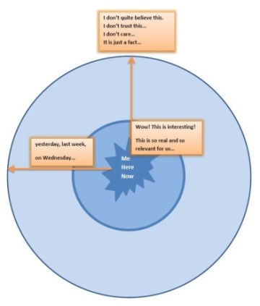
A very helpful device to make these differences clearer for the learners’ learning process is an adaption by Pölzleitner (2010) of the deictic circle that was created by Harman (1990: 233). This “reporting circle” represents a simpler version of his concept that can be easily used in the classroom. The students are asked to write down suitable sentences for each of the situations into the circle. “For each sentence they decide how close to the center or how far out they want to put it — and how this location can help them to decide which tense to use.” This reporting circle (big version on www.epep.at) can be looked at in the following picture.

II. Teaching materials
In the following, I have prepared exercises for three lessons to introduce, to practice and to use (=perform) the two notions of reporting and announcing. I have also designed one testing activity. I also included the reporting circle as an activity, but it can be used throughout the learning stages of the reported speech to support the students’ comprehension and help them if they are not sure and they need additional guidance (besides the teacher) so they can decide what tense use is more appropriate for a sentence that is reported or announced. What is also important to know, when planning exercises for the reported speech, is that the tense forms and the use of tenses (Handout: 47) is not new for the learners, but the “mental processes” that happen when reporting is new for them.

1. First lesson
The first lesson focuses on the following learning stages: Awareness raising, Conceptualization and Proceduralization.

Activity 1.1. Boasting or lying (~15-20mins)
- Step 1 – Truth or Lie?: This step is done with the whole class. The students are presented with different examples of statements the teacher has collected from other teachers beforehand. The students should guess which of the statements are true and which are not.
Guess if the statements of the teachers are true or not – who is telling the truth and who is lying?
Mr. Bowy told me that he went to the ACDC concert two months ago.
Mrs. Kettner told me that she liked spinach as a child.
Mr. Haller told me that he goes jogging every morning.
Mr. Maier told me that he once jumped out of a plane.
Mrs. Liebert told me that she will buy a new car this week.
Mrs. Anders told me that she likes all the classes she teaches.
Mr. Henry told me that was teaching in America for five years before he came here.
Mrs. Hasner told me that she loves buying expensive sunglasses.
Mr. Berner told me that he was a very good dancer when he was a teenager.
Mrs. Müller told me that she gets free tickets for all events in Graz.

- Step 2 – Discover the rule: This step is also done with the whole class or the students can first get together in pairs and discuss it on their own. The teacher uses the sentences that were used before (written down on board, either with chalk or prepared paper strips, or on the OHT or the computer) and asks the learners why they think a certain tense is used in each of the sentences. The learners should first see the difference that in some sentences the past tense is used and in some the present tense and also in one sentence the future tense. It is useful to either put the sentences on the board with paper strips or onto the computer so that the sentences with the past tense can be put onto one side and the ones with present tense and the will future into the other column. Then they should come up with their own hypothesis of when the past tense is used and when the present tense and also once the future tense. The hypothesis of the learners could be as such: In the left column it is about things that happened in the past and are not relevant or important now. In the right column it is about things that are important now or will be important in the future.
Now I want you to look at all the sentences. Can you spot a difference between them?
Prompting questions: Look at the use of the tenses in the second part of each sentence.
Why do you think the past tense is used in the left column and why the present tense and also the future tense in the right column?
Mr. Bowy told me that he went to the ACDC concert two months ago.
Mrs. Kettner told me that she liked spinach as a child.
Mr. Maier told me that he once jumped out of a plane.
Mr. Henry told me that was teaching in America for five years before he came here.
Mr. Berner told me that he was a very good dancer when he was a teenager.

Mr. Haller told me that he goes jogging every morning.
Mrs. Anders told me that she likes all the classes she teaches.
Mrs. Hasner told me that she loves buying expensive sunglasses.
Mrs. Liebert told me that she will buy a new car this week.
Mrs. Müller told me that she gets free tickets for all events in Graz.

- Step 3 – Reporting Circle: As a follow up activity the students work with the help of the reporting circle. The reporting circle shows the learners the importance of time and relevance when reporting things. As a speaker is the centre of attention for him or her, and everything concerning language evolves around him or herself, it is advisable to make the learners aware of this fact when reporting things. A large version of the reporting circle can be found on www.epep.at. In the middle of the circle the speaker (in this case the learner) is the centre “Me Here Now”. The arrow that points to the left side refers to things that happened in the past. The box above the middle is concerned with things that are relevant or interesting for the speaker. The arrow that points to the top refers to things the speaker doesn’t (quite) believe or where he or she doesn’t care about, or things that are just facts. The students are asked to find examples for each of the three. Before that the teacher can give an example for all three. The teacher talks about the two different notions and makes clear that the learners know the difference between them. With the help of this exercise and the following ones it should be clear to them that the past tense is used for reporting and the present tense and the will future for announcing things.
Note: The teacher should also introduce the students to the word ‘claim’ and make them aware of using this verb in order to report things they do not believe to be true. For things they report about past events or facts or things that are true they should mainly use the verbs ‘told and said’ (this is important in the beginning – later on the learners can use other verbs such as ‘promised, offered, agreed, suggested…’.
Now I want you to look at this reporting circle. It helps you to find out when to use which tense. Imagine that you are the centre of this circle. When you look at the arrow on the left side you think of things that happened in the past, maybe yesterday or even a few years ago. When this is the case you use the past tense. An example is: “At my job interview our headmaster told me that I was the best choice for the job.”
When you look at the arrow that points to the top you think of things that you don’t believe or trust or maybe you don’t care about them. An example is: “An old school friend of mine claimed that he didn’t steal my pencil case but I knew that it was a lie.” You also use it for things that are just facts – things that are true or wrong as they are. An example is: “The history teacher told me that George Washington was the president of the U.S. from 1789 – 1797.”
When you look at the book that is very close to the centre you think of things that are very interesting to you or things that are relevant for or when you believe something to be true. An example is: “My best friend told me that she is coming to my birthday party on the weekend.”
Grammar Checker | Analysis of Activity 1.1.
Learning Stage | Step one belongs to the Awareness raising stage and introduces the new grammatical structure of the Reported speech, but not yet questions the learners about it but deals with asking them if the statements are true or false.  Step two belongs to the Conceptualisation stage and brings the learners to think about what is different in the sentences – they build their own hypothesis of the rule for both notions.  Step three belongs to the Conceptualisation and the Proceduralization stage. The students are first presented with the circle where they see if they hypothesis the made up earlier is correct and they also see themselves as the speaker/reporter and what this means for both notions. Then they are asked to produce their own examples for the two notions with the help of given examples from the teacher.
Depth of processing and  mental activity | In the first stage the brain activity is not very high concerning the new grammatical structure as they might not even consider it as very important or recognize it as something new, but they focus on the different statements to speculate if they are true or not and get drawn into the new topic this way.  In the second the third stage require a high brain activity as the students build their own hypothesis about the new grammatical form and also form sentences that are relevant for them.
Dual processing and  authenticity of process | The activity is very authentic in all stages. The first two steps involve information of persons the learners know personally and can relate to. The third step includes information they come up with about their own knowledge and/or information they know. It is also common to report things about people that are close to me (as the teacher does) and to report things that happened in the past and things that take place in the here and now.
Personalisation | The steps are personalised as the students learn things about other teachers they know and they write down things that are relevant to them (for both notions).
Commitment filter | The learners are very likely to commit themselves to all the exercises as they are curious to find out which statements are true or false and then they also find out the ‘rule’ for the new grammatical structure themselves.
Peer/social learning and  interaction | It is an interactive exercise as the learners work together in class (first and second part) or also with a partner or in a group (second part and possibly also the third part when they discuss with what they’ve come up with).
Testing vs. teaching | This is a teaching activity.

Activity 1.2. The new English-Assistant (adapted from Pölzleitner “Our new co-teacher”) (~15-20 mins)
The teacher presents the learners a table of different pictures concerning their new English-assistant teacher. Last week it was his first time being in class and the students asked him loads of questions and he also told them many things about himself. First of all, the teacher gives an example so the learners know how the activity works. Then the students get the worksheet and together with a partner write down the remaining sentences (each pupil his/her own worksheet). This step can also partly be done together orally so the teacher can make sure the students know how to use the new grammatical form correctly. After the students have finished writing down the sentences some of them read them out so the teachers makes sure that they got the sentences correctly.
Note: The words that are underlined are the parts the learners should come up by themselves. At the beginning they are easier, but get more difficult with each sentence.
Look at the following pictures. The pictures show things that Michael told us about himself last week. Look at the first picture. You can see a football because “He told us that he played football for many years when he was a child.” Together with a partner report what he said about the other pictures. Remember to use the words ‘told and said’ for things that were true and ‘claim’ for things that were not.











Michael told us…
He told us that he played football for many years when he was a child.
He told us that he got a motorbike for his twenty-first birthday.
He told us that he owned a dog when he was living in London.
He claimed that he met Christiano Ronaldo at a football game in Madrid but we found out that it was a lie. Then he said that he always wished to meet him (hint: wish).
He told us that he always finished his homework before playing outside with his friends.
He told us that he broke his leg before he came to Austria.
He told us that he stopped smoking because his girlfriend had asked him to.
He told us that he got a tattoo on his right arm.

Grammar Checker | Analysis of Activity 1.2.
Learning Stage | This activity belongs to the Proceduralization as the students have to produce the correct sentences, or rather parts of them in a scaffolded condition. The students report what Michael told them with the help of the pictures.
Depth of processing and  mental activity | This activity is linked to the notion of reporting. The brain activity is high as the students have to think what Michael told them the week before and they have to finish the sentences.
Dual processing and  authenticity of process | The activity is very authentic as the students talk about a person they know and have talked to. It is authentic to talk about someone else and report what he are she told them/me.
Personalisation | The activity is not personalised as the students do not write or talk about themselves. They are not personally involved, but the talk about what they have heard from their new English-assistant teacher.
Commitment filter | The commitment filter in this activity is activated as the students have to think what the English-assistant told them in the previous week. It’s motivating to them to find out if they can still remember a few things that he told them.
Peer/social learning and  interaction | It is an interactive exercise as the learners work together in pairs and they also compare their sentences with the whole class.
Testing vs. teaching | This is mainly a teaching activity.  It can also be adapted to a testing activity where students have to report about someone else with scaffolded conditions.

Activity 1.3. Newspaper articles (~20 mins)
In this activity the students work with real newspaper articles that deal with the recent amok driver in Graz. The teacher tells the students that the reported speech is often used in newspaper articles and that sometimes journalists or writers use the reported speech to convey a certain meaning or message. The teacher hands out small paragraphs from different newspaper articles, where the reported speech is used. The learners are asked to read them carefully and underline the tense (the verbs) that is used in each reported sentence. The teacher asks them to think about why the different tenses are used. It has to be clear that the students see the difference between the two notions. They should be able to explain why either of the tenses is used according to the notion.
Note: the underlined parts are the ones the learners should also underline. They should make small notes in their folder on why a certain tense is used. They can work together with a partner.
Look at the following paragraphs of newspaper articles. They all deal with the recent amok driver in Graz. Read them carefully and underline the tenses that are used for reporting or announcing. You only have to underline the verbs. Try to find out why the reporters use the past tense or the present tense
“The governor of Styria province, Hermann Schuetzenhoefer, said the suspect was "mentally disoriented" and acting alone.”
“Police commander Josef Klamminger told reporters in Graz that the man had been under a restraining order* keeping him from the home of his wife and two children. “ *Kontaktverbot

“Some of 34 injured are in critical condition, Austrian Wiener Zeitung reports.”
“Eyewitnesses claimed he was driving between 60mph and 90mph on a busy road.”

"People were screaming in panic and ran into the surrounding shops to get to safety", witnesses told Krone.”
“The Austrian Wiener Zeitung reports that some of the 34 injured people are in critical condition.”

Grammar Checker | Analysis of Activity 1.3.
Learning Stage | This activity belongs to the Conceptualization stage as the students have to find out why the tenses are used and which notion according to them.
Depth of processing and  mental activity | The brain activity is high as the students have to think why the tenses are used. They also have to find out where each of the two notions is applied.
Dual processing and  authenticity of process | The activity is very authentic as the incident of the amok driver just recently occurred. The students read about the incident that happened in their home town (or at least the town in which they go to school). They have heard things in the news or talked to family and friends about it beforehand.
Personalisation | The activity is not personalised as the students do not write, talk or speak about themselves but they are partly involved personally as the incident took place in Graz.
Commitment filter | The commitment filter in this activity is activated as the students have to conceptualize the two notions and the tenses used in connection to the incident.
Peer/social learning and  interaction | It is an interactive exercise as the learners work together in pairs and the whole class also talks about what they have found out.
Testing vs. teaching | This is a teaching activity.

2. Second Lesson
This lesson mainly focuses on the Proceduralization stage, but also includes the Performance learning stage.

Activity 2.1. What did they say? (adapted from Pölzleitner) (~20 mins)

Note: Before doing this activity it might come in handy to work on the notion of reporting again and do some examples beforehand (using past tense and past perfect tense). The teacher should give some examples where the past tense is used and some examples where the past perfect tense is used. The students should find the difference between the two. Mainly: reporting past events I (the speaker) report about an event that took place in the past. Reporting experience: I (the speaker) report about what someone did before our conversation. Examples: “She told me that she drove to university every day in the summer time.” He said that he had been waiting for hours.”
In this activity the students get a worksheet with many different pictures on them. The students are asked to work together with a partner and discuss all pictures about the following questions: Who are these people? What might they have said? To whom did they say it? The students should be prepared to present the ideas in a group of six people or in class.
Get together with a partner and look at the following pictures. Answer the questions on the worksheet – I recommend that you take notes. Prepare to present some of your ideas to your group and/or to the class.
Reporting: What did they say? Who are these people? What might they have said? To whom did they say it?
 |  |  | 
 |  | 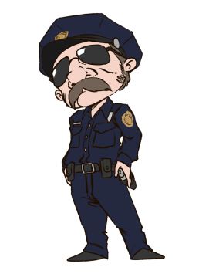 | 
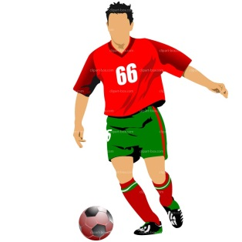 |  |  | 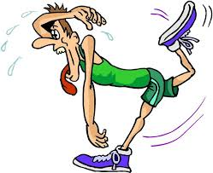

Possible sentences (first row from left to right, and so on):
Her mum said that she was really happy about the gift card.
The boss asked her if she had worked in a supermarket before.
The science teacher told his class that he had studied chemistry for five years.
The father told his child that he was the best basketball player in school.
The news reporter said that several burglars were caught at the robbery scenery.
The chef told the magazine that he had worked for many different restaurants in the past.
The police officer said that he arrested the car driver because he was driving too fast.
The journalist claimed that the prime minister had an affair.
The soccer player said that he was very happy to win the cup last season.
The man from the weather forecast said that it was going to rain but the sun was shining.
The boss told his workers that he didn’t like the way they were spending their breaks.
The runner told his wife that he saw a brown bear while running in the woods.
Grammar Checker | Analysis of Activity 2.1.
Learning Stage | This activity belongs to the Proceduralization stage and focuses onto the notion of reporting. The learners report past events and past experiences.
Depth of processing and  mental activity | The mental activity is high as the students really have to think what the person in the pictures could have said. Then they also have to report these and make sure to use the past tense and/or the past perfect tense correctly.
Dual processing and  authenticity of process | The activity is authentic as it is very common to report what other people experienced or the events that took place in the past.
Personalisation | The activity is not personalised but the students have to come up with creative ideas and can also connect their own experiences or events they know to this activity.
Commitment filter | The commitment filter in this activity is high as the students have to concentrate and be active to come up with interesting ideas. They use their creativity to find different ‘solutions’ for each picture. They can also discuss this thoroughly with their partner
Peer/social learning and  interaction | It is a very interactive exercise as the learners work together in pairs and/or in groups and even share their findings with the whole class. The students listen to the ideas of their colleagues.
Testing vs. teaching | This is a teaching activity that can also be used as a testing one.

Activity 2.2. Detect the lie (~10-15mins)
This is a speaking activity where the students first work together in pairs (partner A and B) and then in a group of four people. It is advisable to pair students that usually do not work together or are not ‘best friends’ so they can find questions where they probably don’t know the answer beforehand. Each student gets a strip of paper with two questions on it. Partner A asks partner B the questions and the other way round. Both take notes of the answers of their partner. The students are asked to come up with at least three more questions they want to ask their partner. When they have finished this two pairs go together into one group. Partner A from group 1 gets together with partner A from group 2 (same thing with partner B from group 1 and 2). They report each other what their partner has answered to the questions.
Please get together in pairs. Everyone is going to get a strip of paper with two questions on it. Please come up with at least three more questions and ask them to your partner. Take (short) notes about what he or she told you. (When they have finished doing this.) Now get together with another pair and partner A from both pairs get together and partner B from both pairs as well. Then report him or her, what your partner has answered to the questions.
What was your favourite TV show when you were little?
What are your plans for this weekend?
(Where did you go to primary school?)
(Why are you so tanned?)
(How did you get to school today?)

Possible answers:
Marie told me that her favourite TV show was Art Attack and Tom and Jerry.
Peter said that he wanted to go swimming at his local open-air pool.
Julian told me that he went to primary school in Graz.
Hannah said that she is tanned because she just came back from a short holiday.
Lisa said that her mum brought her to school today because her bike is broken.
Grammar Checker | Analysis of Activity 2.2.
Learning Stage | This activity belongs to the Proceduralization stage and focuses on the notion of reporting past events and experience. The students produce the sentences in scaffolded conditions.
Depth of processing and  mental activity | The mental activity is high as the students have to answer the questions, followed by reporting what their partner has answered them.
Dual processing and  authenticity of process | The activity is authentic as it is very common to report friends (and family) about what (other) friends have told them about themselves and things they have experienced.
Personalisation | The activity is personalised as the students get to know their colleagues better and they also have to give answers to their partners.
Commitment filter | The commitment filter in this activity is high as the students have to be very active. They ask questions, they answer questions and they report the answers to the partner of another group.
Peer/social learning and  interaction | It is a very interactive exercise as the learners work together in pairs and in groups. The students listen to the answers of their colleagues and take notes.
Testing vs. teaching | This is a teaching activity.


Activity 2.3. Where is the class’ lucky charm? (30 mins)
The class’ lucky charm is nowhere to be found and the students have to find out where it is. Each student gets a strip of paper with some information on it. The students have to interview each other to find out what the others know. Afterwards they are asked to write a report (with at least eight statements) to the English teacher or the class teacher and present the findings. When they have finished writing the report the whole class can discuss with the teacher where the lucky charm. They can only guess but some information might give hints to where it actually is. They can also ask the teacher more questions if they want to. The teacher will disclose the secret at the end of the activity.
The class’ lucky charm is nowhere to be found. (The teacher shows a picture of the lucky charm). Every one of you will get a strip of paper with information on it. You will interview each other and take notes. When you have finished interviewing write a report to your class teacher and present the information that you have collected. When you have finished your report we are going to discuss where the lucky charm could be.
In the following you can find a short list of possible information and what a report could look like.
You saw Maximillian leaving the room after the English lesson with a small bag in his hand.
The last time you saw the lucky charm was this Monday.
The lucky charm looks similar to the one the 4B also has.
The English teacher bought the lucky charm as a present for the class.
The lucky charm lies on the teacher’s desk where everyone can see it.
In the biology lesson, Sebastian left the room to go to the restroom.
I know that Hannah once accidentally brought the lucky charm home with her.
Peter from the classroom next door is often in our classroom.
Mrs. Harry forgot her schoolbag in our classroom.

Nina told me that she had seen Maxi leaving the room after the English lesson. He had a small bag in his hand. Peter told me that the last time he had seen the lucky charm this Monday. Maria said that our lucky charm looked similar to the one of the 4B. Manu said that our English teacher had bought the charm as a present for us. Ronja said that the lucky charm lay on the teacher’s desk. Lisa told me that Hannah once had accidentally brought the lucky charm home with her. Paul said that Peter from the classroom next door was often in our classroom. Maja told me that Mrs. Harry had forgotten her schoolbag in our classroom.
Grammar Checker | Analysis of Activity 2.3.
Learning Stage | This activity belongs to the Proceduralization and Performance stage and focuses on the notion of reporting experience and reporting facts/activities. The students produce the sentences partly in scaffolded conditions but also on their own.
Depth of processing and  mental activity | The mental activity is high as the students have to interview their colleagues, take notes, write a report and discuss all the findings with the teacher. The students need to see the difference in using the past tense and the past perfect tense.
Dual processing and  authenticity of process | The activity is authentic as the students ask others for information and then report this information to someone else.
Personalisation | The activity is personalized, but the students are not involved with their own thoughts or experiences. The students can still bring in their own thoughts and believes when talking about the findings and where they believe the lucky charm is.
Commitment filter | The commitment filter in this activity is high as the students have to be very active in order to get all the information they need. They are also curious to find out where the lucky charm is.
Peer/social learning and  interaction | It is an interactive exercise as the learners have to interview each other. The students listen to what their colleagues think and to additional information the teacher has.
Testing vs. teaching | This is a teaching activity.

Third lesson
This lesson mainly focuses on the Proceduralization and the Performance learning stage.

Activity 3.1. Spot the difference (Newby 1989: 110) (~10 mins)
This activity is to practice the difference between reporting and announcing. Before that, the teacher asks the learners what they can remember from the previous lessons. If necessary the teacher gives a few examples to let the students think of the differences again – they can revise this with a partner and then the class discusses it together. After collecting the information the students are asked to write down the differences between reporting and announcing. Their Difference Box should look similar to Newby’s “The Difference Box” (1989: 130).
We are going to revise the differences between reporting and announcing. First of all, we are going to discuss this all together and then you are asked to write your own Difference Box into your folder to make sure you know the differences and can look them up if you need to.
Afterwards the students get a worksheet where they have to decide which form the speaker will more likely use. They have to underline their choice and think of the reason. I would not change the sentences Newby used in his activity as I find them to be appropriate for the students.
Grammar Checker | Analysis of Activity 3.1.
Learning Stage | This activity belongs to the Conceptualization and Proceduralization stage as the students revise their knowledge of what they know about the two notions and they also use their knowledge in scaffolded conditions.
Depth of processing and  mental activity | The mental activity is not as high. Although the students have to apply their knowledge, they don’t have to produce sentences but only circle the correct verb. The mental activity is higher in the process of thinking why they chose one or the other verb.
Dual processing and  authenticity of process | The activity is authentic in its process as the students first revise their knowledge, then write it down and then apply it.
Personalisation | The activity is not personalized.
Commitment filter | The commitment filter is not as high but the students should feel encouraged to use their knowledge in the activity.
Peer/social learning and  interaction | It is an interactive exercise as the learners can discuss what they’ve remembered together with a partner and they also discuss it together in class.
Testing vs. teaching | This is a teaching activity.

Activity 3.2. Celebrities (~30-40 mins)
The students get a few links to interviews from famous persons. They have to choose one of them or they can search an interview from a different famous person they like to write a report about. The students watch the interviews and take notes. It is recommended that the students don’t have to watch the whole video, but only the first 3-4 minutes so they don’t get overwhelmed. For weaker students, 2-3 minutes might also be enough. Then they are asked to write a report about what the celebrity said in the interview. Although this activity takes quite some time is advisable to do it in class (computer room) so the students can ask questions whenever they need help. The links to the interviews can be found in the ‘Online sources’ section.
You are going to write a report of what a celebrity said in an interview. I have provided a few links for you Choose one of them or search for a different interview of a celebrity you like and take notes. Then write a report of what he or she said in the interview.
Interview one: Justin Bieber (links can be found in the Online Resources chapter)
Interview two: Kylie Jenner
Interview three: Louis Hamilton
Interview four: David Beckham
Example of what a report could look like: The interviewer asked him why he was nervous about the show. He said that he was nervous because he had not been in a TV show for a long time. He also said that he was nervous about what people would think of him because he wasn’t proud of what he did in the last years. She also asked him if he is nervous when he goes on stage. He said that he is still nervous on stage, but that it got better in the last months. The interviewer asked him about his childhood. He said that he liked Madonna when he was little. She was always his idol. She asked him why he recorded a video before he got to her show. He said that he wanted to express his feelings and explain himself to his fans. He said that he was glad to have his fans supporting him.
Grammar Checker | Analysis of Activity 3.2.
Learning Stage | This activity belongs to the Performance stage and focuses on the notion of reporting experience and reporting facts/activities. The students write the report on their own.
Depth of processing and  mental activity | The mental activity is high as the students have to watch the interview, take notes and then write a report. They have to be very concentrated and apply their knowledge.
Dual processing and  authenticity of process | The activity is authentic as the students first collect their information and then apply their knowledge when writing the report.
Personalisation | The activity is partly personalized. The students can choose one of the celebrities or search for another interview. The interviewed persons are interesting to the students as they are quite young and well-known nowadays.
Commitment filter | The commitment filter in this activity is high as the students have to be very active in order to get all the information they need. They are also curious to find out what the celebrity says in the interview.
Peer/social learning and  interaction | It’s not an interactive activity as the students are asked to work on their own.
Testing vs. teaching | This is a teaching activity.

Activity 3.3. Alien language (adapted from Timesaver: 48) (~15-20 mins)
In this activity the students play a fun game called ‘Alien Language’. The students first encode what the aliens said by taking notes on a different sheet of paper and then have to report to the newspapers what the aliens said. Afer that, the students get together in pairs. Both of them are aliens from a different planet but luckily they almost speak the same language. The students are asked to imagine being a visitor on the planet of their partner. First they should both draw a picture of what they would look like as an alien and also name their character. Then they should think of questions they would ask when visiting the other planet and write them down (not in alien code). Then they exchange their questions with their partner and they answer each other’s questions. Together with the class, they should then report them what the other one told him.
You are going to get a worksheet where you have to encode alien language, report what you know and you are also going to imagine that you are an alien visiting another planet. You are going to formulate questions for your ‘alien partner’ and will report his or her answers to the class.
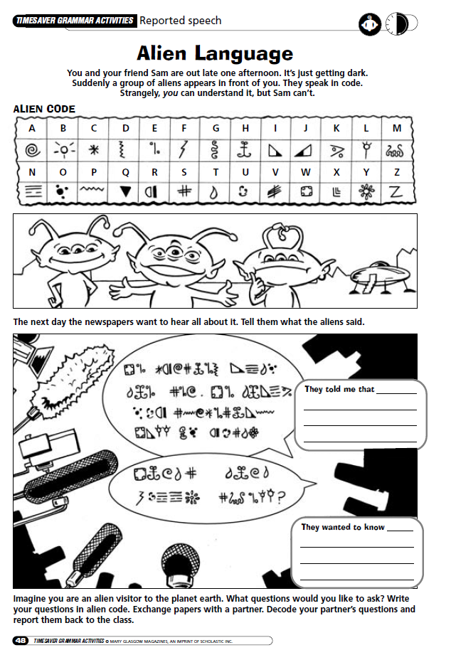

Possible questions and answers:
What do you eat for breakfast? - We eat scrambled dragon eggs and drink hot black guck with it.
Report: Neilome told me that they ate scrambled dragon eggs and drank hot black guck with it.
Do you know that humans exist? - Yes, we always knew that they existed but we never wanted to visit them.
Report: Neilome said that they had always known that humans existed but hey had never wanted to visit them.
Do you also have pets – we love them? – Yes, we own a lot of pets but our favourite are called Nagolas.
Report: Neilome told me that they also own have pets but their favourite ones are called Nagolas.
Grammar Checker | Analysis of Activity 3.3.
Learning Stage | This activity belongs to the Proceduralization and Performance stage and focuses on the notion of reporting experience and reporting facts/activities. The students report the first part in scaffolded conditions, but the last one without any help.
Depth of processing and  mental activity | The mental activity is high as the students have to first encode the alien language and then apply their knowledge to reporting. They have to work together with their partner and collect information.
Dual processing and  authenticity of process | The activity is authentic as the students first report given statements and then come up with their own questions and report the answers of their partner.
Personalisation | The activity is partly personalized. The students do not directly talk about their own life and experiences but they still think of questions they would ask and they answer the questions to what they think they would answer if this alien situation were real.
Commitment filter | The commitment filter in this activity is high as the students are most likely very interested in this game as it’s a lot of fun and the students can use their creativity and imagination.
Peer/social learning and  interaction | It’s a very interactive as the students talk to each other and find out the answers to their questions.
Testing vs. teaching | This is a teaching activity.

Testing activity – The Youth Journalist
Instructions for the students:

Reporting: You work for the school’s newspaper as a journalist. Your colleague just interviewed the headmaster. The newspaper conducted a poll* in the whole school to find out what different topics are interesting to the students. Questions concerning the topics were asked to the headmaster. Unfortunately, your colleague does not have the time to write the report himself/herself and asks you to help him/her out. Look at the notes he/she took and write the article for the newest edition that will be published next month. Remember to choose a good headline for your article. Write between 150-200 words. You don’t have to include all the information.
*eine Umfrage machen
Topic: Other students stealing things from others in school
Headmaster: will definitely work on this issue, doesn’t want the students to feel unsafe, promises that it will getter within the next few months
Topic: New sports hall and volleyball court
Headmaster: not enough money to realise this project, the volleyball court is possible, will talk to parents to collect money
Topic: Online evaluation of teachers
Headmaster: thinks that it is a good idea, wanted to introduce this already a few years ago, back then no good programming teacher in school, thinks that it will be ready next school year
Topic: Christmas party in school
Headmaster: didn’t even know that students want to celebrate a party in school, thinks that the rooms are not appropriate, wants to have a look at other alternatives
Topic: iPads for all classes
Headmaster: says he has been working on this for years, is in contact with the department of education to solve the problem, says that they are not very cooperative, got a good offer from Apple
Possible report:
Recently, the headmaster was interviewed about important topics. All the topics are very interesting to the students of our school. The students were worried because many things were stolen in school. They are sure that other students did it. The headmaster said that he would work on this issue and that he didn’t want the students to feel unsafe. He promised us that it will get better in the next months. We also asked him about a new sports hall and a volleyball court. He said that there wasn’t enough money to realise the project for a new sports hall. But he said that that he would talk to the parents to collect money for getting a volleyball court. The students want to able to evaluate their teachers online. The headmaster said that this was a good idea. He had wanted to introduce this a few years ago. He claimed that it would be ready next year, but we are not so sure about that. Some students also wanted to know if they could have a Christmas party in school. Unfortunately, he said that the rooms weren’t appropriate. I-Pads are really popular nowadays and all classes would like to have them. The headmaster said that he had been working on this for years but the department of education is not cooperative, although he had got a good offer from Apple.

Grammar Checker | Analysis of Activity 3.3.
Learning Stage | This activity belongs to the Performance stage. The students produce a report with the help of some notes.
Depth of processing and  mental activity | The mental activity is high as the students have to apply their knowledge about the notion of reporting. They have to form sentences based on the notes they are provided with.
Dual processing and  authenticity of process | The activity is authentic in its process. The students use provided information to report what the headmaster said during the interview.
Personalisation | The activity is partly personalized. They do not talk about their own experiences, but the students can easily imagine being in the position of a journalist in their own school. Topics that are relevant to the students are raised so the connection is stronger.
Commitment filter | The commitment filter in this activity is in the middle as the students are most likely very interested in the different topics.
Peer/social learning and  interaction | It’s not interactive as it used as a written testing activity.
Testing vs. teaching | This is a testing activity but can also be used as a teaching activity.

III. Sources
Harman, P. Ian (1990). “Teaching indirect speech: deixis points the way.” ELT Journal 44.3: 230-238.
Newby, D. (1989) Grammar for Communication. Vienna: Österreichischer Bundesverlag.
Newby, D. (1992) Grammar for Communication: Exercises and Creative Activities. Vienna: Österreichischer Bundesverlag.
Newby, D. “An Introduction to Cognitive Communicative Grammar“. In Course Handout C+C Grammar (Summer semester, 2015).
Newby, D. Pölzleitner, E. and Klamminger, G. “Communicative Grammar. Course handout and “An Introduction to Cognitive Communicative Grammar by David Newby”. (Summer semester, 2015).

3.1. Online Sources
Pölzleitner, Elisabeth. (2015, March 6). “Reporting”. http://epep.at/ [2015, July 1].
http://www.mirror.co.uk/news/graz-car-deaths-psychotic-truck-5923026 [2015, June 30].
http://www.dailymail.co.uk/news/article-3132535/Man-runs-car-crowd-killing-2-injuring-Austria.html [2015, June 30].
http://rt.com/news/268585-austria-car-stab-kill/ [2015, June 30].

3.1.2. Videos for Activity 3.1.
https://www.youtube.com/watch?v=O4D7epInTUU
https://www.youtube.com/watch?v=EdAOh4FzQMM
https://www.youtube.com/watch?v=f1QOrE-SOqI
https://www.youtube.com/watch?v=t2eGS0unq7o

http://epep.at/?page_id=3499

