Seminar Paper
Teaching the Notion of Adverbs of Manner
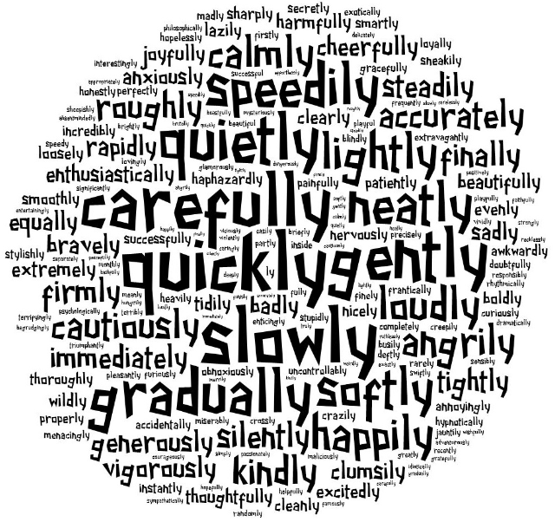

Communicative Grammar
Dr. Elisabeth Pölzleitner
SS 2015

Submitted by

Johanna Grünwald (1211891)
johanna.gruenwald@edu.uni-graz.at
Anja Rieger (1112253)
anja.rieger@edu.uni-graz.at

TABLE OF CONTENTS
Introduction: Why teach Communicative Grammar? 3
Practical Part: Teaching Material for Three Lessons and Analysis
Lesson 1: Activities and Analysis 7
Lesson 2: Activities and Analysis 11
Lesson 3: Activities and Analysis 14
Testing Activity 16
Bibliography 17

Introduction: Why teach Communicative Grammar?
Those of you who have learnt a foreign language are probably familiar with the following scenario: The teacher announces a grammar lesson with the words “Today we are going to study adverbs” and then begins to write the rule for the use of adverbs and their forms on the board. All you do is copying down the rule and then using it to complete fill-in-the-gap exercises in textbooks or on worksheets. After completing the first three sentences you already feel bored because the task has no meaningful context and a few exercises later you might have acquired the necessary skills to master similar tasks successfully, but you have no clue how to use adverbs in real communication. Does any of this sound familiar to you? We dare to say that most of you were taught this way and continue to teach like that because this traditional approach is the one most commonly used in textbooks. In traditional grammar teaching the emphasis is placed on forming correct sentences after the rule has been presented by the teacher and has been dealt with in a brief and unsystematic way. Grammar learning is largely seen as the conscious process of studying the rule, but it is not performance-oriented (see Newby: 2012). Needless to say, this approach does not focus on communicating, which is problematic because actually efficient communication should be the main goal of language teaching; a language only comes alive if you use it in discourse to express your own opinions. Even though the traditional approach might be able to get learners to this level eventually, there exists another approach that makes it a lot easier for learners to internalize grammar rules and use them in the “process of communicating messages between human beings in actual contexts” (Newby: 2012). This approach is named “Communicative Grammar Teaching” and there are several reasons why it supports grammar learning more efficiently and is therefore preferable to the traditional approach.

In order to understand the advantages of the communicative approach, it is important to look at the characteristics an efficient grammar rule should have. Grammar rules for learners should be valid, transparent, systematic and economic (see Newby: 2015). The rule should not have any exceptions and it should be phrased in a way that students can easily understand. In order to accomplish this, the rule should be as short and simple as possible. Unfortunately, many rules in textbooks, which are based on the traditional approach, do not fulfill these criteria because they focus too much of the form of a grammar item. It is, however, considerably more efficient to define grammatical objectives in terms of notions and functions rather than forms. A grammatical notion is a “single grammatical concept which is encoded into a form” (Newby: 2015). This sounds rather abstract, but it is very logical if you look at a concrete example, such as the different notions for adverbs that can be seen in the table on the next page:

Notion | Form
Adverbs of Manner | You must get up quickly.
Adverbs of Degree | It’s terribly late.
Adverbs of Details | I’ve only got half an hour.
Adverbs of Probability | I’ll definitely not get there.
Adverbs of Opinion | Of course, you’ll get there.
Adverbs of Frequency | They usually give you it on the plane.
Using notions as the basis for formulating grammar rules has several advantages (see Newby: 2015). The main ones are that notions relate to meaning and the speaker’s perception of the world. It is natural for human beings to express their thoughts in notions. Strongly related to this is that distinct notions are linked to totally different grammatical concepts and consequently there will not be any confusion about their use, even if they are expressed in the same grammatical form. Moreover, notions make it possible to formulate exceptionless rules, which is rarely the case in form-based traditional grammar rules. Notional grammar is often referred to as “speaker grammar”. It differs from “sentence grammar” because it focuses on grammar as a process. This is done by emphasizing a meaningful context, the relations between speakers and language and the importance of how grammar works, instead of what it is.

This distinction between knowing about grammar and knowing how to use it is important in language teaching and often neglected in traditional approaches, which assume that if you know the rules of a language you can also automatically apply them. However, there is a difference between the two competences, which corresponds to the difference between declarative and procedural knowledge (see Newby: 2015). While traditional grammar exercises tend to support only the development of declarative knowledge, which refers to factual knowledge, the communicative approach focuses on performance and active use of grammar and stresses the importance of using grammar in real contexts. Its aim is to help learners to internalize grammar rules to the extent that they become implicit knowledge, and can be applied automatically. This process of acquiring knowledge is mainly supported by inductive processes, which are characterized by giving the students grammar exemplars and then guiding them in the process of building their own hypothesis about grammatical rules.

It is also important keep in mind that communicative language teaching draws on cognitive approaches to learning and teaching, which has several pedagogical implications, such as the belief that language learning should be meaning driven and goal directed. These goals should be expressed in terms of notions because language learning is considered to be concept learning. Another implication is that grammar activities must be linked to a broader and meaningful context that enables students to include their own knowledge and opinions. Learning is considered to be an active and dynamic process and most importantly, communicative language teaching postulates that understanding emerges from language use; therefore, exercises should also focus on supporting performance. Furthermore, learning is considered to be a stagewise progression that starts with learners’ awareness of new grammar items and ends with their competence to use new grammar items automatically in their own production (see Newby: 2015). What follows from these theories is that when deciding what activity to use for practice, the learning stage of the students must be taken into account.

There are four distinct learning stages that should be addressed to ensure the students’ understanding and correct use of a new grammar item: awareness raising, conceptualization, proceduralization and performance. In order to raise learners’ awareness of a new grammar item, you must provide them with authentic and relevant input, which can be oral or written and it can come from the learners as well as from the teacher. Once you have provided meaningful input, you need to guide the students’ attention in a way that allows them to focus on the new item. This focal attention is important because it ensures that the new item enters the learners’ consciousness and helps them to process it for the next step, which is conceptualization. In this stage, the internalization of rules is the most important component. Learners have to build a hypothesis about the concept of a grammatical notion. They need to test this hypothesis repeatedly before they finally formulate a reliable rule. Throughout this process, the new language is incorporated into their existing knowledge. After this has been accomplished, the learners have to link competence to performance in the proceduralization stage. This is where procedural knowledge emerges from the declarative knowledge that the students have acquired in the previous stage. It is still guided and scaffolded, but learners already encode their own ideas. The final learning stage is performance, where learners are left to themselves to perform various tasks that are embedded in a real-life context and no longer pedagogically structured (see Newby: 2015).
As a teacher using the communicative approach, you need to be aware of the purpose of each of these four learning stages when designing an exercise. You need to know your students’ learning stage to provide them with activities that adequately support their learning. Since you will not always have the time to design your own exercises, it is essential that you know how to analyze exercises provided by textbooks to make sure that they meet the necessary criteria. For this analysis, not only the learning stages need to be taken into account, but you also need to consider the pedagogical principles of communicative language teaching to round off your evaluation. These principles will be explained in more detail in the next paragraph.
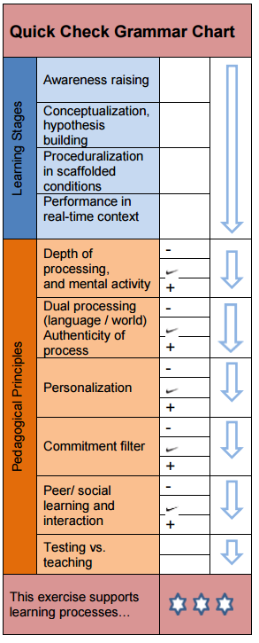
In the exercise analysis, the relevant pedagogical principles are divided into: depth of processing, authenticity of process, personalization, commitment filter, social learning, and the distinction between teaching and testing (see Newby: 2015). Depth of processing refers to the learners’ degree of mental activity and to the extent in which a new grammar item becomes stored in the learner’s memory. Discovery and awareness raising activities are promoted in communicative approaches because they support deep processing, whereas fill-in-the-gap exercises, which are popular in traditional approaches, are cognitively shallow. Dual processing focuses on the authenticity of an activity, both concerning language and context. This means that exercises should require the learners to use language processes that are also used in real communication, for example paraphrasing or gathering of information. Another important factor to be considered is the students’ commitment filter, which describes the degree to which they engage in language learning. This includes affective aspects like enjoyment and fun, but also cognitive aspects, such as curiosity. Personalization and social learning also enhance the learners’ motivation of accomplishing grammar tasks. Last but not least, a distinction between teaching and testing must be made. There are two different types of exercises, summative and formative ones. Summative exercises focus on evaluating whether an item of grammar has been learnt, while formative ones aim at supporting the learning process. It is important to ensure that learners are not being tested when they are actually still in need of practice to process the new language. You need to be aware of the fact that many traditional textbook exercises do not support the learning process but solely focus on testing declarative knowledge.

We hope that the theories and facts we have listed in this essay have been an understandable and convincing introduction to communicative grammar teaching. The points mentioned above aim at showing why the communicative approaches support learning in a highly efficient way and are consequently superior to the traditional approaches. They should also encourage you to critically examine the exercises provided in various textbooks (for example, by using the “Quick Check Grammar Chart” shown above) and help you to incorporate the communicative principles into your own teaching. It may seem more time-consuming at first, but it will pay off because your students will not only learn more, they will also be increasingly motivated and no longer view grammar learning as a complicated obstacle, but as a fun challenge.
Practical Part: Teaching Material for Three Lessons and Analysis
LESSON 1
Activity 1.1: Talent Shows
At the beginning of the first lesson, the topic of talent shows is introduced by asking the students which talent shows they know and if they have ever watched one. Then excerpts from the following videos are shown by the teacher and the students are asked to watch closely what the people are doing during their performance.
https://www.youtube.com/watch?v=uAt5Lm6ys6M&feature=youtu.be (1:33-2:44)

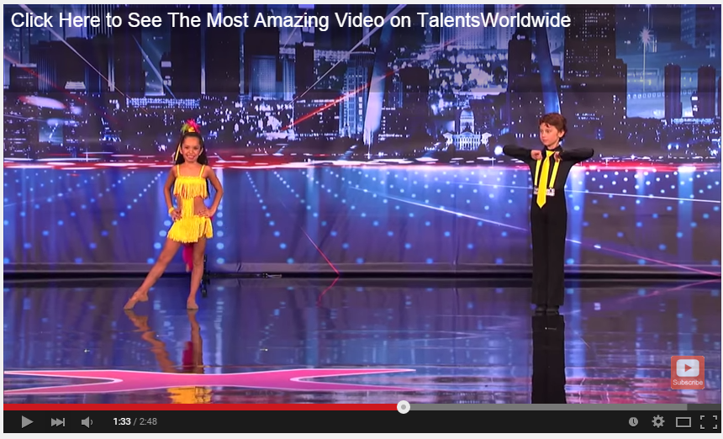
Yasha & Daniela - Amazing and Talented Kid Dancers

(America's Got Talent)

https://www.youtube.com/watch?v=aEjGQB9BKWA&feature=youtu.be (1:40-2:39)

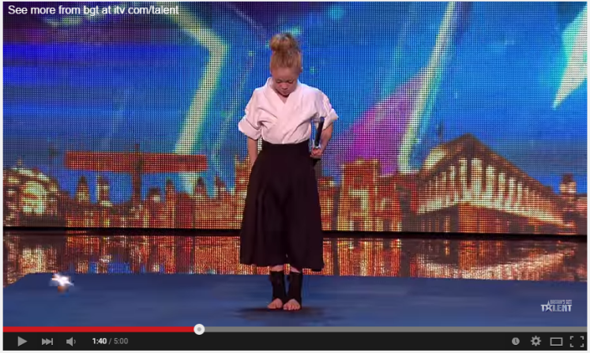
Don't mess with karate kid Jesse

(Britain's Got Talent 2015)

https://www.youtube.com/watch?v=TkhhNfYwFIw&feature=youtu.be (0:30-2:05)

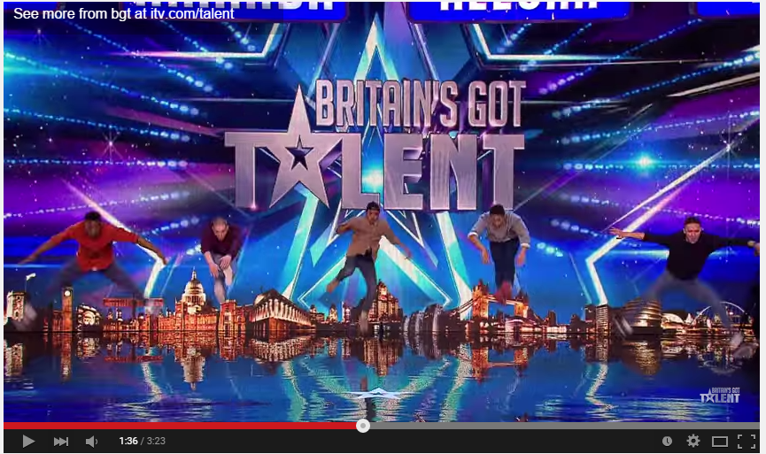
Golden buzzer act Boyband are back-flipping AMAZING! (Britain's Got Talent 2015)

After the videos are shown, the following questions are discussed:
What are the people doing in the video? How are they doing it?
Then the teacher takes notes on the board and organizes the responses in two categories. One category is a collection of adjectives (e.g. good dancers) and the other one of adverbs (e.g. dance well).
The following chart is an example of how the blackboard might look like:
good dancer they were dancing rhythmically
dangerous fighter fighting angrily
great choreography moving elegantly
funny costumes singing enthusiastically
strange expressions shouting loudly

After the videos have been discussed, additional questions can be asked to make the task more personalized, such as: What have you seen other candidates of talent shows perform? What would you perform at a talent show?

After the discussion is over, the students are asked to find a rule for the use of adverbs, guided by the following questions: What do you notice about the forms on the board? When is the one on the left side used? What does the one on the right describe?

Analysis of Task 1.1: Talent Shows
Grammatical objective/learning aim | This activity introduces the notion of manner for adverbs with an interactive awareness raising activity and encourages student to find a general rule for using adverbs.
Learning stage | Awareness raising and conceptualization: Students’ attention is drawn to the different use of adverbs and adjectives based on the difference in form. They are asked to build a hypothesis about the grammatical concept and to come up with their own rule for the use of adverbs.
Depth of processing | Through discovering the difference between adverbs and adjectives on their own the students are required to be mentally active.
Dual processing/authenticity of process | Students have to activate their general knowledge of the world when they are asked to talk about talent shows.
Personalization | At first the students only talk about the videos, but then the activity encourages them to talk about their experiences with talent shoes and their own talents, which increases personalization.
Commitment filter | The videos are entertaining and “rule finding” is like a puzzle to solve, which enhances the students’ curiosity and increases their commitment to completing the task successfully.
Peer/social learning and interaction | Students share their experiences with the whole class and can respond to those of others. The rule finding should be done in pairs.
Testing vs. teaching | This activity is better suited for teaching because it is an oral activity that requires interaction.

Activity 1.2: Stars and their Talents
Students get the following worksheet and have to note down the rule about the use of adverbs they have found. Depending on the time frame, the rest of the worksheet (i.e. the text about stars and their talents) can be completed in class or as homework.
Adverbs – HOW do you DO it?
Complete the rule for the use of adverbs:
You use adverbs to

Read the texts about these stars and their talents and underline all adverbs you can find:


Cristiano Ronaldo is a famous football player. He has won many awards and plays successfully for the Spanish team Real Madrid at the moment. When he joined the team in 2009, he became the most expensive football player in history because his transfer cost 93 Million euros. During his football games he runs fast and moves around quickly. When he takes a penalty, he kicks the ball really hard and normally he scores a goal. He is one of the most marketable athletes and also models from time to time.
Lady Gaga is an American pop star who sings really well and also writes songs for other musicians. She lovingly calls her fans “Little Monsters” and they admire her crazy style. She always dresses strangely and wears unusual outfits, for example, she once wore a dress made of meat, which was received badly by some critics. Her concerts are spectacular shows and when she is on stage, she performs impressive choreographies. She dances rhythmically and uses many special effects. Lady Gaga is her stage name, she is originally named Stefanie Germanotta.

Leonardo DiCaprio is a talented actor who plays his roles so convincingly that he has been nominated for five Oscars. He has received a lot of attention for his role in Titanic in 1997 and since then he has starred in many different films, but most successfully in thrillers and dramas. When he doesn’t work on a film production, he tries to make people aware of global warming because he is fully committed to saving the environment. His romantic life has also been widely covered by the media because he has dated several top models and beautiful actresses.
Complete the rule for the formation of adverbs. How are the exceptions formed?
To form an adverb, you have to
Exceptions: fast –
hard –
good –
Analysis of Task 1.2: Stars and their Talents
Grammatical objective/learning aim | This activity focuses on how adverbs are formed and used in texts to describe actions.
Learning stage | Conceptualization: Students are already aware of the use of adverbs and have to find a rule for their formation. It focuses more on form than the previous exercise.
Depth of processing | Students are encouraged to internalize the form of adverbs through many similar examples. They also have to formulate their own rule and find exceptions to it, which means that they constantly have to test their hypothesis and be mentally active.
Dual processing/authenticity of process | The texts are about famous people they probably know, which links it to their general knowledge of the world and possibly also to their personal interest.
Personalization | This activity is not personalized but it could be, if after comparing the tasks the students were then asked to share their own knowledge about these stars or about others they know and like.
Commitment filter | Students might be interested in the text on a content level because they want to find out more about the stars and they are challenged to find exceptions to the rule, which applies to their curiosity.
Peer/social learning and interaction | No peer interaction necessary, but the answers can be compared with a partner.
Testing vs. teaching | This activity is better suited for teaching because it aims at improving students’ understanding of the rules.
LESSON 2
Compare the tasks on the “Stars and their Talents” worksheet and revise the rules for the use and form of adverbs at the beginning of the lesson.

Activity 2.1: Manner Mimes
Source: http://www.polzleitner.com/epep/Grammar/adverbs/manner-mimes.pdf
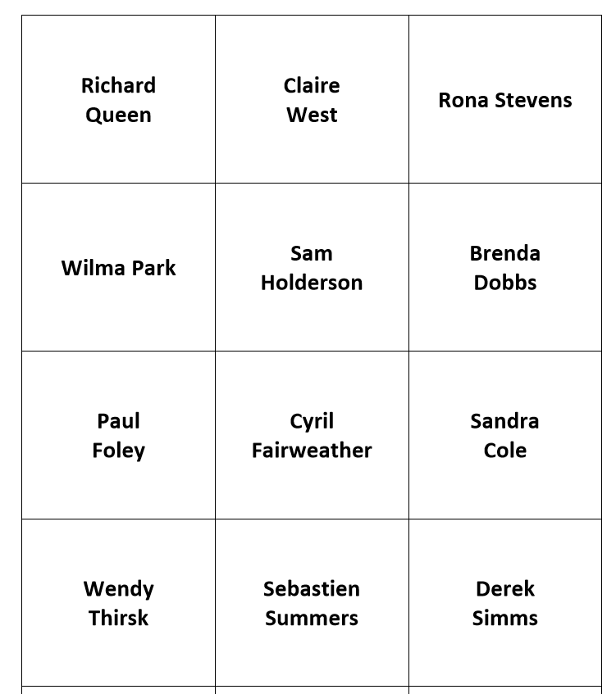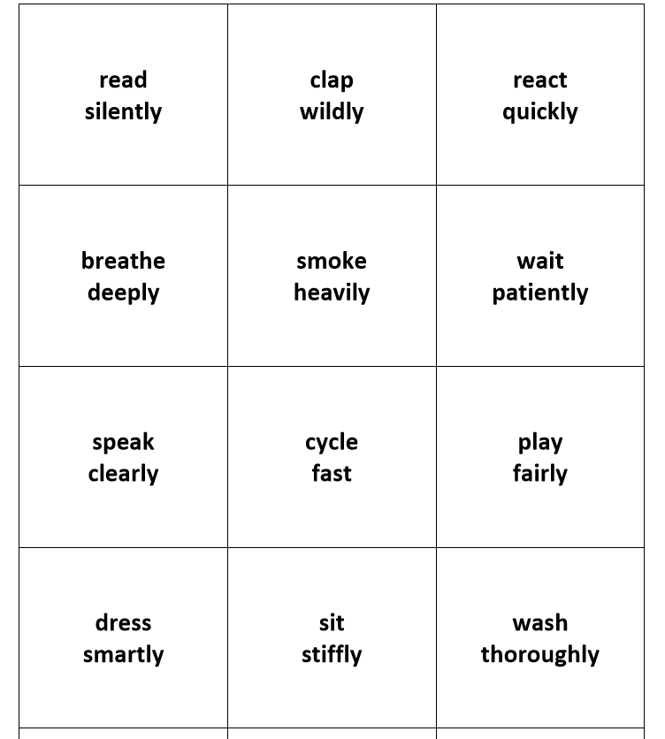

Task 1: Play in groups of four to five. Hand out the cards with the names on top. Each card shows the name of a person on one side and the manner in which he or she does something on the other side. Look at your own cards and make sure you know what the verbs and adverbs mean and how to pronounce them. Ask your teacher for help if necessary.
Start: The youngest player takes a card and introduces the person on it.
For example: His name is Steve Wilson and he …….
The player then mimes the action “skis well” and the others have to guess what Steve Wilson does and how he does it. The initials of the name provide a clue! It is important to mime only, don’t speak or make any noises!

Task 2: Now each student creates three new cards, mimes the action and the others have to guess what the person does and how they do it.

Analysis of Task 2.1: Manner Mimes
Grammatical objective/learning aim | This activity aims at helping the students to internalize the form of adverbs through repetition and shows them common collocations of verbs and adverbs that usually occur together.
Learning stage | Proceduralization: Students are already aware of the concept of adverbs, and repeatedly practice the form. Later, they produce utterances that encode their own idea when they invent actions for their own cards.
Depth of processing | The student who mimes has to “translate” the words on the cards into actions. The others have to do the opposite and “transform” the movement into words. All of them are highly mentally active because the task goes beyond the understanding of written language, but also incorporates understanding body language.
Dual processing/authenticity of process | Through the miming activity, the notion of adverbs of manner is even more closely linked to real-life actions because it explicitly shows that adverbs describe an action and not a state.
Personalization | When students create their own cards, they can work creatively and encode their own ideas.
Commitment filter | Students are very committed to the activity because it is a fun guessing game that they want to win. The fact that they have a challenge when trying to guess what the person is miming also applies to their need for curiosity and solving a puzzle, which means that not only affective but also cognitive factors of motivation are considered.
Peer/social learning and interaction | The activity places emphasis on peer learning, since interaction is essential to successfully complete the game.
Testing vs. teaching | This activity can only be used in teaching because it is a game and requires interaction. The teacher’s role is being an observer and not an evaluator.

Activity 2.2: Which go together? Find matching pairs
Source: Newby, D. (1992) Grammar for Communication: Exercises and Creative Activities. Wien: Österreichischer Bundesverlag Gesellschaft. 117.
Go together with a partner. Find pairs from each box and form sentences. Have a classroom competition to see which group can make the most sentences. You can also try to find some additional adverbs that fit to the given verbs.
badly – brightly – carefully – clearly – easily – hard – neatly – politely – properly – rudely – terribly – thoroughly - tightly
cut – examine – explain – hit – hold – hurt – miss – shine – speak – understand – win – work - write

Example: I cut my finger very badly. Romeo misses his girlfriend terribly.

Analysis of Task 2.2: Which go together? Find matching pairs
Grammatical objective/learning aim | The purpose of this task is to make the students aware of the importance of collocations and to provide them with a collection of matching verbs and adverbs.
Learning stage | Proceduralization: Students know what adverbs are used for and have to produce their own sentences in a scaffolded context.
Depth of processing | By trying to find the right pairs, the students discover which verbs and adverbs fit together and which don’t. If they come up with additional adverbs, they draw on their previous knowledge.
Dual processing/authenticity of process | The exercise is not closely linked to a real-life context, but the concept of collocations is highlighted and can also be applied to a broader context in language learning than solely to adverbs.
Personalization | This activity is not personalized.
Commitment filter | Since the activity is designed as a competition, the students will be motivated to find as many sentences with matching pairs as possible.
Peer/social learning and interaction | In this activity, students work with a partner, which means that peer learning takes place because they can share their own and comment on each other’s ideas.
Testing vs. teaching | Since it is a competition in a fun context, this activity is suited for teaching but it could also be used in testing. However, first it would need some modification, e.g. clearer instructions about how many matching pairs you need to find.

Homework Lesson 2: What are your Talents? (Writing Task)
Imagine you want to take part in a talent show. Write a short text about your talents (they can be your actual talents, but a little exaggeration is also allowed!) and describe the act you want to show. Focus on how you are going to perform and use many adverbs to help the reader to picture your performance as vividly as possible. You can also add a drawing to your text if you want to. (Write about 120 words)
Analysis of Homework Lesson 2: What are your talents? (Writing Task)
Grammatical objective/learning aim | In this activity students are instructed to apply the newly acquired rule accurately in a meaningful context.
Learning stage | Performance: The activity incorporates the application of the rule and learners are left to themselves to accomplish it.
Depth of processing | Very high; students have to draw on their newly acquired knowledge and also include facts about themselves. This activates and maximizes the learners’ mental energy.
Dual processing/authenticity of process | The students are given a context that is not scaffolded, but meaningful and authentic. The task represents a real-life situation and the students are already made familiar with the topic of talent shows in the first lesson.
Personalization | The task allows students to write freely and creatively about their own talents and they are also given the opportunity to let their imagination run free.
Commitment filter | Very high; students are keen on sharing their own talents and expressing their ideas; by including the students’ imaginations, the task becomes more enjoyable and fun.
Peer/social learning and interaction | This activity is a homework assignment, which needs to be done alone. Therefore, no peer learning takes place.
Testing vs. teaching | This activity could be used in teaching as well as in testing, as it gives the teacher the opportunity to assess the students’ learning progress and of their understanding of the rule.

LESSON 3
Activity 3.1: Story time
Source: Newby, D. (1992) Grammar for Communication: Exercises and Creative Activities. Wien: Österreichischer Bundesverlag Gesellschaft. 116-117.
Task 1: Can you improve the stories by adding suitable adverbs? The words in the box will help you but you can use your own if you prefer.
angry – gentle – in terror – in pain – passionate – quick – romantic – slow – soft – sweet – tender – tight – violent - strong

Horror Story:
The great iron door opened slowly and there in front of my eyes stood Count Dracula. As I stared at him ……... his lips began to move. ‘How dare you come into my castle!’ roared Dracula …………. . He held my arm …………….. and shook me ………………. . I screamed ……………. . Suddenly I was able to free myself and I ran ……………. through the iron door.
Love Story:
They looked tenderly into each other’s eyes. He stroked her face……………… and smiled …………… at her. ‘I love you,’ she said ……………. . Suddenly he kissed her ……………… . He held her ………………….. to his chest. She could feel his heart beating ………………. and the sweat running ……………… down his face.

Task 2: Together with a partner, write your own short horror/love story (or if you prefer it, a crime or science fiction story) using as many words in the box as possible. You can also add your own adverbs to make the story even better. You should be finished in 15 minutes and write about 50 – 100 words.

When all of you have finished, you should leave your stories on your desks and walk around the classroom to read the ones the others have written. You can award one star to your two favorite stories (by drawing it on the sheet after reading). At the end of the lesson, the stories with the most stars wins and the “authors” get to read them out loudly to everyone in class.

Analysis of Task 3.1: Story Time
Grammatical objective/learning aim | This activity demonstrates how adverbs can be used to create a more compelling and dramatic story. It also shows where adverbs are usually located in a sentence.
Learning stage | Proceduralization and performance: At first the students only revise how adverbs are formed and are instructed to fill them into the correct gap in a rather scaffolded context; in the second task, though, they create their own stories and apply the rule themselves.
Depth of processing | The first task is more or less a revision, which means that students have to draw back on their existing knowledge, but in the second task they have to activate all their mental resources to create their own story to accomplish the task.
Dual processing/authenticity of process | Students are given a familiar and meaningful context (e.g. horror or love story) and are asked to create their own story where they can include their own ideas and knowledge of the world.
Personalization | The activity does not necessarily reflect the students’ personal lives, but they can of course incorporate their own experiences. They are also encouraged to use their imagination.
Commitment filter | Not very high in the first task, but in the second task students are very motivated because they know that others will read their story and they will be rewarded if they win the competition.
Peer/social learning and interaction | The activity requires interaction and sharing ideas with a partner and later on the whole class is involved.
Testing vs. teaching | The way the activity is planned in this lesson it is only suited for teaching, but it can be adapted and changed into a testing activity, e.g. a free writing task.

Testing Activity: Adjective vs. Adverb
Read the following story and complete the gaps with the correct form (adjective or adverb).

A Terrible Gym Class

Last week we had a ____________ (horrible) gym class. Our gym teacher was __________(sick), so we had a really __________(mean) substitute teacher, Mr. Smith. At the beginning of class, he stormed in ____________ (angry) and started shouting at us _________(loud). Usually, we play soccer, which we really like, but this time we had to run _________(fast) around the track for half an hour. It was a ________ (hot) and _________(sunny) day and I was sweating __________(heavy). Then one of my classmates tripped and hurt himself ____________ (bad). He started crying __________ (miserable), but Mr. Smith told him to be __________ (quiet) and that he should keep running. I felt sorry for my friend, but I was too _________ (scared) to say anything. I am really glad that our old gym teacher is feeling ________(good) again and that he is coming back.

Analysis of Testing Activity: Adjective vs. Adverb
Grammatical objective/learning aim | The grammatical objective is to test explicitly if the students have understood the different use of adjectives and adverbs, and if they can form adverbs correctly.
Learning stage | Proceduralization: Students have to apply their acquired knowledge of the rule in a scaffolded context.
Depth of processing | Students can monitor their own language production and check whether they know how to use the rule accurately.
Dual processing/authenticity of process | The content of the story is authentic and communicative. It is a coherent text and the students are familiar with the topic.
Personalization | There is no personalization in this activity.
Commitment filter | Students want to demonstrate that they can apply the acquired rule accurately.
Peer/social learning and interaction | There is no peer interaction.
Testing vs. teaching | This exercise is solely a testing exercise that is specifically designed to show the teacher and the students if they are able to distinguish between the use of adjectives and adverbs.

Bibliography
Newby, D. (1989) Grammar for Communication. Vienna: Österreichischer Bundesverlag.
Newby, D. (1992) Grammar for Communication: Exercises and Creative Activities. Vienna: Österreichischer Bundesverlag.
Newby D. (2012) “Pedagogical Grammar”. In: M. Bryan, ed. Encyclopedia of Language Teaching and Learning (2nd Edition). New York: Routledge.
Newby, D. “An Introduction to Cognitive Communicative Grammar“. In Course Handout C+C Grammar (Summer Semester, 2015).

Webliography
Manner Mimes: http://www.polzleitner.com/epep/Grammar/adverbs/manner-mimes.pdf [29 May 2015]
Quick Check Grammar Chart: http://www.polzleitner.com/epep/Uni/Grammar/QuickCheckGrammarChart.pdf [29 May 2015]
Picture Links
Cristiano Ronaldo: http://www.realmadrid.com/en/football/squad/cristiano-ronaldo-dos-santos [1 June 2015]
Gym teacher: https://kenthinksaloud.wordpress.com/2015/01/09/why-a-certain-type-of-teacher-are-bullies-and-why-this-has-to-change/ [1 June 2015]
Lady Gaga: http://www.wallpapersdb.org/music/lady-gaga/lady-gaga-hair-wallpaper-3106.htm [1 June 2015]
Leonardo DiCaprio: http://www.fanpop.com/clubs/leonardo-dicaprio/images/23352439/title/handsome-leo-3-photo [1 June 2015]
Word Cloud on title page: http://1.bp.blogspot.com/-xF6AVf-6In0/Ul7w8GAx3MI/AAAAAAAAAUM/NYh2rG1Fhyc/s1600/For+Blog.png [29 May 2015]

Taken from Newby, D. (1989) Grammar for Communication. Vienna: Österreichischer Bundesverlag. 142.

