
Testing exercise - James and Emma

Write a story about the lives of James and Emma, an elderly couple living in Austria.
Be sure to incorporate the dates given on the timeline below. Everything else can be invented.
All sentences describing the events on the timeline have to use for or since.
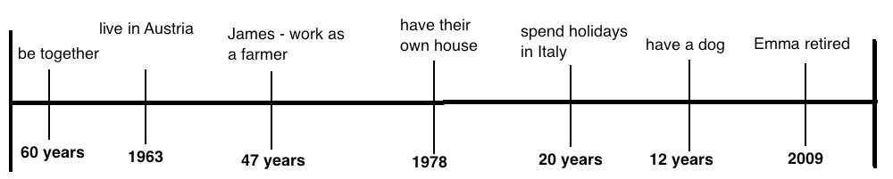
Example: James and Emma have been together for 60 years.

