Present Perfect Tense Memory

Preparation: memory set (26 cards)
Activity description:
Students play together in groups of two to four. All cards are spread on the table face-down; a student picks two cards in each round and looks whether they belong together. If the cards belong together the student answers the question before he/she puts the cards on his/her deck. If a student finds a correct set of cards he/she has another go. In the end, the student with the highest deck of cards wins.
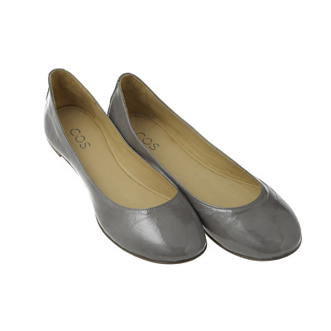

Have you ever worn …?


Have you ever died your …?

Kangaroo meat


Have you ever eaten …?
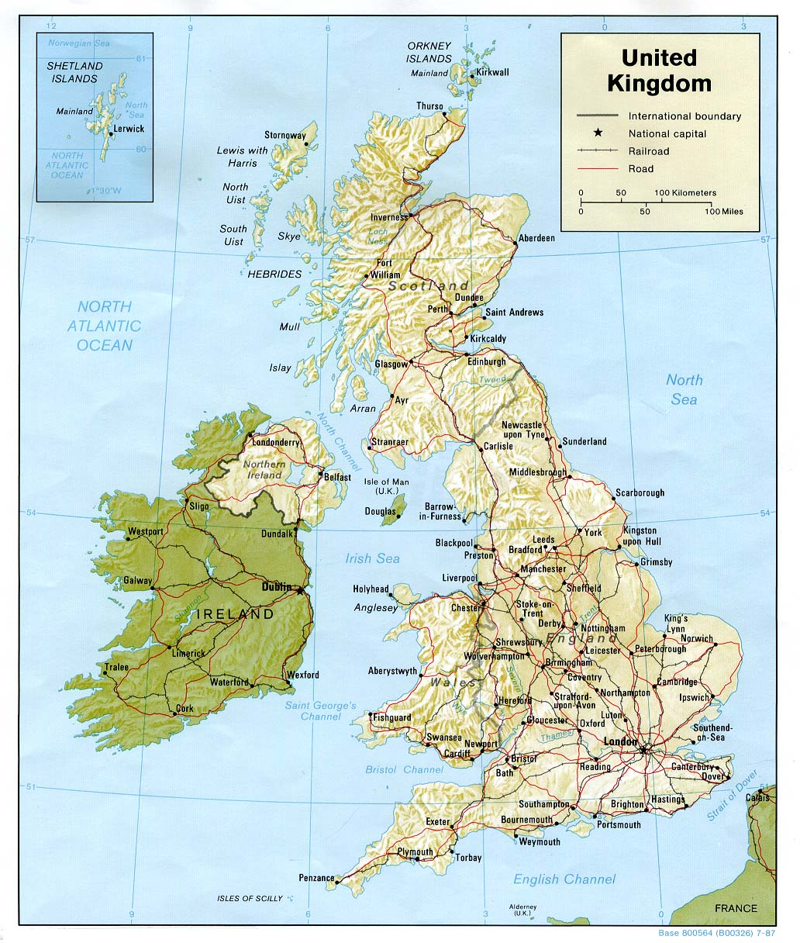

Have you ever been to …?

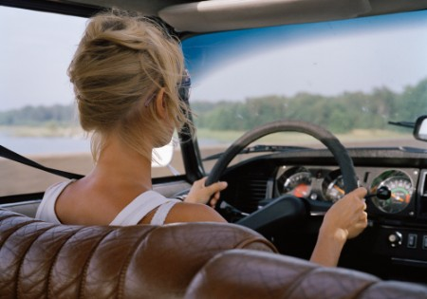

Have you ever driven a …?
kilt
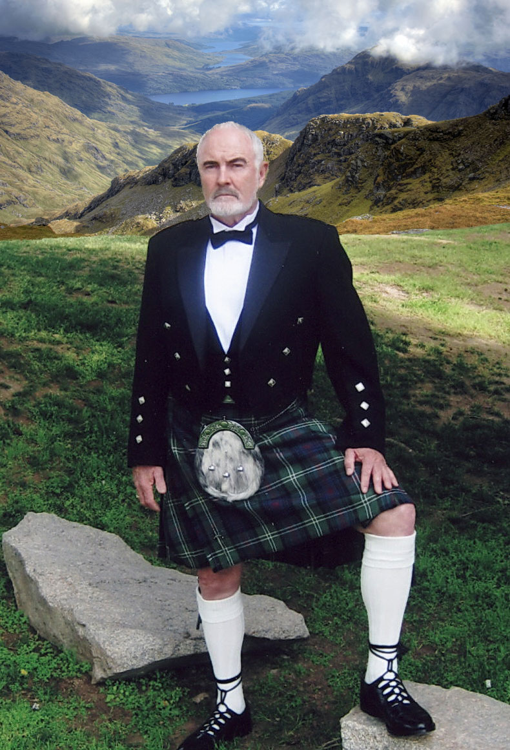

Have you ever worn a …?

Have you ever watched …?


Have you ever drunk … ?


Have you ever won a …?
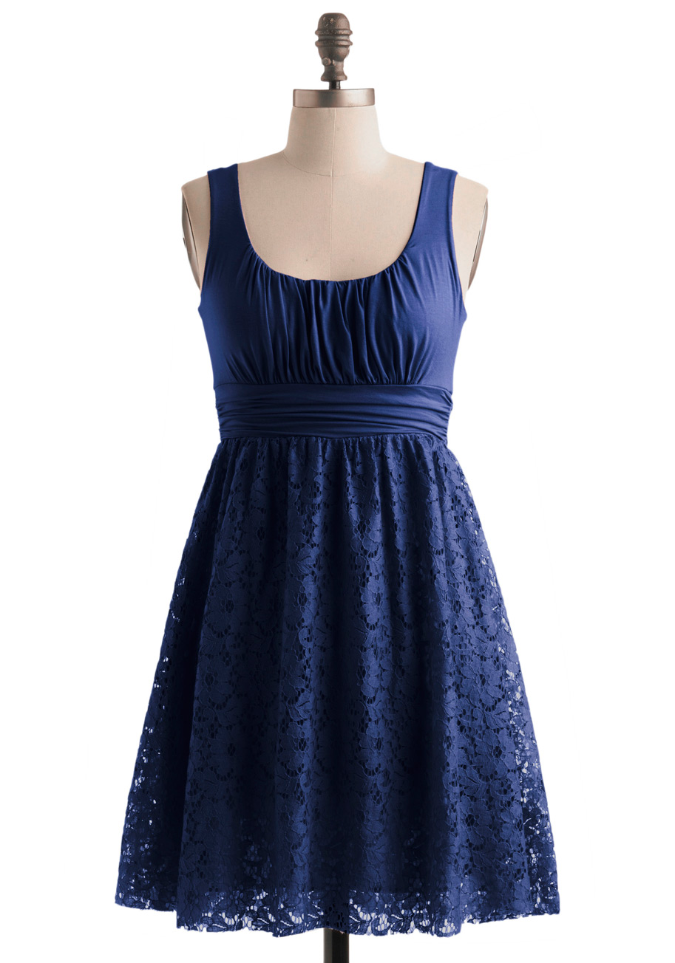

Have you ever worn a …?



Have you ever played …?

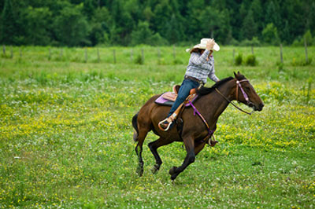

Have you ever ridden a …?

Have you ever had a …?



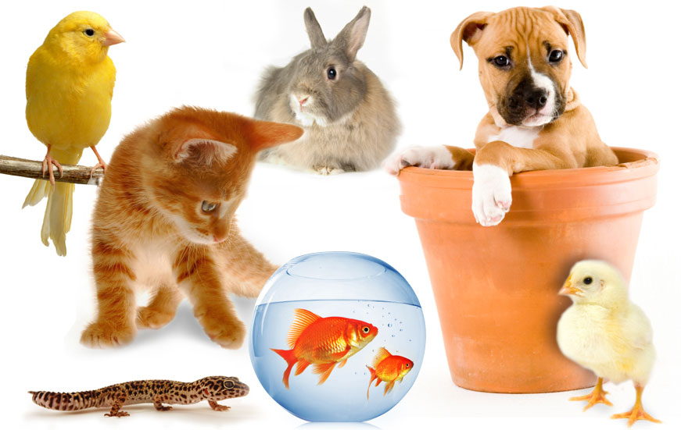

Billy the Boaster (game)

Source: derived from David Newby’s Grammar for Communication, Exercise book, p. 63.

Preparation: cards with pictures

Activity description:
Every student draws a card from the bag and finds a partner. On the cards the students will find words (such as of a place, item, person, etc.) and they have to think of something they would like to do/have/see connected to this item. The other student is “Billy the Boaster” and has done everything the first student would wish to do already.

Student Instruction:
Student A: you will find a picture of something (place, item, person, etc.) on your card. Now think of something you’d like, love or wish for, that has something to do with the item on your card.

Jewelry
Example:
“I’d really love to wear a golden necklace!”
“I would really love to have blue earrings!”

Student B: You are “Billy the Boaster”. Everything (doesn’t matter what) your partner would like to have or do, you have had or done already! Try to be a real boaster and make up funny stuff.
Example:
“Well, I have already worn thousands of golden necklaces in my life!”
“Well, I have had several pairs of blue earrings already.”

Make sure that you play both roles at least twice during the exercise!

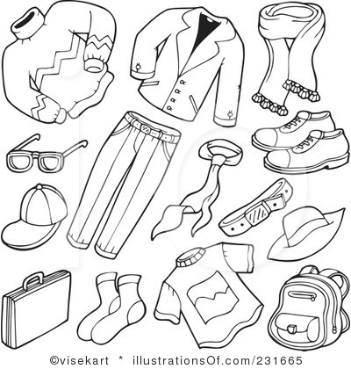
clothing
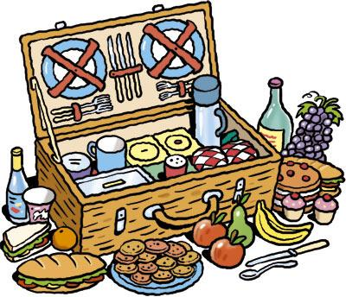
food

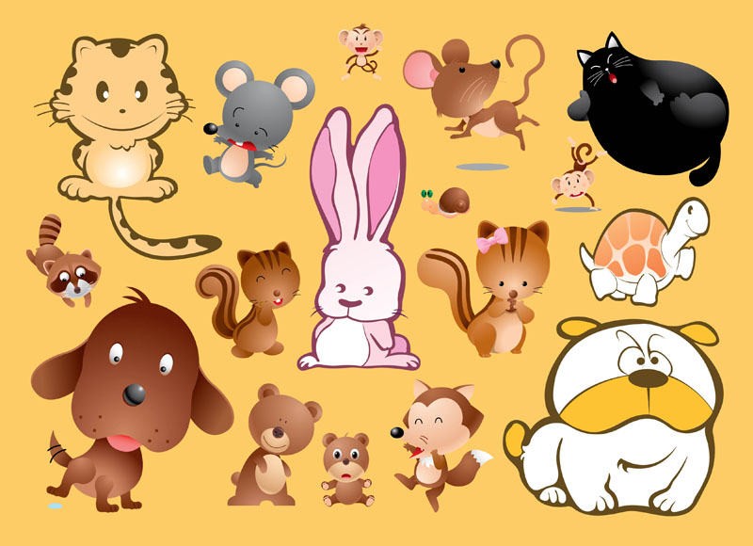
pet
Jewelry
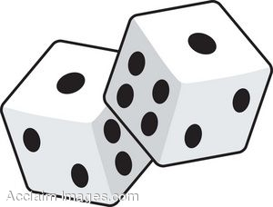
game

place
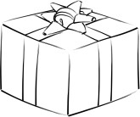
christmas present

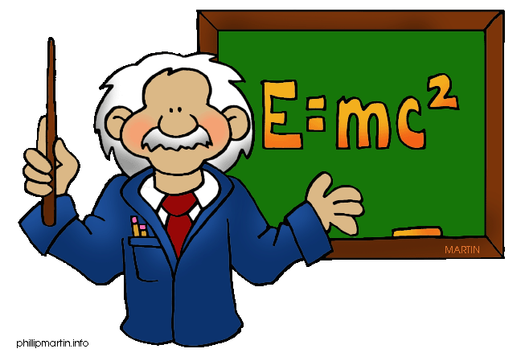
famous person

Billy the Boaster (game)

Source: derived from David Newby’s Grammar for Communication, Exercise book, p. 63.

Preparation: cards with pictures

Activity description:
Every student draws a card from the bag and finds a partner. On the cards the students will find words (such as of a place, item, person, etc.) and they have to think of something they would like to do/have/see connected to this item. The other student is “Billy the Boaster” and has done everything the first student would wish to do already.

Student Instruction:
Student A: you will find a picture of something (place, item, person, etc.) on your card. Now think of something you’d like, love or wish for, that has something to do with the item on your card.
Jewelry
Example:
“I’d really love to wear a golden necklace!”
“I would really love to have blue earrings!”

Student B: You are “Billy the Boaster”. Everything (doesn’t matter what) your partner would like to have or do, you have had or done already! Try to be a real boaster and make up funny stuff.
Example:
“Well, I have already worn thousands of golden necklaces in my life!”
“Well, I have had several pairs of blue earrings already.”

Make sure that you play both roles at least twice during the exercise!

clothing
food

pet
Jewelry
game
place
christmas present

famous person

How many pieces can you win?

Preparation: bag/bowl with questions on strips of paper in it.

Activity description:
Students move freely in the classroom and choose a partner. They ask each other the question on their strip of paper (which they have drawn from the bag) and depending on their answer they win or lose. If they win they can keep their strip of paper and if they lose they have to give it to their partner. A student wins if he/she has had or done a certain thing more often than the other person.

Example:
A: Have you ever showered several times on the same day?
B: Yes.
A: How often?
B: Twice.
A: I once showered four times on the same day.
(Student A wins and can keep his strip of paper)

It is the goal of each student to get as many strips of paper as possible. This means, that the students change partners as soon as they have asked each other the questions and ask someone else in order to win the next strip. In the end, the student who gathered most strips of paper wins.

Questions:
Have you ever been to a very exotic country?
Have you ever cooked a meal for someone? How often?
Have you had a pet? If yes, how many pets have you had?
Have you ever won something?
(a prize, money, …)

Have you ever eaten something very exotic?
Have you eaten a snail? If yes, how old were you?
Have you ever seen / met a famous person?

Have you ever watched several movies on one day? If yes, how many?

Have you ever showered several times on the same day?

Have you ever had several 1’s in a row?

Have you ever given someone an extremely large present for Christmas? (not in terms of costs, but in terms of size)
Have you had a really crazy hair color? How crazy?

Have you ever read a whole book in one day? How many hours did it take you?

Have you had a relationship for a long time?

Building Sentences
Peter | has been bitten | by a dog
Jennifer | has been | to the stables quite often
Thomas | has won | the karate tournament
Caroline | has been | hang gliding
Michael | has followed | Erik´s example of studying.
Erik | has been | to the state library in Vienna
Rebecca | has been | to Rome
Natalie | has swum | across the Donau.
Christoph | has been | inside a walk- in closet
Gerald | has been | to the LoL-Championship
Melanie | has been | to the Netherlands
Judith | has been | inside a cage with a bear
Philipp | has played | Golf
Karin | has thrown | an Olympic hammer.
Katrin | has been | to Italy
Barbara | has ridden | a camel
Mario | has driven | a go cart
Alex | has tricked | Christoph once
Christoph | has driven | a tractor once
Daniel | hasn´t been | to our last lesion
Maria | hasn´t ever been | to detention

but | he hasn´t ever been | afraid of a dog anyway
still | she has never | ridden a pony
also | he has never been | Defeated
luckily | she has never been | in a hang gliding accident
However, | he still has never been | to the library
and | he has also been to the | museum of natural sciences
but | she hasn´t been | to Venice
However, | she hasn´t participated | in a swimming contest yet
but | he hasn´t been | inside a walk in freezer
even though | he has never played | League of Legends
but | she hasn´t visited | Amsterdam
luckily | she has been | in there with a bear cub
and | hasn´t ever lost | a ball
However, | she hasn´t actually been | to Greece
but | she hasn´t been | to Rome
but | she has never ridden | a horse
also | he has won | go cart races
however | Christoph has tricked | Alex once also
luckily | he hasn´t had | an accident yet
but | he has been | to the Förderunterricht
because | she hasn´t ever been | caught being naughty

Preparation:
The names and sentences are unique for every class in order to personalize them. The sentences have to be cut out along the lines to allow students to "build" sentences.
Activity Description:
Students form groups of 4-5 people and have to use the pieces of paper with parts of sentences written on them to form meaningful sentences about the experiences of their peers. Sentences consist of two statements like for example "Peter has been bitten by a dog -- but he hasn´t ever been afraid of a dog anyway.” The follow up sentences can be mixed with the pieces of paper with the first part of the sentence written on them or one could separate the two parts of the sentences in two different piles to vary the difficulty of the exercise.

Student Instructions:
Take the pieces of paper provided to you and try to form meaningful sentences with them. They are all about your class, so think about what you know of your colleagues and use this knowledge to form the sentences correctly and truthfully.
Example: Peter has been bitten by a dog but he hasn´t ever been afraid of a dog anyway.
Work in groups of 4-5 people

The big question mark
Source: Diwold et al. (2008) Friends (activity book), year 3, p. 67. Veritas: Linz
Preparation: You need a dice and counters
Student instruction:

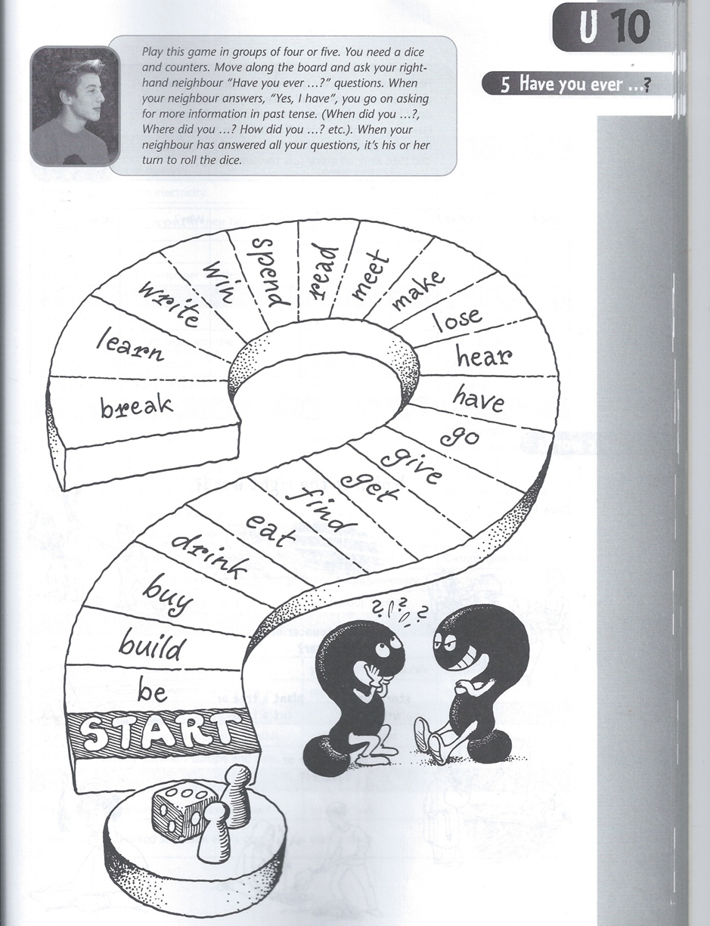

Mysterious superpowers - but they are ours
Activity Description:
Pupils have to imagine having superpowers and draw a short comic about their past deeds and experiences. After this they switch comics with a partner and based on that comic try to guess the superpowers and experiences of their partner. If they have guessed all the powers of their partner or the time limit has passed the pupils have to switch roles meaning the interviewer is now the interviewee. Pupils are specifically instructed to formulate their questions in the Present Perfect Tense.

Student Instructions:
- Today we create our own superhero. Imagine yourself to have superpowers. What would those powers be and what would you do with them? Draw a comic which shows your past deeds.
- After this, switch comics with a partner. Then ask your partner what he/she has experienced as a superhero and based on the comic and on the answers of your partner, try to guess the powers he or she has. Your partner can then correct or confirm your guesses.
- Switch roles.

- Focus on using the Present Perfect Tense!

Example: A: Have you saved an old lady by shooting healing rays at her?
B: No, the old lady was a villain and I defeated her with my laser beams.
A: Have you ever flown around the world really fast?
B: No, since I cannot fly.
A: Have you ever lifted and thrown a whole car?
B: Yes, I have.
A: Do you have super strength?
B: Yes, I do.
A: Have you ever.....

It´s what you do - but who are you?
Preparation:
It is necessary to bring blank pages to class because otherwise the kind of sheet the pupils use could give away who the author is and defeat the purpose of the game.
Change a bit: Write down 10 or 20… interesting experiences that you have ahd and that define you in some way.
Activity Description:
Pupils have to write down experiences which they have had and which define them and then hand in the sheet without adding their name to it. Those sheets are then mixed and every student has to take one sheet out of the pile, read the description of experiences and guess who the author of the text is by walking up to people and asking them questions about their experiences until they can without a doubt say if that person is the author of the text they have received.

Student Instruction:
- Write down what you have done this week on a sheet of paper but do not exceed the limit of 20 sentences. Try to mention and describe experiences which define you because after you are done writing your text you will have to hand in the sheet. Those sheets will be mixed and you will have to pick a random sheet from the pile.

- Read the text and try to find the person who wrote it. Do so by approaching people and ask them questions about their week. (For example: Have you been at the zoo this week?). The person interviewed then has to answer the questions until you can - without a doubt - say if it is the right or the wrong person.

- Remember not to write your name on your sheet.
- Remember to use the Present Perfect Tense

