ORAL ACTIVITY: DECEPTION
Teaching the Notion ‘Experience’
In this oral activity the students are supposed to write down twelve present perfect sentences about things they have and haven’t done in their lives using the verbs in the box. Then they should go together in teams of three and play against another team. Each team should have the same number of players. The oldest student starts reading out a sentence and the opposing team players have to guess whether the statement is true or false. If the opposing team reveals the correct answer, they’ll get one point. Then one player of the opposing team starts reading out one sentence. This continues back and forth until all sentences have been used. The team with the most points wins.
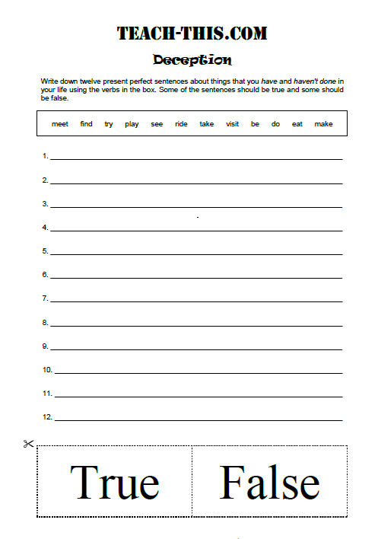
LEARNING STAGE | Proceduralisation
DEPTH OF PROCESSING & MENTAL ACTIVITY | grammar is embedded in a meaningful context; students need to apply the previously learned rule and form when writing the sentences
DUAL PROCESSING & AUTHENTICITY OF PROCESS | Very authentic, the sentences state the students’ personal life and the classmates need to guess whether the statements are true or false.
PERSONALIZATION | Highly personal as students need to use their own experiences to create the sentences.
COMMITMENT FILTER | very exciting; high fun factor; students are keen on finding out the truth and to win points for their team
PEER/SOCIAL LEARNING & INTERACTION | group activity; students get to know their classmates better and also need to work together to find out whether the statement is true or false
TESTING VS. TEACHING | Since this activity is a game, it can only be used in class for teaching purposes.
SUPPORTS LEARNING  PROCESSES? | 3 Stars

