Focus on Language and the Learner

Lecturer: Dr. phil. Elisabeth Pölzleitner
Dear Ms Stieg, Dear Mr Hirt,
Your project is really excellent. I must admit that I have never taught the gerund as s separate topic. I have only taught it as vocab phrases. You have done a really great job here. All your activities will work exceptionally well. I will save your paper in a special place and hope to be able to try out some of your ideas. There’s only one tiny thing: make sure all your picture sources are given. It shouldn’t take more than a few minutes to fix this.
Congratulations!!!!

Grammar Project on Teaching
Notions Using the ‘Gerund’

Written by:
Michael Hirt, 01413930
Martina Stieg, 08935093

Winter Semester 2017/18

University of Graz

Table of Contents
1.1 Introduction 1
2.1 Unit 1 – Notion: Likes and Preferences 1
2.1.1 Unit 1, Activity 1: What I Like and What I Hate Doing 2
2.1.2 Unit 1, Task Sheet 1 - Truth and Lies About Things I Like or Hate Doing 3
2.1.3 Unit 1, Analysis of Activity 1 – Truth and Lies About Things I Like or Hate Doing 4
2.2.1 Unit 1, Activity 2: Highlight the Different Verb Forms 4
2.2.2 Unit 1, Activity 2: Finding the Lies 5
2.2.3 Unit 1, Analysis of Activity 2: Finding the Lies 5
2.3 Unit 1, Activity 3: Homework – Flip Grid Video 6
3.1 Unit 2 – Notion: General Statements 6
3.1.1 Unit 2 - Introduction 6
3.1.2 Unit 2, Activity 2: Gerund Card Game 6
3.1.3 Unit 2, Analysis of Activity 2: Gerund Card Game 12
3.2.1 Project Work – Class T-Shirts 13
3.2.2 Unit 2 - Examples of T-Shirt Slogans 14
3.2.3 Unit 2, Activity 1: Designing T-Shirts with A Message 14
3.2.4 Unit 2, Analysis of Activity 1: Designing T-Shirts with A Message 15
4.1 Unit 3 – Notion: Thoughts 17
4.1.1 Unit 3 – Introduction 17
4.1.2 Unit 3 – Blog Entry (Sample) 17
4.1.3 Unit 3, Activity 1: Memories of School 18
4.1.4 Unit 3, Analysis of Activity 1: Memories of School 18
4.2.1 Unit 1, Activity 2: “Where Is Jennifer?” 19
4.2.2 Unit 1, Activity 1: Witness Statements (“Where Is Jennifer?”) 20
4.2.3 Unit 3, Activity 3: Locating Jennifer (Map) 22
4.2.4 Unit 3, Analysis of Activity 1: “Where Is Jennifer?” 23
4.2.5 Unit 3, Activity 4: “What Happened to Jennifer?” 23
4.2.6 Unit 3, Analysis of Activity 4: “What Happened to Jennifer?” 24
4.2.7 Unit 3, Activity 5: Homework – Write A Blog Entry About Memories 24
4.2.8 Unit 3, Analysis of Activity 5: Homework - ‘Blog Entry About Memories’ 25

Introduction

The “-ing form” of verbs - also known as gerund - is used to describe activities. There are various notions how gerunds are used, and some of them are grammar notions whereas others are more or less linked to certain words which require the gerund as a structure. We have prepared three units including homework or follow-up activities which cover the notions of LIKES AND PREFERENCES (Unit 1), GENERAL STATEMENTS (Unit 2), and THOUGHTS (Unit 3) as they are presented in David Newby’s Grammar for Communication (Newby, David (1992). Grammar for Communication. ÖBV: Wien.133.) The first two units which we have prepared can be carried out consecutively (both of them are designed for a third grade), whereas the third unit can be used independently (it is designed for a fourth grade). For each unit we have integrated homework in order to promote proceduralization and performance.
In our paper teaching instructions are written in blue and marked as boxes with beige background. For Unit 1 the examples of the teacher are also listed in such a box as these examples are teaching examples and voiced by the teacher.

2.1 Unit 1 – Notion: Likes and Preferences

The first unit aims at making the students familiar with the notion of LIKES AND PREFERENCES. It is designed for third grade Unterstufe, the level being A2.
Today I want to talk about activities we like or hate. I have prepared a list of activities which I like or which I hate, and I want to show the list to you.
The teacher tells the students which things she/he likes/enjoys/hates doing. While telling the students the teacher writes the statements in two columns on the board.
Note: the teacher should highlight the verbs which require the gerund in one color and the gerund (verb+ing) in another color, so that the students have a visual aid which should help them notice the verbs as well as the changed verb form that follows.
Suggestion: writing the sentences on the board might take some time. If you want to save time you can prepare the sentences on large paper slips and use magnets to present them on the board in class. Make sure you highlight the verbs like, enjoy, hate etc. in one color and the gerunds in a different color. Another option would be an animated PowerPoint Presentation with the various activities including pictures which should show the activity.

Activities I like or hate doing

- I like skiing at Planneralm.  - I like playing Christmas songs on the piano.  - I like baking cookies with my sister.  - I enjoy singing Justin Bieber songs in the shower.  - I enjoy watching all the Harry Potter films in one day.  - I am interested in gardening.  - I am interested in travelling. | - I hate dancing all by myself.  - I hate walking across a cemetery at night.  - I hate snowboarding.  - I hate playing computer games with my sister.  - I hate staying in bed when I am ill.  - I don’t like dancing in the dark.  - I don’t like shuffling snow in our driveway.  - I hate correcting tests during the Christmas holidays.

The teacher asks the students which activities they like or hate doing. The teacher collects a few oral examples in class.

2.1.1 Unit 1, Activity 1: What I Like and What I Hate Doing

- I want you to write down a minimum of 12 statements about yourself – activities you like or hate doing.
- You should write down 3 statements which are lies.
- If you need any help with words you don’t know, just raise your hands and ask.
- You can split the number between activities you like or hate doing as you wish.
- Make sure you write whole sentences.
While the students complete the task sheet for activity 1 (see following page) the teacher walks around in class, helps with vocabulary and makes sure that students follow the role models which are still on the board.

2.1.2 Unit 1, Task Sheet 1 - Truth and Lies About Things I Like or Hate Doing

 | 
I like ….  I enjoy … | I hate …  I don’t like …

2.1.3 Unit 1, Analysis of Activity 1 – Truth and Lies About Things I Like or Hate Doing

Learning stages
Awareness: The different colored verbs and verb forms in the teacher’s list will make the students aware that there is a new notion for verbs +ing which are not related to the progressive tense.
Conceptualization: The students should develop the concept that when we talk about activities we like or hate doing we need to use the verb form +ing/gerund. In addition to that, students have to highlight the different verb forms in their statements in order to develop their own hypothesis.
Proceduralization: The students will write their own statements using the role models on the board provided by the teacher (scaffolded condition).
Pedagogical principles
Depth of processing |  | The students will process grammar and use their own world knowledge when writing statements about activities which they like or hate doing.
Commitment |  | The students will like the task as they are writing about themselves and their own likes/dislikes. Some of them might even work more on activities they hate doing.
Personalization |  | Students will write about their own likes and dislikes and use their personal experience. The task is personalized as it involves talking about emotions.
Contextualisation |  | Activities which we like or hate doing are common aspects in everyday communication.
Peer and Social Learning |  | This activity does not feature peer and social learning, but this aspect will be covered in the follow-up activity.
Authenticity of process |  | Talking about things we like or hate doing is authentic and part of everyday conversation. It may be applied to housework, we like/hate doing, homework, hobbies as well as leisure activities.
Task-Based |  | As Activity 1 will be used for the following activities as well (comparing lists, finding the lies, finding out surprising statements about your classmates) it is task-based.
Testing/Teaching |  | Activity 1 is designed to support teaching.
This exercise supports learning processes: 

2.2.1 Unit 1, Activity 2: Highlight the Different Verb Forms

Use two different colors to highlight the different verb forms in your statements. Follow the color code of the statements on the board.
By highlighting, we hope that students will develop the concept of using the gerund when talking about activities they like or hate doing.

2.2.2 Unit 1, Activity 2: Finding the Lies

Walk around in class and talk to one of your classmates. Tell him/her what you like/hate doing and let him/her guess which of your statements are lies. Then listen to your classmate’s list and guess which statements are lies. Talk to at least five of your classmates – but only talk in pairs.
The students walk around in class, get together in pairs and compare their task sheets. They guess which activities are lies and which are the truth. The teacher walks around, helps with pronunciation, and observes whether the students use the correct form.
Look at your statements again. Find a rule for the different verb forms and write it in your grammar book. Make sure you include a logo and 6 examples.

2.2.3 Unit 1, Analysis of Activity 2: Finding the Lies

Learning stages
Proceduralization: Telling their classmates about activities they like/hate doing as well as listening to their classmates’ statements will help them proceduralize the concept. It will give the students a lot of speaking time as well as listening time.
Performance: Exchanging information about activities the students like/hate doing is a common aspect in general conversation.
Pedagogical principles
Depth of processing |  | Students will have to listen carefully to their classmates’ statements to find out what are lies and what is the truth.
Commitment |  | The students will like the task as they exchange personal information and try to find out interesting facts about their classmates.
Peer and social learning |  | Exchanging information in pairs and talking to 5-6 different people will give the students a large amount of speaking time as well as listening time.
Personalization |  | Students will exchange personal information about their own likes and dislikes and use their personal experience.
Contextualisation |  | The activity is based on the context “talking about activities we like/hate doing”. It is a common aspect in everyday conversation.
Authenticity of process |  | Talking about things we like or hate doing is common in everyday communication.
Task-Based |  | While comparing lists, students have to find the lies in the statements of their classmates. Apart from that, they might also find out surprising facts about what kind of activities their classmates might like/hate.
This exercise supports learning processes:

2.3 Unit 1, Activity 3: Homework – Flip Grid Video

- Produce a 15 seconds video in which you talk about activities you like/hate doing.
- Upload the video onto the Flip Grid platform.
- Watch 4 videos of students you have not talked to in class and try to find surprising facts about them.
- Write down a minimum of two facts about each classmate into your homework book (8 statements).

3.1 Unit 2 – Notion: General Statements

Unit 2 is designed to make the students familiar with another notion for which they need the gerund form: GENERAL STATEMENTS. Again, it is designed for third grade Unterstufe, level A2.

3.1.1 Unit 2 - Introduction
Today we want to play a card game with you. In the game you have to match pictures and statements.

3.1.2 Unit 2, Activity 2: Gerund Card Game
Teachers can print out the game instructions and the cards and copy the game instructions on a separate sheet of paper. Students should read the instructions carefully and then play the game.
Game Instructions:
This game’s aim is finding a matching picture to a slogan card. For the game there are 28 cards (14 slogan cards, 14 picture cards) ready to be cut out and laminated below the games’ description. There is also a sheet with the solutions for the matching of the pairs.
- The students get together in groups of four
- Each player gets 7 cards (shuffle the cards before handing them to the students)
- First, the students check if they have a matching pair among their 7 cards. If yes, they lay down the pair(s) in front of them and read them out loud. This is an example for a matching pair:
Happiness is …  pulling faces in the mirror. | 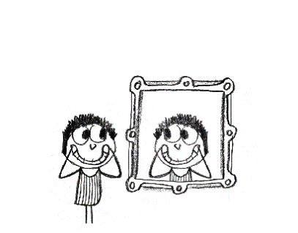

- The next step is playing the actual game: Susan, for example, starts and reads out the slogan of a card (‘Happiness is pulling faces in the mirror’). The other players have to listen and find the matching picture card among their cards. If the picture card is difficult to find, Susan may describe what she sees on her slogan card.
- Thomas has the matching picture card, and gives it to Susan. Susan lays the pair on the floor in front of her.
- Now Thomas reads out a slogan and the other players have to find the matching picture card.
- Ann has the matching picture card and gives it to Thomas. Thomas lays the pair on the floor in front of him.
- Now its Ann’s turn to read a slogan.
- Continue the game until all slogan cards have their matching picture card. Use the sheet with the solutions to find out if all pairs match correctly.
Happiness is  … reading on the grass |  |  | 
Friendship is  … feeling safe. |  |  | 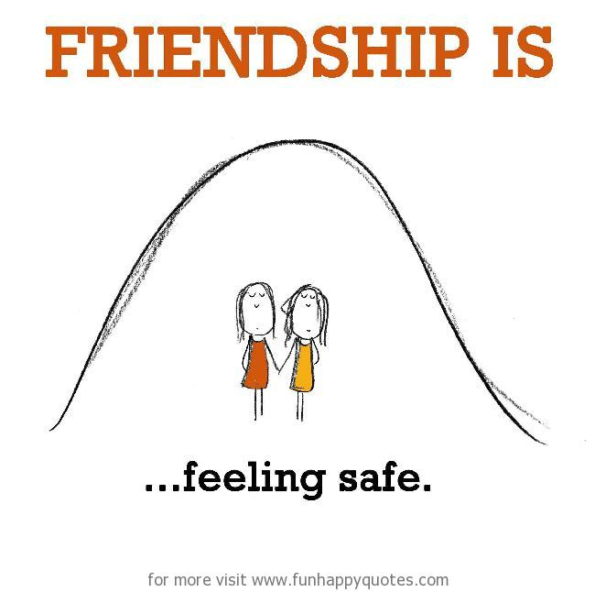
Friendship is  … dancing in the rain. |  |  | 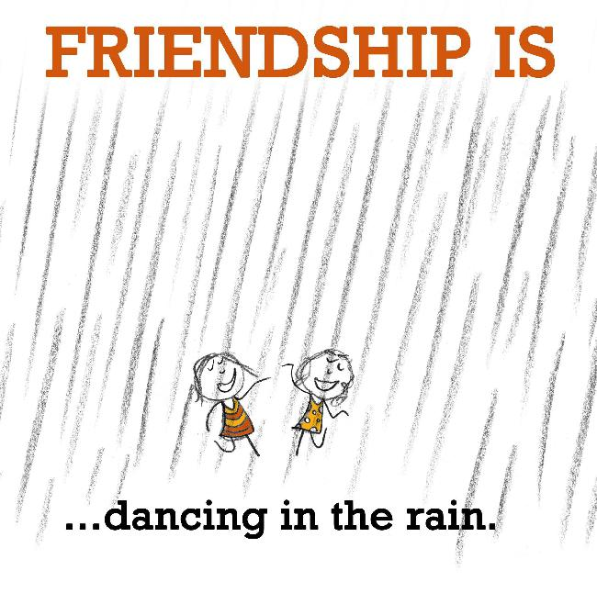
Friendship is  … making secret plans. |  |  | 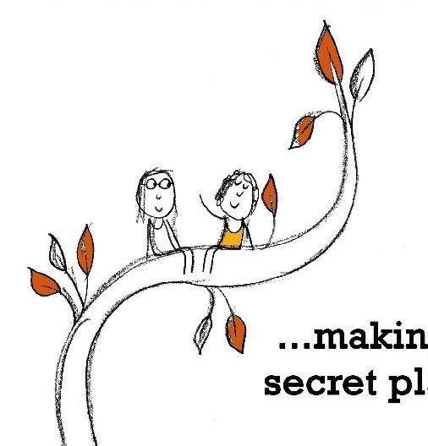
Happiness is  … annoying your sister. |  |  | 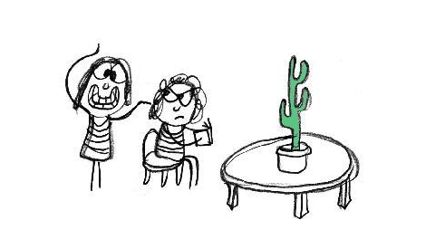
Happiness is  … staying up all night  chatting to your soulmate. |  |  | 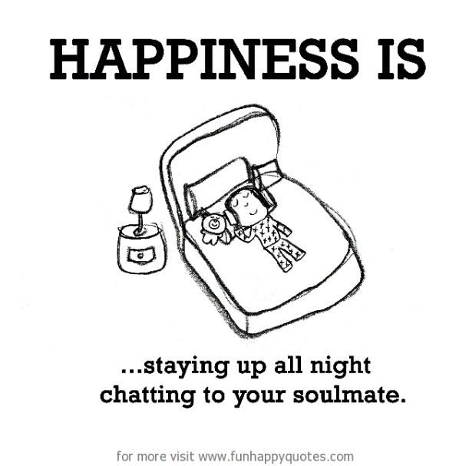
Happiness is  … singing in the car. |  |  | 
Happiness is  … lying on the beach and  talking for hours. |  |  | 
Happiness is  … reading Harry Potter. |  |  | 
Friendship is  … sharing the  dirtiest secrets. |  |  | 
Friendship is  … sharing a piece of chocolate,  no matter how small it is. |  |  | 
Happiness is  … pulling faces in the mirror. |  |  | 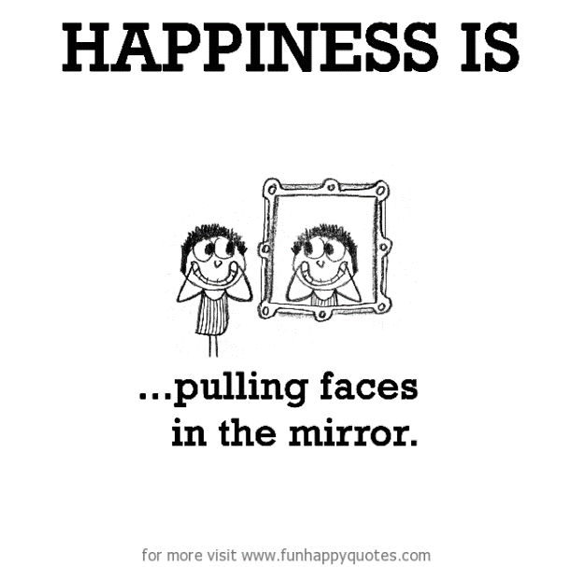
Friendship is  … forgiving each  other’s mistakes. |  |  | 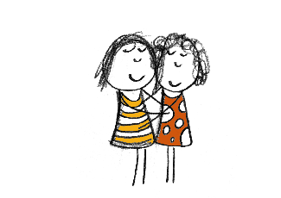
Friendship is  … thinking about funny  moments and  laughing alone. |  |  | 
Friendship is  … not needing words to communicate. |  |  | 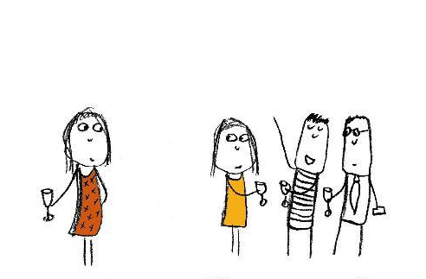
 |  |  |  | 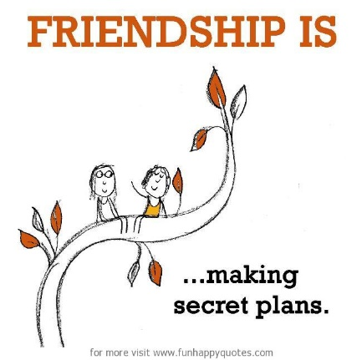
 |  | 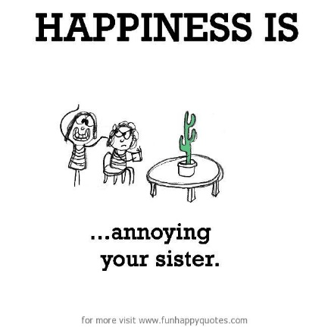
 |  | 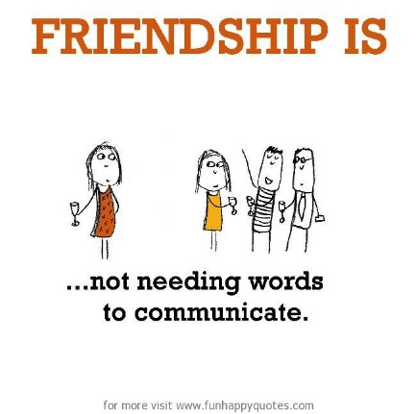
 | 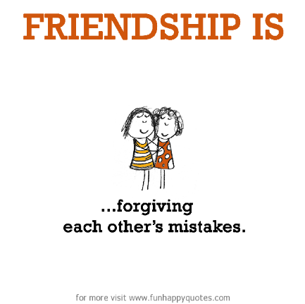 |  |  | 
 | 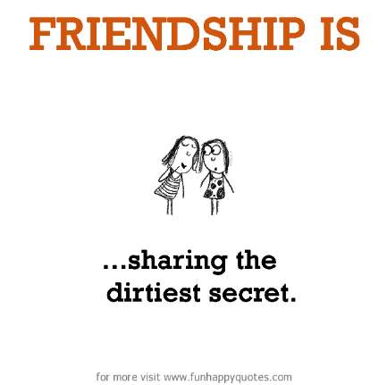 |  |  | 

After having played the card game teachers should check if the groups have the correct matches. It is also important to discuss pictures which may be difficult to interpret with the students. Talk about the images as well as the messages on the cards.
If the students strongly disagree with some of the matches or do not understand the combination of pictures and message, you could ask them to draw their own picture to match the slogan. Students could also prepare their own matching cards as homework.

3.1.3 Unit 2, Analysis of Activity 2: Gerund Card Game

Learning stages
This card-game is mainly designed for the proceduralization of the gerund with the notion of general statements. The students have to say it out loud and listen to it multiple times in the course of this game.
Pedagogical principles
Depth of processing |  | I think that there are multiple types of information and skills that the brain has to process and use in the course of the game. These would be reading and speaking the slogans, then listening to what has been said, interpreting and translating that message into a picture with the same expression. In my opinion, these are natural processes that occur every day when using a language.
Commitment |  | It is a game with witty slogans and funny illustrations. If I was a student, I would want to match these cards because I would want to know which picture belongs to which statement. Of course, there might also be a little competition among the students for getting the most pairs.
Peer and social learning |  | It is of course a social game where you depend on your partner’s cooperation, vocabulary and pronunciation. The students are able to help each other and learn from each other, thus accelerating a healthy and natural learning process through exposure to new structures and actively using them.
Personalization | () | The cards and their matching are fixed. If the teacher decides to include the optional task, the students can choose their own slogan for their self-drawn picture.
Contextualisation |  | The aim is to match the cards by communicating the meaning of a slogan to your classmates. Therefore, it has a clear context. Students are exposed to slogan language on T-shirt, on TV, social media etc.
Authenticity of process |  | As stated before, players of this game have to use skills that naturally occur when language is used. The skills are interpreting and translating a message into an item or a picture. I think that is very important as it strengthens the link between the lexical item and what it actually describes.
Task-Based |  | The outcome is not something materialistic. It is rather the process of using and getting used to the gerund form used in the notion of general statements.
Testing/Teaching |  | This game is intended to support teaching as it lets the students create their own rules and concepts for the use of the gerund.
This exercise supports learning processes:
Sources:
- Pictures and slogans from: https://www.funhappyquotes.com

3.2.1 Project Work – Class T-Shirts

Next week we are going to have some guests – the students from a 3rd year class of our partner school in Sarvar are going to stay in Graz for four days.
You might know that we are having sports competitions and music events there with our guests and I think it would be a nice idea to have “team shirts” for these events, which we will attend as a class. Of course, these shirts will have a similar design so that you can recognize your classmates, but you are allowed to put your own, personal slogan on your shirt.
Therefore, I want to spend today’s lesson on designing possible slogans for your shirts. We are going to look at some slogans now to give you an idea on what a slogan is.
The purpose of this announcement is to seize the opportunity of creating something useful and authentic with the language input the students have received in the previous lesson. They are immediately able to put their knowledge into practice and also the effort on their side will probably be much higher as the students want to show what they can do in light of such events.
If there is no possibility of such an event, the T-shirts could be designed for a sports or music event in school or just for the students to have a definite and personalised outcome where they put their effort and language skills into.
This project can also be completed in cooperation with crafts teachers in your school. The students might enjoy wearing something they have designed and produced by themselves.

3.2.2 Unit 2 - Examples of T-Shirt Slogans

 |  | 
 | 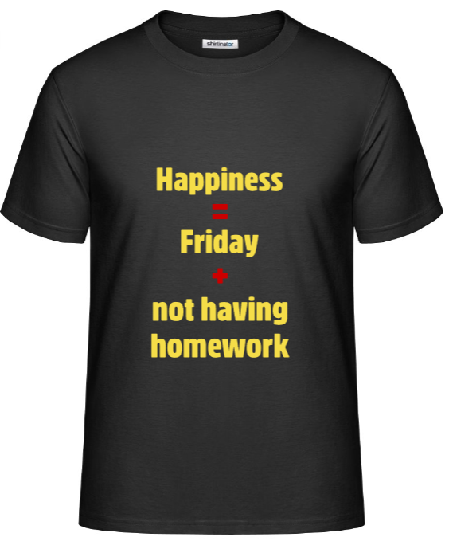 | 
In the lesson the T-shirts and their design can be presented in a PowerPoint presentation.

3.2.3 Unit 2, Activity 1: Designing T-Shirts with A Message
After viewing the T-shirt examples, the students get templates to design their own T-shirt. They have to come up with a slogan as shown before and transfer it onto their template, which they get from the teacher printed out in size A5 (see below). There are some additional words and word combinations to help the students formulate a suitable slogan.
The students may take some time during the lesson to come up with ideas. The T-shirt slogan should be completed as a homework. The students have to be careful to use the correct words and spelling as this will be put on the T-shirt and cannot be changed afterwards. This presupposes independence on the side of the students. They additionally get the chance to take over responsibility for their work, which I think is important for a young and learning human being.
My Personal T-Shirt
- Find a catchy slogan for your personal T-shirt and put it on the template!
- You may use up to 10 words. Have a look at the words below!
Love is  Happiness is  Friendship is  School is  Grammar is  Life is  … is | always  sometimes  often  never  not  … | being  having  knowing  forgiving  remembering  wanting  trying  … | …


3.2.4 Unit 2, Analysis of Activity 1: Designing T-Shirts with A Message
Learning stages
This task is partly conceptualization/hypothesis building as there are many examples and word suggestions to help the students build up their concept about using the gerund in general statements. It is also performance of gerund forms as they use it for a real-life purpose.
Pedagogical principles
Depth of processing |  | The students have to use multiple intelligences such as translating messages into words, formulating a slogan, drawing and designing their slogan on a T-shirt. They will access their ‘world knowledge’ and try to translate what they are fond of into a catchy slogan.
Commitment |  | The students will probably commit themselves a lot as this is their personal T-shirt. They, of course, want to show who they are with their work. Therefore, I think, almost everyone will be dedicated to producing a nice slogan.
Peer and social learning |  | There is no social learning here. I don’t think that it occurs in this task, since the students design their own T-shirts. Of course, the students will exchange some ideas among each other, but this is not required by the task.
Personalization |  | This task is highly personalized, as stated before. The students are free to come up with a slogan and a design of their choice for their personal T-shirt.
Contextualisation |  | The context of this exercise is finding a slogan for a T-shirt. Albeit a one-sided way of communication, a slogan is something that can be seen every day on T-shirts, ads or stickers and the students will definitely get the use of the slogan in this task.
Authenticity of process |  | I think the use of the gerund here is very authentic as it ultimately becomes a real-life product that communicates something about the person wearing the T-shirt.
Task-Based |  | The outcome is obviously a T-shirt that hopefully reminds the students that they can use their English skills to produce something worthwhile and make sense of the world.
Testing/Teaching |  | This task supports teaching as it gives input and inspiration for using the gerund form for the notion of general statements. It also tests if the students can apply it for their personal slogan for their T-shirt.
This exercise supports learning processes:

Sources:
- T-shirt designs: https://www.shirtinator.co.uk/design/personalised-t-shirts/
- T-shirt template: http://www.clipartbest.com/clipart-xTgo5rLTA
- Activity for designing a T-shirt inspired by: Newby, David (1992). Grammar for Communication – Exercises and Creative Activities. ÖBV: Wien. 112.

4.1 Unit 3 – Notion: Thoughts

4.1.1 Unit 3 – Introduction
This unit is designed for a 4th grade Unterstufe, level A2, A2+, some might be B1.
Today we are going to talk about memories – all the different kinds of things and activities we remember about the past. I want to talk about good memories, but also about bad memories.
First of all, I want to read a blog entry with you. The blog is written by George Couros, and the entry I want to read with you deals with his memories of his elementary school way back in the past.

4.1.2 Unit 3 – Blog Entry (Sample)
https://georgecouros.ca/blog/archives/2613 (full version online)
Printed and shortened version (single page for classroom use):
Memories of School
November 22, 2011 by George Couros
Yesterday, I received a notification in Facebook that my old elementary school was soon to be demolished. I will admit that I was a little teary-eyed thinking about it as this was a place where I met many people that have been major influences in my life, along with friends that I am still close to currently.
I decided to write about some of my memories of school, and as I do when I write in this blog, I just wrote. As I started to think back about my teachers, I decided to think of something about each one that I remember. Leaving that school almost 23 years ago, I was amazed at really how much my time at the school has influenced what I am doing today. I always loved school, but I didn’t really realize how much until I wrote yesterday.
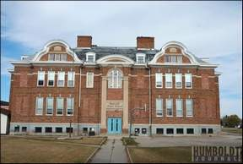
One of my first memories as a child was my mom walking me to school on the first day of kindergarten. I still can visualize the jacket I was wearing. I remember playing football and soccer in the fields pretty much every day we could. We would rush out and I remember my brother Alec always telling me how much I stunk from the sweat. I didn’t care because I could have played all day.
One memory I have was Kelly Bates making this amazing, one-handed catch in the front of the school playing football and we were all in awe. Who knew he would become a CFL player.
I remember auditioning for a play and telling Jay Kennedy that he would not get the part because his voice wasn’t low enough and he punched me in the nose. We still joke about it to this day.
Amazing that I can still remember that much about elementary school. Hopefully my students will remember me as fondly. What I realize writing this is that it is never a building that is important, but the people that make it feel like home. I will miss that place but am glad we will always be able to share our memories with one another.
Go Panthers!

4.1.3 Unit 3, Activity 1: Memories of School
After reading the blog entry I want you to underline the ACTIVITIES George remembers about his time in elementary school.
In class teacher and students compare orally what they have found.

4.1.4 Unit 3, Analysis of Activity 1: Memories of School
Learning stages
This task is simply aimed at awareness. Everything that George mentions in his memories is phrased as remember doing something or seeing something. The phrases keep repeating themselves which should help make the students aware of what kind of structure/form is required in combination with the verb “to remember” when talking about memories from the past.
Pedagogical principles
Depth of processing |  | There is no complex coding involved but the students should be aware of the fact that we are talking about activities which we memorize in the past, and their lexis as well as knowledge of the world will be relevant.
Commitment |  | Reading a blog entry might be fun in any way, and finding out what kind of activities people remember from their past might be interesting in comparison to what the students remember about their time in elementary school.
Personalisation |  | The task is a reading task in which the students read about another person’s experience. The task is not personalised.
Contextualisation |  | The text is an authentic blog entry which might be interesting to read for the students.
Authenticity of process |  | The students should find authentic language used in a blog entry.
Task-Based |  | The task here is only aimed at raising awareness.
Testing/Teaching |  | The task is supposed to support teaching.
This exercise supports learning processes: ()

4.2.1 Unit 1, Activity 2: “Where Is Jennifer?”

Now I would like to play a little mystery game with you. The mystery game is called “Where is Jennifer?” So here is the story.
Jennifer is 18 years old, has just started studying German and has moved into a new apartment in Bush Street. You are on the same volleyball team, and now you are slightly worried because Jennifer has not shown up for the last two training sessions, and she also does not answer her phone. You are definitely worried about her as you haven’t heard anything from her in the last five days. Where is Jennifer???? In order to find out more about her you go to her house, but she doesn’t answer the door bell. So you decide to ask around whether some of her neighbours might have seen her in the last five days.
We think that the students don’t need the story on paper – it is sufficient (and also supports their listening skills) to read/tell the story to them. However, the text is short and could also be shown on the board with the beamer.
Now I need 8 students who want to take a special role in our investigation. Please, follow my colleague outside. You will get further instructions there.
As the unit is designed for a 4th grade NMS there are two teachers. We decided to split the tasks concerning instructions – one teacher instructs the witnesses outside the classroom, and the other teacher gives instructions to the students who will be the investigators.
The students leave the classroom with the teaching colleague and get 8 paper slips with witness statements. They have to read their statement carefully so that they remember all the details. After having prepared their statements they can come back in. If they want to they can develop their role in more detail, but it is important that they do not invent extra clues where Jennifer might be.
Here are the instructions for the witnesses:
Here are your role cards. You are friends or people who live in Jennifer’s area and you remember seeing her last Monday. Read your card carefully, make sure you know it in detail (especially the clues when and where you remember seeing Jennifer). You can add details to your character but do not change the clues about Jennifer. In class your classmates will try to collect information about Jennifer – make sure you only talk to two people maximum at a time.
Here are the teaching instructions for the investigators (students in the classroom):
The rest of the class should now find out where Jennifer is. You will get a map of the area and you will have to talk to different witnesses in order to find out who was in contact or might have seen her five days ago.
Talk to the different witnesses – collect their information and mark Jennifer’s route and the times into the map. Mark the area where Jennifer was last seen five days ago with a red dot.

4.2.2 Unit 1, Activity 1: Witness Statements (“Where Is Jennifer?”)

Here are the statements that you have collected in the neighbourhood:
 | You are Jennifer’s neighbour:  I remember her walking down the High Street towards Bush Street … I think that was last Monday … in the afternoon, around 3 pm. I remember her carrying two shopping bags and a bunch of flowers … She was in a bit of a hurry … and I think she didn’t see me at all … even though we often meet in the hallway … she lives right next door to me …

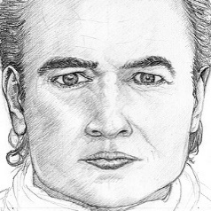 | You are a Tennis player at Jennifer’s Tennis club:  I remember seeing her on Monday … at the Tennis Club …. It must have been around 11. I had just finished a game, and I remember asking her if she wanted to play a game this week. She told me she would be busy this week … but she was definitely playing after me last week …

 | You are a waitress at the ‘Tea Cup’ (café):  Yeah, I saw her … She came to the ‘Tea Cup’, that’s the café where I work as a waitress. It must have been some time last week … I was working on Sunday, Monday and Tuesday … I remember her coming in with a friend, having coffee and the new chestnut cake …. that must have been Monday around 10:30 …. but I am not sure … the place was packed …

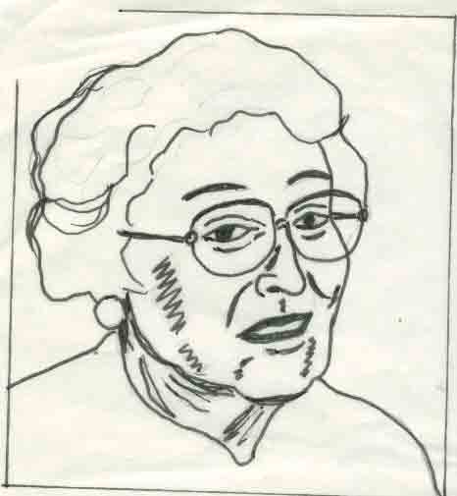 | You are the librarian:  Oh yes, I know this young lady well … she often comes here … she always tells me that she keeps forgetting to return her books on time …. and I always have to charge her … see, libraries are only for free if you are organized … Well, she came in some time beginning of the week …. maybe Monday? It must have been some time in the afternoon … but I am not sure when ….

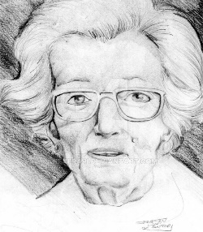 | You live across the street of Jennifer’s apartment:  Jennifer? I saw her last week … Monday … I ran into her at the butcher’s … I remember her wearing such a nice skirt … bright red with a black bird on it … It must have been around 10:30 … I remember hearing the church bell … and when I left the butchery I had to hurry because my parking ticket was about to run off …

 | You are Jennifer’s best friend:  Oh yes, I know Jenny …. she is a friend of mine … but I am really mad at her … I was in hospital last week, just got home …. and last Sunday she came to see me and promised she would be back on Monday … but she did not show up. If you find her tell her to call me … I could use a hand with my bandages …. they are very difficult to change …

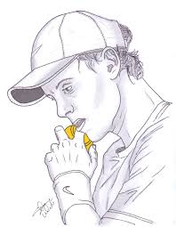 | You are Jennifer’s Tennis partner:  Yeah, I know Jenny … we play tennis every Monday morning at 11 … last Monday … yeah, that was the last time … I remember playing three sets – she won the first two and I won the last … after the game we had lunch at the Bull and Bush pub. I remember offering her a ride home but then she said she had to pop into the library …. she is a pretty good player …. really strong backhand ….

 | You work in the flower shop on High Street:  Jenny? Jennifer? I don’t know that name …. oh, yes, the young lady in the bright red skirt … I know who you are talking about …. she came in last week, I guess it was Monday, some time in the afternoon, and I also remember her buying this huge bouquet … red and pink roses and carnations … she said it was for a friend or hers who was in hospital … she was in a bit of a hurry …. left right away …

4.2.3 Unit 3, Activity 3: Locating Jennifer (Map)

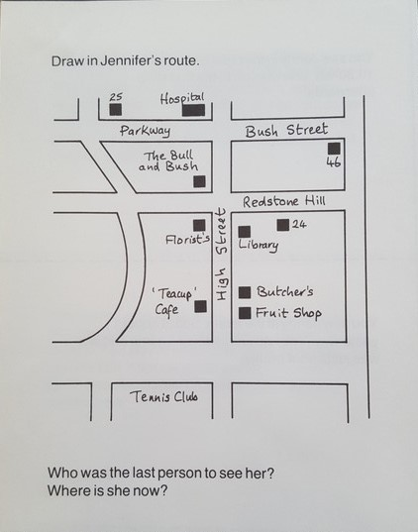

4.2.4 Unit 3, Analysis of Activity 1: “Where Is Jennifer?”

Learning stages
This task is partly conceptualization/hypothesis building and also performance in real-time context. Various eye witnesses talk about their memories and activities/actions they remember.
Pedagogical principles
Depth of processing |  | The students have to read or listen carefully, interpret messages and observations, be oriented in time and place, evaluate statements of the different witnesses – they will be mentally very active and also have to rely on their “world knowledge”
Commitment |  | The students will probably be eager to find out what has happened to Jennifer. The witness statements jump back and forth in time and place, so the students will be curious to solve the mystery. The students who have volunteered to be witnesses hopefully enjoy their role and enliven it.
Peer and social learning |  | Students talk in pairs or groups of three, they change partners eight times, and they exchange information and add up witness statements in order to complete their information gaps.
Personalization |  | The task is not really personalized. Only the students who have a witness role card and have to enact a character can put in a “personal touch”.
Contextualisation |  | The task is embedded in the context of a mystery story and presents different statements by witnesses including information what they remember seeing/observing. The roles are acted out.
Authenticity of process |  | The witness statements are authentic, and the students will hopefully pick up on these phrases. The process of finding out what might have happened to a person is authentic (information gap).
Task-Based |  | The students have to find out what has happened to Jennifer – a clear and purposeful task.
Testing/Teaching |  | The task supports teaching.
This exercise supports learning processes:

4.2.5 Unit 3, Activity 4: “What Happened to Jennifer?”
Now we know where Jennifer was last seen and by whom. Use your imagination and write down what you think happened to Jennifer and why she was gone for so long. You have got 5 minutes time.
The students should write down one or two paragraphs about what they think might have happened to Jennifer and why they think she was gone for so long.
Now I would like you to get together in groups of four and tell each other what you think might have happened to Jennifer. After having exchanged your versions of what might have happened to Jennifer decide as a group which ending you like best.

4.2.6 Unit 3, Analysis of Activity 4: “What Happened to Jennifer?”
Learning stages
This task is designed to promote performance in real-time context. Students exchange their ending of the story (speaking and listening time), and they also have to come up with a solution which ending they like best by discussing the different versions and negotiating their opinion.
Pedagogical principles
Depth of processing |  | For the writing task the students will have to be mentally very active, use their imagination to come up with a good and surprising ending. Thus, they will rely on their grammar, lexis as well as their “world knowledge”.  For the discussion part they will have to argue and decide upon which ending is most fascinating and most surprising.
Commitment |  | The students will probably be eager to write an interesting ending about what has happened to Jennifer.  In the discussion part they might want to support their own version and convince others that it is the best.
Peer and social learning |  | This first part of the task is independent writing.  The second part (discussion) is aimed at peer and social learning – discussing pros and cons, arguing certain issues, defending one’s opinion, convincing others, finding a common solution.
Personalization |  | The task is personalized as the students have to write their own ending. They can use their own imagination and their own concepts of life and the world in order to present something interesting and catchy. In
Contextualisation |  | The writing task is embedded in the context of a mystery story.  Defending your point of view and convincing others about something is a common aspect in everyday conversation.
Authenticity of process |  | The discussion is an authentic way of communicating your ideas and exchanging opinion in a group.
Task-Based |  | The students have to decide upon the best ending.
This exercise supports learning processes:

4.2.7 Unit 3, Activity 5: Homework – Write A Blog Entry About Memories

Homework: Write a blog entry about memories you cherish. Use the blog entry we have read at the beginning of the lesson as a role model. If you want to you can also browse the internet to find other blogs you want to use as an example.
The topic of your blog entry should be memories about the past. You can choose from the following topics:
- Memories about your childhood before you moved from one place to another (e.g. countryside to the city)
- Memories about the time you started secondary school
- Memories about the last Christmas holidays with your grandparents
- Memories about the last camping trip with your family
- Memories about a situation you very much enjoyed
Make sure you present minimum 5 memories and include information about things you remember doing, activities you liked and enjoyed doing. You can also include aspects you didn’t like so much if you want to.

4.2.8 Unit 3, Analysis of Activity 5: Homework - ‘Blog Entry About Memories’

Learning stages
This homework task is mainly concerned with performance in real-time conditions and also with aiding proceduralization.

Pedagogical principles
Depth of processing |  | In order to do this task, the students have to activate their memory to find something to write about. This entails personal commitment and alertness as the students write about something they have experienced before and ‘re-live’ these memories again.
Commitment |  | These memories are highly personalized and constitute an important part of the personality and character of a student. I think the commitment will be high as a student usually wants to tell something about him- or herself.
Peer and social learning |  | As it is a homework to be done individually, no peer or social activities are required here (unless the students copy from each other).
Personalization |  | As stated before, the degree of personalization is high because each student has to draw on his or her own memories.
Contextualisation |  | The purpose of this homework is to tell others about one’s memories in form of a blog. Blogging is well-known and is a common form of communicating what someone thinks is important to write about.
Authenticity of process |  | There are many blogs about all different kinds of topics. The necessity to write about something depends on how much someone wants the world to know. I think that students usually want to tell something about themselves if there is a healthy atmosphere among the students that encourages them to do so. Texts like this appear on websites and student magazines.
Task-Based |  | It depends on what will be done with the outcome. If the texts are eventually put on a website or in a student magazine, for example, they serve a greater purpose than just being written for the teacher. Nevertheless, the students will have a text about themselves that lets them re-live some parts of their lives.
Testing/Teaching |  | This homework task is rather designed for assessing how well the students are able to use the gerund form in connection with remembering and thoughts. They will learn and practice the use of the gerund in this task but overall it is designed to monitor the students’ abilities.
This exercise supports learning processes: ()

