Term Paper
Will-Future
Notion: Predictions
Level: Year 2
This is an excellent unit full of creative and meaning full ideas. Your instructions are clear and idiomatic.
Just perfect.
Please correct the tiny errors to make it 100% perfect.
10/10


Focus on Language and the Learner
(Fachdidaktisches PS 2)
Dr. Elisabeth Pölzleitner
SS 2018

Nina Klammer (01414070)
Sarah Kurz (01512355)
Date of Submission: 11 June 2018

Table of Content
Introduction 3
Lesson 1 4
- Activity 1.1.: Rhyme 4
Analysis of Activity 1.1. 5
- Activity 1.2.: Weather forecast 5
Analysis of Activity 1.2. 7
- Activity 1.3.: Creation of an own weather forecast 7
Analysis of Activity 1.3. 8
- Homework 1 8
Analysis of Homework 1 10
Lesson 2 11
- Activity 2.1.: Que sera 11
Analysis of Activity 2.1. 13
- Activity 2.2.: Horoscopes 13
Analysis of Activity 2.2. 16
- Homework 2 17
Analysis of Homework 2 18
Lesson 3 18
- Activity 3.1.: Fortune teller warm-up 18
Analysis of Activity 3.1. 19
- Activity 3.2.: The cartomancy game 20
Analysis of Activity 3.2. 23
Testing Activity + Analysis 24
Bibliography 27

Introduction
This paper focuses on the grammatical notion of predictions, which describes one category a speaker of English employs when talking about the future. Communicative grammar defines grammatical objects no longer as a set of forms, but as a set of meanings, either notional or functional. Some advantages of using a notional, meaning-based approach is that the notional approach reflects the way grammar is used in real life. Grammar can therefore be integrated in contexts. One form, in our case the will future, can often express different meanings. Thus, it is highly likely that different meanings are confused. Through using a meaning-based, notional approach this danger of confusing different meanings can be avoided. Furthermore, rules are easier understood and more reliable, since the meaning-based, notional approach enables students and teachers to look at grammatical meaning more systematically (cf. Newby “Theory and Practice in Communicative Grammar”: 30) On these grounds the main objective of the activities introduced in this paper is to get away from a traditional approach and to grammar teaching that focuses on a meaning-based, notional approach.
The activities planned will cover three lessons. Additionally, we have included homework and a testing activity, which is based on the topics and activities that were dealt with. However, the overall goal was to create teaching material and not testing material. Our set of activities is aimed at Basic English users (A1 - A2, year 2) and their understanding of the will future with the focus on the notion predictions. The aim of the exercises is to get the students to talk, make connections to their world and ultimately to be able to produce written products and oral utterances making predictions.
The activities introduced in this paper include the different stages of learning: awareness raising, conceptualisation, proceduralisation and finally performance. The students should be able to notice and focus on the new grammar, understand the grammar rule, use it in scaffolded exercises and eventually use it in open contexts. The teaching materials are also accompanied by a theoretical analysis, with which we evaluated the chosen activities according to different criteria of communicative grammar tasks.

Lesson 1

Activity 1.1.
Rhyme
Recite the rhyme about the weather:
“Look outside now; can you say
What the weather is like today?
Is there sunshine, is there rain,
Is wind blowing down the lane?
Are there snowflakes falling down
Are there big clouds floating around?
Look outside now; can you say
What the weather is like today?”
(cf. https://www.kidsparkz.com/preschool-sings-weather.html)
Repeat the rhyme several times. Encourage your students to say the rhyme with you.
Then ask several students what the weather is like today. Collect the adjectives on the blackboard (they are useful for later).
Continue by asking several students what the weather will be like tomorrow. Pay attention to the students’ answers. Repeat the students’ answers, emphasizing the use of the will-future. Ask the students whether they have noticed a difference between describing today’s and tomorrow’s weather. You want to highlight the difference between describing a present situation and predicting an event or situation in the future.

Analysis 1.1
Grammar Checker | ☆
Learning Stage | This activity belongs to the Awareness Raising stage, as the pupils notice and focus on new grammar and are made curious about it when the teacher asks questions. It can also be seen as part of the conceptualisation stage, as the students might understand the grammar rule through repetition of the rhyme, but they are still unconscious of it.
Depth of Processing, mental Activity | The activity does not require particularly high processing, as the students just have to repeat the rhyme. However, they need to show understanding of the basic concept in order to notice a difference between present tense and will-future.
Dual Processing & Authenticity of process | The students have to deal with a rhyme. The rhyme itself might not be authentic, but the following task is as talking about the weather is a part of everyday life. They will have to use the will-future to talk about the weather.
Personalization | This activity is not particularly personalized.
Commitment filter | It can happen that the commitment filter is not activated in this  Activity, as some students might find it boring to repeat a rhyme. However, the students hopefully are more motivated by finding out the purpose of the activity.
Peer/Social learning, interacting | This activity does not involve peer learning or interaction.
Teaching VS testing | It is a teaching task, since the exercise supports learning by actively involving the learners.

Activity 1.2.
Weather Forecast
(adapted from PrimeTime1 2017: 90, https://www.thoughtco.com/the-oregon-weather-forecast-1210091)
Ask students where they find or receive information about the weather. Collect these sources on the blackboard. Help students if they do not know the English counterpart to the German word. Circle the source (weather forecast) which the lesson will focus on. If the students have not mentioned it, write it down and describe the term to the students.
Hand out the worksheet. Tell the students to listen to the weather forecast carefully (if necessary twice) and to tick the right symbols.
Read the weather forecast to your students. Try to create an authentic situation and take on the role of the weather forecaster:
“Weather Forecaster: Good afternoon and welcome to today’s weather forecast. Let's take a look at the weather outside now. What's it like? It's currently raining and cloudy in Vienna. It’s also quite cold with a temperature around 12°C.
Shall we see what the weather will be like tomorrow? It will be windy in the morning. However, the sun will start shining during lunchtime. In the afternoon, Vienna will see cloudy weather again with some rain later in the evening.
That's the weather forecast for this afternoon. Have a good day!”
(adapted from: https://www.thoughtco.com/the-oregon-weather-forecast-1210091)
After the students have listened to the weather forecast they should continue with the writing exercise (②).

Weather Forecast

① Listen to the weather forecast and tick √ the right symbols.
6 a.m.-10 a.m. morning | 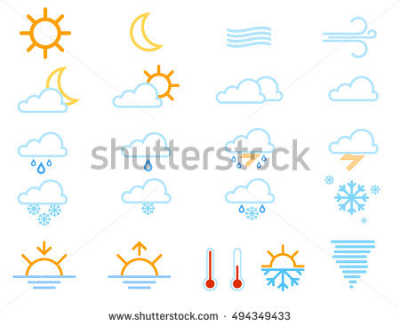  □ | □ | □ | □
11 a.m.-2 p.m.  lunchtime | □ | □ | □ | □
3 p.m.-6 p.m.  afternoon | □ | □ | □ | □
6 p.m.-8 p.m.  evening | □ | □ | □ | □
What will the weather be like tomorrow
② You have completed the listening. Now look at the weather chart above and complete the sentences.
1. In the morning it will be ____________________________________
2. Around _____________________________________________ the _________________ will shine.
3.In the___________________________________________________________________________
_______________________________.
4.________________________________________________________________________________

Grammar Checker | ☆ ☆
Learning Stage | Conceptualization/Proceduralisation: The students internalize the structure of the sentences, by listening and reproducing it many times.
Depth of Processing, mental Activity | The depth of processing is not too high in this activity. In the task the  students do not need to produce their own language, but they rather  concentrate on the new structure.
Dual Processing & Authenticity of process | The learners form correct meaningful sentences as all of the sentences are universally true, but it has to be mentioned that these sentences are very general. However, the information/fact might be useful to the students sooner or later.
Personalization | This activity is not personalized, as the students have to write what they have heard and not what they have experienced.
Commitment filter | Students can be creative when completing the sentences and this activates the commitment filter.
Peer/Social learning, interacting | This activity does not involve peer learning or interaction.
Teaching VS testing | The activity is a mixture between teaching and testing. Since the students have to fill in the gaps and show their understanding of will-future.

Analysis 1.2.

Activity 1.3.
Creation of an own weather forecast
(adapted from: https://www.youtube.com/watch?v=TokQZDsky_M&t=117s)
The students get together in pairs. Hand out a big poster to each student. The students should create their own weather forecast.
Give the following instructions
- Create your own weather forecast
- Think about a city
- What will the weather be like tomorrow (morning, lunchtime, afternoon, evening)
- Draw the different weather symbols on your poster. They have to be in the right order (morning – top of the poster, evening – bottom of the poster)
- Practice your weather forecast with your partner
- You can have little notes, but do not write full sentences. Try to speak freely!
- Ask your partner to video record you and upload your recording to Flipgrid or send it to your teacher. Then you record your partner.
- Your presentation should not be longer than 2 minutes

Analysis 1.3.
Grammar Checker | ☆ ☆ ☆
Learning Stage | Proceduralisation: The exercise refers to this stage because students write sentences on their own. The task is not very restricted, but still language production takes place in scaffolded conditions.
Depth of Processing, mental Activity | This activity requires very high depth of processing. Students need to come up with their own examples and create a cohesive chain of  sentences.
Dual Processing & Authenticity of process | Students have to use world knowledge and their own experiences to complete the task.
Personalization | The exercise is very persona, because the pupils write about imagined scenarios, but still they start with a personal fact.
Commitment filter | Commitment filter is activated when the students can be creative by imagining and creating their own weather forecast.
Peer/Social learning, interacting | Interaction is a central aspect in this activity, as the students have to work on the forecast in pairs, practice it together and record each other.
Teaching VS testing | This activity is a teaching activity, because pair work is usually not part of testing situations. The exercise supports learning, since the students have to produce utterances using the will future.

Homework 1
(adapted from: PrimeTime1 2017: 90)
The students should write their own weather forecast for the day of their next English lesson and compare it with the real weather. Has their weather forecast been right?

Write a weather forecast for the day of your next English class and compare it with the real weather. Is your weather forecast right?
The first sentences have already been given to you. Your weather forecast should not be longer than 120 words.
You can use some phrases from the box below
Useful phrases
snowy ● rainy ● windy ● sunny ● cloudy ● foggy ● hot ● warm ● cold ● chilly ● freezing ● a rainy day ● a snowy evening ● a foggy morning ● a sunny afternoon ● strong winds ● sunshine ● it will snow ● it will rain ●

Let’s see what the weather will be like tomorrow. It will be ...
______________________________________________________________________________________________________________________________________________________________________________________________________________________________________________________________________________________________________________________________________________________________________________________________________________________________________________________________________________________________________________________________________________________________________________________________________________________________________________________________________________________________________________________________________________________________________________________________________________________________________________________________________________________________________________________________________________________________________________________________________________________________________________________________________________________________________________________________________________________________________________________________________________________________________________________________________________
Analysis Homework 1
Grammar Checker | ☆ ☆ ☆
Learning Stage | The homework task is similar to activity 1.3. and focuses on proceduralisation: The students have to write a whole forecast on their own. The task is not very restricted, but still language production takes place in scaffolded conditions.
Depth of Processing, mental Activity | This activity requires very high depth of processing. Students need to come up with their own examples and create a cohesive chain of sentences.
Dual Processing & Authenticity of process | Students have to use world knowledge and their own experiences to complete the task.
Personalization | The exercise is very persona, because the pupils write about imagined scenarios, but still they start with a personal fact.
Commitment filter | Commitment filter is activated when the students can be creative by imagining and creating their own weather forecast.
Peer/Social learning, interacting | There is no interaction is this activity, as it is a homework activity, which the students have to complete on their own.
Teaching VS testing | This activity can be used for both, testing and teaching.

Lesson 2

Activity 2.1.

Que sera
(own idea)
The students listen to Doris Day’s song “Que sera – Whatever will be”.
Hand out a sheet of paper with the lyrics to the students. Then give the following instructions.
- Listen carefully to the songs
- Some of the words on the sheets are wrong
- Find these words and correct them with the words you hear
- Compare the text with your neighbour
- Have you noticed anything about the wrong words? Which word did you mostly use for the correction (WILL)
- What can you remember about the will future form the last lesson?
- What do you think the song is about?
  - Prediction


QUE SERA - Doris Day
When I was just a little boy, I asked my mother, "What should I be?
Should I be pretty? Should I be poor?" Here's what she said to me:
"Que sera, sera, whatever can be, can be; the future's not ours to see.
Que sera, sera, what can be, can be."
When I was just a child in kindergarten, I asked my friend, "What am I try?
Should I paint pictures, should I sing songs? "This was her wise reply:
"Que sera, sera, whatever might be, might be; the future's not ours to see.
Que sera, sera, what might be, might be."
When I grew up and fell from a cliff.
I asked my sweetheart, "What lies ahead?
Can we have rainbows day after day?” Here's what my sweetheart said:
"Que sera, sera, whatever should be, should be; the future's not ours to see.
Que sera, sera, what should be, should be."
Now I have horses of my own.
They ask their mother, "What can I be? Can I be handsome?
Can I be rich? " I tell them tenderly:
"Que sera, sera, whatever will be, will be; the future's not ours to see.
Que sera, sera, what will be, will be.
Que sera, sera!"

Analysis 2.1
Grammar Checker | ☆ ☆
Learning Stage | The learning stage of this activity is awareness raising. The learners notice and focus on new grammar. They have to listen to the song “Que sera”, find the wrong words and replace them with the words they hear. The students will mostly replace the wrong words with “will” (will-future) and therefore focus on the new grammar item. They will hopefully be reminded of the last lesson and the principles/rules discussed.
Depth of Processing, mental Activity | The students have to be mentally active. They have to listen carefully to the song, find the wrong words and replace them by the correct ones. Different senses are involved, which stimulates deeper processing.
Dual Processing & Authenticity of process | The learners are not actively producing/using language, since this activity is focused on the form (rewriting specific words/phrases).  The activity uses authentic language. The language input in this exercise corresponds with the language learners may have experienced. A main English source, especially of young learners, is music.
Personalization | This activity is not particularly personalized.
Commitment filter | We think that the students will enjoy this activity, since the song is uplifting, popular and will eventually get stuck in the students’ head after listening to it once or twice.
Peer/Social learning, interacting | The students have to discuss the findings with a partner. Then the song will be discussed in class.
Teaching VS testing | The exercise supports learning. The students have to find replace the wrong word with the correct one. By doing so, they will recognize a specific pattern/rule and will hopefully be reminded of the new grammar item (discussed in the last lesson).

Activity 2.2.

Horoscopes
(adapted from Teach This file:///C:/Users/Nina/AppData/Local/Packages/Microsoft.MicrosoftEdge_8wekyb3d8bbwe/TempState/Downloads/horoscopes.pdf)

In this imaginative two-part worksheet activity, the students have to create horoscopes for their classmates with the future simple form “will”.
Ask the students about their zodiac sign. Write the zodiac signs on the blackboard. Do the students know all signs of the zodiac?
Give the following instructions and hand out the relevant worksheet:
- Get together in pairs
- Look at the worksheet
- Try to write a horoscope for all the signs of the zodiac
- You can either make predictions for the following day or the following week
- Be careful about using the will future
- You can write about topics such as health, money, family, friends, free time, love, luck and travel or you can come up with your own ideas
Wait until the students have finished. Then give the following instructions:
- Take your horoscopes and put them on the classroom wall
- You can put your horoscope wherever you want
- After every student has finished, move around and read the different horoscopes
- Did they come up with interesting, creative, reliable predictions?
- Who do you think came up with the most interesting and reliable prediction? Give a vote.
- Try to remember these predictions (most popular vote)
- After everyone has finished reading the predictions, take your sheet off the wall. You will need it for your homework.
Parts of the next lesson (or the lesson after the weekend) can be used to continue with the activity. The pair with most interesting, reliable predictions read their predictions again. The other students let them know, whether some of these predictions turned out to be true.
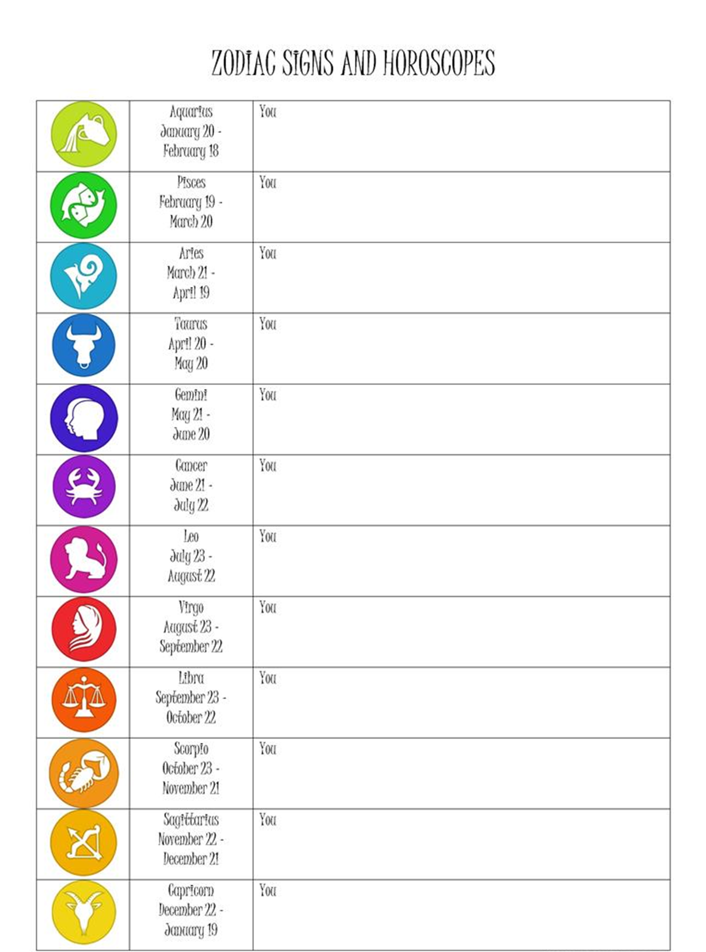

Analysis 2.2
Grammar Checker | ☆ ☆ ☆
Learning Stage | The learning stage of this activity is performance. The pupils are able to use the grammar in an open context, in this case use the will future in order to create horoscopes. They focus on the overall message, namely predictions.
Depth of Processing, mental Activity | The students have to be mentally active. The have to combine their grammar knowledge, lexis and their world knowledge in order to create accurate/reliable/interesting horoscopes.
Dual Processing & Authenticity of process | The learners actively produce sentences. They use the grammar (will future) in natural, “language-like” ways, namely to make predictions. The students have to produce an utterance to the context cues provided (horoscopes).
Personalization | The activity can be seen as rather personalised. The students are able to express their own ideas. They are able to include their personal ideas and previous knowledge when producing the various predictions.
Commitment filter | We think that the students will enjoy this activity. Predicting the future will arouse curiosity. Students will wonder what the other pairs predicted about their own future/the future of their fellow classmates. Furthermore, this activity involves a feeling of success, since one horoscope will be appointed as the most relieable/interesting/… one (cf. voting)
Peer/Social learning, interacting | The students have to work with a partner in order to create the horoscopes. Furthermore, the students have to read the horoscopes of the other students, which can be seen as a form of social interaction.
Teaching VS testing | The exercise supports learning. The students have to make predictions in order to create their own horoscopes. There is no right or wrong. The predictions can be creative, interesting or reliable.

Homework 2:
Search for a horoscope page in the newspaper or on the internet. Compare these predictions with the predictions you have made in class. Are there any similarities and/or differences? Take notes and bring them to the following lesson.

Analysis Homework 2
Grammar Checker | ☆ ☆ ☆
Learning Stage | The learning stage of this activity is performance. The pupils have to focus on the overall message. They compare their own predictions with the predictions made in newspapers/online.
Depth of Processing, mental Activity | The learners have to be mentally active. This homework can be described as “discovery activity”. The learners have to find horoscopes in newspapers or online and compare them with the horoscopes they have created in class. The learners have to search for similarities (and differences), they have to discover similarities and/or differences.
Dual Processing & Authenticity of process | The students do not have to produce their own utterances and/or use language in natural, language-like ways. However, they have to encode utterances of others, when comparing their own predictions/horoscopes with those of others.
Personalization | This activity is not particularly personalized.
Commitment filter | We think that the students will actively engage in this activity and will be interested in the predictions “professional” horoscopes make about the(ir) future.
Peer/Social learning, interacting | The students have to work individually (homework).
Teaching VS testing | The exercise supports learning. By comparing and contrasting their own text with another one, students may adopt new vocabulary and further focus on grammar.

Lesson 3

Activity 3.1.

Fortune Teller - Warm-up
(adapted from Busy Teacher: https://busyteacher.org/19917-predictions-fortune-teller.html)
This warm-up activity should introduce the topic of fortune telling.
Ask the students whether they know what a fortune teller is. If they don’t know what a fortune teller is, explain it to them: A fortune teller is somebody who predicts your future in exchange for money. However, we do not know whether the things he/she predicted will come true or not. Ask what the students think of fortune tellers. Would they pay somebody to tell them their future? Would they want to know what their future holds?
Instruction:
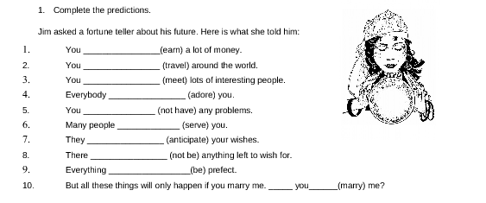
- Complete the fortune teller’s predictions by using the will-future.

Analysis 3.1
Grammar Checker | ☆
Learning Stage | Conceptualisation: The learners have to understand the grammar rule in order to fulfil this short task.  Proceduralisation: The students have to use the grammar rule in a scaffolded exercise. The verbs are given in brackets. The students simply have to fill in will and the correct form of the verb. Thus, I would say that the main focus is on the grammar rule.
Depth of Processing, mental Activity | The learners will not be highly mentally active. The activity is a simple fill-in-the-gap activity, which does not require the learners to be very mentally active.
Dual Processing & Authenticity of process | The learners are not actively producing/using language. They insert will and the correct form of the word given in brackets.
Personalization | This activity is personalized.
Commitment filter | I do not think that the learners’ cognitive needs are met in this exercise. The learners may receive additional information according to the language repertoire of a fortune teller, but it will not arouse their interest or curiosity.
Peer/Social learning, interacting | Individual activity: The students do not engage in social interaction and/or peer/social learning.
Teaching VS testing | I would rather consider this exercise as a testing exercise, since it tests whether the students can apply the grammar they have already learned.

Activity 3.2.

The Cartomancy-Game
(adapted from One Stop English: www.onestopenglish.com/community/lesson-share/winning-lessons/grammar-and-vocabulary/grammar-the-futures-bright/156549.article)
Predicting the future by reading cards
The students have to get together in pairs. You need a need a set of cards for each pair. Only 13 cards of a deck are needed:
- Hearts: Ace Jack, 10, 9, 8, 6, 4
- Clubs: Ace, Jack, 9, 5
- Spades: 6
- Diamonds: 8
Before playing the game introduce the idea of cartomancy: What is cartomancy? Do the students believe in cartomancy? Did they ever try cartomancy (or do they know somebody who did?)
Short note: Print the worksheet double-paged!
Hand out the worksheet and the set of cards and give the following instructions:
- Get together in pairs
- Read the explanatory worksheet first (front page). Try to remember the meaning of as many cards as possible. You can use the worksheet to cheat if you do not know the meaning of a card
- Shuffle the cards
- Choose 6 cards blindly
- Place them face up on the table
- What do the cards say about the future of your partner?
- Try to remember what you have read. If you cannot remember, look it up on the worksheet
- Predict the future to your partner.
- You can find an example of what you could say on the worksheet.
- Switch! Let your partner predict your future (Same procedure: Shuffle the cards, …)
- Turn your worksheet. Write the predictions about your own future on the blank lines (only your future). The first example has already been given to you

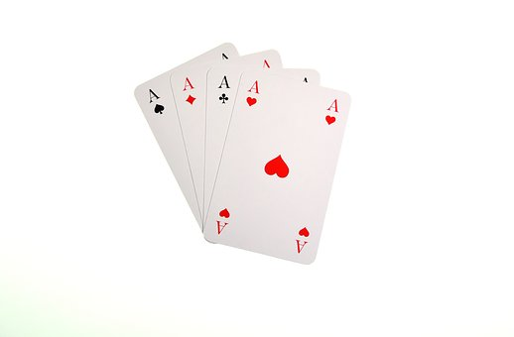
PREDICTING THE FUTURE
Your card is the Ace of Hearts. It means love and happiness.
You can make the following prediction about your partner’s future: You will live a very happy life and be lucky in love.

- The Ace of Hearts means love and happiness
__________________________________________________________
- Jack of Hearts stands for a lot of money.
__________________________________________________________
- 10 of Hearts means good luck and success.
__________________________________________________________
- 9 of hearts means a wish or a dream coming true.
__________________________________________________________
- 8 of Hearts means an invitation to a party.
__________________________________________________________
- 6 of Hearts means sudden good luck.
__________________________________________________________

- 4 of hearts means a lot of traveling.
__________________________________________________________
- Ace of Clubs means sudden wealth, maybe a win.
__________________________________________________________
- 5 of Clubs means new friendship.
__________________________________________________________
- Jack of Clubs indicates a meaningful experience in your life.
__________________________________________________________
- 9 of Clubs stands for intelligence.
__________________________________________________________
- 6 of Spades means small changes in the future.
__________________________________________________________
- 8 of Diamonds stands for a harmonious family life.
__________________________________________________________

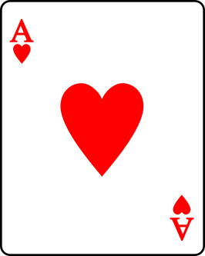
Your card is the Ace of Hearts. The Ace of Hearts means love and happiness, Lucky you, this is a very good card to get.
Prediction about your future : I will live a very happy life and be lucky in love.
Now write your own predictions (predictions of your partner), similar to the example given:
________________________________________________________________________________________________________________________________________________________________________________________________________________________________________________________________________________________________________________________________________________________________________________________________________________________________________________________________________________________________________________________________________________________________________________________________________________________________________________________________________________________________________________________________________________________________________________________________________________________________________________________________________________________________________________________________________________________________________________________________________________________________________________________________________________________________________________________________________________________________________________________________________________________________________________________________________________________________________________________________________________________________________________________________________________________________________________________________________________________________________________________________________________________________________________________________________________________________________________________________________________________________________________________________________________________________________________________________________________________________________________

Analysis 3.2
Grammar Checker | ☆ ☆ ☆
Learning Stage | Proceduralisation: The pupils are able to use the grammar in scaffolded exercises. The students are provided with an example and various phrases they should use to produce their utterance using the correct grammar form. However, the focus is not consciously on the grammar rules themselves.  Performance: The students are able to use the grammar in an open context, in order to make predictions and reflect upon the predictions about their own lives. When reproducing the predictions, the students focus on the overall message, rather than the grammar item.
Depth of Processing, mental Activity | The students have to be mentally active. They have to (try to) remember the various symbols and their meaning. According to the cards and their meaning they have to predict the future of their partner. The cards are chosen randomly, which awakes curiosity, since the students want to know what the various symbols tell the “card reader” (their partner) about their future.
Dual Processing & Authenticity of process | The learners have to actively produce utterances in more or less natural, language-like ways. Will future is mainly used in order to make predictions in real-life situations. The learners make predictions about their partner’s future.
Personalization | The exercise is not particuallary personalized, since the meaning of the cards is already given to the students and they do not have enormous room to express their own ideas and/or apply their own structures.
Commitment filter | Telling somebody what their future will be like is always interesting, fun and a little mystical as well. Therefore, we think that the students will fully enjoy this activity.
Peer/Social learning, interacting | The students have to work with a partner and actively engage. The partners have to switch roles. Everybody takes the same role at least once. Furthermore, the students have to interact with their partner, by playing the role of a fortune teller and predicting them their future.
Teaching VS testing | The exercise supports learning. The students have to use the grammar in an (more or less) open context. They have to interact with their partner and actively produce utterances using the grammar.

Testing Task
Weather forecast
Write a weather forecast for different cities around the world using the chart below. In your forecast include the name of the city, the date, the time, the temperature and, of course, the weather. Don’t forget to use the will-future for your predictions and start and end your forecast with a typical greeting and farewell.
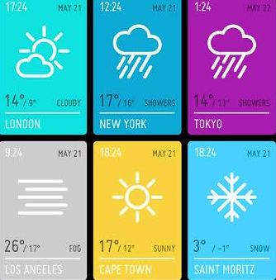

________________________________________________________________________________________________________________________________________________________________________________________________________________________________________________________________________________________________________________________________________________________________________________________________________________________________________________________________________________________________________________________________________________________________________________________________________________________________________________________________________________________________________________________________________________________________________________________________________________________________________________________________________________________________________________________________________________________________________________________________________________________________________________________________________________________________________________________________________________________________________________________________________________________________________________________________________________________________________________________________________________________________________________________________________________________________________________________________________________________________________________________________________________________________________________________________________________________________________________________________________________________________________________________________________________________________________________________________________________________________________________

Analysis Test
Grammar Checker | ☆ ☆ ☆
Learning Stage | The learning stage of this testing activity is performance. The students have to be able to use the grammar in an open context and focus on the overall message of their written product. The students have to generate their own sentences, they have to use the grammar to produce a weather forecast (prediction).
Depth of Processing, mental Activity | The students have to be mentally active. The students have to extract information form the pictures provided and produce their own sentences, which requires a strong mental activity.
Dual Processing & Authenticity of process | The learners have to actively produce phrases in sentences in more or less natural, language-like ways. Will future is mainly used to make predictions. The students have to use the grammar to produce their own written product according to the weather symbols provided to them.
Personalization | The exercise is not particularly personalized.
Commitment filter | The students may not fully commit themselves to this activity. However, the activity might meet their cognitive needs, since the students are required to extract information form the graphic provided and form their own sentences. It could be a challenging task for students, since it requires strong mental activity.
Peer/Social learning, interacting | Since it is a test, the students have to take it individually.
Teaching VS testing | The exercise tests the students’ knowledge. However, it does test the learners’ understanding and knowledge of the grammar in a meaningful way. The students have to form their own sentences in order to create a weather forecast.

Bibliography

Newby, David. “Theory and Practice in Communicative Grammar” In: Pölzleitner, Elisabeth (2017). Focus on Language and the Learner Course Handout. (p. 26-34) Graz.

Books
Hellmayr, Georg et.al. (2017): Prime Time 1. Coursebook. Wien: Österreichischer Bundesverlag Schulbuch GmbH & Co. KG

Video
https://www.youtube.com/watch?v=TokQZDsky_M&t=117s [10.06.2018]

Websites

https://www.kidsparkz.com/preschool-sings-weather.html [10.06.2018]

https://www.thoughtco.com/the-oregon-weather-forecast-1210091 [10.06.2018]

file:///C:/Users/Nina/AppData/Local/Packages/Microsoft.MicrosoftEdge_8wekyb3d8bbwe/TempState/Downloads/horoscopes.pdf [10.06.2018]

https://busyteacher.org/19917-predictions-fortune-teller.html [11.06.2018]

www.onestopenglish.com/community/lesson-share/winning-lessons/grammar-and-vocabulary/grammar-the-futures-bright/156549.article [11.06.2018]

