SS 2016
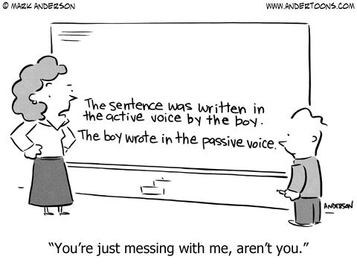
This is an awesome project. WOW!!!
Use these activities in class as soon as you can. Will work really well in any classroom – try them out in your next practicum.
pö

TERM PAPER: PASSIVE
511.420 COMMUNICATIVE GRAMMAR
DR. ELISABETH PÖLZLEITNER

Beatrix Hirtenlehner (1311335)
Margund Kerschbaumer (1112320)

Content

1. Introduction: Why teach C+C Grammar? 2
2. Lesson One 6
2.1 Collection Phase 6
2.2 Titanic 7
2.3 Passive Bricks 9
2.4 Homework Task: Inventions 11
3. Lesson Two 13
3.1 Passive Happy Families 13
3.2 Passive Quiz 16
3.3 Find Someone Who 20
3.4. Homework Task: Production Processes 22
4. Lesson Three 23
4.1 Name 3 23
4.2 Bombsaway 26
4.3 Board Game 28
5. Testing Task 30
6. Bibliography 32

1. Introduction: Why teach C+C grammar?
The following dialogue takes place between two teachers who have very different ideas of how to teach grammar effectively.
In the conference room...
T: I don't understand why so many pupils in my fourth form still make third-person-s mistakes. I mean the rule is so simple! If you talk about an action of a third person you put a 's' at the end of the verb. What is wrong with the kids that don't get this simple rule in their brains?
C: Come on, a missed third-person 's' is not the end of the world -- but maybe you should rethink your ways of teaching grammar if you're not happy with the outcome? I've noticed that you're very much in favour of the traditional approach to grammar.
T: Rethink my ways of teaching? I've been teaching for 25 years now, I think I know how to teach! And anyway, what do you mean by traditional? How do you teach grammar?
C: There are different approaches to teaching grammar. Traditional grammar primarily sees language as a set of forms and structures, while grammatical meaning plays a secondary role. It focuses on the students' ability to form correct sentences, which is why typical exercises are gapped sentence or sentences for transformation. Traditional grammar exercises like these mainly focus on how to test declarative knowledge, which is knowledge about facts and things, and often lack context. It is primarily about an understanding of rules and learners take on a rather passive role. Knowing a rule does not necessarily mean knowing how to use it in real life conversations. However, the reason why we teach grammar is to enable our students to communicate successfully. I am totally convinced of the cognitive and communicative approach because in my opinion it has many advantages over the traditional approach.
T: Which advantages would that be?
C: Well, in contrast to the traditional approach, the communicative approach tends to develop both, declarative and procedural types of knowledge, which means knowing how to. Grammar is more than just getting the tenses, word endings and word order right. It is all about conveying ideas. Therefore, activities must be meaningful and embedded in real life context - such aspects are considered in a communicative approach. In traditional grammar, the sentence is the main unit of analysis. However, it does not work to look at single sentences. Just think of the different future notions such as intentions, arranged activities or predictions. Often there is not one correct option because it depends on the speaker and the context whether something is, for example, likely to happen or rather fixed.
T: Excuse me, but what do you mean by 'notions'?
C: The idea of notions is the following: a notion is a content-concept. Notional grammar comes from the meaning side and shows that one idea is expressed in certain ways, which also makes it a natural process because you link one concept with one form. It is one connection. For example, going to can be used in different situations. There are situations where it is used for intentions, such as in I am going to play tennis next week and there are examples where it is used for interpreting signs, such as in Oh, look at the clouds, it is going to rain. In traditional grammar, these two notions are mixed in exercises and the kids learn that going to is used for intentions and interpreting sings. However, in notional grammar these two notions are split. This means that the kids become familiar with only one notion at a time. They learn for example: if I plan something, I use 'going to'.
T: But they need to learn both of these notions at one point or the other. And they also need to learn that there is another possibility to talk about the future. What about the will-future? I always introduced both tenses and did exercises which focused on contrasting these two.
C: Well, of course, I just want to say that one should not make it such a big grammar issue with lots of rules. One may use some lessons to talk about plans for the upcoming week or for the upcoming Easter holidays. After using 'going to' for expressing plans has become familiar and natural to them, you may introduce 'will' as another way to talk about the future, namely about predictions. I believe that this approach makes it a lot easier for pupils to truly understand the concepts. And they do not feel that it is all about some grammar rules. What they do is learning how to use language to express certain ideas, which is the point in learning a language.
T: Mhm, these ideas sound very interesting.
C: Another problem of traditional grammar is that it uses a lot of metalanguage when explaining rules, which makes it hard for pupils to understand them.
T: Oh yes, I have to admit that I also have the impression that the grammar rules are sometimes too abstract for students, especially if they are beginners of learning English.
C: What is more, many grammar rules found in our school books can be de-verified by examples. Just think of the rules about the shift of tenses in reported speech. There is no single correct option because it always depends on extra information - it depends on the context! If pupils just learn these unnecessary rules by heart, this knowledge - although not even entirely correct - will fade again quickly.
T: I see...
C: That's why I also think that it is much more effective to define teaching goals in forms of grammatical notions. The advantage is that pupils can express their grammatical competence in terms of can-do descriptors, for example I can make predictions about the future using 'will'. Besides, defining teaching objectives in terms of notions is one of the pedagogical implications of a cognitive view of learning.
T: Ah, I think I've heard something about this cognitive view in one of my last seminars. What were the main ideas underlying this view again?
C: Grammar activities should be embedded in contexts and learners should bring in their own ideas and knowledge because then they do not simply play a passive role but are actively engaged. Additionally, grammar exercises should focus on competence and performance, the potential to use grammar and the skill of using grammar in realistic contexts, rather than just knowledge of grammar.
T: Ah, and I remember that learning is seen as an active and dynamic process and that one should make sure that learners are as mentally active as possible.
C: Yes, exactly, because the more actively cognitive processes are used, the more efficient learning will be. And another idea is that teachers should consider different learning stages when giving exercises.
T: You mean the stages of presentation, practice and production, right?
C: No, these are the learning stages in traditional teaching which take a teacher's perspective rather than the learner's perspective. The cognitive learning stages are raising awareness, conceptualisation, proceduralisation and performance in real-life context. Raising awareness means that pupils are introduced to a new grammatical item. These need not to be single sentences. For example, you can hand out a text with many passive constructions in it and your pupils have to find these new structures and build a hypothesis. This is already part of the conceptualisation stage. Conceptualisation means that learners start making generalisations and internalize rules. At this stage, the concept behind the new grammatical form has to have been already understood. Proceduralisation refers to the link of competence to performance. This stage slowly guides the learners to the performance stage. It is therefore essential to use activities in which learners produce utterances that encode their own ideas. In the performance stage, learners will be able to apply all the knowledge to express themselves effectively.
T: I guess teaching becomes more coherent if one takes into account these learning stages.
C: Definitely. If we give pupils grammar activities to do, we should always be clear about which learning stages they support. Additionally, we should also keep pedagogical principles and communicative criteria in our minds. Pedagogical principles support learning processes and communicative criteria determine whether an activity can be authenticated.
T: Could you give me some examples of pedagogical principles?
C: Of course, for example 'depth of processing' refers to the mental activity of learners when doing activities. The 'commitment filter' involves learners' cognitive and affective needs. Always think of whether an activity is motivational and whether it arouses curiosity. Another pedagogical principle is 'peer/social learning' and this means that learners should interact with each other. 'Interaction' is also a communicative criterion. Other communicative criteria are for example 'personalisation' and 'dual processing'. 'Personalisation' means that learners can bring in their own ideas and knowledge and 'dual processing' refers to the authenticity of the process that pupils go through when doing an activity. For example, producing utterances as a reaction to what has just been said is an authentic process.
T: So to sum it up, grammar activities should always be embedded in a clear and realistic context and enable learners to produce language from their own personal perspective. Authentic language should be used, activities should be task-based and integrate several skills. Additionally, grammar activities should require learners to interact and to rehearse complex encoding.
C: Exactly! Now you're already a communicative grammar expert!
T: Well, I think I've learned a lot today. Thank you for all the information. It is good to have such young and engaged colleagues who are a breath of fresh air to us.

2. Lesson One

2.1 Collection Phase
(based on ideas discussed in the course)
The collection phase at the beginning of the first lesson is meant to be guided by the teacher and serves an awareness-raising, oral activity. It is about exposing the pupils to passive-constructions without them knowing that the activity is actually about grammar. The teacher's statements/questions depend on things that can be found in the classroom. For example, the teacher could involve the pupils into a conversation by asking question such as:
- "Oh Felix, what are your shoes made of?"
- "What else is made of .... in this room?"
- "Do you have an idea where this ..... was produced?"
- "Julia, your T-shirt is really nice. Do you know where it was produced?"
- .....
Hopefully, pupils imitate the teacher's use of the passive when responding to the questions. Since the statements/questions concern items possessed by the pupils they should be motivated to communicate and tell their peers about their possessions. We would spend about 15 minutes for this oral, introductory activity.

Analysis of the "Collection Phase"
Learning stage | Awareness raising: the learners are exposed to a new grammatical item - the passive voice - through teacher input.
Depth of processing,  mental activity | The pupils do not know that the conversation should lead them to learning a new grammatical form. However, mental activity is high as pupils should respond to the questions by the teacher using their real-life knowledge.
Dual processing | The teacher's statements/questions depend on things that can be found in the classroom and are thus related to real life. The pupils are encouraged to think about certain objects (what they are made of, where they might have been produced, ...)
Personalization | This activity is partly personalized as the teacher's questions concern items possessed by the pupils. However, the students might not contribute equally to the conversation and share their knowledge.
Commitment filter | Since the questions by the teacher concern items possessed by the pupils they should be motivated to communicate and tell their peers about their possession.
Peer/social learning, interaction | This activity is oral and interactive. However, it does not involve peer learning at this stage as the pupils do not know that they are about to learn the passive voice.
Teaching vs. testing | This introductory activity is used for teaching only.

2.2 Titanic
(Text taken from https://en.islcollective.com/resources/printables/worksheets_doc_docx/reading_passagethe_titanic_with_passive_voice/passive-voice-reading/23776)

To get the students' attention, begin with showing them a short clip of Titanic – e.g. the “I’m flying” scene (https://www.youtube.com/watch?v=1YGfrGKK9Mo) and ask them whether they know or have seen the movie. The movie is not the newest and it has become a classic example of a love story, so a lot of the students are probably familiar with the movie.
Continue with letting them guess the following questions:
- When was the Titanic built?
A. 1912 B. 1850
- The people constructing the ship thought the Titanic was .... ?
A. very elegant B. unsinkable
- What caused the sinking of the ship?
A. The engine didn’t work anymore. B. A collision with an iceberg.
- What is the name of the two actors playing the main protagonists in the movie? A. Leonardo DiCaprio and Kate Winslet B. Tom Cruise and Nicole Kidman
- In which year did the latest Titanic movie hit the cinemas?
A. 2012 B. 1985

After discussing the questions, let them see whether they have chosen the correct answer and tell them to read the following short text. Tell them to pay attention to any grammatical structure that is new to them. Do they recognize a pattern? How many examples of the passive voice do they spot?
Task: 1) Read the following short text about the Titanic and find out whether you have chosen the correct answers in the quiz.

Titanic

The Titanic was built in 1912. It was designed in a new way and it was thought to be unsinkable. This is why it wasn’t given enough lifeboats for the passengers and crew. The hull was damaged by a collision with a huge iceberg and it sank very fast. A total of 1,513 people drowned that day. Due to this disaster, a lot of magazines were printed which reported about the catastrophe in many languages. Furthermore, new international safety laws were passed and Ice Patrol was established. In 1985 the wreck was located on the sea bed and the ship was explored. Several successful films have been made about the Titanic since then, and the most recent was released in 1997 (which was reissued in 2012 as 3D version). The main characters were portrayed by Kate Winslet and Leonardo. DiCaprio.



2) The text includes several examples of a particular structure that is new to us. Can you find them? Do you recognize a pattern?
Analysis of "Titanic"
Learning stage | Awareness raising: the learners notice a new grammatical structure - the passive - and recognize a pattern. The text provided is short and not very difficult because pupils should focus on the passive forms.
Depth of processing,  mental activity | Mental activity is high as the pupils have to identify a new grammatical item. The depth of processing is increased by the different steps of the activity and by activating more than one channel.
Dual processing | All the questions and the text are related to real life as they are based on a true story. Some pupils might have already been confronted with some of the facts.
Personalization | This exercise is not personalised, however it still fits the purpose of directing their attention to this grammatical topic.
Commitment filter | The attention of the students is attracted by the varied type of exercise (it involves a video, a short quiz and a text). It does not get boring so the commitment filter is active.
Peer/social learning, interaction | The whole class is involved. We work on the contents and go through the questions and exchange ideas and findings.
Teaching vs. testing | Teaching only. The design is not actually meant for testing as it serves an awareness raising activity.

2.3 Passive Bricks
(This exercise is based on David Newby's Grammar for Communication. Exercises and Creative Activities → activity 198)

Print each of the categories on differently coloured paper and cut them out. Let the students form groups of three or four and give them a set of cards.

Task:
- Shuffle the cards and place them in front of you with the words facing upwards.
- Rearrange and order the sentences. Each sentence has to include all three colours once.
- When you have done that, try to come up with a rule for the passive form and discuss it with your partner.

Topic | Process | Additional information
  Honey | is made | by bees.
  Strawberries | are harvested | in May, June and July.
  Your tests | were marked | by your teachers.
  The house | was given | a new coat of paint.
  A new house | was built | on the property.
  Rudolph Rednose | was told | to finish his homework.
  Tokyo | is visited | by people from all over the world.
  Many birds | are heard | singing in spring.

Analysis of "Passive Bricks"

Learning stage | Awareness raising and conceptualization/hypothesis building: the students should realize the new grammatical item and recognize a pattern.
Depth of processing,  mental activity | Mental activity is rather high because pupils want to construct sentences. They have to pay attention to which phrases belong together and should also pay attention to the passive form. In addition, they have to find a rule for the passive form.
Dual processing | They have to make sense of the words/phrases – just like when they are reading a book or solve a normal puzzle. Games like this are authentic because everyone - kids in particular - plays games in their free-time.
Personalization | The exercise is not personalised as the statements do not relate to personal experience.
Commitment filter | The commitment filter is activated; it’s a funny game to practise with your colleagues and you can be active by using your hands to rearrange the words. The visual type is further stimulated by the colours.
Peer/social learning, interaction | Social learning and interaction are involved: They try to make sense of the sentences in groups and discuss ideas for a rule in pairs.
Teaching vs. testing | This exercise aims at raising pupils' awareness - so it is used for teaching only.

2.4 Homework Task: Inventions
The following activity should be a home exercise, however, there will be a follow-up activity at the beginning of the next lesson. The pupils will be asked to move in the classroom and talk to their peers about what they have found out. We think that such a follow-up activity is suitable because it will probably be motivating for the pupils to share their findings with their classmates.

Task:

Think of some inventions or things that you like and try to find out some information about them, for example
- when they were invented and by whom
- how they are made or
- where they are made, ...

Formulate 10 meaningful sentences!

Example: My favourite book "Harry Potter and the Philosopher's Stone" was written by J.K. Rowling.

_______________________________________________________________________________________________________________________________________________________________________________________________________________________________________________________________________________________________________________________________________________________________________________________________________________________________________________________________________________________________________________________________________________________________________________________________________________________________________________________________________________________________________________________________________________________________________________________________________________________________________________________________________________________________________________________________________________________________________________________________________________

Analysis of "Homework Task: Inventions"
Learning stage | Proceduralisation/Performance: The students have to formulate sentences using the passive voice. Apart from that they can freely choose what they write about.
Depth of processing, mental activity | The depth of processing and mental activity are high because the pupils have to think about inventions and products, find out some information about them and record their findings.
Dual processing | They have to find out some information about their chosen objects and thereby learn something new. It is not that simple to find and combine the findings. This task is closely related to both grammar and their real life.
Personalization | This activity of sharing information is highly personalised as the students shall find out and write about something they are truly interested in.
Commitment filter | The pupils are asked to find out some information about objects they are interested in. They can freely choose what to write about. Thus, they should be motivated and the commitment filter should be active.
Peer/social learning, interaction | Since this activity is meant to be homework, it does not include social learning or interaction.  However, the follow-up activity at the beginning of the following lesson involves interaction as the pupils should share their findings with their classmates.
Teaching vs. testing | Teaching: The aim of the exercise is to practise the passive voice and to automate the structure without a strong focus on the grammar.

3. Lesson Two

3.1 Passive Happy Families
(Adapted from https://www.hueber.de/media/36/idn2-l22-E1-Passivquartett.pdf)

Task: The following game is similar to the German game "Quartett".
Form groups of three. You will get a set of cards.

- Distribute the cards equally. The youngest player starts the game.
- Each family consists of four cards.
- On each card, 4 steps for the production of the object at the top are mentioned.
- The picture shows you what your card is about.
- Try to collect families by asking a group member for a specific card you do not have:
Start you sentence with "For producing....", add a process and ask for the required object.
Example: “For producing teddy bears, size and form are selected. Max, do you have the size and form?”
- If the asked player has the card, he/she gives it to you and you are allowed to ask for another card in the same way.
If the asked person does not have the requested card, he/she can take a turn.
- The game continues until no families are separated any more.
The person with the most cards wins the game.
Note: You can only ask for a specific card!

Teddy Bear  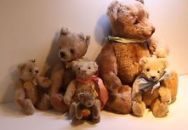  - size and form are selected  - fabric is cut into pieces  - eyes are glued onto the bear  - all the parts are sewn together | Teddy Bear  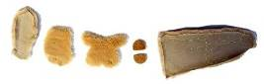  - size and form are selected  - fabric is cut into pieces  - eyes are glued onto the bear  - all the parts are sewn together | Teddy Bear  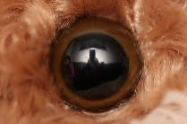  - size and form ar  e selected  - fabric is cut into pieces  - eyes are glued onto the bear  - all the parts are sewn together | Teddy Bear    - size and form are selected  - fabric is cut into pieces  - eyes are glued onto the bear  - all the parts are sewn together
Wine  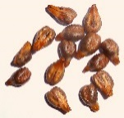  - Seeds are planted in fertile soil  - Plants are watered regularly  - Ripe grapes are pressed in the machines  - Liquid is filled into glass bottles | Wine    - Seeds are planted in fertile soil  - Plants are watered regularly  - Ripe grapes are pressed in the machines  - Liquid is filled into glass bottles | Wine    - Seeds are planted in fertile soil  - Plants are watered regularly  - Ripe grapes are pressed in the machines  - Liquid is filled into glass bottles | Wine    - Seeds are planted in fertile soil  - Plants are watered regularly  - Ripe grapes are pressed in the machines  - Liquid is filled into glass bottles
Book    - a book is written by an author  - many trees need to be felled  - paper needs to be produced  - a printing machine is required | Book    - a book is written by an author  - many trees need to be felled  - paper needs to be produced  - a printing machine is required | Book    - a book is written by an author  - many trees need to be felled  - paper needs to be produced  - a printing machine is required | Book    - a book is written by an author  - many trees need to be felled  - paper needs to be produced  - a printing machine is required
Movie    - Actors are casted for the roles  - different costumes are designed  - an appropriate location is rented  - sufficient budget is needed | Movie    - Actors are casted for the roles  - different costumes are designed  - an appropriate location is rented  - sufficient budget is needed | Movie    - Actors are casted for the roles  - different costumes are designed  - an appropriate location is rented  - sufficient budget is needed | Movie    - Actors are casted for the roles  - different costumes are designed  - an appropriate location is rented  - sufficient budget is needed

Analysis of "Passive Happy Families"
Learning stage | Proceduralisation: Students try to collect a family by talking about processes that are involved in the production of certain objects - of course they need the passive here.
Depth of processing,  mental activity | The pupils are mentally active. On each card there are four steps which are involved in the production process. They have to select the process their card is about by linking it to the picture. In addition, pupils have to be attentive because if they want to win the game, they need to remember which group members did not have a particular card.
Dual processing | This activity draws on pupils' real life knowledge to construct meaning. They probably also learn something new in this activity.
Personalization | This activity is not personalised as it does not relate to pupils own experiences.
Commitment filter | Since this activity is a competitive game that kids usually like playing, we assume that the commitment filter will be active.
Peer/social learning, interaction | This exercise is a group activity, thus social interaction is involved. Pupils can also monitor their peers' utterances.
Teaching vs. testing | The activity is meant as an alternative to traditional exercises. It is a playful activity which should be used for teaching. Students practise the grammar without noticing it consciously.

3.2 Passive Quiz
(Based on and adapted from http://www.polzleitner.com/epep/Grammar/PassivePairs.pdf and from David Newby’s Grammar for Communication. Exercises and Creative Activities. see task 200 on p.101)

In this past passive quiz students create sentences about facts and inventions using the past passive. Each team or group needs one copy of cards which has to be cut as indicated. There should also be an uncut version for each group to make comparison easier afterwards.
Task: Work in pairs or groups of three. You get two sets of cards.
- Find the correctly matching two cards and create sentences. The cards with the coloured background provide the information you need to create the sentences.
You will have to find your own verbs to complete the sentences meaningfully.
- When you have done that, you will get one intact copy of the worksheet so that you can check your answers.
- Choose 5 pairs of cards and write down the sentences on a sheet of paper. Keep this sheet of paper in your folder.

Note:
This is not a competitive game. Work as a team and see if you can solve the quiz.

  the first iPhone | 2007
  song "Shake it off" |   by Taylor Swift
  the first email | 1971
  the Eiffel Tower | 1889
  Eurovision Song Contest 2016 | by Ukraine
  "The Kiss" | by Gustav Klimt
  first Olympic games | in Athens in 1896
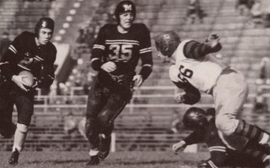  first football game | by the Americans
  the Hunger Games |   by Suzanne Collins
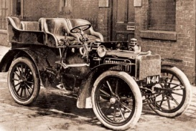  the first car | by Gottlieb Daimler in 1885
  the first steps on the moon | by Neil Armstrong
  America | in 1492
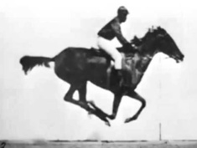  the first film | at the end of the 19th century

Analysis of "Passive Quiz"
Learning stage | Proceduralisation/Performance: Students know the concept and are able to use it. They find appropriate verbs and create meaningful sentences in pairs.
Depth of processing, mental activity | This exercise requires a high depth of processing as they have to construct meaningful sentences by finding the matching cards and appropriate verbs. The students have to be mentally active since they have to pay attention to which cards belong together and to the passive form.
Dual processing | The process is authentic as the sentences include information the students might have encountered in their lifetime. They need this knowledge to guess the answers.
Personalization | This exercise is not personalized, however, the students might take advantage of these facts sometime in their life.
Commitment filter | The pupils want to find out which pieces of information belong together and thereby activate their commitment filter.
Peer/social learning, interaction | The students interact with each other and work in a team, so they can also learn from each other.
Teaching vs. testing | This exercise is used for teaching; the setup of the activity is made for them to practise the passive and to get to know some new information at one go – they will not be familiar with all the facts.

3.3 Find Someone Who
(Adapted and altered from Hadfield – Intermediate Communication Games, game 20 and http://www.polzleitner.com/epep/Grammar/pres-perf-tense-experience.pdf)

Task:
- Look at the five sample statements under the heading "Find someone who" in the grid and write down 3 own ideas.
- Walk around in the classroom and find a classmate for whom a specific statement is true by asking a question.
- Write down the name and some details. Answer your classmate's question and continue asking other peers.

Use the present perfect tense (I have been, I have seen,...) to talk about general experiences and the past simple to give further details and to talk about specific events.

Example:
A: Have you ever been treated unfairly by others?

B: Yes, I have been treated unfairly by my parents. Last week I had to go to bed while
my brother was allowed to stay up and watch TV.
Or: No, I have never been treated unfairly by others until now.

Find someone who... | name
who will be picked up from school
is allowed to have parties at home
has been stung by a bee
has been given a lot of presents
has been told a lie by a friend

Analysis of "Find Someone Who"
Learning stage | Proceduralisation: Students use the clues from the grid to formulate questions and use the grammar without focusing on the rules.
Depth of processing,  mental activity | Their mental activity is high because they have to think about some questions they would like to ask and they have to process the information they gather from their classmates. They also need to answer questions and talk about their experiences.
Dual processing | Dual processing is given as the students ask and answer the questions based on their real life experience. Asking about experiences and giving information is an authentic process.
Personalization | This exercise is highly personalised as the pupils give information about themselves and talk about personal experiences. In addition, they also need to come up with 3 own ideas / questions they are interested in and which they will ask their peers.
Commitment filter | The affective filter is activated; students get to know something new about their colleagues and get the opportunity to talk about personal experiences.
Peer/social learning, interaction | Social learning is given as the students interact with each other when walking around in the classroom.
Teaching vs. testing | We would rather use this exercise for teaching and practising how to actively use the passive.

3.4 Homework Task: Production Processes

(based on ideas discussed in the course)




In today's lesson we have learned something about the production of teddy bears, wine, books and movies. For homework, search for a video on YouTube that shows a production process. Type (for example) "how chocolate is made" into the search field and see what you can find. Three examples are listed below. You can use one of these links or choose a video on your own. When you have found and watched a video try to recapitulate the production process. Think of the most important steps and write a short summary of how your "object" is made. Your text should be about 150 words long. Use the passive where appropriate!

Examples:
How chocolate is made: https://www.youtube.com/watch?v=Ye78F3-CuXY
How honey is made: https://www.youtube.com/watch?v=iT6IQx26eHk
How pencils are made: https://www.youtube.com/ watch?v=Q_9_VkNHs1E

Analysis of "Homework Task: Production Processes"
Learning stage | Performance: Students watch a video and need to summarize the most important steps involved in a specific production process.
Depth of processing, mental activity | Mental activity is extremely high. The pupils watch a video and need to recapitulate essential steps and write them down in their own words. Pupils have to be aware that the passive is used to describe processes of production.
Dual processing | The process is very authentic. The pupils can choose any topic/object they are interested in and learn something new about it. Since it is all about the production of any real objects, this task is closely related to real life.
Personalization | This task is very personal as it enables the pupils to truly follow their interests. Pupils will not only practice grammar when doing this exercise but also extend their real-life knowledge in their fields of interest.
Commitment filter | This exercise draws on curiosity and will hopefully be enjoyed by the pupils as they can look for videos about something they are truly interested in. Thus, the commitment filter should be active.
Peer/social learning, interaction | There is no interaction in this activity. We will probably talk about the students' findings at the beginning of the next lesson so that the students get the opportunity to tell their peers what they have found out.
Teaching vs. testing | This exercise can be used for teaching and testing. If one wants to use it as a testing activity, it does not only test grammar but also pupils' comprehension skills.

4. Lesson Three

4.1 Name 3
(Based on and adapted from http://www.teach-this.com/images/resources/name-three.pdf )
This exercise provides an opportunity for students to practise present and past passive: Before starting the game, cut out the different boxes from the grid. Then the pupils form teams of three to four and take one of the card sets.
Task:
1. Distribute the cards evenly.
2. The youngest person begins and takes a card.
If it is your turn, take a card and formulate a sentence using the passive and beginning with "Name 3". Make sure to combine both pictures from each card.

Examples: Name 3 books which were made into films.
Name 3 buildings which were built in Europe.
Name 3 buildings which can be found in Europe.
Name 3 famous people which were born in the UK.
3. The other group members have to come up with three things that are asked for.
The person who first comes up with three correct answers can keep the card.
4. The next person takes a card and formulates a sentence beginning with "Name 3".
5. The game continues until all the cards have been used.
6. The winner of the game is the person who owns the most cards at the end of the game.

 |   
   | 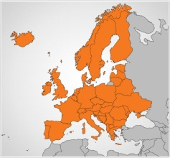  
  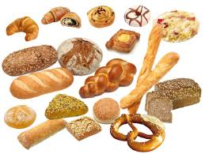  products |   
  buildings |   
   | 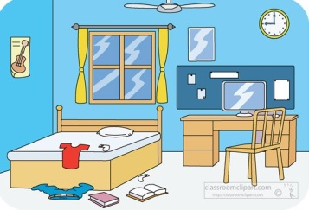  objects

Analysis of "Name 3"

Learning stage | Proceduralisation/Performance: Pupils are already familiar with the structure of passive sentences and now have to form sentences using the passive voice.
Depth of processing, mental activity | The mental activity is high because pupils have to make sense of the pictures and find appropriate verbs to create meaningful sentences. In addition, they have to think of 3 objects/people and name them.
Dual processing | Dual processing is given because pupils need real life experience / knowledge in order to form meaningful sentences and name 3 objects/people.
Personalisation | This activity is not really personalised as it does not necessarily relate to pupils' own experiences but rather to their knowledge about the world.
Commitment filter | The commitment filter is activated as the activity is a game and probably each student wants to win the game. They can show how fast they can come up with three things.
Peer/social learning, interaction | Each student plays against the other group members, but the person asking the question has to evaluate the answers. Hence, peer learning and interaction is present.
Teaching vs. testing | This exercise is for teaching only. Pupils do not only use and practise the passive voice, but they are also given the opportunity to test their knowledge of the world.

4.2 Bombsaway
(taken and adapted from: http://www.mes-english.com/forums/viewtopic.php?t=214)
In the following activity, pupils practice the passive voice in an entertaining game by asking questions using the passive voice. Each pupil gets a sheet of paper with the instructions and two grids:
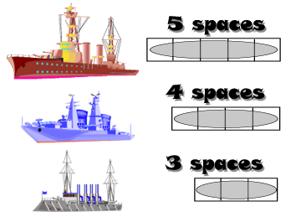
Task: Work with a partner.
- Draw in 2 of each boat in your ocean (6 ships in total).
Do not show them to your partner!
- Now attack enemy ships by calling a square. In order to do that, you need to ask appropriate and meaningful questions, for example:
Were cookies eaten by children?
Will the homework be done next week?
- Mark the squares you have already called in the second grid "enemy's ocean":
O ... if you hit a ship X ... if you missed
- If a ship is hit twice, it sinks.
- The one who first sinks all the enemy ships wins.

 | by children | in the evening | by the teacher | next week | by your friends | in the garden | school | every week | in Graz
the cookies
tennis
homework
photographs
vegetables
e-mail
book
birthday presents
housework

 | by children | in the evening | by the teacher | next week | by your friends | in the garden | school | every week | in Graz
cookies
tennis
homework
photographs
vegetables
e-mail
book
birthday presents
housework

Analysis of "Bombsaway"
Learning stage | proceduralisation/performance: the pupils know the concept already and now need to combine different phrases do create a question using the passive voice.
Depth of processing, mental activity | The students have to be mentally active. They have to find a verb to combine two phrases meaningfully, formulate a question and also pay attention to the passive form.
Dual processing | The students need to come up with questions to sink the partner's ships. Forming questions is an authentic process and essential in conversations. In this exercise, the questions are not asked to gather information (it's more "a means to an end"), so it partly lacks authenticity. However, pupils may ask very similar questions in their real life with the purpose to get information.
Personalization | This exercise is not personalized as it does not relate to pupils' own experiences.
Commitment filter | The commitment filter is activated as pupils play a competitive game and want to win.
Peer/social learning, interaction | This exercise involves social learning: The pupils probably come up with lots of different options (since they can choose any verbs that fit). Thus they hear ideas they might not have thought of themselves. They can also monitor each other. In addition, we think that this game promises a lot of fun.
Teaching vs. testing | As this exercise is an interactive game, we think that it can only be used for teaching.

4.3 Board Game

(Taken and adapted from https://en.islcollective.com/resources/printables/worksheets_doc_docx/speaking_the_passive_voice/intermediate-b1-activity/19275).

Task: Get together in groups of three. You will get a copy of the board, a die and one counter per person.
- Everyone throws the die. The person whose die rolls the highest number begins the game.
- Advance on the board according to the number of the die. Look at the instruction and talk for about 30 seconds about the specific topic. Then it's the next person's turn.
- The next person continues in the same manner.
- Continue until everyone reaches the end of the board.

Use the present perfect tense (I have been, I have seen,...) to talk about general experiences and the past simple to give further details and to talk about specific events ("zooming in").

Example for the first playing field:
"I was treated unfairly last week by my parents. I was sent to bed at 9pm but my older brother was allowed to stay up and watch TV. That was so unfair because I also wanted to watch the movie. It was Harry Potter and the Philosopher's Stone, which is also my favourite book."

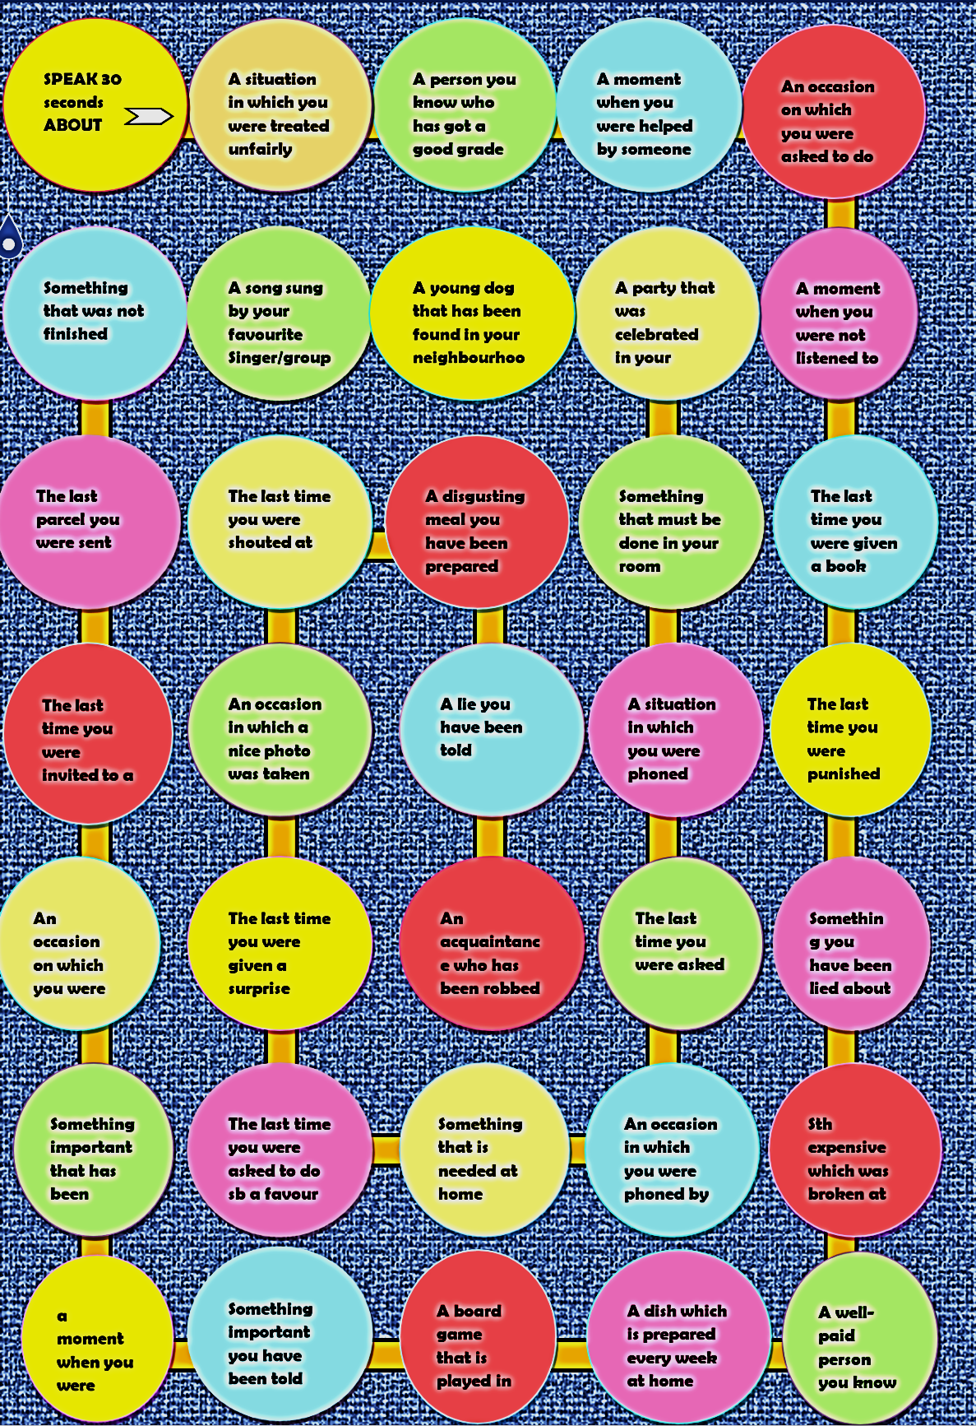
Analysis of the Board Game
Learning stage | Performance: Students talk freely about a certain topic using passive structures.
Depth of processing,  mental activity | By talking to others and listening to the other group members they process the information on deeper levels. Mental activity is high as the students have to tell their peers spontaneously about a certain event.
Dual processing | They are challenged to talk spontaneously and freely about a certain topic. It is an authentic process as this is exactly what people do in real-life conversations.
Personalization | The game is highly personalised; everyone is free to share his thoughts and experiences with the group members.
Commitment filter | Active: Students are motivated by being involved in conversations, by telling others their stories and by getting to know new stories.
Peer/social learning, interaction | Interaction and social learning are definitely given as the pupils talk to each other and maybe also learn from each other.
Teaching vs. testing | Both: It is well suited for practising, but you could also use it for monitoring their progress.

5. Testing Task

task invented by Margund and Beatrix

Your parents took some time off from work and you spent the last 2 weeks on a beautiful island in the Caribbean with them. Now you have returned home and you have just opened the door when you realize that something has been changed. Your parents’ clothing has been scattered on the floor. Books and letters have been placed on the living room table. The kitchen window has also been opened.
Task: Write a report for the police in which you describe what has been changed in your home. Consider questions like these and use the passive where appropriate.
- What has been stolen?
- Have any objects been damaged or moved?
- Has anything been broken?
- What has been noticed by the neighbours?
- Has anything been found that might belong to the thief?

Analysis of the Testing Task
Learning stage | Performance: Students are asked to do this task on their own and they have to use grammar to communicate their ideas.
Depth of processing, mental activity | Students are mentally active because they need to imagine the situation in order to come up with different ideas. They also need to find appropriate vocabulary and use the passive structure where appropriate.
Dual processing | Depending on where the students live, they are more or less likely to experience such a scenario. However, anyone watching the news and reading some newspapers will have come across headlines that report about an increased percentage of burglaries these days. Thus, pupils are confronted with a current issue.
Personalization | The task is partly personalised. It does not relate to the students' own experience (unless they have experienced a situation like that). However, the students will imagine their house and can decide what might have been changed in this particular situation. They can refer to objects they really have at home or invent some.
Commitment filter | The commitment filter hopefully becomes activated since the pupils are asked to write about their own home in a particular situation.
Peer/social learning, interaction | Obviously, since this is a testing task, there is no interaction with other students. Students write the report for the police on their own.
Teaching vs. testing | This task can be used for teaching and testing: Students are asked to use the passive when appropriate, i.e. when describing what has been changed in their home. By writing an authentic report about the changes, they demonstrate their language skills and show what they have processed so far.

6. Bibliography

Hadfield, Jill – Intermediate Communication Games, game 20
Newby, Pölzleitner and Klamminger (2016). "An introduction to Cognitive Communicative Grammar". Course Handout. Graz

Newby, David (1989/1998). Grammar for Communication. Vienna: ÖBV.

Newby, David (1992/1993). Grammar for Communication: Exercises and Creative Activities. Vienna: ÖBV.

http://www.polzleitner.com/epep/Grammar/PassivePairs.pdf [2016, May 3]

http://www.polzleitner.com/epep/Grammar/pres-perf-tense-experience.pdf [2016, May 15]

https://en.islcollective.com/resources/printables/worksheets_doc_docx/reading_passagethe_titanic_with_passive_voice/passive-voice-reading/23776 [2016, May 7]

https://www.hueber.de/media/36/idn2-l22-E1-Passivquartett.pdf [2016, May 7]

http://www.teach-this.com/images/resources/name-three.pdf [2016, May 12]

http://www.mes-english.com/forums/viewtopic.php?t=214 [2016, May 13]

https://en.islcollective.com/resources/printables/worksheets_doc_docx/speaking_the_passive_voice/intermediate-b1-activity/19275 [2016, May 6]

Sources of the pictures:
“Honey” [Online]. Home of the Honey Bee and the Maple Tree. http://www.honeymapletree.com/honey.html . [2016, May 16].

„Nutritional Value of Cherry and Strawberry“ [Online]. Oganicfacts. http://www.organicfacts.net/health-benefits/fruit/health-benefits-of-cherry.html . [2016, May 16].

“Wähle einen passenden Termin für deinen Kurs“ [Online]. Studymed. https://www.studymed.at/ . [2016, May 16].
„... Child Clipart Image - Boy with crew cut wearing a backpack as he.“ [Online]. Clipartbest. http://www.clipartbest.com/he-clipart . [2016, May 16].
“Cool Colors: 10 Crazy Painted Houses & Home Painting Ideas” [Online]. Dornob.
http://dornob.com/cool-colors-10-crazy-painted-houses-home-painting-jobs/ . [2016, May 16].

“hands holding design of a house in empty lot” [Online]. Rucker Financial. http://rucker.com.au/services/property-development/ . [2016, May 16].

“Travel to Tokyo JAPAN | Tokyo view Time Lapse HD 2015” [Online]. YouTube. https://www.youtube.com/watch?v=KYZSs6swOhg . [2016, May 16].
„Singing Bird“ [Online]. Quotesgram. http://quotesgram.com/singing-birds-quotes/ . [2016, May 16].
“Opération tranquilité vacances” [Online]. P-O Life. http://anglophone-direct.com/operation-tranquillite-vacances/ . [2016, May 23].

Ideas and theory based on Newby D., "An introduction to Cognitive Communicative Grammar" in Course Handout C+C Grammar, summer term 2016

