
KF-Universität Graz
Communicative Grammar (Fachdidaktisches PS 2)
Supervisor: Dr. phil. Elisabeth Pölzleitner
SS 2015

Teaching the Present Perfect Tense
Notion: Change & Completion




Submitted by:
Lisa Kos (1211299)
lisa.kos@edu.uni-graz.at
Eva Leick (1211786)
eva.leick@edu.uni-graz.at

Contents

- Why and how to teach grammar in a communicative way 3
- Teaching materials for three lessons (including theoretical analyses) 7
First Lesson 7
Activity 1.1: I’ve changed my room 7
Activity 1.2: Can you spot the change? 8
Homework 1: Message in a bottle 9
Second Lesson 10
Activity 2.1: English: check!? 10
Activity 2.2: What I’ve done today 11
Activity 2.3: Black Stories 12
Homework 2: Research project (I) 13
Third Lesson 13
Activity 3.1: Research project (II) 13
Activity 3.2: Today’s checklist 14
Activity 3.3: A lot of news! (I) 15
Homework 3: A lot of news! (II) 15
Testing Activity: What has changed? 16
- Sources 17

- Why and how to teach grammar in a communicative way
Have you ever had a conversation with someone who did not share your mother tongue? Do you sometimes talk to someone using L2? Do you remember your first experiences in speaking with a native in a language you had just recently started to learn? We assume you can answer all three questions with ‘Yes’. Now was it difficult for you to communicate with the other person? ‘Sometimes’ probably is your response. But why was it difficult? Because of the grammar? Because you did not remember the rule for a certain grammatical form or a form for a rule? No – because of misunderstandings. Because either you or the other person lacked the necessary language to express what they wanted to say.
How can you overcome this problem if you want to continue talking to people in a foreign language? Simply, you start or continue learning it. And most commonly this learning happens in school. At this point, you might already have started to recall your own school days and realized that what you were taught in the language classroom might not have primarily been designed to help you communicate with others or express your ideas and opinions. Instead, you were probably one of the many students that were traumatized by a teacher who made you study tons of complicated and self-contradictory rules by heart and then expected you to efficiently speak English or any other L2. This method of teaching grammar is called traditional grammar teaching and has successfully managed to scare people off from learning a foreign language for many years and still does. Wait, this simply cannot be right! Isn’t there any easier and more efficient way of teaching grammar? Actually, - and we are very glad to tell you – there is. The approach is called Cognitive Communicative Grammar or C+C grammar and is way more effective than traditional grammar teaching. Let us present you several reasons for that and you will see how we dare to utter such a bold statement.
First of all, C+C grammar uses meaning-based teaching objectives. Instead of focussing on forms (as traditional grammar teachers do), C+C grammar highlights the functions of grammar and circles around actual language performance. Let us clarify this by providing an example: Imagine your friend wanted to tell you about her intentions for tonight. Maybe she would say something like ‘I am going to watch Dirty Dancing with my roommate tonight’ or ‘I am finally going to finish the book by John Locke’. Naturally, the going-to-form is used by your friend to express intentions. This link between the grammatical form and the concept of meaning or the communicative purpose behind utterances such as the example sentences are labelled ‘notions’. In the language classroom, it is important that the teacher only introduces one notion at a time to make sure that the students have completely understood them and to avoid confusion. The aim of teaching notions is that the students are able to use them correctly without having to think consciously or even panic (believe us, that can happen if you were taught to constantly turn on your red alarm when using grammar) when doing so.
But how can such a performance stage be reached? The answer to that is simple: C+C grammar activates our brain in more depth than traditional grammar teaching does. Teaching forms and rules leads to an activation of the students’ declarative memories. This does not appear to be problematic at all at first, but in fact it is: Knowing grammar consciously (competence) and actually being able to use it (performance) are quite different skills. C+C grammar aims to store grammatical knowledge in the procedural rather than the declarative memory due to a quite straightforward reason: If grammatical knowledge is proceduralised it becomes part of the long-term memory and when that happens, students are able to use it wherever and whenever they want to without ever having to think about it again (unless they wish to, of course) as it has become automatized. Not having to think about something consciously frees up the working memory and allows the students to focus on other relevant or new language aspects. To sum up, C+C grammar teaching has realized the importance of deep processing, which pays off as students use their storage capacity of memory more efficiently.
Moreover, contextualisation is another important feature of C+C grammar teaching that is not considered in traditional approaches. Let’s briefly recall the scenario described in our introductory sentences: Even if the two speakers might lack important lexical and/or grammatical competences, they can usually still understand what their conversation is about on a very basic level due to the given context (and body language, of course). So, if context plays such an important role in communication, why do traditional grammar approaches often completely blank out any context as, for example, in prototypical fill-in-exercises? Even when trying well-meaningly, we cannot come up with a legitimate reason why this could be helpful for any language learner. In C+C grammar, exercises always need to be embedded in a clear context, which make them communicative and authentic. One example that illustrates the importance of context very well is the use of reported speech and its time shift in English: The statement ‘Today we met Georg and he told us that he went (he is now studying at KFU) to BG/BRG Gleisdorf, just like us.’ is absolutely acceptable in grammatical terms even though no tense shift occurred. If we, however, knew that Georg actually went to a different school we would say ‘Georg told us that he had gone to BG/BRG Gleisdorf, just like us (but that’s actually a lie)’. Depending on the information we have about Georg’s educational background we interpret his statement differently, which further influences our use of grammar when reporting.
After having explained some general information about the C+C approach, let us now briefly show you what else needs to be considered when teaching grammar in a communicative way. First of all, grammar rules must be short and simple. Nobody is keen on learning page-long and confusing rules plus their exceptions by heart – and what’s more: the students are highly unlikely to remember even half of them. As we’ve already explained, learners have to actively process grammar in order to fully understand it and to automatize the grammatical forms so as to be able to use them accurately. A bunch of abstract rules doesn’t really help here. What does help is to provide lots of input and gradually guide the students towards the point at which they can produce correct output.
In other words, the C+C approach provides a step-by-step model to grammar teaching: first, students need to be made aware of a grammatical phenomenon, i.e. of one notion (awareness stage) and should then be given the chance to work out the rule (conceptualisation stage). You’ve heard right: the most effective method for students to grasp the meaning of a grammatical notion is to discover it themselves! This interconnects their brain areas and helps them remember the rules by increasing their mental activity. Next, the use of the notion that is being taught must be practiced and automatized until the students are actually able to apply their knowledge accurately (proceduralisation stage), but with occasional help from the teacher. Finally, there’s the performance stage, at which the students should manage to use the new notion without any kind of assistance and without any kinds of relevant mistakes.
Have we already managed to confuse you with all the terms and concepts by now? Don’t worry, as long as you’ve understood the basic principles of the C+C approach and as long as you keep assessing your own teaching – whether you’re teaching a class of High School students a foreign or yourself -, you’re sure to conduct pretty decent communicative lessons. Wait, assessing your own teaching? How do you do that? The most important thing when analysing one’s own grammar lessons or rather individual exercises and activities is that everything you do meets communicative and pedagogical criteria. In order to be communicative, an exercise must include language that the students also come across in reality as well as meaningful real-life tasks, it must be embedded in a context and it must involve the students on a personal level. Also, students should be given tasks that don’t only ask them to fill in forms but to also produce their own sentences and apply all their grammatical knowledge. Last but not least, a communicative activity should trigger meaningful conversations, foster not only speaking, but – if possible - also reading, listening and writing and have a certain aim that the students can look forward to when fulfilling the task.
As for the pedagogical criteria, the activities that you choose or create must enable students to draw on previous knowledge and require them to activate their brain, i.e. they should be able to fully process the new grammar information. Furthermore, exercises should not be used to test the students’ knowledge, but to enhance it and they shouldn’t look at whether a certain student knows about grammar, but whether they can use it accurately and appropriately. As is the case with everything in school, grammar activities should also be designed to be fun and engaging for students in order to increase their motivation and encourage them to commit themselves to the task. Finally, a pedagogically valuable exercise should support peer interaction – not only to improve the students’ relationships with each other, but also because pupils can often learn as much from their peer as they can from their teacher.
In order to give you an impression of how communicative grammar exercises look like and how they can quickly, easily and effectively be analysed, we are now going to present teaching material for three lessons on one particular notion – in our case the notion of Change/Completion (present perfect tense) - and assess them with the help of the Quick Check Grammar Chart (by E. Pölzleitner, see epep.at), a helpful tool that combines both communicative and pedagogical criteria. We hope that we’ve been able to convince you of how essential it is to teach English in a communicative way and that you can profit from the following teaching materials.
Hang on, that’s all very well, but aren’t there any disadvantages of communicative grammar teaching? At this point we have to admit that nothing is completely flawless and neither is the C+C approach. There are actually some minor problems that occur when it comes to applying communicative grammar teaching in the language classroom.
First of all, as this approach has only been around for a relatively short period of time and is - especially among teachers who have been practicing traditional grammar for quite a long time - often misunderstood as something vague and not sufficiently thought-through, there is a lack of materials for communicative grammar teaching. This leaves many teachers who weren’t so sure about “this new kind of teaching” in the first place feeling even more insecure and leads them to fall back into old habits, i.e. traditional grammar teaching.
In contrast, teachers who are enthusiastic but not really well-informed about this new way of teaching grammar might refuse to confess that communicative grammar teaching doesn’t work wonders. It’s certainly the best approach out there at the moment, but this doesn’t mean that it miraculously solves all the problems that come with the difference in the students’ levels of learning. Some will understand certain notions right away, while it will take others much longer to grasp their meaning and finally become able to use them. Now if teachers blindly trust that communicative grammar teaching will make everyone a grammar expert and don’t assess their teaching critically, they might ignore their students’ deficits and fail to adapt the – basically very helpful – material accordingly.
Also, the transition from the old to the new way of teaching grammar is a bit of a problem: not everyone is familiar with communicative grammar teaching and if those in charge of the students – teachers, tutors, parents etc. – have different opinions and teach grammar in different ways, the students will sooner or later be confused and won’t know to whom to listen or which grammar rules to consult when having to use a reference book. It would be essential for everyone involved to work together with a common goal in mind and a common guideline as a means, but this simply hasn’t happened so far.
In sum, the small issues of communicative grammar teaching can be narrowed down to one common problem. It’s not that it’s ineffective. It’s not that it takes longer than traditional grammar teaching. It’s not that it’s inappropriate for students. It’s simply that this approach hasn’t spread to all schools and all English teachers yet and that there are still people out there who doubt its benefits! In other words, the problems don’t arise because teachers follow the C+C approach – they arise because so many still don’t follow it. But this problem can’t be hard to solve, can it? Exactly, and that’s where YOU (unless you’re not teacher or learner of English or any other foreign language) come in: inform yourself, share the idea, explain its principles, try them out yourself and add to the growing number of great teaching materials! Don’t miss the chance to be part of the change that English language teaching is going through at the moment – the change from form-focused instructions to a meaning-based, student-centred and efficient approach to grammar that helps the learner to actually use the language in communicative situations. And what else would be the point in knowing a language than to communicate with others? Amen.

- Teaching materials for three lessons (including theoretical analyses)
First Lesson
Activity 1.1 I’ve changed my room (adapted from Your Ticket to English 3, p. 44-5) [~25 min.]
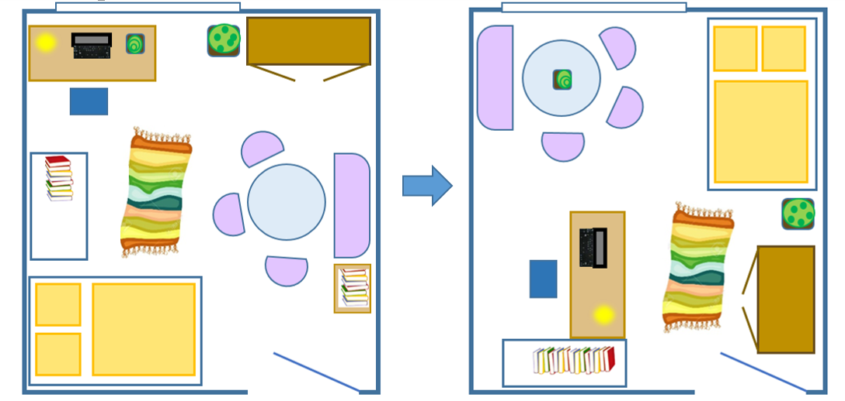
- Show the students the first picture and tell them that this is your (or your friend’s) bedroom, which you have rearranged yesterday. Let the students guess what you have changed and repeat their sentences to ensure the usage of the ppt. Then show them the second picture and ask them to spot the actual differences.

Discuss the following questions:
- Why have I changed my room this way? (because it’s bad for the eyes to have the computer in front of the window)
- Which version do you like better? Was it a bad idea to rearrange everything?
- What form did I use for talking about the changes?
- Have the students draw their own room and switch drawings with a partner. They should then redraw their partner’s room, rearrange the furniture and change various details (altogether at least 5 things). Have them switch drawings again. Now everyone has to find out what the partner has changed in their room and write it down in at least 5 sentences.

Grammar Checker | Theoretical analysis of activity 1.1
Learning Stage | Awareness – Proceduralisation: 1st part can be used for raising awareness to the grammatical structure and letting the students build their own hypotheses. In the 2nd part the accurate use of the structure is practiced.
Depth of processing & mental activity | When describing the changes, the students can only use two different verbs, which doesn’t require a lot of brain activity. However, the constant repetition helps to brainwash the forms into their heads and ensures that they will remember “You’ve put/you’ve moved” as a model structure.
Dual pr. & authentic-city of process | This activity is very authentic in its process. It’s common to talk about changes one has made to one’s room and to draw plans for this purpose.
Personalisation | The activity is personalised in that students present their room and also learn something about people that they know – their classmates & teacher.
Commitment filter | Students are likely to commit themselves to the exercise as they are curious about their teacher’s room as well as about their partners’ ones.
Peer/ social learning & interaction | This is an interactive exercise that requires the students to participate (first part) in order to find the solution and to work with a partner (second part).

Activity 1.2 Can you spot the change? [~20 min.]
Tell the students to closely observe the classroom and each other for ~2 minutes. Then ask for 1-2 volunteer(s) and send them out. Change 10 details in the classroom and call the ‘detectives’ back in. They now have to find out what is different. Monitor the process and provide some example questions:

- Has someone swapped pieces of clothing with someone else?
- Have we moved a piece of furniture?
- Have some students changed places?
- Have any windows/drawers etc. been opened/closed?
If the detectives haven’t discovered all 10 details within 10 minutes, the others can start giving hints (e.g. “We have removed something yellow.”, “Sarah has put on someone else’s sweater. Whose?” etc.) The activity can be repeated several times.

Grammar Checker | Theoretical analysis of activity 1.2
Learning Stage | Proceduralisation: students have to produce their own correct sentences in scaffolded conditions.
Depth of processing & mental activity | Maximum brain activity: students have to change something, detect changes and speak about them; the activity’s content is linked to the notion.
Dual processing & authenticity of process | The activity resembles the situation that most students are familiar with: while they were away, their parents have changed the house/flat, the teacher has redecorated the classroom etc.
Personalisation | The exercise is personalised in that it is all about the students’ classroom, their appearance and their own ideas.
Commitment filter | This fun activity highly engages students and gets them talking immediately.
Peer/ social learning & interaction | The activity involves maximum social interaction. The whole class has to participate by changing things and collaborating (detectives).

Homework 1 Message in a bottle (inspired by You & Me 3, p. 56) [5-10 min. explanation]
Prepare a message in a bottle, bring it to class and show the piece of paper to the students. Tell them that you have found this bottle at a river bank, read out the text and pass it around. Have the students write their own messages as a homework, collect them and put all of them into a bottle/ tie them to a balloon full of helium. Together you can watch the ‘bottle of change/balloon of change’ drift/fly away.

Dear finder,
So much has changed in my life, but I want to keep
some of it a secret. This is why I’m writing to you, because I’m dying to tell someone! First of all, I’ve fallen
in love with Sophie. I’ve even started writing secret messages to her! Her favourite colour is green, so I’ve dyed my hair green. Mum doesn’t like it, but I’ve already turned 13, so I’ve stopped listening to her.
Something else: my cat Minky has fallen ill. She has lost her appetite and we have taken her to the animal hospital – poor Minky! And one last thing: my brother has moved into a new flat! I can’t wait to visit him!
Yours,
David Anonymous

PS: It’s great to write down what’s on your mind – you should do it as well!

The students can use these questions as guidelines for their letter:
Has someone’s appearance changed?
Has someone bought something?
Has something been painted/repaired/destroyed…?
Has someone fallen ill/ recovered from an illness?

Grammar Checker | Theoretical analysis of Homework 1
Learning Stage | Proceduralisation: students have to produce their own sentences according to the model. Without the do-it-yourself part, the activity could be used for awareness raising and conceptualisation as well.
Depth of processing & mental activity | Students have to activate their brains so as to form meaningful messages and produce accurate sentences that are true for themselves.
Dual p. & authentic-ity of process | Students are familiar with the idea of sending a message in a bottle/with a balloon. However, they might doubt that the teacher has actually found such a bottle by the river, especially with a message written in English.
Personalisation | The activity is highly personalised. The students have to think about what has changed in their own lives.
Commitment filter | The call to action in the “PS:” of the letter as well as the aim of the activity (sending secrets/worries etc. away) are motivating for the students.
Peer/ social learning & interaction | This activity doesn’t necessarily involve social interaction, but reflecting on their lives might increase the students’ social competence in the long run.

Second Lesson
Activity 2.1 English: Check (inspired by Friends 2 coursebook, p. 125) [~15 min.]
English - completion - list 2015 | English - activities – not – done – yet 2015
I’ve already read 5 English books. | I haven’t read the third Hunger Games book in English yet.
I’ve already watched 4 English movies. | I haven’t been to the KIZ Royal in Graz yet.
I’ve listened to my all-time favourite CD twice this month. | I haven’t listened to Megan Trainor’s album yet.
I’ve written 2 articles in English. | I haven’t finished the text for the year book yet.
I’ve checked out several English web sites on the Internet. | I haven’t registered on Twitter yet.

Make two lists (see above) on the board, then ask individual students questions about their use of English in this year (e.g. Hannah, have you already watched an English movie this year? Is there one you would like to see but you haven’t watched yet?).
Let the students discover what is new about the grammar in these lists and questions. If they have found the correct answers underline ‘I’ve’ and ‘I haven’t’, ‘already’ and ‘yet in different colours on the board. Then give them the following instructions:
a) Make your own list of the things you have already done this year and used English for. Then write
down the things you haven’t yet done but would like to do.
b) Turn to your neighbour and tell him/her about your list. Find out if you have done nearly the same
things or completely different ones.

Grammar Checker | Theoretical analysis of activity 2.1
Learning Stage | This exercise is designed as an awareness raising activity: students have to find out what is ‘new’ about the grammar presented to them.
Depth of processing & mental activity | The depth of processing in this activity is intermediate. Students have to be mentally active to discover the new grammar items and immediately use it in their own speech production.
Dual processing & authenticity of process | The structure of this exercise (= to-do-list character) as well as the topic (‘use of English in daily life’) are authentic. The combination of both is, however, quite uncommon and would usually not occur outside a school setting.
Personalisation | The provided sentences in the activity do not involve students on a personal level. They are, however, encouraged to talk and asked about their personal experiences by the teacher.
Commitment filter | The commitment filter in this exercise is activated. Students have to concentrate and be creative in order to discover the present perfect tense. They thus focus mainly on understanding and repeating the new grammar items (first unconsciously then consciously). The emphasis still lies on the expression of meaning, though.
Peer/ social learning & interaction | Students can benefit from their peers’ answers in the first part of the exercise. Part b) also promotes social learning.

Activity 2.2 What I’ve done today (adapted from You & Me 2 coursebook, p. 109) [~15 min.]
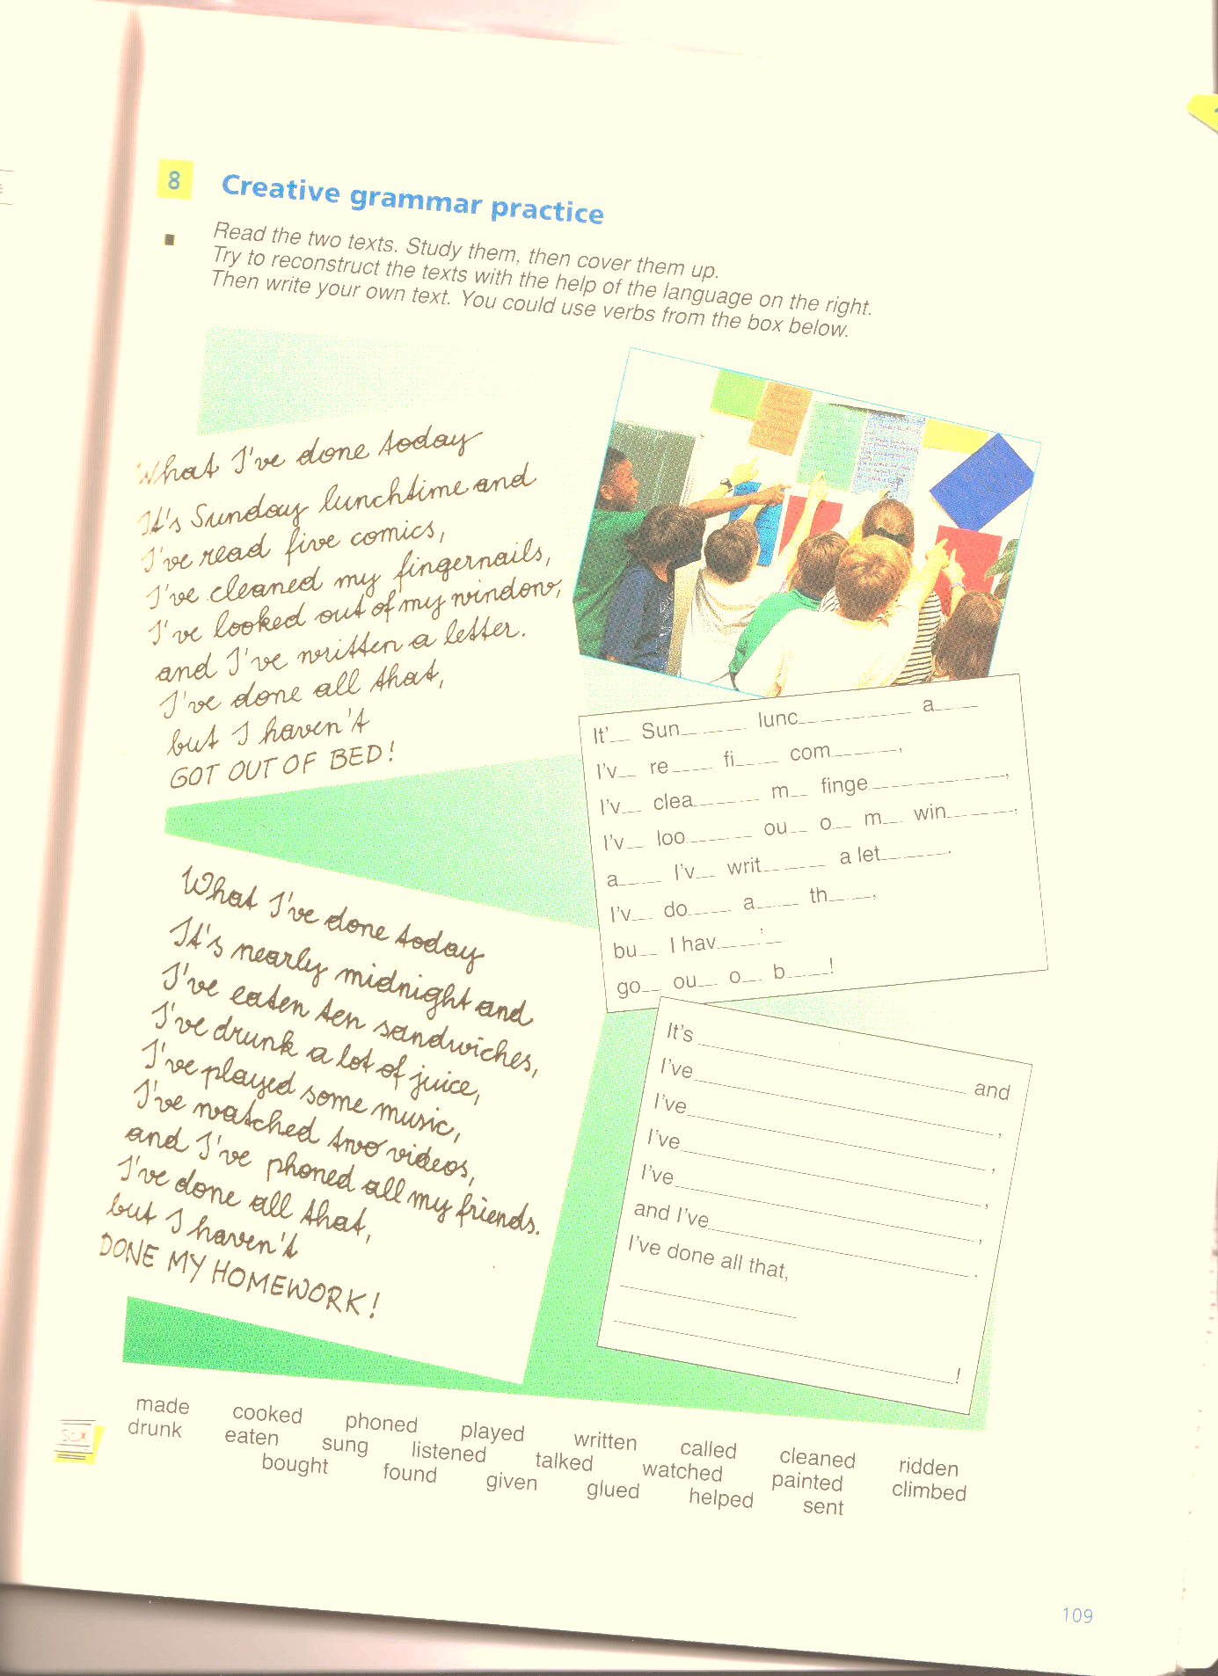
Let the students read through the two texts titled ‘What I’ve done today’. Afterwards, briefly discuss the following questions (in the box) in class:
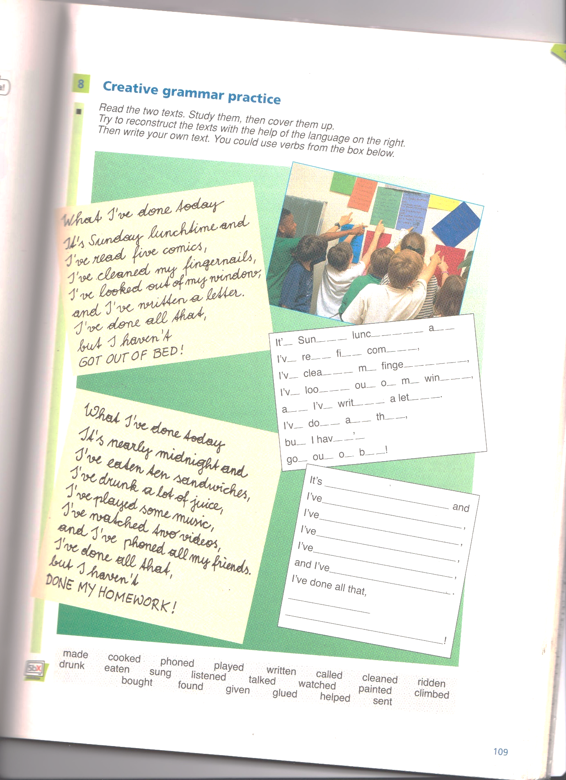
Why are these texts funny?
Who of you has ever felt like that?
Is this poetry/ art? Why/ Why not?

Let the students write a text in the same style. Here are some verbs that might help them get inspired but they should feel free to use any verbs they want to.
make – cook – phone – play – write – call – clean – ride – drink – buy – eat – sing – listen – find – talk – give – glue – watch – help – paint – send – climb
You can also rhyme your poem!

Grammar Checker | Theoretical analysis of activity 3.2
Learning Stage | This activity is best used during the proceduralisation stage due to the strict structure of the poem.
Depth of processing & mental activity | The mental activity during this exercise is high as students have to be creative. The scaffolded conditions, however, restrict them in their creativity.
Dual p. & authentic-ity of process | Students have to come up with an authentic list of activities and a surprising twist at the end.
Personalisation | The structure of the poem encourages students to personalise their texts. However, students could easily just write sentences that are not connected to their real lives instead.
Commitment filter | The c. filter is activated in this task as students have to use their creativity and come up with meaningful activities in the present perfect tense.
Peer/ social learning & interaction | This activity does not include peer learning.

Activity 2.3 Black Stories [~15 min.]
Tell the students the first black story (see below) and ask them to find out what has happened. They should think about these things: Have they seen anything out of the ordinary? Has anything changed? Has someone said anything special?
They may only ask questions that you can answer with YES or NO. Explain and write the following guidelines on the board:
What has changed? What has been done? (Change/ completion) -> Present perfect tense
What happened? What did they do? (Event) -> Past simple tense


STORIES: (see last page for solutions)
- The Mysterious Match
A man is found dead in a field. He is clutching a match.

- Anthony and Cleopatra
Anthony and Cleopatra are lying dead on the floor of a villa in Egypt. There is a puddle on the floor. The door is locked from the inside and the window is tilted. There is no mark on either of their bodies and they have not poisoned.

- Swimmer in the Forest
A dead man is found in the middle of a forest. He is equipped with swimming trunks, a snorkel and a facemask. The nearest lake is 8 miles away and the sea is 100 miles away.

- The Realization
A man is walking downstairs in a building when he suddenly realizes that his wife has just died.

- The Deadly Dish
Two men go into a restaurant. They both order the same dish from the menu. After they have tasted it, one of the men pulls out a gun and shoots the other man, then himself.

Grammar Checker | Theoretical analysis of activity 2.3
Learning Stage | Proceduralisation: Practicing the usage of the ppt (and the past simple). The teacher can monitor the student’s questions to ensure accuracy and repeat the sentences in the ppt to help the students automatize the form.
Depth of processing & mental activity | The activity involves high brain activity; students have to maximise their mental resources in order to solve the mystery. As the grammar is embedded in a meaningful context, it is firmly fixed in the brain.
Dual pr & authentic-ity of process | The stories are a bit far-fetched, but the game itself would be played in the same form in a setting different from the classroom and is therefore authentic.
Personalisation | The activity is not really personalised, but the students will automatically link the situation in the story to something they have experienced themselves and use their personal knowledge to come up with a solution.
Commitment filter | The activity is exciting and fun; the students are keen on finding the answer.
Peer/ social learning & interaction | The whole class is involved; students can combine their peers’ ideas with their own thoughts and solve the riddle together.

Homework 2 Research project (I) (inspired by epep.at “GIBS building sprayed) [~5 min. expl.]

Have the students get together in 5 groups, give each group a specific topic (1. behaviour of students, 2. happiness of students, 3. facilities, 4. lessons, 5. extracurricular activities) and ask them to do some research on their topic:
You are a committee of educational experts that wants to ensure the quality of schools. This week, you are investigating what has changed in [insert school name] since last year.
In order to get all the information you need, you may speak to students from other classes, different teachers, the caretaker & the cleaning staff, conduct surveys etc. Ask them what the situation was like last year, what it’s like now and what has changed.
- Has the school bought new equipment?
- Have the teachers started giving more/less homework?
- Has the students’ level of happiness increased? …
Be prepared to hold a short presentation in front of the other expert committees next lesson. You can prepare diagrams, make lists, design posters – whatever presents your findings best.
The head of the committee is looking forward to learning about all the recent changes in the school!

Third Lesson
Activity 3.1 Research project (II) [~25 min.]
Briefly remind the students of the form they should use when they talk about changes and then have each group present its research project in class. Afterwards, lead a short discussion about the findings.
Grammar Checker | Theoretical analysis of Homework 2 & activity 3.1
Learning Stage | Performance: students should speak accurately without the teacher’s help.
Depth of processing & mental activity | The demanding task of finding relevant data, translating it into English and presenting the findings accurately requires high brain activity.
Dual pr. & authentic-ity of process
Personalisation | The activity is highly personalised; students get to know their school better.
Commitment filter | This exploratory task makes the students feel like scientists and raises their motivation accordingly.
Peer/ social learning & interaction | The group work fosters peer learning as well as social interaction with other members of the school.

Activity 3.2 Today’s Checklist (adapted from Friends 2 coursebook, p. 122 & Red Line 2, p. 53)
I have… | me | partner | Ranking
…had breakfast.
…listened to the radio
…read today’s newspaper.
…thought about the holidays.
…made myself lunch for school.
…taken the bus.
…spoken to a teacher.
…sung a song.
…written an e-mail.
…quickly done my homework in the morning.
2 Things you have both done today:
1)
2)
Instructions for students: Tick off the things in the list you have already done today. Then turn to your neighbour and ask them if they have already done these things today. Put a or x in the in the spaces provided. Then find two extraordinary but true things you have both done today add them to your list. The goal is to find 2 activities no one else in class has done today. (Example: We’ve both talked to a stranger in the bus today.) [~15 min.]


Compare the results in class. Which of the given activities has been done by most students? Write down on the board how many students have done the individual activities and then rank them from 1-10 and let the students write the rankings in the space provided on the sheet. Then each group tells the class their shared activities. Let’s find out who has done the most extraordinary activities!

Grammar Checker | Theoretical analysis of activity 2.2
Learning Stage | Proceduralisation due to scaffolded conditions. If the students were, however, encouraged to ask their partner about specific details the present perfect tense is also used in real time performance.
Depth of processing & mental activity | This exercise fosters deep processing as students have to work for themselves, talk to a peer and compare the list in class. In each step they have to repeat the present perfect tense several times.
Dual processing & authenticity of process | The exercise requires students to make use of their knowledge of the world. The activities presented in the list are authentic and could happen in everyone’s daily life.
Personalisation | The focus of this activity lies on personalisation. Students are asked to speak about their own day and then have to find out about their neighbour’s.
Commitment filter | Due to the high personalisation of this activity the commitment filter is also quite active. Further, students should make use of their creativity when finding two shared things they have done today.
Peer/ social learning & interaction | The peer learning in this exercise is very high. First, students have to talk to a partner and then the whole class is involved.

Activity 3.3 A lot of news! (I) (inspired by The Good Grammar Book, p. 56) [~10 min.]
Instruction for students: Joanne Wells has just arrived home from work. Her children Simon and Josey and her husband Mike have been really busy in the meantime and have a lot of news to tell her. Complete the following sentences by putting words in the gaps that describe what has changed while she was away.
Example: Simon: Mom, look! I’ve finally completed my puzzle! Isn’t it cool?
- Josey: Mom, I am so sad! The cat ……………..…………………. and we can’t find her anywhere! What should we do?
- Mike: Darling, did you see that I ……………….……………… the garden gate? It’s red now!
- Simon: I tried to phone grandma but I didn’t reach her because she ……………………..… to visit her friend in Germany!
- Josey: I ……..……already…………………all my homework! Can I go play with Mary?
- Mike: Honey, I broke your favourite mug yesterday, I am really sorry! But I ………….already………… you a new one! It’s on the kitchen shelf!
Homework 3 A lot of news! (II) (inspired by The Good Grammar Book, p. 56) [~2 min. exp.]
Have the students write down 5 sentences describing what has happened at their home/ in their family while they were in school and/ or their parents at work.
Example: My brother has practiced playing the saxophone.
Grammar Checker | Theoretical analysis of activity 3.3. & Homework 3
Learning Stage | This exercise is best used in the proceduralisation stage. Students practice the notion of change and completion in scaffolded conditions.
Depth of processing & mental activity | The processing is of medium depth. Students need to understand the contexts and use their creativity to come up with fitting words (more than one are possible). The exercise does, however, not require high brain activity.
Dual p. & authentic-ity of process | The exercise is authentic and encourages students to use their knowledge of the world.
Personalisation | Activity a) is not personalised as it is about a fictive family and their home. The homework exercise b) is highly personalised.
Commitment filter | The commitment filter in this exercise is quite low. Being able to fill in the gaps meaningfully might, however, give students a feeling of success. The homework exercise actives the commitment filter as students have to talk to their family or look around their home to find out what has changed.
Peer/ social learning & interaction | This activity should be done individually.

Testing activity: What has changed? (Inspired by epep.at: “Before and After”-game)
Look at the pictures below. What can you see? Write down what has changed in each picture.
  1.  Example: Joe has cleaned his sneakers! |   2.
    3. |     4.
  5. |   6.

Grammar Checker | Theoretical analysis of the testing activity
Learning Stage | The learning stage is performance as this activity is designed for testing. In a real test, it would probably make sense to leave out the example sentence at the beginning (depending on students’ proficiency level).
Depth of processing & mental activity | Students need to be mentally active and have understood the concepts of the present perfection notion in order to successfully complete this task.
Dual processing & authenticity of process | This activity is very authentic and students need to make use of their knowledge of the world. Therefore, more than one answer could be correct for each picture. (e.g. It has gotten dark! It has become night! The sun has completely set! etc.)
Personalisation | This testing activity is not personalised. This is, however, not a disadvantage: it avoids additional stress for the students as it does not ‘force’ them to give away personal things or involve them on a private basis.
Commitment filter | The commitment filter is activated in this exercise due the deep processing. In general, the commitment filter is always more active in testing situations than in teaching.
Peer/ social learning & interaction | No peer learning – this is a testing activity. Students should complete it on their own.

- Sources
Bibliography: | Webliography:
The new You & Me 3 | www.epep.at
The new You & Me 2 | http://menotek.com/
Friends 2 (coursebook)  Your Ticket to English 3 | http://restorationportland.com/blog/62-will-you-take- the-esporta-challenge
The Good Grammar Book with Answers (by M. Swan & C. Walter)  HO Communicative Grammar | https://hereslookinatyousquid.files.wordpress.com/2012/06/snow-white.jpg  http://trulyfreefilm.hopeforfilm.com/2013/06/the-film-biz-sooooo-slow.html

Solutions to the Black Stories:
1 | He has jumped out of a sinking hot air balloon. The people in it had drawn matches to decide who should go over board to stop the balloon from sinking. By drawing the shortest match, the man has made himself a volunteer.
2 | A. & C. are fish. A gust of wind – coming from the tilted window – has swept their bowl from the table.
3 | There has been a forest fire, during which a fire-fighting plane transferred water from the lake to the forest. The diver was picked up as well and dropped in the middle of the forest.
4 | The building is the hospital in which the man’s wife is linked to a life-support machine. The light has just gone out due to a power cut in the whole building, making him realise that the machine must be off now as well.
5 | The man has tasted alligator meat for the first time. Some years ago, he had been shipwrecked together with a group of people, including the other man in the restaurant. As he was badly injured, the others had to feed him to keep him alive, but didn’t find anything eatable on the island they had stranded on. One of the others had died, so they fed him to the injured and told him that it was alligator meat. After having tasted real alligator meat in the restaurant, the man knows that the others had lied to him and that he had probably been fed human flesh.

