

KF-Universität Graz

Communicative Grammar (Fachdidaktisches PS 2)

Dr. Phil. Elisabeth Pölzleitner

SS 2015

Teaching Conditional II

Notion: Hypothetically speaking






Submitted by:

Christina Orel
Matr. Nr.: 0914379
christina.orel@edu.uni-graz.at

Contents

- Introduction:
What does it mean to teach C+C grammar? .................. p 3-6

- Teaching material for three lessons + analysis ............. p 7-19

  - Lesson 1 ............................................................................... p 7-11
  - Lesson 2 + homework .................................................... p 12-15
  - Lesson 3 ............................................................................... p 16-18
  - Testing activity .................................................................. p 19

- Sources ............................................................................................. p 20

1. Introduction
What does it mean to teach C+C grammar?
Conversation between a teacher favoring the traditional grammar approach (TG) and one who attempts to convince his/her colleague to follow the communicative grammar approach (CG).

CG: Teaching communicative grammar in classes has many advantages over teaching grammar in the traditional way because a communicative method provides the students with a better opportunity to actually use the grammar in a context and apply everything learned to real-life situations.

TG: But what’s the difference to traditional grammar? I teach my students the rules of how grammatical forms are expressed and when they have to use certain forms, for example the ‘going to’ future.

CG: The problem with the teaching of rules and forms instead of focusing on notions such as ‘expressing intentions’ instead of ‘going to’ is that when learners are given only instructions of how to do something and don’t need to be mentally active, for example, to form rules by themselves, they often have difficulty using grammar outside the classroom. Skehan (1996) writes that focusing only on forms often doesn’t lead learners to use grammar effectively but rather encourages the belief that language learning means simply knowing rules.
I criticize traditional grammar because it focuses on grammatical knowledge while not giving sufficient attention to grammatical competence and performance. Grammatical knowledge means the awareness and understanding of rules, for example, being able to do fill-in-the-gap exercises. However, it is important to not neglect grammatical competence, the potential to use grammar in different games and exercises which are open-ended played in class, and grammatical performance – the skill of using grammar in real-life situations and contexts.

TG: But what exactly does it mean to teach grammar in a communicative way?

CG: I’m sure you have heard about the communicate approach which has been widely implemented in classrooms since the 1990s. According to Richards (2006, p. 23) “it describes a set of general principles grounded in the notion of communicative competence as the goal of second and foreign language teaching. A new approach that has evolved as our understanding of the processes of second language learning has developed”. A communicative grammar view sees grammar as process such as this communication model shows:

Seeing grammar as a process emphasizes the importance of including the learners’ schematic structures in their mind that help them to encode and decode language. The speakers’ cognitive competence should be kept in mind when teaching them something new. The mode further stresses that language is not only a case of knowing but also of using; it is necessary to enable students to use a language effectively in real-life situations. Performance is important as you can see in the communication model.
A grammatical notion is a single grammatical concept encoded into a form. The learners’ perceptions of the world help them to understand the concept and use it. You said before you explain your students how to use the ‘going to’ form, which makes it impossible for them to use their background knowledge and knowledge of the world to get the form correctly. When you teach grammar with notions, for example by showing them how to ‘express intention’, namely with using ‘going to’ they know what they are supposed to do. Notions give meanings to forms and show learners how to use grammar in various situations without giving explicit rules. They rather form rules by themselves in their head, which is much better as it ensures that these grammar concepts are stored in their head and can be accessed in real-life situations.

TG: And how should I as a teacher make sure that my students’ schematic constructs play a role in my teaching?
CG: You should choose grammar activities carefully and make sure that they are embedded in contexts. Further, the learners should have the opportunity to bring in their own ideas and knowledge and stay as mentally active as possible.

TG: How would you suggest introducing new grammar if not in the traditional way?

CG: The most important aspect in introducing new grammar is for the learners to become aware that there is in fact something new there to learn. This is be achieved by providing meaningful and authentic input for the pupils. If their awareness is not raised and the new grammar is only presented to them, they will not engage in learning this. Therefore the first learning stage is to get pupils to become aware of the grammar and focus on it. This is but the first stage in learning grammar, there are four learning stages. Awareness raising, conceptualization, proceduralization and performance; these learning stages are the intake of the students which enables them to produce a correct output.
TG: But what makes a good grammar activity suitable for the C+C grammar approach?

CG: A good grammar activity is meaning-drive; learners are able to interpret the language activities according to their own memories and real life experiences as well as their already existing knowledge about grammar and its rules. Furthermore the processing of grammar is easier when a multitude of senses is involved in the grammar activities, so instead of giving only fill-in exercises which have but shallow form of processing, only writing a required form into the space. It is far more efficient to include various senses and also encourage the pupils to learn from each other, which leads me to maybe the most convincing argument for C+C grammar teaching and that is, it is fun. The affective and cognitive needs of learners are met and therefore the learning of grammar is a natural process as it should be and is in the L1.

TG: That’s very interesting indeed, but what about the time aspect? Doesn’t it take up a lot of time to actually go through these four learning stages?

CG: Not at all. The activities of C+C grammar teaching can be easily included into the curriculum using the notions to come up with exercises, which are considered relevant topic-wise and also help the learners to acquire the authentic use of language and therefore the correct way of using grammar without even thinking about it. I really hope these arguments were convincing enough for you and you reconsider your stance towards grammar teaching. If you have any further question, I am more than happy to answer them for you.

TG: No, at the moment I think I am fine, even if I am slightly dazzled by the variety of points for teaching grammar in a cognitive communicative way.

yes, you have certainly made your fictitious partner curious and interested in the c+c approach.
Good, clear arguments

2. Teaching material for three lessons + analysis

2.1 Lesson 1

Activity 1: (Awareness-Raising-Activity)

Task:
Show the students the following two Cartoons. Let them read the Cartoons and ask them to find out differences concerning meaning and verb forms with a partner. Since they have already learned when to use Conditional I, they should be able to come up with possible solutions.

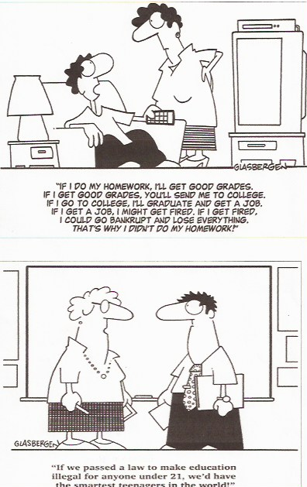
Copyright 2004 by Randy Glasbergen

Analysis of Activity 1
Grammatical objective | This task is used as an engaging activity and introduction into Conditional II. Students make their first experiences with Conditional II and they should get aware of the difference between Conditional I and Conditional II (meaning, form).
Activity type | Pair work, written activity
Learning aim | Students should get their first impression and realize the difference between CI and CII.
Pedagogical principles | I chose this activity, since reading Cartoons is mostly fun and students can make their own observations with a partner. Therefore they find rules by themselves, which helps them to store it in their long-term-memory.
Communicative principles | Since they work together with a partner, they have to interact and communication takes place.

Grammar Checker | Theoretical analysis of Activity 1
Learning Stage | The learning stage is ´awareness´ as pupils should get engaged in the topic and should notice and focus on new grammar.
Depth of processing & mental activity | The depth of processing is very high, since students have to come up with their own observations and find own solutions, including formulating a grammar rule in their own words. Therefore this activity involves high brain activity.
Dual processing & authenticity of process | The activity presented is fairly authentic, since students will come across Cartoons in real life quite often.
Personalization | This activity is not really personalized, but Cartoons very often raise student´s interest.
Commitment filter | Student´s are engaged by the Cartoons and are motivated to search for differences and make their own observations.
Peer/social learning & interaction | As students have to work together in pairs, the interaction is high and social learning takes place.

Activity 2

Task:
Then turn into a class discussion and collect student´s ideas and lead them to the notion and meaning of Conditional II – hypothetically speaking. Afterwards discuss how to build it and let them write down their own formulated rule into their grammar book. Additionally, let them create and add their own little Cartoon, using Conditional II.

Examples students came up with (1. Unterrichtspraktikum):

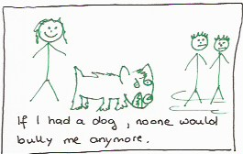



Analysis of Activity 2
Grammatical objective | Students should understand the meaning of Conditional II and when to use it. Furthermore, they should form their own grammar rule and support this rule by drawing and creating their own Cartoons.
Activity type | Class discussion, individual work
Learning aim | Students should be able to see the difference between CI and CII and understand the meaning behind it.
Pedagogical principles | Creating own rules and drawing Cartoons is an engaging and motivating way how to get introduced into a new grammar notion.
Communicative principles | Students can share their ideas and observations with the whole class and learn from each other.

Grammar Checker | Theoretical analysis of Activity 2
Learning Stage | The learning stage is still ´awareness raising´, since students focus on new grammar and formulate their own rules.
Depth of processing & mental activity | This activity involves a high depth of processing. Students have to understand the meaning of Conditional II and come up with their own rule. By drawing own Cartoons into their grammar books, they have the chance to be creative and their brain activity is high.
Dual processing & authenticity of process | Students will have to come up with own observations and rules in their further life, which is fairly authentic. They get the chance to improve their ability to draw their own conclusions.
Personalization | This activity is partly personalized, since students can formulate their own rule and draw their own Cartoon, where they can draw on own experiences.
Peer/social learning & interaction | The class discussion is based on interaction, which supports social learning.

Activity 3
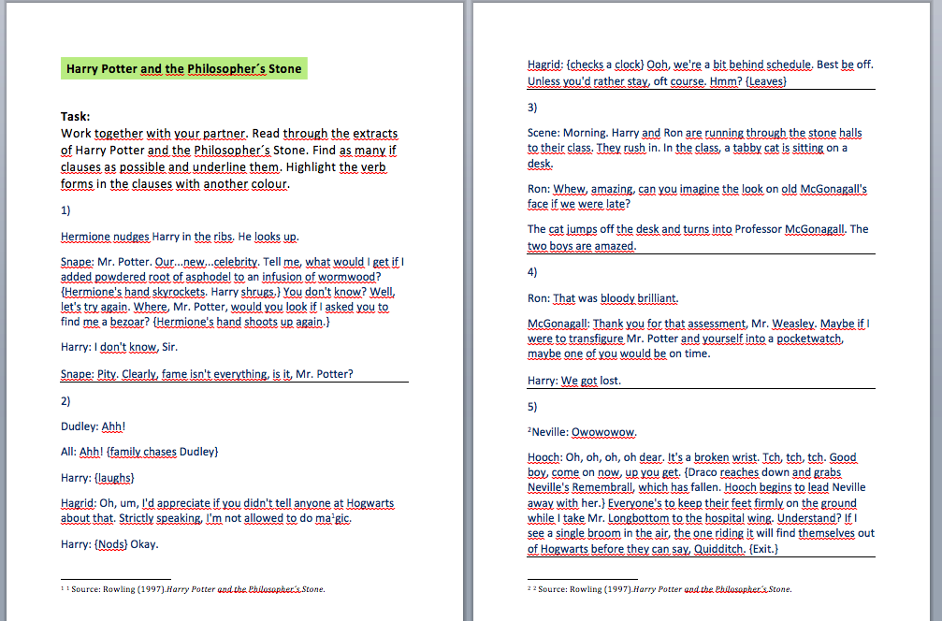
Only if there is time left! Otherwise I would give the worksheet as homework.

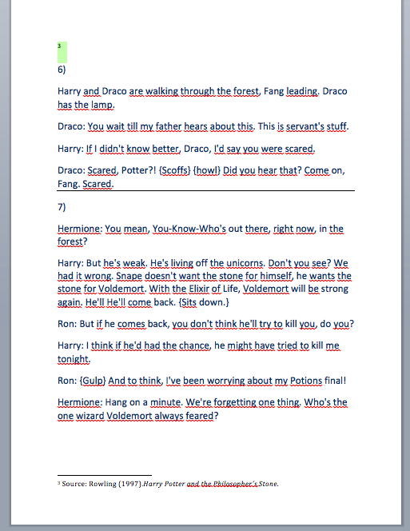

Grammar Checker | Theoretical analysis of Activity 3
Learning Stage | This activity belongs to the learning stage of ´awareness´, but mostly to ´conceptualization´. Students focus on new grammar and already understand the meaning of hypothetical speaking.
Depth of processing & mental activity | Since this notion is absolutely new for students and they are usually interested in Harry Potter, their mental activity is fairly high.
Dual processing & authenticity of process | Reading books and being aware of different notions is definitively an authentic situation.
Personalization | This task is not really personalized, but most students at that age are interested in Harry Potter and can engage with this topic.
Commitment filter | Reading extracts of a very famous book is probably exciting and fun.
Peer/social learning & interaction | Since they are asked to work together in pair, interaction is high and peer learning takes place.

2.2 Lesson 2

Activity 1

Task:
Ask your students to stand up, listen to this song and move/shake/dance how they feel like right now.

What would you do (if I did that to you)
from Steppenwolf

Link: https://www.youtube.com/watch?v=VL4KeVchMPk

Afterwards hand out the lyrics and ask your students to work together in pairs. Go through the text and discuss with your partner what the songwriter wants to express.
Lyrics:
Ahh saw me walkin the other day  he saw me comin said get outta my way  He told me that I was in the wrong groove  He told me that I would have to move  I looked at him ah right in the eye  Ah say hey man! Tell me why  He said I was different  didnt fit in his grace  'cause all the people round  got the same kinda face  What would you do  if I did that to you hey hey hey hey  What would you do  if I did that to you hey hey hey hey  What would you do  if I did that to you Yeah  I went to see mah baby  ta give me some love  I needed some understandin  I need it so much  I went to see mah baby  ta give me some love  The sugah that she gave me  I couldnt get enough  Well she wouldnt see me  she didnt have time  Cause she found a new man  with better lovin than mine  I couldnt get her ta see me  she closed her front door  She told me it was over  I was free once more | What would you do  if I did that to you hey hey hey hey  What would you do  if I did that to you hey hey hey hey  What would you do  if I did that to you ahh  What would you do  Hey what would you do now  What would you do  if I did that to you  What would you do  What would you do now  What would you do  if I did that to you  What would you do  What would you do now  What would you do  if I did that to you  What would you do  What would you do now  What would you do  if I did that to you...

Analysis of Activity 1
Grammatical objective | This task is used as an engaging activity. By reviewing the form of Conditional II with the help of a funny activity, students should get used to the new notion of hypothetically speaking.
Activity type | Listening comprehension + moving, Pair work, Reading comprehension
Learning aim | By listening to this song, students should review the CII and get used to the form. Additionally, students should work on their reading aims and learn to interpret texts.
Pedagogical principles | This activity is an engaging way how to start a lesson. At the same time, students can stand up and move/dance which is good for their brain activity and supports learning.
Communicative principles | Since students have to find out the message of the song together with a partner, they have to communicate actively.

Grammar Checker | Theoretical analysis of Activity 1
Learning Stage | This activity belongs to the learning stage of ´awareness´ , since pupils focus on rather new grammar. It may also belongs a little bit to the stage of ´conceptualization´, because pupils already understand the grammar rule and know the meaning of the notion.
Depth of processing & mental activity | The depth of processing is probably not rather high, but students have to come up with their own interpretation of the song which requires mental activity.
Dual processing & authenticity of process | The activity presented is fairly authentic, since students will come across many situations in which they have to interpret things and get the message out of something. Therefore dual processing takes place.
Personalization | This activity is not really personalized.
Commitment filter | Student´s are engaged by the song and are motivated to listen to the lyrics carefully, which makes learning fun.
Peer/social learning & interaction | Students can dance with each other and have fun. They also work in pairs, which requires interaction and communication.

Activity 2
Build groups of four and play the game. Take turns asking each other the questions: „What would you do if you ... „

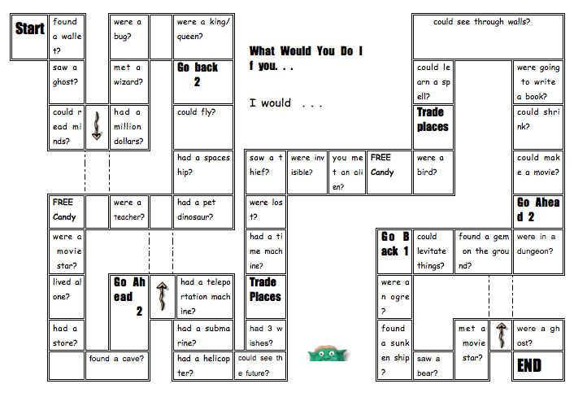

After about 15 minutes I would stop the game and ask the students to think about 10 questions they would like to ask their group members and let them write it down. All questions must follow the structure of “What would you do if…”. Afterwards they can play the same game with their own questions.

Grammar Checker | Theoretical analysis of Activity 2
Learning Stage | From my point of view, this activity belongs to the learning stage of ´proceduralization´ , because students already understand when to use Conditional II and are able to use it in a scaffolded exercise.
Depth of processing & mental activity | The depth of processing is high, since students have the chance to come up with own questions of interest that motivates them to use grammar in a funny game. Additionally, their mental activity is fairly high.
Dual processing & authenticity of process | It is quite authentic to ask classmates questions of personal interest.
Personalization | Since they ask questions they came up with on their own, this exercise is highly personalized.
Commitment filter | Playing games is a good way to practice a new notion, since students have fun and usually tend to learn faster and more efficiently.
Peer/social learning & interaction | It is a group work, students are playing a game and they have fun. Therefore social learning takes place and interaction is quite high.

Homework

Question 3 persons and write down their answers.

If you won the lottery, what would you do?

Grammar Checker | Theoretical analysis of the homework task
Learning Stage | The learning stage is ´conceptualization´. Pupils have to understand the grammar rule, but still have a strong conscious focus on the rule.
Depth of processing & mental activity | The depth of processing is probably not rather high, but questioning people and write down their answers (using the correct if-sentence) requires a rather high mental activity.
Dual processing & authenticity of process | Talking about hypothetic issues/situations is fairly authentic and students may come across such situations in their everyday lives.
Personalization | Students have to interview persons they know (parents, friends etc), which makes the task personal.
Commitment filter | It is fun to interview parents or friends and students are interested in their answers, which makes it exciting.
Peer/social learning & interaction | The interaction within this task is high, since they have to talk to three persons and lead a short communication. This makes this activity authentic as well.

2.3 Lesson 3

Activity 1

Get together in groups of 4. Have a look at this Cartoon a second time and try to come up with your own school law.

If you had the power to pass a new school law, how would this look like? What would you change/improve?

These key words may help you:
- discrimination
- student rights & discipline
If you need to look up some vocabulary, you are allowed to use your smartphones or the computers in class!
- athletics
- Curriculum
- facilities
- health & nutrition
- privacy & technology
- . . .

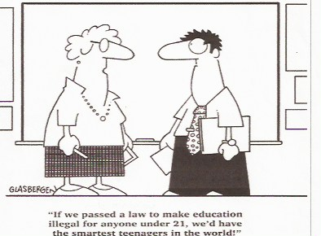

Analysis of Activity 1

Grammatical objective | Students should review the new learned grammar notion (unreal future situations). But they get one step further and actually use the Conditional II and write their own laws.
Activity type | Group work (groups of four)
Learning aim | Reviewing how to build Conditional II and how to use it. Understanding the meaning and being able to apply it appropriately.
Pedagogical principles | Writing their own law is fairly personal and encourages students to express their thoughts and opinion. They can engage with the topic, since they can draw on their own experiences concerning school laws and think about things they would like to change.
Communicative principles | Since this is a group work, students have to work together, interact with each other and use the English language as a tool to pass their personal law.

Grammar Checker | Theoretical analysis of Activity 1
Learning Stage | This activity belongs to both stages, ´conceptualization´ and ´proceduralization. Students already understand the grammar rule and are able to use it in a scaffolded exercise.
Depth of processing & mental activity | The depth of processing is very high, since they come up with own ideas and create a personal law within their working groups. Their brains are actively working ,,, I´m sure ;)
Dual processing & authenticity of process | Although the Cartoon is already given, students are encouraged to use their own experience and knowledge in order to come up with a law that expresses their wishes and dreams.
Personalization | This activity is mainly personalized. Although it is a group work, each group member can bring in his/her own ideas.
Commitment filter | Creating an own law, suggesting changes, bringing forward own ideas is fun and give students the chance of being creative.
Peer/social learning & interaction | This kind of group work needs a high level of interaction and communication, as they have to come up with their own law.

Activity 2

Task:
Write down the main idea of your law on a poster. Feel free to be creative
Present the main idea of your law to your class members and give them three arguments why you think your law should be published. Afterwards we arrange a voting in class and see which law is the most attractive one.

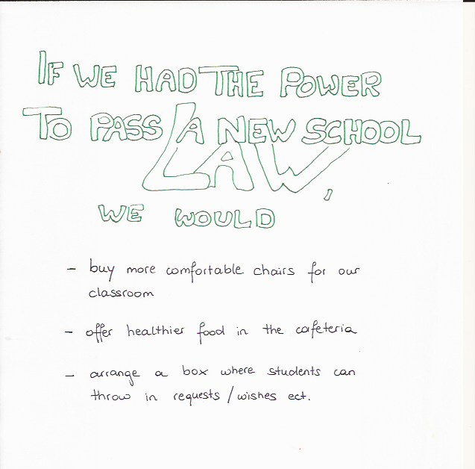
Example:

Grammar Checker | Theoretical analysis of Activity 2
Learning Stage | This activity belongs to the learning stage of ´proceduralization´. Pupils are already able to use the notion of hypothetic speaking in a ´scaffolded´ exercise. They do not have a strong conscious focus on rules.
Depth of processing & mental activity | The mental activity is really high, since being creative and presenting own statements is a demanding task. Students have to structure their thoughts carefully and present the gist of their message.
Dual processing & authenticity of process | Presenting solutions or findings is definitively a good and authentic exercise. Furthermore, arguing and presenting one´s statement is helpful for many situations in their everyday lives.
Personalization | Students find arguments why their law should be published. Also creating their own law as well as arguing makes this task personal.
Commitment filter | Students usually enjoy creating a poster. Doing a voting is very exciting and students can compete with each other. This may raises their motivation.
Peer/social learning & interaction | Working together in groups and preparing a short presentation requires high interaction and communication.

2.4 Testing activity

Imagine the following situation. Write down 5 sentences.

If you had magical power, what would you like to do?



Source: http://kulturzeitschrift.at/kritiken/film-kino/harry-potter-und-die-heiligtuemer-des-todes-2

Grammar Checker | Theoretical analysis of Activity 2
Learning Stage | This activity belongs to the learning stage of ´performance, since this is a testing activity and students have to be able to use Conditional II in context. They are able to focus on the overall message, without a strong conscious focus on rules.
Depth of processing & mental activity | In testing activities, student´s mental activity is usually very high, since they try hard to produce good language without making mistakes. Students will probably not be confronted with such a task in real life, but talking about hypothetical things is still authentic at their age.
Dual processing & authenticity of process | Students will probably not be confronted with such a task in real life, but talking about hypothetical things is still authentic at their age.
Personalization | I consider this activity as personalized, since students can express their dreams, imaginations and talk about themselves.
Commitment filter | Since this is a fairly personalized task, the commitment filter is quite active.
Peer/social learning & interaction | Since this is a written test, social learning or interaction does not take place.

3. Sources

♦ Course material: Communicative Grammar. An Introduction to Cognitive Communicative Grammar by David Newby

♦ Elisabeth Pölzleitner´s English Pool: http://epep.at/?page_id=2435

♦ Glasbergen Randy (2004). Comics.

♦ Rowling (1997). Harry Potter and the Philosopher´s Stone.

Yes, this is an excellent paper. All your activities are well-planned and will work very well in class. They will certainly help your learners to understand the concept and link it to the correct form. Just perfect. Meaningful, creative ideas, clear instructions…
congratulations!!!!

