

Communicative Grammar
3rd Conditional: Imagined Past
SS 2015
Dr. phil. Elisabeth Pölzleitner
Matrikelnr.: 1212725
Claudia Schwankner



Table of Contents

- Why teach Communicative Grammar? 3-6

- Practical Part + Theoretical Part: Material & Analysis 7-16

Awareness raising pair work 7
 Benjamin Button 8
 Board Game 9
 Card Game 12
 Speaking 13
 Surprise Stories 14
 If it had happened to me 15
 Testing-activity 16

- Bibliography 17

- Why teach Communicative Grammar?

Telling my flat mate that I just came home from a communicative grammar lesson seemed to confuse her quite a lot. “How do the words grammar and communicative go together?” she asked, and so I told her.
Teaching grammar, for most of us, means studying rules, learning irregular forms by heart etc. But this is probably the worst way to teach grammar. Instead, we should try to make grammar tasks as communicative as possible. Teaching grammar communicatively makes it more efficient and effective.
Studying rules by heart, which then even contradict each other and which are completely out of context really is the worst case scenario of teaching grammar. The key to teach grammar best is to present it in a way that corresponds to our brain processes. And at least as important as that, we need to create tasks that fit into the context. Topics which are appropriate to age and level of the pupils and which they can identify with. To exercise past tense, students will be a lot more motivated to talk about their last holidays than to form past tense sentences about Mr. XY and what happened to him some years ago.
Just try to think back to your own school time when you did grammar lessons. I am sure you had to draw a time line in your school exercise books for every single tense you learned, but did you ever think of these time lines when you were speaking English? I think people never do that, and if they did, it would confuse them even more. The reason for this is actually very straight forward. Neither in our native language nor in any foreign language we store grammar in lists of grammatical properties. We rather store the ideas we have and want to express in certain concepts. These concepts build up our knowledge about the world. To express this knowledge to other people we need to encode it in language. The things we want to express with language are called notions, which are then encoded into linguistic forms or more often said grammatical forms. In other words and most important, specific concepts are linked to specific grammatical forms. For example, let us take the present perfect tense. One notion of this tense is ‘experience’. “Have you ever been bitten by a snake?” – “Unfortunately yes. I’ve been bitten by a snake on my last trip to Australia.” By these notions we no longer focus on any rules or how to form a tense and when to use it. By doing enough work on it, especially on the proceduralization stage, it will come naturally after a while.
A further great advantage of teaching notions rather than having a list of rules as in traditional grammar is that in communicative grammar there is always a limited amount of information presented. In traditional grammar students more or less drown in information, because by having these rule sheets they are supposed to learn all the information at once. Doing one notion after the other as for example with present perfect tense you would start to teach the notion of experience, go on with change and completion, then introduce the notion of duration etc. the whole learning happens step by step and students will be able to process the new input and really get something out of it.
To make the students really digest one notion there should be tasks which belong to different learning stages. The first stage is called ‘awareness raising’. In this part it is important to enter the learners’ consciousness. At this stage learners are looking for patterns in the target language. It is important that the teacher does not give any explanation but gives the students a change to try finding out how the notion and the form work together by themselves. This allows them to activate their own problem-solving strategies and hypothesis-building skills. As a next step, which is often combined with the awareness raising, we need to work on conceptualization. This means that we guide the learners in the right direction and support the process of internal rule building.
Now that they have come up with a way of explaining this grammatical rule for themselves, we need to give them enough time to really digest and fix the new information which happens at the ‘proceduralization stage’. It is important that student get into the habit of using the structure. This is going to be done by offering activities of that notion in different contexts. These activities can be oral or written activities, board games, card games, short speeches they have to record and then upload to a database and many more possibilities. Including the learners’ interests, memories and personal experiences will help a lot in these activities. Very often grammar tasks from traditional grammar books can be changed into exercises that are in some way related to the students’ lives and therefore lead to more successful learning because they are personalized.
The last stage is called performance. At this stage learners should be able to perform tasks which are not scaffolded or pedagogically structured. In other words, students are left to themselves to solve a task. They are able to use the new form to describe their own ideas and generally create meaning using it. So now, if enough time was spent on each stage, learners should be able to use the new form in the right context.
Here is a table, to have a short overview of the stages:
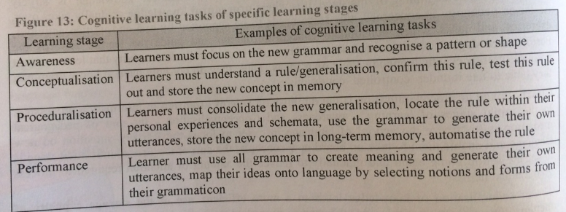
Now, for each of the exercises and activities of all learning stages it is important to consider the following features:
- Depth of processing
- Authenticity of process
        - Personalization
        - Commitment filter
        - Peer/social learning and interaction
        - Testing vs. teaching
By depth of processing it is meant how mentally active the learner is when doing grammar exercises. To reach high mental activity you could, for example, try to include as many senses as possible as in an exercise where they have to pantomime words, speak with each other which obviously means listening too and write down the right phrases. Also problem-solving tasks or activities that raise curiosity will help.
The tasks should also be authentic which means that the language used in them should correspond to the learner’s language. Using situations that are likely to happen in real life is much more authentic than inventing any off-the-wall story.
Grammar activities need to take into account the aspect of personalization and give learners the opportunity to apply their own schematic constructs and express their own ideas in order to produce language. When we represent information, ideas etc. we do so from our own personal perspective.
Students must be motivated to commit themselves to learning grammar. Tasks should include fun to motivate them, but also resultative motivation, for example feelings of success when doing problem-solving tasks. Exercises should produce the AHA-effect.
For learning grammar it is also crucial to do peer/social learning. On some occasions peers might be better teacher than the actual ones, because once a student has understood the new form he or she can adapt it to his or her classmates’ knowledge or point of view and teach it perfectly. It also happens quite often that shy pupils do not dare to ask the teacher about a certain thing they did not understand, but peer learning will solve the problem.
There are different types of exercises, some have the aim of teaching, others the aim of testing. Of course, many tasks can also be used for both. For example a pair or group work activity would probably only be used as a teaching one, whereas tasks which show if the rule has been learnt and understood would be used in testing.
Taking all these aspects into account when planning any activity, exercise or homework task, the result is much higher brain activation than you would have while doing a simple fill-in-the-gap exercise and therefore you will have a lot more success in teaching and learning grammar.

Yes, if I wasn’t convinced already – I’d definitely give it a try now.
Well done –clear and to the point.

- Practical Part + Theoretical Part: Teaching materials for three lessons + Analysis
 Pair work: Read through the interview with Taylor Swift with your partner carefully. Then read it again and switch roles.
I: Taylor, do you like being a famous singer?
T: Oh yes, I love it! If I hadn’t decided to become a singer, I would have had to take over my mother’s cleaning agency.
I: Oh gosh, I’m sure you wouldn’t have liked that. Why did you change your music style from country to pop?
T: If I hadn’t changed to pop, I think I wouldn’t have had so much success. Pop is what the new generation wants to dance to.
I: Sure, and what about love? Do you think being famous changed your love-life?
T: Definitely! I wouldn’t have met Justin Bieber, Taylor Lautner, Jake Gyllenhaal and the most important one and love of my life Calvin Harris. If I hadn’t become famous , I wouldn’t have met all these great people like my manager, my best friend Karlie Kloss and so many more.
I: Isn’t there anything you do not like in the world of a celebrity?
T: Yes of course there is. I often imagine how things would have gone if I had taken a different path, but still I’m happy with it just as it is.
I: Thank you very much for this nice interview.
T: You’re welcome!

Can you identify the structure Taylor Swift uses? Read through the text again and find out:
- How do you form conditional 3?
- What is expressed by conditional 3?

Learning Stages | Awareness raising / Conceptualization
Grammatical objective | Introducing the notion of imagined past, forming the third conditional and get a first impression of the appropriate use.
Depth of processing | High because of problem-solving and rule-finding exercise. By choosing a discovery task the students will get mentally active.
Authenticity of process | Language corresponds to the learners’ language. An interview like this is very likely to happen in real life.
Personalization | Popular topic which is in the interest of the students.
Commitment filter | AHA-effect is produced when finding out the rule.
Peer/social learning & interaction | Social Interaction when reading the interview and discovering the rule. One can learn from the other.
Teaching vs. testing | Teaching activity

 Watch the short video-clip from the movie “The Curious Case of Benjamin Button” and try to take notes (keywords). Then try to reconstruct the sentences (beginnings are given) with a partner.
If only the shoelace…
If the delivery truck…
If the package…
If the man…
If the taxi driver…
If the woman…
If the woman had gotten into an earlier cab…
Daisy and her friend…
and the taxi…

HW: Think of an incisive or important moment/happening in your life and try to describe it in a similar way as Mr. Button did. What would have happened if something had gone differently? Write at least 150 words.
https://www.youtube.com/watch?v=JZj1Yeb-tVg (Benjamin Button)

Learning Stages | Awareness raising when watching the video. Conceptualization when doing the worksheet.  Homework: Proceduralization
Grammatical objective | Learners get another insight in how the third conditional is used.
Depth of processing | The discovery aspect will lead to deeper mental processing.
Authenticity of process | Video-clip from a very popular movie. Students see that the way they are using language corresponds to the real life.
Personalization | Homework really makes them think about their own past life and therefore the conditional makes sense for them because they need to use it to tell their own experiences.
Commitment filter | Watching a video-clip will raise motivation and there students commit themselves to learning. Also the feeling of success when getting the answers right will cause feelings of success and through this they develop a positive association with the third conditional.
Peer/social learning & interaction | By reconstructing the phrases with a partner students can help each other to use the right form or to collect missing information.
Teaching vs. testing | I would rather use it as a teaching exercise but I believe it could also be used as a listening task in an exam.

 a) Missed opportunities: Form groups of 3-4 people. Place the outcome cards face down in the middle of the board. Throw the dice one after the other. Once you’ve landed on a missed opportunities square take an outcome card and form an if-sentence. The outcome card will tell you whether to make a happy ending or a sad one. Write down your sentences on the my life sheet.
Example: If I hadn’t gone on a rock climbing course, I wouldn’t have met my best friend.
The person whose birthday is coming up next begins.
(Materials: Tokens + Dice + Board Game + Outcome Cards + My Life Sheets for every group)
(Jill Hadfield: Intermediate Grammar Games)
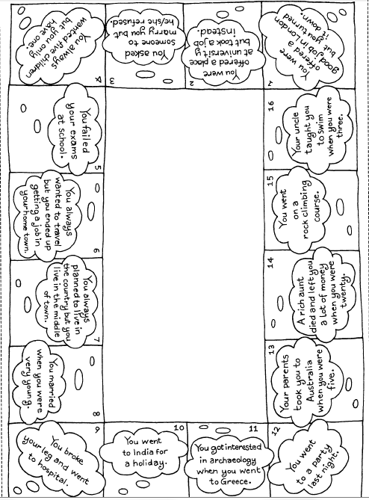
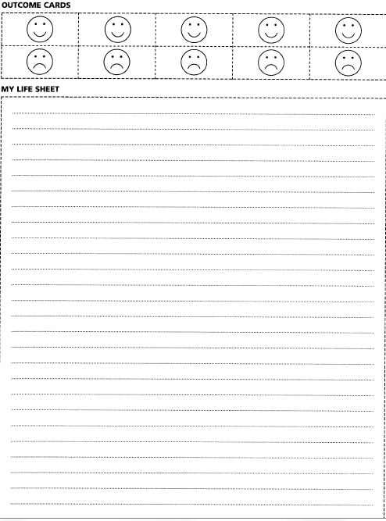
b) Now join a different group and tell them about your ‘lives’.
Learning Stages | Proceduralization
Grammatical objective | consolidating learnt notion; different contexts in which the third conditional is used; connection to their own lives.
Depth of processing | Speaking as well as listening and writing are included which leads to deeper processing.
Personalization | Learners see that the learnt input is useful to express their own world and lives. (Some situations might not be true to the pupils yet, but still they will be clear to them).
Peer/social learning & interaction | This is a group activity, so the students interact with each other and have the opportunity to ask their classmates and group partner for help if needed.
Teaching vs. testing | Definitely a teaching exercise because of group work.

 Form groups of 3-4 people. Match the cards with the same colour and try to get the words in the right order. Then form sentences as shown in the following example:
Taxi/ late/ Sandra/ miss the train.
If the taxi hadn’t been late, Sandra wouldn’t have missed the train.
Then talk about your own experiences with being late or missing a train and try to use as many if-sentences as possible. (From: Busy Teacher)
ANDREW
GET STUCK
TRAFFIC JAM
BE LATE
JANE
WRITE DOWN
ADRESS
GET LOST
MR. WEASLEY
OVERSLEEP
MISS HIS FLIGHT
JAMES & ANNE
MISS BUS
BE ON TIME
ROB
CALL HIS MOTHER
FORGET
SISTER’S BIRTHDAY

Learning Stages | Proceduralization
Grammatical objective | Consolidating the learnt notion; make reference to students’ own lives and see how it makes sense to use the third conditional to express imagines past.
Personalization | By creating their own sentences about their own lives students build reference to their own world and make sense of the learnt form.
Commitment filter | Learners commit themselves to use the right form because of talking about their own lives. They want to share their experiences with their classmates.
Peer/social learning & interaction | Students find out the right solutions together and by talking about their own stories, a very natural atmosphere is created.
Teaching vs. testing | Teaching activity
 Pair work: Talk to a partner and try to complete the given sentences.
(From: English Is a Piece Of Cake)
- ….. I would have been happier
- If I had been born in the 19th century…..
- If I had been an only child…..
- …..the world would have been a better place.
- If Superman had been a girl….
- If the 2nd World War hadn’t happened….
- …..I would have been a supermodel.
- …..I wouldn’t have got an education.
Learning Stages | Proceduralization
Grammatical objective | Consolidating the notion and make the students aware of the importance of the use of this form to express their own imagined past, regrets.
Authenticity of process | Situations students are very likely to have already made up their mind about it before. Now they are able to express their thoughts in the right form.
Personalization | Students have to imagine their own life in different situations.
Teaching vs. testing | Teaching exercise; could also be used as a testing exercise obviously without the pair work.
 Take a piece of paper and write down any if-clause about your imagined past life.
Example: If I hadn’t joined the choir in my town,
I wouldn’t have met my best friend Victoria.
Do this in two lines as shown in the example and fold the paper so that the if-clause is hidden. Then give your sheet to your neighbor on the left. Once you get the sheet from your neighbor, start writing a new if-clause, beginning with the part of the sentence you can see.
In this case: If I hadn’t met my best friend Victoria,
I wouldn’t have learnt how to play the guitar.
Do this until your original sheet has come back to you. Then we’ll listen to the results.

I would not give these instructions to the learners on a worksheet or in any other written form. They would learn it by trying it out. As a teacher I would only give short instructions how to start and then everything will finds its way on its own.

Learning Stages | Proceduralization
Grammatical objective | Make the students aware of talking about an imagined past and make them think about what can be expressed with it (regrets, analyzing past events,…)
Depth of processing | Students will be extra careful about using the right form, because everyone can see their sentences or listen to it at the end.
Authenticity of process | This task is very authentic because it is all about the students sentences and therefore about their interests.
Personalization | It is personalized because every student creates one sentence for each story and gives a little piece of their own to every single one.
Commitment filter | Students will get curious about what the result stories will look like which leads to active participation.
Peer/social learning & interaction | Students are not as much interacting as in other activities, but they will give special effort in this activity because they will try to make their sentences extra funny to get cool result stories.
Teaching vs. testing | Can only be used as a teaching activity.

 If it had happened to me… (Newby: Grammar for Communication – Exercises and Creative Activities)
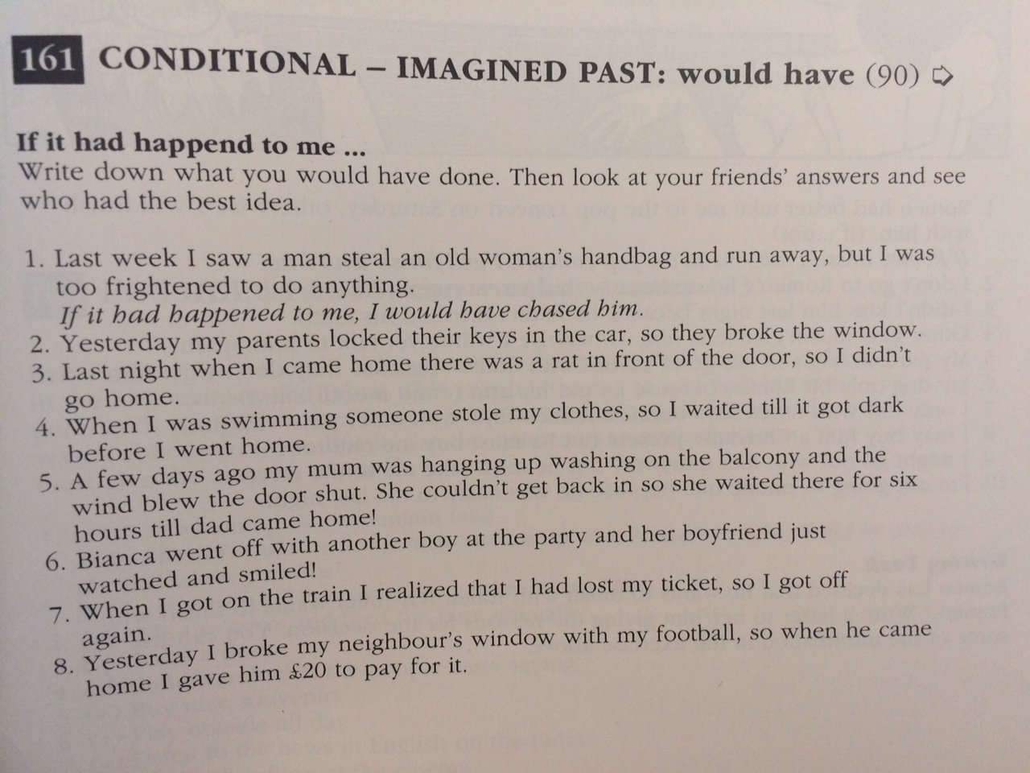
Learning Stages | Proceduralization
Grammatical objective | This exercise again makes the students repeat the structure and see the use and importance of the learnt form.
Depth of processing | Students have to find their own ways of solving the problems, which creates high brain activity.
Authenticity of process | These are all situations that could happen to the learners in real life and so they have to come up with realistic solutions.
Personalization | By finding their own solutions reference to the students’ lives is created.
Commitment filter | Students get motivated by the desire to have better solutions as their partners.
Peer/social learning & interaction | Students will try to find very good solutions in order to have a better one as their partner with whom they are going to compare it.
Teaching vs. testing | Teaching as well as testing exercise. Could be used in a test without the aspect of comparing with a partner.

 Testing-activity (Newby: Grammar for Communication)
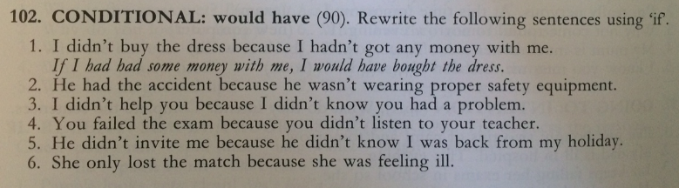
Learning Stages | Performance in real-time context
Grammatical objective | Students have to show their knowledge about how to express imagined past and their ability to use the right form.
Authenticity of process | This task asks for the students own ideas and uses situations which could very likely happen in their real lives.
Personalization | It is personalized because they need to relate the given situations to their own lives.
Teaching vs. testing | I would use this task as a testing exercise in an exam.

- Bibliography

„Benjamin Button and The Third Conditional”. Wikipedia [Online]. https://www.youtube.com/watch?v=JZj1Yeb-tVg. [2015, June 3rd]
English Is A Piece Of Cake. [Online] http://www.englishisapieceofcake.com/third-conditional.html. [2015, June 3rd].
Hadfield, Jill (2003). Intermediate Grammar Games. A collection of grammar games and activities for intermediate students of English. [Online] Essex: Longman. [2015, May 20th]
Newby, David. E. Pölzleitner. G. Klamminger. Communicative Grammar. Course handout and “An Introduction to Cognitive Communicative Grammar” by David Newby. Graz: Department of English Studies.
Newby, David (1989). Grammar for Communication. Vienna: Österreichischer Bundesverlag.
Newby, David (1992). Grammar for Communication – Exercises and Creative Activities. Vienna: Österreichischer Bundesverlag.
Pölzleitner, Elisabeth (2012). Conditionals. [Online] http://epep.at/?page_id=2435. [2015, June 2nd].
“Third Conditional Text and Practice Cards”. Busy Teacher. [Online] http://busyteacher.org/5816-third-conditional-text-and-practice-cards.html. [2015, June 2nd].

