Lesson 1- Activity 3: What object is it?
Source -slightly adapted-: http://www.teach-this.com/resources/grammar/passive [22.5.2015]
(compare to- Passive Descriptions)
Procedure:
The class is divided in two teams who compete against each other.
A volunteer takes one card and then has to describe the object he or she sees on the card to the class. The questions below the picture might help the students to stay in the passive voice. After every sentence each team may make one guess what the described object is. The team who provides the correct answer receives one point and the student who guessed correctly has to describe the next object in front of the class.
The team with the most points wins.
- What is it produced of?  - Who uses it? – It´s used by...  - What is it used for?  - Where is it used?  - Is it allowed to use it all the time? | - What is it produced of?  - Who uses it?  - It is used by...  - What is it used for?  - Where is it used? | - What is it made of?  - Who uses it?  - It is used by...  - What is it used for?  - Where is it produced?
1.What is it made of?  2.Who uses it? – It´s used by...  3.What is it used for? | 1.When is it more likely to be eaten? (Breakfast/Lunch/Dinner?)  2.In which country was it first made? | 1.What material are they made of?  2.Who owns them?  3.Are they used frequently?
1.What is it made of?  2.Who uses it? – It´s used by...  3.What is it used for?  4.Has this object been replaced by technology? | 1.What is it made of?  2.Who uses it? – It´s used by...  3.What is it used for? | 1.What is it made of?  2.Who uses it? – It´s used by...  3.What is it used for?
  1.What is it made of?  2.Who uses it? – It´s used by...  3.What is it used for? | 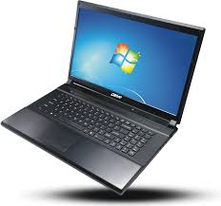  1.What is it made of?  2.Who uses it? – It´s used by...  3.What is it used for? | 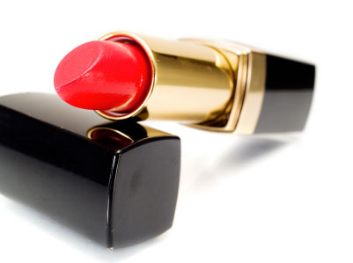  1.Who uses it? – It´s used by...  2.Where can it be bought?  3.What is it used for?

Note: We decided to design this game as a whole class activity rather than playing it in little groups, as we thought that it would make monitoring easier.
Note: According to Newby´s (1998:123) reasons for using the passive, this activity belongs to the “zusätzliche Information” category.

