present activities --- miming


What is your friend doing?

Play in groups of 3.
You can find pictures of objects on each card. One student after the other takes a card and mimes what he/she is doing with the object. You can decide yourself what you want to do with the object (sometimes you can even choose which object you would like to take). The other students have to guess what you are doing and which object your card shows. Ask questions like “Are you eating something?” The student who guesses the most objects wins the game.

Examples:
Are you eating an apple?
I think you are writing a letter.
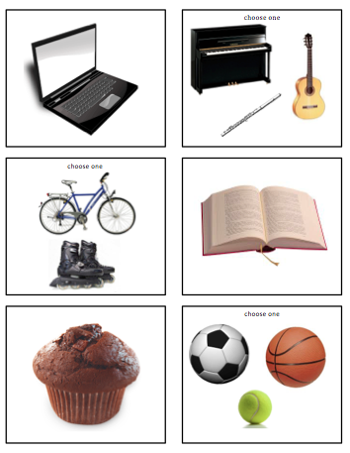

 | ANALYSIS ACTIVITY 1
Learning stage | Proceduralization
Depth of processing,  mental activity | Students are mentally active because they have to decide what they would like to mime and have to be creative.
Dual processing/ Authenticity | In the activity everyday life objects are involved which students are likely to use.
Personalization | The activity is personalized because realistic activities are involved. Students can also decide for themselves what they would like to mime.
Commitment filter | The commitment filter is activated because the activity is fun, creative and a competition.
Peer/ social learning and interaction | The activity encourages peer learning and social interaction.
Testing vs. teaching | The activity is only suitable for teaching.

