Pupils have to do 3 different activities in this lesson. They can choose the sequence of the activities. The activities and their instructions are located in the classroom. The teacher explains the different activities at the beginning of the lesson.

Activity 1


What are people in … doing right now?

Play in groups of 3. One student picks up a card. He /she has to describe what people are doing in this country right now. There are some words given with which you can form sentences about what people in the country are doing right now. You can of course also come up with your own sentences. The other students have to guess which country is meant. The student who guesses the country gets the card. In the end, the student with the most cards wins the game.

Examples:
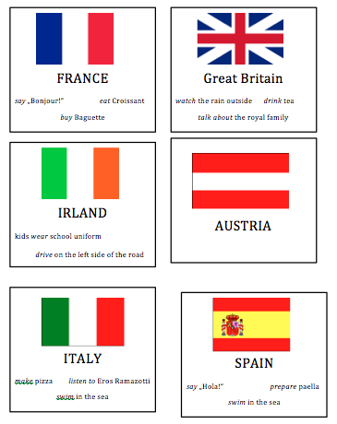
People in this country are eating … right now.
Add a few more countries – also places with a bit time difference so the kids can say ---
they are sleeping, they are having dinner… they are building a snowman…
 | ANALYSIS ACTIVITY 1
Learning stage | Proceduralization
Depth of processing,  mental activity | The activity has high depth of processing because students have to think about what people are doing in different countries at the moment (in case they cannot think of anything they cards help them)
Dual processing/ Authenticity | The activity is not very authentic.
Personalization | The activity is personalized as students can draw on knowledge they have because they have already been to one of the countries.
Commitment filter | The activity is fun and a competition and therefore activates the commitment filter.
Peer/ social learning and interaction | The activity encourages peer learning and social interaction.
Testing vs. teaching | The activity is only suitable for teaching.

LESSON 3

Activity 1


IRLAND

kids wear school uniform

drive on the left side of the road

FRANCE

say „Bonjour!“ eat Croissant

buy Baguette




AUSTRIA

Great Britain

watch the rain outside drink tea

talk about the royal family

SPAIN

say „Hola!“ prepare paella

swim in the sea

ITALY

make pizza listen to Eros Ramazotti

swim in the sea
