Just for us:
ignore activites, but most of the pictures are really useful for us.
use to “harvest” good pics for daily routines and present activities
You have worked a LOT for this paper and most of the materials can be used in class if you polish them according to my instructions.
Your paper shows me that you are highly motivated to try out the notional approach and are willing to put in a lot of time in order to produce appealing materials.
Please follow my instructions to clean up your work. I have made lots of comments and corrections. The language in your instructions is too complicated for this age group and often confusing (even for me).
The disorganized structure of your paper has made it very time-consuming to give you feedback. I had to work on two screens to see the instructions and the materials in the appendix and understand what the learners were supposed to do.
In the future, keep these things together – leave out most of the teacher’s instructions. If the students understand what they need to do, the teacher will not need to read the same again.
You have found very nice source materials and useful pictures.
So, all in all this is quite good work, even if it was quite frustrating for me to work my way through it.
Leitner, Sophie Katharina (01512503)

ENF.001 Language and the Learner WS 2017/18 Mag. Dr. Elisabeth Pölzleitner
Grammar Project
Teaching the present simple and progressive tense

Table of contents
Table of content 1
Grammar Project 2
Lesson 1 3
Activity 1: Teacher’s routine 3
Activity 2: My routine 4
Activity 3: Kathy’s routine 5
Activity 4 and homework: Interview a partner 6
Lesson 2 and 3 8
Activity 1: Writing task - Write your own grammar page! 9
Activity 2: Game - Domino 10
Activity 3: Writing task - Routine - story 11
Activity 4: Boardgame 12
Activity 5: Worksheet - What is happening? 13
Activity 6: Song - Lemon tree 14
Activity 7: Worksheet - What are these people doing? 15
Activity 8: Song - Breaking free 16
Activity 9: Game - Miming cards 17
Activity 10: Writing task - What’s happening? 19
Activity 11: Writing task - Write your own grammar page 2! 19
Homework Lesson 2: 21
Homework Lesson 3: 22
Testing Activity: 23
Appendix: 24
Material Lesson 1: 24
Material Lesson 2 and 3: 24

Grammar Project

Grammar topic: Present simple, 3rd person -s, Present progressive tense
Communicative use: daily routines, habits (Lesson 1 – 2); actions that are happening right now (Lessons 2 – 3).
Aim: teach the use of the present tense
Level of pupils: A1, first year of English
Pre-knowledge: the students already know some vocabulary, how to form easy sentences and questions and they have just learned how to tell the time (these lessons will serve as practical usage for this as well)

Overview:
Learning Stage | Exercise | Material
Awareness raising | Telling a story  Kathy’s daily routine | Word-cards  Worksheet
Conceptualization and hypothesis building | Telling a story – spotting the lie  Kathy’s daily routine - questions | Worksheet
Proceduralization in scaffolded conditions | Never-ending story | strips
Conceptualization and hypothesis building | Write your own grammar page | Grammar folder (students)
Proceduralization in scaffolded conditions | Domino | Domino cards, solution
Proceduralization in scaffolded conditions | Your dream routine | Paper strips, example
performance in real-time context | Boardgame | Game, dices, solutions
Awareness + conceptualization | Reading: What is happening? | Worksheet
Awareness + conceptualization | Song: Lemon tree | Worksheet, computer/mobile phones, solutions, maybe vocabulary book
Conceptualization and hypothesis building | What are these people doing? | Worksheet, solutions
Conceptualization and hypothesis building, Proceduralization (in case of the more challenging worksheet) | Song: Breaking free | Worksheet, solutions
Proceduralization in scaffolded conditions | Game: Miming | Cards, sheets with vocabulary if the students aren’t familiar with it yet
Proceduralization/Performance in real-time context for some students | Writing: What is happening? | Picture, useful phrases sheet
Conceptualization and hypothesis building | Write your own grammar page | Grammar folder (students)

General notes:
Lesson one only talks about the present simple tense. As for lesson two and three, a table at the beginning states clearly which exercises aim to teach the present simple and which exercises aim to teach the present progressive tense. Therefore, the broad goal (teaching them the simple or the progressive) is not stated specifically at the beginning again.
Furthermore, the date of access of all links is January 3, 2018. T

Lesson 1
This class aims to introduce the new vocabulary and the structures of the simple present tense. For most parts, the lesson raises awareness and helps the students to build hypotheses. Some scaffolded activities are also included. In the following lessons, they will proceduralize this knowledge.

Activity 1: Teacher’s routine
Stage: Awareness raising (listening to the teacher), conceptualization and hypothesis building (talking about the lie and vocabulary in the present simple tense)
Material: picture cards and vocabulary cards (see Appendix)
Source: https://images.clipartof.com/small/1114319-Clipart-Moodie-Character-Singing-In-The-Shower-Royalty-Free-Vector-Illustration.jpg (shower), https://thecliparts.com/wp-content/uploads/2016/07/boy-waking-up-clipart.jpg (wake up), http://cliparting.com/free-teacher-clipart-3317/ (teach), http://weclipart.com/gimg/2FD1A2EF3264DBBD/going-to-the-bathroom-5-going-potty-clip-art-1300-x-1390.jpg (go to the bathroom), http://laoblogger.com/images/brush-hair-clip-art-10.jpg (brush hair), http://laoblogger.com/images/girl-getting-dressed-clipart-5.jpg (get dressed), http://cliparting.com/free-breakfast-clipart-19352/ (have breakfast), http://laoblogger.com/images/clipart-horseback-riding-1.jpg (ride a horse), https://i.pinimg.com/736x/11/95/4d/11954d9dd1f80def963311978ea355bf.jpg (brush teeth), https://classroomclipart.com/clipart-view/Clipart/Family/family-having-meal-dinner-together_jpg.htm (have lunch), https://101clipart.com/wp-content/uploads/02/Reading%20Newspaper%20Clipart%2006.jpg (read newspaper), http://moziru.com/images/homework-clipart-correction-4.png (correct homework).
Time: ca. 10 - 15 minutes
Aim: students are made aware of the use of the present tense in combination with daily routines; new vocabulary is introduced
Explanation for teachers:
- The teacher describes his/her routine and puts pictures of the activities on the board. There is one mistake in the daily routine that the students should find.
“I’m going to tell you about my daily routine! However, I’m also going to tell you one thing that I actually don’t do normally … can you spot the lie?”
For example: “I get up every day at 6 o’clock in the morning (puts picture where person gets up on the board). First, I go to the toilet (puts picture where person goes to the toilet on the board). Then, I take a shower and get dressed. Afterwards I have breakfast and read the newspaper. Around 7 o’clock I brush my teeth and comb my hair. I ride my horse to school. For the next few hours I teach English classes. At two o’clock I go home. I cook something and have lunch. In the afternoon, I correct homework and prepare the next lessons. At six o’clock the whole family has lunch together. Usually, we just eat something small. Afterwards we play games, meet friends or watch a movie. At ten o’clock I brush my teeth and go to bed.
- Hand out vocabulary cards. “Now, everybody of you has a word or a phrase card. Who knows what their phrase means? Put it next to the picture on the board!” (ask what they see on picture no. 1 etc. if students don’t start to participate immediately)

- What do you think was the lie? Talk to your partner! Use these phrases:
I think she doesn’t … ; I think …. is a lie.

Analysis:
Depth of processing and complex encoding: | The learners need to think about the new words and the knowledge about normal daily routines, therefore they are going to be mentally active.
Commitment filter: | The learners should spot the lie; therefore, they need to listen to the story. Since everybody gets a vocabulary card they also have to think if they remember what that word meant.
Peer and social learning and interaction: | There is just a little speaking part, but mostly they have to listen carefully.
Personalisation: | They know what a daily routine in Austria is likely to look like and therefore have to draw on their personal experiences in order to spot the lie.
Contextualisation: | It is the first one of the exercises, but a couple of exercises regarding daily routines are going to follow.
Authenticity of process: | Yes, the phrases for spotting a lie are used a lot in English.
Task-based: | There is no real output.
Testing versus teaching: | As long as the teacher provides a welcoming atmosphere in the classroom it supports teaching.
This exercise supports learning processes …

Activity 2: My routine
Stage: Proceduralization in scaffolded conditions
Material: My routine – cards (appendix), vocabulary sheet (pictures/text: https://www.slideshare.net/krulynn/sem-2-l-5-daily-routine-flashcards )
Time: ca. 10 minutes
Aim: students apply the present simple tense and the vocabulary they have just learned.
Explanation for teachers:
Students get “My routine”-cards. They fill in these cards with the activities given and two own examples. Faster students can draw one of these activities in the space below. These cards will be used in a later activity as well!
Explanation for students:
Take one of the “My routine”-cards. What do you do on a typical day? When do you do the five activities that are written on the cards? Fill in the answers and try to find two more activities you do every day! You can also include a little drawing of yourself of an activity in the space below if there is time!
Analysis:
Depth of processing and complex encoding: | They need to combine the vocabulary they have just learned with their “world knowledge” of the everyday activities they do, therefore they have a lot to think about and connect.
Commitment filter: | The students probably enjoy this activity because they can produce something personal. Furthermore, they also get some room to be creative.
Peer and social learning and interaction: | This is something to work on alone.
Personalisation: | They write about what they do on their typical day. There are five things they all do very often and have to use, but there are also two sentences where they can write whatever they want.
Contextualisation: | It is clear that they use this language in order to talk about their routines since they do exactly this in this exercise.
Authenticity of process: | They use the language in a similar way that natives use it – just very simplified at this level.
Task-based: | They produce cards which show their daily routine.
Testing versus teaching: | As long as students know that they are allowed to make mistakes as long as they try to do their best it supports teaching. If the teacher marks every card with a red pen, this feeling gets lost.
This exercise supports learning processes …

Activity 3: Kathy’s routine
Stage: Awareness raising (reading), conceptualization and hypothesis building (questions)
Material: worksheet (appendix) (source: Course material PPS2: Begleitende Lehrveranstaltung; Mag. Dr. Da Rocha and Mag. Weinzettl – slightly changed)
Time: ca. 10 - 15 minutes
Aim: the students should realize that there is an additional -s when talking about the 3rd person, if someone finishes earlier they can compare and discuss their answers in pairs.
Students read the text on the worksheet and fill in the answers. If there are any questions, teachers help the students. The solutions are compared in class together. Afterwards, the teacher asks the students what rules they found for the -s and corrects these rules if necessary.
Analysis:
Depth of processing and complex encoding: | While the students are reading they have to think about the words they have just learned and the meaning of the text. They can already see that there are questions afterwards, which will motivate them to try to understand the text.
Commitment filter: | The text is about a girl in Great Britain, therefore especially the kids who are interested in other cultures will enjoy this exercise.
Peer and social learning and interaction: | Social learning is only involved if they finish earlier.
Personalisation: | The personalized version of this task follows in the activity afterwards.
Contextualisation: | Yes, they first learned how to talk about their own routines and now they learn to talk about someone else’s routines, which they will apply shortly afterwards.
Authenticity of process: | They get input in order to form the answers, but this kind of scaffolding only helps them to find the right answers. The type of language they need to answer the questions is everyday language.
Task-based: | The outcome is a completed worksheet.
Testing versus teaching: | As long as the teacher provides a welcoming atmosphere in the classroom it supports teaching. It must be clear for the students that mistakes are allowed.
This exercise supports learning processes …

Activity 4 and homework: Interview a partner
Stage: Proceduralization in scaffolded conditions
Material: My routine – cards (appendix)
Time: ca. 10 minutes
Aim: students apply the present simple tense and the vocabulary they have just learned.
Explanation for teachers:
Students take out their “My routine”-cards. They ask their partners (they should find someone they haven’t talked to a lot!) when they do x etc. They also ask what other activities they do. Homework – write the routine of their partners; they should try to produce something nice since we’ll hang the texts up in class.
Explanation for students:
Find a partner! Both of you take out your “My routine”-cards. Ask your partner about his/her answers and write them down.
For example: “When do you get up?” “What else do you do?”
For homework, write a short text about the routine of your partner on a blank sheet of paper!
The beginning might look similar to this:
My friend Joe gets up at 6 o’clock in the morning. He …
We will make a gallery of all the people in class, therefore try to make it a very nice sheet!
Analysis:
Depth of processing and complex encoding: | They need to think about the vocabulary, the present tense and what they know about the other person.
Commitment filter: | The students get to know their partners better. Since they probably don’t know them very well at this point, this might also be an interesting activity to see what habits the others have.
Peer and social learning and interaction: | They get to talk in groups of two. This is very engaging, especially since they probably want to find out if their partner has any cool/special/…. habits.
Personalisation: | They write down things about people they really know personally.
Contextualisation: | After talking about daily routines for almost a whole class, the context is very clear.
Authenticity of process: | Especially when trying to arrange meetings/… it is very likely that someone talks about their daily routine, and this is a first step for this activity that might follow a few weeks later.
Task-based: | As a homework, they should present their friend. Therefore there is a result that will be visible and this probably motivates them to do it well.
Testing versus teaching: | As long as students know that they are allowed to make mistakes as long as they try to do their best it supports teaching. If the teacher marks every card with a red pen, this feeling gets lost.
This exercise supports learning processes …

Lesson 2 and 3
These lessons aim to help the student practice the simple present tense in real-time contexts. The rules of the present simple should already be clear which allows the students to work on their own on different stations. While working on the stations they will find out that there is also another form ending with -ing, and they will explore these rules themselves – they need to do activity 9 and 10 first! In the next lesson it would be a good idea to repeat the present progressive once again to make sure that everybody has understood the rules (the teacher might not see all of the problems occurring in class)
Overview for the teacher
 | Tense | What? | skill | Material (besides explanation) | stage | Teacher correction
1 | simple | Write your own grammar page |  | Grammar folder (students) | conceptualization | x
2 | simple | Domino | Speaking | Domino cards, solution | Proceduralization
3 | simple | Your dream routine | Writing | Paper strips, example | Proceduralization | x
4 | simple | Boardgame | Speaking | Game, dices, solutions | performance in real-time context
5 | Progr. | Reading: What is happening? | Reading | Worksheet | Awareness + conceptualization | x
6 | progr. | Song: Lemon tree | Listening | Worksheet, computer/mobile phones, solutions, maybe vocabulary book | Awareness + conceptualization
7 | Prog. | What are these people doing? | Reading | Worksheet, solutions | Conceptualization
8 | Prog. | Song: Breaking free | Listening | Worksheet, solutions | Conceptualization, Proceduralization
9 | progr. | Game: Miming | Speaking | Cards, sheets with vocabulary if the students aren’t familiar with it yet | Proceduralization
10 | progr. | Writing: What is happening? | Writing | Picture, useful phrases sheet | Proceduralization/performance in real-time context for some students | X
11 | Progr. | Write your own grammar page |  | Grammar folder (students) | conceptualization | x

Explanations for the student:
Here’s the to-do-list for this and the next session! We are going to work in small groups with altogether eleven stations. There are mandatory tasks – tasks you HAVE to do, and there are voluntary tasks – tasks which you CAN do. You need to fulfill all mandatory tasks and one of the voluntary tasks/color.
You can vary the order of the tasks with the same color. Make sure you finish the first color before starting the next one! If you finish early complete all the voluntary tasks that you haven’t done yet.
 | Mandatory? | What? | How many people? | Any problems/questions? | Check!
1 | mandatory | Write your own grammar page | 1
2 | voluntary | Domino | 2-3
3 | mandatory | Your dream routine | 1
4 | voluntary | Boardgame | 2-4
5 | mandatory | Reading: What is happening? | 1
6 | mandatory | Song: Lemon tree | 1
7 | voluntary | What are these people doing? | 1
8 | voluntary | Song: Breaking free | 1
9 | mandatory | Game: Miming | 2-4
10 | mandatory | Writing: What is happening? | 1
11 | mandatory | Write your own grammar page | 1

Activity 1: Writing task - Write your own grammar page!
Stage: Conceptualization and hypothesis building (revision)
Material: Grammar folder
Time: ca. 15 minutes
Aim: students think about what they have learned in the lesson before once more and try to make the grammar rule “theirs”
Explanation for students:
Take out your grammar booklet! Make a page about the use of the Present Simple tense – this is the tense we use for example for routines. What do you remember? When do we need an -s? Find some example sentences from the text and the description of your own routine and add them.
In case you don’t remember it anymore, don’t be afraid to ask your teacher!
When you have finished this activity, bring your grammar folder to your teacher and let him/her check it.
Explanation for the teacher:
Most of the time, students have several English classes a week. In case there are blocked lessons/… once a week it might be that the first lesson has already happened a few days before this lesson. If this happens make sure that the students know what to do and what the 3rd-person -s is, for example by presenting the texts they wrote as a homework. Otherwise just read through the grammar pages afterwards and make sure that everybody is on the right track.
Depth of processing and complex encoding: | They need to rethink the rules they learned one/two days ago and write them down themselves. Therefore, everything that is not clear yet will probably arise as well and the teacher can explain these things once again.
Commitment filter: | The learners know that this is their resource in the future and that they will need this paper more often.
Peer and social learning and interaction: | They don’t work together in this activity, however I think that it is necessary to work on their own sometimes too in order to make sure that they really understood the rules.
Personalisation: | They should include their own examples to form the rule in their own words, therefore it is highly personalized.
Contextualisation: | They are learning to build the present tense at the moment, therefore the context is perfect for this activity.
Authenticity of process: | The language is not very natural since grammar explanations are not part of everyday conversations.
Task-based: | The result is a nice page for their grammar booklet which they will use in the next year(s).
Testing versus teaching: | It supports learning as it helps the students realize what they already know and what they don’t know yet. Teachers can help them more easily to understand everything they don’t know yet by knowing what exactly this is.
This exercise supports learning processes …

Activity 2: Game - Dominoes
Stage: Proceduralization in scaffolded conditions (revision)
Material: Domino, Adverbs of frequency – cards (cut out and maybe laminate, they are just there to help them in case they need them)
Time: ca. 10 minutes
Number of players: 2-3
Aim: students combine the grammar once more with the vocabulary, therefore it should really “stick” afterwards; in addition to this, the verbs of frequency are introduced
Source: Picture adverbs: https://www.theenglishstudent.com/blog/adverbs-of-frequency; pictures on the domino cards: https://www.slideshare.net/krulynn/sem-2-l-5-daily-routine-flashcards
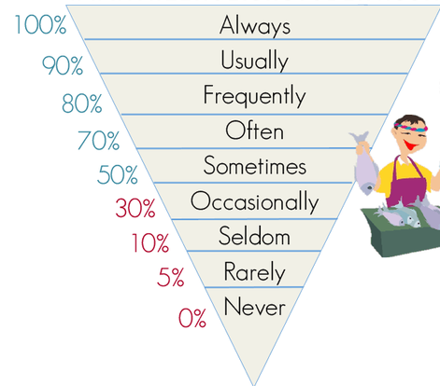
Explanation for students:
It’s time to play dominoes! Get together in groups of three. Everybody gets the same number of cards. The person who has got the card that says “start” on it begins. The person who has the word that matches the picture puts it next to it and so on. Every time you have a matching card you have to say a sentence using the phrase. If your card is red, you say a sentence about yourself. If your card is blue, you say a sentence about somebody else.
Try to include some of the words you see in the chart! They help you to say how often you do something.
e.g.
START |  |  | to have a shower | 
My sister always/never/sometimes/usually takes a shower in the morning.
Depth of processing and complex encoding: | The students repeat once more the vocabulary they already know. Furthermore, they incorporate some new structures and they practice the 3rd person -s.
Commitment filter: | Since they have to build sentences which involve their own habits or habits of people they know really well they are more likely to like this exercise compared to describing the life of someone they don’t know. Furthermore, Domino is always fun.
Peer and social learning and interaction: | The learners get to play in groups and interact with each other.
Personalisation: | The examples they have to give are all related to themselves or to people they know well.
Contextualisation: | This exercise combines the already learnt vocabulary and grammar with one little new aspect.
Authenticity of process: | The language is rather authentic, since for example if a group of friends goes on vacation together/… it is necessary to compare the daily routines in order to find a “vacation” routine.
Task-based: | The finished Domino is the end product. Students usually want to complete a game.
Testing versus teaching: | This exercise helps students to automatize the vocabulary and the structures. Since they don’t have to write anything down and the teacher cannot control every sentence said it is not possible to “test” the students.
This exercise supports learning processes …

Activity 3: Writing task - Routine - story
Stage: Performance in real-time context
Material: Paper strips (1/3 DIN A4-Paper, long side), provide one example if possible (see appendix for printable example; cut out and glue together)
Time: ca. 15 min
Source: Picture adverbs: https://www.theenglishstudent.com/blog/adverbs-of-frequency; Idea: http://www.polzleitner.com/epep/Grammar/PresentRoutines.pdf
Aim: Using the language learnt to write a story about their dream-day routine.
Explanation for the teacher:
You find the preparation for the example in the appendix. Cut it out (just on the edge, don’t cut the line!), fold the sheet on the line, twist it once and glue the ends together.
Explanation for students:
What would be your “dream” daily routine? What would you want to do every day?
Write these things on the paper!
Look at the example and try to also divide your story very evenly so that it never stops once it is glued together It shows how the things are repeated every day!
Try to include some words that tell the reader how often you do something, e.g. I always get up at 10 o’clock. I never have to get up at 8 o’clock.
Depth of processing and complex encoding: | The students repeat what they have already learned and include the new structures introduced in this lesson.
Commitment filter: | The end result is really fun to play with, therefore the students will like to create these strips.
Peer and social learning and interaction: | There is no interaction involved in this task. However, it is possible that students present their work afterwards to a partner/…
Personalisation: | They write about their own dream routine, therefore it is very personalized.
Contextualisation: | This exercise combines the already learnt vocabulary and grammar with one little new aspect.
Authenticity of process: | When getting to know someone we usually talk about our routines to some extend as well. This is the language we need in order to do this.
Task-based: | The result is a cool tool to use, because it shows how the things are repeated.
Testing versus teaching: | The exam can use a similar task just without the fun part of putting it together.
This exercise supports learning processes …

Activity 4: Boardgame
Stage: Proceduralization in scaffolded conditions/Performance in real-time context
Material: Boardgame, dice, “solution” sheet
Time: 20 min
Number of players: 2 – 4
Source: https://en.islcollective.com/resources/printables/worksheets_doc_docx/board_game_-_how_often/frequency-board-game/862
Aim: Students should speak about daily routines and include the things they have learned while having fun; for some students, this is still a proceduralization activity – some might already be able to do it without the additional hints and therefore they perform in real-time context.
Explanation for students:
The student with the darkest shirt begins. He/She throws the dice and moves forward according to the number on the dice. The picture shows a certain activity. He/She asks the person sitting on his/her left how often they do this activity. (How often do you …?) The person answers. (I … once a week/…). Now this person throws the dice. Whoever reaches the end of the game first wins.
Be careful about what your classmates say and try to help them if you spot a mistake!
If you don’t know a word/picture you can look on the sheet next to it – there you find the correct phrases.

Depth of processing and complex encoding: | The students use the vocabulary and grammar in a fun game which combines the two elements.
Commitment filter: | Since students especially at this age really enjoy playing games they are likely to enjoy this exercise without thinking too much about the fact that they are learning at the moment.
Peer and social learning and interaction: | They get to talk to their peers and furthermore they find out more about them. They maybe even get to know their classmates better or find out some fun details about their lives.
Personalization: | They get to talk about themselves and ask their classmates questions which is highly personal.
Contextualization: | This exercise combines the already learnt vocabulary and grammar with forming questions and having fun.
Authenticity of process: | Especially when talking about hobbies, it is very common to ask “oooh how often do you do this?”.
Task-based: | They don’t have something to hold in their hands but the have more knowledge about their classmates.
Testing versus teaching: | This activity is suitable for teaching.
This exercise supports learning processes …

Activity 5: Worksheet - What is happening?
Stage: Awareness raising and hypothesis building
Material: worksheet
Time: 10 min
Source: https://www.io-home.org/image_pool_secure/bild1233117111353948480.jpg
Aim: Students should realize that there is another time that is used to describe what is happening at the moment. In order to make sure that the students built correct hypothesis, they let the teachers read through their explanations and the teacher can then give them more clues/help them to get on the right track.
Explanation for students: further explanations on? the worksheet
What is happening in this school? Read the text and answer the questions!
Explanation for teacher: in case there is only one teacher in the classroom, there is a solution sheet for the task included as well. However, if possible, use personal discussion to make sure they understand the grammar.
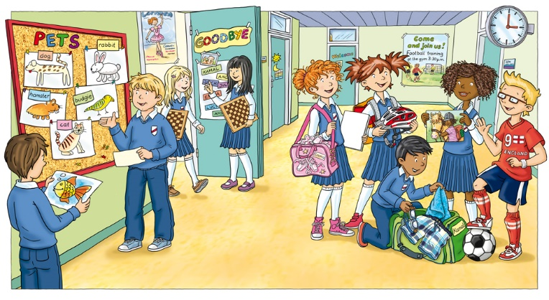

Depth of processing and complex encoding: | The students get to explore a new grammar topic on their own. This requires a lot of concentration while they are introduced step by step.
Commitment filter: | They have to solve the “puzzle” – what is different? what has happened? Hopefully this exercise makes them curious about what this tense is. There is only one little clue and they have to find it (describe the action) or look if they can solve the problem just by reading the text a couple of times.  It might work better in a class where the students are accustomed with finding their own explanations and theories. Otherwise, maybe include something else before this activity or more material for students who have difficulties.
Peer and social learning and interaction: | This is an exercise they have to complete on their own.
Personalization: | They have to think about their own ideas and concepts in order to explain this time and get to talk to the teacher afterwards.
Contextualization: | This is one of the two first activities that confronts the students with the present progressive tense and in my opinion it is fitting for an introduction.
Authenticity of process: | The language used in the text is authentic. The explanations of the students afterwards might not be as authentic, but they don’t have to be – they only serve the purpose of helping them grasp the concept.
Task-based: | There is no real product besides the worksheet.
Testing versus teaching: | This activity is suitable for teaching.
This exercise supports learning processes …

Activity 6: Song - Lemon tree
Stage: Awareness raising
Material: “Lemon tree” – sheet, solutions
Time: 10 min
Source: http://englishwordoftheday2010.blogspot.co.at/2013/06/present-continuous-with-scenes-from-tv.html
Aim: Students should see that there is a different time that is used to talk about what is happening at the moment. There are two different worksheets (one easy and one more challenging) and two different videos to choose from. Therefore, this task should be doable for all students. The video with the animations furthermore helps them to understand the content even though they might not know all of the words! (This is also the reason why there are no vocabulary explanations on the worksheet)
Explanation for students:
When life gives you lemons … make lemonade!
- Choose your worksheet! Do you want to try the challenging one, or do you prefer the easier one?
- Listen to the song “Lemon tree” by Fool’s Garden and fill in the gaps! (Start with https://www.youtube.com/watch?time_continue=166&v=XAFS43NKFag including lyrics and animation; If you want to you can also take a look at the original video: https://www.youtube.com/watch?time_continue=6&v=bCDIt50hRDs)
- Correct the gaps and look for any vocabulary you don’t understand with the solution sheet. Write down the words you want to remember.
- Do you notice anything strange when looking at the verbs?

Hint: Do you see the -ing verbs? When are they used? Do you have an idea? Try some other -ing – activities and try to find out when they are used! (when exactly do the things happen?)

Depth of processing and complex encoding: | They have to listen and fill in the gaps at first. Afterwards, they have to think about the new verb form they encounter in the song. This is a slow introduction to the new topic but they still need to use their brain a little bit.
Commitment filter: | Even though they may not know the song in the beginning it will really get stuck in their head. The students who enjoy older music will like this exercise.
Peer and social learning and interaction: | They have to work on this exercise alone.
Personalization: | There are two different levels, but the rest of this activity doesn’t allow the students to be creative or talk about their experiences. In my opinion, they first have to find out about the structures before they can use it in a creative/personal context.
Contextualization: | This is an introductory activity. Because of this, it makes sense that it slowly starts to make the students aware of the new tense.
Authenticity of process: | It’s not everyday language but already language that sounds a little bit more “built”. However, this is very typical for music and therefore authentic when talking about music and songs.
Task-based: | There is no “product”, but the task still serves the purpose of making them aware about the present progressive tense.
Testing versus teaching: | This activity supports teaching as it slowly introduces the new tense.
This exercise supports learning processes …

Activity 7: Worksheet - What are these people doing?
Stage: Conceptualization and hypotheses building
Material: Worksheet and solutions
Time: 10 min
Source: https://en.islcollective.com/resources/printables/worksheets_doc_docx/what_are_these_people_doing/present-continuous-present/11421
Aim: This exercise provides a lot of input and correct phrases using the present progressive tense. This will help them to grasp the concept and make sense of everything. I would only suggest it for students who need a lot of “direct” input (meaning that a couple of songs and texts are not enough or too complicated for the beginning).
Explanation for students:
You live in a huge house together with your family and lots of neighbors. Your aunt has just called, and she wants to know what everybody is doing and where everybody is! Can you answer her question? Look at the picture!
Which picture belongs to which sentence? Fill in the numbers and check your answers afterwards!
Depth of processing and complex encoding: | They have to read the text, look at the pictures and find the matching picture. They first have to understand the sentences before they are able to complete the rest of the tasks.
Commitment filter: | Since this activity involves a lot of searching learners who like puzzles hopefully enjoy it.
Peer and social learning and interaction: | This is an exercise they have to complete on their own.
Personalization: | This is not a very personalized activity. The purpose of this is to repeat the structures a couple of times in order to make the forms clearer for the students.
Contextualization: | Almost everybody has an aunt that is famous for wanting to know everything. Of course, it is a little bit exaggerated that she wants to know what 25 people are doing at the same time.
Authenticity of process: | The language is used in a natural way and in a natural context.  It is also possible to include a little “role-play” in the end, where one student leaves the class and calls another student with the mobile phone asking him/her what xy are doing at the moment.
Task-based: | There is no end-product.
Testing versus teaching: | This exercise supports teaching since it makes the use of the tense even clearer for the students who need more support.
This exercise supports learning processes …

Activity 8: Song - Breaking free
Stage: Proceduralization in scaffolded conditions
Material: “Breaking free” sheet, solutions
Time: 10 min
Aim: Students should see that there is a different tens form that is used to talk about what is happening at the moment. There are two different worksheets (one easy and one more challenging) and two different videos to choose from. Therefore, this task should be doable for all students. The video with the animations furthermore helps them to understand the content even though they might not know all of the words! (This is also the reason why there are no vocabulary explanations on the worksheet)
Explanation for students:
Gabriella and Troy from High School Musical also sing a lot about what is happening now in their heads!
Listen to “Breaking free” and fill in the worksheet.
https://www.youtube.com/watch?v=ZLa__49Ltv4

Correct your worksheet afterwards!
Depth of processing and complex encoding: | The students have to think about what they hear and fill in these words.
Commitment filter: | A lot of the students probably know the song and might want to find out about the content of it.
Peer and social learning and interaction: | They have to work on this exercise alone.
Personalization: | It is not a very personalized task altogether, but they have to look for the words that they don’t know (opposed to a prepared vocabulary list). Furthermore, there are two different level worksheets.
Contextualization: | This song includes a lot of present progressive sentences.
Authenticity of process: | It’s not everyday language but already language that sounds a little bit more “built”. However, this is very typical for music and therefore authentic when talking about music and songs.
Task-based: | There is no product they have to produce.
Testing versus teaching: | This activity is supposed to support teaching, because a lot of pupils would know the lyrics and have an easier time filling out the exercise in a test than other students.
This exercise supports learning processes …

Activity 9: Game - Miming cards
Stage: Proceduralizations in scaffolded conditions
Material: Cards, Vocabulary sheet (in case they are not familiar with these words yet)
Time: 15 min
Source:
Singen: http://www.nikolaamrhein.de/photo-album/freizeit-singen.html#previous-photo
Malen: http://www.nikolaamrhein.de/photo-album/freizeit-malen.html
Running: http://www.nikolaamrhein.de/photo-album/freizeit-sport-treiben.html#previous-photo
Schwimmen: http://www.clipartsfree.de/clipart-bilder-galerie/sport-bilder-clipart/schwimmen-clipart-bild-kostenlos-4753.html
Fernsehen: http://www.animaatjes.de/cliparts/fernseher/clipart_televisie_animaatjes-28-211458/
Computer game: https://previews.123rf.com/images/indomercy/indomercy1412/indomercy141200040/34255423-boy-playing-spiel-Standard-Bild.jpg
Klavier: http://www.thinkstockphotos.ca/image/stock-illustration-little-boy-playing-piano/493337850
Buch: http://www.thinkstockphotos.ca/image/stock-illustration-black-beautiful-girl-sitting-on-the/823857448/popup?sq=reading%20book/f=CIHVX/s=DynamicRank
Baum: http://www.thinkstockphotos.ca/image/stock-illustration-kids-playing-tree/538781254/popup?sq=sitting%20in%20a%20tree/f=CIHVX/s=DynamicRank
Berg:http://www.thinkstockphotos.ca/image/stock-illustration-businessman-with-flag-on-a-mountain/500155684/popup?sq=climbing%20a%20mountain/f=CIHVX/s=DynamicRank
Duschen: http://www.thinkstockphotos.ca/image/stock-illustration-happy-smiling-man-take-shower/846505878/popup?sq=shower/f=CIHVX/s=DynamicRank
Weinen: http://www.thinkstockphotos.ca/image/stock-illustration-baby-crying-vector-isolated/849384380/popup?sq=crying/f=CIHVX/s=DynamicRank
Tanzen: http://www.thinkstockphotos.ca/image/stock-illustration-rockabilly/536249265/popup?sq=dancing/f=CIHVX/p=2/s=DynamicRank
Taking photos: https://de.123rf.com/clipart-vektorgrafiken/photographer.html?imgtype=2&oriSearch=klavier&sti=oelq3kprjtdidl0ykt|&mediapopup=28030055
Homework: http://www.thinkstockphotos.ca/image/stock-illustration-happy-kid-homework/614046900/popup?sq=homework/f=CIHVX/s=DynamicRank
Listening to music: http://www.thinkstockphotos.ca/image/stock-illustration-portrait-of-a-girl-listening-to-music/546183054/popup?sq=listening%20to%20music/f=CIHVX/s=DynamicRank
Zähne putzen: http://www.thinkstockphotos.ca/image/stock-illustration-cute-boy-brushing-his-teeth/614432052/popup?sq=brushing%20teeth/f=CIHVX/s=DynamicRank
Basketball: http://wikiclipart.com/girls-basketball-clipart-2_34270/
Hamburger: https://de.123rf.com/photo_30337976_stock-vector-cartoon-boy-eating-burger.html
Driving: http://www.thinkstockphotos.ca/image/stock-illustration-cartoon-man-driving-a-car/600096480/popup?sq=driving%20car/f=CIHVX/p=2/s=DynamicRank
Baking a cake: https://www.istockphoto.com/at/vektor/comic-mann-mit-geburtstag-kuchen-gm165762225-16249074
Sleeping: http://sweetclipart.com/cute-little-girl-sleeping-1742
Apple: https://www.clipartsgram.com/download/G6CzN0h
Riding a bike: http://hddfhm.com/clip-art/cliparts-children-riding-in-bicycle.html

Number of players: 2 – 4
Source: http://englishwordoftheday2010.blogspot.co.at/2013/06/present-continuous-with-scenes-from-tv.html
Aim: Students should see that there is a different time that is used to talk about what is happening at the moment. There are two different worksheets (one easy and one more challenging) and two different videos to choose from. Therefore, this task should be doable for all students. The video with the animations furthermore helps them to understand the content even though they might not know all of the words! (This is also the reason why there are no vocabulary explanations on the worksheet)
Explanation for students:
The student with the shortest hair starts. He/She draws a card (without looking at it!). Then, he/she looks at the picture and tries to mime it. The rest of the group has to guess what they are doing. The first one who guesses correctly can keep the card. Now it’s his/her turn! He/She draws on of the cards that has not been used yet and mimes it.
The student who has got most of the cards in the end wins!

This is how the questions are formed:
Are you verb+ing ? (e.g. “Are you rapping?” Are you playing the guitar?”)

Depth of processing and complex encoding: | They get to work together in groups and use vocabulary and grammatical structures they are currently working on.
Commitment filter: | The learners want to guess the right word.
Peer and social learning and interaction: | They get together in groups and have fun while doing this activity, therefore they are likely to enjoy it.
Personalization: | Everybody uses different gestures/… to show words and the words will also be connected to these gestures afterwards. Therefore, it is highly personalized.
Contextualization: | This activity combines the vocabulary they have just learned with the new grammatical concept. Furthermore, they know exactly what to ask for.
Authenticity of process: | It is very common to ask someone what they are doing at the moment, e.g. telephone conversations. Therefore, this activity uses language in a very natural way.
Task-based: | The “only” end product is the language used and the gestures (which are likely to help them remember the vocabulary as well)
Testing versus teaching: | It supports learning and it is almost impossible to test this activity.
This exercise supports learning processes …

Activity 10: Writing task - What’s happening?
Stage: Proceduralization in scaffolded conditions
Material: exercise book, helpful phrases worksheet (if necessary)
Time: 20 min
Aim: Students already know what the present progressive is and should now use it to describe a picture.
Explanation for students (a): Take a walk around the school building! What is happening right now? What are the people in the cafeteria doing? Do you see any students on the hallways? Is anyone outside (take a look through the window!) Write 10 sentences including actions that you see! If you remember the task about what was happening in the school well, try to do it on your own. If you need some help, take one of the sheets with helpful phrases.
Depth of processing and complex encoding: | They have to think about the vocabulary and the grammar they have just learned and write a text.
Commitment filter: | It’s their school and their environment they get to explore in a way they don’t get to see it normally! They are likely to be interested on what else is going on in the building while everyone is in their classroom.  The picture offers a lot of possibilities and it is likely that every student finds something they like to describe.
Peer and social learning and interaction: | They have to work on this activity on their own, but they may interact with other people in the school building.
Personalization: | The learners can choose to describe the persons and actions they want to describe. Furthermore, it is possible to use a worksheet with helpful phrases if they need it.
Contextualization: | They use the language they have just learned to describe a given picture. Therefore, they need the vocabulary and the structures in the way it is normally used as well.
Authenticity of process: | Describing actions is one of the possibilities where this tense is used, and this activity uses this.
Task-based: | They produce their own text.
Testing versus teaching: | This activity supports testing as well as teaching, depending on what the teacher does with the text (write down every single mistake or giving the student good feedback on how to improve)
This exercise supports learning processes …

Alternative (b): if the school doesn’t offer enough possibilities to do this task (students are not allowed to leave the room, there is no cafeteria, …), there is a picture and an explanation attached in the appendix that can also be used to fulfill this exercise.

Activity 11: Writing task - Write your own grammar page 2!
Stage: Conceptualization and hypothesis building (revision)
Material: Grammar folder
Time: ca. 15 minutes
Aim: students think about what they have learned in the lesson before once more and try to make the grammar rule “theirs”
Source: Idea: University course “Language and the Learner” (Mag. Dr. Pölzleitner) and http://epep.at/?page_id=2288
Explanation for students:
Take out your grammar booklet! Make a page about the use of the Present Progressive tense – this is the tense we use for things that are happening right now. What do you remember?
Before you start writing look for another person who is also working on this task.
- Try to explain to each other when to use the present progressive tense and find some example sentences! In case you are not sure if you are correct go ahead and ask your teacher!

Write on your sheet:
- How is this tense formed?
- Find some example sentences from the text and the description of your own routine and add them.
- Make sure you write down everything you need to know since this is your resource for the next few years!
After you have finished this activity, bring your grammar folder to your teacher and let him/her check it.
Explanation for teacher:
They have worked on the present progressive by themselves, therefore it is even more important to check if they understand what they are doing. In order to do this, they write down what they know. Make sure to correct these papers carefully (maybe with sticky notes/… so that there work is not “destroyed”, but they can improve it on their own), since it is probably the most difficult part of these exercises!
Depth of processing and complex encoding: | They need to think about what they have done during the last exercises and write everything down themselves. Therefore, everything that is not clear yet will probably arise and the teacher can explain these things once again.
Commitment filter: | The learners know that this is their resource in the future and that they will need this paper more often.
Peer and social learning and interaction: | They don’t work together in this activity, however I think that it is necessary to work on their own sometimes too in order to make sure that they really understood the rules.
Personalisation: | They should include their own examples to form the rule in their own words, therefore it is highly personalized.
Contextualisation: | They are learning to build the present progressive tense at the moment, therefore the context is perfect for this activity.
Authenticity of process: | The language is not very natural since grammar explanations are not part of everyday conversations.
Task-based: | The result is a nice page for their grammar booklet which they will use in the next year(s).
Testing versus teaching: | It supports learning as it helps the students realize what they already know and what they don’t know yet. Teachers can help them more easily to understand everything they don’t know yet by knowing what exactly this is.
This exercise supports learning processes …

Homework Lesson 2:
Explanation for students:
Look at this comic!
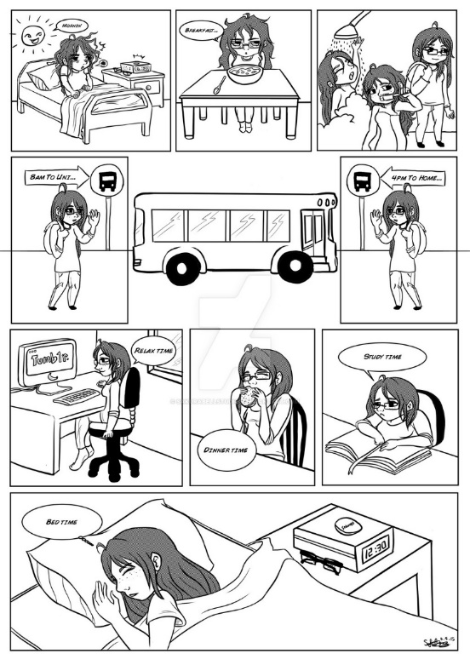
Try to make a little picture story which is similar to the comic!
- Draw at least four little pictures! (Yes, you can use stick-figures! )
If you don’t like to draw at all you can also make a comic using this website: http://stripgenerator.com/strip/create/
- Try to include one picture where your mum/dad/brother/sister is also shown!
- Add descriptions to the pictures, e.g. “I get up at 6 o’clock.”, “My brother and I have breakfast together”.

Depth of processing and complex encoding: | They need to think about what they know and transform it. They involve another skill and get to be creative which helps them to remember the structures.
Commitment filter: | A lot of children like to be creative and there is also the possibility to use the website for the children who don’t like to draw. Therefore, most of the students will hopefully enjoy this activity.
Peer and social learning and interaction: | They have to do it at home on their own.
Personalisation: | They make their own version of the comic, therefore they get a personal connection.
Contextualisation: | Since they are talking about their own routines/dream routines/… since the last lesson, this is a nice way to end this topic for (most of) them – some might still have some exercises left to do regarding this topic.
Authenticity of process: | The learners will use language in a natural way. The descriptions of the pictures are everyday sentences.
Task-based: | They get a nice result – a handmade comic (drawn or illustrated on the computer)!
Testing versus teaching: | This activity supports teaching as it reminds the students once more of what is important about the present simple tense.
This exercise supports learning processes …

Homework Lesson 3:
Since they have already worked a lot during the last few lessons, they now get a small homework. The aim of it is to check if they have understood the difference between the two tenses.
Source: http://learnenglishkids.britishcouncil.org/sites/kids/files/attachment/grammar-games-present-simple-and-present-continuous-worksheet.pdf
Explanation for students:
Read the text and circle True or False. Look carefully!
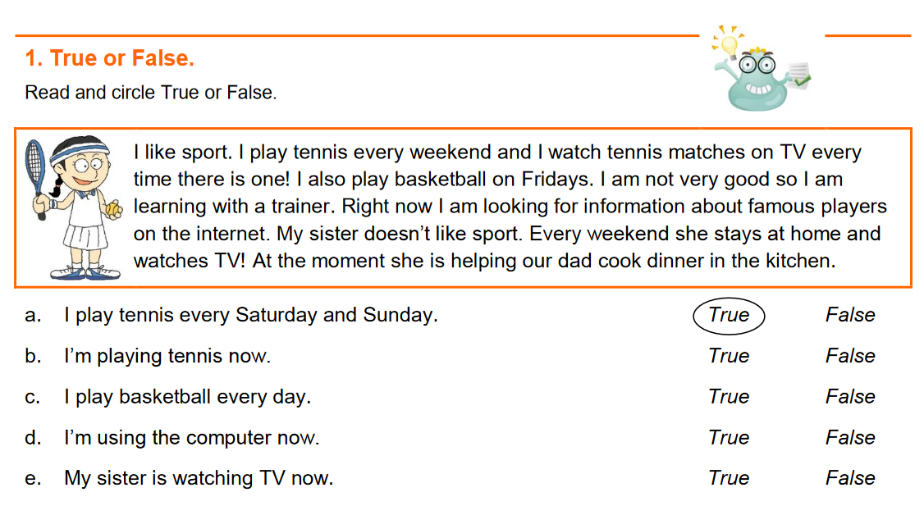
Fill in the correct form of the verbs! Do you use the present simple tense that we use for routines, or the present progressive tense we use for the things that are happening right now? Look at every sentence carefully and decide!
Afterwards, check which of these sentences are true for yourself! Do you sleep for a long time at weekends? Make a smiling face next to the correct statements!
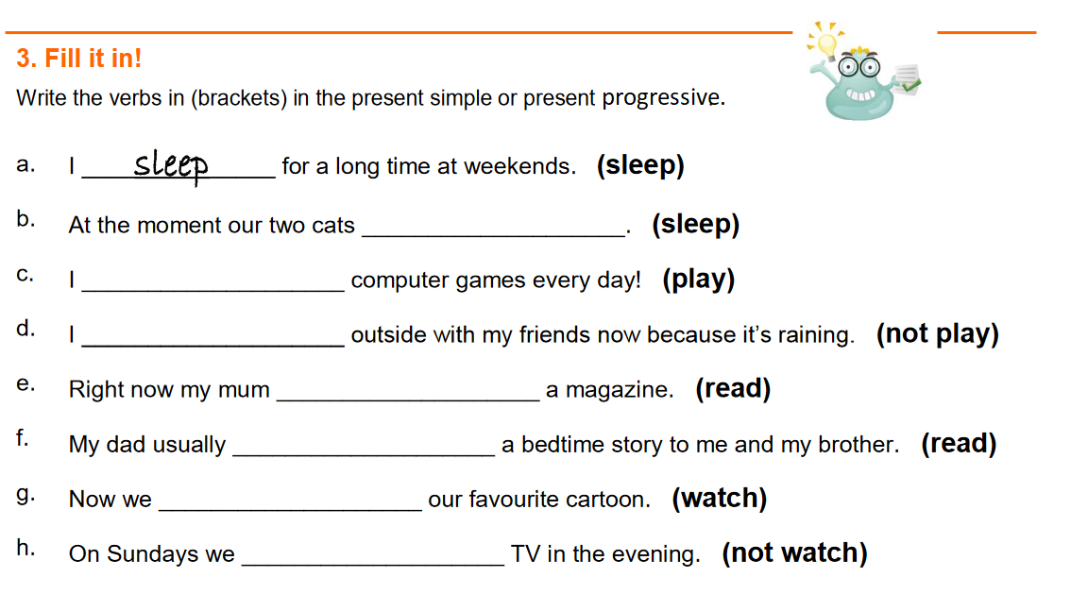
Depth of processing and complex encoding: | They need to think about what they know and use it. Since there are various options (not just one time, but also third person -s, …) they have a lot to concentrate on.
Commitment filter: | This activity lacks fun. However, it might still motivate students because they see what they can now achieve compared to one week/… ago.
Peer and social learning and interaction: | They have to do it at home on their own.
Personalisation: | Most of it is not really personal, however the last step (which of these sentences are true for yourself?) is personalized.
Contextualisation: | They know that these structures are used to express what is happening generally/right now.
Authenticity of process: | The learners will use language in a natural way.
Task-based: | There is only a filled in exercise sheet in the end. In my opinion it is not always possible to include the production of a product, and there have already been various products in the exercises before.
Testing versus teaching: | This activity can be used for both purposes.
This exercise supports learning processes …

Testing Activity:
Source: picture: https://www.io-home.org/portfolios/f/showBild?k_User=253&k_BildDB=56874
What is happening in this picture? Choose five different people and describe what they are doing! Write at least five sentences!
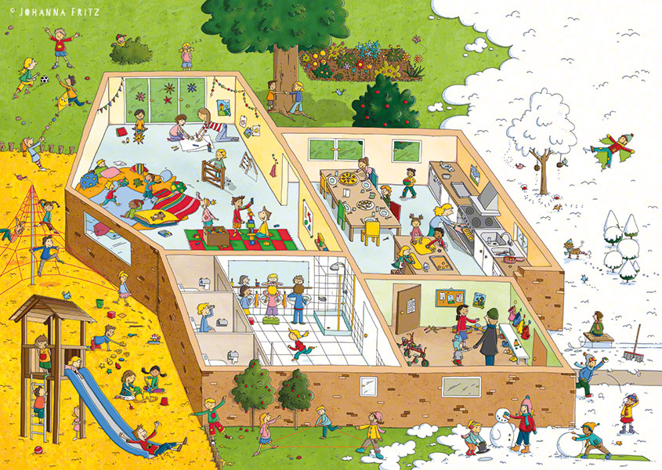

Appendix:

Material Lesson 1:
- talking about routines: word cards
- My routine
- My daily routine – vocabulary
- Kathy’s routine

Material Lesson 2 and 3:
2 | Domino | Domino cards, solution
3 | Your dream routine | Paper strips, example
4 | Boardgame | Game, dices, solutions
5 | Reading: What is happening? | Worksheet
6 | Song: Lemon tree | Worksheet, computer/mobile phones, solutions, maybe vocabulary book
8 | Song: Breaking free | Worksheet, solutions
7 | What are these people doing? | Worksheet, solutions
9 | Game: Miming | Cards, sheets with vocabulary if the students aren’t familiar with it yet
10 | Writing: What is happening? | Picture, useful phrases sheet
 | To do list
 | Task descriptions


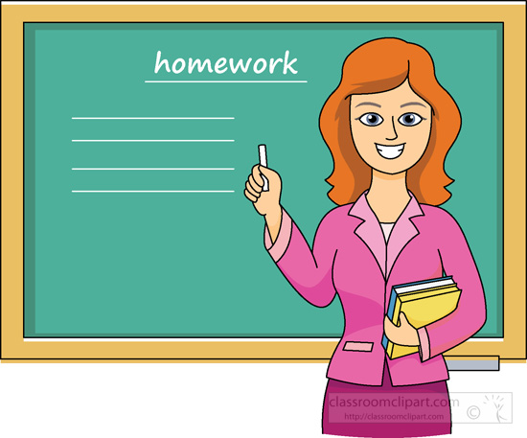


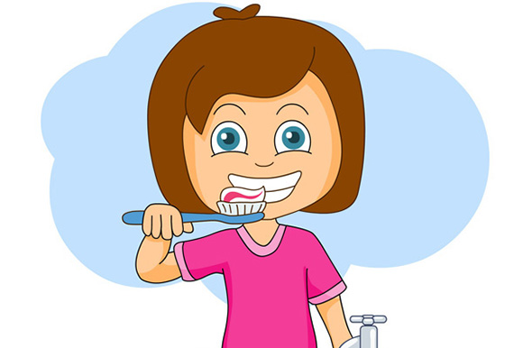

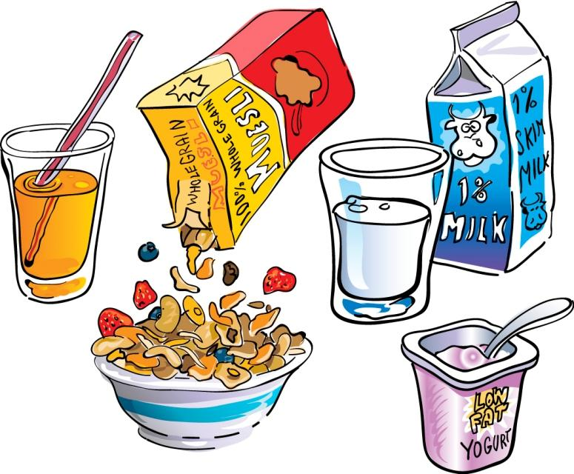
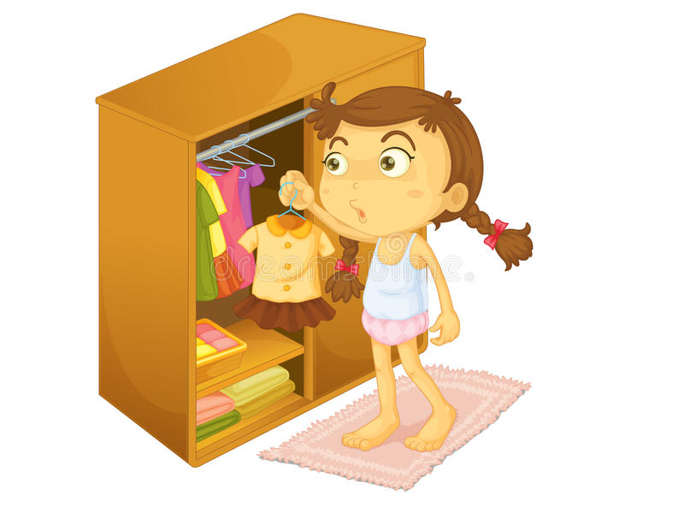

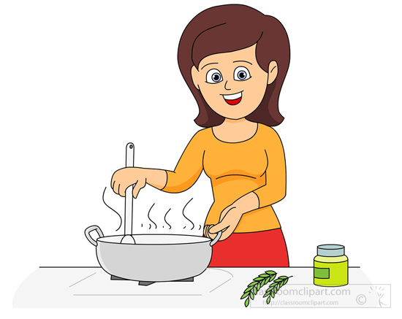


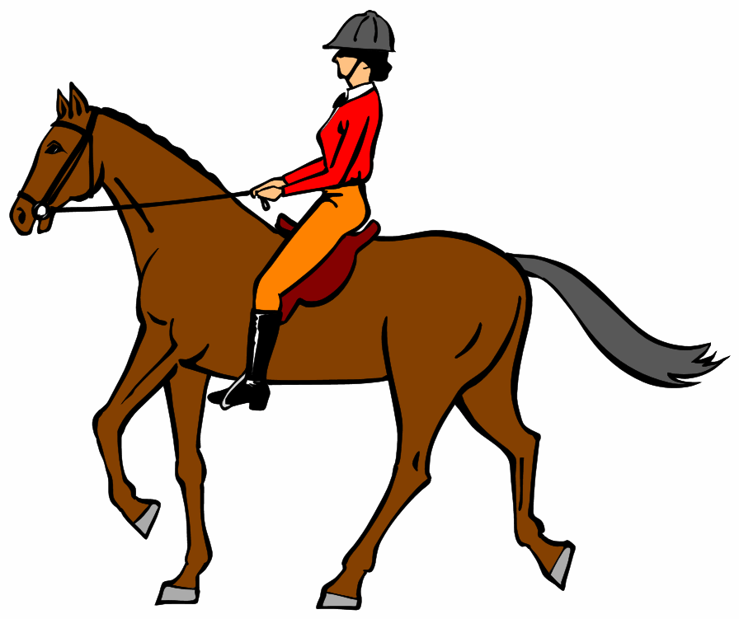
My daily routine

I __________________ at _______________.
I __________________ at _______________.
I __________________ at _______________.
I __________________ at _______________.
I __________________ at _______________.
I __________________ at _______________.
I __________________ at _______________.
I __________________ at _______________.

get up – go to school – have breakfast – have lunch – do my homework – go to bed
My daily routine

I __________________ at _______________.
I __________________ at _______________.
I __________________ at _______________.
I __________________ at _______________.
I __________________ at _______________.
I __________________ at _______________.
I __________________ at _______________.
I __________________ at _______________.

get up – go to school – have breakfast – have lunch – do my homework – go to bed
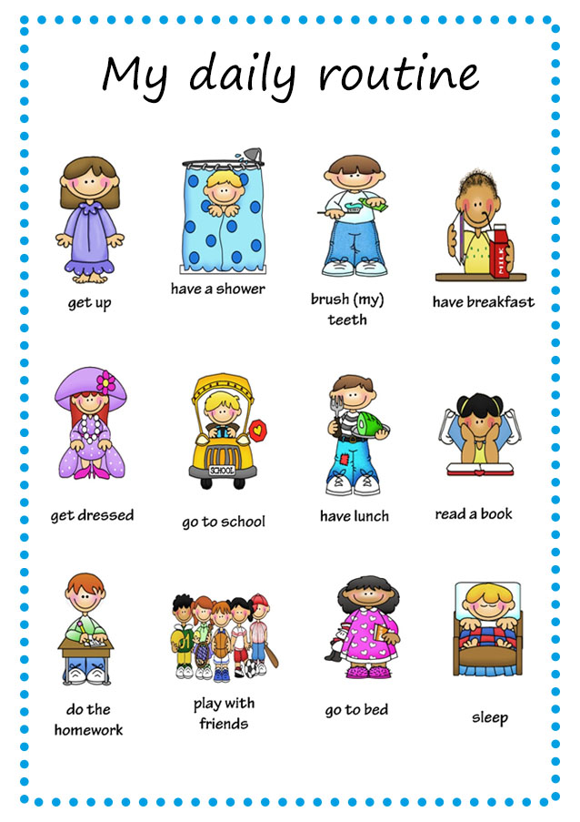
Worksheet: Daily Routines
- Read the story about Kathy
Kathy is eleven years old and she lives in Brighton, England. She usually gets up at a quarter to eight, she has a shower, gets dressed and then she brushes her teeth. After that, she goes downstairs and has breakfast. For breakfast she usually has milk, toast and orange juice.

Then she grabs her school bag and goes to the bus stop to catch the school bus. Classes start at half past eight and finish at half past four. She usually has lunch at the school canteen with her schoolmates at about 12 o’clock. Her best friend is Amy and Kathy always sits next to her at lunch.
After school she returns home and does her homework. She is a very hard-working pupil and she never misses a school task! After homework, she usually listens to music and watches television a bit.
At half past seven it is time for dinner. Then she usually reads a book or chats with her parents for a while. Finally, she goes to bed at about ten o’clock, but before that she brushes her teeth.
3) Answer the questions
1. What time does Kathy get up?
______________________________
2. What does she eat for breakfast?
______________________________
3. Does she go to school on foot?
______________________________
4. What time does school start?
______________________________
5. What does Kathy do when she returns home?
______________________________

- Order Kathy’s daily routine.
___ She goes to bed at about ten
o’clock.
___ She gets dressed.
___ She catches the bus to school.
___ She has lunch at the school
canteen.
___ She listens to music.
___ She gets up.
___ She does her homework.
___ She has a shower.
___ She has dinner.
Domino: cut out the cards
START |  |  | to have a shower | 
to get up |  |  | to play with friends | 
to get dressed |  |  | to brush my/her/his/… teeth | 
to go to school |  |  | to read a book | 
to have breakfast |  |  | to sleep | 
to do the homework |  |  | to have lunch | END

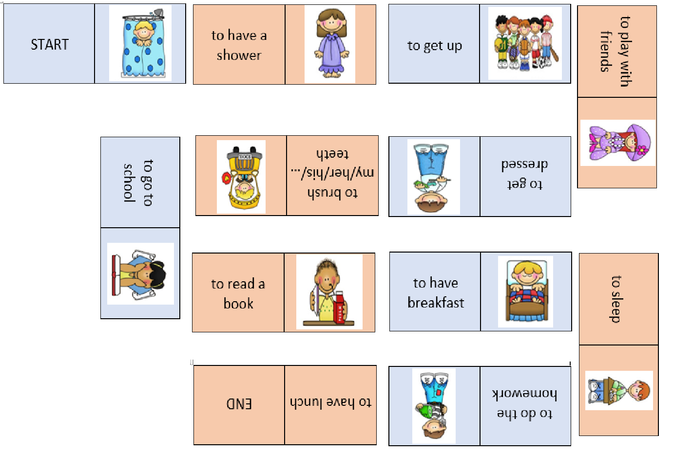

8:00
Routine-Story example
At 8 o’clock, I sleep. I don’t want to get up before 10 o’clock!

10:00
At 10 o’clock my mum wakes me up. We have breakfast together. I eat chocolate croissant, which is my favorite food! I go to school at 11 o’clock to see my friends. I’m happy that my school doesn’t start earlier!

14:00
At 2 o’clock I go home. My dad is usually also at home and we have lunch together. We eat spaghetti, which I really like!

16:00
At 4 o’clock I always play with my friends or play my favorite video games and then I read some cool magazines.

18:00
For dinner, I can always choose what mum cooks. We normally have tomato soup! After dinner, everybody plays card games.

20:00
Fold the sheet where the line is. Cut out the text. Glue it together so that 20:00 is right before 8:00 – in order to do this, you have to twist the paper once!
I have to brush my teeth at 8 o’clock. I go to bed at 9 o’clock, and my cats are always allowed to sleep in my bed.

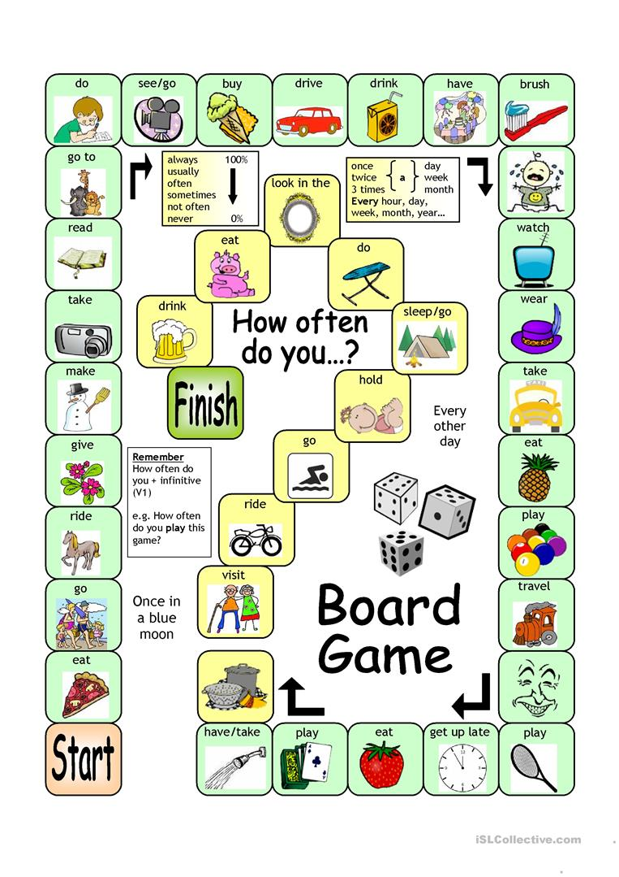
watch



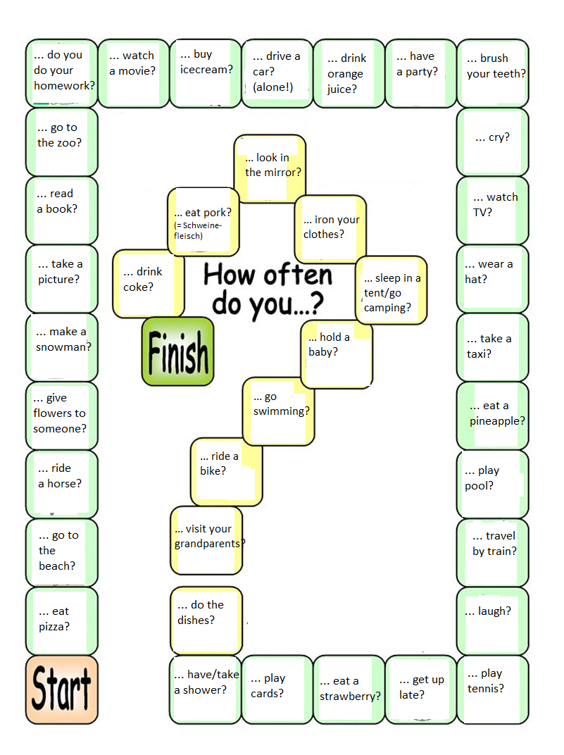

What is happening in this school?
- Take a look at the picture! What do you see? You don’t have to write anything down yet.
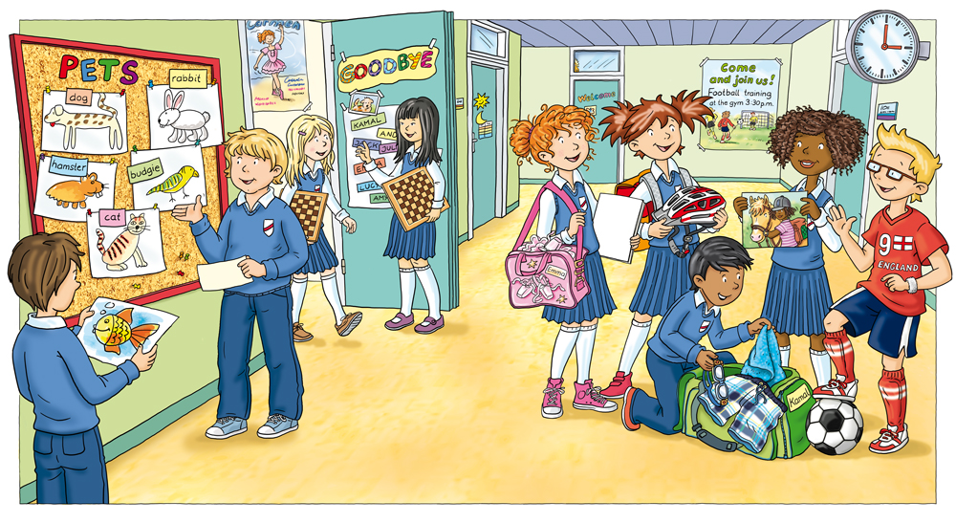

- Read the description about what is happening in the school!
The boy on the left is looking at a drawing of a fish. The boy with the blonde hair next to him is talking about one of the animals on the board and pointing towards it. Two girls are leaving their classroom and they are carrying chessboards. On the right, there is a group of people. The boy with black hair is packing his sport clothes into his bag. The boy on the right with the blonde hair is playing with his soccer ball. The girl with the curly brown hair is showing a picture to her friends.

- Mark all the verbs in the text!

- How are the actions described (look at the form of the verbs!) ? What happened to the verbs?
_________________________________________________________________________________________________________________________________________________________________________________________________________________________________
___________________________________________________________________________
- Show this sheet to your teacher and talk about your thoughts about this type of verbs!
What is happening in this school? - Solutions
- Take a look at the picture! What do you see? You don’t have to write anything down yet.

- Read the description about what is happening in the school!
The boy on the left is looking at a drawing of a fish. The boy with the blonde hair next to him is talking about one of the animals on the board and pointing towards it. Two girls are leaving their classroom and they are carrying chessboards. On the right, there is a group of people. The boy with black hair is packing his sport clothes into his bag. The boy on the right with the blonde hair is playing with his soccer ball. The girl with the curly brown hair is showing a picture to her friends.

- How are the actions described? What happened to the verbs?

All the verbs that describe what is happening right now are different!
They use the form am/is/are + verb -ing

Lemon tree – Fool’s Garden (easier version)
- Fill in the gaps and bring the chorus in the correct order!
- Correct it and take a look at the words you don’t know yet.
- Do you notice anything new about the verbs?
I ___ __________ here in the boring room
It's just another rainy Sunday afternoon
I ___ __________ my time
I got nothing to do
I ___ __________ around
I___ __________ for you
But nothing ever happens and I wonder
I___ __________ around in my car
I___ __________ too fast
I___ __________ too far
I'd like to change my point of view
I feel so lonely
I___ __________ for you
But nothing ever happens and I wonder
I wonder how
I wonder why
Yesterday you told me 'bout the blue blue sky
And all that I can see is just a yellow lemon-tree
I___ __________ my head up and down
I___ turning turning turning turning turning around
And all that I can see is just another lemon-tree
Sing, dah...
I___ __________ here
I miss the power
I'd like to go out taking a shower
But there's a heavy cloud inside my head
I feel so tired
Put myself into bed
While nothing ever happens and I wonder
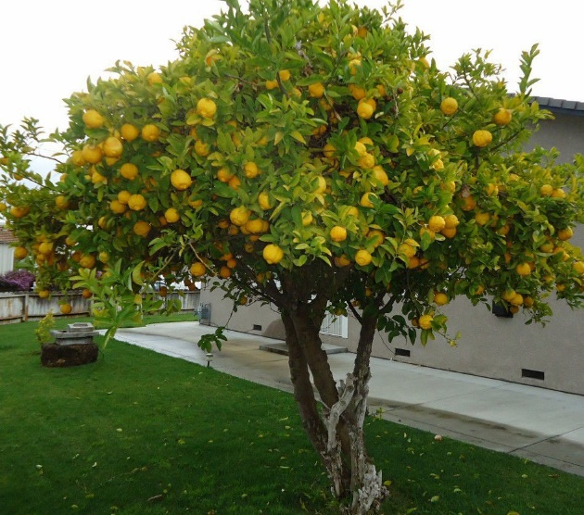
Isolation is not good for me
Isolation I don't want to sit on the lemon-tree
I'm steppin' around in the desert of joy
Baby anyhow I'll get another toy
And everything will happen and you wonder
I wonder how
I wonder why
Yesterday you told me 'bout the blue blue sky
And all that I can see is just another lemon-tree
I'm turning my head up and down
I'm turning turning turning turning turning around
And all that I can see is just a yellow lemon-tree
Yet I wonder, I wonder
I wonder how
I wonder why
Yesterday you told me 'bout the blue blue sky
And all that I can see, and all that I can see, and all that I can see
Is just a yellow lemon-tree

Lemon tree – Fool’s Garden (more challenging version)
- Fill in the gaps and bring the chorus in the correct order!
- Correct it and take a look at the words you don’t know yet.
- Do you notice anything new about the verbs?
I ___ __________ here in the boring room
It's just another rainy Sunday afternoon
I ___ __________ my time
I got nothing to do
I ___ __________ around
I___ __________ for you
But nothing ever happens and I wonder
I___ __________ around in my car
I___ __________ too fast
I___ __________ too far
I'd like to change my point of view
I feel so lonely
I___ __________ for you
But nothing ever happens and I wonder
I wonder how
I wonder why
Yesterday you told me 'bout the blue blue sky
And all that I can see is just a yellow lemon-tree
I___ __________ my head up and down
I___ turning turning turning turning turning around
And all that I can see is just another lemon-tree
Sing, dah...
I___ __________ here
I miss the power
I'd like to go out taking a shower
But there's a heavy cloud inside my head
I feel so ________
Put myself into bed
While nothing ever happens and I wonder
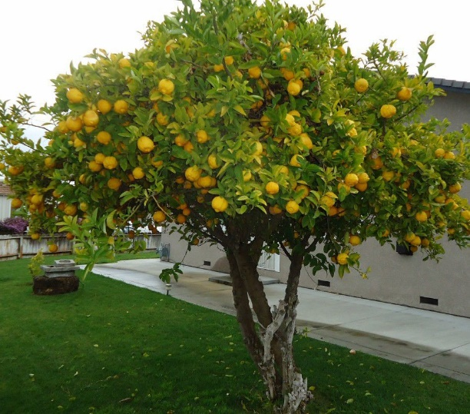
Isolation is not good for me
Isolation I don't want to sit on the lemon-tree
I'm stepping around in the desert of joy
Baby anyhow I'll get another ____
And everything will happen and you wonder
( ) I wonder why
( ) I'm turning turning turning turning turning around
( ) Yet I wonder, I wonder
( ) And all that I can see is just a yellow lemon-tree
( ) And all that I can see is just another lemon-tree
( 1 ) I wonder how
( ) I'm turning my head up and down
( ) Yesterday you told me 'bout the blue blue sky
I wonder how
I wonder why
Yesterday you ____ me 'bout the blue blue sky
And all that I can see, and all that I can see, and all that I can see
Is just a yellow lemon-tree

Lemon tree - Solution and translation

I'm sitting here in the boring room  It's just another rainy Sunday afternoon  I'm wasting my time  I got nothing to do  I'm hanging around  I'm waiting for you  But nothing ever happens and I wonder  I'm driving around in my car  I'm driving too fast  I'm driving too far  I'd like to change my point of view  I feel so lonely  I'm waiting for you  But nothing ever happens and I wonder  I wonder how  I wonder why  Yesterday you told me 'bout the blue blue sky  And all that I can see is just a yellow lemon-tree  I'm turning my head up and down  I'm turning turning turning turning turning around  And all that I can see is just another lemon-tree  Sing, dah...  I'm sitting here  I miss the power  I'd like to go out taking a shower  But there's a heavy cloud inside my head  I feel so tired  Put myself into bed  While nothing ever happens and I wonder  Isolation is not good for me  Isolation I don't want to sit on the lemon-tree  I'm steppin' around in the desert of joy  Baby anyhow I'll get another toy  And everything will happen and you wonder  I wonder how  I wonder why  Yesterday you told me 'bout the blue blue sky  And all that I can see is just a yellow lemon-tree  I'm turning my head up and down  I'm turning turning turning turning turning around  And all that I can see is just another lemon-tree  Yet I wonder, I wonder  I wonder how  I wonder why  Yesterday you told me 'bout the blue blue sky  And all that I can see,  and all that I can see,  and all that I can see,  Is just a yellow lemon-tree | Ich sitze hier in diesem langweiligen Zimmer.  Es ist mal wieder einer von diesen verregneten Sonntagnachmittagen.  Ich verschwende meine Zeit,  habe nichts zu tun.  Ich hänge herum,  ich warte auf dich,  Aber es passiert wieder mal gar nichts und ich grübele vor mich hin.  Ich fahre mit meinem Auto rum,  Ich fahre zu schnell,  ich fahre zu weit.  Ich würde so gerne meine Sichtweise verändern // an etwas anderes denken.  Aber ich fühl mich so einsam,  ich warte auf dich.  Aber nichts passiert und ich grübele.  Ich frage mich weshalb,  ich frage mich warum.  Gestern hast du mir noch vom blauen Himmel vorgeschwärmt,  aber alles was ich sehen kann ist bloß ein gelber Zitronenbaum.  Ich dreh meinen Kopf, auf und ab  ich dreh ihn weiter immer im Kreis herum.  Aber alles was ich sehen kann, ist noch ein weiterer Zitronenbaum.  Und ich singe da ….  Ich sitze hier,  Ich vermisse die Kraft // fühle mich kraftlos  Ich möchte hinausgehen und duschen  Aber in meinem Kopf, da ist eine dunkle Wolke.  Und ich fühl mich so müde,  leg mich ins Bett.  Während nichts passiert, und ich grübele.  Einsamkeit ist nicht gut für mich,  Einsamkeit ich habe keine Lust auf diesem Zitronenbaum zu sitzen.  Ich laufe herum durch diese Wüste der Freude // trostlose Wüste  Irgendwie werde ich schon ein anderes Spielzeug finden,  dann wird alles passieren und dann wirst du es sein, der grübelt.  Ich frage mich weshalb,  ich frage mich warum.  Gestern hast du mir noch vom blauen Himmel vorgeschwärmt,  aber alles was ich sehen kann ist bloß ein gelber Zitronenbaum.  Ich dreh meinen Kopf, auf und ab  ich dreh ihn weiter immer im Kreis herum.  aber alles was ich sehen kann ist bloß ein gelber Zitronenbaum.  trotzdem grüble ich, grüble ich  Ich frage mich weshalb,  ich frage mich warum,  Gestern hast du mir noch vom blauen blauen Himmel erzählt/vorgeschwärmt,  Aber alles was ich sehen kann  Aber alles was ich sehen kann  Aber alles was ich sehen kann  Ist nur ein gelber Zitronenbaum.

Breaking free – High School Musical (more challenging version)
- Put the first part of the lyrics on the left side in the correct order
- Fill in the missing words
- Correct it and look up the vocabulary you don’t know – write it in your vocabulary book! (you find the translation on the solution sheet)
- What is this song about? Explain it in 3 – 5 sentences.

  ___ Can you feel it building? Like a wave the ocean just can't control  Connected by a feeling, ooh, in our very souls (very souls)  Rising 'til it lifts us up, so everyone can see  ___ We're soaring, flying  There's not a star in heaven that we can't reach  If we're trying, so we're breaking free  ___ We're breaking free  We're soaring, flying  There's not a star in heaven that we can't reach  If we're trying, yeah, we're breaking free  Oh, we're breaking free! Ooh  ___ We're breaking free  We're soaring, flying  There's not a star in heaven that we can't reach  If we're trying, yeah, we're breaking' free  Oh, we're breaking' free! Ooh  ___ You know the world can see us  In a way that different than who we are  Creating space between us, 'til we're separate hearts  But your faith, it gives me strength  Strength to believe | Running, climbing  To get to the _______ to be all that we can be  Now's the time  So we're breaking free, (we're ________ free, ooh yeah)  More than _______, more than faith  This is truth, this is fate  And together we see it ___________  More than you, more than me  Not a want, but a need  Both of us, breaking free!  Soaring, flying  There's not a _________ in heaven that we can't reach  If we're trying, yeah, we're breaking free (breaking free)  We're running, ooh _______________  To get to the place to be all that we can be  Now's the time (now's the time)  So we're _________ free (oh we're breaking free), ooh  You know the __________ can see us  In a way that’s different than who we are

Breaking free – High School Musical (easier version)
- Put the first part of the lyrics on the left side in the correct order
- Fill in the missing words – build the -ing form of the verbs in the (brackets)
- Correct it and look up the vocabulary you don’t know – write it in your vocabulary book! (you find the translation on the solution sheet)
- What is this song about? Explain it in 3 – 5 sentences.

___ Can you feel it building? Like a wave the ocean just can't control  Connected by a feeling, ooh, in our very souls (very souls)  Rising 'til it lifts us up, so everyone can see  ___ We're soaring, flying  There's not a star in heaven that we can't reach  If we're trying, so we're breaking free  ___ We're breaking free  We're soaring, flying  There's not a star in heaven that we can't reach  If we're trying, yeah, we're breaking free  Oh, we're breaking free! Ooh  ___ We're breaking free  We're soaring, flying  There's not a star in heaven that we can't reach  If we're trying, yeah, we're breaking' free  Oh, we're breaking' free! Ooh  ___ You know the world can see us  In a way that’s different than who we are  Creating space between us, 'til we're separate hearts  But your faith, it gives me strength  Strength to believe | ___________ (run), climbing  To get to the place to be all that we can be  Now's the time  So we're _________ (break) free, (we're breaking free, ooh yeah)  More than hope, more than faith  This is truth, this is fate  And together we see it ____________ (come)  More than you, more than me  Not a want, but a need  Both of us, _______ (break) free!  Soaring, flying  There's not a star in heaven that we can't reach  If we're ________ (try), yeah, we're breaking free (breaking free)  We're running, ooh climbing  To get to the place to be all that we can be  Now's the time (now's the time)  So we're breaking free (oh we're breaking free), ooh  You know the world can see us  In a way that’s different than who we are

Breaking free – Solutions
We're soaring, flying  There's not a star in heaven that we can't reach  If we're trying, so we're breaking free  You know the world can see us  In a way that’s different than who we are  Creating space between us, 'til we're separate hearts  But your faith, it gives me strength  Strength to believe  We're breaking free  We're soaring, flying  There's not a star in heaven that we can't reach  If we're trying, yeah, we're breaking' free  Oh, we're breaking' free! Ooh  Can you feel it building?  Like a wave the ocean just can't control  Connected by a feeling, ooh, in our very souls (very souls)  Rising 'til it lifts us up, so everyone can see  We're breaking free  We're soaring, flying  There's not a star in heaven that we can't reach  If we're trying, yeah, we're breaking free  Oh, we're breaking free! Ooh  Running, climbing  To get to the place to be all that we can be  Now's the time  So we're breaking free, (we're breaking free, yeah)  More than hope, more than faith  This is truth, this is fate  And together we see it coming  More than you, more than me  Not a want, but a need  Both of us, breaking free!  Soaring, flying  There's not a star in heaven that we can't reach  If we're trying, yeah, we're breaking free (breaking free)  We’re running, ooh climbing  To get to the place to be all that we can be  Now's the time (now's the time)  So we're breaking free, (we're breaking free, yeah)  You know the world can see us  In a way that’s different than who we are | Wir segeln, fliegen  Da ist kein Stern im Himmel den wir nicht erreichen können  Wenn wir es versuchen, können wir uns losreißen  Du weißt die Welt kann uns sehen,  in einer Weise, die anders ist als wir sind  Schaffen Platz zwischen uns, bis wir abgrenzende Herzen sind  Aber dein Vertrauen macht mich stärker,  stärker um zu glauben  Wir reißen uns los  Wir segeln, fliegen  Da ist kein Stern im Himmel den wir nicht erreichen können  Wenn wir es versuchen, können wir uns losreißen  Oh, wir reißen uns los!  Kannst du spüren wie es sich aufbaut?  Wie eine Welle die der Ozean nicht kontrollieren kann  Angekoppelt an einem Gefühl, ooh in unsren Seelen  (Seelen ohh)  Steigen bis wir abheben sodass uns jeder sehen kann  Wir reißen uns los  Wir segeln, fliegen  Da ist kein Stern im Himmel den wir nicht erreichen können  Wenn wir es versuchen, können wir uns losreißen  Oh, wir reißen uns los!  Rennen, klettern  Um zu dem Platz gelangen an dem wir alles sein können was wir wollen  Jetzt ist die Zeit,  also reißen wir uns los (Wir reißen uns los ohh yeah)  Mehr als Hoffnung, mehr als Vertrauen,  Das ist wahr, das ist Schicksal,  Und zusammen werden wir es kommen sehen  Mehr als du, mehr als ich,  Kein Bedürfnis, sondern eine Notwendigkeit  Jeder von uns reißt sich los  Wir segeln, fliegen  Da ist kein Stern im Himmel den wir nicht erreichen können  Wenn wir es versuchen, können wir uns losreißen Oh wir reißen uns los (Oohh)  Rennen, klettern  Um zu dem Platz gelangen an dem wir alles sein können was wir wollen  Jetzt ist die Zeit,  also reißen wir uns los (Wir reißen uns los ohh yeah)  Du weißt die Welt kann uns sehen,  auf eine Weise, die anders ist als wir sind...

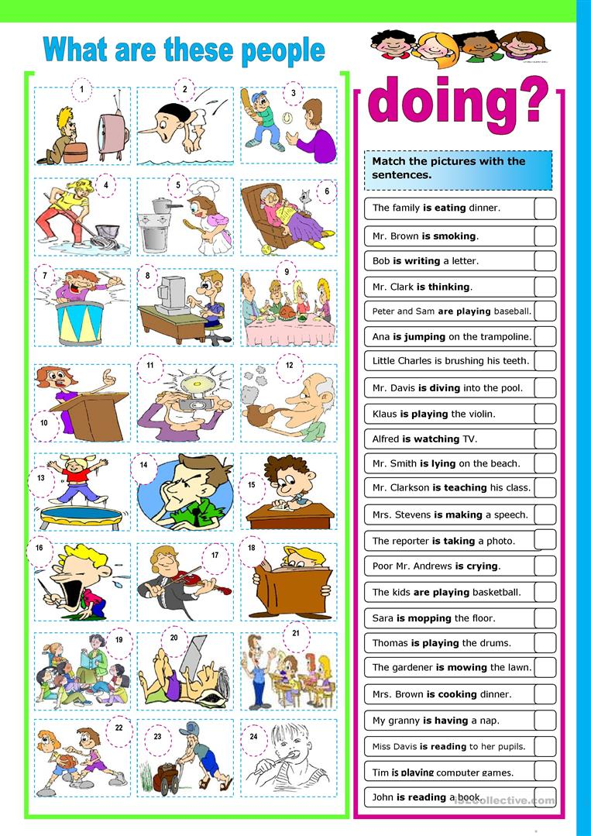

Match the pictures with the sentences!
Solutions
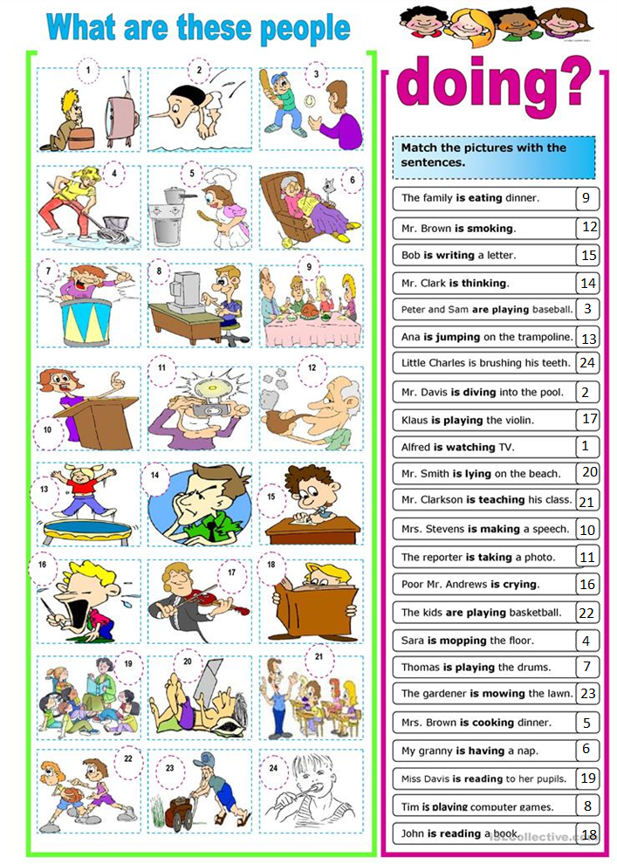
Miming game: cut out the cards
  You are singing a song. | 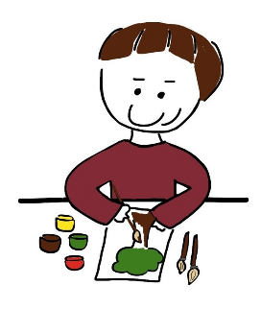  You are drawing a picture. |   You are swimming.
  You are watching TV. |   You are playing a computer game. |   You are playing piano.
  You are reading a book. | 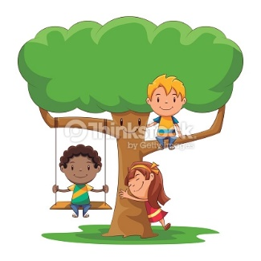  You are sitting on a tree. |   You are climbing a mountain.
  You are having a shower. |   You are crying. |   You are dancing.
  You are running. |   You are taking pictures. |   You are doing your homework.
  You are listening to music. |   You are brushing your teeth. |   You are playing basketball.
  You are eating a hamburger. |   You are driving a car. |   You are baking a cake.
  You are sleeping. |   You are eating an apple. | 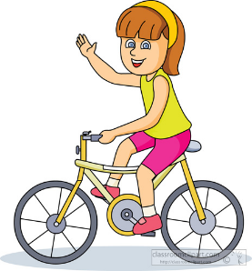  You are riding a bike.

Activities Vocabulary
 | bake a cake |  |  | play a computer game
 | brush your teeth |  | 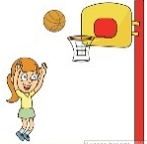 | play basketball
 | climb a mountain |  |  | play piano
 | cry |  |  | read a book
 | dance |  | 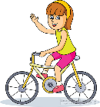 | ride a bike
 | do your homework |  |  | run
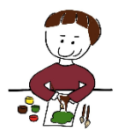 | draw a picture |  |  | sing a song
 | drive a car |  | 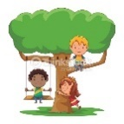 | sit on a tree
 | eating an apple |  |  | sleeping
 | eating a hamburger |  |  | swimming
 | having a shower |  |  | taking pictures
 | listening to music |  |  | watching TV

Writing task:
What’s happening in this picture? Write at least 10 sentences including an action!
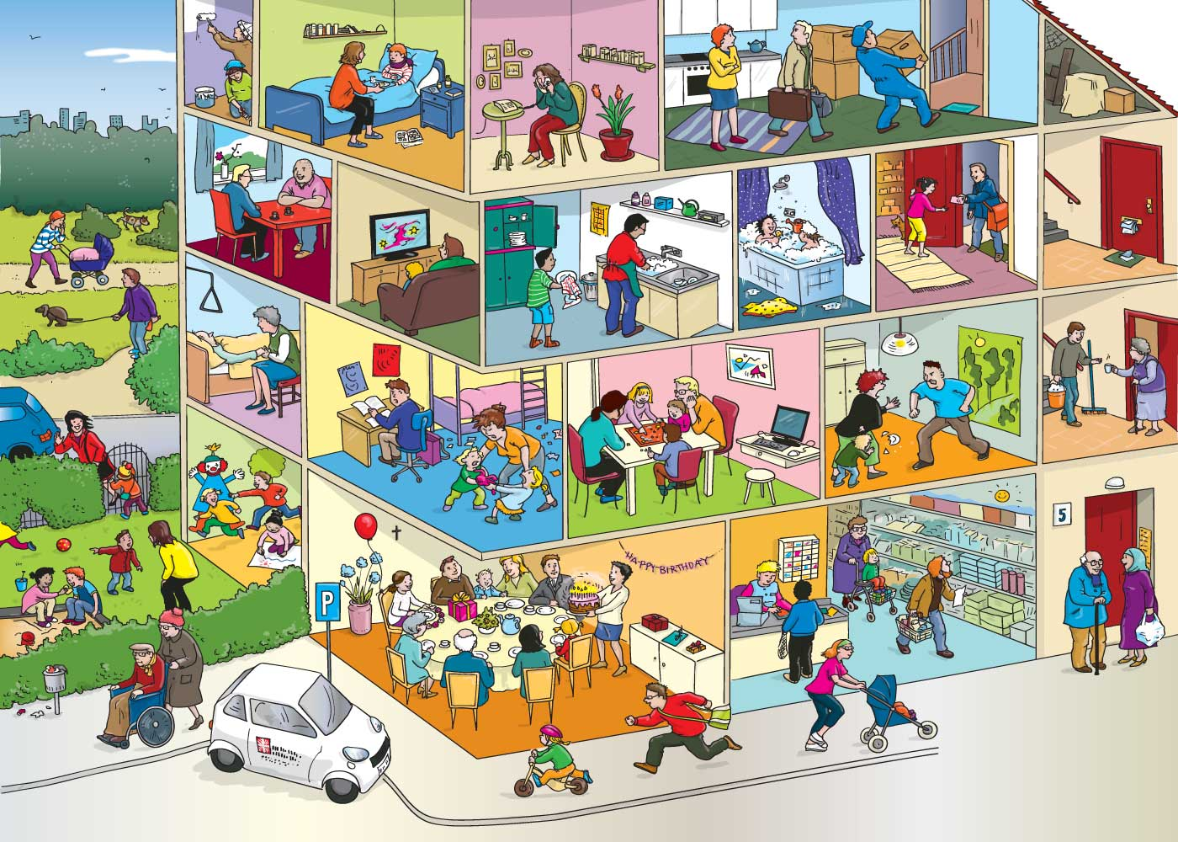

Writing task: helpful phrases
In the room on the ground/first/second/third floor ….  In the yard …. (= Garten)…  Next to the car/…  Outside of the house … | ... the young/old … boy/man/girl/woman ….  with the blond/brown/black hair …. | …is… | Verb + -ing
 | … the couple (= das Paar)  … the man and the woman … | …are… | Verb + -ing

celebrate -> celebrating | play -> playing | sleep -> sleeping
do -> doing | read -> reading | take a bath -> taking a bath
fight -> fighting | ride a bike -> riding a bike | talk -> talking
listen -> listening | run -> running | wait -> waiting
paint -> painting | sit -> sitting | walk -> walking
offer -> offering (e.g. to offer coffee/… - etwas anbieten) |  | watch -> watching

Writing task: helpful phrases
In the room on the ground/first/second/third floor ….  In the yard …. (= Garten)…  Next to the car/…  Outside of the house … | ... the young/old … boy/man/girl/woman ….  with the blond/brown/black hair …. | …is… | Verb + -ing
 | … the couple (= das Paar)  … the man and the woman … | …are… | Verb + -ing

celebrate -> celebrating | play -> playing | sleep -> sleeping
do -> doing | read -> reading | take a bath -> taking a bath
fight -> fighting | ride a bike -> riding a bike | talk -> talking
listen -> listening | run -> running | wait -> waiting
paint -> painting | sit -> sitting | walk -> walking
offer -> offering (e.g. to offer coffee/… - etwas anbieten) |  | watch -> watching

To-Do-List
Here’s the to-do-list for this and the next class! You need to fulfill all mandatory tasks and one of the voluntary tasks/color. You can vary the order of the tasks with the same color. Make sure you finish the first color before starting the next one! If you finish early complete all the voluntary tasks that you haven’t done yet.
 | Mandatory? | What? | How many people? | Any problems/questions? | Check!
1 | mandatory | Write your own grammar page | 1
2 | voluntary | Domino | 2-3
3 | mandatory | Your dream routine | 1
4 | voluntary | Boardgame | 2-4
5 | mandatory | Reading: What is happening? | 1
6 | mandatory | Song: Lemon tree | 1
7 | voluntary | What are these people doing? | 1
8 | voluntary | Song: Breaking free | 1
9 | mandatory | Game: Miming | 2-4
10 | mandatory | Writing: What is happening? | 1
11 | mandatory | Write your own grammar page | 1

To-Do-List
Here’s the to-do-list for this and the next class! You need to fulfill all mandatory tasks and one of the voluntary tasks/color. You can vary the order of the tasks with the same color. Make sure you finish the first color before starting the next one! If you finish early complete all the voluntary tasks that you haven’t done yet.
 | Mandatory? | What? | How many people? | Any problems/questions? | Check!
1 | mandatory | Write your own grammar page | 1
2 | voluntary | Domino | 2-3
3 | mandatory | Your dream routine | 1
4 | voluntary | Boardgame | 2-4
5 | mandatory | Reading: What is happening? | 1
6 | mandatory | Song: Lemon tree | 1
7 | voluntary | What are these people doing? | 1
8 | voluntary | Song: Breaking free | 1
9 | mandatory | Game: Miming | 2-4
10 | mandatory | Writing: What is happening? | 1
11 | mandatory | Write your own grammar page | 1

Activity 1: Write your own grammar page!
Take out your grammar booklet! Make a page about the use of the Present Simple tense – this is the tense we use for example for routines. What do you remember? When do we need an -s? Find some example sentences from the text and the description of your own routine and add them.
In case you don’t remember it anymore, don’t be afraid to ask your teacher!
When you have finished this activity, bring your grammar folder to your teacher and let him/her check it.

Activity 2: Domino
It’s time to play domino! Get together in groups of three. Everybody gets the same number of cards. The person who has got the card that says “start” on it begins. The person who has the word that matches the picture puts it next to it and so on. Every time you have a matching card you have to say a sentence using the phrase. If your card is red, you say a sentence about yourself. If your card is blue, you say a sentence about somebody else.
Try to include some of the words you see in the chart! They help you to say how often you do something.
e.g.
START |  |  | to have a shower

My sister always/never/sometimes/usually takes a shower in the morning.

Activity 3: Routine - story
What would be your “dream” daily routine? What would you want to do every day?
Write these things on the paper!
Look at the example and try to also divide your story very evenly so that it never stops once it is glued together It shows how the things are repeated every day!
Try to include some words that tell the reader how often you do something, e.g. I always get up at 10 o’clock. I never have to get up at 8 o’clock.

Activity 4: Boardgame
Number of players: 2 – 4
The student with the darkest shirt begins. He/She throws the dice and moves forward according to the number on the dice. The picture shows a certain activity. He/She asks the person sitting on his/her left how often they do this activity. (How often do you …?) The person answers. (I … once a week/…). Now this person throws the dice. Whoever reaches the end of the game first wins.
Be careful about what your classmates say and try to help them if you spot a mistake!
If you don’t know a word/picture you can look on the sheet next to it – there you find the correct phrases.

Activity 5: What is happening?

What is happening in this school? Read the text and answer the questions! You find the detailed explanations on your worksheet!

Activity 6: Lemon tree
When life gives you lemons … make lemonade!
- Choose your worksheet! Do you want to try the challenging one, or do you prefer the easier one?
- Listen to the song “Lemon tree” by Fool’s Garden and fill in the gaps! (Start with https://www.youtube.com/watch?time_continue=166&v=XAFS43NKFag including lyrics and animation; If you want to you can also take a look at the original video: https://www.youtube.com/watch?time_continue=6&v=bCDIt50hRDs)
- Correct the gaps and look for any vocabulary you don’t understand with the solution sheet. Write down the words you want to remember.
- Do you notice anything strange when looking at the verbs?

Hint: Do you see the -ing verbs? When are they used? Do you have an idea? Try some other -ing – activities and try to find out when they are used! (when exactly do the things happen?)

Activity 7: Worksheet: What are these people doing?
You live in a huge house together with your family and lots of neighbors. Your aunt has just called, and she wants to know what everybody is doing and where everybody is! Can you answer her question? Look at the picture!
Which picture belongs to which sentence? Fill in the numbers and check your answers afterwards!

Activity 8: Breaking free
Gabriella and Troy from High School Musical also sing a lot about what is happening now in their heads!
Listen to “Breaking free” and fill in the worksheet.
https://www.youtube.com/watch?v=ZLa__49Ltv4

Correct your worksheet afterwards! Write down the words you want to remember! (in your vocabulary book)

Activity 11: Write your own grammar page 2!
Take out your grammar booklet! Make a page about the use of the Present Progressive tense – this is the tense we use for things that are happening right now. What do you remember? How is it formed? Find some example sentences from the text and the description of your own routine and add them. Make sure you write down everything you need to know since this is your resource for the next few years!
Before you start writing look for another person who is also working on this task. Try to explain to each other when to use the present progressive tense and find some example sentences! In case you are not sure if you are correct go ahead and ask your teacher!
When you have finished this activity, bring your grammar folder to your teacher and let him/her check it.
Activity 9: Miming cards
The student with the shortest hair starts. He/She draws a card (without looking at it!). Then, he/she looks at the picture and tries to mime it. The rest of the group has to guess what they are doing. The first one who guesses correctly can keep the card. Now it’s his/her turn! He/She draws on of the cards that has not been used yet and mimes it.
The student who has got most of the cards in the end wins!

This is how the questions are formed:
Are you verb+ing ? (e.g. “Are you rapping?” Are you playing the guitar?”)

Activity 10 (b) : Writing task: What’s happening?
What do you see on this picture? What is happening in this house? Write 10 sentences including actions that you see! If you remember the task about what was happening in the school well, try to do it on your own. If you need some help, take one of the sheets with helpful phrases.
Activity 10 (a) : Writing task: What’s happening?
Take a walk around the school building! What is happening right now? What are the people in the cafeteria doing? Do you see any classes on the hallways? Is anyone outside (take a look through the window!) Write 10 sentences including actions that you see! If you remember the task about what was happening in the school well, try to do it on your own. If you need some help, take one of the sheets with helpful phrases.
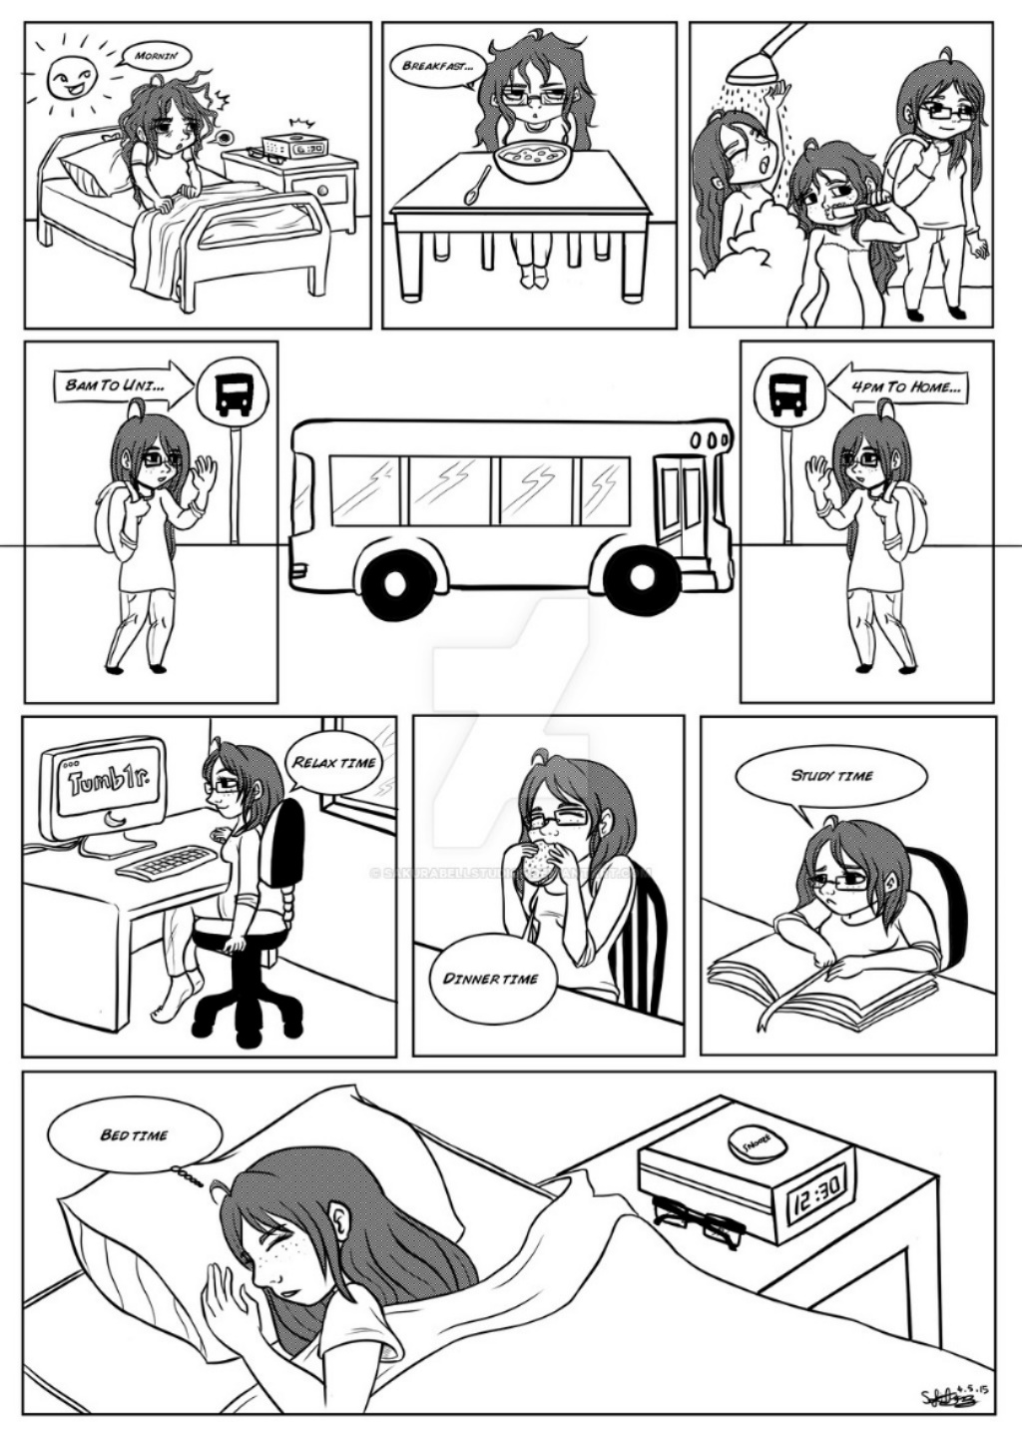
Homework: Present simple tense Design your own comic!

Look at this comic!
Try to make a little picture story which is similar to the comic!
- Draw at least four little pictures! (Yes, you can use stick-figures! )
If you don’t like to draw at all you can also make a comic using this website: http://stripgenerator.com/strip/create/
- Try to include one picture where your mum/dad/brother/sister is also shown!
- Add descriptions to the pictures, e.g. “I get up at 6 o’clock.”, “My brother and I have breakfast together”.
Homework: Present simple and progressive Worksheet
Read the text and circle True or False. Look carefully!

Fill in the correct form of the verbs! Do you use the present simple tense that we use for routines, or the present progressive tense we use for the things that are happening right now? Look at every sentence carefully and decide!
Afterwards, check which of these sentences are true for yourself! Do you sleep for a long time at weekends? Make a smiling face next to the correct statements!

