How efficient are these exercises?
Work with a partner.
Have a look at these exercises and do them yourself.
What do they practice?
What’s going on in your brain while you do them?
Watch yourself and take a few notes after each exercise.

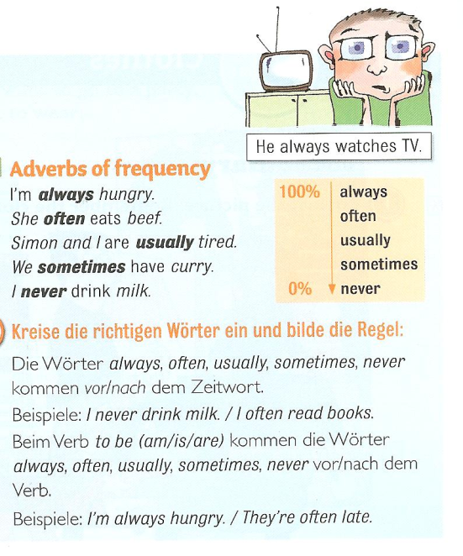
Figure 1

Adverbs of frequency
Our friend helps us. (always)
I go shopping in Paris. (never)
She is late. (usually)
I get headaches. (often)
He forgets my birthday. (always)
You are right. (usually)
They stay in bed late. (sometimes
I don’t go to the doctor. (often)
Source: 1

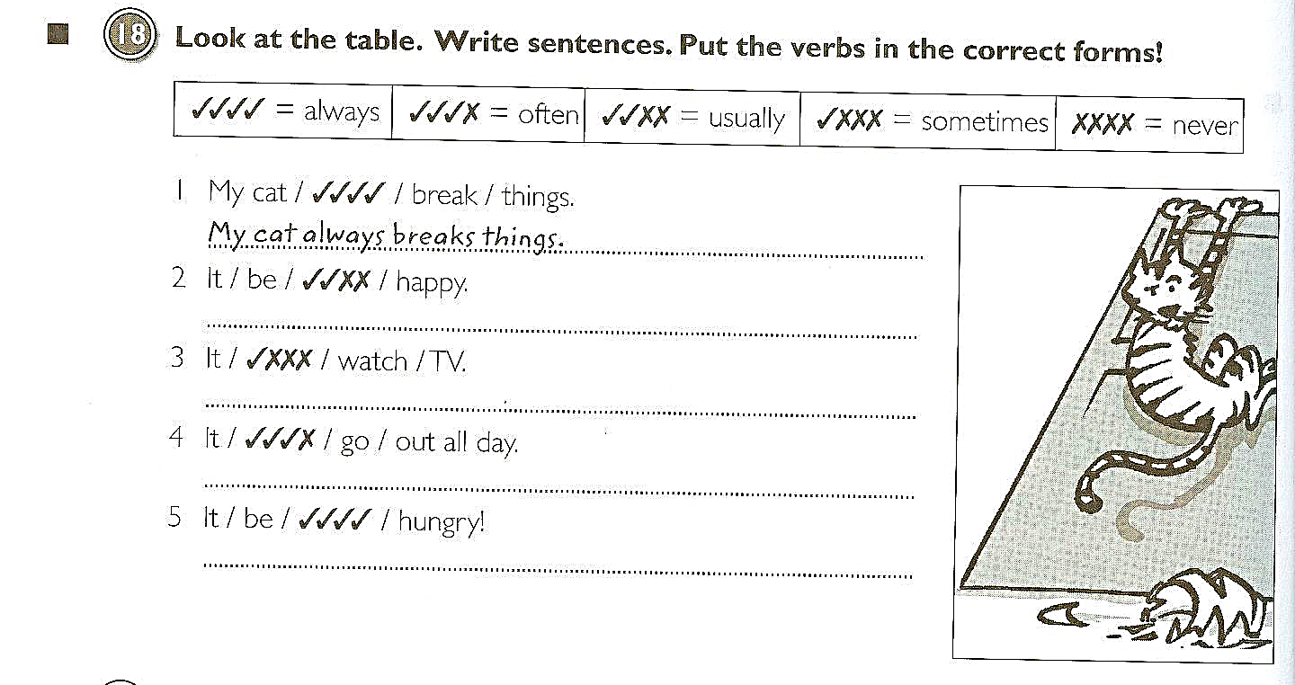
Source: 2

Adverbs of frequency:
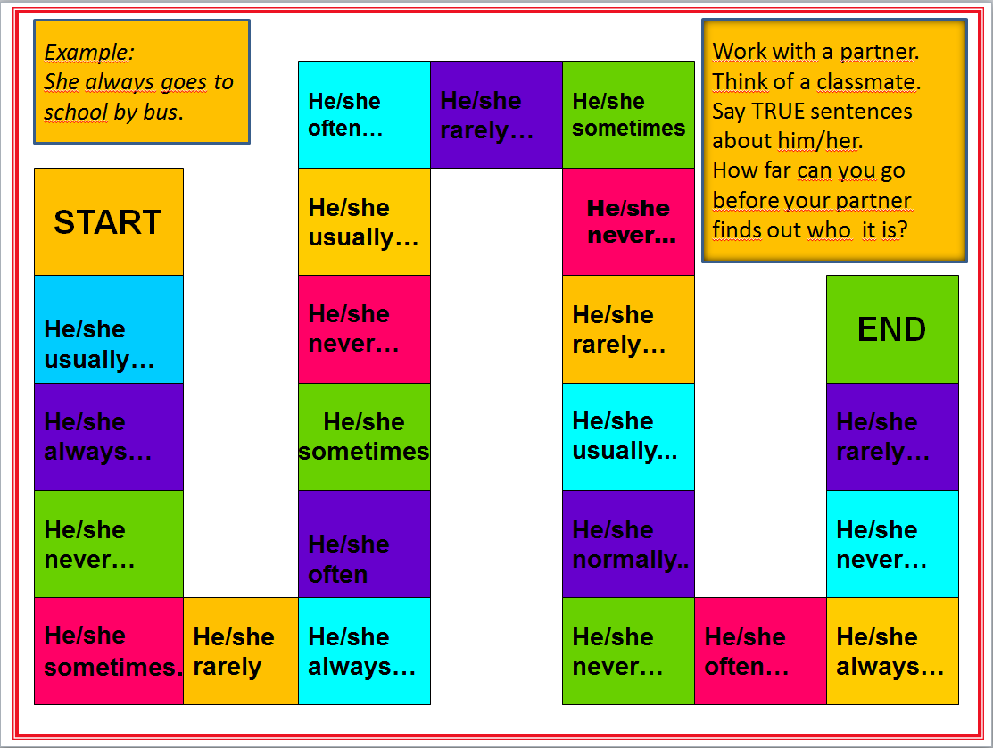
Boardgame

Asking Questions in English

Compare the following exercises
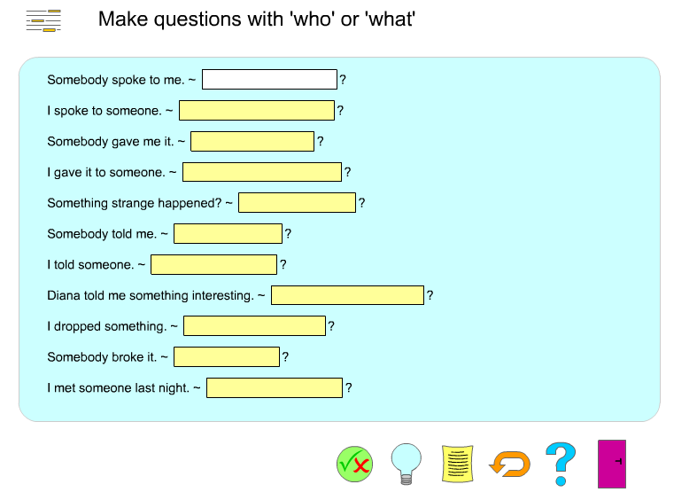

http://www.englishgrammarsecrets.com/questions1/menu.php

What do you think they asked?
? | John’s in the garden and Sylvia is in town.
? | Put on your blue trousers.
? | Because I wasn’t feeling well.
? | Mum gave it to me for my birthday.
? | I did. I’m sorry. I’ll buy you a new one.
? | Yesterday. The postman brought it just before I went to work.
? | I think it’s M-I-S-S-I-S-S-I-P-P-I but you’d better look it up.
? | I went by taxi. I missed the bus!
Source 3

Form questions
Ask for the underlined part. Write the complete English question into the gap.
Example:
The class plays football.
_______________________
Answer:
The class plays football.
What does the class play?
1) John is writing a letter.
?
2) She walks home from school.
?
3) The children are sitting in the garden.
?
4) Peter runs with his dog on Sundays.
?
5) My rabbit has a cage in the garden.
?
6) They go to work by bus.
?
7) David likes cats because they are nice.
?
8) Jenny isn't sleeping late today.
?
9) We are going to the cinema.
?
10) I'm leaving now.
?

http://www.englisch-hilfen.de/en/exercises/questions/form.htm
Finding out about my friends
1. Leider hat der Computer die Fragen und Antworten durcheinandergebracht. Wo passen die folgenden Fragen hin. Schreib sie in die richtigen Kästchen.
2. Then write your own answers into the 2nd column. (Schreibe deine eigenen Antworten in die zweite Spalte. Die rechte Spalte hilft dir dabei.)
3. ENGLISH ONLY: Now ask 3 classmates and write down their answers. Use the back of the sheet. (Bitte sprich nur Englisch.)
4. Homework: Write about two of your friends. Use an A4 sheet for homework and always write your name on it. (Schreibe deine Hausübung auf ein schönes A4 Blatt. Vergiss nie deinen Namen rechts oben zu vermerken und schreib sauber und sorgfältig. Dies erfreut nicht nur mein Auge, es hilft dir auch die Dinge besser zu behalten.
What’s your name?
How are you today?
Where do you come from?
Where do you live?

Do you have any brothers and sisters?
Do you have any pets?
What are your favorite hobbies?
When is your birthday?

Question | Mrs. Pö’s answer | Possible answers: Wähle aus was für dich past.
Question | Add your own answers. | Possible answers: Wähle aus was für dich past.
 | My birthday is on the 30th of January. | My birthday is on the 1st (first) 2nd (second),  3rd (third), 4th (fourth),  5th (fifth)…of  January, February,  March, April, May,  June, July, August, September, October, November, December
 | I like reading, jogging and skiing. | I like playing tennis, playing the piano, watching TV, playing computer games, painting, dancing…
 | Yes, I have one sister. | I do not have any brothers and sisters. I am an only child.
 | My name is Lis Pölzleitner
 | Yes, I have a cat and four ducks. | I have a dog, a hamster, some fish, a guinea pig, a horse, a budgie, three white mice (one mouse), a rat, a turtle, …
 | I’m fine, thanks. And how are you? | I’m tired. I’m not feeling well today. I’m o.k.
 | I live in Graz, St. Peter.
 | I come from Bruck an der Mur


Asking questions:
Use the words from the boxes to write five questions. Use each word once.
When  What  Why  How  Where | does  are  is  does  do | the children  Sue and Katy  Thomas  Anna  Mrs. Pölzleitner’s | have for dinner  birthday  not at school today  live  go to school | ?

Now find out more about your teacher(s). Write questions and guess the answers. Then ask your teacher and find out if your guesses were correct.
What… | Tick off your correct answers:
Your answer:
When
Your answer:
Where
Your answer:
Why
Your answer:
How
Your answer:
How many
Your answer:
Who
Your answer:

No! No! No! :
  - I do not like/ X does not like…
  - I don’t like / X doesn’t like…
What are the things you do not like at all? Write down five sentences.
Then ask three classmates what they do not like at all and write sentences.
1.Example: I do not like….
2
3
4
5
1 My friend...
2
3
4
5
1 My friend …
2
3
4
5

What do you have in common? Are there any things none of you likes?
Example: Peter and I do not like…

Dogs, dogs, dogs.
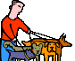
- Whose dogs are these? Match the pictures with the words.
Peter’s dog.
Tom’s dogs.
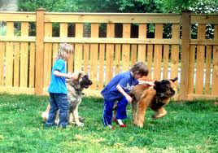
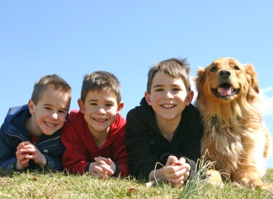
The boys’ dog.
The boys’ dogs.
The dog’s tricks.
No dogs allowed here.
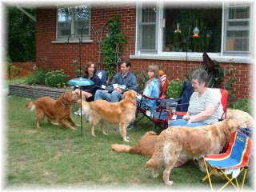

- Now label these pictures. Where do you need an apostrophe?
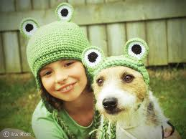

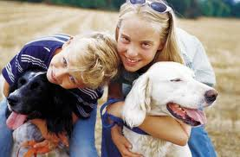

Example: Our neighbors’ dogs
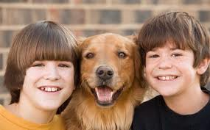

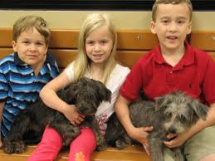
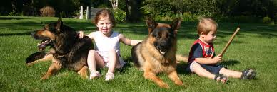



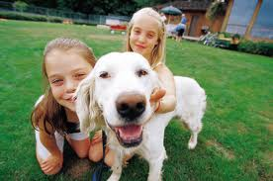
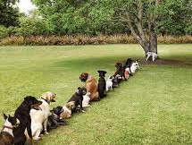

Homework:
Make your own matching exercise (like exercise 1). Choose a different topic – find or draw 6 pictures and write 6 sentences. Bring your page to class and ask one of your classmates to match the pictures and the phrases.
Sources:
- Gerngross et al. (2007) More 1, Student’s Book. Helbling. 53
- Gerngross et al.(2007) More 1, Workbook. Helbling. 64
- Newby, D. (1992) Grammar for Communication. Vienna: Österreichischer Bundesverlag. 187
All others: Elisabeth Pölzleitner

