Teaching communicative grammar

Elisabeth Pölzleitner, David Newby

Key words

Communicative grammar
Grammatical notions
Grammatical objectives
Learning aims
Learning stages
Factors that optimise learning

In this chapter we ask the following questions:

What is communicative grammar?
What are the main differences between traditional and communicative grammar?
How can grammatical objectives be defined?
What criteria can we apply to evaluate, adapt and design grammatical activities?

The Austrian context

As in many European countries, grammar exercises and activities found in Austrian schoolbooks and widely-used classroom practices tend to follow a fairly traditional approach to the teaching of grammar. Teachers looking for guidance from the latest version of the Austrian school curriculum on how to teach grammar may be disappointed; whereas previous versions of the curriculum provided discussion of principles of communicative grammar and specified grammatical objectives in terms of grammatical notions (see discussion below), recent versions have been dominated by specifications of learning content in terms of skill-based learning outcomes without making specific references to grammatical categories. Nor will teachers find much support from international manuals on foreign language methodology: grammar is the one area of language teaching which has been neglected by many methodologists who find it difficult to incorporate it into communicative approaches. Indeed, both among teachers and among methodologists, grammar is often seen as a ‘problem’. In this chapter, we illustrate how grammar, if taught according to certain principles, is wholly compatible with modern approaches and theories of learning. These principles and the categories and terms discussed in this chapter are dealt with in more detail in Newby 2017.

Tasks of the (grammar) teacher

When teaching grammar, teachers have to carry out several pedagogical tasks. The most important are:
- Setting grammatical objectives so that teachers know exactly what they are teaching and learners know what they are learning. As we shall see, whether objectives are specified by means of grammatical meaning or by grammatical form will have important consequences.
- Dealing with grammar rules. The most common way of ‘transmitting’ rules to the learner is by teacher/textbook explanation; other ways are picking up rules ‘implicitly’ by using grammar or discovery of rules in the course of activities.
- Selecting or designing grammar activities. This entails recognising the learning aim of a specific activity and evaluating how well this activity might support this aim.
- Providing or designing a sequence of grammar activities which leads learners from initial awareness of a grammar rule to a stage where they can use grammar automatically.
- Testing grammar. Assessing how well grammar has been acquired by learners. This task must be carried out by taking into consideration of the overall aims of learning. A fill-in-the-gap test does not necessarily provide information about whether learners are able to use grammar for communication.

Reasons for learning grammar

Before considering aspects of pedagogy, we need to begin with a statement of why our learners learn grammar and what the overall outcome of our teaching should be. This statement might run as follows: the overall purpose of learning grammar is to be able to express your own ideas in real situations in language that is as correct, meaningful and appropriate as possible. Let’s look at each of these in turn:

It follows from the phrase ‘own ideas in real situations’ that if our grammar exercises consist solely of fill-in-the-gap, transformation, translation exercises etc., they do not provide learners with the opportunity to personalise grammar – that is to say, to use grammar to say what they think or feel – and to rehearse grammar in actual contexts. Teachers regularly complain that students are able to fill in the correct forms in gapped tests, but they do not use the same forms in their free production. If our goal is performance in real-life situations, we must make sure that the students practice grammar in such contexts. For this purpose, we need specific types of ‘communicative’ activities – see for example, Ur 2009.

‘…correct, meaningful …’ The main purpose of all language use is to express meanings. Clearly, there is a close relationship between formal correctness and grammatical meaning. Some grammatical mistakes may even obscure the message or lead to misunderstandings. While traditional grammar has always paid attention to grammatical meaning, it has not given it the prominence that it is assigned in a communicative grammar approach, where grammatical meaning is at the centre of objective setting and activity design.

‘Appropriate’ grammar is an aspect which is often ignored in grammar teaching and refers to register or style. When teaching vocabulary or speaking skills, teachers often distinguish between formal and informal language – e.g. get/receive, good morning/hi etc. This distinction also applies to grammar usage: My colleague and I attended a conference (formal) vs. Philip and me went to a football match (informal).

Grammar and grammar rules: what are they?

One way of defining language is that it is a system for providing information about the things and events in the world and for expressing what we think and what we experience in our daily lives. Different aspects of language play different roles in this ‘information’ process. Vocabulary expresses the various concepts we talk about – things (nouns), properties (adjectives, adverbs), actions (verbs etc. – and grammar provides more detailed information about how the speaker perceives these things, properties and events. For example, whether the things are general or specific (articles), how we can compare properties (e.g. comparative/superlative), when an event occurred/will occur (tenses etc.) It follows from this view that a communicative approach sees grammar as a meaning-carrying system which provides important information.

As far as grammar rules are concerned, rules simply mean ‘regularities’. The term should not be confused with the ‘you must/mustn’t do this!’ meaning of rules in general English. Acquiring grammar rules means internalising a systematic relationship between meanings and forms of grammar - in short, learning grammar means making meaning-form connections.

Differences between traditional and communicative grammar

It should be stressed that many practices commonly applied in grammar teaching are not based on specific theories of language or language acquisition but have established themselves over centuries and in many cases have not been questioned or put under the microscope to examine how effectively they support the learning of grammar. That is to say, teaching grammar tends to be the result of tradition rather than of any coherent theories. Added to this is the problem that very few researchers and methodologists have come up with plausible alternatives which can be implemented in everyday classroom teaching. The main differences between traditional and communicative approaches to teaching grammar are listed in figure 1.

Figure 1: Traditional and communicative grammar

Category | Traditional grammar | Communicative grammar
Objectives | Formal teaching objectives | Meaning-based objectives
Rules | Teaching through explanation  Learning by understanding | Teaching through activities  Learning by using, discovery etc.
Exercises | Exercises which test knowledge | Exercises which support learning
Exercises | Exercises which restrict use  (fill-in-the-gap etc.) | Exercises with encourage use  (open-ended, games etc.)
Aims | Grammar is an end in itself | Grammar is a means to an end

The purpose in comparing the two grammatical orientations is not to reject traditional teaching entirely but to recognise its shortcomings. For example, we are not suggesting that ‘teaching through explanation’ or fill-in-the-gap exercises have no place in grammar teaching. Rather, such practices need to be evaluated by teachers according to specific criteria and replaced or supplemented by communicative pedagogical practices when it is felt that these will provide better support for learning.
Notional grammar: setting objectives

In teaching an area of grammar such as tenses, traditional approaches have designed curricula and specified teaching objectives in terms of grammatical forms – present simple, past progressive, going to future etc. The problem here is that these forms express quite different meanings so that it is often not clear to teachers and learners what exactly it is that is being taught and learnt. Placing meaning rather than form at the centre of grammar enables us to take a notional approach to specifying objectives. A grammatical notion can be defined as a single meaning of a grammatical form. Examples of grammatical notions can be found in figure 2.

Figure 2: Notional objectives

Notional objective | Utterance | Formal objective
[referring to a present activity] | You’re being stupid! | present progressive
[arranged activity] | I'm playing tennis tonight. | present progressive
[expressing intention] | I’m going to use my new racket. | ‘going to’ future
[interpreting signs] | It’s going to be a tough match. | ‘going to’ future
[reporting experiences] | Have you ever been to France? | present perfect
[expressing duration] | She’s been away for hours. | present perfect
[making an assumption] | I think they must be Irish. | modal - ‘must’
[expressing compulsion] | You must go to bed now. | modal - ‘must’
[reporting compulsion] | I have to do my homework. | modal – ‘have to’

It can be seen that the notional objectives are far more specific and informative since they express what a speaker wants to communicate, whereas the formal objectives merely relate to a grammatical category that is often abstract and difficult to grasp for the learners. In school textbooks it is gradually becoming more common to adopt notional specifications of objectives; for example, several Austrian textbooks formulate grammatical objectives as ‘intentions and plans’ rather than ‘the will future’.

A further objectives-related consideration is how teaching/learning objectives can be made as transparent as possible to learners: it is important that learners know, on the one hand, what they are learning and on the other, whether they have achieved their learning aim. One big advantage of a communicative/notional approach is that notional objectives can be expressed in terms of ‘I can’ descriptors to be found in the Common European Framework (Council of Europe, 2001) and in the various versions of the European Language Portfolio:

I can express an intention using ‘going to’
I can talk about an arranged activity using the present + _ing
I can talk about my experiences using the present perfect.

Notional grammar: dealing with grammar rules

There are two general issues relating to grammar rules:

a) How should they be formulated? This relates to the explanation of how a piece of grammar works; rules are expressed in metalanguage by the teacher, textbook or grammar reference book, or by the learners themselves if discovery approaches are applied – what the Austrian curriculum refers to as ‘induktives Erschliessen grammatischer Sachverhalte aus kommunikativen Zusammenhängen und Textbespielen’ (https://www.bmbwf.gv.at/Themen/schule/schulpraxis/lp/lp_ahs.html).

b) How are rules best acquired by learners? The question of whether grammar rules should be made explicit at all is a matter of controversy among methodologists. However, most teachers – and the authors of this chapter – believe that explanations of grammar can serve a useful purpose as part of a framework of pedagogical activities.

As far as a) is concerned, the meaning-based formulations of notional grammar will provide more specific and simpler rules than the complex and highly abstract rules often found in reference books based on grammatical forms. The rules of notional grammar describe clear meaning-form connections. In the following two examples, the form is the same but the notion is different.

Notion: Experience, Form: present perfect
Utterances:
A: What’s the most dangerous thing you’ve done in your life?
B: Oh, that’s hard to say. I’ve done lots of dangerous things. I’ve climbed several mountains. I’ve ridden on a tiger. I’ve held poisonous snakes in my hands.
Rule: I am relating what I have done or experienced at some point in my life. I’m only interested in whether something has happened, not when it happened.

Notion: Changes and completion, Form: present perfect
Utterances:
A: Hello, Lizzie. My goodness! I hardly recognised you. You have grown! Your hair’s different too!
B: Yes, I’ve had it cut short.
A: How are your parents?
B: Dad’s in hospital. He’s broken his leg.
Rule: I am reporting on a new or changed situation.

(adapted from Newby1989, pp. 84-85)

Of course, simply being told the rule is only one element of acquiring a rule. An explanation also needs to be embedded in clear contextualised examples of use, as in the above dialogues. In addition, the process of acquisition needs to be supported by various types of activities. And this leads us to the next issue: what types of grammatical exercises best support grammar acquisition?

Learning stages

Virtually all learning theories see learning as taking place in a series of stages, which will guide learners from initial awareness of a new item of grammar through to the skill of using grammar freely in oral and written use. Traditional grammar, which sees stages largely in terms of the teacher, is based on a so-called PPP approach: Presentation-Practice-Production. According to this, the teacher first presents the new grammar and gives a rule; the grammar point is then practised and finally the learner should be able to produce, or use, grammar. There are various problems with this model: it neither specifies what form this ‘practice’ should take nor does it explain how practice will lead to production.

If the quality of learning is to be improved, a stage model that is focused not on teaching, as is PPP, but on learning. Moreover, this model needs to be rooted in valid learning theory. The model presented in this section is based on theories deriving from so-called Cognitive linguistics and related learning theories (see Newby 2015 for full version). It is closely linked to theories of memory and skill acquisition and aims to help teachers to understand how learners register new information and store it in long-term memory so that it is available for use. This stage model includes the following four stages:

- Awareness – learners notice, make sense of and register new grammar
- Conceptualisation – learners understand or ‘internalise’ the rule and begin to store it in their minds
- Proceduralisation – learners rehearse the use of grammar so that it is gradually transformed from knowledge into a skill
- Performance – learners are able to use grammar automatically without a conscious focus

The following activities represent the four stages. Look at the examples and then read the explanations on the next page.

Example 1:

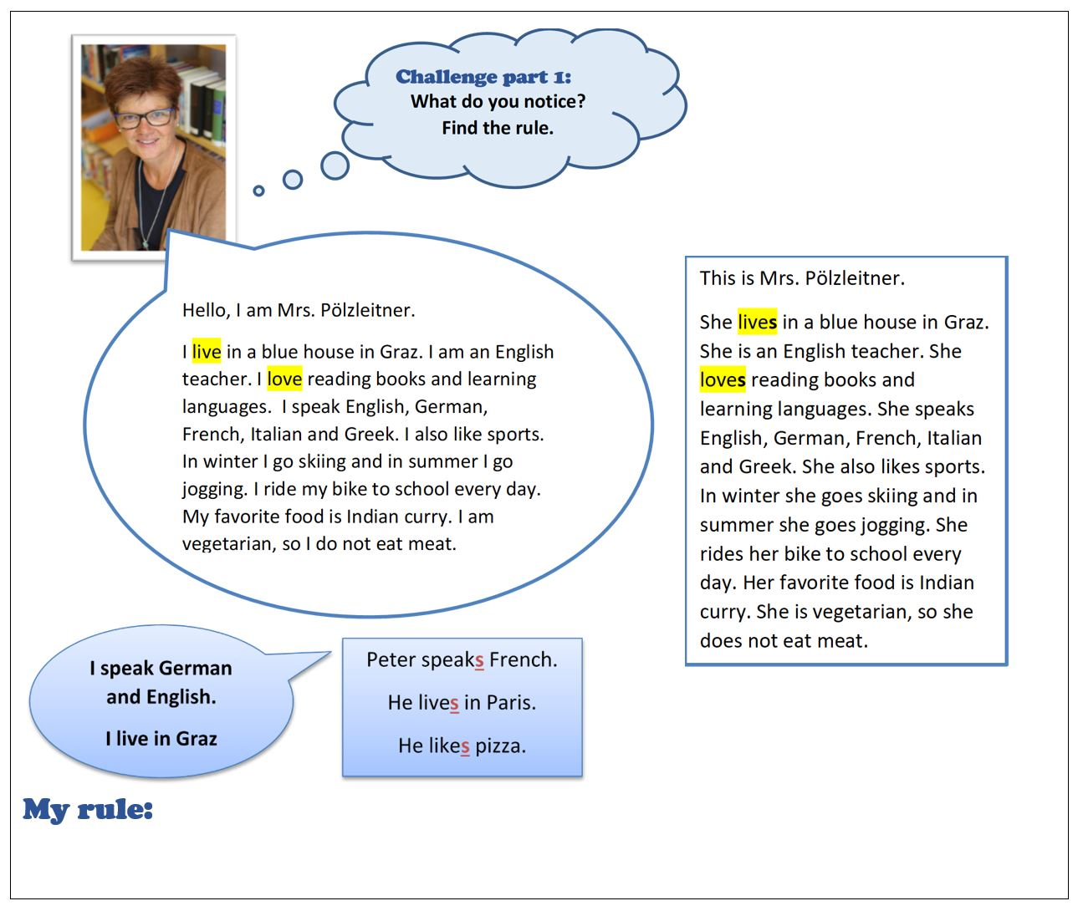

Example 2:

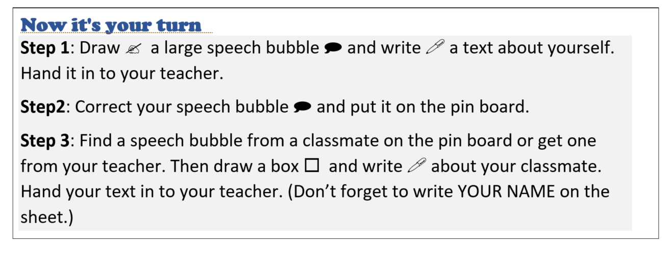

Example 3:

Present a classmate:

Work with a partner. Record a short video where you present your classmate. Tell us everything that you know about your new friend.

Example 4:
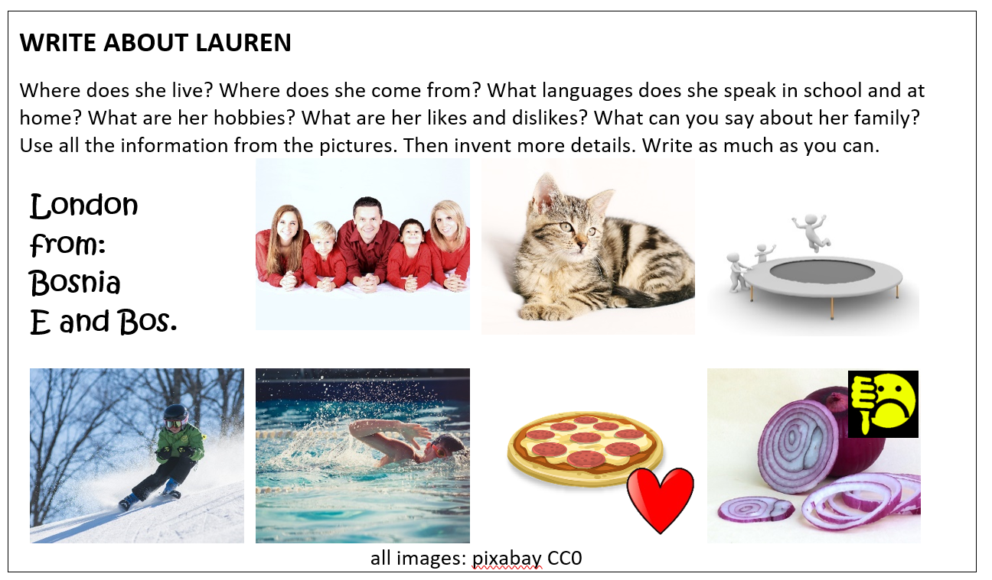

The aim of example 1 is to make the learners aware of the 3rd person s that is used to talk about another person. At this level and age, hardly any grammatical meta-knowledge can be expected from learners. Adding an s in the third person would not be a problem, if the learners had a concept of the ‘third person’. By exploring the speech bubble and the text in the box, learners realize that talking about themselves is different from talking about someone else and a different form is needed. This may seem very basic to adults, but children need to develop such basic concepts of meaning in order to form reliable meaning-form connections that will lead to automatic use of correct language.

Example 2 takes this exploration a step further. Learners produce two short text samples based on the given models, one about themselves and one about a classmate. This stage of conceptualisation is scaffolded by two factors: formatting (speech bubble versus box) helps the learners understand the idea of ‘self’ versus ‘other’. In addition, the exercise is strongly personalized and allows learners to talk about their real self and a classmate, representing the ‘other’. This links these abstract concepts to learners’ personal experiences and thus makes them more tangible.

In example 3, learners practice the new language. At the proceduralisation stage, the meaning-form connections become stronger and more automatic. Ideally, this activity consists of several short tasks where the learners speak or write about people or animals around them. They might be asked to present a classmate, a family member and/or a pet. Both speaking and writing activities should be included in this stage.

In example 4, learners use the new rule in order to write about a fictitious person. This is slightly more abstract than talking about someone they really know. The difference between the task(s) in stages 3 and 4 are minimal and the activities could be used interchangeably. At this stage, the learners are ready to use the new language in unrehearsed situations. This last example would therefore be suitable for an exam.

Advantages of a stage model

A stage model has important applications for teaching grammar. First, we can locate a specific exercise or activity within a particular learning stage; thus, when giving students a grammar activity, we can be clear about which learning stage or stages this activity supports. Second, we can analyse sequences of exercises in a school coursebook or grammar practice book that deal with an area of grammar to determine if there are exercises that lead the learner from initial awareness through internalisation and proceduralisation to the stage of performance. Many coursebooks and reference grammars provide few exercises which go beyond the conceptualisation stage. If this is the case, the teacher will need to look for or design additional grammar activities to cover other learning stages.

Designing an effective grammar exercise

In order to make optimum use of the learning stage model to analyse grammar activities teachers should apply two additional categories. In a previous section, we discussed the importance of identifying grammatical objectives; in addition, we also need to identify the learning aim of an activity – that is to say, what we expect the activity to achieve in terms of learning outcomes. For example, the central learning aim of a fill-in-the-gap exercise is to test the learner’s understanding of a rule; whereas learning aims of more open-ended proceduralisation stage activities will be to gain confidence in using grammar and to rehearse using an item of grammar to generate ideas. Having established the learning aim, we then need to find criteria to judge how well an activity supports this aim. These will be of a cognitive, affective and communicative nature. Cognitive criteria will be concerned with how well learners make use of their innate mental resources; affective criteria will be concerned with how willing learners will be to engage with activities; communicative criteria will be concerned with how closely grammar activities correspond to real-life language use. By applying these criteria, we can evaluate the quality and effectiveness of exercises. The following list focuses on some of the principal factors which optimise learning.

Factors which optimise learning:

- Repetition. Learners need multiple opportunities to engage with the new grammar. However, quantity alone is not a sufficient criterion: the quality of the contact is a crucial factor.
- Depth of processing. The extent to which grammar becomes internalised is partly dependent on how mentally active learners are and how intensively they make use of their cognitive resources. In a nutshell, more intense brain activity means more learning.
- Commitment filter. Learners are more likely to engage with the grammar being learnt if they have positive feelings towards the activities they are carrying out. Problem solving, enjoyment, success, having fun, being creative, humour etc. will all positively influence their degree of engagement, and higher engagement leads to stronger connections in the neural networks of the brain.
- Personalisation. Learners have the opportunity to draw on their personal experiences and express their own thoughts, wishes and ideas. These personal connections will have two main effects: Firstly, they will make the learning of a new grammatical item more meaningful and relevant and will thus raise the learners’ engagement level. Secondly, personalized activities allow the learners to make strong links between existing concepts and memories in their brains and the new grammar.
- Peer interaction. In pair- and groupwork oral activities learners share ideas and cooperate on performing tasks. This provides learning support in a relaxed environment and gives them feedback on their and their peers’ language. Oral activities have the extra advantage of using several senses (hearing, speaking, movement) and thus lead to activity in several parts of the brain.
- Contextualisation. Grammar is embedded in a clear context, or learners can easily imagine a context. Similar to personalisation, contextualisation plays an important role in linking the new language to existing networks in learners’ brains. By recalling and visualizing typical situations where the new language naturally occurs, learners make multidimensional meaning-form connections.
- Authenticity of process. Learners use grammar in natural, ‘language-like’ ways, rather than just manipulating forms. Inauthentic exercises (e.g.: put active into passive) do not lock into natural language acquisition processes.
- Task-based. When using grammar, learners also fulfil a purposeful task that will have an outcome or end product. Task-based activities tend to be more engaging and the results or products are often perceived as achievements by the learners.

Conclusion

In this chapter, we have discussed and illustrated how grammar materials and practices can, on the one hand, be embedded within principles of the communicative approach and, on the other, can support the learning of grammar by following insights into language learning provided by cognitive linguists and learning psychologists. Readers who would like more information on these approaches might like to consult the following: Achard, M. and Niemeier, S. (2004), DeKeyser, R.M. (ed.) (2007), Caine & Caine (2011), Herrmann, U. (ed.) (2006). This combination of insights from language description and learning theory provides clear guidelines for teachers in selecting and designing grammar materials. Taking a communicative approach to grammar requires teachers to take a critical view of traditional grammar practices and to be willing to explore and experiment with new ways of teaching. At the same time, teachers need to monitor their learners’ affective and cognitive development and to understand the learning processes that support this development. In this way, they can assess the efficiency of their grammar teaching.

Activities and questions for reflection

Analyse the following activities according to the above criteria. How efficient are they? Which of the learning stages do they support? Then compare your results with the key provided below.

Example 1  Complete the sentences. Use the going to future.  1. He ………………... a letter to his friend. (to write)  2. We ………….……..pizza tonight. (have)  3. Our neighbors ………………..away. (move)  4. Thomas …………………… football in the afternoon. (play) | Example 2  Complete the text.  I have lots of plans for the upcoming weekend. On Saturday I ……………… my grandparents in Vienna. We …………………. to the Prater. There we …………………. on all the cool rollercoasters and we ………………… in my favourite restaurant. I ………………….. a big Cheeseburger with fries. It ……………………… a great weekend.

Example 3 Survey: What are your plans for the upcoming weekend?

Ask your classmates what they are going to do on the weekend.
Who is going to do the most exciting things? Make a list, then present the three most interesting plans to the class.

Example 4 Solve the puzzle
1. Match the pictures and the sentences.  2. Now it’s your turn: Draw your own puzzle.  Choose an animal or a person and a thing that they own.  Draw 5 pictures and write 5 sentences. Write your sentences in the wrong order.  Ask your teacher to check. Then ask a friend to solve your puzzle. | 

Example 5: Experiences
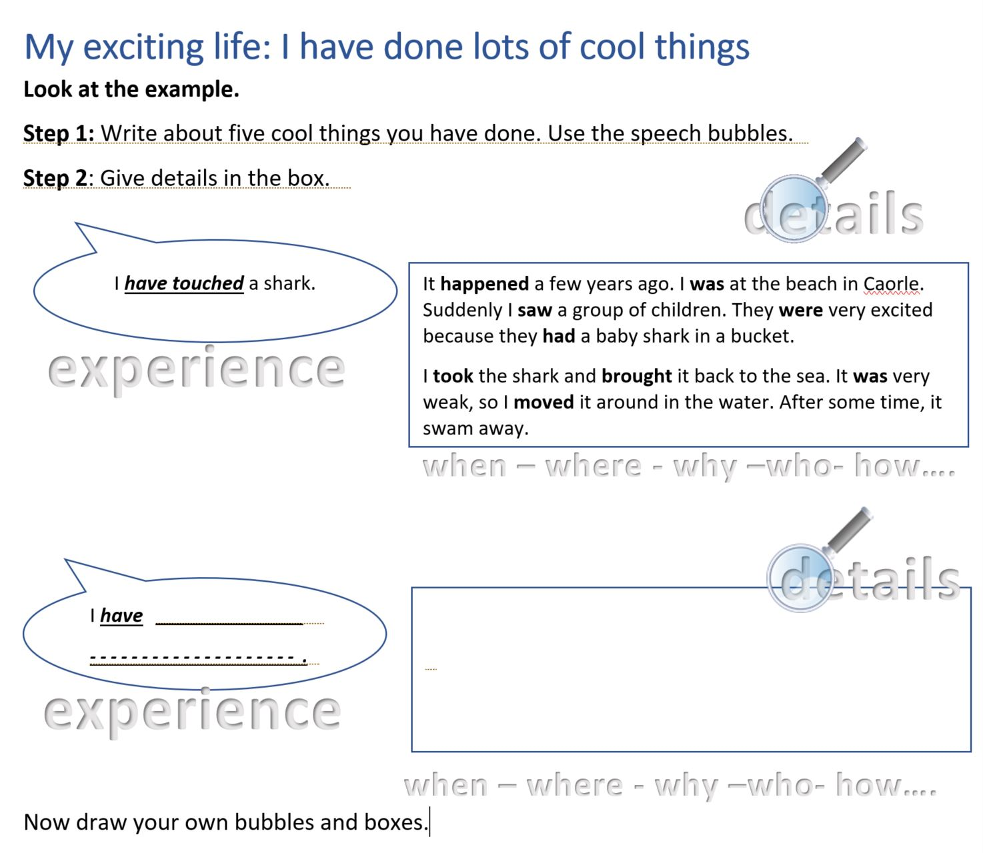

Comments on reflective questions

Examples 1 & 2
Learning stages: exercise 1, conceptualisation; exercise 2 proceduralisation
Pedagogical principles:
The two exercises look fairly similar at first sight. Both are gap filling activities. However, exercise 1 uses decontextualized sentences where the learners only have to put the given verbs in the correct form. Hardly any mental processing is needed to fulfil this task.
Example 2 offers a coherent text and the learners have to process the meaning and fill in a fitting verb and its correct form. For beginners whose active vocabulary is still very limited, the teacher might provide a box of verbs to choose from. This makes the exercise easier, but still demands some active processing of the meaning.
Neither of the exercises is personalized or highly engaging and they do not involve any peer-interaction. Filling in given words in a sentence is not an authentic process, filling gaps in a coherent text comes a little closer, since the task involves reconstructing a meaningful story.

Example 3
Learning stage: proceduralisation – or performance
Pedagogical principles:
The activity is authentic and engaging, learners interact with their peers and find out about each other’s real personal plans. They process language actively, moreover the oral activity involves several senses. When speaking the learners will not only show increased brain activity in the areas that are typically responsible for language, but also in the parts of the brain responsible for hearing and movement of the mouth and tongue. This increased brain activity leads to more learning, since wider neural networks are involved. See for example Macedonia (2011), Herrmann, U. (2006)

Example 4
Learning stage: conceptualisation
This task can be very demanding for the learners. In order to match the sentences and the pictures they need to understand that the different forms (spellings) refer to singular and plural meanings and thus tell them whether there is one owner and one object or several owners and objects. For most students this is a major new realisation that makes them aware of the different meanings that the letter “s” can have in the English language.
Pedagogical principles:
The matching task demands deep processing on the meaning level. Creating a puzzle of their own demands a high degree of processing. Solving and creating a puzzle are engaging activities and language is used in authentic ways, even if no wider context is given. In step two the learners interact with a peer who must solve their puzzle. This is usually followed by some peer discussion or explanations of the correct solutions.

Example 5
Learning stage: Proceduralisation
Pedagogical principles:
The learners write about their own experiences and have to distinguish between the two concepts of [general experience] and [specific events / details]. Peer and social learning are not yet included here but can be easily implemented in a follow-up activity. e.g.: Find the person who has done the coolest, most interesting things.

References
Achard, M. and Niemeier, S. (2004) Cognitive Linguistics, Second Language Acquisition, and Foreign Language Teaching. Berlin: Walter de Gruyter.

Caine, R.N. and G. Caine. "Understanding a Brain-Based Approach to Learning and Teaching." Educational Leadership 48.2 (1990): 66-70. 06 11 2011. <http://www.sedl.org/scimath/compass/v03n02/1.html>.

Council of Europe. (2001). Common European Framework of Reference for Languages.
Retrieved from https://www.coe.int/t/dg4/linguistic/Source/Framework_EN.pdf

DeKeyser, R.M. (ed.) (2007) Practice in a Second Language. Perspectives from Applied Linguistics and Cognitive Psychology. Cambridge: Cambridge University Press.

Macedonia, Manuela and Karsten Müller. "The impact of iconic gestures on foreign language word learning and its neural substrate."

Österreichisches Sprachen-Kompetenz-Zentrum. (2004). Europäisches Sprachenportfolio. Mittelstufe (10-15 Jahre). BMBWK, Wien

Newby, D. (1989). Grammar for Communication. Vienna: Österreichischer Bundesverlag

Newby, D. (2015). The role of theory in pedagogical grammar: A Cognitive + Communicative approach. Eurasian Journal of Applied Linguistics ,Vol 1, No 2 (2015). Online: http://www.ejal.eu/index.php/ejal/article/view/51

Herrmann, Ulrich. "Gehirnforschung und die neurodidaktische Revision schulisch organisierten Lehrens und Lernens." Herrmann, Ulrich. Neurodidaktik. Weinheim und Basel: Beltz, 2006.

Ur, P. (2009) Grammar Practice Activities (2nd. edition). Cambridge: Cambridge University Press.

Suggestions for further reading

Newby, D. (2017) ‘Designing communicative grammar activities’. In Fäcke, C. and Mehlmauer-Larcher, B. (Hrsg.) Fremdsprachliche Lehrmaterialien – Forschung, Analyse und Rezeption. Frankfurt-am-Main: Peter Lang.

This chapter provides a fuller account of the theories and principles discussed here.

Norrington-Davies, D. (2016). From Rules to Reasons: Practical ideas and advice for working with grammar in the English language classroom. Hove: Pavilion Publishing

This book provides useful resources and examples for teachers who want to explore communicative-cognitive grammar with their learners.

Herrmann, Ulrich. (ed.) Neurodidaktik. Weinheim und Basel: Beltz, 2006.

This book presents important findings of the neurosciences in easily readable chapters. It gives practical examples that will raise teachers’ awareness of important aspects of efficient teaching and learning.

Ur, P. (2009) Grammar Practice Activities (2nd. edition). Cambridge: Cambridge University Press.
This book provides a large collection of communicative grammar activities, as well as a helpful introduction to communicative grammar teaching.

