
Department of English Studies
Section ELT Research and Methodology
Karl Franzens Universität, GRAZ
PS 2
Communicative Grammar

Course handout and “An Introduction to Cognitive Communicative Grammar” by David Newby

Teach him to think for himself? Oh, my god, teach him rather to think like other people!
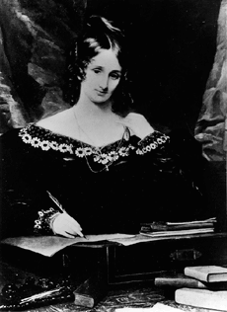

‘Would you tell me, please, which way I ought to go from here?’
‘That depends a good deal on where you want to get to,’ said the Cat
‘I don’t much care where -’ said Alice.
‘Then it doesn’t matter which way you go,’ said the Cat.
‘- so long as I get somewhere,’ Alice added as an explanation.
‘Oh, you’re sure to do that,’ said the Cat, ‘if you only walk long enough.’



David Newby, E. Pölzleitner
CONTENTS OF THE HANDOUT
Content of the course 2
Communicative Grammar- Course Requirements and Assessment 4
How efficient are these exercises? 7
An Introduction to Cognitive Communicative Grammar for teachers 14
1: What is Pedagogical Grammar? 14
2: What is Grammar? 18
3: Grammar - rules and objectives 20
4: Learning grammar 28
5: Grammar Pedagogy – a C+C approach 37
6: Evaluating grammar activities 42
7: A few examples: for more examples go to epep.at 45
Traditional and C+C approach to the passive – a comparison 46
BIBLIOGRAPHY - Pedagogical Grammar 53
Elisabeth Pölzleitner’s Grammar Quick Checker: 54

Content of the course

The course Communicative Grammar is both theoretical and practical in nature. As far as theory is concerned, we shall be considering how learners learn grammar most effectively and efficiently. As far as practice is concerned, we shall consider how teachers might facilitate learning through pedagogy – grammar materials and activities. In particular, we shall take a critical look at traditional grammar practices and consider Communicative alternatives.

Aims of course
- You will have a greater understanding of what ‘Communicative’ grammar means and how it differs from traditional grammar.
- You will increase your understanding of grammar rules – seen from a ‘Notional’ perspective.
- You will have a deeper understanding of how grammar is learnt and how pedagogy can support learning.
- You will be shown lots of examples of Communicative grammar activities which might be used in your own teaching.
- You will be able to analyze grammar activities – exercises, games etc. according to theoretical categories and assess their effectiveness.
- You will develop an ability to adapt existing grammar activities to make them more effective and to design activities of your own.

Theory
All language teaching, whether of grammar or other aspects, must based on some kind of theory. Achard (2004: 176) states that ‘no pedagogical decision can be made in the absence of a learning theory’. The theory of this course derives from what is called ‘Cognitive+Communicative Grammar’ (C+C Grammar). This theory was first formulated in:
Newby (2003) A Cognitive+Communicative theory of pedagogical grammar. (Graz University: Habilitationsschrift)
During the semester, you will be given three articles which explain the main aspects of the theory of C+C Grammar. These can be downloaded from the Anglistik Fachdidaktik Home Page or from your Moodle page. The articles are:

Newby, D. (2012) "Pedagogical Grammar". In: M. Byram, ed. Encyclopedia of Language Teaching and Learning (2nd edition). New York: Routledge.
This provides a short overview of issues relating to pedagogical grammar.
Newby, D. (1998) "Theory and Practice in Communicative Grammar". In: R. de Beaugrande, M. Grosman, and B. Seidlhofer, eds. Language Policy and Language Education in Emerging Nations. Series: Advances in Discourse Processes Vol. LXIII. Stamford: Ablex Publishing Corporation.151-164.
This explains, in particular, a Notional approach to grammar
Newby, D. (2008) “Pedagogical Grammar: A Cognitive+Communicative Approach”. In: W. Delanoy and L, Volkmann, eds. Future Perspectives for English Language Teaching. Heidelberg: Universitätsverlag Winter. 29-44
This outlines both Cognitive and Communicative aspects
C+C theory leads to a quite different pedagogy from that of traditional grammar. It is important that you understand the main theoretical categories if you are to pass the course.

Practice
All the theoretical aspects discussed in the course will be illustrated by means of practical examples: oral activities and written exercises which we shall try out together in class and which you will analyse. Many of the activities discussed will be taken from David Newby’s grammar books (see below). Other materials will be taken from school textbooks currently used in Austrian schools or from Elisabeth Pölzleitner’s website: http://epep.at
For your class assignments and Seminararbeit, you will need to consult school textbooks. Several copies of most books are available in the Institute library.

Materials used in this course
The theories discussed in class have been implemented in David Newby’s reference grammar book, which is approved for use in Austrian schools, and the accompanying book of activities:
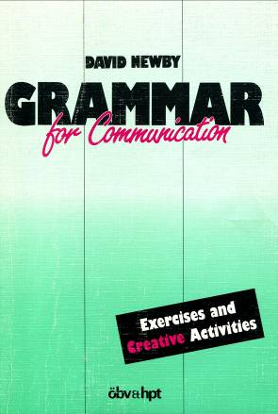
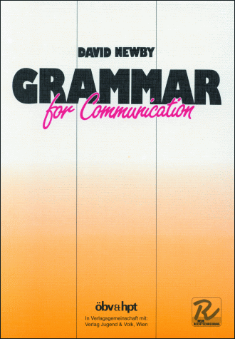

Newby, D. (1989) Grammar for Communication. Vienna: Österreichischer Bundesverlag

Newby, D. (1992) Grammar for Communication – Exercises and Creative Activities. Vienna: ÖBV

We shall use both of these books during the course. The way of describing grammar, the grammar rules and the communicative activities you will find in them strongly reflect the theoretical aspects of grammar to be discussed in the course. You are strongly advised to buy copies - at least of Grammar for Communication as we shall use it regularly. They will also be useful to you in your teaching career. The books are available from Buchhandlung Dradiwaberl in Zinzendorfgasse. Some copies are available in the University library.

Photocopiable card games and grammar activities
We shall try out and analyse in class several card games and grammar activities. Photocopiable sheets of these games can be found on Elisabeth Pölzleitner’s website epep.at or on the Moodle page of this course.

Moodle
We shall make extensive use of the MOODLE platform. You must consult it regularly for information and upload your assignments regularly and on time. All course communication will go through this Moodle platform.

Communicative Grammar- Course Requirements and Assessment

To profit most from this course make sure you
- Attend the lessons regularly
- Participate actively and ask lots of questions
- Do your weekly assignments in order to come to class prepared.

To pass the course you will:
- Carry out regular out of class assignments and reading tasks
- Hold an oral presentation related to one of the assignments (in groups).
- Write a term paper in which you will plan, analyze and evaluate grammar teaching materials
- Carry out an online Self-Assessment task from the European Portfolio for Student Teachers of Languages (EPOSTL). You will begin this in the next two weeks and continue till the end of the semester. (See separate handout: Self-Assessment of EPOSTL descriptors)

Assessment criteria

 |  | 1 | 2 | 3 | 4 | 5 | 6 | 7 | 8 | 9 | 10
Theory: You understand the theoretical concepts discussed in this course:  - notions, functions, pedagogical principles,  - cognitive learning stages | in your paper
 | in the regular assignments and presentation
Application: You can apply the theory to plan practical classroom activities. | in your paper
 | other assignments
Language: Your language is mostly correct and idiomatic. Your instructions for the learners are clear and appropriate for the learners’ level. | in your paper
 | other assignments
Formal requirements: Layout, organization, quoting , completeness, meeting deadline(s)

Your final course grade will consist of your paper (can be done in pairs), your regular assignments online, your presentation and your in-class participation. You will receive ONE grade on the paper – both partners are responsible for the quality of all the parts. If you feel that your pair-work is not working as planned – hand in your own paper.

Assignments
You will upload your assignments to Moodle and be prepared to talk about them in class. Weekly assignments MUST be uploaded on time – at least one hour before the following lesson.

Oral presentation:
Each week, one or two groups will be asked to present their assignments at the beginning of the next class. Group presentations must not last longer than 20 minutes.

Term-paper
Your term paper must be handed on time. Please check the deadlines on Moodle and on the course schedule. Otherwise a mark of nicht genügend will be recorded. Upload your paper to Moodle – you need not hand in a printed version.
Aim: The aim of your paper is to show that you have understood the theoretical concepts of communicative grammar teaching AND can apply them to your teaching.
To do this your term paper will consist of a short introduction, a practical and a theoretical part. You may work with a partner as long as you share the workload evenly and cooperate actively in all stages of the project (see details at the bottom).

Preparation
Choose a grammar topic and a group of learners (state age and level!).
Consult the course handout and revise the theoretical concepts. Read the articles which have been uploaded during the course or other books about methodology of grammar teaching. Revise the grammar topic in the Newby Grammar to make sure you fully understand the notional concepts and communicative use.

Introduction: Why teach C+C grammar? What does it mean?
You have exactly four pages to introduce the basic ideas and concepts of C+C grammar. Imagine the following situation: Your school’s principal wants to improve the efficiency of grammar-teaching and has asked you to subtly convince your colleagues to follow the C+C approach. Write a 4 page text introducing the most important theories and concepts of C+C grammar and explain why this approach is more efficient than traditional grammar rules. Plan your text carefully in the style of a persuasive essay or a creative format (a letter to a colleague, a dialog…)
You may wish to refer to the course handout, to the articles on Moodle or to other books you have read. This section may also contain tables, graphs or other tools that help you get your message across as efficiently as possible.

Practical Part: Teaching materials for three lessons
In the practical part plan in detail how you would introduce and practice your chosen topic in class. Plan three lessons + homework and one testing activity that could be used later in the Schularbeit. All your materials must meet the criteria of efficient communicative tasks that we have discussed in this course.
You may use tasks and activities from published textbooks, grammar reference books or online materials. If necessary, adapt and improve them or design your own activities. Do not forget to quote your sources carefully. Organize your materials clearly and write clear instructions for the learners using language that is appropriate for the learners’ age and level. Layout your materials nicely so they could be used in class.
Tip: If you design your own activities always try them out with a partner. Check if you would actually use the language you were expecting or if you’d have to force yourself to use it in unnatural ways.

Theoretical Part: Analysis
In the theoretical part of your paper demonstrate your ability to analyse the activities you have chosen and show how the principles and theoretical categories discussed in the course are relevant to your teaching. Use the “grammar quick checkers” and the list of categories in 7.1 (Evaluating grammar activities) to help you in your analysis. Decide which categories are most meaningful for your particular topic. Always start with grammatical objective and learning aim. When you use categories to analyze activities (e.g. cognitive learning stages etc.) you must explain why you think a particular exercise can be assigned to a certain category. For example, if you think an exercise corresponds to the ‘proceduralisation’ stage, explain why you conclude this.
Your paper must be handed on time. Deadlines are important for teachers. Check the deadlines on Moodle and on the course schedule.

A note on pair-work
Pair-work can be very efficient and can help both partners to learn from each other and critically test their own knowledge and understanding. If you decide to do this project with a partner make sure you
- brainstorm and plan your project together
- discuss in detail why you think the exercises and activities of your choice are efficient and fulfil all the criteria of C+C grammar teaching
- share both the practical and theoretical work evenly between you
- try and test each other’s activities and ideas to see if they really work
- critically proofread each other’s contributions and cooperate in improving and polishing them
- Pair-work is NOT: one person doing the work while the other partner is having coffee

Length
Your paper should be not more than 15 pages in length (excluding contents, bibliography etc.). It must comply with the usual requirements for writing an academic paper (format, bibliography etc.). Avoid wordy and repetitive bla-bla and show that you can express your thoughts clearly and efficiently.

Deadline:
in the last session of the course: i.e.: …………………………………………………………

How efficient are these exercises?
Work with a partner.
Have a look at these exercises and do them yourself.
What do they practice?
What’s going on in your brain while you do them?
Watch yourself and take a few notes after each exercise.
What do you like /not like about them?

Adverbs of frequency
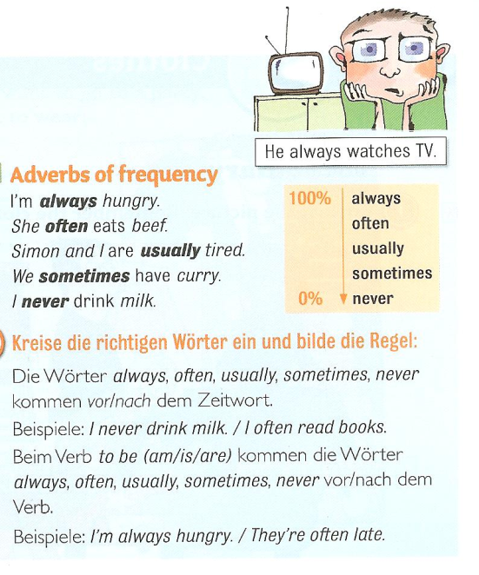
Our friend helps us. (always)
I go shopping in Paris. (never)
She is late. (usually)
I get headaches. (often)
He forgets my birthday. (always)
You are right. (usually)
They stay in bed late. (sometimes
I don’t go to the doctor. (often)

Source: 1

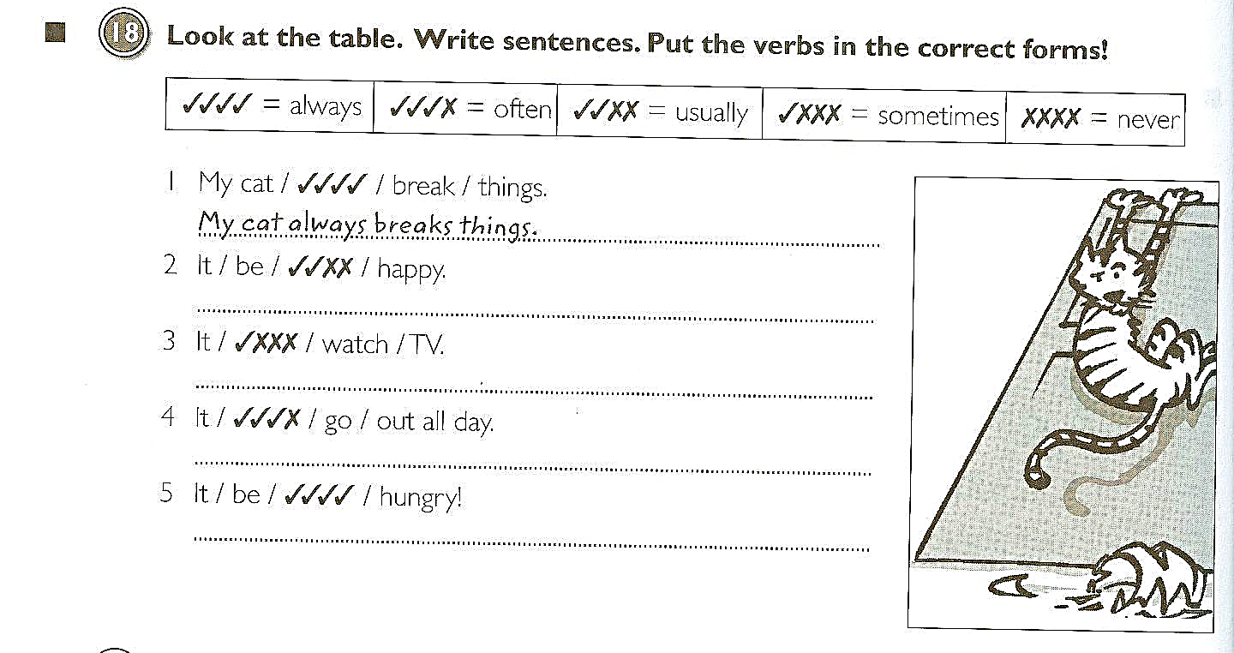
Source: 2

Adverbs of frequency:
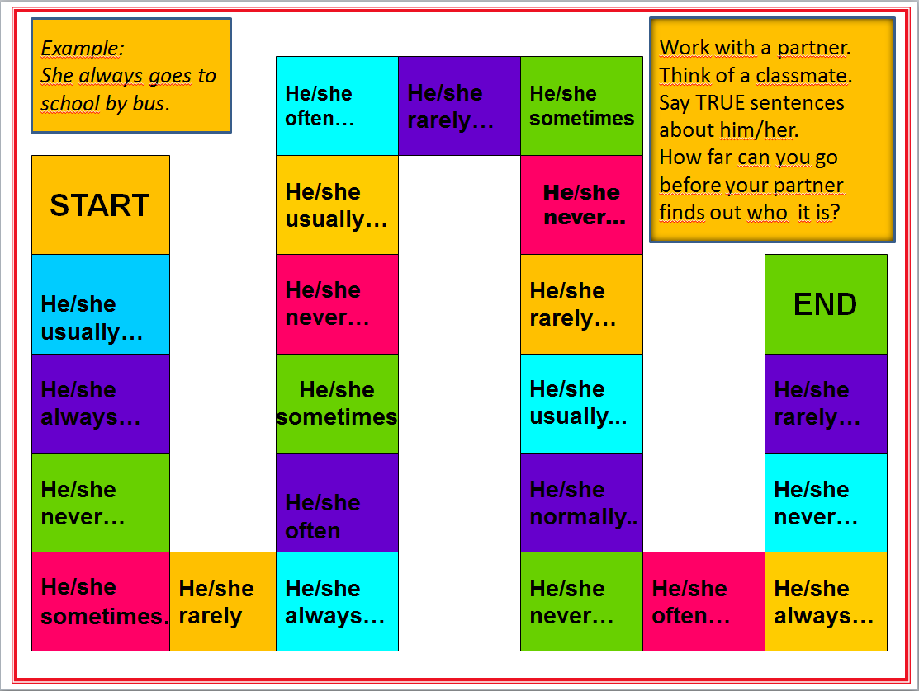
Boardgame

Asking Questions in English
Compare the following exercises

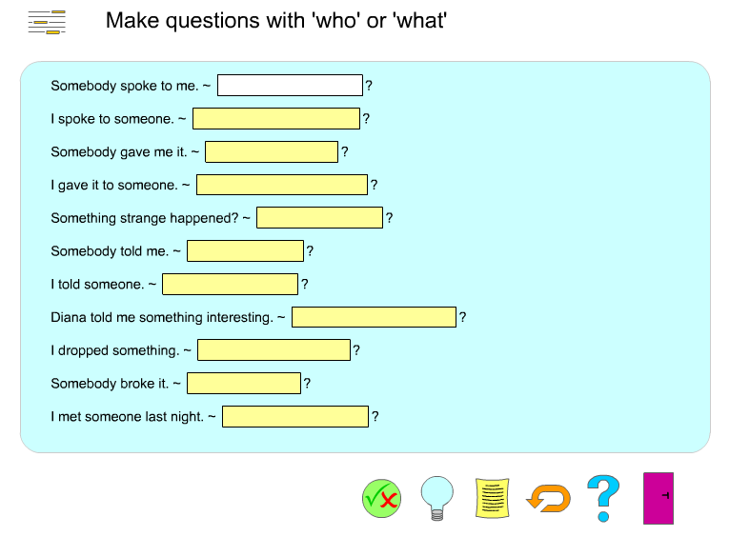

http://www.englishgrammarsecrets.com/questions1/menu.php

What do you think they asked?
? | John’s in the garden and Sylvia is in town.
? | Put on your blue trousers.
? | Because I wasn’t feeling well.
? | Mum gave it to me for my birthday.
? | I did. I’m sorry. I’ll buy you a new one.
? | Yesterday. The postman brought it just before I went to work.
? | I think it’s M-I-S-S-I-S-S-I-P-P-I but you’d better look it up.
Source 3

Form questions
Ask for the underlined part. Write the complete English question into the gap.
Example:
The class plays football.
_______________________
Answer:
The class plays football.
What does the class play?
1) John is writing a letter.
?
2) She walks home from school.
?
3) The children are sitting in the garden.
?
4) Peter runs with his dog on Sundays.
?
5) My rabbit has a cage in the garden.
?
6) They go to work by bus.
?
7) David likes cats because they are nice.
?
9) We are going to the cinema.
?
10) I'm leaving now.
?

http://www.englisch-hilfen.de/en/exercises/questions/form.htm

Finding out about my friends

- What’s the question? Read Mrs. Pö’s answers in column 2 and write the fitting question (passende Frage) into column 1.
- What about you? Write your answers into column 2.
- ENGLISH ONLY: Now interview 3 classmates. Remember: We speak ENGLISH only!
- Homework: Write about yourself. Use the back of your collage and present yourself (stell dich vor).
How are you today?
Where do you live?
What languages do you speak? What’s your name?

Do you have any brothers and sisters?
Do you have any pets?
What are your favorite hobbies?
When is your birthday?

1 | 2 | 3
What’s the question? | Mrs. Pö’s answer | Possible answers:
What’s the question? | Add your own answers. | Possible answers:
 | My name is Elisabeth Pölzleitner.
 | Your answer:
 | My birthday is on the 30th of January. | My birthday is on the 1st (first) 2nd (second), 3rd (third), 4th (fourth),  5th (fifth)…of January, February,  March, April, May, June, July, August, September, October, November, December
 | Your answer:
 | I like reading, jogging and skiing. | I like playing tennis, playing the piano, watching TV, playing computer games, painting, dancing…
 | Yes, I have one sister. | I do not have any brothers and sisters. I am an only child.
 | Yes, I have a cat and four ducks. | I have a dog, a hamster, some fish, a guinea pig, a horse, a budgie, three white mice (one mouse), a rat, a turtle, …
 | I’m fine, thanks. And how are you? | I’m tired. I’m not feeling well today. I’m o.k.
 | I live in Graz, St. Peter.
 | I speak German, English, French, Italian and Greek.

Asking questions:
Use the words from the boxes to write five questions. Use each word once.
When  What  Why  How  Where | does  are  is  does  do | the children  Sue and Katy  Thomas  Anna  Mrs. Pölzleitner’s | have for dinner  birthday  not at school today  live  go to school | 

Now find out more about your teacher(s). Write questions and guess the answers. Then ask your teacher and find out if your guesses were correct.
What… | Tick off your correct answers:
Your answer:
When
Your answer:
Where
Your answer:
Why
Your answer:
How
Your answer:
How many
Your answer:
Who
Your answer:

No, No, No…

  - I do not like/ X does not like…
  - I don’t like / X doesn’t like…
What are the things you do not like at all? Write down five sentences.
Then ask three classmates what they do not like at all and write sentences.
- Example: I do not like….
2
3
4
5
1 My friend...
2
3
4
5
1 My friend …
3
4
5
What do you have in common? Are there any things none of you likes?
Example: Peter and I do not like…

Dogs, dogs, dogs.


- Whose dogs are these? Match the pictures with the words.
Peter’s dog.
Tom’s dogs.


The boys’ dog.
The boys’ dogs.
The dog’s tricks.
No dogs allowed here.




- Now label these pictures. Where do you need an apostrophe?



Example: Our neighbors’ dogs









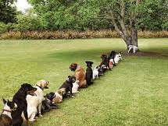

Homework:
Make your own matching exercise (like exercise 1). Choose a different topic – find or draw 6 pictures and write 6 sentences. Bring your page to class and ask one of your classmates to match the pictures and the phrases.
Sources:
- Gerngross et al. (2007) More 1, Student’s Book. Helbling. 53
- Gerngross et al.(2007) More 1, Workbook. Helbling. 64
- Newby, D. (1992) Grammar for Communication. Vienna: Österreichischer Bundesverlag. 187
All others: Elisabeth Pölzleitner

An Introduction to Cognitive Communicative Grammar for teachers
© David Newby, 2013

1: What is Pedagogical Grammar?

1.1 Why do pupils learn grammar?

‘The overall aim of learning grammar is to be able to express your own ideas in real situations in language that is as correct, meaningful and appropriate as possible. It is the teacher’s task to facilitate this grammatical skill with maximum efficiency.'

1.2 Tasks of pedagogical grammar

The focus of this course will be pedagogical grammar (PG), which can be defined as follows:
Pedagogical grammar refers to measures taken by teachers, learners, materials designers, grammarians etc. to facilitate the development of grammatical competence and the skill of using grammar.
The main tasks of pedagogical grammar are the following:

- Formulating grammar rules to describe grammar based on a suitable theoretical model in ways that are transparent for learners;
pedagogical reference grammar, school textbook, lessons etc.
- Selecting & grading areas of grammar to be presented to the learners and establishing criteria for the sequencing of grammar
curriculum, school textbook etc.
- Learning aims and processes: consider aims of individual exercises or of sequences of teaching in terms of learning processes; how can learning processes be activated and supported?
- Formulating grammatical objectives: grammatical functions, notions, patterns forms…
- Selecting efficient methodology to facilitate learning: presentation forms, exercises, activities etc.
school textbook, teaching materials etc.
- Testing grammar: selecting areas of grammar and exercise types which fulfil criteria of testing theory (validity, reliability etc.)
Schularbeiten, Matura etc.

1.3 Competences of PS 2 – EPOSTL
It follows from the above definition of PG that a variety of competences listed in the European Portfolio for Student Teachers of Languages (EPOSTL) will be developed in this course. The most important are the following:
E P O S T L |  |  | SELF ASSESSMENT
Category | Descriptors
Learning aims & needs | Context: Aims and Needs (p16)  2. I can take account of overall, long-term aims based on needs and expectations.  4. I can take into account the cognitive needs of learners (problem solving, drive for communication, acquiring knowledge etc.).  5. I can take into account the affective needs of learners (sense of achievement, enjoyment etc.).
Grammatical objectives | Lesson Planning: Identification of Learning Objectives (p34)  5. I can decide whether to formulate objectives in terms of skills, topics, situations, linguistic systems (functions, notions, forms etc.).
Grammar rules | Methodology: Grammar (p27)  3. I can deal with questions learners may ask about grammar and, if necessary, refer to appropriate grammar reference books.  4. I can use grammatical metalanguage if and when appropriate to the learners’ needs.
Learning processes &  Methodology | Methodology: Grammar (p27)  1. I can introduce a grammatical item and help learners to practise it through meaningful contexts and appropriate texts.  Methodology: Grammar (p27)  2. I can introduce, and help students to deal with, new or unknown items of grammar in a variety of ways (teacher presentation, awareness-raising, discovery etc.).  Methodology: Grammar (p27)  5. I can evaluate and select grammatical exercises and activities, which support learning and encourage oral and written communication.  Lesson Planning: Lesson Content (p35)  5. I can plan activities which link grammar and vocabulary with communication.  Independent Learning: Virtual learning Environments (p49)  2. I can use various ICT resources (email, Web sites, computer programmes etc.)  Methodology: Speaking/Spoken Interaction (p22)  12. I can evaluate and select a range of oral activities to develop accuracy (grammar, word choice etc.).  Methodology: Writing/Written Interaction (p24)  12. I can evaluate and select writing activities to consolidate learning (grammar, vocabulary, spelling etc.).
Testing grammar | Assessment: Designing Assessment Tools (p52)  1. I can evaluate and select valid assessment procedures (tests, portfolios, self-assessment etc.) appropriate to learning aims and objectives.  Assessment: Self- and Peer Assessment (p54)  1. I can help learners to set personal targets and assess their own performance.  Assessment: Error analysis (p57)  3. I can deal with errors that occur in class in a way which supports learning processes and communication.  4. I can deal with errors that occur in spoken and written language in ways which support learning processes and do not undermine confidence and communication.

1.4 The Austrian school curriculum

AHS-Lehrplan, Unterstufe. Didaktische Grundsätze:

- Als übergeordnetes Lernziel in allen Fertigkeitsbereichen ist stets die Fähigkeit zur erfolgreichen Kommunikation – die nicht mit fehlerfreier Kommunikation zu verwechseln ist – anzustreben. Somit sind die jeweiligen kommunikativen Anliegen beim Üben von Teilfertigkeiten in den Vordergrund zu stellen.
- Der Vermittlung von Wortschatz und Grammatik in vielfältig kontextualisierter und vernetzter Form ist größtes Gewicht beizumessen, zB ist Vokabular, wo immer möglich, in Kollokationen, Redewendungen und Phrasen mit impliziter Grammatik einzubetten.
- Der funktionale Aspekt der Grammatik hat Vorrang gegenüber dem formalen Aspekt.
- Generell sind die situative Einführung und ein induktives Erschließen grammatischer Sachverhalte aus kommunikativen Zusammenhängen und Textbeispielen anzustreben.
- Grammatische Teilsysteme dürfen sich keineswegs verselbstständigen und wegen ihrer leichteren Überprüfbarkeit indirekt zum eigentlichen Lernziel des Fremdsprachenunterrichts werden.
- Wo es sinnvoll ist, sind grammatische Strukturen besser ohne Regelformulierung als lexikalische Einheiten zu vermitteln.

In the section on ‘Context: Curriculum’ one EPOSTL descriptor states:
TASK 1
I can understand the requirements set in national and local curricula. (EPOSTL p. 15)
Read the statements from the Lehrplan and consider:
a) Do they reflect the ways in which you were taught grammar at school?
b) How might these statements influence your teaching?

1.5. Approaches to Pedagogical Grammar

As Chalker points out, there tends to be a tacit assumption among many students, teachers and pedagogical grammarians that there exists what she calls a single, ‘God’s truth’ view of grammar: ‘traditional’ ways of categorizing and describing grammar based on formal, rather than semantic, categories (1994: 42). However there are different ways of approaching grammar, based on the theories that may underlie them. We shall be discussing four approaches to grammar:
- Traditional grammar
- Communicative grammar
- Acquisition-based grammar
- Cognitive grammar
These are summarized in the table on the next page.

Reading assignment
Download and read the following article on Moodle:
Newby, D. (2012). Pedagogical Grammar.

Figure 1: Summary of approaches to grammar (based on Newby, 2002)

Label | Some key concepts | View of language | View of learner | View of teacher
Traditional grammar | grammatical structures; deductive learning of rules; accuracy controlled practice; ‘PPP’ | system of forms which  express meanings | student as a knower of  language | teacher informs and  controls
Communicative grammar | communicative competence; context; fluency; notions & functions; skills; interaction; inductive learning | language as a means of social interaction; communicative events; system of meaning options | student as a user of  language | teacher manages contexts for communication
Acquisition-based grammar | naturalistic acquisition; comprehensible input; intake | language as a set of innate mental processes;  universal grammar | student as an acquirer of language (as in L1) | teacher provides  comprehensible input
Cognitive  grammar | learner-centred, cognitive processes, styles and strategies; learning stages awareness-raising; constructivism | language as concept formation within more general knowledge structures, information processing | student as a responsible learner of language | teacher facilitates awareness and supports learning

1.6 Three areas of theory

Figure 2: Areas of theory necessary in pedagogical grammar

Linguistics:
How language works

Learning/
2nd language acquisition
Methodology:
What can teachers do to support learning?

2: What is Grammar?

2.1 Definitions of grammar
Grammar can be defined in various ways, as these examples show:
Definition 1. Lock, Functional English Grammar (1996: 4)
‘Grammar includes two aspects: (1) the arrangement of words and (2) the internal structure of words.’
Definition 2. Batstone, Grammar (1994: 4)
‘At its heart, then, grammar consists of two fundamental ingredients - syntax and morphology - and together they help us to identify grammatical forms which serve to enhance and sharpen the expression of meaning.’
Definition 3. Ur, Grammar Practice Activities, (1988: 4)
‘Grammar may be roughly defined as the way a language manipulates and combines words (or bits of words) in order to form longer sentences.’
Definition 4: Ur, A Course in Language Teaching, (1996: 87)
‘One possible definition might be: Grammar is a set of rules that define how words (or parts of words) are combined or changed to form acceptable units of meaning within language.’
Definition 5. Leech, Deuchar, Hoogenraad, English grammar for today. (1982: 3)
‘We shall use grammar in reference to the mechanisms according to which language works when it is used to communicate with other people. We cannot see this mechanism concretely because it is represented rather abstractly in the human mind. One way of describing this mechanism is a set of rules which allows us to put words together in certain ways, but which do not allow others.’
Definition 6. Batstone, Grammar (1994:5)
‘When we talk of grammar as process, we are thinking of the myriad of ways in which it is deployed from moment to moment in communication. Some understanding of grammar as process will be invaluable if we are to help learners to employ grammar effectively in their own grammar use.’
TASK 2
What do you consider good or bad about these definitions? Try to write your own definition.

2.2 Cognitive+Communicative Grammar (C+C Grammar)

In this course we shall be considering grammar from a ‘Cognitive+Communicative’ (C+C) perspective (Newby 2002). The C+C axis refers to two separate but complementary aspects of theoretical analysis: language description and language learning.

Language description – theory of what grammar is
A C+C approach to language seeks to analyse and describe grammar, on the one hand in terms of the mental processes that underlie the use of language (Cognitive), and on the other, as an act of communication, as a dynamic process in which a speaker’s perceptions of the world are encoded into messages (Communicative). By adopting a communicative view, we can approach language from a discourse-linked, context-based direction; by adopting a cognitive view, we can approach it from a psychological, mind-based direction. It follows from this that any definition of grammar must reflect what the Common European Framework of Reference (2001: 9) calls an action-oriented conception of language.

Language Learning – theory of how grammar is learnt
A C+C approach to learning will analyse how new grammatical concepts are processed and stored in long-term memory (Cognitive) and the role played in learning by language use (Communicative).

2.3 Grammar as a Communicative Event
A C+C view requires us to see grammar as a process rather than a product. This process can be modelled as follows:
Figure 3: Communication Model – Communicative Event
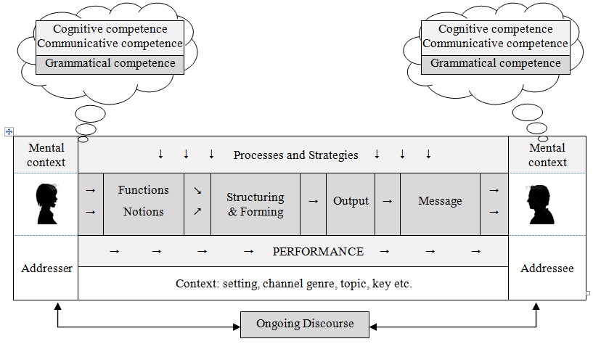

One advantage of representing language in this way is that it stresses that language must be seen both in terms of knowledge and of use; the communication model depicts not only competence but also performance.

Both the Communicative Approach to language teaching and Cognitive Linguistics are very much concerned with seeing language as a means of expressing meaning into form. This applies to all kinds of meaning including grammar. Richards and Rodgers list four principles of a Communicative view (2001: 161):
- Language is a system for the expression of meaning.
- The primary function of language is for interaction and communication.
- The structure of language reflects its functional and communicative uses.
- The primary units of language are not merely its grammatical and structural features, but categories of functional and communicative meaning as exemplified in discourse.
It follows from this that grammar can be seen as a way of encoding meanings into form. Grammatical meaning will be at the core of our discussions of pedagogical grammar.

2.4 C+C Definition of Grammar
Based on a C+C view, grammar can be defined as follows:
Grammar is:
- the knowledge of a system of concepts (i.e. notions) stored in the mind of speakers of a given speech community through which they express how they perceive lexical items
semantic competence
- the knowledge of the shared system for forming the words and morphemes which realize these concepts and for patterning them in ways which show their relation to each other
formal competence
- the process by which speakers apply this knowledge in actual situations to encode their perceptions into grammatical form
performance

3: Grammar - rules and objectives

3.1 Grammar rules
A grammar rule can be defined in psycholinguistic terms as a generalization or regularity stored in the minds of speakers. A rule in a pedagogical reference grammar or school textbook can be defined as metalanguage used to describe such regularities.
Pedagogical grammar rules must be:
- valid or true – cannot be de-verified by examples
- transparent – understandable by learners
- systematic – for example, in the use of terminology
- economic – not contain unnecessary information
Remember that grammar rules found in grammar books or textbooks do not come from God but are formulated by human beings. We shall find when we analyze rules that grammarians very often make statements that can be de-verified and prove unreliable.
Grammar rules that are found in most pedagogical grammars and school textbooks fall into the following categories:
- Rules of meaning – explaining what grammar means (tenses, articles etc.)
- Rules of patterning – for example, how to form a question
- Rules of forming – for example, regular and irregular past tense, comparatives (_er, more)
- Rules of relations/agreement between concepts– such as the third person ‘s’

It should be added that these categories are not mutually exclusive: knowledge of rules of meaning always requires knowledge of rules of form when an utterance is encoded. As far as English is concerned – though not all languages – major problems for learners seem to lie within the first category, ‘rules of meaning’. It will be this area that will be given most attention in this course.

3.2 Ways of setting grammatical objectives
It follows from these four categories that objectives can be specified in various ways as shown in figure 4.
Figure 4: Categories of grammatical objectives

Category of objective | Specific objective | Examples
grammatical function | describing/modification | pretty, with a nice face
general world concepts | expressing location | next to, opposite, over there
grammatical notions  (meanings) | arranged activity | I'm playing tennis tonight.
grammatical notions  (meanings) | expressing intention | I’m going to use my new racket.
grammatical notions  (meanings) | making a prediction | I’ll probably be back by six.
process | passive | We were beaten 3-0.
process | indirect speech | He said he was ill.
communicative function | likes - dislikes | I like swimming
pattern (syntax) | question form | What did he say?
form (morphology) | irregular past tense | was, had, went, saw, gave
form (morphology) | plural forms | boys, men, ladies, kisses

3.3 Notional Grammar

It emerges from the meaning form orientation of the Communication Model (figure 3) that grammatical notions take a central place in grammatical description. As they represent the core of the system of communication, we need rules and terminology (metalanguage) to describe grammatical notions systematically. This is the task that Notional Grammar (Newby 1981, 1989a, 1991etc.) sets itself.

Notional grammar can be defined as a theoretical framework for analysing and explaining in a systematic and coherent fashion the Conceptualization system underlying grammatical meaning and the process of grammaticalisation that speakers employ when encoding utterances. Its dual aims are to provide a specification of grammatical meaning which fulfils the theoretical criteria of linguistic analysis and to package its findings in pedagogically accessible form.
A (grammatical) notion (NG) can be defined as a single grammatical concept which is encoded into a form. Together with lexical notions speakers’ perceptions of the world around them can be encoded into form.

In traditional grammar it is forms of grammar which are usually listed in the contents pages of reference grammars and school textbooks – the ‘going to’future, the present progressive, indefinite articles etc. It is in formal terms that teaching objectives are often expressed. In a Notional approach, teaching objectives will be defined in terms of notions. To do this we need a fixed and systematic set of terminology to differentiate between different notions. Examples of Notions can be found in figures 5 and 6. Just as grammatical forms are given labels – present perfect, indefinite article etc. – it is equally important to give Notions labels. You will notice in the figures below that the terms in square brackets indicate a Notional label.

Figure 5: Future Notions - examples.
Notion |  | Form
[arranged activity] | - | I'm playing tennis tonight.
[expressing intention] | - | I’m going to use my new racket.
[interpreting signs] | - | It’s going to be a tough match.
[making a prediction] | - | I’ll probably be back by six.
[spontaneous decisions] | - | I think I’ll change my racket.

Figure 6: Present perfect notions
Notion |  | Form
[Experience] | - | I’ve never been to England.
[Changes/completion] | - | You’ve had a haircut!
[Duration - state] | - | I’ve been here since yesterday.
[Duration – activity] | - | They’ve been playing tennis for an hour.
[Recentness – state] | - | I’ve been on holiday.
[Recentness – event] | - | I’ve just seen a car accident.
[Recentness – activity] | - | I’ve been watching television.

One big advantage of a Communicative/Notional approach is that it makes it possible for learners to express their grammatical competence in terms of the kind of ‘I can’ descriptors to be found in the Common European Framework of Reference:
- I can express an intention using ‘going to’.
- I can make predictions about the future using ‘will’ etc.
- I can talk about my experiences using the present perfect.
The view that notions should be given prominence in pedagogical grammar derives from the following four hypotheses (Newby, 2003: 275):
- Notions represent the primary semantico-grammatical unit of encoding and decoding. Human beings express and comprehend notions.
- Notions are psycholinguistically real. They represent concepts stored in the ‘mental grammaticon’ and utilised in the process of grammaticalisation.
- A notion is an autonomous semantic concept. Different notions, even if encoded into the same form, express psychologically separate and distinct grammatical concepts.
- There is a systematic relationship between notion and form. A notion is always encoded into the same form.
The implications of these hypotheses are considerable. On the one hand, 1 and 2 will lead us to give paramount focus to notions both in grammatical description and in pedagogy. This will apply to both the setting of objectives and the formulation of rules. It follows from 2 and 3 that notions are both identifiable and describable. Explaining grammatical notions will therefore represent the central task of a pedagogical grammarian. With hypothesis 4, I am stating my belief in the absolute systematicity underlying the meaning-form relationship. The implication of this is that grammarians should arrive at exceptionless rules which explain the systematic relationship between notion and form. Whilst these hypotheses might at first sight seem somewhat abstract, they are an essential starting point for a coherent pedagogical model. They have been used as guiding principles in my own pedagogical reference grammars (Newby, 1989 etc.). Three pedagogical implications of NG are:
- Teaching objectives should be defined as grammatical Notions not as forms.
- Rules must explain single Notions of a form (there is no single rule to explain, e.g. the present simple).
- Notional objectives will also provide a springboard to communicative methodology.
NG is part of what can be referred to as ‘Speaker grammar’, which differs from ‘Sentence Grammar’. The difference between these approaches can be found in figure 8.

Figure 7: Sentence-grammar vs. speaker-grammar
 | Sentence-grammar |  | Speaker-grammar
RATIONALE | grammar as a product | ~ | grammar as a process
AIMS OF  ANALYSIS | what grammar is | ~ | how grammar works
AIMS OF  ANALYSIS | how to form sentences | ~ | how to encode utterances
OBJECT OF ANALYSIS | relations between language and language | ~ | relations between speakers and language
OBJECT OF ANALYSIS | external product | ~ | internal mental processes
 | context unimportant | ~ | context important
MODE OF ANALYSIS | observing/analysing sentences | ~ | modelling communication
MODE OF ANALYSIS | ‘post-mortem’ analysis | ~ | ‘dynamic use’ analysis
MODE OF ANALYSIS | linguistic | ~ | psycho-, sociolinguistic
MEANING | observation fallacy | ~ | psycholinguistic validity
 | what grammar can mean | ~ | what grammar does mean

In addition to the communicative perspective emerging from the Communicative Event view of language (figure 3) a process view of grammar will lead us to examine certain categories of what might be described as the speakers’ cognitive competence; that is to say, schematic structures that help language users to encode and decode language. Language use always takes place not only in a physical, external context but also in a mental context of language users. One category of cognitive competence relevant to pedagogical grammar will be considered – that of grammatical frames.

Grammatical frames

Figure 8: Present perfect misunderstanding – grammatical and cognitive categories


FRAME 2
[Coming Back]

MY PERSPECTIVES
[Me as student]
[Me as returner]]
FRAME 1
[Oral Examination]

MY PERSPECTIVE
[Me as university lecturer]
Have you
been
to England?
No, I’ve
been to Spain.
Notion:
[Past Experience]
Notion:
[Recent Event]

A grammatical frame can be described as is a frequently occurring scenario in which specific notions tend to be encoded. The misunderstanding quoted above (figure 5) arises not from our different knowledge of language but from our conflicting frames. Within the student’s mental context is what can be termed the [Coming back] frame. As a result, there are experiences in her mind that she expects might be talked about. Within this frame it often occurs that speakers refer to ‘recentness’, and thus encode the Notion of [Recent event] – I’ve been to Spain - or as a [Recent activity] – I’ve been feeding the ducks.

Notional grammar will enable us not only to identify meaning-based objectives and specify meaning-based rules; it will also show how grammatical meaning is embedded in other types of semantic and pragmatic meaning. This can, in turn, be utilised in a pedagogical reference grammar. The extract in figure 9 is based on Grammar for Communication, page 89.

3.4 Selection and grading

A Notional approach provides a systematic way of specifying grammar. An example of a Notional analysis of the present progressive is shown in figure 10. Such a list has the following advantages:
- It states explicitly, systematically and transparently what grammar means.
- It provides the teacher with an overview of all notions.
- It helps teachers to be clear about what exactly they are teaching pupils.
- It helps teachers to grade and select the Notions they wish to teach.

TASK 3
Look at the list of Present Progressive Notions in figure 10 and consider:
What Notions would you select to teach in Unterstufe?

Unit tasks
Reference grammars will describe one and the same area of grammar in different ways.
a) Look at the Notions which refer to future time in Grammar for Communication (p. 93 ff.)
b) Compare this with two pedagogical reference grammars from the library (headings, terminology, rules.)
TASK 4

Reading assignment
Download and read the following article from the Fachdidaktik website or from Moodle:
Newby, D. (1998). "Theory and Practice in Communicative Grammar".

Figure 9: Pedagogical grammar entry: Recent activities
Grammatical event
Formal label
Notional label
RECENT ACTIVITIES present perfect progressive
Prototypical
examples
Rule from  speaker perspective | Example  You look very happy. What have you been doing?  I’ve been watching a Charlie Chaplin film on television.  You lucky thing! I’ve been doing my homework.  I am referring to an activity or set of activities which have been taking place recently. | Co-text/Context
Salient meaning


Explanation
Lexical collocations
Verbal shape
Common verbs:
activities: play, rain, rain, sing, watch
can be single activity: You look very hot. Have you been running?
Look, it’s been snowing!
or repeated activities: Our car needs a service. It’s been using a lot of petrol.
thoughts and feelings: want, hope, think, expect
repeated: I'm glad you’ve come. I’ve been wanting to talk to you.
I’ve been thinking about getting a new computer.
Communicative uses:
- Coming home.
A: Hi, Amy! Have you had a nice day?
Frames/scripts
pragmatic meaning
B: Not bad. I’ve been shopping with dad. What about you?
A: I’ve been doing the gardening. It was really relaxing.
- Announcing news on TV or radio.
‘The Queen has been visiting the British Museum.’
‘People from all over Britain have been enjoying the hot weather.’

Figure 10: The notions of the present progressive
Notional tag | Examples | Time  relevance | Shape of  action | Diagram of  salient meaning*
- [Present activity] | Don’t interrupt. I'm talking.  You’re being stupid.  I'm having a shower. | now | single activity | Now  ~
- [Current activity] | I'm reading ‘War and Peace’ at the moment.  We’re intending to buy a new car at some point.  I'm having a lot of headaches at the moment.  I'm going jogging every day while I'm on holiday.  You’re always breaking things! | surrounding now | iterated activity  iterated state  iterated event | Now  ~ ~ ~ ~  - - - -
- [Changing activity] | Your English is improving.  You’re playing better every day.  More and more people are owning their own houses.  I'm gradually realising that grammar can be fun. | changing  now | iterated activity  iterated state  iterated event | Now  ~ ~ ~ ~  - - - -
- [Inception/  termination] | She’s going to a new school now. (inception)  He’s no longer living in Sheffield. (termination)  I'm liking it much better now. (inception)  She’s loving her new job. (inception)  (Diagram only shows ‘inception’) | started/stopped now | iterated activity  iterated state  iterated event | Now  ~ ~  - -
- [Arranged activity] | We’re playing Glasgow Rangers next week.  She’s getting her new car on Friday.  I'm spending my holidays in America. | arranged  now | single activity  iterated activity  single event | Now  ~ ~
(Newby 2003: 337)*
Key: ~ indicates a single activity; ~ ~ an iterated (repeated) activity; - indicates a single state; - - an iterated (repeated) state;
events are not depicted in the diagram; arrows shows salient perceptions of a speaker’s thoughts;

4: Learning grammar

In the Methodology – Grammar section, one EPOSTL descriptor states the following:
- I can evaluate and select grammatical exercises and activities, which support learning and encourage oral and written communication. (p27)
In order to make this assessment we need to focus on various aspects of grammar:
- What do we mean by learning?
- To what extent do exercises really help learners?
- Do grammar exercises lead to actual communicative ability?
The following sections will focus on these three important questions.

4.1 What has to be learnt?
Learning grammar involves not only a knowledge of the grammatical code but also the ability to use grammar. In addition, the grammar that is being learnt must always be seen in terms of a more general skill development. We shall discuss three categories:
- Grammatical Knowledge – an awareness and understanding of grammatical rules, seen in the ability to do, for example, fill-in-the-gap exercises
- Grammatical Competence – the potential to use grammar, seen in open-ended grammar exercises, like the ‘Guess the Question’ game we played in class.
- Grammatical Performance – the skill of using grammar in real time and in realistic contexts.
One criticism of traditional grammar is that there is a tendency to focus on grammatical knowledge but to give insufficient attention to the other two categories mentioned above.

4.2 Aspects of learning theory

Issues
Discussions, and different theories of grammar learning and teaching, tend to result from how the following questions are answered:
- To what extent do grammar exercises and activities actually help?
- What is the role of the teacher in learning?
- What role does the explicit knowledge of grammar rules play?
- What kind of language activities and tasks support learning?
- What role can the learners themselves play in facilitating their own language learning?
- What role can the learners’ peers play in the language learning process?

Types of knowledge
In characterising the nature of knowledge a distinction is commonly made by psychologists between two types, which relate both to language and to more general types of behaviour. These are declarative and procedural knowledge, which Anderson (1990: 219) defines as follows: ‘Declarative knowledge refers to knowledge about facts and things; procedural knowledge refers to knowledge about how to perform various cognitive activities.’ The former is popularly labelled ‘knowing that …’; the latter, ‘knowing how …’. Traditional grammar exercises tend to focus on developing, or testing, declarative knowledge. Communicative methodology attempts to develop both types. Procedural knowledge is important if learners are to use grammar in real contexts.

Explicit and implicit knowledge
Explicit knowledge will be defined as ‘meta-knowledge’; that is to say, knowledge that is expressed through metalanguage, such as a grammar rule or explanation, or through the use of other forms of representation, such as a time chart to help the understanding of tenses. Such explicit meta-knowledge is expressed in the rules of reference grammar books or may be expressed by teachers or learners. Implicit knowledge will be defined as sub- or unconscious knowledge. This type is intuitive and not verbalised.

Means of acquiring knowledge – deductive vs. inductive
Deductive processing means that learners first process metalanguage – e.g. a grammatical rule found in a school textbook – before they process language – the new grammatical item and the language in which it is embedded. In deduction-based methodology learners are first presented with a grammatical rule and then given exercises to apply their knowledge of this rule. They thus ‘deduce’ what grammatical item to use. The type of reference-cum-practice grammar book which has grammatical explanations on the left-hand side of the page and exercises on the right relies heavily on the process of deduction being employed.
Inductive processes on the other hand are employed when learners are provided with grammar exemplars, be it in a text, dialogue or single sentences, on the basis of which they set up hypotheses as to the nature of rules which underlie the grammar occurring in the exemplars. Acquiring and applying knowledge by deductive means is at the core of many traditional grammar practices; communicative and learner-centred approaches tend to favour induction.

4.3 Cognitive approaches to learning – general hypotheses
Since the 1980s applied linguistics has been strongly influenced by the premise that there are strong similarities between first and second-language acquisition. According to this view, foreign language teaching should replicate as far as possible the conditions under which L1 proceeds so that language will be acquired in a ‘naturalistic’ way. As a result of this view, it was claimed by linguists such as Krashen (1982) that grammar should not be given a conscious focus.
This view of acquisition is challenged, however, by those who take a Cognitive approach to learning theory. Cognitive accounts of language learning have gained in importance in recent years. Cognitive theories of learning derive from cognitive psychology rather than linguistics. Whilst there is no unified view of what cognitive learning actually entails, certain general principles can be identified which underlie most cognitive approaches. Some of these are shown below, together with the main pedagogical implications:

Hypotheses and pedagogical implications of a Cognitive view of learning
- Language learning is concept learning; learning is meaning driven and goal directed.
We must define teaching objectives largely in terms of Notions; task-based activities should be used.
- Language is embedded in a network of schematic constructs and contexts which facilitate both communication and language learning.
Grammar activities should be embedded in contexts and learners should bring in their own ideas and knowledge
- Knowledge of language emerges from language use (Croft and Cruse, 2004: 1).
grammar exercises should focus on competence and performance rather than just knowledge.
- Learning is an active and dynamic process in which individuals make use of a variety of information and strategic modes of processing (O’Malley and Chamot 1990: 217).
Teachers must ensure that learners are as mentally active as possible.
- Learning a language entails a stagewise progression from initial awareness and active manipulation of information and learning processes to full automaticity in language use. (O’Malley and Chamot, 1990: 217)
When giving learners activities, teachers must take into account learning stages. (see 5.5)

4.4 Processes, styles, strategies, commitment
Four aspects of human cognition are relevant to learning grammar; these are shown in figure 11.
At the heart of cognitive learning theory are the learning processes by means of which human beings perceive, categorise, store and remember information. These processes can be subdivided into processes, styles and strategies – the cognitive triad – plus a more general category of what will be termed the commitment filter.

Figure 11: Four cognition-related categories of learning (Newby, in preparation)
Language learning processes
Processing preferences (styles)
Learning
strategies
Commitment
filter

These terms will be defined as follows:
Language learning processes | Innate processes by means of which the human mind perceives, categorises, conceptualises and remembers new information.
Processing preferences (styles) | Individual ways of perceiving, conceptualising and memorising new information.
Learning strategies | Strategies and measures employed by learners in order to optimise or accelerate learning. These are mainly intentional and conscious.
Commitment filter | Elements of the learners’ mindset, both affective and cognitive, which influences the degree to which they engage with language learning and pedagogical activities.

Language learning processes
Of these categories it is that of learning processes which is the most important and which will form the focus of our discussions. Having some idea of what happens in the minds of learners when they acquire new information will help considerably when analysing and designing grammar exercises and activities. The kinds of processes we are concerned with are what is sometimes called cognitive operations. These include:
- engaging with new information – i.e. releasing and activating mental resources
- attending to an item of grammar
- focusing on what is salient or noticeable about new grammar
- making a generalisation (i.e.) a rule about new grammar
- analogy – comparing the new grammar with other L1 or L2 grammar
- testing out a rule by using grammar
- activating schematic knowledge to make sense of new grammar
It is one of the premises of C+C Grammar that the more actively cognitive processes are used, the more efficient learning will be. It is therefore one of the tasks of the teacher to provide activities which cause students to activate mental processes as strongly as possible.

Learning preferences (learning styles)
Learners learn grammar in different ways, depending on their individual processing preferences. For example, acquiring a new grammar rule may proceed along various paths. Some methodological options available are seen in figure 12.
Figure 12: Different methodological options to help students conceptualise new grammar
Method | Procedure | means of learning | rules are ... | learning process | knowledge type
Explanation | Teacher gives students a rule | learning by understanding | explicit | deductive | declarative
Exemplification | Teacher gives examples of use | learning by acquiring | implicit | inductive | declarative
Exploration | Pupils analyse the data given to them by the teacher | learning by reflecting | explicit | inductive | declarative
Utilisation | Pupils are given a language task to perform | learning by using | implicit | inductive | procedural

It should be added that these methodological options are not mutually exclusive. ‘Explanation’ will almost always be accompanied by ‘exemplification’. It could be said that traditional grammar teaching tends to rely too heavily on the ‘explanation’ option. A Communicative approach will tend to stress ‘utilisation’; a Cognitive approach ‘exploration’.
An EPOSTL descriptors states:
TASK 5
- I can introduce, and help students to deal with, new or unknown items of grammar in a variety of ways (teacher presentation, awareness-raising, discovery etc.). (p35)

Look at some school textbooks and see how grammar is introduced.

Learning strategies
I shall make a distinction between innate learning processes, including metacognitive processing (Learning-CogOps), and conscious learning strategies, which will be defined as intentional pedagogical measures - behaviour patterns, routines and actions - adopted by learners to foster learning. (It should be noted that this definition does not necessarily correspond to that given by other researchers (compare, for example, Wenden & Rubin, 1987, Oxford, 1990 and O’Malley & Chamot, 1990). Learning strategies may be defined in broad terms – for example, practising grammar at home using a self-study reference book; or specific – for example, peer monitoring during a classroom activities. This category is important as it will lead us to consider what types of activities are actually helpful to learners.

Commitment filter
The final cognitive category in the focus of C+C learning theory is commitment, which is defined as elements of the learners’ mindset, both affective and cognitive, which influence the degree to which they engage with language learning and pedagogical activities. It can be seen as an attitudinal aspect of the learner’s mental state vis-à-vis learning grammar in general (long-term) or a specific learning task (immediate) and will influence to what extent and how efficiently cognitive processes are employed.
  TASK 6 | Read the following EPOSTL descriptors:  - I can take into account the cognitive needs of learners (problem solving, drive for communication, acquiring knowledge etc.).  - I can take into account the affective needs of learners (sense of achievement, enjoyment etc.).  What measures might you take to fulfil learners’ cognitive and affective needs?

4.5 Learning stages
One of the premises of a Cognitive approach, identified by O’Malley and Chamot (1990: 217), is the following:
‘Learning a language entails a stagewise progression from initial awareness and active manipulation of information and learning processes to full automaticity in language use.’
Seeing learning in terms of stages is not new and can be found in various learning and teaching models. However, there is a considerable difference in how these stages are described. Figure 13 shows two different views of language learning/acquisition stages.

Figure 13: Learning stages in different approaches
Approach | Learning stages
Traditional teaching | Presentation Practice Production
Naturalistic acquisition | Input Intake Output

Cognitive learning stages
Figures 14 (a. and b.) show the Cognitive view of learning stages which will form the basis of discussions in this course. It is loosely based on a stage-model of language processing used by cognitive psychologists (for example Anderson, 1990).
Figures 14a. and b.: A cognitive model of learning stages

INPUT
PROCEDURALISATION
Use of grammar in scaffolded conditions
CONCEPTUALISATION
Rules of grammar
AWARENESS
PERFORMANCE
OUTPUT

Explanation of cognitive learning stages:
Input – materials provided by the teacher/textbook + pupils’ existing knowledge und schemata
Learning stages | Awareness | pupils notice and focus on new grammar
Learning stages | Conceptualisation | pupils ‘understand’ a grammar rule; usually conscious knowledge
Learning stages | Proceduralisation | pupils are able to use grammar in ‘scaffolded’ exercises without a strong conscious focus on rules
Learning stages | Performance | pupils are able to use grammar in open contexts; focus on the overall message
Output – what pupils say or write

In some ways a Cognitive specification of learning stages can be compared to the teaching stages found in traditional grammar pedagogy: presentation – practice – production (PPP). However, whereas traditional grammar takes a teacher’s perspective, a cognitive view will see stages from the learner’s perspective and will focus on the tasks that need to be accomplished in the human mind at each stage in order for grammar to be internalised. It will be noted that this model sees grammar both in terms of competence and of performance. Here we can also see a link to the Communicative approach, which stresses the importance of seeing language in terms of both knowledge and skills. In the following, the individual stages of the model will be explained and differences between a Cognitive and a traditional view of learning will be discussed.

Input
A cognitive view of input is much broader than that normally taken in discussions of second language learning. This different perspective derives from two sources: first, from seeing language in terms of process rather than product; second, from seeing input not only in terms of teacher input but also learner input.
A narrow traditional view of input will see it in terms of items of new language embedded in a text or dialogue – i.e. the language product – which is presented to the learner. Whilst this represents the core of input, a Cognitive view also needs to take into account a range of linguistic and cognitive resources, which are brought to bear on language input by learners. This in turn enables us to take a constructivist view of input. The pedagogical implications of this are that, at the following awareness stage, grammar activities will be designed which incorporate the learner’s existing knowledge, both linguistic and schematic. This will provide for a more active initial stage of learning than is normally found in traditional grammar pedagogy.

Awareness
Awareness is the stage in which an item of grammar enters the learners’ consciousness and in which they release mental energy to process it (see Van Lier, 1996: 6). In the context of learning, awareness takes on a specific meaning, which does not correspond to its undifferentiated use in general English. Here it indicates what Eysenck (1984: 49ff.) refers to as focal attention and takes on a very active sense, which is well characterised in an early definition given by William James (1890: 403): ‘Focalisation, concentration, of consciousness are of its essence. It implies withdrawal from some things in order to deal effectively with others.’ The notion of ‘dealing effectively’ is particularly appropriate since it points to this more active sense of awareness.

Conceptualisation
Conceptualisation refers to the process of making generalisations about grammar on the part of the learner. In other words, we are concerned with the internalisation of rules. This stage requires learners to process language input in two ways: on the one hand, they must comprehend an overall message; on the other, they must build a hypothesis about the nature of a grammatical concept or pattern which has been registered during the awareness stage - a new notion, a new form, a new discourse structure etc. These dual tasks of comprehension and processing are closely linked: the overall meaning of a message will help learners to form hypotheses about the rules which underlie a new piece of grammar. In addition, learners will make use of contextual information and their own schematic constructs, all of which will lead to their making a generalisation about an underlying rule and incorporating this new rule into their personal ‘grammaticon’. In short, it can be said that pedagogy concerns the management of the evidence-hypothesis-rule process.
It will be noted that ‘hypothesis building’ suggests that, as in first-language acquisition, the learner is left to him/herself to work out grammar rules, but this is not necessarily the case. It is the task of pedagogy – teachers, materials, grammar books – to support the hypothesis process. In traditional grammar, rules are handed to the learner in pre-fabricated form so that the learner is the passive receiver of rules. Other approaches will provide discovery activities which help learners to discover rules themselves. (Different Conceptualisation options were shown in figure 12.) It is an important task of grammar pedagogy to strike a balance between providing support for learners and encouraging them to make use of their own mental resources.

Proceduralisation
Whereas Conceptualisation is concerned with the acquisition of new knowledge, Proceduralisation relates to the skill aspect of language use in both oral and written production. Proceduralisation is the stage which links competence to performance; if grammatical knowledge is largely declarative at the beginning of this stage, it is where procedural knowledge gradually takes over. As far as pedagogy is concerned, this stage needs to be supported by oral and written activities, exercises and tasks which consolidate concept formation and guide the learner towards the Performance stage. It is an essential design feature of a Proceduralisation activity that learners must produce utterances which encode their own ideas. Thus, they do not only have to know grammar, they have to use it under ‘controlled’ conditions.
Closely linked to Proceduralisation is the diminishing role of attention in information processing. In the initial stages of learning - Awareness and Conceptualisation - the aim of pedagogical mediation is to ‘freeze the action’ of language in order to focus the learners’ attention on new language and enable them to take on board new concepts; the aim of the Proceduralisation stage is to set the action going again and gradually to reduce the amount of attention required to process grammatical items.
The Proceduralisation of knowledge leads to a more efficient use of the storage capacity of memory. Once a grammatical concept becomes proceduralised, this has the function of reducing the load on memory since declarative knowledge does not need to be retrieved from memory when language is being processed. Proceduralised language knowledge becomes part of long-term memory and this then frees up the working memory to deal with other language-related processing tasks.

Performance
In this final stage, activities will incorporate all the processing demands that performance entails in a real-time context. Learners will be able to perform tasks which are not scaffolded or pedagogically structured. In other words, learners are given a task and left to themselves to accomplish it.

Output
Output is not a learning stage but the language used by the learner. It may provide evidence of internal mental processes. Output can be monitored by students themselves, by their peers or by teachers. Monitoring is an important means of providing feedback to the learner.

Pedagogical uses of learning stages
A stage model has the following applications for the teacher:
- We can locate a specific exercise or activity within a particular learning stage. When we give pupils a grammar activity to do, we should be clear about which learning stage or stages this activity supports. Many grammar exercises found in school textbooks and reference grammars only support the Conceptualisation stage. If this is the case, we may need to look for or design additional grammar activities which move learners through the Proceduralisation and Performance stages. Paying attention to learning stages will help to make grammar teaching more coherent and learning more effective.
- Coherence: by means of learning stages we can analyse all the exercises in a school textbook that deal with an area of grammar – for example, indirect speech – and find out if there are exercises that lead the learner from initial awareness through Conceptualisation and Proceduralisation to the stage of Performance. In fact, we shall find that this is usually not the case: many textbooks and reference grammars provide few exercises which go beyond the Conceptualisation stage.
- Cognitive learning tasks of a particular learning stage: we can be clear about the contribution an exercise or activity should make to learning and what learners should be able to do when they reach a certain stage. Examples of cognitive tasks are given in figure 13 below.

Figure 13: Cognitive learning tasks of specific learning stages
Learning stage | Examples of cognitive learning tasks
Awareness | Learners must focus on the new grammar and recognise a pattern or shape.
Conceptualisation | Learners must understand a rule/generalisation, confirm this rule, test this rule out and store the new concept in memory.
Proceduralisation | Learners must consolidate the new generalisation, locate the rule within their personal experiences and schemata, use the grammar to generate their own utterances, store the new concept in long-term memory, automatise the rule.
Performance | Learners must use all grammar to create meaning and generate their own utterances, map their ideas onto language by selecting notions and forms from their grammaticon.

It should be noted that many exercises do not fall within one learning stage but support two: e.g. Awareness + Conceptualisation; Proceduralisation + Performance.
Look at the following exercises on p. 52 of the handout.
TASK 7
Which learning stages do they support?

5: Grammar Pedagogy – a C+C approach

Teachers often give grammar exercises to their students without much consideration of why a particular exercise might be appropriate to the learning stage a learner might be at or whether it actually helps the learner to learn grammar. In this section we shall consider how insights form Cognitive+Communicative learning theory can guide the design of pedagogy.
In order to illustrate various theoretical points I shall show two grammar exercises. Reference will be made to them in the following discussions.

Example a) from M. Swan and C. Walters, How English Works, p. 151)
Present perfect and past: revision. Put in the correct forms.
Dear Eileen,
Hope things are okay with you. The doctor (come) yesterday. He (not like) my cough. I (lie) in bed looking at the ceiling since Tuesday, and I can tell you, I'm fed up with it. I (never be) ill like this before – don't know what's happening to me. And the weather’s was terrible. It (rain) all day, and I can't even have a cup of tea to cheer myself up, because the milkman (not come) this morning. Don't know why – I'm sure I (pay) his bill.
Example b) from Grammar for Communication, Exercises and Creative Activities, p.65
Present perfect: [experience] {present perfect} & [past events] past tense. Use the notes below to write dialogues. (Make up the last few dialogues yourself.)

1. Example:
A: (hold snake?)  B: (yes – two)  A: (where?)  B: (pet shop – garden) | Have you ever held a snake?  Yes, I have. I’ve held two.  Where did you hold them?  The first time was in a pet shop and the second was when I found one in my garden.

2. | A: (helicopter?)  B: (no)  A: (aeroplane?)  B: (yes)  A: (where?)  B: (Australia)  A: (what do?)  B: (uncle) | 3. | A: (read a Harry Potter book?)  B: (yes, one)  A: (like?)  B: (fantastic)  A: (see Harry Potter film?)  B: (yes)  A: (like?)  B: (boring) | 4.  5.  6.  7.  8. | A: (sleep in open air?)  B: (3x)  A: (stay up all night?)  B: (2x)  A: (find any money in street?)  A: (pop concert?)  A: (bitten by a dog?)

5.1 What makes a ‘good’ grammar activity?

Factors that support learning
Various researchers in the fields of cognitive psychology and neuroscience have identified factors that accelerate or optimise language learning. The following list is summarised from a variety of sources.
- Attention: Learners must attend to input and attention must be maximised in activities.
- Meaning-driven processing: Learners’ memories will be enhanced if their own interpretations of language meaning is at the heart of activities.
- Associations: Learners should be encouraged to associate new items with their existing knowledge.
- Depth of processing: Learners should be given tasks which require them to process language at different and deeper levels.
- Repetition: Learners need multiple contacts with new language.
- Multi-modal processing: Learners should process language through a variety of senses and processing modes, including affective.
- Social learning: Learners must be given opportunities to learn from each other.
- Cognitive needs: Learners will commit themselves to activities more strongly and process information more deeply if cognitive needs are fulfilled (to solve problems, discover satisfy their curiosity, make sense of new information etc.).
- Affective needs: Learners will commit themselves to activities more strongly if affective needs are fulfilled (reduction of negative stress, fun, ‘self-actualisation’ etc.).

These factors will be discussed in the next section in connection with activity analysis and design.

Principles and criteria for assessing grammar activities
The C+C model provides various parameters for analysing and assessing the effectiveness of grammar activities. We shall consider two categories: Pedagogical Principles, based on Cognitive views of learning, and Communicative Criteria, based on theories of language use. These categories have the following analytical tasks:
Pedagogical Principles – to what extent does a grammar activity support learning by activating and optimising learning processes and thus contribute to the overall aims of learning grammar?

Communicative Criteria – to what extent does a grammar activity support the development of both grammatical and communicative performance by simulating conditions of language use?

Pedagogical Principles will determine whether an activity can be validated – i.e. plays a useful role in learning; Communicative Criteria will determine whether an activity can be authenticated – i.e. corresponds to communicative use. Validation and authentication can be seen from the learners’ perspective: if learners validate an exercise, they (subconsciously) accept that what they are doing makes a good contribution to their learning; if learners authenticate an activity, they recognise that the way they are using language corresponds to some extent to how they are likely to use it in real life.
In the design of activities, validity is an essential feature since activities must always be assessed in terms of the contribution they make to learning. As far as authenticity is concerned, this must be matched to the learning stage of a particular activity. This will be discussed in a later section.

5.2 Pedagogical Principles
It is the aim of grammar pedagogy to support learning processes. Consideration of the following aspects of pedagogical grammar will help us to analyse and to design grammar materials.
- Depth of processing
The extent to which a new item of grammar becomes stored in the memory of the learner is partly dependent on how mentally active the learner is when doing grammar tasks. Depth of processing will be determined by the nature of the grammar task given to students.
Traditional methodology tends to provide activities which are ‘cognitively shallow’. For example, at the Awareness-Conceptualisation stage, the mental activity of the learners may be restricted to understanding what they have been told by teachers, textbooks etc. Activities such as fill-in-the-gap tend not to require learners to strongly activate their mental energy. As a result, they may hear or see the language input, but do not process it adequately - what might be called the ‘in-one-ear-and-out-of-the-other’ phenomenon.
Discovery activities on the one hand lead to far deeper processing. A cognitive view stresses the maximising of mental resources, and tasks are designed with this in mind.
- Schematisation/construction
Learners must be given the opportunity to apply their existing knowledge structures to a learning task. At the Awareness-Conceptualisation stages of learning, this may include their knowledge of both their first and foreign languages. At the Proceduralisation stage, this will particularly apply to the schematic constructs they bring to bear on exercises. This principle is linked to ‘personalisation’ (see Communicative Criteria).
- Commitment filter
Pupils must be encouraged to ‘commit themselves’ to learning grammar. This may include affective aspects such as enjoyment or fun but also what is sometimes termed ‘resultative motivation’: i.e. pupils experience feelings of success (Erfolgserlebnisse) when doing grammar exercises and activities. The cognitive filter also refers to cognitive needs such as curiosity, problem solving, drive for communication, acquiring knowledge etc. Exercises should produce an ‘AHA!’ effect rather than an ‘OJE!’ effect.
- Peer/social learning
All learning is influenced by the learners’ social environment. The contribution to learning made by interaction between learners and their peers is an important factor. On some occasions, peers may be better at teaching than teachers! Group work activities can include peer monitoring as part of their design.
- Summative vs. formative exercises (testing vs. teaching/supporting learning)
These are two terms commonly used in testing theory but are equally appropriate to grammar exercises. A summative exercise has the main aim of testing whether an item of grammar has been learnt, whereas a formative activity has the specific aim of supporting the learning process. A shorthand way of distinguishing between them is testing vs. learning activities. Many exercises found in school textbooks do not help the learner to learn but merely test declarative knowledge – whether a rule has been learnt. Summative/testing exercises very often take the form of contrastive exercises (present perfect or past tense etc.). We should remember that contrastive exercises might cause confusion in the minds of the learners and may therefore not support learning processes.
- Do you know vs. can you use
In a previous section, a distinction was made between declarative and procedural knowledge. Many grammar exercises only focus on the former. However, students need exercises which require them to use grammar if they are to go beyond the Conceptualisation stage..

5.3 Communicative grammar activities
A Communicative approach to learning and teaching attempts to replicate the real-life conditions of language use and to apply them in the design of pedagogy. Communicative activities are essentially meaning-driven and goal orientated. grammar incorporates two general aspects:
a) language – the contextual, notional view of grammar discussed in a previous section
b) methodology – the design of grammar exercises and activities.
Whether grammar activities can be described as ‘Communicative’ can be decided according to certain criteria. There is no simple binary distinction between ‘Communicative’ and ‘Non-Communicative’ activities. It could be stated that the more of the Communicative Criteria which a grammar activity fulfils, the farther along the continuous cline towards ‘100% Communicative’ it might be located. However, learning stages must also be taken into account. For example, a discovery activity such as the Passive Bricks activity we tried out in class, does not fulfil any of the Communicative Criteria and therefore has zero authenticity, but in this case this does not matter since the aim is to raise awareness and support the Conceptualisation of grammar, not to use it. On the other hand, activities at the Performance stage are likely to fulfil most of the Communicative Criteria.

Communicative criteria for assessing grammar exercises
- Authentic language.
The examples used as input and in exercises correspond to the kind of authentic language learners have experienced, or are likely to experience in real life.
- Contextualisation.
Language used in an explanation or exercise is embedded in a clear context, or the exercise facilitates contextualisation (imagining a context) by the student.
- Personalisation.
When we produce language we are representing information, ideas, knowledge etc. from our own personal perspective. Grammar activities need to take into account this ‘personalisation’ aspect of language and give pupils the opportunity to apply their own schematic constructs, and express their own ideas, from their own perspective in order to produce utterances.
- Complex encoding
Whenever human beings produce language, they are processing two general areas of cognition. On the one hand, they represent the world around them – what they see, think, remember, experience etc.; on the other hand, they map their perceptions of the world onto language. If pupils are to get to the Performance stage of the Cognitive Stage model, they must be given the opportunity as soon as possible to rehearse this complex encoding. Grammar exercises which merely require students to fill in gaps or to change one sentence into another require grammar processing but no complex encoding.
- Authenticity of process.
To produce language, learners apply processes that human beings use when encoding utterances. Fill-in-the-gap with words given in brackets or transforming direct into indirect speech are totally lacking in process authenticity, whereas paraphrasing an utterance is an authentic process. Producing utterances as a reaction to what has just been said or to a context cue also has process authenticity.
- Interaction.
Learners use the grammar item to interact with other learners in ways which require a response – for example, in an oral group work activity.
- Task-based.
In addition to producing correct utterances, students fulfil a purposeful cognitive task which will have some kind of outcome or end product. Task-based activities are always message-based (see 4 above).
- Integrated skills (e.g. spoken fluency, writing texts).
The aim of an activity is not only to practice grammar but to provide practice in spoken or written skill development. As far as speaking is concerned, this might entail a role play; with writing, it might entail writing an email or a report. A caveat needs to be added here: virtually all grammar exercises and activities require the learners to speak or write – a multiple choice format is an exception. However doing, say, a grammar exercise orally in pairs does not mean that speaking skills in general are being developed. Activities will only fulfil this criterion if learners produce discourse which goes substantially beyond the language required by the grammatical exercise itself (for examples, ‘Writing Tasks’ in Grammar for Communication – Exercises and Creative Activities).

Two Examples
An example of a grammar activity which fulfils several of these criteria is the following, the aim of which is to practise the generation of meaningful ‘wh’ questions. In this activity students have to write questions which may lead to the answers given.

1. A: Why are going to bed already?
B: Because I feel tired.
2. A. _____________________________________________________?
B: A hamburger, please.
3. A. _____________________________________________________?
B: Let's go to France. I've never been there.
4. A. _____________________________________________________?
B: English and Spanish.
5. A. _____________________________________________________?
B: For five years. She really loves it there.
6. A. _____________________________________________________?
B: Fantastic! we had seats in the front row!

With the exception of criterion 7 (task-based) this activity appears to satisfy all the Communicative Criteria.
The following exercise – a type found in many grammar books – seems to fulfil none of the communicative criteria.
- Where ____________________ (Mary - buy) her new dress?
- When ____________________ (you - go) to bed last night?
- What ____________________ (you - want) for breakfast.
It is often possible to make exercises such as the one above more Communicative simply by leaving out the words in brackets. If this is done, then more complex encoding is required.

Traditional vs. Communicative Grammar
Following our discussions, it is possible to summarise the most significant differences between Traditional and Communicative grammar.
Traditional | Communicative
Formal teaching objectives | Meaning-based objectives
Learning by understanding | Learning by using etc.
Exercises which test knowledge | Exercises which support learning
Grammar is an end in itself | Grammar is a means to an end

6: Evaluating grammar activities

Categories to be used in analysis

The following categories can be used to analyse and evaluate grammar activities.
- Grammatical objective(s) | - | Notion, form etc. (see 3.2) (note that the exact objective, e.g. a notion, may not be stated in the activity; however, you, as the teacher, must identify the objective)
- Activity type | - | Oral, written; individual, group; fill-in-the-gap, completion, problem-solving task etc.
- Procedure: what learners do |  | Fill in gaps; discuss answers in pairs; listen and underline words etc. (Even if the book you are analysing does not state this clearly, you must state how you would use this activity in class)
- Learning aim | - | What exactly are pupils supposed to learn by doing this exercise?- e.g. test their knowledge, understand how to use, practise using etc.
- Cognitive learning stage(s) | - | Conceptualisation, Proceduralisation etc. (see 4.5)
- Pedagogical Principles | - | Why is this activity effective or not effective? (see 5.2) - Choose those which are particularly relevant to your analysis.
- Communicative Criteria | - | Clear context etc. (see 5.3) - choose those which are particularly relevant to your analysis
- Coherence (with other activities in the unit or book which have the same grammatical objective) | - | How does this particular activity relate to other grammar activities in a textbook unit or in a whole textbook? Are all learning stages covered?
Whenever you analyse an exercise, you must ALWAYS identify
- the grammatical objective and
- the learning aim of the exercise.
If you do not do this, you as the teacher will not know why you have given pupils a particular exercise.

Written grammar exercises – checklist of item types
The following list will help you to identify the activity type (see 2 above).
- ORDERING
  - write sentence from jumbled words in sentences
  - write sentences using words in different boxes
- MULTIPLE CHOICE
  - choose correct answer from distractors
- INTERPRETATION
  - explain meaning of similar sentences which have different interpretations
- COMPLETION (GAP FILLING)
  - fill in gaps in sentences
  - fill in gaps in dialogues
  - as a) and b) + cue word in brackets
  - as a) and b) + bank of words above exercise
- MATCHING
  - match two halves of sentences
  - write sentences based on substitution tables
- TRANSFORMATION
  - change one sentence into another (e.g. direct indirect speech)
- REFORMULATION
  - paraphrase a sentence using a different construction
- EXPANSION
  - expand cue words into sentences
  - expand cue words into dialogues
- COMPOSITION (Open-ended, imagination required)
  - complete partial sentences
  - answer questions using a sentence containing a particular grammatical item
  - add second line to dialogue using a particular grammatical item
  - interpret or explain information in a chart or picture

First impressions: grid for analysing grammar activities demonstrated in class
Name of activity | Grammar objective | Procedure | Principles | ++ | - -

7: A few examples: for more examples go to epep.at

The Passive
THE PASSIVE – A C+C approach

- Grammatical objective(s) | - | Process – using the passive; form – passive construction
- Activity type | - | Group, problem-solving activity
- Learning aim | - | to understand how a passive is formed (explicit) and how it is used (implicit)
- Cognitive learning stage(s) | - | Awareness Conceptualisation
- Pedagogical Principles | -
- Communicative Criteria | -
- Coherence | -

Text of cards for passive bricks
TOPIC |  | PROCESS |  | ADDITIONAL INFO.
Most cameras |  | are made |  | in Japan.
Zebras |  | are eaten |  | by lions.
Kilts |  | are worn |  | in Scotland.
English |  | is spoken |  | in Australia.
Llamas |  | are ridden |  | in South America.
Cricket |  | is played |  | in summer.
Stamps |  | are sold |  | in post offices.
E-mails |  | are sent |  | through the Internet.
Paper |  | is made |  | from trees.
Comics |  | are read |  | by most children.
Materials: Each group is given three sets of cards – topic, process and additional information, which have been copied onto different coloured paper. The cards are shuffled and then arranged in three columns with the text facing upwards.
Task 1 – Engagement phase: Matching exercise – students have to form ten meaningful sentences by rearranging cards. Each sentence must contain three bricks, one from each category.
Task 2 – Focusing phase: Students look at the sentences they have formed and identify any grammar which is new to them.
Task 3 – Reflection phase: The teacher asks if the students know or can guess what the sentences mean and if there is any similar structure or function in their own language.
Task 4 – Consciousness phase: Students are asked to write down in groups the rules for forming the passive.

Traditional and C+C approach to the passive – a comparison
Traditional grammar - change the active into the passive
PRESENTATION PRACTICE TESTING
Principles
- based on transformation
- teacher-centred
- rules: deductive
- declarative knowledge
Disadvantages
- pedagogically - complex
- devoid of meaning
- ‘cul-de-sac’ methodology - no link to performance
- leads to ‘alienation’
Advantages
- easy method for teacher to teach and test
- structured for weak and lazy students
- appealing for students who prefer maths to FL

Cognitive/Communicative – awareness-raising approach
INPUT AWARENESS CONCEPTUALISATION
- Principle replicates language processes
- activates cognitive processes
- dual aims of input: comprehension + processing
- awareness-raising, discovery
- learning by doing
- world knowledge incorporated
- L¹ knowledge incorporated
- student-centred
- student is mentally active
- social learning
- rules: inductive + use-based
- declarative & procedural knowledge
Advantages
- pedagogically simple
- link to use/performance
Disadvantages
- open-ended, unpredictable
- more commitment required by learner and teacher

CHANGE IT BACK: ACTIVE OR PASSIVE?*
Try to change the following sentences into the passive. Then read them and decide how they sound. If you think they sound better in the active form, change them back again. Write down you final choice.
- My sister had a baby last week.
A baby was had by my sister last week. (??????) ACTIVE!!
- The dog jumped over the fence.
- A flash of lightning knocked him into the river.
- My sister knocked my front teeth out with a baseball bat.
- My mum married my dad in 1965.
- A bishop married my mum and dad.
- They painted their house during the holidays.
- Rembrandt painted this picture.
- Four girls kissed me at the party.
- She kissed her boyfriend in front of the headmaster.
- I used mum's computer last night and broke it!
- Pupils use computers at our school but they often break them.

Reporting Words and Ideas: Process Approach

1.WHAT IS REPORTING?
- reporting takes place in the reporter’s context - here and now. This provides the speaker’s orientation
- we report the meanings of impressions that we remember, not the actual words
- we think back to the time of the meeting/conversation/thought
- whether anything was said does not actually influence the choice of tenses (see examples)
- the difference between 'now and then', 'here and there' leads to our choices of tense, time/place adverbs, pronouns etc.
2. EXAMPLES:
a) I didn't buy the toy car. It was broken.
b) I didn't buy the toy car. The salesman told me it was broken.

a) When I saw John, he was going to church.
b) When I saw John, he said he was going to church.

a) I could see you were ill and it was obvious that you wouldn't go to school yesterday.
b) I thought you were ill and assumed you wouldn't go to school yesterday.
c) Your mum said you were ill and that you wouldn't go to school yesterday.
3. LEARNING OBJECTIVES:
a) tense forms - not new for the learners
b) use of tenses - not new for the learners
c) mental processes when reporting - new for the learners
4. DOES 'BACKSHIFTING' ALWAYS TAKE PLACE.
a) Reporting: the speaker does not identify with or doubts the information.
He said he was ill. He claimed he had never been to England!
b) Announcing: the speaker not only reports but announces this information; he/she identifies with it. Quite common in the future.
The doctor told my wife she is going to have a baby!
My wife said she has known for weeks.

Reported speech discovery activity
This activity is done orally by students working in pairs. The texts and activities required are on the two cards below, A1) and A2). Each pair requires one set of cards. The cards should be copied or glued back to back so that the students cannot see both texts at the same time.
A1) | REPORTING WHAT SOMEONE SAID
a) What do they do in the dialogues?
Maria has just met an English tourist. Write the numbers in the boxes next to the dialogue.
Asking for information Giving information Making a suggestion

Tourist: Can you go skiing near here?
Maria: Yes, sure you can. Can you ski well or are you a beginner?
Tourist: Oh, I’m quite good. I go every weekend.
Maria: Well, in that case you can go to the Dachstein.
Tourist: I don’t know where it is.
Maria: Well, I’ll take you there.

A2)
b) Fill in the gaps to complete the report.
This morning I met an English tourist who ………. me if he could go
skiing near here. I ….….. him if he could ski well or if he was a
beginner. He ….. me that he was quite good because he went skiing
every weekend….. I ….. that he could go to the Dachstein.
He ….… he didn’t know where it was so I took him there.
c) Discover the rule
The underlined verbs are in the past tense. Can you guess why? Would the same tense be used in your own language?
d) Report writing
Imagine that you had a similar conversation with an English-speaking tourist. Write a short report about what happened and what was said.

Procedure:
a) Students work in pairs and first identify the functions of the utterances in the dialogue. Feedback may be given by the teacher at this stage. Students then fill in the gaps in the report.
b) Students work in pairs and carry out the discovery task. The teacher may need to ask additional prompting questions.
c) students work on their own and write an imaginary report about a similar incident. This will be a ‘learning by using’ activity and moves in the direction of the following learning stages (Proceduralisation, performance).
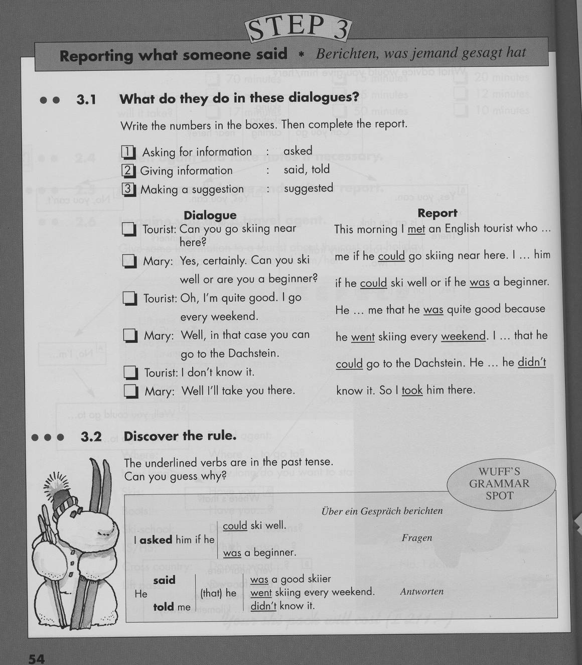
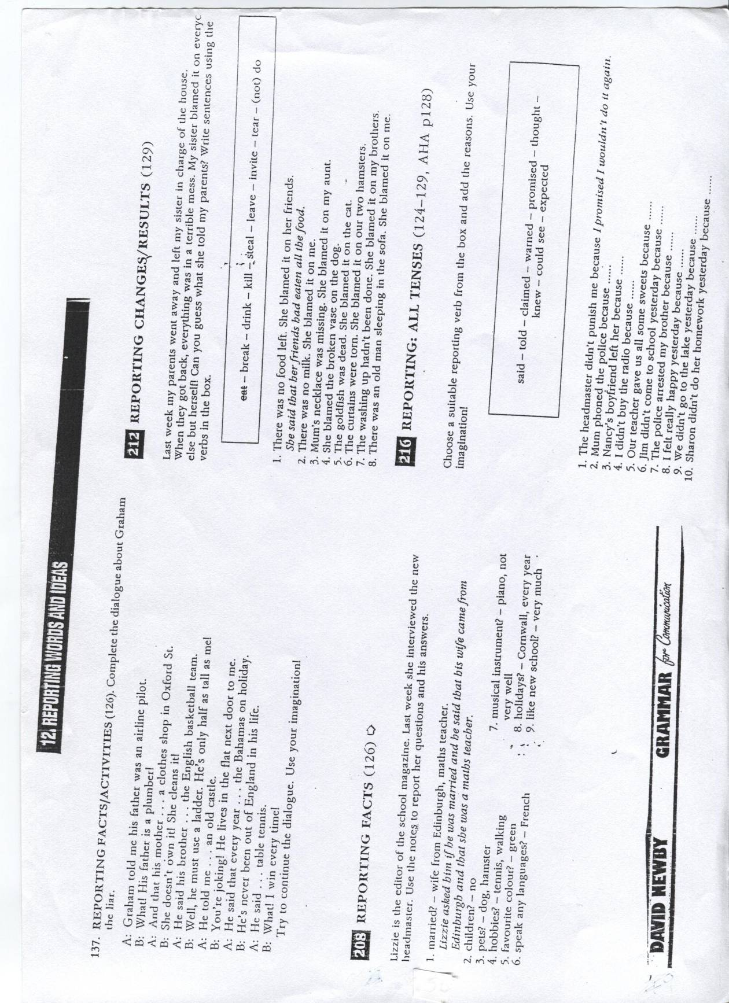
This activity is based on an exercise from Your Ticket to English (see below)
Do these two exercises.
Enter your answers (keywords) into the reporting circle on the next page. Where would you put them?
Use two colors – one for each exercise.
The Reporting Circle

I don’t quite believe this.
I don’t trust this…
I don’t care…
It is just a fact…
I

Wow! This is interesting!
This is so real and so relevant for us…

yesterday, last week,
on Wednesday…
Me
Here
Now

Do the following exercises from the green Newby grammar. Write your complete answers on a sheet.
Exercise 207, 208, 209 on p. 105-106. Also do the writing tasks that goes with ex. 209.

Conditionals
Cambridge English for Schools 4. (1996)

BIBLIOGRAPHY - Pedagogical Grammar

Theory
Batstone, R. (1994) Grammar. Oxford: Oxford University Press.
Bygate, M. et al (eds.) (1994) Grammar and the Language Teacher. Hemel Hempstead: Prentice Hall
Harmer, J. (1987) Teaching and learning Grammar. London: Longman.
Newby, D. (1998) 'Theory and Practice in Communicative Grammar' in R. de Beaugrande, M. Grosman, B. Seidlhofer, (eds.) Language Policy and Language Education in Emerging Nations, Series: Advances in Discourse Processes Vol. LXIII, pp 151-164. Stamford, Conneticut: Ablex Publishing Corporation
Newby, D. (2000) ‘Pedagogical Grammar’. In M. Byram (ed) Routledge Encyclopedia of Language Teaching and Learning. London: Routledge.
Newby, D. (2006) ‘Communicative Language Teaching’. In Fenner, A.B. and Newby, D. (eds.) Coherence of principles, cohesion of competences: Exploring theories and designing materials for teacher education. Graz/Strasbourg: European Centre for Modern Languages/Council of Europe Press
Newby, D. (2006) ‘Grammar awareness-raising in an initial teacher education seminar.’ In Fenner, A.B. and Newby, D. (eds.) Coherence of principles, cohesion of competences: Exploring theories and designing materials for teacher education. Graz/Strasbourg: European Centre for Modern Languages/Council of Europe Press
Newby, D. (2008) “Pedagogical Grammar: A Cognitive+Communicative Approach”. In: W. Delanoy and L, Volkmann (Eds.) Future Perspectives for English Language Teaching. Heidelberg: Universitätsverlag Winter, 29-44
Newby, D. (2003) A Cognitive-Communicative Theory of Pedagogical Grammar. Habilitationsschrift. Karl-Franzens Universität Graz.
Newby, D. (2012) Cognitive+Communicative Grammar in Teacher Education. In J. Huettner, B. Mehlmauer-Larcher, S. Reichl, B. Schiftner. Bridging the Gap: Theory and Practice in EFL Teacher Education. Clevedon: Multilingual Matters. 101-123
Odlin, T. (ed) (1994) Perspectives on Pedagogical Grammar. Cambridge: Cambridge University Press.
Parrott, M. (2003) Grammar for English Language Teachers. Cambridge: Cambridge University Press.
Sharwood Smith, M. (1988) ‘Consciousness Raising and the Second Language Learner’ in W.E. Rutherford and M. Sharwood Smith (eds.) Grammar and Second Language Teaching. Boston: Heinle & Heinle
Thornbury, S. (2008) How to teach grammar. Harlow: Longman.

Reference grammars (examples)
Biber, D., Johansson, S., Leech, G. (1999) Longman Grammar of Spoken and Written English. London: Longman.
Carter, R. and McCarthy, M. (2006) Cambridge Grammar of English. Cambridge: Cambridge University Press.
Chalker, S. (1984) Current English Grammar. London: MacMillan.
Chalker, S. (1990) English Grammar Word by Word. Walton: Nelson.
Leech, G. and Svartvik, J. (1994) A Communicative Grammar of English. 2nd edition London: Longman.
Murphy, R. (1985) English Grammar in Use. Cambridge: Cambridge University Press
Swan, M. & Walter, C. (1997) How English works. Oxford: Oxford University Press

Grammar activities
Dean, M. (1993) English Grammar Lessons. Oxford: Oxford University Press .
Hadfield, J. (1987) Advanced communication games. Thomas Nelson and Sons.
Hadfield, J. (1990) Intermediate communication games. Thomas Nelson and Sons.
Hall, N. and Shepheard, J. (1991) The Anti-Grammar Grammar Book. London: Longman.
Jones, L. (1992) Communicative Grammar Practice. Cambridge: Cambridge University Press.
Littlejohn, A. and Hicks, D. (1996) Cambridge English for Schools. Cambridge: Cambridge University Press.
Newby, D. (1989) Grammar for Communication. Vienna: Österreichischer Bundesverlag
Newby, D. (1992) Grammar for Communication – Exercises and Creative Activities. Vienna: Österreichischer Bundesverlag
Obee, B. (1999) The Grammar Activity Book. Cambridge: Cambridge University Press
Rinvolucri, M. (1984) Grammar Games. Cambridge: Cambridge University Press.
Ur, P. (1988) Grammar Practice Activities. Cambridge: Cambridge University Press
Watcyn-Jones, P. (1995) Grammar Games and Activities. Harmondsworth: Penguin.

Elisabeth Pölzleitner’s Grammar Quick Checker:

Quick Check Grammar Chart |  | - |  |  | +
Learning Stages | Awareness raising
Learning Stages | Conceptualization and hpothesis building
Learning Stages | Proceduralization in scaffolded conditions
Learning Stages | Performance in real-time context
Pedagogical Principles and Communicative Criteria | Depth of processing and Complex encoding : Will the learners be mentally active and process grammar, lexis and their “world knowledge”?
Pedagogical Principles and Communicative Criteria | Commitment filter:  Will the learners`cognitive and affective needs be met? (e.g.: curiosity, problem solving, enjoyment, fun, success)
Pedagogical Principles and Communicative Criteria | Peer and social learning and interaction:  Pair – or groupwork, sharing, oral activities, jigsaw activities…
Pedagogical Principles and Communicative Criteria | Personalisation:  Do the learners have the opportunity to draw on their personal experiences and express their own ideas?
Pedagogical Principles and Communicative Criteria | Contextualisation:  Is the exercise embedded in a clear communicative context?
Pedagogical Principles and Communicative Criteria | Authenticity of process:  Will the learners use language in natural, “language-like” ways (rather than manipulate forms)?
Pedagogical Principles and Communicative Criteria | Task-based:  Do the students fulfil a purposeful task that will have an outcome or end product?
Pedagogical Principles and Communicative Criteria | Testing versus teaching:  Does the exercise support learning or only test it?
This exercise supports learning processes… |  |  | 

Be careful when quoting from the handout and quote the theory part as: Newby, D. “An Introduction to Cognitive Communicative Grammar” in Course Handout C+C Grammar, (xx Semester, year)

