Grammar Games and Activities Published on the Internet

Communicative Grammar
Dr.phil. Elisabeth Pölzleitner

WS 2012/13

Waltraud Wolfmayr
0873175

Date of Submission: 14th January, 2013

Contents

Aim 2
Introduction 2
Analysis 2
Conclusion 11
Bibliography 12
Webliography 12

Aim
The present paper’s aim is to analyze grammar games and activities published on the internet. Its main attempt is to find internet sites with exercises that could be used for teaching grammar in class and to give suggestions for adaptations of poor exercises.

Introduction
There are numerous English grammar sites that offer exercises to learners of English. Basically, I have chosen two internet sites for the analysis, one as a good and one as a bad example. From each site, I will take a few representative sample exercises to prove my point.
For the analysis, I will be using the Quick Check Grammar Chart that we have received in the course. Thus, my analysis will be based on the cognitive learning stages and the pedagogical principles (Newby 2010: 19ff). Furthermore, I will take into consideration the communicative criteria for assessing grammar exercises (Newby 2010: 26). In this way, the question will be answered whether the chosen exercises would support learning.
A special focus will be laid on the question whether the exercises could be used for teaching in class or how they could be adapted for teaching.

Analysis
The first grammar activity that I am going to analyze is from the BBC LEARNING ENGLISH homepage. There is a section called “Grammar, Vocabulary & Pronunciation”, which offers different online exercises for English learners. Another section is designed for teachers where one can download material or do exercises with pupils online. In “Grammar Challenge”, there are worksheets for teachers on specific grammatical structures. I have chosen to analyze the speaking activity and worksheet on the will & going to future.

The learning aim is to understand the difference between will and going to and knowing how to use them. First, there is this speaking activity:
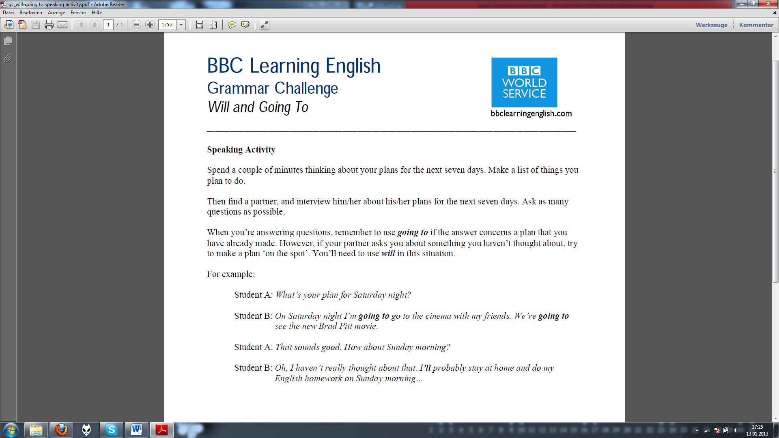
This exercise cannot be assigned to one particular cognitive learning stage. In a sense, it is awareness-raising. Pupils notice and focus on the different use of going to and will. This would work best if the pupils were given the sample sentences first. However, it can also be assigned to the conceptualization stage. Pupils learn to understand the difference between the two different notions and build their hypotheses. However, this awareness raising and conceptualization mostly takes place when they read the instructions. When it comes to the speaking activity itself, it covers mostly the proceduralisation stage. Pupils tell their own ideas, but the task is scaffolded and pupils do not have to focus their attention on the grammar too much because there are only two possibilities. Either, they are talking about their plans, or they are making a plan about something they have not thought about yet.
In my view, this activity supports learning processes, as it involves several pedagogical principles. The depth of processing should work well, as pupils have to be mentally active. They do not only have to understand the difference between the two notions, but they also have to produce it and think of meaningful and real-life examples. This leads to the next pedagogical principle, the dual processing. Pupils do not only produce meaningless sentences without a context, but they encode their perceptions of the world into language. They think of concrete things they plan to do, which leads to the pedagogical principle personalization. This exercise is highly personalized because pupils are being encouraged to talk about their real life from their own perspective. Also, the process is authentic because the situation could take place in real life as well. Actually, pupils’ plans for the next days, especially the weekend, are something they often talk about. Therefore, motivation and commitment should be existent. As they talk to someone in class, interaction and social learning is being encouraged as well. Last, but not least, the activity does not test declarative knowledge, but falls into the procedural knowledge category.
All in all, the exercise could be used very well for communicative grammar teaching. It is, however, important to consider that it teaches two notions at one time. The first notion is the “intentions and plans” (Newby 1998: 97) and the second is “deciding” (Newby 1998: 94). I would advise to teach both notions individually before using this task.
On the homepage, one can find a more detailed explanation of how to form the will and going to future, the Grammar Expert’s explanation. There are also ideas for using Grammar Challenge in class, which are not entirely supportive for learning. For example:
7. Scrambled Sentences – Take example sentences from the Grammar Expert’s explanation, and mix the words up. The students have to re-order the words to make correct sentences. After the exercise, students can look back at the Grammar Expert’s explanation and find the answers.

I doubt that the motivation and commitment would be very high in this case. I would not be interested in re-ordering words to make sentences which explain grammar to me. If it was an exciting story, it would be different.
Another idea is a fill-in the gap exercise:
2. Gapfill – Give students the text of the Grammar Expert’s explanation, with key words blanked out. Students try to work out what the missing words should be, then listen / read and check their answers.

A meaningful way in which this fill-in the gap exercise could be used, would be to hand out the sample sentences from the speaking activity above and to ask the students to make hypotheses about the difference of the two notions. Then it would be an awareness-raising activity and it would support depth of processing. Next, the teacher hands out the explanation, with key words blanked out, and the pupils fill in the missing words and check their answers with the teacher afterwards. This would support conceptualization, and the pupils would then probably be ready for the speaking activity in the proceduralization stage.
On the homepage, the program can also be downloaded in the form of an mp3. It includes an expert commentary and examples of a dialogue with a language learner. This is not very supportive for learning and too long, in my point of view. However, it could be useful for the teacher.
After doing the activities, there is a link to the quiz page to practice will and going to.
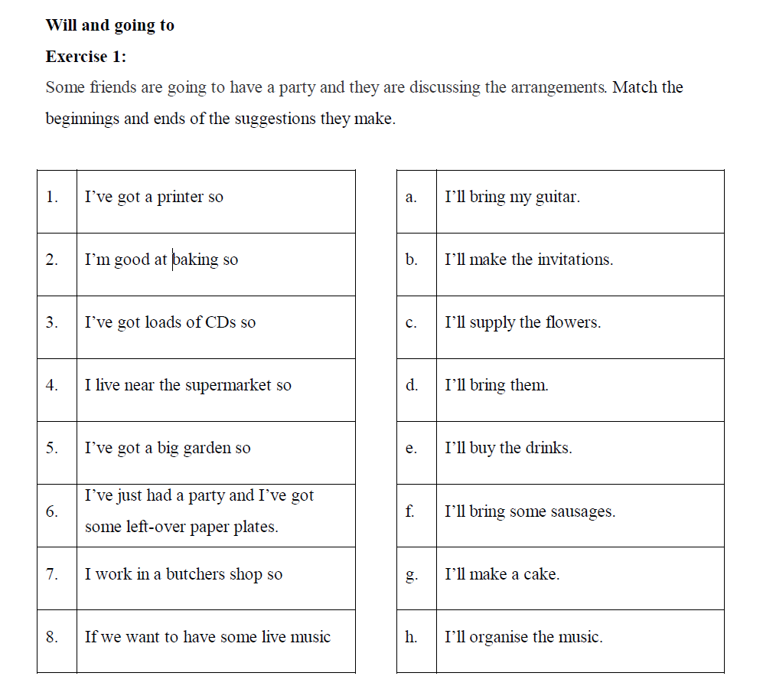
This exercise can also be done online. Its aim is to test one notion, the will future for making arrangements. However, one does not have to be able to form the will future, nor do they have to understand the grammatical item. There is no sense in using this exercise after the speaking activity above. I would rather use it before, in order to introduce the notion “deciding” (Newby 1998: 94) which is also used for making arrangements. It could be taken as an awareness raising activity. For example, the pupils first have to do the exercise, and then they have to find out what the sentences have in common.
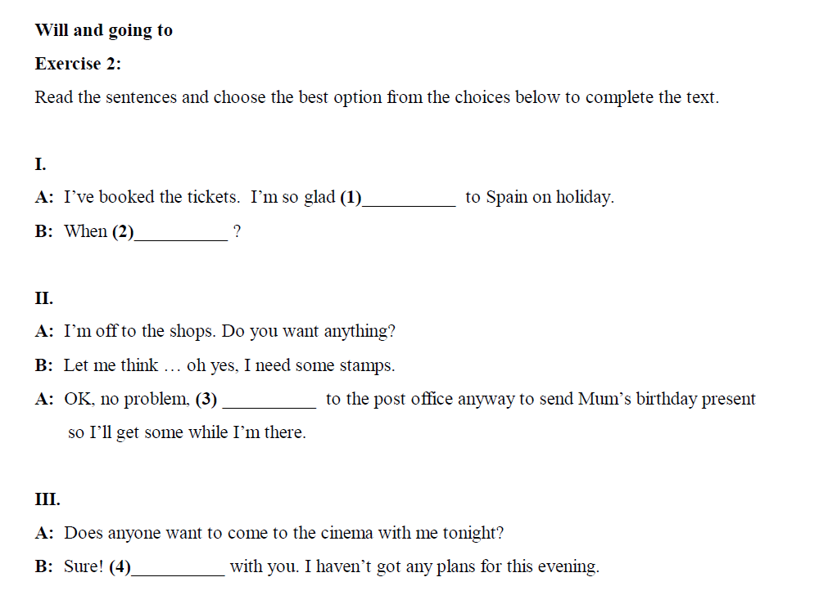
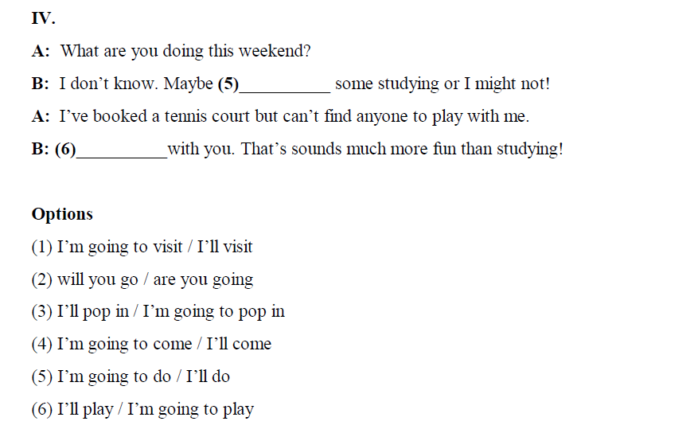

The second quiz aims to test whether someone can use the will and going to future correctly. Pupils do not have to express their own ideas or interact with others. However, in each mini-dialogue, little contexts are created which supports the authenticity of language. I can imagine that this exercises could function as a kind of repetition of the notions “intentions and plans” and “deciding spontaneously” (Newby 1998: 94, 97).

The second internet site I am going to analyze is www.english-hilfen.de. This one could be compared to Smile. There are gap-filling exercises, sentences to be finished and multiple choice questions. They are exercises to test rather than teach. It seems that this has been done on purpose because there is one section that contains grammar explanations, and one section with exercises only. Next to an exercise, there is always a number which tells the years of learning English that are required.
The explanations are given in the traditional way. Only a small part focuses on the use of a grammatical item and the rest explains the form and gives examples. All in all, it is more confusing than helpful, even to someone like me who basically knows the grammar that is covered on this site.
This is an example of a grammar explanation of the conditional type III:
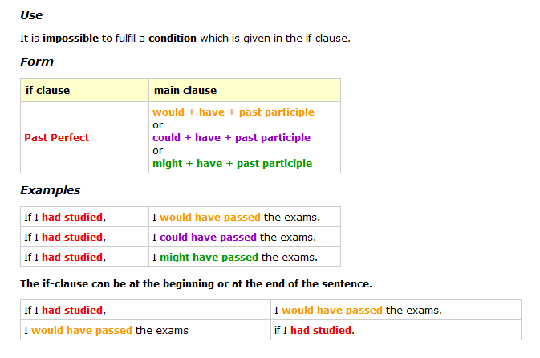

The exercises are basically all of this kind:
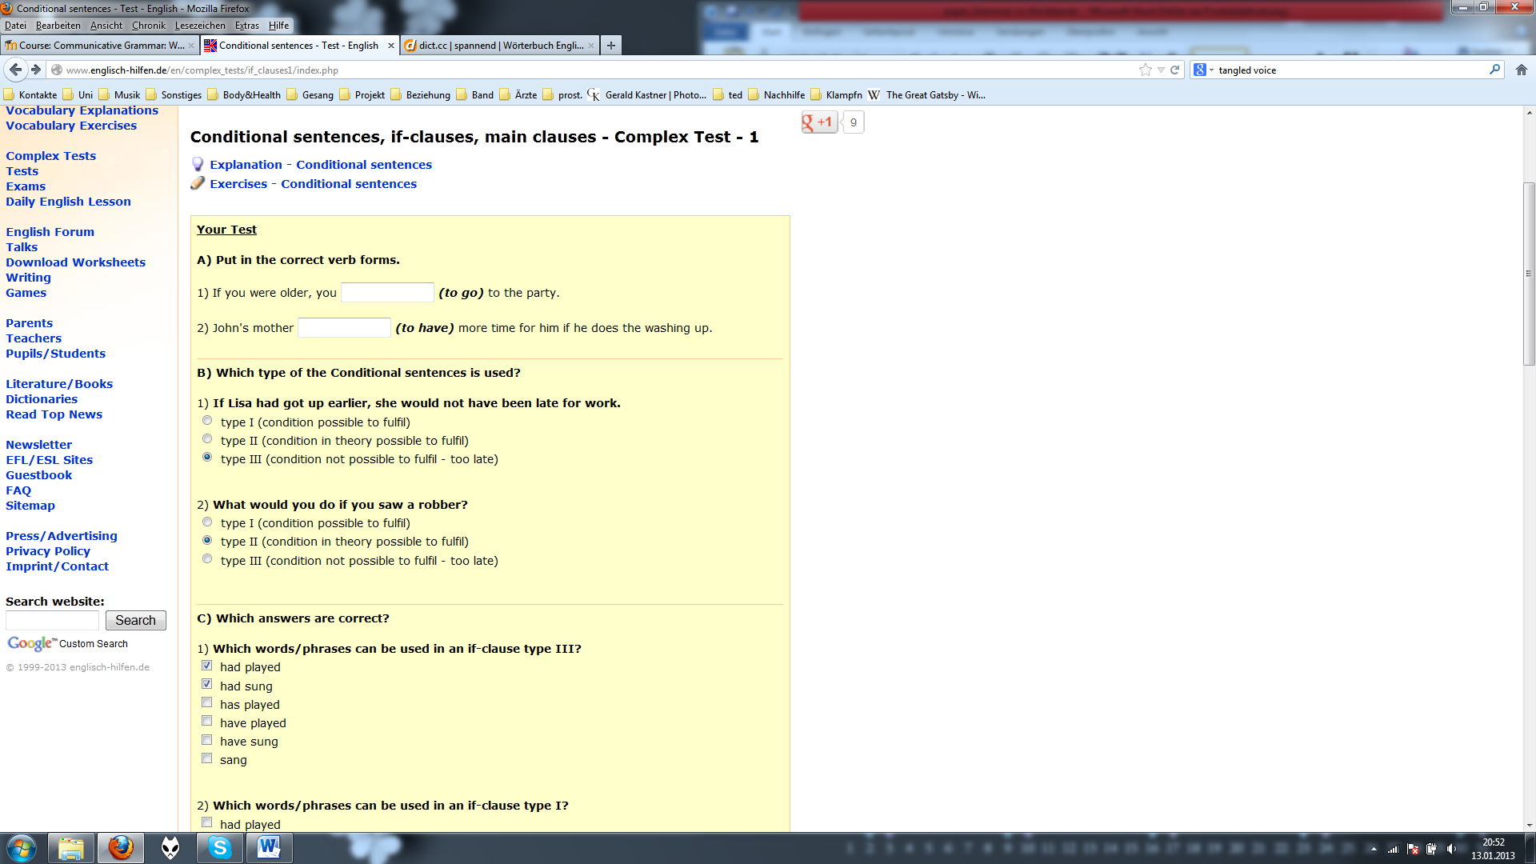
Analyzed according to the criteria we have discussed in class, these exercises score very badly. They lack depth of processing and mental activity, dual processing, personalization, and pupils would perhaps not be very committed to do them. Exercise A is simply testing whether someone has learned the rules of how to form the different conditionals. There is no context given, which could be changed if there were some extra sentences given, for example in the form of a mini-dialogue.
Exercise B is confusing because the explanations for type I, II and III are so vague that one could think that not only type II, but also type III was a “condition in theory possible to fulfill”. For example, in theory Lisa could have got up earlier and then she would not have been late for work.
A possible use for these exercises would be to take single sentences and make games.
For example, take sentence B 2: “What would you do if you saw a robber?” This sentence could be used as a starting point for a speaking activity. Each pupil gets a picture and then goes around in class and asks classmates questions starting with, “What would you do if…” After the classmate has responded, they swap their cards. After some minutes, the pupils sit down again and the teacher asks questions like: “What was one of the most interesting answers you got?”

Examples:

…you had lots of money? …you were able to fly? …were a wizard?
Thus, the online exercises could be used as an inspiration for games and activities in class, but they could not be used the way they are to support learning.
Another way to use exercise B is to take the first sentence as an inspiration for a speaking activity in class.
Instructions: Make groups of 3-4 pupils. Deal out all the cards and read them out one at a time. Then, everybody in the group tries to imagine something that could have been done differently. Start with: “If you…”
For example:
“I’ve got a terrible hangover.”
“If you hadn’t drunk so much wine, you wouldn’t have a hangover now.”
  I’ve spent all my pocket money. |   I’ve got a terrible hangover.
  I lost my temper (got angry). |   I was late for school.
  I am freezing. |   I forgot to do my homework.
  I have failed the Biology test. |   I have broken my leg.
  I’ve burnt the meal. |   My bike was stolen.

In these scaffolded conditions, the exercise can be used for the proceduralisation stage. It aims to cover more or less all pedagogical principles, from high mental activity to social learning and interaction.
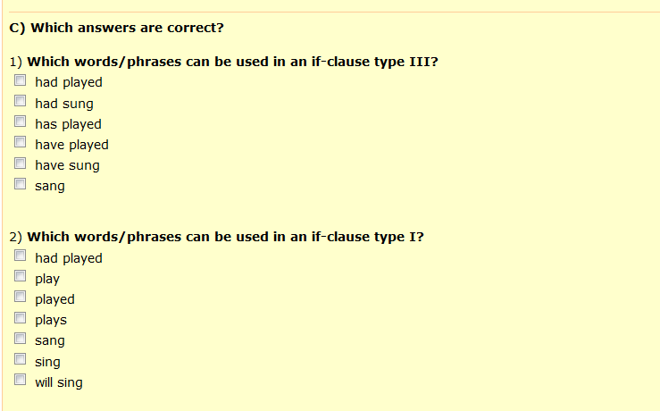
These questions and answers will not support learning and understanding conditionals because they are only testing declarative knowledge in a difficult way. These are exercises of the kind where pupils would draw a grid with the rules of the three forms of the conditional. Even to an advanced user of the English language, the questions would not be easy to answer because one never thinks in this way when he/she uses English in real-life. Thus, there is no authenticity of process.

Conclusion
Through my studies, I have discovered that there are numerous English grammar sites, but only very rarely there are good exercises to be found. If someone wants to teach in the traditional way, the World Wide Web is full of offers. However, as I wish to teach communicative grammar, I have to take a closer look. There are some useful activities, as the BBC homepage proves. Nevertheless, the most I can draw from the internet, is inspiration for adaptations of exercises.
Most of the internet sites are not aimed at teachers anyway. They should help learners of English in their private studies. However, I have discovered that many exercises are testing rather than teaching and they are confusing to inexperienced students. Therefore, learners of English should not be advised to use English grammar sites without a guide.

Bibliography

Newby, David (2010). Communicative Grammar. Course Handout.
Newby, David (2002). Grammar for Communication. 2nd ed. Wien: öbvhtp

Webliography

http://www.bbc.co.uk/worldservice/learningenglish/radio/specials/1649_gramchallenge34/
http://www.englisch-hilfen.de/en/grammar/if_type3.htm
http://www.englisch-hilfen.de/en/complex_tests/if_clauses1/index.php

