Teaching One Notion of the Present Perfect Tense

Notion: Experience

Song: I still haven’t found what I’m looking for – U2

Listening to a song can be a fun awareness raising activity to introduce the students to a certain grammatical concept – in that case the present perfect notion experience. A song is a nice way of exposing children/learners to correct language that is embedded in context. Also, rhythm is a nice side effect, as it is a strong help for memorizing.
Concerning the choice of the song, it is a good idea to choose a song that is well-known, fits the age group and deals with a topic your learners can identify with or talk about. A well-chosen song can be a great benefit to the commitment filter and the personalization aspect.

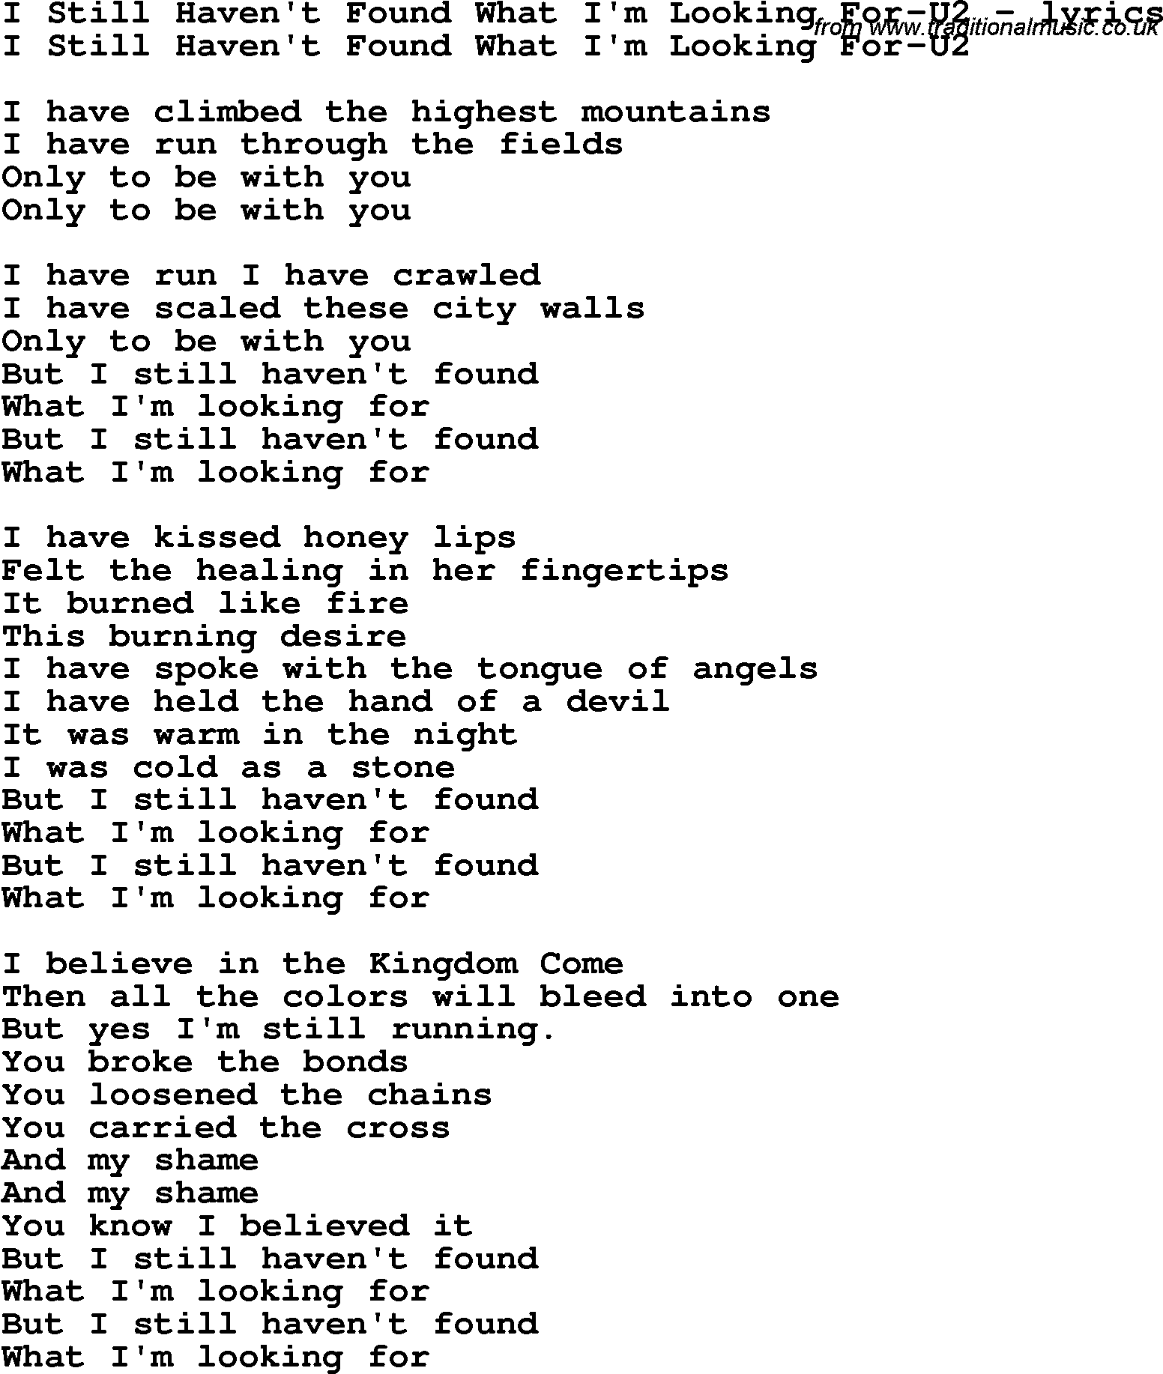

1) The awareness raising part could be to let the students listen to the song twice. First time: listen and lean back, second time: fill in the blanks on the handout (handout prepared by teacher).
Partner work: with a partner check/compare your results and then figure out what is new in the text (e.g. highlight new forms)

2) Conceptualization task: In an additional task, with a partner come up with a rule. What do you notice? Can you find a rule for the use of the present perfect tense? When do you think it is used? What do you try to express with it?
Room for IDEAS:

YOUR RULE: ______________________________________________________

_____________________________________________________________________

_____________________________________________________________________

3) In a third activity you can start working on the proceduralization stage. Students can produce their own utterances here, “play with” the language, use language in scaffolded and guided conditions to brainwash the concept into their brains.

Task: Form your own true sentences what you have experienced in the past or what you still have not experienced (have done, have completed, have achieved, etc.)
Example: Have you ever climbed a mountain? Have you ever swum with a dolphin?

Quick Grammar Checker:

Learning stage: Awareness raising (1), Conceptualization (2), Proceduralization (3)
Depth of Processing: Students need to listen actively in order to fill in the missing words (1), they are exposed to correct language embedded in meaningful context, the rhythm of songs also helps to memorize the new forms and concept behind it. Coming up with their own rules also asks for being mentally active (2), so does creating your own sentences (3)
Dual Processing: Authentic use of language (3), producing their own utterances.
Personalization: high as students get to talk about own experience and make up their own sentences (3),
Commitment filter: songs are always fun, so the commitment is probably high, choosing a song that deals with a topic the students are interested in, like talking about, can identify with, etc. can additionally contribute positively to their commitment and motivation, writing about their own lives and experience is also a motivation factor. (3)
Peer/Social Learning: Finding a rule in pairs is much better than on your own – two brains see and detect more than one. Sharing your ideas makes it a social and communicative activity that is also more fun and affects the commitment filter
Testing vs. Teaching: more of a teaching activity, task (3) could be part of a test

