Appendix 3: based http://www.canada-esl.com/lessonsmain/haveyouever.pdf

Cards Game: Truth or Lie?
This is your turn! Now you can show off a bit!!!

Get together in groups of 4. The first of you starts picking a card from the „Have you ever“ cards pile and asks the „Have you ever...“ question according to the picture on the card. Then the asked student can either say the truth or not. The rest of the group is allowed to ask the student three follow-up questions in order to know if he or she is telling the truth. Afterwards you can bet (maximum 5 Euros) on whether the student is telling the truth or not. Finally you have to reveal the truth. The winner is the student who has received the most money.
Try to be as persuasive as possible!
Have fun!!!

Cards:
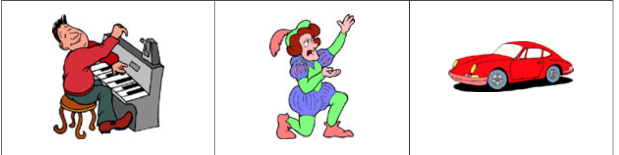
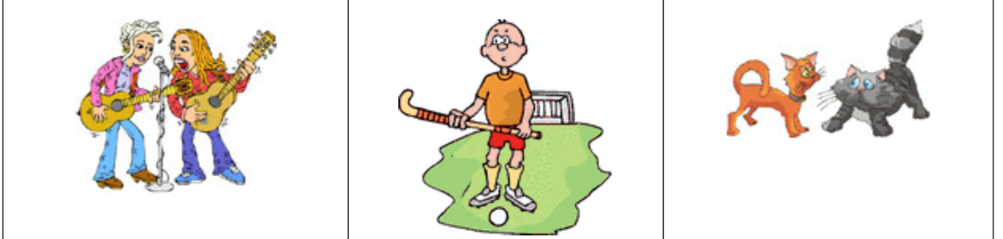
 | 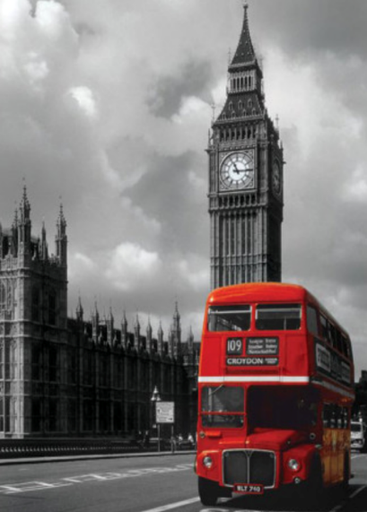 | 
 | 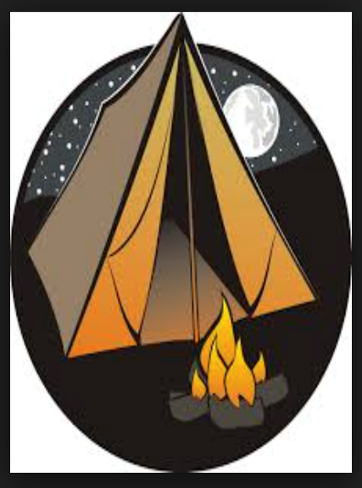 | 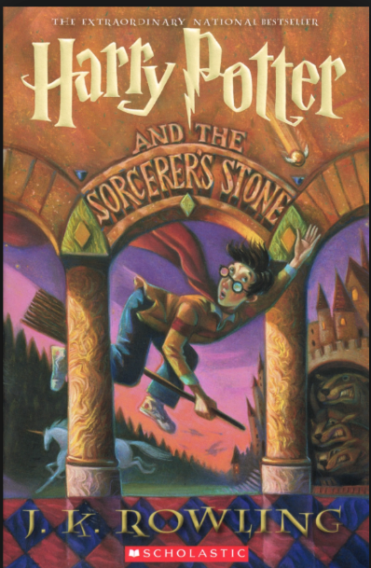
 |  | 
 |  | 
 | 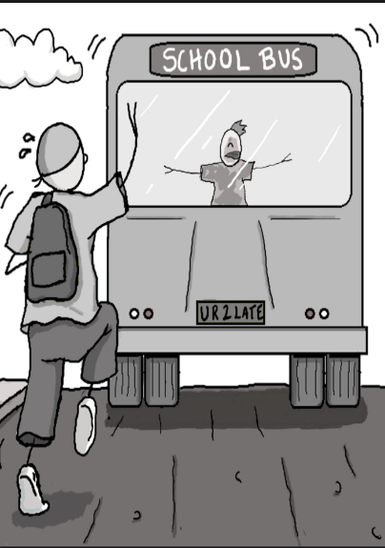 | 
 |  | 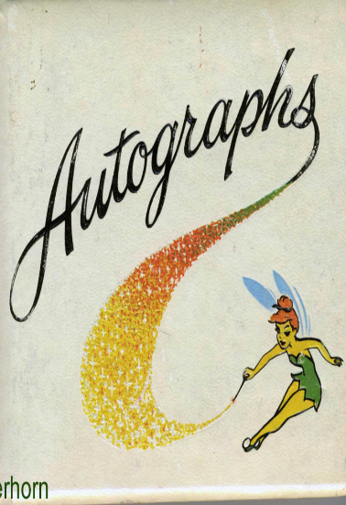
Appendix 4: http://busyteacher.org/5418-have-you-ever-present-perfect-boardgame.html




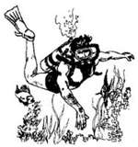

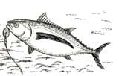
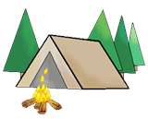








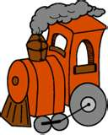
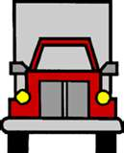
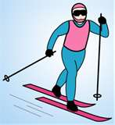





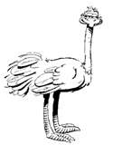


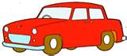










break
ride
bake
crash
drink
go to
drive
climb
shoot
wake up b4
play
try
go
eat
build
travel
lose
catch
visit
make
take
go to
see
eat
see
give
ride
fall down
try
fly in
go
ride
sleep
go to
go to
rent
meet
write
Finish
Start




Have

you ever…?
Board
Game
Remember
Have you (ever) + past participle (V3)

e.g. Have you ever played this game?
Have you ever broken a bone?
Have you ever ridden an elephant?
Have you ever baked a cake?
Have you ever crashed a car?
Have you ever drunk whisky?
Have you ever been to Rome?
Have you ever driven a lorry (truck)?
Have you ever climbed a mountain?
Have you ever shot a deer?
Have you ever woken up before
4 AM?
Have you ever played tennis?
Have you ever tried scuba diving?
Have you ever gone roller skating?
Have you ever eaten ostrich?
Have you ever built a tree house?
Have you ever travelled by train?
Have you ever lost your keys?
Have you ever caught a fish?
Have you ever visited New York?
Have you ever made a snowman?
Have you ever taken a photo?
Have you ever been to the zoo?
Have you ever seen a ghost?
Have you ever eaten pizza?
Have you ever seen a UFO (spaceship)?
Have you ever given flowers?
Have you ever ridden a horse?
Have you ever fallen down the stairs?
Have you ever tried windsurfing?
Have you ever flown in an aeroplane?
Have you ever gone skiing?
Have you ever ridden a camel?
Have you ever slept in a tent?
Have you ever been to London?
Have you ever been to Paris?
Have you ever rented a motorbike?
Have you ever met a (movie) star?
Have you ever written to Santa?

Finish

Answer Key

Start

