Overview of Tense Notions and Aspects
In the course of the semester enter a typical example sentence for each notion. Your sentence should not only be correct but TRUE for yourself. Choose examples that say something about your own experiences in life.
Then draw a “logo” for each notion. The logo should remind you of the concept and typical contexts of the notions.
Tense Form &  Logos for each notion | Notion | p. | Your true sample sentence
 | Present States | 69 | Present Simple  I live in Graz. I am a student.
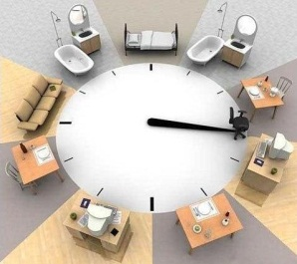 | General Routines | 70 | Usually I get up at about six. I take a shower and get dressed. I have breakfast and go to the university.
 | Present Events  Handlungs-abfolgen  (sports reporting/  recipies...) | 70 | Ronaldo kicks the ball towards the Arsenal goal; Messi jumps high and heads the ball – it´s a goal!
 | Arranged Events  (trip schedule...) | 71 | Welcome on board Austrian Airlines flight 232 to Vienna. We leave at 8:30 a.m.
 | Present Activity | 73 | Present Progressive  I am drinking a tea now.  I am planting some flowers in the garden.
 | Present Routines (temporary) | 75 | I´m intending to go to America in the summer.
 | Present Changes  (developments) | 76 | My English pronunciation is improving.
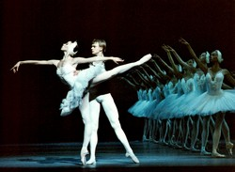 | Arranged Activities  (making a date, arguing) | 77 | At the end of June I am going to watch “The Nutcracker” at the Opera house in Graz.
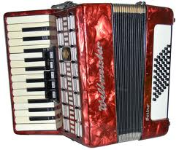 | Past Events | 79 | Past simple  My grandfather died in 2008.  I played accordion when I was young.
 | Past States | 80 | I lived in a small town with my parents and my sister.
 | Circumstances | 81 | Past prograssive  I was cooking the lunch when my boy-friend came home.
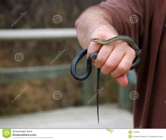 | Experience | 84 | Present Perfect  I have never held a snake.
 | Changes and Completion | 85 | I have finished my work.  I have cut my hair.  I have done my dinner.
 | Duration of a State | 86 | I have been here since three days.
 | Recent Events (news) | 87 | I have just seen my Professor.
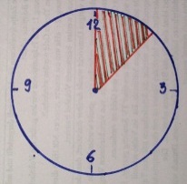 | Duration of an Activity | 88 | Present perfect progressive  I have been waiting for you since two o´clock.
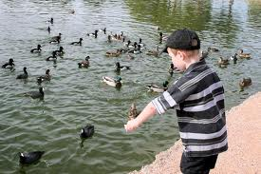 | Recent Activities | 89 | I have been feeding the ducks.
 |  | 91 | Past perfect  The next morning I noticed that my cat had eaten all the goldfish.
 | Predictions and Expectations | 93 | The future (weak attitude)  I hope that my parents will come to see me in Graz.
 | Formal Announcements | 95 | THE DUKE and Duchess of Cambridge will visit Nottingham with the Queen.
 | Deciding | 92 | I´m beginning to feel very tired. I think I´ll go to bed.
 | Intentions and Plans  (going to) | 97 | The future (strong attitude)  I am going to spent two weeks in summer with my sister.
 | Interpreting Signs | 98 | My cousin is going to have a baby.

