Overview of Tense Notions and Aspects
In the course of the semester enter a typical example sentence for each notion. Your sentence should not only be correct but TRUE for yourself. Choose examples that say something about your own experiences in life.
Then draw a “logo” for each notion. The logo should remind you of the concept and typical contexts of the notions.

Tense Form &  Logos for each notion | Notion | Your true sample sentences
Present Simple | Present States  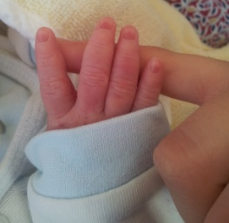 | - I am a mother of a wonderful son.  - I live in a flat in Graz.  - I am a student at KF university.
 | General Routines | - I go to the park with my son every day.  - On weekends we always visit my parents.  - I usually don’t have much time for studying.
 | Present Events  Handlungs-abfolgen  (sports reporting/  recipies...)  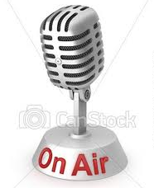 | - He gets the ball, runs, kicks off... offside!  - Mix butter and eggs until smooth, add sugar and flour and stir thoroughly.  - The queen leaves the church, waves to the crowd and smiles.
 | Arranged Events  (trip schedule...) | - Our plane departs at 6:30 am.  - The train leaves in 20 minutes.  - The guided tour starts in front of the museum.
Present Progressive | Present Activity | - I am studying at the moment.  - My son is crying very loudly.  - I am eating a banana right now.
 | Present Routines (temporary) | - I am helping them out in their bar.  - We are having the time of our lives here in Rome!  - I am wearing my sister’s clothes until she comes back.
 | Present Changes  (developments)  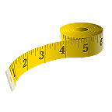 | - My son is growing really fast.  - I am getting promoted in my job.  - Flowers are spreading everywhere.
 | Arranged Activities  (making a date, arguing)   | - I am visiting my grandparents on Saturday.  - You are participating in the contest in July, aren’t you?  - Tonight I am watching the new movie.
Past Simple | Past Events | - I gave birth to my son when I was 22.  - As a young girl, I read ‘Hanni und Nanni’.  - My grandfather built our house in 1962.
 | Past States | - At the age of 10 I had many pets.  - In primary school I was the tallest girl in class.  - There was less traffic beneath our house 5 years ago.
Past Progressive | Circumstances | - I was doing my homework when my son woke up and cried.  - I was singing loudly while I was showering.  - Last night at 2 am we were watching a spooky film.
Present Perfect Simple | Experience | - I’ve lived in the US and have visited many places there.  - I’ve never done bungee jumping.  - I’ve seen dolphins and whales.
 | Changes and Completion | - I’ve finished my homework.  - I’ve dyed my hair blonde.  - My brother has lost a lot of weight.
 | Duration of a State | - My parents have been married since 1983.  - I’ve known my best friend for almost 15 years.  - The weather has been bad since Tuesday.
 | Recent Events (news) | - A truck has just hit a car in Attemsgasse.  - Kate and William have just left the wedding chapel.  - I’ve just phoned my mother.
Present Perfect Progressive | Duration of an Activity   | - I’ve been waiting for my son to be born for hours.  - I’ve been living in Graz since 2010.  - My son has been playing music all day long.
 | Recent Activities | - Recently, I’ve been studying very hard for an Italian exam.  - Why are you sweating? Have you been working out in the gym?  - I’ve been collecting childhood photos recently.
Past Perfect |  | - I had not seen a whale before I went on the boat trip.  - Yesterday it was very icy, because it had been snowing the day before.  - When I came home I realized that I had not locked the door.
The Future  (weak attitude) | Predictions and Expectations | - I think I will spend a lot of money this summer.  - I wonder what the weather will be like on the weekend.  - I hope I will pass the exam.
 | Formal Announcements | - There will be a vocabulary revision on Monday.  - You will find the keys hidden under the carpet.  - There will be another concert in May.
 | Deciding | - Tomorrow I will go to bed early.  - I think I will take the chocolate cake.  - Maybe it will be better to stay at home tonight.
The Future  (strong attitude) | Intentions and Plans  (going to) | - I am going to buy a new car in autumn.  - I am going to Greece in summer!  - In October I am going to visit my friend in Italy.
 | Interpreting Signs   | - It looks as if it is going to rain in a minute!  - Stop watching TV or you are going to fail your exam!  - Ouch! I am going to have a big bruise on my leg.

