Overview of Tense Notions and Aspects
In the course of the semester enter a typical example sentence for each notion. Your sentence should not only be correct but TRUE for yourself. Choose examples that say something about your own experiences in life.
Then draw a “logo” for each notion. The logo should remind you of the concept and typical contexts of the notions.
Tense Form &  Logos for each notion | Notion | p. | Your true sample sentence
Present Simple    ME | Present States | 69 | My name is Sabrina. I am 21 years old. I go to university in Graz and I want to be a teacher.
 | General Routines | 70 | On Saturdays I usually get up at 6 in the morning. I always work on Saturdays and help some pupils to improve their English.
 | Present Events  Handlungs-abfolgen  (sports reporting/  recipies, stories...) | 70 | Two muffins sit in the oven. One muffin says to the other one: “Hot in here, isn’t it.” Then the other one says, “OMG! A speaking muffin!”
 | Arranged Events  (trip schedule...) | 71 | My plane to the Netherlands leaves on 26th of January at 7.05 a.m. and it arrives in Amsterdam two hours later.
Present Progressive   | Present Activity | 73 | I am currently working on my logos for the tense notions.
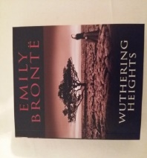 | Present Routines (temporary) | 75 | I’m already reading the book you gave me for Christmas. It is really interesting.
 | Present Changes  (developments) | 76 | Austria is not only experiencing a climate crisis but also a refugee crisis. However, it is not trying to solve the problem but is putting the blame on others.
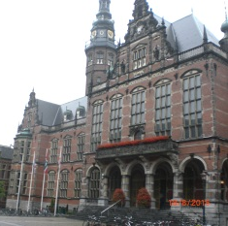 | Arranged Activities  (making a date, arguing) | 77 | I’m studying in Groning starting next week. So, you have to go for a coffee without me for a while
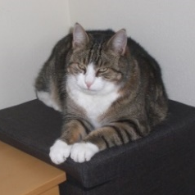  Past Simple | Past Events | 79 | When we moved into our new house, I got a cat. She gave birth to many other cats. Some kittens died because they were too weak. Finally, two kittens survived and we could keep them. My favourite one was tiger but he wasn’t happy with four other cats around him. So I found a nice lady who could cuddle him all day long.
 | Past States | 80 | The town where I grew up was really quiet. There was a lot of forest around our house and the garden was huge and had a lot of flowers and trees in it.
Past Progressive   | Circumstances | 81 | The night view of the city was beautiful. The street lights were shining in the darkness and the people were walking around and chatting with each other. I was watching the beautiful scenery in the middle of Seoul, when I suddenly heard two people arguing…
Present Perfect Simple  Who has ever….?   | Experience | 84 | I have been to Ireland once.  I have never eaten strange things but my brother has tried a worm.  I have seen many sights in Amsterdam during my holidays.  I have screamed because of spiders lots of times.
 | Changes and Completion | 85 | I have been to a different hairdresser.  I haven’t started with the term paper yet.  I have already started with this week’s assignment.
 | Duration of a State | 86 | I have had my cat since I was four. She has been with me for almost 17 years
 | Recent Events (news) | 87 | A: OMG What has happened to your head? You have a huge bump!  B: I have bumped into the traffic lights once again.
Present Perfect Progressive     | Duration of an Activity | 88 | A: I’m so sorry. I’m late. Have you been waiting for a long time?  B: Yes, I have! I have been waiting for hours. Dinner is already cold!!
  :,-( mum | Recent Activities | 89 | A: Why are you crying, mum? What have you been doing?  B: I have been watching a really sad film on TV.  A: Really, mum? A sad one? I don’t trust you anymore. You even cry when it is a funny movie, mum.
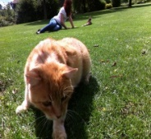  Past Perfect |  | 91 | I got my cat as a birthday present when I was four. I was allowed to have one because we had just moved into a really big house with an even bigger garden and I could keep many more cats.
The Future  (weak attitude)   | Predictions and Expectations | 93 | I hope I will eat really tasty food while I’m in Groningen.  I hope there won’t be too much bad weather while I’m there.
 | Formal Announcements | 95 | Sunrise Avenue will hold a concert in May. They will play there long awaited live concert in Vienna, their management has announced.
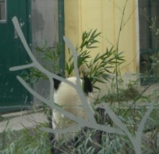 | Deciding | 92 | A: Hey, do you already have plans for the weekend?  B: No, not really… but I think I will go to the zoo with my brother. Will you come with us?  A: Yeah, sure. Great idea! I’ll come with you. I want to see some panda bears.
The Future    (strong attitude) | Intentions and Plans  (going to) | 97 | I’m going to travel to South Korea as soon as I have finished my studies. I’m going to travel through the country bay train. I have already researched interesting places I want to visit.
 | Interpreting Signs | 98 | Oh no! There are so many dark clouds today. There is going to be a thunderstorm for sure.

