Interesting quotes about learning grammar

Cristina Sanz and Kara Morgan-Short, “Positive Evidence Versus Explicit Rule Presentation and Explicit Negative Feedback: A Computer-Assisted Study”, Language Learning 54:1, March 2004, pp. 35–78

We conclude that ,[ ...] when learners are exposed to positive evidence presented through task-essential practice, the provision of explicit information through explanation or feedback may not produce increases in acquired knowledge.
The focus on form (FonF) literature claims that attention needs to be directed to form in the process of transforming input into intake for subsequent integration into the language system. Attention can be redirected from meaning to form implicitly, through exposure to structured input, or explicitly, through provision of information oh how the language works. Our study suggests that explicit information may not be necessary to draw attention to form. .. Our study shows that primary linguistic data (i.e. positive evidence), when presented in a manner in which learners crucially process the form in order to get the meaning, leads to form-function-meaning mapping and is therefore a successful means of promoting processing for language learning.
[…]
We are led to conclude that language acquisition is associative in nature and triggered only by exposure to input through task-essential practice, unaffected by metalinguistic information.

Morgan-Short K, Finger I, Grey S, Ullman MT (2012) Second Language Processing Shows Increased Native-Like Neural Responses after Months of No Exposure. PLoS ONE 7(3): e32974. doi:10.1371/journal.pone.0032974
Conclusion
This ERP study of an artificial language examined the behavioral and neural consequences of a substantial period of no exposure to an L2, which is a common scenario in second language learning. The results show that, following the attainment of a relatively high proficiency level in the L2, several months of no exposure to the language does not necessarily lead to a degradation of performance, that is, to attrition. Rather, proficiency can be maintained, and an increase in native-like neural processing of syntax can occur. The results demonstrate that substantial periods of no exposure are not necessarily detrimental, and that indeed they can be followed by neural gains, at least under some circumstances. Importantly, this pattern was found whether the learners had undergone explicit, classroom-like training, or implicit, immersion-like training, and thus it appears to hold independently of the type of L2 training. Additionally, the implicitly trained group showed more native-like processing than the explicitly trained group both before and after the period of no exposure, indicating that type of training also affects the attainment of native-like processing. Thus, the attainment of native-like syntactic processing in the brain appears to be affected by substantial periods of time, even with no L2 exposure, as well as by type of exposure, in addition to the previously implicated factors of age of acquisition and proficiency (which itself may have been confounded with periods of no exposure and type of exposure in previous studies). The findings in this study may be at least partly explained by a combination of forgetting and consolidation in declarative and procedural memory, two memory systems on which L2 grammar learning appears to depend. Overall, the study has a wide range of implications, and suggests a research program with potentially important consequences for second language acquisition and related fields.
p. 13
The group differences at end of training are thus likely to be explained by differences in the content of the two training paradigms. In particular, the evidence suggests that implicit, immersion-like training leads to more native-like neural processing than explicit, classroom-like training – at retention as well as at end of training. However, it is not yet clear why this might be true. One possibility is that the greater native-like processing in the implicit group was due primarily to the larger number of meaningful phrases and sentences presented in the implicit than explicit training conditions. On this view, native-like processing critically depends on the number of meaningful phrases and sentences presented to L2 learners, and not on implicit or explicit training per se.

p. 15
The present study suggests that this ERP pattern also occurs in the explicitly trained group, but that the shift occurs much later, and partly as a consequence of presumed consolidation. Thus both implicitly and explicitly trained L2 learners appear to follow the expected shift from declarative to procedural memory, but at a greatly delayed rate for those undergoing explicit training, possibly due to inhibition of proceduralization by the early acquisition of explicit knowledge in declarative memory. Thus the results both further support and specify the model – though note that the implication of the two memory systems and the shift between them by no means precludes at least some other models (e.g., [126,127]). The possibility that explicit training may retard the development of native-like grammatical processing is intriguing, and warrants further examination. It suggests that even though explicit training might provide early advantages, its longer term consequences may not be so beneficial

The Role of Procedural Memory in Adult Second Language Acquisition
Katherine A. Brill-Schuetz , Kara Morgan-Short , 2014
https://mindmodeling.org/cogsci2014/papers/055/paper055.pdf
Abstract
This study examined the role of procedural memory in adult second language (L2) development. Participants were trained on an artificial language under either explicit or implicit conditions. Development in the L2 was assessed by grammar tests at two time points. Measures of procedural memory were administered and were used to create high and low procedural groups. Results revealed an advantage in L2 development for learners with high procedural memory when trained in the implicit condition. Overall, this study suggests that procedural memory may be an important factor in adult L2 development but its role may differ under different learning contexts.

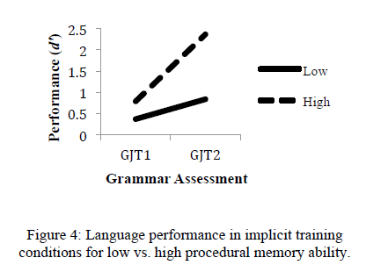
p. 263f.
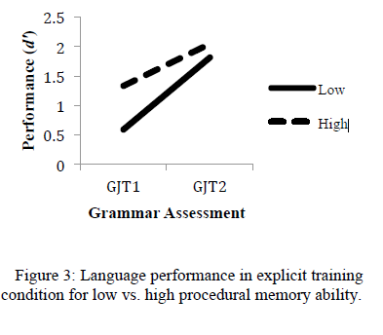

More specifically, participants with high procedural memory ability performed better than participants with low procedural memory ability on final grammar assessments when they had been trained under implicit conditions. Thus higher procedural memory ability led to higher levels of L2 development, particularly under implicit conditions. Indeed, it appears that high procedural memory ability paired with implicit training conditions produced an optimal learning context. (p. 264)

