Assignment: Analysis of grammar activity
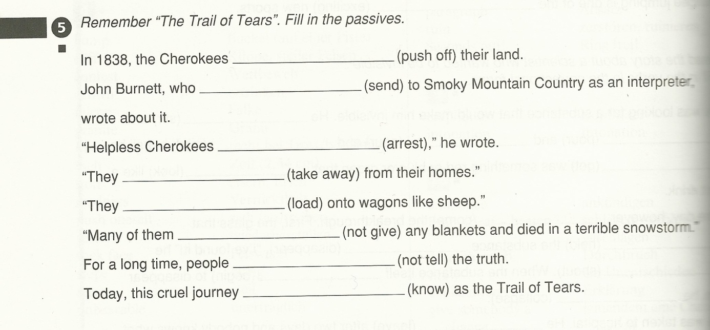
Textbook/workbook: “The New YOU & ME 4”, Unit 3

- Grammatical objective(s)
category of objective: process
specific objective: passive
- Activity type
Completion (Gap filling): fill in gaps in sentences + cue word in brackets
- Learning aim: the aim of this exercise is the students’ internalisation of rules concerning the passive. To be more precise, it is solely concerned with the students’ correct forming of the passive (person/thing + be + past participle).
- Cognitive learning stage(s): conceptualisation
- Pedagogical principles
no dual processing, no personalisation, lack of commitment filter: Even though the content of the exercise (“The Trail of Tears”) is known by the students (assuming that they have already read the said story in the textbook) it is rather unlikely for them to engage affectively with the exercise. The students cannot express their own ideas or opinions with regard to the issue addressed, namely the Cherokees’ expulsion from their home. The context is rather artificial. When it comes to the internalisation of the correct passive forms this exercise might at least be of some use (very little use though). Regarding interaction, however, the exercise does not take this aspect into consideration. Students are supposed to fill in the gaps on their own. There is no room for interaction or the actual use of passive. In most cases teachers tend to add the phrase “Compare your results with your neighbour” which is, frankly spoken, insufficient. Lastly, this exercise is concerned with testing rather than with learning/teaching.
- Communicative principles
Neither context nor use/processing of language are realistic; no personalisation (see above), it’s not an open-ended exercise, no integrated skills such as vocabulary, writing or speaking are required.
In general, this exercise is not communicative.
- Coherence
In the textbook itself there are rarely any exercises with regard to grammar yet the workbook provides a wide range of grammar exercises. Numerous other exercises within the unit itself as well as within the workbook as a whole are similar to each other. Taking the analysis and the resulting (mainly) negative aspects of this exercise into consideration, it is rather questionable to which extent the exercises provided will serve the purpose of teaching grammar effectively.

