Analysing grammar exercises

Exercise taken from MORE! 2 Workbook, Unit 8, p.51, ex. 11 on future:

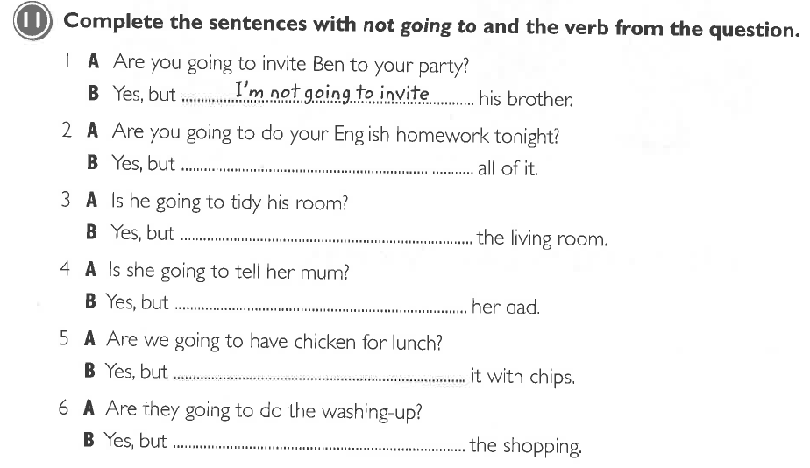

- Grammatical objective:
  - Category of objective = grammatical notion
  - Specific objective = [expressing intention]
  - form = be + going to + verb

- Activity type:
  - individual
  - fill-in-the-gap

- Learning aim:
  - practise the form
  - practise negation
  - (there are better ways to practise the form-….)

- Cognitive learning stages:
  - Conceptualisation

- Pedagogical principles:
  - The exercise might be effective in terms of practising the form because it is like a drill, a constant repetition of the same phrase. The only variation is the verbs that change.
  - This however, might be boring for pupils. Boring exercises result in little engagement and commitment with grammar. This leads to shallow processing and pupils will not remember the practised piece of grammar very well.
  - The exercise does not allow the integration of own ideas or expression of one’s opinion. (no personalisation!) It is of the kind that would also work with nonsense words and is therefore not worth much pedagogically.
  - No dual processing is involved (but the exercise is one of the conceptualisation stage, therefore at the beginning of the process of acquiring a new piece of grammar and therefore this might be alright)
  - However, the exercise is consistent in terms of the notion that it is concerned with: it only trains the notion of expressing intention

- Communicative principles:
  - There is very little context provided, but as there is only one notion to fill in and verbs are given, too, this is no problem
  - Language is not really presented authentically. The individual sentences as such are authentic, but the exercise as a whole or rather the mini-dialogues aren’t; a 2-line dialogues like those are really not realistic. It’s more of a drill than of a naturally occurring dialogue (or rather part of a dialogue) Language is not used in a way that natives would use it or rather it does not provide students with the skills they need to be able to communicate freely. (But as I already mentioned, at the beginning it might be an acceptable exercise to practise the form. However, there are, without a doubt, better exercises for this purpose)
  - Meaning of this grammar exercise is quite clear, its aim is undeniably the notion of expressing intention and only this notion! (the exercise is consistent in this regard) (only exception: I would rather allocate the notion of [interpreting signs] to number 5 (probably A stands in the kitchen with a raw chicken and B interprets the signs ?) but I think it could also be regarded in the way, that B wants to know A’s intention.
  - Personalisation: see above!
  - The exercise is a closed-end exercise, there is no creative process involved
  - The exercise is not really task-based either, there is no greater/super -ordinate end than to repeat the form again and again. (no problem to be solved, opinion to be stated etc.)
  - There are no integrated skills apart from the new vocabulary of the unit that is used to form the sentences.

- Coherence
  - The exercise relates to exercise no. 10*, which is a similar one, only a bit easier. There are statements expressing intentions as well as some pictures and the aim of the task is to match them. Interestingly, in exercise ten, there are some sentences I would rather allocate to the notion of [interpreting signs] than to the notion of [expressing intentions]. In the Student’s book, however, where the new piece of grammar is introduced, the authors only refer to the notion of intention: ‘Du verwendest going to, wenn du etwas planst oder beabsichtigst, etwas zu tun.’ In number 10 in the Workbook, however, are sentences like: ‘They’re not going to catch the bus’ and there is a picture in which two boys are running after a bus which has just left the station. It can’t really be their intention to miss the bus; therefore it is the [interpreting signs] notion that applies here.

*
