Evaluating Grammar Activities
For the purpose of this assignment I have chosen an activity that can be discovered in David Newby´s Grammar for Communication. Exercises and Creative Activities on page 105.
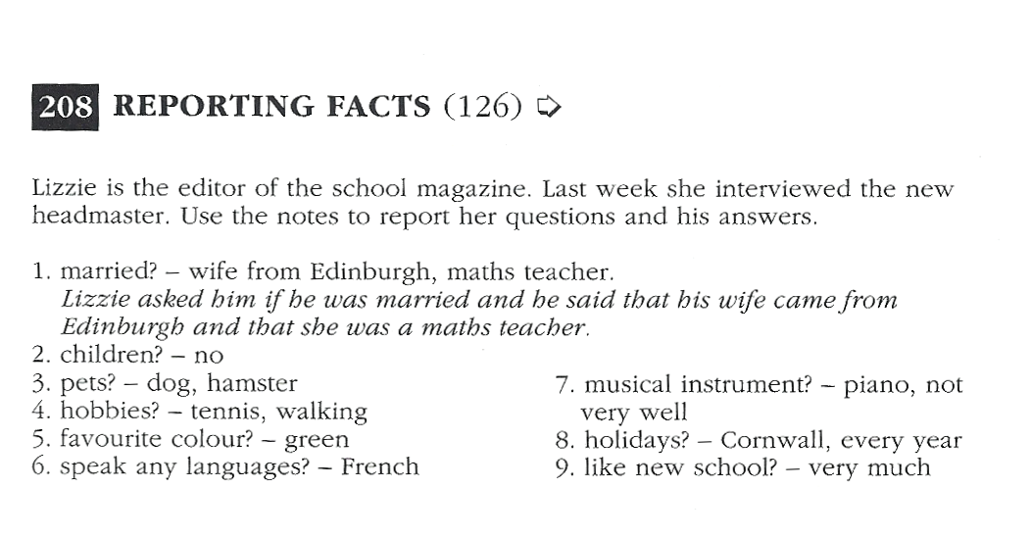
This grammar exercise involves integrated skills (speaking, vocabulary, writing) to generate meaning and is embedded within a clear and realistic context as it arises from an actual situation: A girl named Lizzie works as an editor of a school magazine and she interviewed the headmaster of her school. This interview needs to be reported by the learners. In order to understand this exercise, the first number is already completed and can be used as an example.
Grammatical objective: This activity falls in the category of process as learners are asked to report facts and use indirect speech.
Activity type: Learners can practice this activity in class and as an oral activity either in pairs or small groups and then written for homework. This task intends to use various notes in order to report the editor´s question.
Learning aim and cognitive learning stage: The aim of this grammar exercise is to report facts in the form of an oral as well as written activity. As far as the cognitive learning stage is concerned, this exercise applies to the stage of conceptualisation. On the one hand, pupils must comprehend the message of reporting facts and on the other hand, they must build a hypothesis about the nature of indirect speech.
Item types of this written grammar exercise:
- Expansion
- Learners have to expand notes into sentences.

E.g. (2) children? - no.
= She asked him if he had any children and he said he didn´t.
Source: Newby, David (1992): Grammar for Communication: Exercises and Creative Activities. Vienna: Österreichischer Bundesverlag, 105.

