Evaluating Grammar Activities

I found the following exercise in Unit 3 of the activity book “friends” for the 4th grade. It is a grammar activity which is supposed to train the present progressive tense:

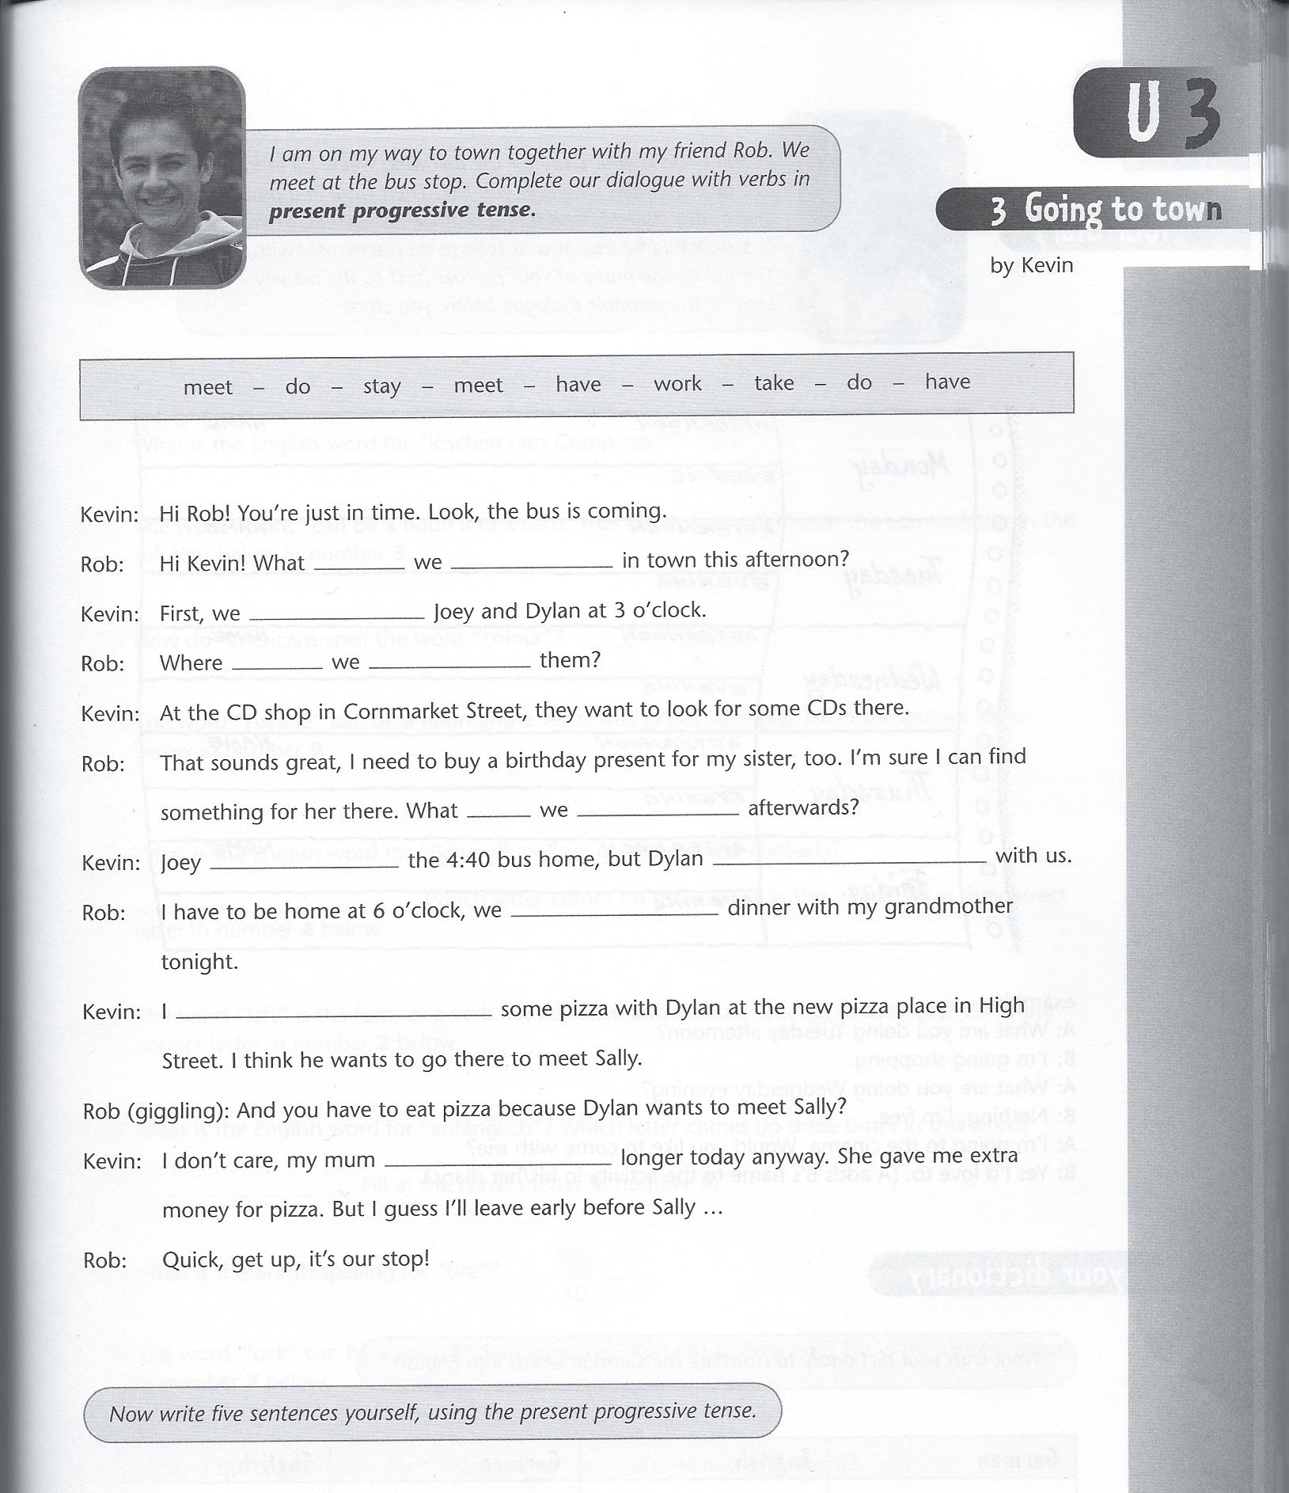

Grammatical objective: In the first part of the activity the students are supposed to fill in the right word from the given box in the gaps, forming the present progressive tense. In the second step the pupils are told to write five sentences, using the present progressive tense. Thus, the main objective of the task is to form the present progressive tense.

Activity type: 1st part fill-in-the-gap, 2nd part writing task (some kind of composition task, because there is a certain drill for the writing task)

Learning aim: With this exercise students should train forming the present progressive form as well as using it in individually formed sentences.

Cognitive learning stage: Conceptualisation (also in the 2nd part of the activity because of the drill to use the present progressive form and because the writing part immediately follows the fill-in-the-gap task. Thus, the pupils do not have to think about the tense they are using to form the sentences very much)

Pedagogical principles: When it comes to the effectiveness of the activity I must say that the exercise is only useful for the awareness of the form of the present progressive tense. As the instructions of the activity say “Complete the dialogue with verbs in the present progressive tense” the drill concerning the task is very obvious. As a result, the pupils own mental activity is reduced to a minimum and thus the students will do the exercise “automatically” since they are asked to produce the same structure again and again. This means that the pupils will not understand the use and meaning of the present progressive tense with this activity, but will only be able to form it when they are asked for it in the instructions.
In the 2nd part of the activity the pupils are asked to form sentences themselves, using the present progressive tense again. This activity is slightly better as it allows a certain degree of freedom and creativity. However, when it comes to the present progressive tense the students will produce it very automatically and without a lot of thinking, again. This is because the preceding activity in which the students were asked to form the present progressive and thus are still in the “forming modus”. Moreover the context is totally missing which will be dealt with in the next part of the analysis.

Communicative principles: As the first part of the activity represents a dialogue in which two young persons are talking about their free time activities, it can be said that there is some kind of connection to the real world. Moreover the instructions of the top of the activity simulate a situation, in which a boy says “I am on my way to town together with my friend Rob. We meet at the bus stop”. Thus, a certain context is created. However, there is a clear lack of context in the 2nd activity, which reduces the quality of the activity enormously. The students could write about anything they want to, which can be very difficult for them. Thus, a few tips and instructions would have been very helpful in order to motivate the students to fulfil the activity in a creative and interesting way.

Coherence: When it comes to how the activity relates to other grammar activities in the text book “friends” it can be said that it is very isolated, meaning that there are no other exercises relating to the activity. This is true for the majority of exercises in the text books. However, there are a few activities in the activity book which relate to activities in the course book vice versa. What all exercises have in common is a lack of context, which results (together with other factors) in a very low quality of the text book in my opinion.

