PS: Communicative Grammar
Dr. Pölzleitner, SS 2013
Andrea Taras
Conditional exercise

Exercise 1 From: Your turn 3, p. 81
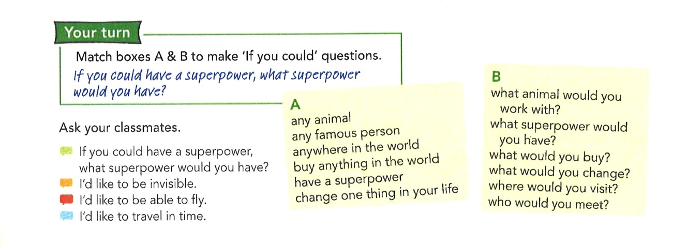

Notions | Conditional: imagined present
Learning Stages | This activity could be used during the proceduralization stage, as students are asked to produce their own ideas and put their procedural knowledge to use, although conditions are still scaffolded
Depth of processing | The activity has good depth of processing, as students are asked to answer questions on both a linguistic level and a content level and encode their own ideas. They must expend mental energy in
Dual processing | Students’ knowledge of the world is directly utilized, and they must express their own opinions and use language in a meaningful way in order to answer the questions.
Personalization | The activity is personalized in its utilization of students’ opinions and ideas to practice the notion/form.
Commitment filter | This activity activates the commitment filter by drawing on students’ need for communication and combining it with relatively fun, thought-provoking questions instead of simply requiring that students transform verbs or reform sentences.
Peer/social learning and interaction | This is an oral exercise, which emphasized peer interaction and social learning.
Teaching vs. testing | This exercise would be better suited to teaching than testing, although it could be used in a oral exam in which the teacher asks the student these questions. However, I would still say that the conditions are a bit too scaffolded to use it for testing as is.

If I were to use this activity in class, I would further adapt it to have students include a reason for their answers (i.e. I would like to travel in time because then I would never be late for anything). Asking follow-up questions gives students another chance to talk about their own ideas, and encourages even more mental activity than simply picking an answer for each question. Individual questions could also be selected and adapted in order to make a text-writing task (i.e. If you could meet any famous person in the world, who would it be? What would you ask them? What would you two do together for a day?).

Exercise 2 From: Newby’s communicative grammar, p. 80

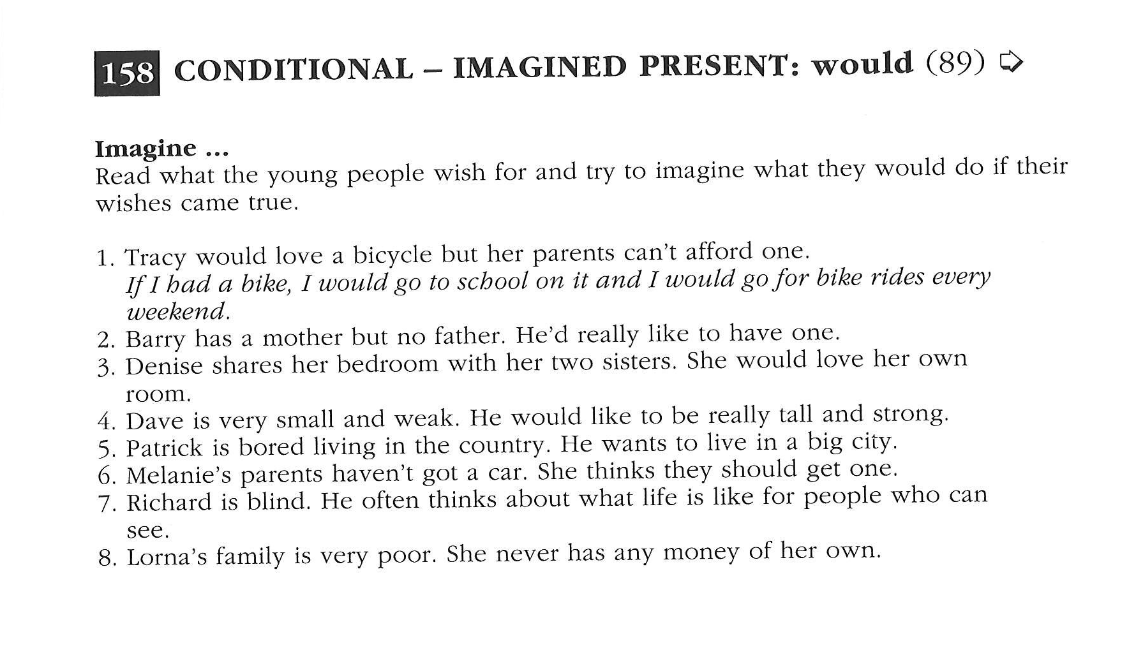
Notions | Conditional: imagined present
Learning Stages | Conceptualization/proceduralizatzion. Conditions for doing the exercise are still somewhat scaffolded, but students are still asked to encode their own ideas in order to complete it.
Depth of processing | Depth of processing is good in this exercise; students must apply their own ideas to the task, thus making use of their mental energy.
Dual processing | Students need to apply their knowledge of the world to this activity, as the answers to the questions are fairly open and ask students to think about different situations.
Personalization | This activity asks students to think of what they would wish for in the situations described, thus making the exercise personalized.
Commitment filter | The lack of communication and fun in the exercise makes me think that this exercise wouldn’t necessarily activate the commitment filter as well as the previous exercise, but perhaps a feeling of success after completing a a fairly unstructured exercise might make up for this.
Peer/social learning and interaction | This activity does not encourage peer learning, although this could easily be changed by having students compare their ‘wishes’ with those of their classmates.
Teaching vs. testing | This activity could be used for teaching or testing, but the scaffolding in the activity makes it more likely that it would be used in teaching.

I liked that this activity provided just enough scaffolding to make the task clear to students, but not so much that it became an exercise in substitution. Although it is not the most interesting exercise, it does practice the notion very concretely and allows students to express some of their own ideas. In order to make the activity more communicative and encourage peer learning, you could have students come up with their own situations in which people wish for things and have a partner tell them what they would wish for in those situations.

