Analysis of a grammar exercise
Michael Schmid

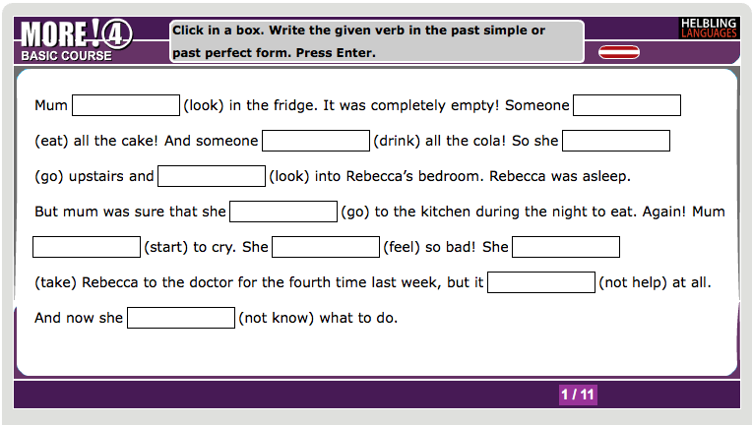
Source: More! 4 (Online). http://www.more-online.at/?pagename=sbx-demo-more-4-pastperfect [2012, June]

Grammatical Objectives / Learning Aim
The grammatical objective of this exercise is to practice reporting past events. It therefore focuses on this grammatical function of the past simple and the past perfect form. The students have to decide which of the two tenses is the correct one in the given sentences.

Activity type
The activity type is written. Since the exercise is taken from the online material of the textbook that is available to all students, it is most likely given as a task that has to be solved individually as homework. The exercise is a gap-filling exercise that provides the students with the infinitive form of the verb in brackets.

Pedagogical Principles (personal selection)
The learning stage of the students filling out this exercise should be the stage of conceptualization. The students already have to know the grammar rule that leads to the right answer, but they are still using it in a very guided context that leaves no room to use it in a free, realistic context. For that stage the exercise is justifiably but not very good. The exercise is providing no chance of giving any personal or creative input. The form of the exercise is very rigid and straightforward, which leads the students to rush through it and the only feeling of success is the end of the exercise. This lack of personalization is, arguably, appropriate for the learning stage of conceptualization. It is a very early stage and therefore has to be straightforward and simple. However, the real problem with this exercise is the low engagement level. The fact that the verbs are already given makes dual processing of the content unnecessary for the leaners. It requires the students to process the language, but not the semantic content of the text. This results in a very low level of engagement and also motivation.

Communicative Principles (personal selection)
The context of the text is clear and all the sentences are part of a connected text. This makes the exercise more authentic and brings it closer to imitating and actual, realistic situation. However, this also means that the given verbs in the brackets are unnecessary. The authors of the book should have included the integrated skill of choosing the right vocabulary. Then the exercise would include more engagement and the context would become actually meaningful. In its current form, the exercise does not need the context to be completed. The students do not have to engage on a deep level and are just filling in the gaps.

Conclusion
The analyzed grammar exercise is not very good. It has to be noted that the rigid form and lack of personalization are acceptable for this stage of learning. However, the lack of dual processing and the given verbs in brackets make it far too easy for the student to complete the task in an offhand way. The context seems to be only pro forma and has, in connection with the given verbs, no clear aim. A way to improve this exercise would be to leave out the verbs in brackets to give the context meaning and bring the students to a deeper level of engagement.

