Communicative Grammar (FPS 2) Peter Mittersteiner
Dr. David Newby 0230328

Exercise Analysis

For the analysis I have taken the following exercise (Illustration 1) from the "More! 3 Workbook, Enriched Course". The exercise is taken from Unit 8 entitled "Steven Spielberg superstar". In the corresponding Student's Book, the relevant grammar is explained in a grammar box (Illustration 2) in German.
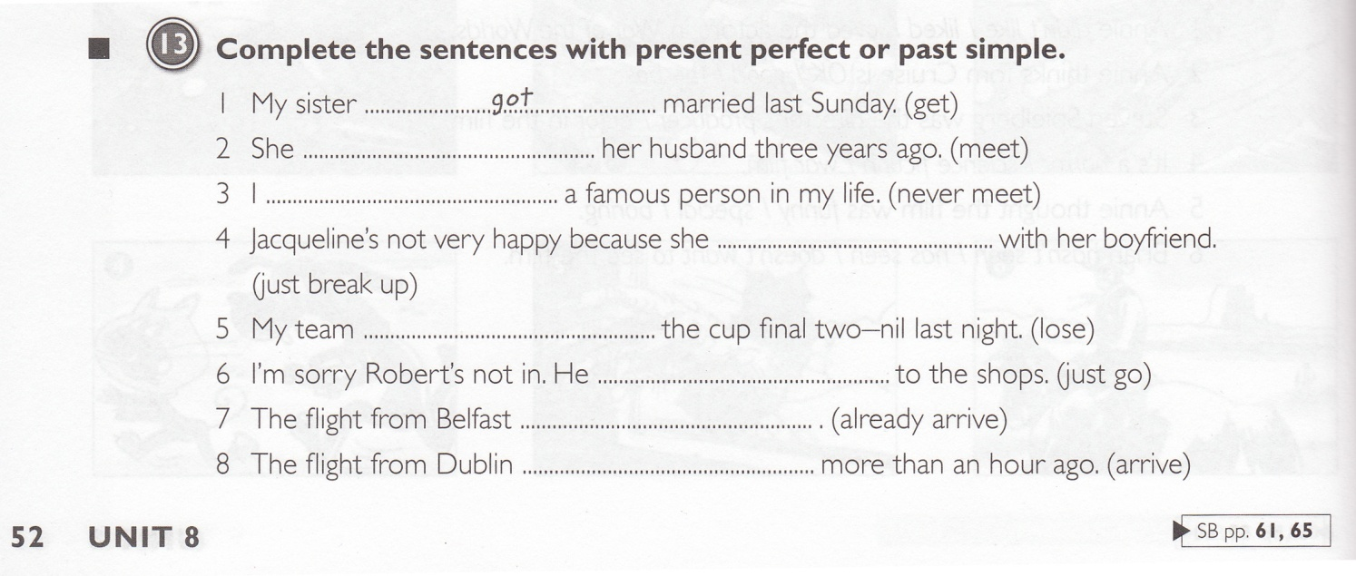
Illustration 1
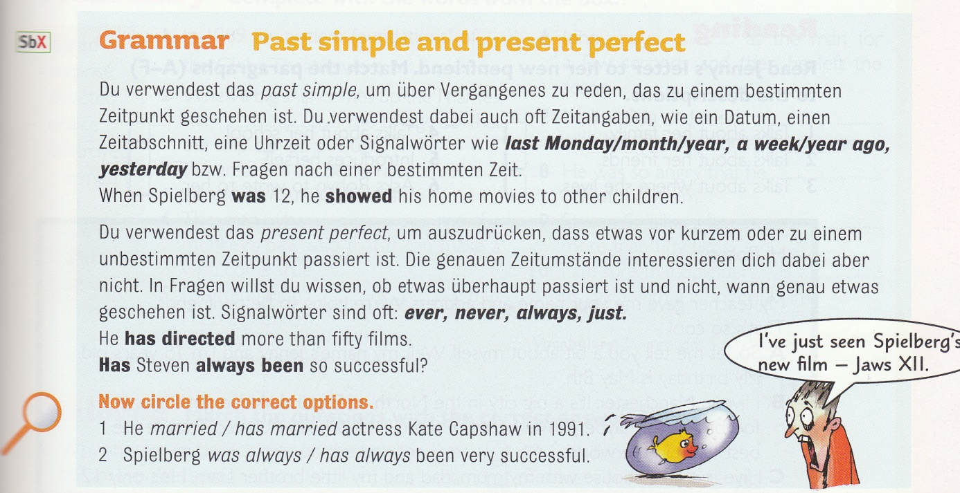
Illustration 2
As far as the exercise is concerned, it is a simple written completion exercise, where students have to fill in the gaps (in sentences with cued words in brackets). Arguably, there are two grammatical objectives. One would simply be the correct forms of present perfect and past simple, as students obviously need to know these forms in order to complete the exercise. The second and primary objective of this exercise is for pupils to decide which tense to use in each sentence. For this, students have to grasp the meaning of the sentence and based on what they have learned, decide which tense to use. It follows, that the learning aim would be for students to learn when to use present perfect and past simple.

Concerning the cognitive learning stage, the exercise would probably have to be located in the conceptualization stage. The exercise is clearly guided, does not involve any dual processing, is not open ended and does not encourage pupils to add any real-world language input of their own. Consequently, pupils are likely to focus on the rules they have been given in the grammar box (perhaps even look at them for reference while doing the exercise) and decide on a sentence by sentence basis which tense to use. During this exercise, they might attempt to internalize the rules, but they are not practicing the use of these two tenses in their own language production.

The pedagogical effectiveness of this exercise is fairly limited. While it can help pupils to conceptualize that there are different occasions for each tense, what it mainly does is have them look for signal words that they can then find in the grammar box and on this basis decide which tense to use. However, this is not how language works and it is not how the tenses are chosen in a real world situation. In addition, there is no personalization, no dual processing , the exercise is not fun and the sentences are isolated. Also, even though pupils have to use the correct tense, this exercise has all the ingredients for a testing exercise that relies on declarative knowledge (rules, signal words) and focuses on "do you know".

Even as a conceptualization exercise, there is a problem with the rules that are given. The rules are not always true (in other words, they are not really rules at all) and do not distinguish between different notions of the tenses at hand. As an example, for the present perfect the rule is: "recent or unknown point in time" + signal words. The signal words already though, only state that the present perfect is "often" used with "ever, never, always, just" but not always. In the exercise, at least the following notion for the present perfect is not covered with the rule: experience (3). This is neither a recent event, nor an unknown point in time, it relies entirely on the signal word. Signal words, however, can be deceiving since sentence 4 a vast majority of native speakers would complete with "just broke up" rather than "has just broken up", although the rule and signal word in this case would clearly indicate that this is a "recent event" and has one of the signal words on top of it.

The exercise is not very communicative for the following reasons: The context could be more realistic if there was a coherent text or short story instead of just isolated sentences. Language is not processed in a realistic way, since normally humans do not think of entire sentences with the verb in brackets only to then decide which tense to use. Except for the exercise being task-based, it does not rate high on any of the criteria for communicative exercises.

The above criticism is lessened by the fact that this is only the second exercise in the workbook concerning the use of present perfect and simple past. Of the 4 following exercises, 2 are of the same type (filling in the correct tense with verbs giving in brackets) and two exercises take the learner to other learning stages, where they have to write entire dialogues of their own or fill in entire sentences. The problem remains however, that for a conceptualization exercise, it is very important to provide clear concepts and this is hardly the case here. Also, the rules the Student's Book provides are neither precise nor are they really valid generalizations. Therefore, pupils might internalize faulty concepts, which should be avoided.

