Analysis of a grammar exercises
present perfect progressive

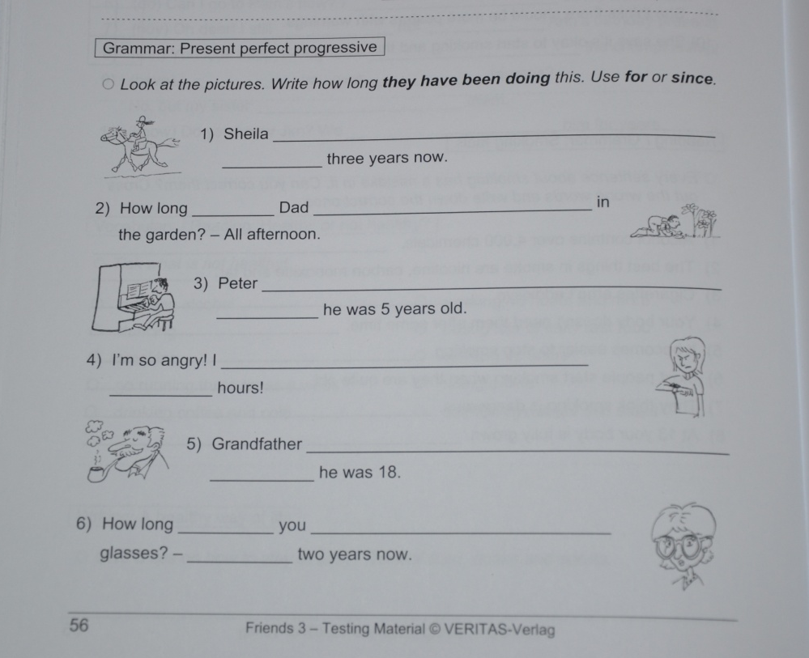
The following grammar exercise is taken out of the exercise book “Friends 3” (Frießnegg, B & Strauß, A . 2008. Friends 3: Standard & Plus, Testing Material. Linz: Veritas Verlag. 56)

I decided to analyse this exercise according to the pedagogical principles that determine whether an exercise is effective or not.
1. Learning stage
This exercise “supports” the conceptualization stage as the student has neither to build up his own sentences nor to bring in his personal perception of the world. It is a simple reproduction of grammatical patterns that are already provided by the instruction.
2. Depth of processing
This exercise does not activate the student´s mental energy at all and is thus cognitively shallow. The only thing that has to be achieved is to be able copying grammatical constructions. The actual context in which present perfect progressive occurs is not paid any attention. Moreover, the student is not given any information about the grammatical notion that this exercise is actually addressing.
3. Dual processing
There is zero dual processing. This is usually never the case with traditional fill-in-gaps exercises as the student is already given a sentence where only the grammatical form is missing. Therefore, the learner does not need to think and reproduce his own perception of the world onto language. Even if this exercise requires the student to process language, it does it in a way that prevents learners from activating and improving their declarative as well as procedural knowledge. Instead, this exercise rather tests vocabulary knowledge.
4. Personalisation
This principle cannot be found. The above exercise already provides ideas and thus leads to a passive commitment on the side of the learner.
5. Commitment filter
Exercises should contain a certain fun factor and include potential experiences of success. The latter might occur to a minimal extent in the exercise; however it is not connected with a satisfying understanding neither of the tense nor of the notion. Clever students could possibly have an “AHA!”-effect as far as the notion (duration of an activity) is concerned by reading the instructions carefully: “Write how long they have been doing this!”. This is, however, a game of hide-and-seek that is not accurate in language teaching and that does not support foreign language learning.
6. Learner´s schematic knowledge
Students do not have to bring in their own ideas! They are already entirely provided.
7. Social learning
This written exercise does not demand any group work and is thus not enhancing the pupils’ social competence.
8. Interaction
Just like with social learning there is no interaction, which is generally rather difficult to evoke with written exercises. Besides that, the exercise is zero communicative.
9. Testing vs. teaching
As the above exercise is not a contrastive one, it does not test but is rather supposed to support learning. However, the exercise does not successfully fulfil its original purpose, as no additional information concerning the grammatical notion is provided.
10. Do you know vs. can you use?
This exercise has no intention of requiring students to use grammar. Instead, it focuses on the declarative knowledge in a very passive way. However, it is the active participation that makes learners advance from one learning stage to another until they are finally able to accomplish tasks in a real-time context by themselves.

