Eric’s Intercultural Experiences
A reading-writing project to prepare language learners for an exchange trip abroad.
Lis Pölzleitner & Jennifer Schumm Fauster
Class-trips abroad are certainly one of the most motivating experiences for language learners. After years of studying the language in the classroom, they can finally test their skills in real life. This is especially the case if the learners live in host families in the foreign country and accompany their host-brothers and sisters to school for a week. On the other hand, class-trips are very expensive and therefore should be more than fun package-tours during school time. In order to ensure that the latter is the case, it is important for teachers to prepare their learners for their stay abroad so that they can profit from it as much as possible.
The aim of the following paper is to present a reading-writing project, which is framed around Shaun Tan’s (2008) picture book story “Eric.” The purpose of the project was to prepare language learners for a class trip abroad in which they were not only required to consider their perceptions and expectations of what they might experience in their given host country but also reflect on their experience abroad once they were back in their home country. In this way, it was hoped that learners’ curiosity about the culture(s) of their given host country could be further enhanced, preconceived cultural notions and stereotypes could be addressed and that learners gained a deeper understanding of both their own culture(s) and those they experienced while abroad.
Defining culture
The use of culture in this reading-writing project will be understood as that used in the concept of intercultural competence. This understanding of culture goes beyond “Big C” or “little c” understandings of culture, which refer more to artifacts and culturally-induced behaviors, respectively (Tomalin & Stempelski, 1993). Although based on the understanding of culture in the nation state, intercultural competence
characterizes a form of language competence that is less focused on approximating a native speaker linguistic or pragmatic norm than it is based on the subjective experience of the language learner engaged in the process of becoming bi- or multilingual and struggling with another language, culture and identity. (Kramsch, 2009, p. 223)
Thus, when taking an intercultural approach to culture, emphasis is placed more on how the language learner negotiates, creates and mediates meaning for them personally in a cross-cultural context.
Intercultural learning in the language classroom
According to Müller-Hartmann and Schocker-v. Ditfurth (2009), the Common European Framework of Reference for Languages (CEFR) sees intercultural competence as “the main goal of foreign language learning” (p. 18). Indeed, the CEFR states that one of the main purposes of language education is to promote intercultural learning.
In an intercultural approach, it is a central objective of language education to promote the favourable development of the learner’s whole personality and sense of identity in response to the enriching experience of otherness in language and culture. (Council of Europe, 2001, p. 1)
Furthermore, in reference to the foreign language learner, it recognizes that not only language learners’ linguistic competences but also cultural competences are enhanced when learning another language, thus highlighting the development of the intercultural dimension:
The learner of a second or foreign language and culture does not cease to be competent in his or her mother tongue and the associated culture. Nor is the new competence kept entirely separate from the old. The learner does not simply acquire two distinct, unrelated ways of acting and communicating. The language learner becomes plurilingual and develops interculturality. The linguistic and cultural competences in respect of each language are modified by knowledge of the other and contribute to intercultural awareness, skills and know-how. They enable the individual to develop an enriched, more complex personality and an enhanced capacity for further language learning and greater openness to new cultural experiences. (Council of Europe, 2001, p. 43; italics and bold print in the original)
The understanding of intercultural competence used in this reading-writing project is based on Byram’s (1997) model, which has played an important role in promoting the intercultural dimension in the foreign language classroom (Kearney, 2016; Spitzberg & Changon, 2009). According to Byram (2009), “[t]he model in question is firmly based in foreign language teaching,” and when proposed, “deliberately referred to the Council of Europe,” which, as noted above, has been instrumental in promoting interculturality in foreign language teaching and learning (p. 322). Byram’s (1997) model is composed of five dimensions of intercultural competence. These include:
- Attitudes: curiosity and openness, readiness to suspend disbelief about other cultures and belief about one’s own;
- Knowledge: of social groups and their products and practices in one’s own and in one’s interlocutor’s country, and of the general processes of societal and individual interaction;
- Skills of interpreting and relating: ability to interpret a document or event from another culture, to explain it and relate it to documents or events from one’s own;
- Skills of discovery and interaction: ability to acquire new knowledge of a culture and cultural practices, and the ability to operate knowledge, attitudes and skills under the constraints of real-time communication and interaction;”
- Critical cultural awareness/political education: an ability to evaluate critically and on the basis of explicit criteria perspectives, practices and products in one’s own and other cultures and countries” (Byram, 2000, p. 9).
An advantage of working with Byram’s (1997) model in the language classroom is that it provides language teachers with a set of teaching objectives which can inform their teaching and guide their assessment of learners’ intercultural competence(Kearney, 2016; Moeller & Nugent, 2014). In this reading-writing project, Byram’s (1997) model served as a basis for the teaching objectives.
Intercultural learning during a stay abroad
While the foreign language classroom provides many ways to promote learners’ intercultural competence, there is no denying that it can be further enhanced by taking the opportunity to go on a class-trip abroad. However, in order for the stays abroad to be fruitful, it is important that learners “continue to work as a class with their teacher” (Byram, 1997, p. 68). The reason for having continued contact with the teacher is the general acknowledgement that “[w]hile intercultural experience is likely to enhance participants’ intercultural learning and personal development in many ways, immersion itself does not guarantee success” (Hua, 2014, p. 159).
A recent large-scale longitudinal study by Vande Berg et al. (2009) supports Byram’s (1997) and Hua’s (2014) view that intercultural learning should be further mediated by a mentor when learners are on a stay abroad. In the study, students’ language skills and intercultural competence were assessed while abroad on sixty-one study programs within the Georgetown Consortium Project. The findings of the study showed that students’ language skills and intercultural competence did develop compared to the students who did not go abroad; however, they also showed that time spent abroad is not a guarantee that these areas will indeed develop. For this reason, Vande Berg et al., (2009) recommend that learners have contact with a “well-trained cultural mentor” who ensures that both language skills and intercultural understanding are further developed (p. 32).
Although supporting learners’ intercultural learning during a stay abroad seems to be paramount, this is only one phase of the process when preparing learners for their class trip. Byram, Gribkova and Starkey (2002) state that there are three phases which teachers should keep in mind: the preparatory phase, the fieldwork phase and the follow-up phase.
In the preparatory phase, Byram et al., (2002) state that learners should be given the opportunity to “externalise their thoughts, anxieties and excitements about their visit” (p. 14). This “helps the teacher to know […] learners’ starting point” (Byram et al., 2002, p. 14). The work done during this phase should then be revisited after learners have returned from their stay abroad allowing them to “compare and contrast expectations and experience” (Byram et al., 2002, p. 14).
In the fieldwork phase, during which learners are actually experiencing being abroad, they should be given the “opportunity for withdrawal from the demands of being in a new environment, an opportunity for reflection alone and together with others” (Byram et al., 2002, p. 14). During this phase, it is also important for teachers to act as ‘cultural mentors’ by discussing misunderstandings or any difficulties they may be encountering. For Byram et al., (2002), it is imperative that this is done while the learners are abroad “as the emotional involvement is very deep and [therefore] needs to be handled immediately” (p. 15).
The final stage of a class-trip abroad is the follow-up stage. During this stage, learners are asked to reflect on their stay. For Byram et al., (2002),
the emphasis should be on further reflection on individuals’ experience during the visit and, by sharing and comparing, on an attempt to analyse and conceptualise what has been experienced as a basis for understanding (some aspects of) the other environment and the people who live there. (p. 15)
This phase seems to be very important in order to ensure that learners consider what they have experienced concerning both knowledge but also personal experiences (Byram et al., 2002).
Finally, Byram et al., (2002) state that besides having learners express their thoughts and experiences in written form, they can also be encouraged to do so “with the aid of visual representations” (p. 15). To this end, they recommend letting learners “draw, take photographs, make diagrams to capture experience and to express their feelings” (Byram et al., 2002, p. 15). In this way, learners have additional outlets to express themselves when words in their L1 or L2 may not be enough (Byram et al., 2002).
Choosing the right input to introduce the topic
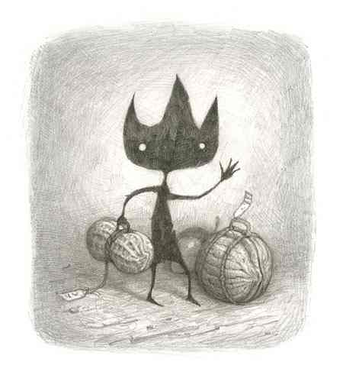
We chose the picture book story “Eric” by Shaun Tan (2008) in order to introduce the topic. In Tan’s story, which is told from the viewpoint of the host family, an extraterrestrial exchange student named Eric visits a family and surprises them with his unexpected behavior and questions. He seems very inquisitive, asking questions which may seem bizarre to those who have become blind to the patterns of everyday life. His hosts come to the conclusion that some of Eric’s behavior must be a “cultural thing.” The story is told in beautiful pictures that leave a lot of room for interpretation, and is accompanied by a minimum of words. The story raises the question of how culture shapes our perception and behavior. While textbooks regularly present topics of surface culture, such as sights, holidays, celebrations and habits, Shaun Tan’s story invites the reader to explore the uncharted depth of “deep culture,” the invisible strings that guide us. Thus, learners are invited to reflect on their attitudes about other cultures as well as their own and use skills of interpreting and relating when observing Eric’s behavior.
Figure 1 Eric, Shaun Tan 2008
Figure 1: Eric, Shaun Tan 2008
Why a picture book?
At first sight the picture book might seem a bit childish for 15-year-old learners, but when looking more closely, it opens a whole new world waiting to be explored. The pictures and minimal words create more questions than answers. According to Tan (2001), “a successful picture book is one in which everything is presented to the reader as a speculative proposition, wrapped in invisible quotation marks, as if to say `what do you make of this?´” This openness provokes questioning and
in asking questions of the book, the reader is inevitably asking questions about their own experience in seeking individual closure. What aspects of it are familiar, and why? What does it remind you of, or make you think about? This is a picture book that works through such resonance rather than recognition, or any didactic imperative; ideas and feelings are evoked rather than explained.
In this sense, the story “Eric” provides a springboard for exploring subtle cultural values and behaviors and raising learners’ awareness of cultural differences they might encounter while on a class-trip.
In addition, for Miller (2014), working with pictures combined with discussions and writing tasks, can intensify the reading experience as well as promote intercultural learning. Miller (2014) states:
Zusammenfassungen des Geschehens, Spekulationen und Diskussionen über bestimmte Ereignisse mit Bezug zur Lebenswelt der Schüler sowie alle gängigen Verfahren der kreativen Umgestaltung der Vorlage in Texte als Vorlage für das szenische Spiel sind denkbar. Gerade solche Transformationen führen dazu, dass das dargestellte Fremdverstehen von den Schülern immer wieder erkannt und bewusst nachvollzogen werden muss. (p. 11)

Eric’s intercultural experiences: a reading-writing project
The project was designed as a cross-curricular project in the learners’ first and second foreign languages in a class of 15-year-old students in Austria. The main part of the project was carried out in English (learners were in their 5th year of learning the language), some of the smaller parts were done in the learners’ second foreign language (learners were in their 3rd year of Spanish or French) in order to prepare them for their respective trips to Spain or France. Due to the lower level of proficiency in Spanish and French, these parts mainly dealt with the description of events and basic surface culture phenomena like food, daily routines at home and in school. The more demanding tasks and class discussions were done in English in order to allow the learners to dive deeper below the surface and consider different perspectives as well as preconceived notions. The class trips to France and Spain lasted a week and were followed by return visits of the foreign students at the Austrian school. The tasks in this project can be used to prepare language trips and intercultural exchange trips to any country or culture.
The main teaching goals of this project were:
- to develop learners’ curiosity about new cultures and experiences
- to raise learners’ awareness of cultural aspects of their everyday lives
- to challenge learners’ attitudes including preconceived notions and stereotypes
- to develop learners’ understanding of the various layers of “culture” (surface culture, deep culture) and their influence on human behavior (universal / cultural / personal dimensions of human behavior)
- to develop learners’ skills of interpretation (observing, comparing/contrasting)
- to improve learners’ story-writing skills in English (L2)
- to teach the language of “thank-you cards” and “describing personal experiences” in the learners’ L3 (French or Spanish)
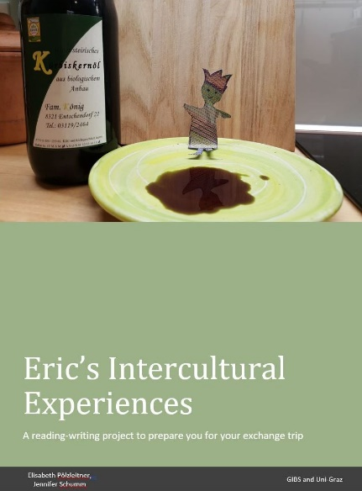
Getting started
Figure2: Student booklet, Pölzleitner, Schumm
On the first day of the project, the learners were given a copied project-booklet including all of the tasks which they would be required to do both individually and in small groups. They were told that that booklet would serve as kind of portfolio to scaffold their whole experience of going abroad from preparation time in Austria to their return home again.
The tasks are presented below. For each given task, learner instructions are provided, followed by teachers’ observations. The tasks alternately deal with the learners’ home culture and their views of the foreign culture both before and after their trips. It was hoped that the project would help them to notice more than just surface culture phenomena during their trips and to question what they encountered. A complete copy of the student booklet can be downloaded from www.epep.at/eric

Task 1: Eric’s questions:
Instructions:
Read the story of the foreign exchange student Eric, then discuss the following questions in class:
At the beginning of the story the narrator says: “Secretly I had been looking forward to having a foreign visitor – I had so many things to show him. For once I could be a local expert, a fountain of interesting facts and opinions. Fortunately, Eric was very curious and always had plenty of questions. However, they weren’t the kind of questions I had been expecting.”
What kind of questions would you have expected from Eric?
Teachers’ observations:
As expected, the students enjoyed reading the story and could easily relate to the idea of having a foreign exchange student in their homes. They quickly collected a long list of likely questions that they would have imagined from Eric. Interestingly the most common question in all student booklets was: What is your WIFI password? Other very common questions concerned everyday routines in their families and school, questions about the program and local sights and shopping opportunities (e.g., What time do we have to get up? How do we get to school? Where do we eat lunch? Where can I get a tram ticket?). In this task, learners’ expectations and personal experiences were elicited in order to prepare the ground for the next step.
Task 2: Eric’s questions
Instructions:
What kinds of questions do you think Eric actually asked? Look at the pictures taken from the story and speculate what kind of questions Eric might have asked. Write them down on this page. Then discuss possible answers with your partner.

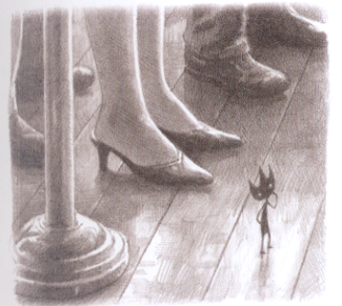 | 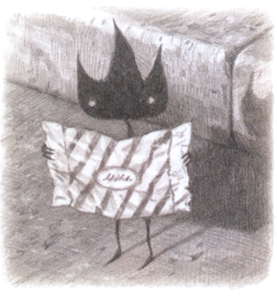 | 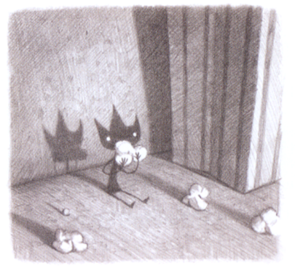
Figure 3: Eric, Shaun Tan, 2008
Teachers’ observations:
In this task, learners were required to switch perspectives and look at their everyday world through the eyes of an outsider– an extraterrestrial even. Most learners found this quite challenging and, therefore, it took a while to find possible questions. In the first round of questions, they asked the obvious: Why are they wearing shoes? or What is the floor made of? Eventually learners started to see more than just objects and started to question some of their everyday behaviors such as: Why do women wear different shoes than men? Why is each piece of candy wrapped individually? Why do we all eat popcorn in the movie theater – why not something else? These questions led to interesting discussions about the role of men and women in our society and the way we waste resources and pollute our environment. The question about popcorn in movie-theaters led to a discussion of typical foods that are eaten on special occasions. This task served as an eye-opener and encouraged the learners to look at their own culture with a magnifying lens and to become aware of the cultural dimension of everyday routines that they had never questioned.

Task 3: The cultural iceberg
After this first attempt at switching perspectives the students were ready to tackle the topic of culture on a more theoretical level and explore the concept of the “cultural iceberg.” Referring to culture as an iceberg is an often used metaphor to depict the various parts of culture(s). The visible part of the iceberg stands for aspects of culture which are more readily recognized while the invisible part of the iceberg refers to aspects of culture that take more time for people to notice (see Hua, 2014; Utley, 2004).
Instructions:  Eric’s questions are unexpected; they cannot be answered by a guidebook for tourists. His questions refer to “deep culture,” while the typical tourist questions would refer to “surface culture.” Have a look at the cultural iceberg to understand these two concepts better.  Then draw a cultural iceberg for Austria and fill it with keywords of things and ideas that make up Austrian culture. What would you put in surface culture and deep culture?  Draw a second iceberg for the country you are going to visit. Draw your iceberg before your trip and fill in all the things you already know or expect to find. Add, change and correct your ideas after your trip. | 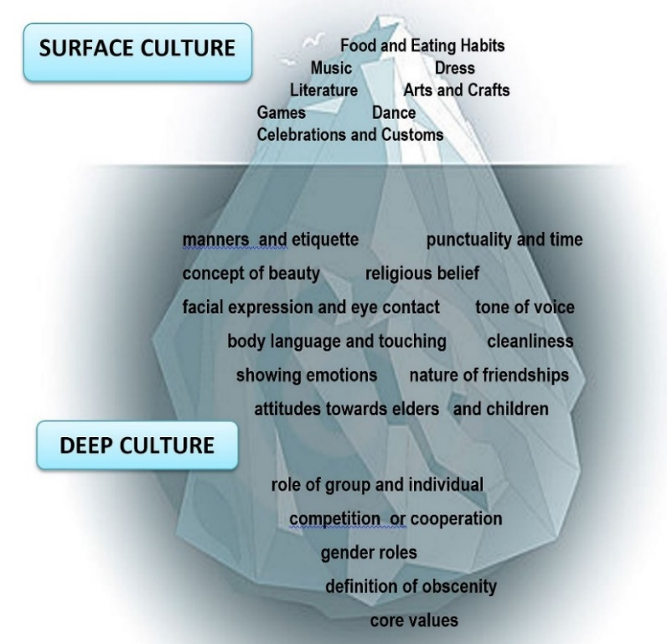  Figure 4: Cltural iceberg
Teachers’ observations
After discussing the different layers of the cultural iceberg, the learners drew their own icebergs: one for Austria and one for the country of their upcoming exchange trip. The first collection of cultural features was fairly stereotypical and can mainly be classified in terms of “surface culture.” The most common features that were collected are shown in the table below.

The learners’ perceptions and expectations before the trips
Austria | France | Spain
Food | Food | Food
Kaiserschmarrn, Germknödel, Wienerschnitzel, Kernöl, Mozartkugeln, Sachertorte, apple strudel, beer | French bread (baguette), cheese, snails, oysters and frogs | tortillas, paella, potatoes, tapas, spicy food
Dress | Dress | Dress
Dirndl and Lederhosen were mentioned by almost all students, even if hardly any of them own these. | No special clothes were mentioned for the foreign cultures.
Music and Arts | Music and Arts | Music and Arts
The “Austrian icebergs” showed Mozart, Beethoven (although he was actually German), folk music, yodeling, dancing the waltz, traditional Austrian folk dancing, accordion music, Klimt, Vienna Opera Ball. |  | dance, Tango, Flamenco, bullfights
Sports and games | Sports and games | Sports and games
skiing, soccer, card games (Schnapsen) |  | swimming, beaches,
Celebrations: | Celebrations: | Celebrations:
Christchild (rather than Santa), Bleigießen (“pouring-lead”; a fortune-telling custom done at New Year’s)

After the trip, learners added new features that they had become aware of during the program. Thus, they revisited with their initial perceptions and compared them to what they had experienced while abroad. Their answers varied depending on the countries they had visited, but it is obvious that the learners noticed several aspects of deep-culture that they had not been aware of previously. The following topics were mentioned by the majority of the students: ways of greeting, homes, food, table manners, punctuality and time, discipline and politeness, showing emotions, volume/tone/pace of voice and religious practices. Below is a sample of some of observations they made:
Greeting: Greeting was mentioned and discussed by all groups and the number of expected hugs or kisses in different countries lead to a lively discussion among the two groups.
Home: The students noticed that in Austria we take off our shoes when entering our homes. They had also become aware of the fact that we drink tap-water rather than bottled water and learned to appreciate the high quality of our drinking water, a detail that many had not been aware of before.
Food: Students listed some typical foods of their host country. The most interesting thing they noticed is the absence of dark bread (rye bread), which is the preferred type of bread in Austria.
Table manners: Many students were puzzled by different table manners. They noticed that Austrians keep their forks in the left hand during the whole meal, while their Spanish hosts shifted their forks to the right after cutting the food, just like Americans do.
In the French group most students commented on the fact that their hosts did not use plates for breakfast but only napkins, which left lots of breadcrumbs on the table. This made them feel uncomfortable.
Punctuality and time: Many students commented on a different understanding of meeting times and explained that Austrians tend to arrive at meetings on time or 15 minutes late, while, for example, their Spanish partners were always very late (up to two hours late). They also noted that everything happened much later in the day and dinner was served at a time when they would normally go to bed at home.
Discipline and politeness: This was the topic that was discussed most by the students. They noticed several differences concerning politeness. Many commented that the German “Du/Sie” seemed to create more respect towards teachers (even though we only speak English at our school). The learners noticed that teachers were addressed by their first-names in Spain and, therefore, felt that they were respected less; discipline in school was more relaxed in both Spain and France, and some learners found the students’ behavior impolite.
Almost all of the students who had been in Spain commented on the fact that their hosts were surprised by the fact that they showed their gratitude and said “thank you” after each meal and whenever their hosts had done something nice for them. This behavior was discussed in almost all families and the students found out that saying “thank you” is not expected as much as it is in Austria. This difference became even more obvious when the foreign exchange students visited Austria and were hosted by our students’ families. Some complained about rather rude behavior – which could later be explained simply by the fact that the exchange students had never thanked their hosts for all the trouble and all the effort they had put in to accommodate them and to offer them an interesting and varied program.
Showing emotions: This was commented on repeatedly by the Spanish group. Learners noticed that their hosts showed positive as well as negative emotions very clearly and directly.
Volume, speed and tone of voice: The learners noticed a higher volume as well as more emotional modulation among their Spanish peers.
Religion: The students who had gone to France noticed that religion did not play any visible role in society and that wearing crosses was forbidden in school. On the other hand, the students who had been in Spain noticed that most of their peers were wearing little crosses around their necks and seemed to be practicing their catholic religion openly.

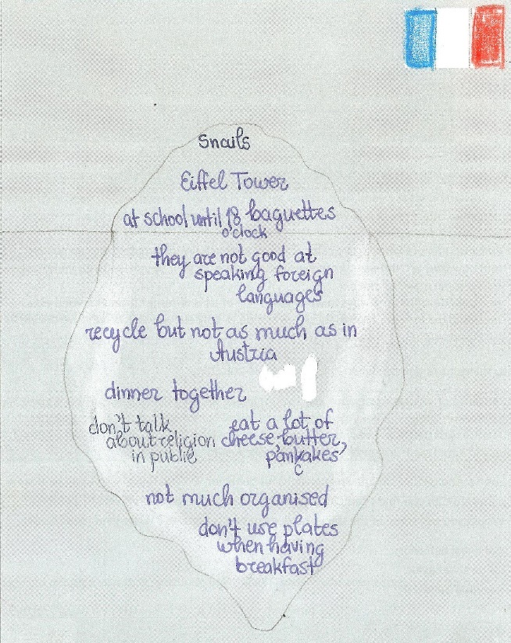  Figure 5: A cultural iceberg for France | 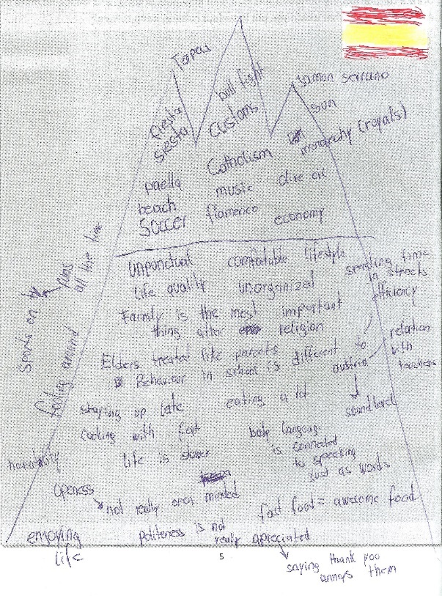  Figure 6: A cultural iceberg for Spain
Task 4: Universal, cultural and personal behaviors
In order to avoid unreflected stereotyping, the following step focused on the different dimensions of human behavior as proposed by Hofstede’s (1997) pyramid model of universal, cultural and personal behaviors. The students first found examples of these layers in Shaun Tan’s story “Eric” and then analyzed their cultural icebergs according to these categories.
Instructions:
Look at the pictures in “Eric” and consider his behavior. Do you think everything he does is cultural? Can you find examples of behavior that can be seen as universal or personal? Would you put some of the things he does in two categories?
Teachers’ observations
After exploring the story for behaviors at these three levels, learners used the examples collected in their cultural icebergs and shared their impressions. As with the iceberg task, this one was also re-visited after learners had returned from their stays abroad. In a whole-class discussion, learners hypothesized about whether some of the behaviors they had noticed during their trips might be considered as universal, cultural or personal.
This discussion was eye-opening for many learners, as some of their categorizations were confirmed while others were disputed by their classmates. In the course of this discussion learners noticed that they had not seen any evidence of some of the expected and stereotypical behaviors that they had collected in their icebergs. Obviously French families do not eat oysters, frogs and snails every day and rather than wearing haute couture design fashion, many of the hosts went to school in their jogging pants. On the other hand, students who claimed that all Spanish children drink juice-boxes on a daily basis were corrected by others and found out that such routines may be influenced by a family’s awareness of health issues or even by socio-economic status, rather than by culture. It seemed that through the exchange of observations, students became more cautious and more careful concerning their classifications and preconceived notions of different cultures.
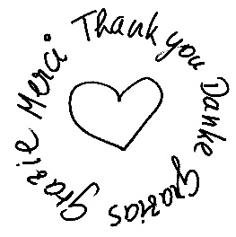
Task 5: Saying “thank you”
This task explores the notion of gratitude in different cultures. In Shaun Tan’s story, Eric leaves behind a shelf full of colorful flowers made from all the little bits and pieces of scrap-materials that he had wondered about and collected during his stay. While all of the other pages of the story are black and white, Eric’s fare-well gift is printed in color. The learners were asked to speculate about this fact and they noticed the high value attributed to showing one’s gratitude and the joy this can create.
Figure7: Thank you

Instructions:
After Eric leaves, the family isn’t really sure whether he enjoyed his stay or not. However, when they open the cupboard where he had slept and studied, they got their answer.
- How did Eric say “thank you” to his host family?
- Why do you think this page is in color and not black and white?
- How do people show their gratitude in Austria? In your culture?
- How do people say “thank you” in France/Spain?
Write a “thank you” card for your host family. Thank your potential host family for your wonderful stay. Include details of what you liked a lot and what you are grateful for. Write your card in English and in French/Spanish. Ask your French/Spanish teacher for any words that you need in order to express your ideas.

Teachers’ observations:
The aim of this task was to raise learners’ awareness of the importance of saying “thank you” and showing their appreciation of their host families’ efforts and hospitality. In Austrian culture, these can be seen as highly valued social skills. One is generally expected to thank one’s host after each meal and to regularly express one’s appreciation of the host’s efforts to make one’s stay comfortable. A lack of doing so may be interpreted as a sign of dissatisfaction and/or rudeness.
As teachers, we instructed the students to thank their hosts during their trips and to leave a personal thank-you card in an unexpected “surprise” place in their hosts’ homes on the last day. Interestingly this little task led to highly interesting discussions in class after the students’ return to Austria. Since the topic of saying “thank you” had been made a conscious issue in this project, many students addressed it in their host families and learned, for example, that their Spanish hosts did not expect to be thanked for little things. The Spanish families found the fact that the Austrian students thanked them after each meal and for every little favor they had done as quite surprising. As a result, they found the Austrian students’ behavior to be too formal and just as inappropriate as some of the Austrian students later noted about the Spanish exchange partners staying with them in Austria who never thanked them or their parents for all of the efforts they had made in order to please them. Interestingly, becoming aware of this seemingly insignificant difference turned out to be of major importance for developing intercultural understanding and relationships.
Task 6: Story writing: slipping into Eric’s mind and walking in his shoes
The final task required learners to apply the newly gained perspectives and insights they had gained by completing the reading-writing project as well as by spending time abroad in their respective country. In order to achieve this, learners were asked to write their own “Eric” stories in the vein of Shaun Tan’s story. Each student wrote one episode of “Eric in Austria” and a second one about “Eric in France or Spain.” To prepare for this task, the students re-read the original story and tried to slip into the role of Eric and see the world through his eyes. They created their own little Eric or Erica figures from paper or cardboard and took pictures took pictures of things that Eric(a) might have noticed from a visitor’s point of view in their homes, school and town in Austria. After doing this, they wrote up Eric(a)’s story. They repeated this procedure during their stay abroad, where they took pictures of Eric(a) in situations that showed small cultural differences that they had noticed and later used these to illustrate their stories. The detailed, step-by-step instructions for the learners can be found in the downloadable project booklet (see above).

For this final task, the learners followed the typical steps of process writing. In their final products, learners, which many took great pride in, illustrated their stories with their pictures of Eric(a) and published them as online flipbooks using the free web-service www.aXmag.com. This last step of making their work visible to each other and the general public seems to be highly important and creates a strong motivation to produce high quality work. As described in numerous publications on the neuroscience of learning, e.g. Zull (2002, p. 221ff) feelings of success are associated with the release of dopamine and other neurotransmitters in the brain and trigger a positive motivational spiral in the learners. In our own teaching, the motto “FIP: Format, Imagination and Pride” has again and again triggered a positive spiral of good effort and creativity that leads to a sense of achievement and success in the learners. A selection of the final flipbook stories can be found on the project page on www.epep.at/eric.
Teachers’ reflections
The final stories seemed to show once again that learners found it easier to reflect on cultural aspects in the foreign country than noticing cultural aspects in their own environment, even after hosting their exchange partners in their homes. Another challenging aspect of writing these stories was that they were required to switch perspective. Shaun Tan’s original story is narrated from the point of view of the host family who is trying to interpret Eric’s behavior. This switching of perspective was fairly difficult for the learners. As a result, many learners simply narrated Eric’s experiences as they had perceived them themselves. Nevertheless, we encouraged the learners to play with this switch of perspective in their second drafts in order to improve their writing skills and their awareness of different points of view in stories. As can be seen in the final stories, many students succeeded very well and some of the stories can really be considered follow-up adventures of Shaun Tan’s Eric. Below are a few excerpts from students’ story-books:

Eric in Austria
Eric Liked Austrian Food
First of all, Eric was not used to the food we eat here and how we eat. Once he asked why we pour this dark-green oil over our salad. We told him that it was made of pumpkin seeds and it would taste delicious but I think he didn’t quite understand. Eric actually was very enthusiastic about the traditional “Sachertorte”. Once he tried it, he would want more and more. When we asked him he said that he’d never eaten anything as delicious before. But he was kind of confused that we would eat dessert and drink coffee right after the main meal. To Eric many regional products like Styrian “Speck” and “Grammelschmalz” were new but he tried them. He didn’t really react but I think he didn’t like it a lot after we told him what it was made of.
Figure 8: Eric with pumpkin seed oil
Eric in Graz: When we took the tram together he noticed that we didn’t enter in the front door but preferably took the last or middle doors and didn’t have to show our passes when we got on the tram or bus.

Eric in School 2
At school he went from classroom to classroom looking at the back of chairs for their numbers indicating their size. And Eric was also always asking the weirdest questions, for example about the seeds on top of so many types of breads, why we ate dark bread or why we decorated it with weird-tasting seeds.

Eric in School 1
…It was also new to Eric that the students usually go to the teachers’ classrooms. He thought that every class had its own room and the teachers would come to them. He told me that it is the other way around in Austria.
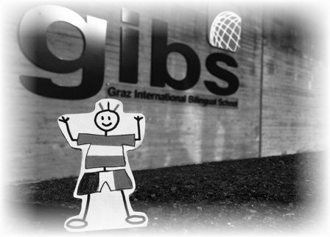
Figure 9: Eric at GIBS

Eric in Graz: Opening
We had a foreign exchange student stay at our house a while ago. We were all really excited to have him around and to show him all the cool things in Graz. We thought that he might like the great view from the ,,Schlossberg’’ or a nice walk in the city center. We soon learned that Eric, our exchange student, was a bit different to other foreign exchange students. He preferred the small things. It was the smallest detail that would catch his attention.

Eric in France:
Breadcrumbs all over…
When Eric was in France he noticed a lot of things that were new to him. When we ate our breakfast he wanted to have a plate for his bread. Here in Rennes we don’t use plates for the “petit-déjeuner”! We cut our bread and spread butter on the bread directly on the table. In general, meals were quite new and confusing for him. Another thing he told me was that we only eat baguette (in general white bread). It seems like in Austria they mainly eat whole-grain bread. Eric also noticed that the dishes in restaurants are not spiced in the same way as in his home country. He even told me that he ordered a “mousse au chocolat” and in the end it was salted…
Eric in France:
Don’t wear your cross for school…
…When Eric came to school with me he asked me whether we had no Muslims at school. I had to explain to him that in France your religion is not wanted in public space because everyone, no matter what religion, is equal and shouldn’t show the signs of their belief. School is considered as a public space – that means that the women are not allowed to wear a headscarf, and also other signs of your personal believes are not wanted to be seen. That’s why they don’t teach religion as a school subject.

Eric in Spain:
You need not take off your shoes…
At home he noticed some more things. When we entered our apartment he wanted to take off his shoes just like he is used to do in his home country. When we then told him that in Spain everybody leaves their shoes on in their home, Eric was astonished.
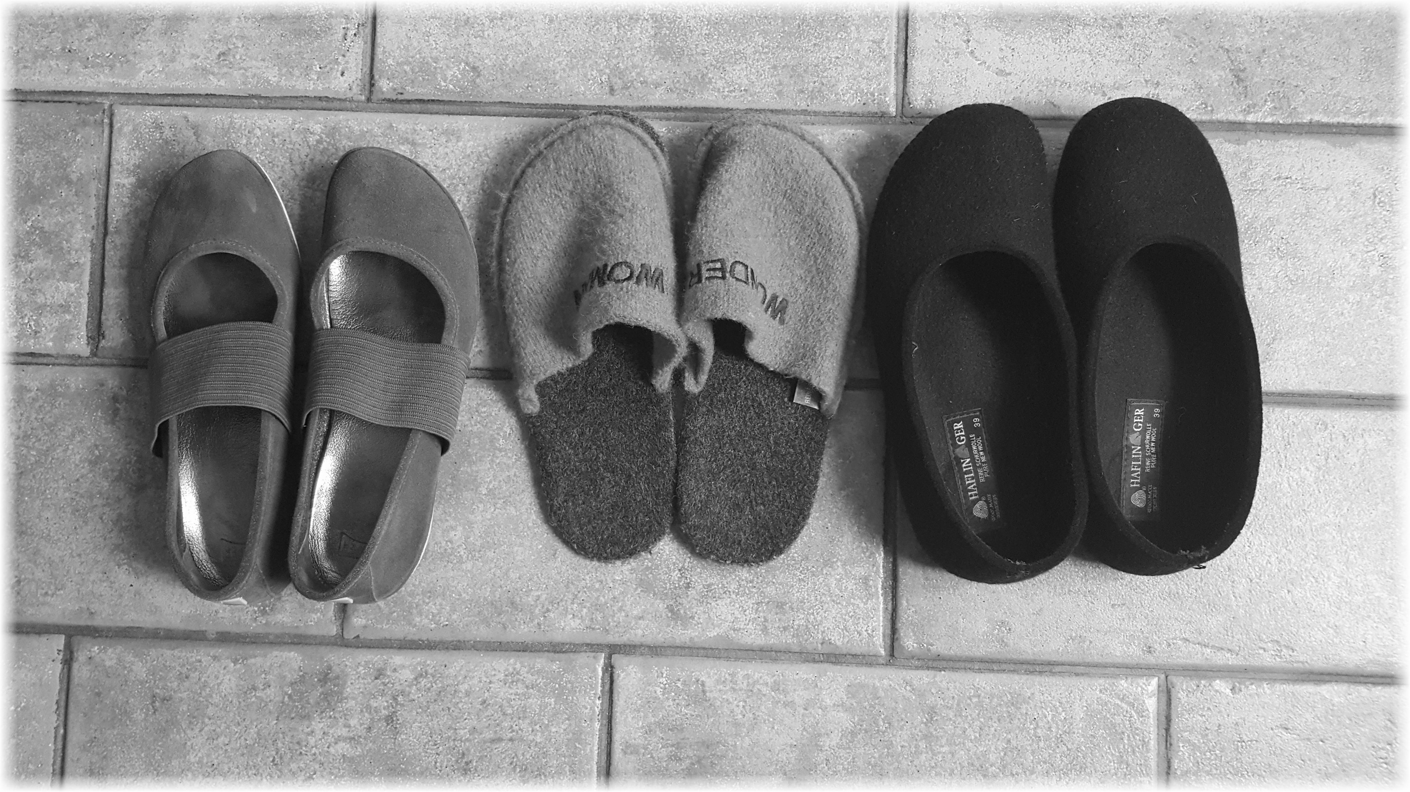
Figure 11: Slippers

Eric in France:
Drinking tea from a bowl…
The first morning I went down the stairs to eat some breakfast. I asked for some bread and a tea, but then I noticed something weird. First, my host mother handed me the tea but not in a cup like I am used to but in a small bowl. At first I thought that all the cups were in the dishwasher, however, every time I asked for tea or coffee a little bowl was placed in front of me.
After a few days I figured out why they used bowls instead of cups. I noticed that my host family dunked their bread in their tea or coffee; this is why they needed the extra space. From my point of view this is not something I want to do with my bread, I tried it once but not a second time, the bread was just too soft for my taste.
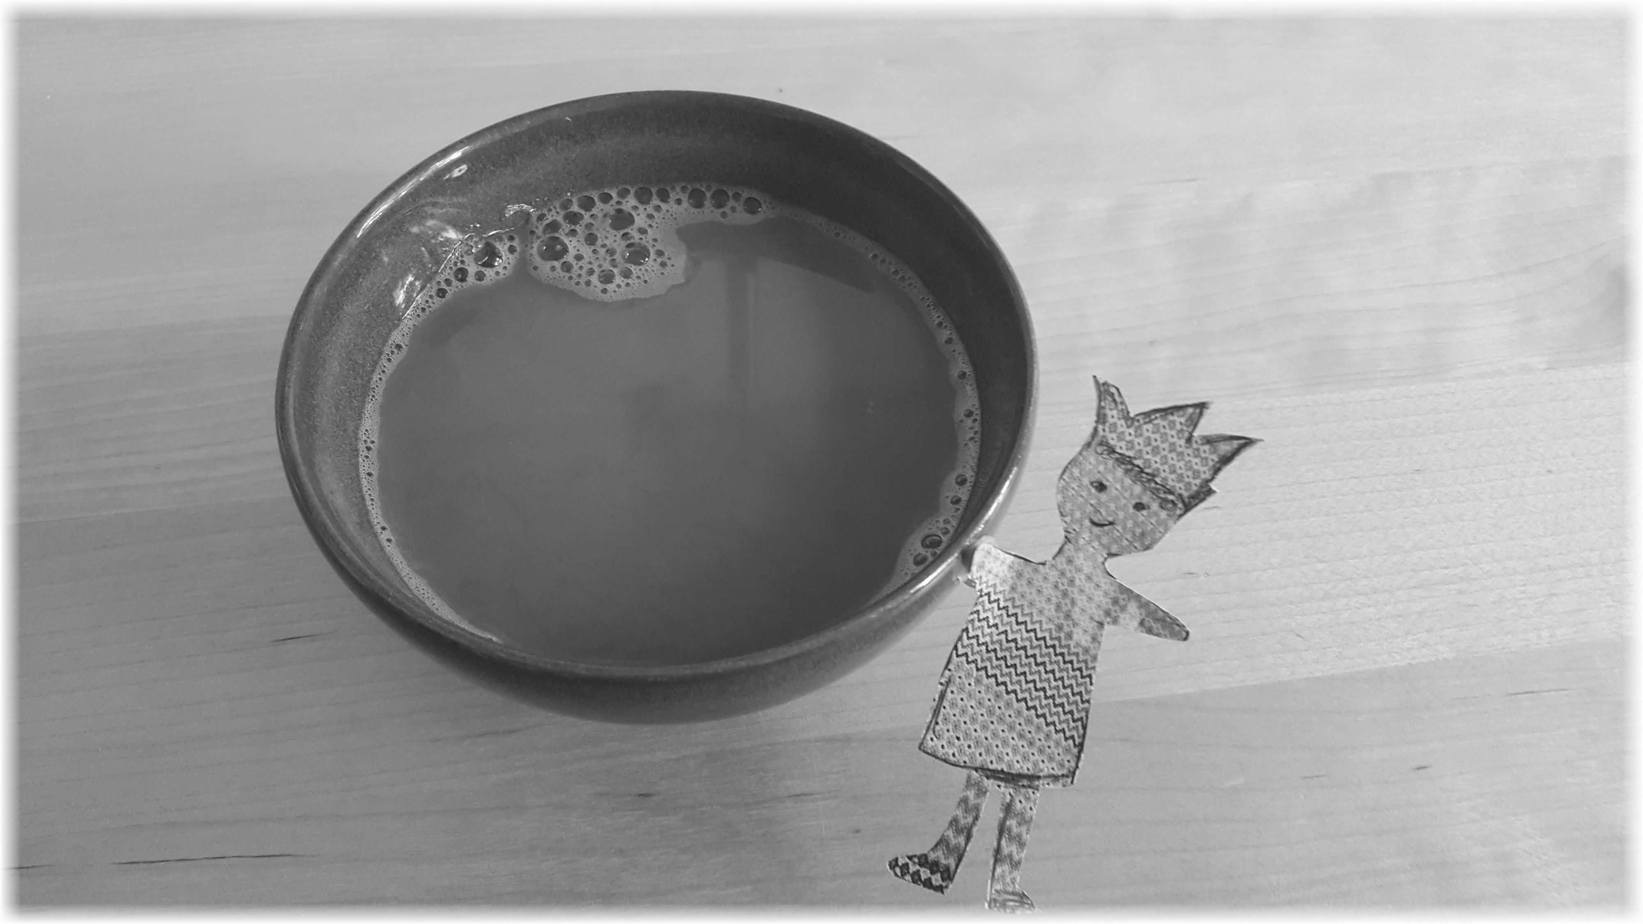
Figure 10: Coffee from a bowl

Eric in France:
TV all day
He also thought it was very interesting that our TV was only on in the evening, while his TV at home was on full time as entertainment in the afternoon.

Eric in Spain:
Don’t always say ‘please’ and ‘thank you’…
…Something else I observed was that Eric always said “Thank you”, “yes, please” or “no, thanks”. So I approached him and told him that in Spain you never say “thanks” or “please”, only if you don’t know someone or the person is superior. It took some time but he got used to all of it during his stay.

Eric in Spain:
Strange bathroom habits…
He also told me about some typical Spanish bathroom facts. Firstly, his host family lives in a really small apartment, however they have two bathrooms. The toilet and the shower are not separated. Each bathroom has a shower or bath tub, a toilet and of course a sink. By flushing the toilet in Spain, he realized that the buttons to flush the toilet always looked the same and had two options – one for just a little water and one for a full flush.
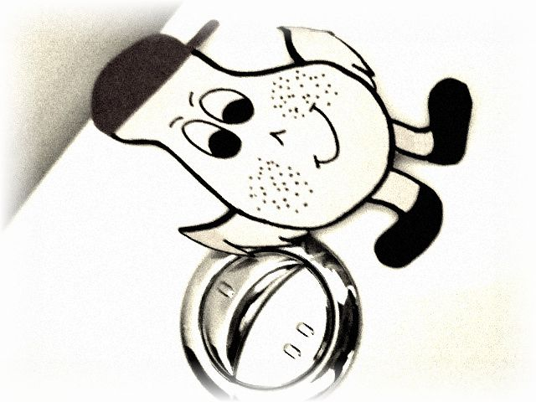
Figure 12: Eric flushing the toilet

Eric in Spain:
Dinner in pajamas
Eric wasn’t used to the fact that the whole family takes a shower before they have dinner and also eat dinner in their pajamas. Actually, dinner was served sooo late that pajamas seemed like a good choice.

Conclusions
According to Ghosn (2002), literature can be used “to transform, to change attitudes, and to help eradicate prejudice while fostering empathy, tolerance, and an awareness of global problems” within the foreign language reader (p. 176). Thus, literature can be seen “as a change agent” (Ghosn, 2002, p. 176). Although the picture book “Eric” was used more as a springboard for learners’ preparation for their class-trip abroad as well as reflection on it, reading the story combined with the given discussion and writing tasks seemed to help to mediate learners’ intercultural competence, especially concerning attitudes, knowledge and skills of interpreting and relating. This project also seems to show the importance of preparing learners for class-trips abroad in every stage of the experience as well as the important role that teachers have in ensuring that learners are given the support and space they need to profit from the intercultural experience. Henry Miller once said: “One’s destination is never a place, but a new way of seeing things.” We hope that by working with this reading-writing project, our learners were given the opportunity to do just that.

References
Byram, M. (1997). Teaching and Assessing Intercultural Communicative Competence. Clevedon: Multilingual Matters.

Byram, M. (2000). Assessing Intercultural Competence in Language Teaching. Sprogforum, 18(6), 8-13. Retrieved from: http://library.au.dk/fileadmin/www.bibliotek.au.dk/ Campus_Emdrup/Sprogforum_arkiv/SPROGFORUM_NO._18_Interkulturel_kompetence.pdf [04.13.2011].

Byram, M. (2009). Intercultural competence in foreign language education. In D.K. Deardorff (Ed.), The Sage handbook of intercultural competence (2nd ed., pp. 321-332). Thousand Oaks, CA: Sage.

Byram, M., Gribkova, B., & Starkey, H. (2002). Developing the Intercultural Dimension in Language Teaching: A Practical Introduction for Teachers. Strasbourg: Council of Europe.

Council of Europe. (2001). Common European Framework of Reference for Languages.
Retrieved from https://www.coe.int/t/dg4/linguistic/Source/Framework_EN.pdf
[21.07.2016].

Ghosn, I. (2002). Four good reasons to use literature in primary school ELT. ELT Journal, 56(2), 172-179.

Hofstede, G. (1997). Cultures and Organizations. Software of the Mind. New York, NY: McGraw-Hill.

Hua, Z. (2014). Exploring Intercultural Communication. Language in Action. London: Routledge.

Kearney, E. (2016). Intercultural Learning in Modern Language Education. Bristol: Multilingual Matters.

Kramsch, C. (2009b). Cultural Perspectives on language learning and teaching. In K. Knapp & B. Seidlhofer (Eds.), Handbook of Foreign Language Communication and Learning (pp. 219-246). Berlin: Mouton de Gruyter.

Miller, M. (2014). Interkulturelles Lernen ohne Worte! Shaun Tan’s Graphic Novel “The Arrival.” Unterrichtpraxis, 2, 7-11. Retrieved from www.praxis-fremdsprachen unterricht.de [10.2.2014].

Moeller, A. J., & Nugent, K. (2014). Building intercultural competence in the language classroom. In S. Dhonau (Ed.), Unlock the Gateway to Communication. Central States Conference Report (pp. 1-18). Eau Claire, WI: Crown Prints.

Müller-Hartmann, A., & Schocker-v. Ditfurth, M. (2013). Introduction to English Language Teaching. Stuttgart: Klett Lerntraining.

Spitzberg, B. H., & Changnon, G. (2009). Conceptualizing Intercultural Competence. In D.K. Deardorff (Ed.), The Sage handbook of intercultural competence (2nd ed., pp. 2-52). Thousand Oaks, CA: Sage.

Tan, S. (2001). "Picture Books: Who Are They For?". Retrieved from shauntan.net: http://shauntan.net/images/whypicbooks.pdf [20.06.2016]

Tan, S. (2008). Eric. In S. Tan, Tales from Outer Suburbia (pp. 8-18). New York: Scholastic.

Zull, J. (2002). The Art of Changing the Brain. Sterling, Virginia: Stylus Publishing.

Vande Berg, M., Connor-Linton, J., & Paige, M. R. (2009). The Georgetown Consortium Project: Interventions for student learning abroad. Frontiers: The Interdisciplinary Journal of Study Abroad, 18, 1-75.

Table of Figures: Unless otherwise mentioned, all images by E. Pölzleitner
Figure 1: Eric, Shaun Tan 2008
Figure 2: Student booklet, Pölzleitner, Schumm
Figure 3: Eric, Shaun Tan, 2008
Figure 4: Cultural iceberg
Figure 5: A cultural iceberg for France
Figure 6: A cultural iceberg for Spain
Figure 7: Thank you
Figure 8: Pumpkin seed oil
Figure 9: Eric at GIBS
Figure 10: Coffee from a bowl
Figure 11: Slippers
Figure 12: Eric flushing the toilet

