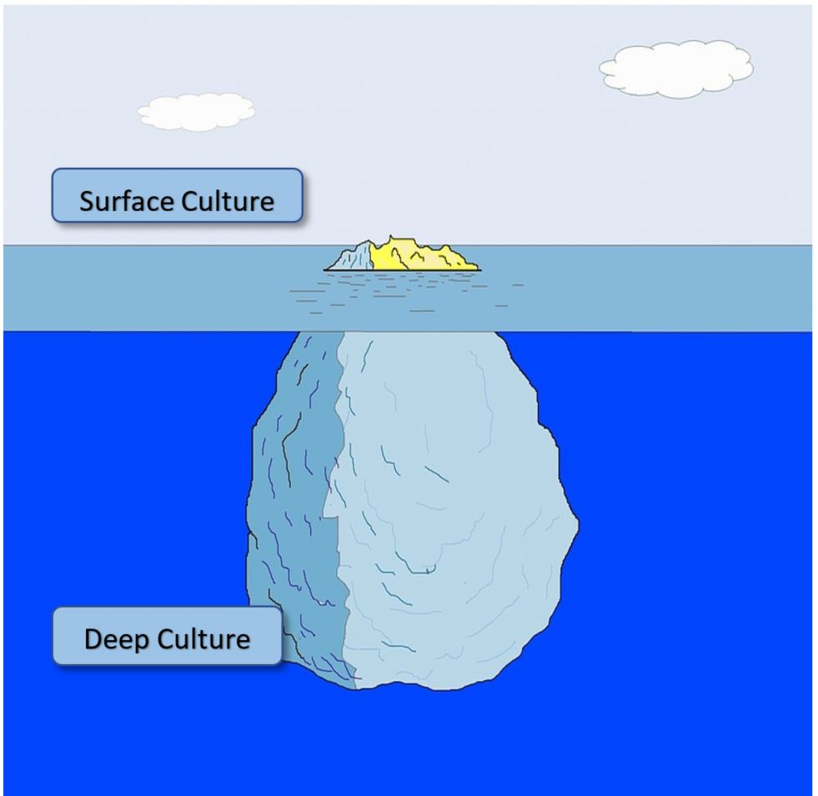
Find the whole Eric project on: http://epep.at
Search for “eric”.

Find the whole Eric project on: http://epep.at
Search for “eric”.

Find the whole Eric project on: http://epep.at
Search for “eric”.

Find the whole Eric project on: http://epep.at
Search for “eric”.

