Intercultural competence and literature

Key Words

Culture
Intercultural competence (IC)
Literature
Young adult literature (YAL)

In this chapter, we ask the following questions:

What is the present status of intercultural education in Austria’s school curricula?
How has the shift towards emphasizing IC affected language teaching?
How can teachers promote IC?
What role can literature play in enhancing learners’ IC?

Theoretical perspectives and the Austrian context

Austria has a greater cultural diversity than ever before, and, as a result, teachers today often find themselves facing increasingly multicultural, multilingual classes which can sometimes be challenging and need to be managed proactively in order to create an atmosphere of equality and respect within the classroom. If addressed actively, this cultural diversity can be a real asset for all stakeholders as it offers everyone involved opportunities to learn to interact in a global, diverse and challenging world. With this in mind, the need for intercultural learning in the EFL classroom could never be more crucial and relevant.

Since 1992, intercultural education has been included in Austria’s school curricula as an Unterrichtsprinzip, which should be taught across the curriculum, thus showing its relevance and interdisciplinary nature. More recently, curricular guidelines concerning this transversal curriculum principle were revised in the ‘Interkulturelle Bildung – Grundsatzerlass 2017 (BMBWF, 2017, p. 1). While the formal status of intercultural education remains the same within the new curriculum guidelines, the updated understanding of the concept reflects recent research as well as contemporary pedagogical classroom practices. (BMBWF, 2017, p. 2). This includes acknowledgement of debates surrounding various terminology such as interculturality, transculturality and multiculturality which the current curriculum has placed under the umbrella term of intercultural education. The main goals of the Grundsatzerlass is to help learners develop an open-minded attitude towards otherness, to raise their awareness of Eurocentric and ethnocentric beliefs and to provide them with the skills to explore different perspectives in today’s open, heterogeneous societies.

When discussing the concept of IC in foreign language education, reference must be made to the role of the Council of Europe (CoE) and CEFR. In addition to providing descriptors of the four language skills, namely, speaking, listening, reading and writing, the CEFR “was the first major European policy document to give significant emphasis to the intercultural nature of language learning” (Kelly, 2012, p. 411). In this way, the CEFR made a policy shift from language teaching being about communicative competence to an emphasis on the development of intercultural competence. The CEFR describes the language learner as follows: “The learner of a second or foreign language and culture does not cease to be competent in his or her mother tongue and the associated culture. Nor is the new competence kept entirely separate from the old. The learner does not simply acquire two distinct, unrelated ways of acting and communicating. The language learner becomes plurilingual and develops interculturality. The linguistic and cultural competences in respect of each language are modified by knowledge of the other and contribute to intercultural awareness, skills and know-how. They enable the individual to develop an enriched, more complex personality and an enhanced capacity for further language learning and greater openness to new cultural experiences”(Council of Europe, 2001, p. 43; italics and bold print in the original).

The CEFR also provides teachers with a common language to speak about the IC of their learners. These include the areas of knowledge, skills and attitudes. More recently another skill area has been included in the CEFR-Companion Volume (CEFR-CV), namely, mediation which highlights the collaborative processes of meaning-making (Council of Europe, 2018). Mediation refers to certain characteristics which can enable communication and “is also used to describe a social and cultural process of creating conditions for communication and cooperation, facing and hopefully defusing any delicate situations and tensions that may arise” (CEFR-CV, 2018, p. 106).

Concerning Austria’s school curricula, the CEFR’s understanding of IC has served as the basis for how the concept is seen in the country’s current language education (Dalton-Puffer, Boeckmann & Hinger 2019, p. 215). However, regardless of the emphasis placed on the importance of intercultural education in educational documents such as the CEFR, Dalton-Puffer, Boeckmann and Hinger (2019) suggest that in everyday practice in EFL classes in Austrian schools, cultural topics and related areas like literature are given less precedence (p. 215). They contribute this to factors such as the increased heterogeneity of classrooms, which, interestingly, reduces some foreign language teachers’ perceived need to spend class time dealing with cultural issues as pupils are experiencing cross-cultural exchanges on a daily basis. Another reason that is often mentioned is the standardized Matura, since many teachers feel pressured to use the class time for developing the competences required to pass the exam (Dalton-Puffer, Boeckmann & Hinger 2019).

Culture in the foreign language classroom
The understanding of culture in language teaching has changed considerably over the years. Viewed historically, Kramsch (2009) suggests that culture has evolved from being seen as a very static concept primarily focusing on the characteristics of nationality to a more flexible understanding of the concept which acknowledges that culture is no longer defined by national borders and history. Regardless of this shift in perspective, Kramsch (2009) also recognizes that these various understandings of culture have their place in language teaching.

For teachers, this means that talking about cultural beliefs, values and behaviours of English speaking countries still has its place in the language classroom. This is also reflected in coursebooks and for younger learners especially, makes the complex concept of culture more accessible. In addition, knowledge of cultures where English is predominantly spoken is one way of bringing the language experience to life. However, the shift in perspective also means that teachers need to go beyond the knowledge level and consider the role of English as a global lingua franca in today’s world. This means that teachers need to consider more than fixed language and cultural context if they want their language learners to succeed in the various communicative situations they may find themselves in. This viewpoint is also reflected in the CEFR-CV’s recent inclusion of mediation, which addresses skills such as facilitating pluricultural space, acting as an intermediary in informal situations and adapting language, accordingly.

Intercultural competence in the foreign language classroom
When considering the intercultural dimension of language teaching, teachers can refer to the CEFR descriptors as well as a wide selection of models designed to help educators in setting their teaching objectives. Perhaps the most widely used and accessible model at the moment is the one proposed by Byram (1997). This model was designed primarily for classroom use and refers specifically to the CEFR. Byram’s model includes five main competences and more detailed sub-competences. The latter describe and clarify the main competences for both teachers and learners, thus allowing teachers to focus on individual aspects of intercultural learning. In addition, the model can be used as a tool for assessment where progress in individual competences and their sub-competences can be evaluated.
Below is a list of the five main intercultural competences:
“Attitudes: curiosity and openness, readiness to suspend disbelief about other cultures and
belief about one’s own;

Knowledge: of social groups and their products and practices in one’s own and in one’s interlocutor’s country, and of the general processes of societal and individual interaction;
Skills of interpreting and relating: ability to interpret a document or event from another culture, to explain it and relate it to documents or events from one’s own;
Skills of discovery and interaction: ability to acquire new knowledge of a culture and cultural practices, and the ability to operate knowledge, attitudes and skills under the constraints of real-time communication and interaction;”
Critical cultural awareness/political education: an ability to evaluate critically and on the basis of explicit criteria perspectives, practices and products in one’s own and other cultures and countries” (Byram, 2000, p. 9).
For a list of sub-competences see Byram’s seminal work: Teaching and Assessing Intercultural Communicative Competence (1997).
An advantage of working with Byram’s (1997) model in the language classroom is that it provides language teachers with a set of teaching objectives which can inform their teaching and guide their assessment of learners’ IC. One criticism of Byram’s (1997) model is that its focus is more on national cultures in contrast to a more transcultural and global understanding of culture. However, Byram’s (1997) model was written for language teachers who are still “working within a tradition that focuses on national cultures” (Byram, 2009, p. 330). When looking at many foreign language course books, it becomes clear that emphasis is often placed on certain aspects of the target culture language or even the given culture, whereas there is less focus on facilitating skills that learners will need when communicating cross-culturally. This is where teachers will need to supplement teaching materials in order to provide their learners with strategies required when using English in various settings.

A more recent model worth mentioning which advances the CoE’s plurilingual agenda is FREPA: A Framework of reference for pluralistic approaches to languages and cultures - Competences and resources. FREPA was designed to further the language education policies of the CoE as it considers the development of language learners’ plurilingualism and IC as its main aims. Like the CEFR and Byram’s (1997) model, it is composed of a number of competences and descriptors and can be used to inform teaching objectives as well as material design. An advantage of the framework is that it is very comprehensive and covers both global competences as well as the dimensions of knowledge, attitudes and skills, taking both plurilingual and IC of language learners into account. A complete list of the descriptors for the respective resources presented in the FREPA framework can be found at: http://www.ecml.at/tabid/277/PublicationID/82/Default.aspx. Admittedly, the descriptors are quite detailed in order to ensure comprehensiveness; however, their explicitness can help teachers and teacher educators formulate their objectives for both curriculum design as well as classroom use. Therefore, it almost goes without saying that teachers working with the FREPA framework will have to choose a limited number of descriptors that seem to be relevant for their specific classrooms.
In addition to considering which intercultural competences teachers want to develop in their learners, they also need to take into consideration that intercultural learning is a process that each learner will experience differently. In addition, like in language learning, learners will most likely work at their own pace and may require more time to understand/acquire certain aspects of IC. These aspects are reflected in the learning aims of teaching resources available for developing IC which offer a wide selection of activities that appeal to different learners’ needs and styles of learning (see further reading below). The selection of activities include: icebreakers, games, ranking tasks, experiential activities, case studies, critical incidents, role plays, various forms of media and simulations which can be done with different age groups and group sizes in order to cater to learners’ individual needs. Interestingly, one point that they all have in common is that the activities end by giving learners the opportunity to reflect on what they take away from the task. This final step is crucial as learners are required to reflect on what they have learned, and it also shows that intercultural learning is a life-long process that never stops.

Using Literature to enhance intercultural competence in the foreign language classroom
There are many reasons to incorporate literature into the language classroom: it helps to develop the skill of reading, it is a comprehensible form of input for language acquisition, it can be used to provide good models for written English (genre/text type), it can serve as a source for teachers to focus on language in context (grammar, vocab, paragraphing, cohesion, etc.), it can be used to introduce topics and themes and, last but certainly not least, it can help to contribute to a community of learning and help learners discover the pleasure of reading. While this list is by no means exhaustive, it does show the potential that literature has in language learning as it can be used by teachers to achieve many teaching objectives.
Another reason for using literature in the language classroom is that it can also help in developing learners’ IC. Literary texts can provide learners with knowledge about the target language and culture. Secondly, they can help learners gain insights into their own culture(s) by reflecting on aspects presented in the texts and referring them back to the learners’ own culture(s). Taking this into account and discussing different viewpoints with others who have read the same text can help learners call into question beliefs and assumptions they unconsciously carry around with them. Helping learners to reflect on their world views is an important step in developing IC. In addition, learners can experience another world vicariously which otherwise might remain remote for them. Finally, reading literature in a foreign language can help facilitate learners’ interpretative skills in which they are required to relay what the text means to them, thus enhancing mediation skills.
Various types of literature can be used for the purpose of promoting intercultural learning, which include poems, short stories, novels, etc. The same can be said for the type of genre. Teachers’ decisions will be made primarily on the objectives they want to achieve as well as learners’ language level and interests amongst other points to consider. However, one type of literature has proven to be very suitable in connection with developing the intercultural dimension in the EFL classroom, namely, multi-cultural literature. More specifically, multi-cultural literature that deals with the immigrant experience is recommended as the characters often face challenges when interacting with members of the new culture they are living in and/or members of different cultures who they come in contact with. For this reason, this type of multi-cultural literature can provide contextual situations in which learners can become aware of and analyze cultural diversity. While such literature may lead to highlighting more differences and misunderstandings between people with different cultural backgrounds, which teachers need to consider in order to avoid reinforcing stereotypes, it also provides a voice to the people who are represented in it. Thus it gives learners insights into situations they may not be familiar with. An example of a multi-cultural reading project designed for classroom use will be given below in the section ‘practical applications’.
When choosing multi-cultural literature for classroom use, teachers will have to consider the complexity and language level of the books. In most cases, books, which are defined as Young Adult Literature (YAL) will be more appropriate, while adult literature will be reserved for advanced readers at B2 level and above. For Blasingame (2007), YAL has four main characteristics; it
1. has characters and issues young readers can identify with; those issues and characters are treated in a way that does not invalidate, minimize, or devalue them.
2. is framed in language that young readers can understand.
3. emphasizes plot above everything else.
4. is written for an audience of young adults. (p. 11)

Blasingame’s (2007) definition of YAL highlights the main prevailing features of this type of literature and at the same time also highlights its merits for classroom use. In most cases, it can be seen as literature that speaks to young adult learners as it presents their worlds, in a mode of communication they understand and with them as the target audience in mind. For this reason, actions, experiences and views presented in the literature will most likely not seem remote to learners but something they can identify with on at least one level. Perhaps most importantly, YAL may be a way to show them that reading and literature can be pleasurable. Concerning multi-cultural YAL, a wide selection of excellent books have been published in more recent years so teachers will easily find appropriate books for any age group and reading

Practical Applications

Seen from the perspective of a practical language teacher in Austria, the need for developing learners’ intercultural competence seems to be an integral part of their language learning.
As addressed above, using YAL can be an ideal way to develop learners’ awareness and acceptance of cultural diversity and thus develop an atmosphere of mutual respect and appreciation. When reading YAL, learners dive into an unknown world where they can identify with characters and walk in their shoes for a while. In this safe environment, they learn to switch perspectives and look at the world from a different point of view. By decentering their own perspectives, learners can slowly allow themselves to challenge their beliefs, develop more open-minded attitudes, and thus develop a space of interculturality in their minds.

Activity: Intercultural Reading Projects: The following steps should be considered when designing an intercultural reading project in which learners read and respond to YAL.

What do teachers need to consider when planning an intercultural reading project?

1. Choosing the books:
When choosing books for an intercultural reading project the learners’ age, reading level and previous reading experiences need to be considered. The novels should not be too challenging on the language level and not too long. Offering a choice of books rather than one class reader, which all learners have to read, usually improves learners’ motivation and gives them a sense of empowerment. In addition, it will give them the opportunity to compare the different experiences and perspectives presented in the books and thus widen their horizon. Working with one book only does not allow this. Examples of popular multicultural YAL can be found online. A good source to start with is: https://www.goodreads.com/shelf/show/ya-multicultural .

The choice of books should also include male as well as female protagonists. This will make it easier for the learners to identify with the main characters and their problems. If the learners can really identify with the main characters and allow themselves to walk in their shoes and feel their pain and pleasure, more of the intended intercultural learning will happen.

2. Time:
A typical timeframe for an intercultural reading project is two to three weeks, including a session of presentations. Unfortunately, many teachers feel that they cannot afford to spend time on reading projects because they have to cover all the units in the textbook. Knowing how much students can learn from a reading project can help teachers put the textbook aside for a while and spend time on an intercultural reading project with a clean conscience.

3. Choosing a focus:
In order to get the most out of an intercultural reading project it is necessary to focus on two to three main teaching objectives. Byram’s model or FREPA are excellent starting points where teachers can find appropriate objectives for their target group. With a clear goal in mind, teachers can then start planning a number of pre-, while- and post-reading tasks that will guide the learners in their reading and help them reach these objectives.

The following two examples of intercultural reading projects show a variety of tasks that can easily be modified for different books and target groups.

Example 1: Intercultural reading project: Eric’s intercultural experiences. (Pölzleitner and Schumm-Fauster, 2017)

Literary Input:
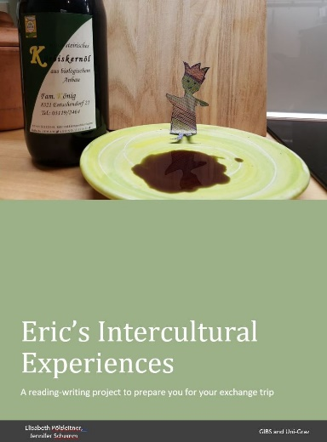
The project is based on the picture book Eric by Shaun Tan. (Tan, 2008) In Tan’s story an extra-terrestrial exchange student visits a family and surprises them with his unexpected behavior and questions. He seems very inquisitive, asking questions which may seem odd to those who have become blind to the patterns of everyday life. Shaun Tan’s stories do not usually give any answers, but they encourage the readers to ask lots of questions. The story of Eric raises the question of how culture shapes our perception and our behaviour. It encourages us to reflect about our everyday practices and redefine what is “normal”. Shaun Tan invites the reader to explore the area of “deep culture”, the invisible strings that guide us.
Figure 1: Student tasks for the project

Goals: prepare learners for an exchange trip abroad; raise learners’ awareness of cultural differences between their home and the culture in their host country and host family; develop learners’ understanding of the various layers of “culture” (surface culture, deep culture) and their influence on human behavior (universal/ cultural/ personal dimensions of behavior)

Rationale: Class trips abroad are very popular in Austria and have a fixed place in most schools. Even if it is not realistic to believe that a 10-day trip will dramatically improve learners’ language skills, these trips can be highly motivating for learners and they can contribute strongly to promoting their IC. This reading project helps facilitate learners’ IC.

Pre-knowledge: Basic knowledge of cultures included in project; at least CEFR A2/B1 in L2 and/or L3 in order to complete the tasks

Level: CEFR A2 to B1 or higher. The project can be used for any international class-trips, irrespective of the target language. In our example the students went to Spain, France and Russia. Most tasks were completed in English, some basic tasks were done in the learners L3.

Procedure

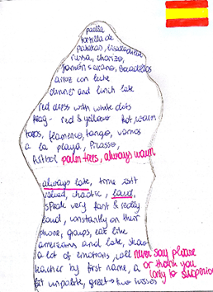
First, learners read the very short picture book Eric and then work with a project booklet containing about 15 tasks. These tasks encourage the learners to look at their own everyday practices and compare them to the practices of their host family. The learners are introduced to the concept of the “cultural iceberg” (for a description of this concept, see Activities and Reflective Questions below) and explore different levels of culture by filling in their personal cultural iceberg as well as the cultural iceberg based on their experiences in their host country.
Figure 2: Cultural Iceberg for Spain
In a further step, learners compare these experiences with their classmates, and learn to understand the personal, cultural and universal dimensions of human behaviour. Thus, several stereotypes can be discussed and resolved.


The second part of the project consists of a story writing activity where the students create their own Eric figure and take photos of Eric in interesting “cultural” situations, both at home and in the host country. The students then write a sequel to the original storybook where they describe Eric’s cultural experiences in both places.
The project has been tried out in several classes and has always led to very interesting discussions about culture and cultural identity. All project materials including the handouts for the learners and examples of learner products can be downloaded from: www.epep.at/eric and are free for classroom use.
Figure 3: Eric drinking his morning coffee

Example 2: Crossing Borders is an intercultural reading project based on a set of young adult novels Crossing Borders (Schumm Fauster & Pölzleitner, 2013)

Literary input:
In the project, learners choose from a selection of young adult novels in which at least two cultures are represented by the protagonists. In all of these novels the protagonists have to cross borders on their journey to discovering their cultural identity. They cross borders of all kinds, such as national, cultural, racial, religious, gender, social or ethnic borders and share their experiences with the readers.
Here is a selection of books, which have been used :

Sherman Alexie, The Absolutely True Diary of a Part-Time Indian
Marina Budhos, Ask Me No Questions
Ann Jaramillo, La Linea
Melissa Schorr, Goy Crazy
Jacqueline Woodson, If you Come Softly
Angie Thomas, The Hate U Give
…

Goals: to acquire knowledge of the lifestyles, problems and practices of the social groups represented in the books; to challenge the learners’ attitudes including their preconceived notions and stereotypes; to develop learners’ curiosity about new cultures and experiences as well as about their own and to promote learners’ empathy towards others

Rationale: As in the previous example, the learners compare their own experiences and practices with those of the protagonists and explore differences and similarities between their cultures, thus giving learners new insights not only into other cultures but also into their own as they are required to reflect on both. In the process, learners’ openness towards others may also be promoted.

Pre-knowledge: learners should have at least CEFR B1 in order to be able to enjoy and read the books chosen.

Level: CEFR B1

Procedure

After choosing one of the novels the students receive a package of pre- while- and post-reading tasks that guide them through the project.

Below is a selection of tasks that can be used with any books in order to enhance intercultural learning:

1. Learners compare their hopes and dreams with those of the main characters by filling out a chart in which they note how they view life and how the main characters do. This activity can help learners to realize that young people all over the world share very similar dreams of being safe, having a loving family and friends they can trust.
2. Learners collect all the stereotypes about the protagonists’ cultures that they have come across while reading their respective novel. After reading their chosen book, they compare their own list with the stereotypes mentioned in the novels and discuss these with the class. This task can help learners to question their own stereotypes and encourages them to focus on similarities rather than differences.

3. Venn diagrams are often used for comparison as they allow learners to note similarities as well as differences. In this reading project, Venn diagrams are used to help learner compare their local culture with the protagonists’ cultural practices. What is interesting about this activity is that learners often note that they have many important aspects in common with the protagonists (e.g., the importance of family) and aspects of their life that are less important (e.g., dinner times) are the ones that are placed in the spaces that they do not share.

4. In the last part of the project, learners work with discussion prompt cards and short role-plays where they explore the protagonists’ perspectives more intimately. In the role-play situations learners put themselves in someone else’s shoes and experience the situations from a different perspective. For example, learners imagine that one of the protagonists has moved to their town and joined their class. The learners wonder how these new students would be accepted and integrated – or what it would be like to invite one of them to their family as an exchange student. In all these cases the students are personally and emotionally involved and have the chance to play with these situations in a safe environment. It is hoped that this will help them open their doors a little wider and perceive otherness with curiosity rather than fear.

5. Finally, each reading group presents their novel to the class. The main aim of these group presentations is to help the learners to see the wider picture by comparing and discussing the different characters’ experiences. Moreover, these presentations can motivate the students to read another book that seems interesting to them.

A more detailed description of the project has been published in Modern English Teacher (Schumm Fauster & Pölzleitner, 2013). The project materials and steps can also be downloaded from www.epep.at/crossing-borders.

Activities and questions for reflection

- Activity: Cultural icebergs
The concept of the cultural iceberg is one of the most useful tools for classroom use as it helps depict aspects of culture which we notice quite quickly and those that take time to notice and understand. Draw an iceberg for your native culture and another one for your experiences with the culture of an English-speaking country of your choice. Replace the general terms in the iceberg model by personal memories of experience and intercultural encounters. Be as specific as possible, using names, places and dates.
After you have completed your icebergs, compare them by reflecting on the following questions: What do you notice about the iceberg representing your native culture? What do you notice about the iceberg representing the culture of an English-speaking country of your choice? What aspects are highlighted in both icebergs? What aspects are missing? Why do you think this is the case? What have you learned about the concept of culture from doing this task?
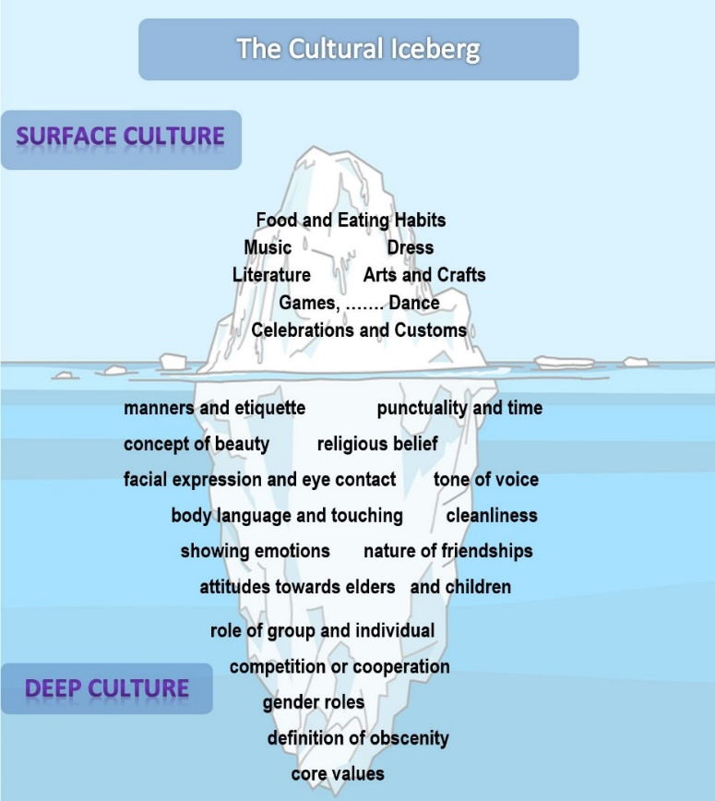
2. Activity: Stereotype detectives
In a table list about four to five cultural groups in your environment. Also include your own culture. Then collect all the stereotypes about these groups that you have come across. In a third and fourth column collect examples that either support or contradict these stereotypes. Use concrete examples from your personal experiences or from recent media reports.
Cultural or ethnic groups | Stereotypes that you have come across | Concrete examples  that support this stereotype | Concrete examples that contradict this stereotype

Now reflect on this activity: Where do stereotypes come from? How are they spread and shared? What impact can stereotypes have on individuals? What can teachers do in the classroom to create an equitable atmosphere for all students?
3. Question for reflection: Look at a chapter in a coursebook that you are using now or have used. What aspects of culture are addressed? How are they addressed? Is there anything that you would add in order to develop the aspect further?

4. Question for reflection: Refer to Byram’s model or FREPA and design a lesson plan in which your objective is to enhance learners’ intercultural competence. What are your objectives? What classroom activities will you use to achieve them?

References
Blasingame, J. (2007). Books That Don’t Bore ’Em. New York, NY: Scholastic.
BMBWF (2017). Bundesministerium für Bildung und Forschung: Interkulturelle Bildung – Grundsatzerlass 2017 [Austrian Federal Ministry of Education, Science and Research]. Retrieved from: https://bildung.bmbwf.gv.at/ministerium/re/2019_20.html
Byram, M. (1997). Teaching and Assessing Intercultural Communicative Competence. Clevedon: Multilingual Matters.
Byram, M. (2000). Assessing Intercultural Competence in Language Teaching. Sprogforum, 18(6), 8-13. Retrieved from: http://library.au.dk/fileadmin/www.bibliotek.au.dk/ Campus_Emdrup/Sprogforum_arkiv/SPROGFORUM_NO._18_Interkulturel_kompetence.pdf [04.13.2011].

Byram, M. (2009). Intercultural competence in foreign language education. In D.K. Deardorff (Ed.), The Sage handbook of intercultural competence (2nd ed., pp. 321-332). Thousand Oaks, CA: Sage.

Candelier, M., Camilleri-Grima, A., Castellotti, V., de Pietro, J-F., Lörincz, I., Meißner, F-J., Noguerol, A., & Schröder-Sura, A. (2012). FREPA. A Framework of Reference for Pluralistic Approaches to Languages and Cultures. Competences and resources. Strasbourg/Graz: Council of Europe.
Council of Europe. (2018). Common European Framework of Reference for Languages. Companion Volume with new descriptors
Retrieved from https://rm.coe.int/cefr-companion-volume-with-new-descriptors-2018/168078 7989

Dalton-Puffer, C., Boeckmann, K-B., & Hinger, B. (2019). Research in language teaching and learning in Austria (2011-2017). Language Teaching, 52, 201-230.
Kelly, M. (2012). Second language teacher education. In J. Jackson (Ed.), The Routledge
handbook of language and intercultural communication (pp. 409-421). Abingdon: Routledge.

Kramsch, C. (2009). Cultural Perspectives on language learning and teaching. In K. Knapp & B. Seidlhofer (Eds.), Handbook of Foreign Language Communication and Learning (pp. 219-246). Berlin: Mouton de Gruyter.
Pölzleitner, E. & Schumm Fauster, J. (2017). Eric’s Intercultural Experiences. In K. da Rocha et al. (Eds.), Picture That! Picturebooks, Comics and Graphic Novels in the EFL Classroom (pp.121-140). Studienreihe der Pädagogischen Hochschule Steiermark. Band 9. Graz: Leykam.
Schumm Fauster, J. & Pölzleitner, E. (2013). Crossing Borders. In Modern English Teacher (22)1: 25-30.
Tan, S. (2008). Eric. In S. Tan, Tales from Outer Suburbia (pp. 8-18). New York: Scholastic.

Suggestions for further reading:

Berardo, K. et al (2012). Building Cultural Competence. Innovative Activities and Models. Sterling, Virginia: Stylus.
This is a hands-on book that provides teachers with a selection of activities as well as models which they can take into the language classroom. Each activity is designed to develop a number of intercultural comptences.
Duff, A. & Maley, A. (2007). Literature (new edition). Oxford: OUP.

This is a practical book that provides teachers with various ideas on how they can incorporate all types of literature into the language classroom. The book has a strong language focus.

Paran, A., & Robinson, P. (2016). Literature. Oxford: OUP.

This book considers various literary genre. By way of example, it provides teachers with insights into how to incorporate them into the language classroom.

Wintergerst, A. & McVeigh, J. (2011). Tips for teaching culture. Practical Approaches to Intercultural Communication. New York: Pearson Longman.

This books provides a good overview of different ways teachers can address cultural issues in the classroom. It provides copiable materials as well as short theoretical explanations which support the practical nature of the book.

Commentary on reflection questions

3. Question for reflection: Look at a chapter in a coursebook that you are using now or have used. What aspects of culture are addressed? How are they addressed? Is there anything that you would add in order to develop the aspect further?

Depending on the chapter/book teachers look at, this question will have different answers. This question should, however, prompt teachers to think about what aspects of culture/IC are actually covered in the coursebooks they work with and where they might see the need to supplement them with additional materials.

4. Question for reflection: Refer to Byram’s model or FREPA and design a lesson plan in which your objective is to enhance learners’ IC. What are your objectives? What classroom activities will you use to achieve them?

As with the question above, this one will be answered differently by different teachers. What is important is that teachers familiarize themselves with both models and consider how they might help them in integrating the intercultural dimension into their classrooms. The models also show how many activities that teachers already do with their pupils can be slightly modified to allow for opportunities of intercultural learning.

(word count: 5, 469 – maximum 4,500)

