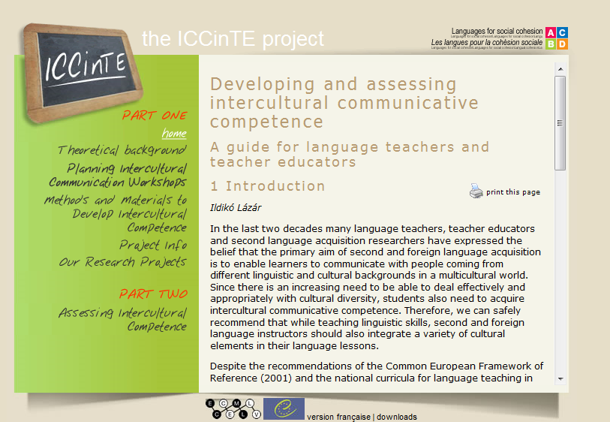

http://archive.ecml.at/mtp2/iccinte/results/en/index.htm

Byram: Assessing Intercult. Competence:
http://inet.dpb.dpu.dk/infodok/sprogforum/Espr18/byram.html

also saved on lp – uni- intercult. competence, byram…

